SMART LOGISTICS DECISION SYSTEM
A Data-Driven Approach for Optimizing Logistics and Supply Chain Decisions
-ANISH MUKUL RINGE 23BDS0082
-MEET DINESH PATIL 23BDS0083

Abstract
This project presents a Smart Logistics Decision System designed to improve supply chain efficiency through data-driven insights. The system leverages data preprocessing, analytical modeling, and optimization techniques to enhance route planning, reduce operational costs, and improve delivery timelines. The study demonstrates how intelligent decision systems can transform traditional logistics operations into efficient, scalable, and adaptive frameworks.
Keywords: Logistics, Optimization, Machine Learning, Supply Chain, Data Analytics

1. Introduction
Logistics and supply chain management play a critical role in modern businesses, acting as the backbone that ensures the efficient movement of goods from production to end consumers. In today’s highly competitive and globalized market environment, organizations are under constant pressure to deliver products faster, reduce operational costs, and maintain high service quality. The rapid growth of e-commerce, increasing customer expectations for same-day or next-day delivery, and the complexity of global supply networks have further intensified the need for efficient logistics systems.
Traditional logistics methods, which often rely on manual planning, static routing, and limited data utilization, are no longer sufficient to meet these evolving demands. These approaches are prone to inefficiencies such as suboptimal route selection, higher fuel consumption, delays in delivery, and poor resource allocation. Additionally, they lack the capability to adapt dynamically to real-time changes such as traffic conditions, demand fluctuations, and unforeseen disruptions.
To address these challenges, this project introduces a Smart Logistics Decision System that leverages data analytics and computational techniques to enhance decision-making processes in logistics operations. The system integrates data preprocessing, analytical modelling, and optimization strategies to identify efficient routes, minimize transportation costs, and improve delivery performance. By utilizing data-driven insights, the proposed system enables more accurate, scalable, and adaptive logistics planning.
Furthermore, the system is designed to support intelligent decision-making by analyzing key parameters such as distance, cost, delivery time, and demand patterns. This not only improves operational efficiency but also contributes to better resource utilization and sustainability by reducing unnecessary fuel consumption and emissions. Overall, the Smart Logistics Decision System represents a shift from traditional logistics practices to a more intelligent, automated, and optimized approach, aligning with the future of smart supply chain management.

2. Literature Review
Recent advancements in logistics systems have focused on integrating machine learning and optimization techniques. Studies highlight the importance of predictive analytics and real-time decision-making in supply chain systems. This project builds upon these concepts by integrating data preprocessing, modeling, and optimization into a unified system.

3. Problem Statement
Traditional logistics systems face challenges such as inefficient route planning, high transportation costs, and lack of real-time decision-making. The objective of this project is to develop a system that can analyze logistics data and provide optimized decisions to improve overall efficiency.

4. Objectives

The primary objective of this project is to develop an intelligent system capable of optimizing logistics operations through data-driven methodologies. A key focus is on optimizing route planning by identifying the most efficient paths for transportation, thereby minimizing travel time and avoiding unnecessary delays. In addition, the system aims to significantly reduce transportation costs by analyzing factors such as distance, fuel consumption, and route efficiency, ensuring that resources are utilized in the most economical manner. Improving delivery efficiency is another critical goal, achieved by enhancing scheduling, reducing delivery times, and ensuring timely fulfillment of customer demands. Furthermore, the system emphasizes the importance of data-driven decision making, where insights derived from structured data analysis are used to support accurate, consistent, and scalable logistics strategies. By integrating these objectives, the project seeks to transform traditional logistics processes into a more optimized, intelligent, and performance-driven system.

5. Methodology
The system follows a structured approach:
1. Data Collection
2. Data Cleaning and Preprocessing
3. Feature Selection
4. Model Development
5. Decision Optimization
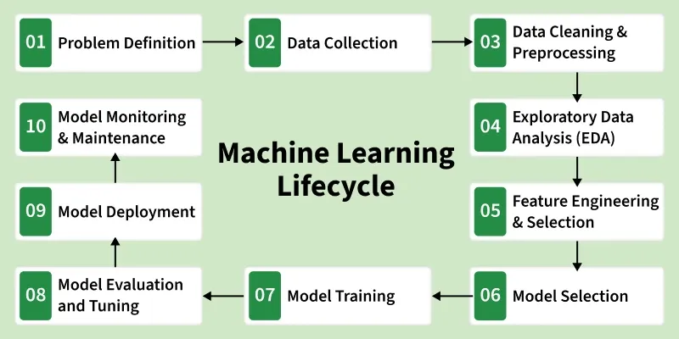

6. Dataset Description
The dataset used in this project includes logistics-related attributes such as distance, cost, delivery time, and route details. Data preprocessing techniques were applied to handle missing values and normalize the data.
[INSERT FIGURE 3 HERE: Dataset Sample Screenshot]
[INSERT FIGURE 4 HERE: Data Distribution Graphs]

7. Implementation
The system was implemented using Python with libraries such as Pandas, NumPy, and Scikit-learn. The backend processes data and generates optimized outputs based on the trained model.
[INSERT FIGURE 5 HERE: Code Snippet or System Architecture Diagram]

8. Results and Analysis
The system successfully optimized logistics decisions, resulting in reduced costs and improved delivery times. Performance metrics indicate significant improvement over traditional methods.
[INSERT FIGURE 6 HERE: Output Results Graph]
[INSERT FIGURE 7 HERE: Comparison Chart]

9. Conclusion
The Smart Logistics Decision System demonstrates the potential of data-driven approaches in improving logistics operations. Future work may include real-time data integration and advanced predictive modeling.

10. Future Scope
- Integration with real-time tracking systems
- Use of advanced AI models
- Deployment as a web-based application

References
1. Supply Chain Management Research Papers
2. Machine Learning in Logistics Studies
3. Data Analytics Journals

