Register-aware computation prioritizes EBV–self peptide pairs for experimental testing across HLA class II contexts
Anish Sharma^{1*}
October 17, 2026
Abstract
Epstein–Barr virus (EBV) infection precedes multiple sclerosis in almost all patients, and molecular mimicry between viral and self-antigens is one proposed explanation. We developed a hypothesis-generation workflow that ranks EBV–self peptide pairs for subsequent peptide–HLA binding and register-mapping experiments while quantifying register dependence. Across 6,400 allele-specific comparisons in four HLA class II contexts, two BALF5–TALDO1 pairs were sequence-prioritized. In a separate enriched 49-pair panel, they alone met a locked three-output, dual-arm presentation-support/register routing rule at a permissive 20% percentile cutoff; neither met it at 10% or below. No audited pair had a BH-adjusted $q<0.05$ in the constrained sequence null, and both leads had within-allele maxT $p=1.0$. Predicted peptide placement varied with input and template, and direct-binding evidence was identified only for the DRB1*15:01 viral arm. The workflow therefore provides a transparent shortlist for experimental binding, register mapping, and T-cell cross-reactivity testing, not evidence of molecular mimicry.
¹Liberal Arts and Science Academy, 1012 Arthur Stiles Road, Austin, TX 78721, USA
*Correspondence: anishsharma0212@gmail.com
Keywords: Epstein–Barr virus; multiple sclerosis; HLA class II; molecular mimicry; peptide register; immunoinformatics

Background
Multiple sclerosis (MS) is an autoimmune disease that can cause degeneration of motor, sensory, visual, and cognitive abilities through immune-mediated damage affecting myelin sheaths in the brain, spinal cord, and optic nerves [2]. In 2022, Bjornevik et al. studied a cohort of more than 10 million U.S. military personnel, 955 of whom developed MS. Their analysis reported an approximately 32-fold increase in MS risk following EBV infection; cytomegalovirus showed no comparable association. Serum neurofilament light chain increased only after EBV infection, indicating that EBV may precede detectable neurological injury [1]. Lanz et al. identified an antibody from an MS patient that recognized both EBV EBNA1 and the human CNS protein GlialCAM [3].
Lanz et al. identified cross-reactive antibodies [3], but T-cell cross-reactivity has not been mapped comprehensively. T-cell receptors (TCRs) recognize peptides in the binding groove of a human leukocyte antigen (HLA) molecule. Sequence-only comparisons therefore omit the HLA-binding component of immune recognition. HLA alleles also have different structural preferences, which affect pMHC binding affinity and the binding register, the placement of the nine-amino-acid core in the HLA groove. The register determines which residues are anchors and which may contact the TCR [23, 24].
The pipeline integrates peptide-HLA predictions, register-aware sequence alignments, and predicted peptide-HLA structures to prioritize viral–self peptide pairs for laboratory testing. Its sequence and structural outputs do not establish stable cell-surface presentation, functional T-cell activation in vivo, or experimentally confirmed registers.

Materials and Methods

Study design
This study describes a computational prioritization pipeline designed to route EBV–human self-peptide pairs to subsequent experimental peptide-HLA binding and binding-register validation. The workflow integrated predicted HLA-II presentation support, register-aware sequence alignments, structural modeling, and downstream evidence review. Computational predictions alone do not establish natural processing and presentation in vivo, surface pMHC stability, TCR recognition, functional cross-reactivity, molecular mimicry, or MS relevance.

Peptide curation and allele-specific pairing
An EBV repertoire was curated from the Immune Epitope Database (IEDB) by filtering EBV source peptides with positive T-cell assay outcomes from MHC class II alleles in human hosts [4]. Human self-proteins included myelin-associated and CNS proteins from positive IEDB MHC-II T-cell records and additional 15-mer peptides derived from UniProt sequences [5]. Duplicate assay records sharing accession, coordinates, and sequence were merged. Imported IEDB records lacking an “Exact Epitope” classification or outside 11–30 amino acids were removed, as were sequences containing X, B, or Z. The immutable curation files retain the source record, exclusion flag, duplicate-resolution key, protein-coverage rule, peptide length, and final membership for every arm. Forty EBV and forty human peptides were retained per allele and paired within each allele to create 6,400 comparisons. This curated, disease-informed input universe is not a proteome-wide sample and cannot estimate a population frequency of mimicry-like pairs.
The initial sequence screen was limited to HLA-DRB1*03:01, HLA-DRB1*08:01, HLA-DRB1*13:03, and HLA-DRB1*15:01. Each HLA allele was evaluated independently; pMHCs from different alleles were not compared. HLA-DRA*01:01 was the alpha chain in every pMHC model.

TCR-facing sequence-similarity scoring
The original 6,400-comparison V3 matrix contains one frozen, declared nine-residue core for each peptide arm. These declared cores were used as the input to the initial score; they were not changed after pairs were ranked. The local V2 register records identify the core caller as the IEDB recommended-binding service and retain the input peptide, allele, returned core_peptide, rank, IC50, and raw-response filename. The service’s internal model version, invocation date, and any service-side tie behavior were not captured in the frozen response and cannot be reconstructed from the local files. The archival V3 protocol ordered candidates by TCR-facing BLOSUM62 score (descending), physicochemical mismatch (ascending), TCR-facing identity (descending), local-surface percentile (ascending), and lexical pair identifier (ascending). Reported archival ranks are therefore deterministic lexicographic positions conditional on the declared cores, rather than primary-score effect sizes. V17 reports the primary-score block and a surface-free lead ablation alongside each principal rank; local-surface percentile is retained only as an audited archival tie key and did not determine routing class or any principal conclusion.
Sequence similarity was calculated with BLOSUM62 [9]. For cores $a$ and $b$, at $I=\{P2,P3,P5,P7,P8\}$, the normalized score was S(a,b)=i∈I​B(ai,bi) / i∈I​max{B(ai,ai),B(bi,bi)}. Thus, the denominator is the sum of the larger residue-specific self-substitution score at each compared position. Scores were calculated only for the nominally TCR-exposed/core non-anchor positions P2, P3, P5, P7, and P8 in aligned nine-residue binding cores. This custom normalization is bounded above by 1 for exact identity across the compared positions; lower values reflect less favorable BLOSUM62 substitution support. Higher scores indicate greater substitution-matrix resemblance at this nominally exposed interface; they are not measures of T-cell recognition, cross-reactivity, presentation, or molecular mimicry. Percentile rankings were calculated independently within each allele’s 1,600-pair cohort.
The later lexicographic quantities are fixed ordering descriptors. Physicochemical mismatch summarizes scaled charge, hydropathy, hydrogen-bond donor/acceptor, and aromaticity differences at the nominally exposed residues. Local-surface percentile is the within-allele mean percentile of six peptide-surface features, each summarized by its 75th percentile across available model combinations: side-chain exposure mismatch, exposure-weighted centroid and orientation differences, exposed-residue distance-matrix difference, chemistry mismatch, and exposed-backbone RMSD. Because predicted placement varied with input and template, V17 treats this value as an archival annotation, not affirmative structural evidence (Supplementary Methods SM1).

Evidence audit and candidate prioritization
Eight candidate pairs selected from the 6,400-comparison matrix underwent a standardized manual evidence audit. Predicted binding support, predicted register agreement, IEDB sequence and provenance records, public immunopeptidome evidence, viral sequence conservation, and human self-protein tissue expression or rarity were evaluated. Pairs were classified as high priority, medium priority, or hold. No pair was high priority; two were medium priority; and six were held because one or both peptide arms did not meet binding criteria, provenance was unverified, immunopeptidome support was absent, or registers disagreed. The medium-priority pairs were BALF5₆₂₇₋₆₄₁-TALDO1₁₀₈₋₁₂₂ in HLA-DRB1*13:03 and BALF5₆₂₇₋₆₄₁-TALDO1₂₁₆₋₂₃₀ in HLA-DRB1*15:01. The eight-pair audit categories were separate from the later 49-pair provisional classifications.

Binding predictions and binding-register analysis
For the initial eight-pair review, we used NetMHCIIpan-4.3 EL and MixMHC2pred context to predict peptide-HLA class II percentile ranks [6, 7, 8]. These presentation/eluted-ligand-oriented outputs are not direct equilibrium-affinity measurements. Throughout, “presentation-support” and “routing criterion” refer to these outputs, not to a binding gate. Full computational support required both outputs to return ranks of $≤5\%$ for both viral and self peptide arms. Lesser support required at least one output at $≤5\%$ or both outputs at $≤20\%$. We describe direct binding only when an exact peptide–allele assay record was identified.
Binding-register analysis defined the register as the predicted P1-P9 core within the open-ended HLA class II groove [23]. NetMHCIIpan-4.3 EL and MixMHC2pred context cores were compared. Any different core sequence, including shifted or overlapping nine-residue windows, was recorded as register disagreement. Major anchor positions (P1, P4, P6, P9) were separated from predicted TCR-facing positions (P2, P3, P5, P7, P8) for downstream analysis.

Expanded 49-pair cohort selection
The expanded 49-pair cohort was analyzed separately from the initial eight-pair evidence audit. All final pair identifiers matched entries in the original 6,400-comparison V3 matrix. The cohort contained seven HLA-DRB1*03:01 pairs, 14 HLA-DRB1*08:01 pairs, 16 HLA-DRB1*13:03 pairs, and 12 HLA-DRB1*15:01 pairs, corresponding to 98 peptide arms. It broadened candidate coverage while retaining the four alleles represented in the initial audit (Supplementary Methods SM2).

Experimental-routing class rules
Experimental-routing classes were assigned after the expanded 49-pair screen solely to organize subsequent experimental binding and register-mapping work. Class numbers are administrative routing labels, not biological-confidence grades. Evidence-retrieval availability was recorded separately and neither penalized nor qualified a candidate. These labels do not establish peptide-HLA affinity, natural presentation, T-cell recognition, cross-reactivity, molecular mimicry, or disease relevance (Supplementary Methods SM2).

pMHC structural modeling
Heterotrimeric pMHC complexes (HLA-DRA, relevant HLA-DR beta chain, and target peptide) were modeled using the AlphaFold 3 web server, with five returned models per job [11]. Quality checks verified coordinate completion; peptide pLDDT and peptide-chain ipTM were reported separately because well-defined HLA chains can dominate global complex confidence. The first 85 C$α$ atoms of HLA chain A and chain B were aligned by Kabsch fitting. Peptide backbone RMSD was then measured over an 11-mer window nested around the proposed nine-residue core. AlphaFold outputs were treated as predicted models, not experimental coordinates, and analyzed independently of TCR-docking simulations.

PANDORA/MODELLER template-dependent register stress test
PANDORA coupled with MODELLER was used as a cross-method, register-sensitivity stress test rather than as a binding-affinity or TCR-recognition model [19, 20]. Two preselected, forced pMHC-II templates were used: 1BX2 (primary) and 6CQQ (sensitivity template). For each template, only the first pMHC copy was retained and remapped to chains M/N/P; TCR chains and duplicate pMHC copies were excluded. Targets used HLA-DRA*01:01 and HLA-DRB1*15:01 sequences. Target termini were retained, rather than silently removed by template alignment. Each template–peptide–register condition requested 20 slow-loop-refinement models, with up to four local jobs. The local runtime was pinned to PANDORA commit 618bbb573645bd428697666475a2e47a2e418d01; the locked environment record includes the MODELLER/PANDORA runtime probe. Reciprocal 1BX2/6CQQ calibration required complete 20-model runs, no target-template leakage, one expected-register top-five model below 2 Å, and a lower top-five median expected-register RMSD than both adjacent register decoys (Supplementary Methods SM8).

Calibration and exploratory modeling
The literature-derived Hy.2E11 cross-reactive benchmark, BALF5₆₂₇₋₆₄₁-MBP₈₅₋₉₉ (residue numbering as in the DR2–MBP structural literature [13]; UniProt P02686 residues 217–231), served as a structural-comparison reference, not a calibration set [12]. The benchmark contains HLA-DRA*01:01-HLA-DRB5*01:01 for BALF5 (PDB: 1H15) and HLA-DRA*01:01-HLA-DRB1*15:01 for MBP (PDB: 1BX2). It was therefore treated as a DR15 haplotype-level control, rather than a same-allele comparison; it does not validate either BALF5-TALDO1 pair or establish biological mimicry.
Poisson-Boltzmann/APBS pMHC surface-potential comparison was explored as an exploratory surface-resemblance descriptor [14]. Its score was excluded from primary ranking because a 30-result control gate yielded 15 failed and 12 missing results. Candidate outputs were excluded from ranking and cannot support shared-TCR or cross-reactivity claims; BALF5 replicate models remain exploratory internal predictions rather than docking validation (Supplementary Methods SM8).

Statistical calibration and sensitivity analyses
We tested whether observed TCR-facing BLOSUM62 scores exceeded scores expected after residue-position alignments were disrupted. Each HLA allele had a separate simulation with 40 EBV cores and 40 self cores, yielding 1,600 pairwise comparisons. We completed 10,000 replicates independently for each allele at random seed 20260914 (Supplementary Methods SM3).
We then evaluated threshold sensitivity in the frozen 49-pair panel using percentile ranks from the IEDB-recommended binding method, NetMHCIIpan 4.3 EL, and MixMHC2pred 2.1 context. We assessed thresholds of 1%, 2%, 5%, 10%, and the explicitly permissive 20%, with exact-core and $±1$-residue register rules considered separately (Supplementary Methods SM3). The three outputs are correlated computational inputs, not independent biological measurements.
We also assessed four-metric rank sensitivity in the four allele-specific cohorts of 1,600 pairs each. The metrics were nominally TCR-exposed BLOSUM62, full-core BLOSUM62, nominally TCR-exposed sequence identity, and Grantham distance. A candidate was termed multi-metric rank-concordant when it fell within the top 1% under at least three metrics; it was partially rank-concordant when it did not meet that criterion but fell within the top 5% under at least three metrics. This heuristic check does not validate the score as a predictor of TCR cross-recognition (Supplementary Methods SM3).

Reproducibility
The local reproducibility package retains source files, software environments, random seeds, input logs, response-file references, and SHA-256 dataset checksums, including the complete 6,400-pair universe and the 49-pair continuous predictor records. It supports replay from frozen intermediate outputs. It cannot fully regenerate the historical remote IEDB core call because the service version and invocation metadata were not captured. Unevaluated or incomplete public-database evidence was labeled “Not Reported.” Computational ranking did not use nominal $p$-values, FDR corrections, or probabilistic “mimicry probability” values. A public DOI archive has been prepared with the frozen source files, input manifests, commands, environment locks, complete predictor outputs, failed-method artifacts, and source data for each display item.
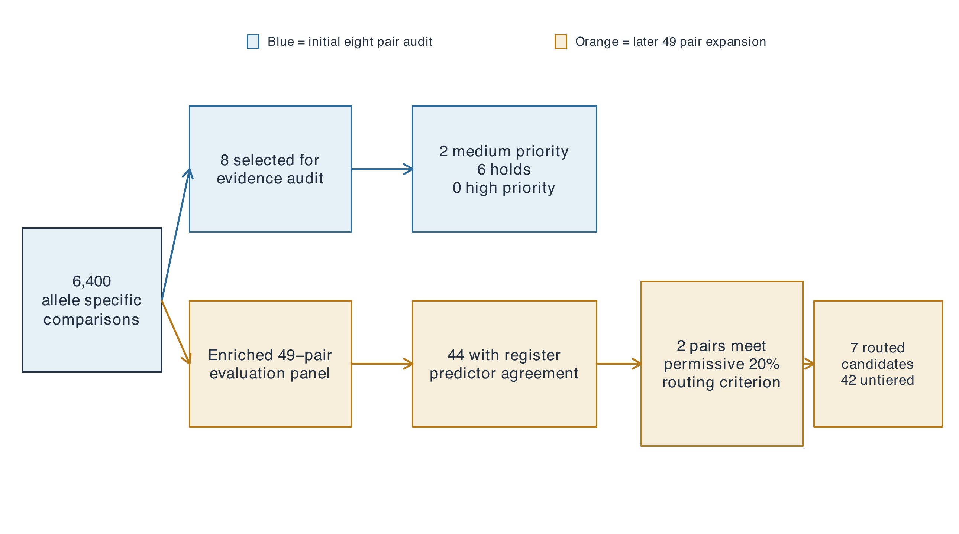
Figure 1. Workflow for computational prioritization of EBV-human peptide pairs. The 6,400 allele-specific comparisons informed an initial eight-pair evidence audit (blue) and a separate enriched 49-pair evaluation panel (orange). Boxes report the audit or provisional-classification outcomes for each track. The tracks used different review criteria and do not constitute a single sequential funnel or an independent validation sequence.

Results

Initial sequence comparisons across four HLA alleles
A total of 6,400 allele-specific peptide-pair comparisons were evaluated across four target alleles, with 1,600 pairs per allele. Sequence-similarity metrics were derived across nominally TCR-exposed/core non-anchor positions P2, P3, P5, P7, and P8. Actual TCR footprints can differ by receptor, allele, register, peptide conformation, and peptide-flanking-residue contacts. Score distributions were right-skewed across all alleles, with a small subset of pairs showing elevated nominally TCR-exposed sequence similarity (Supplementary Figure S1). These scores represent relative BLOSUM62 substitution-matrix resemblance, not percent identity or a probability of cross-reactivity. The top sequence-ranked pairs within each allele are reported in Supplementary Table S1.
BALF5₆₂₇₋₆₄₁-TALDO1₁₀₈₋₁₂₂ scored 0.28125 in HLA-DRB1*13:03 (lexicographic rank 13/1,600), and BALF5₆₂₇₋₆₄₁-TALDO1₂₁₆₋₂₃₀ scored 0.31429 in HLA-DRB1*15:01 (lexicographic rank 14/1,600). They use different TALDO1 peptide regions. Each lead had a singleton primary-BLOSUM value, so exchanging the next two tie keys or omitting the archival surface key did not change its rank (Supplementary Table S6). That precision does not extend to other ranks in the matrix. Both pairs had 40.0% identity at the five nominally TCR-exposed positions; full-core identity was approximately 22.2% in *13:03 and 33.3% in *15:01.
Register uncertainty is central to interpretation of these scores. Across fully contained alternative viral/self nine-mer windows, the DR13 lead’s score ranged from $−0.37931$ to 0.28125 and the DR15 lead’s score ranged from $−0.34375$ to 0.82143; neither lead met the pre-existing register-robust flag across the nine allowed window pairs. These ranges do not constitute a re-ranked discovery analysis or establish that every enumerated window is a plausible binder. They show that the biologically motivated P2/P3/P5/P7/P8 comparison is conditional on the frozen core assignment. The integrated audit in Table 1 therefore presents frozen-core score and primary-score block separately from downstream routing and structural sensitivity.
Table 1. Integrated audit of the two pairs routed under the prespecified protocol. All values are conditional on frozen declared cores. The all-window range is a sensitivity result, not an ensemble score or a re-ranked screen.
Allele | Pair | Frozen score; primary block; archival rank | All-window score range; robust? | Routing and direct evidence | Null and structural interpretation
DRB1*13:03 | BALF5₆₂₇₋₆₄₁-TALDO1₁₀₈₋₁₂₂ | 0.28125; 13–13 ($n=1$); 13 | $−0.37931$ to 0.28125; no | Strict 20% rule only; no verified allele-specific public record | maxT $p=1.0$; input-sensitive predicted placement; no calibrated DR13 structural conclusion
DRB1*15:01 | BALF5₆₂₇₋₆₄₁-TALDO1₂₁₆₋₂₃₀ | 0.31429; 14–14 ($n=1$); 14 | $−0.34375$ to 0.82143; no | Strict 20% rule only; viral-arm exact allele binding record | maxT $p=1.0$; template-sensitive predicted placement; no register confirmation

Frozen-data ablations
Replacing the normalized five-position BLOSUM62 score with its raw sum (or raw mean) gave within-allele rank correlations of 0.979–0.988 and moved the DR13 and DR15 routed pairs from ranks 13 and 14 to ranks 8 and 5, respectively (Supplementary Table S8). Removing the archival local-surface key left top-16, top-40, and top-80 membership unchanged in every allele; only two of the 49 enriched-panel rows shifted, by one or two ordinal positions. The surface annotation did not change the analyzed shortlists, whereas the sequence-score normalization changed the lead ranks.
The 20% all-three-output result depends on the specified output set. Removing the archival IEDB output retained the same two pairs. Removing NetMHCIIpan or MixMHC2pred admitted two or three additional pairs, respectively. This leave-one-output analysis treats the outputs as correlated computational inputs, not independent measurements. The two-pair result is therefore specific to this routing protocol, rather than a general presentation claim (Supplementary Table S8).
The shared viral parent peptide was TGGVYHFVKKHVHES. The DRB1*13:03 self peptide was DARLSFDKDAMVARA with declared core LSFDKDAMV; the DRB1*15:01 self peptide was SVTKIYNYYKKFSYK with declared core IYNYYKKFS. The corresponding viral declared cores were YHFVKKHVH and VYHFVKKHV, respectively. Per-position score components and continuous presentation-prediction values are provided in Supplementary Table S5.
The four-metric rank sensitivity was calculated for all 6,400 pairs (Figure 2). For the DR13 BALF5₆₂₇₋₆₄₁-TALDO1₁₀₈₋₁₂₂ pair, it met the multi-metric rank-concordance criterion with a nominally TCR-exposed BLOSUM62 rank of 13 (within the top 1%), nominally TCR-exposed identity rank of 2 (within the top 1%), a full-core BLOSUM62 rank of 173 (outside the top 5%), and a Grantham distance of 39.2, which is rank 15 (within the top 1%). For the DR15 BALF5₆₂₇₋₆₄₁-TALDO1₂₁₆₋₂₃₀ pair, it met the criterion with a nominally TCR-exposed BLOSUM62 rank of 14 (within the top 1%), a full-core BLOSUM62 rank of 3 (within the top 1%), a nominally TCR-exposed identity rank of 4 (within the top 1%), and a Grantham distance of 44.6, which is rank 33 (within the top 5%). The pairwise within-allele Spearman correlation $ρ$-values ranged from 0.432 to 0.781, showing moderate-to-strong agreement among related sequence metrics. Competition ranks are used for this label, so ties can yield more than 16 pairs at the nominal top-1% boundary; the full rank and tie-size fields are retained in the V3 matrix. Although neither pair ranked uniformly highly across every metric, the DR13 pair was high in nominally TCR-exposed BLOSUM62, identity, and Grantham similarity, while the DR15 pair was high in both BLOSUM62 formulations and identity. These results remain prioritization results and are not cross-reactivity evidence.
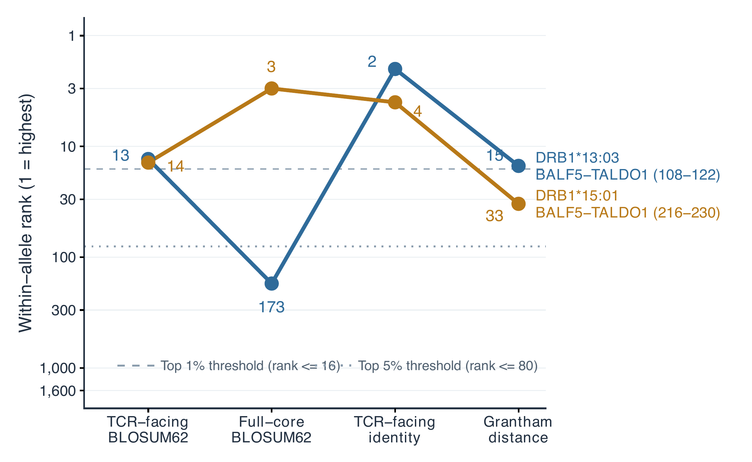
Figure 2. Four-metric rank sensitivity of the BALF5-TALDO1 pairs. Within-allele competition ranks are shown for TCR-facing BLOSUM62 similarity, full-core BLOSUM62 similarity, TCR-facing sequence identity, and Grantham distance. The vertical axis uses a reverse logarithmic scale, such that rank 1 indicates the greatest similarity. The HLA-DRB1*13:03 and HLA-DRB1*15:01 comparisons contain TALDO1₁₀₈₋₁₂₂ and TALDO1₂₁₆₋₂₃₀, respectively.

Constrained-null simulation results
Four of the eight audited pairs had nominal unadjusted $p$ values below 0.05, but none met $q<0.05$ after Benjamini-Hochberg adjustment (BH $q=0.0632$-$0.0819$). Because the eight pairs were selected after inspection of the original screen, these BH values are descriptive post-selection calibration, not confirmatory discovery statistics. The within-allele maxT values are the more conservative family-wise summary; both BALF5-TALDO1 comparisons had maxT $p=1.0$. Complete outputs, including null medians and 95% null intervals, are reported in Supplementary Table S4. This process tests only conditional sequence-score extremeness and does not provide information about presentation, TCR recognition, or cross-reactivity.

Initial eight-candidate evidence review
Eight candidates selected from the 6,400-pair matrix underwent deep evidence review, yielding two medium-priority candidates, six holds, and zero high-priority candidates under that original audit rubric (Supplementary Table S2). The two medium-priority candidates were BALF5₆₂₇₋₆₄₁-TALDO1₁₀₈₋₁₂₂ in HLA-DRB1*13:03 and BALF5₆₂₇₋₆₄₁-TALDO1₂₁₆₋₂₃₀ in HLA-DRB1*15:01. Retrieval availability was retained as a separate audit field and did not define these categories. Binding-prediction concordance is shown in Supplementary Figure S2.
Both BALF5-TALDO1 pairs showed predicted core-register agreement, although the registers remain unconfirmed experimentally. Neither pair satisfied full binding consensus. For the HLA-DRB1*13:03 candidate, the viral arm met the $≤5\%$ criterion while the self arm did not. In HLA-DRB1*15:01, neither arm met full-binding consensus. These thresholds describe the initial review; later predictor outputs differed. No corroborating experimental evidence under the review protocol, including IEDB eluted-ligand records or PRIDE-sourced immunopeptidome records, was identified for either self peptide [18]. IEDB lists one cellular MHC mass-spectrometry ligand record for TALDO1₁₀₈₋₁₂₂ (IEDB epitope 2008648) [4], but its MHC is recorded only as generic HLA class II, so it does not support a specific allele. The six held candidates had register discordance, insufficient binding support in one or both arms, or absent public experimental evidence. This review was an initial eight-pair evaluation and remained distinct from the later 49-pair provisional tiers.

Focused structural assessment of predicted binding registers
The two medium-priority pairs were structurally assessed alongside a DRB5*01:01 restriction test. Thirteen AlphaFold 3 jobs, each returning five models, generated 65 structural models. All passed checks for coordinate completeness, correct chain identifiers, and peptide-sequence integrity. In HLA-DRB1*13:03, viral parent-nested median RMSD was 0.445 Å; BALF5 showed consistent coordinate recovery, whereas TALDO1₁₀₈₋₁₂₂ had lower confidence and large positional uncertainty across the descriptive 5$×$5 comparison. This candidate’s modeled pMHC geometry is unresolved, not merely a minor caveat. In HLA-DRB1*15:01, viral and human RMSD values were 1.712 Å and 0.888 Å, respectively; viral BALF5 parent models varied, while the TALDO1₂₁₆₋₂₃₀ 11-mer was comparatively consistent. In HLA-DRB5*01:01, viral RMSD was 0.247 Å and longer parent-peptide modeling did not stabilize either competing TALDO1 register.
Models of shorter 11-mers frequently converged to consistent placements, but these placements were rarely retained when parent 15-mers were modeled, producing alternate poses and register shifts (Figure 3). Peptide-level pLDDT and peptide-chain ipTM were consequently examined separately from global pMHC metrics; HLA confidence can obscure peptide uncertainty. No discrete pocket-occupancy or core-start classifier was validated for these AF3 models. Thus, RMSD, pLDDT, and ipTM are descriptive confidence and sensitivity measures, not register-state measurements; sequence-predictor agreement did not establish atomic-backbone structural confirmation.
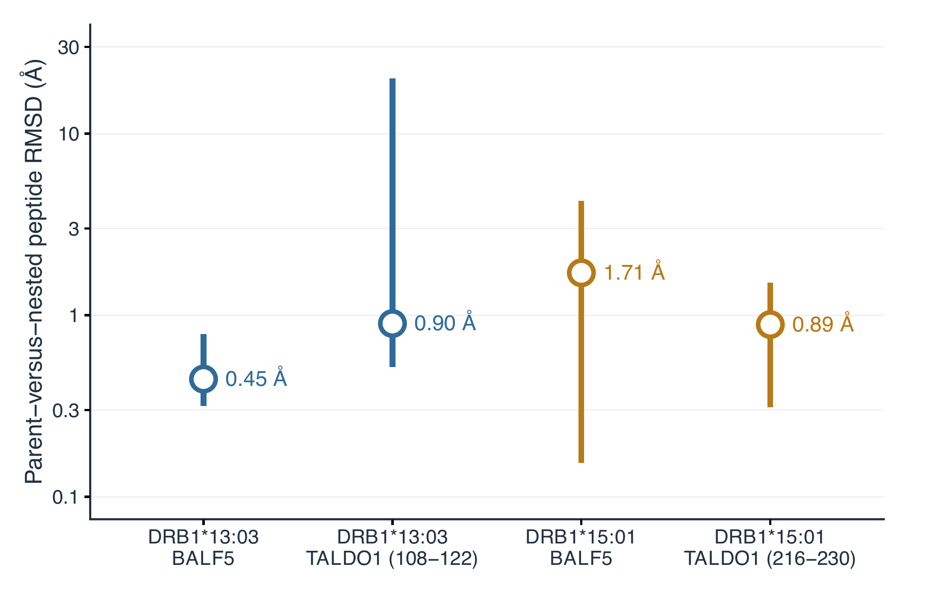
Figure 3. Sensitivity of predicted peptide coordinates to input length. Parent 15-mer and nested 11-mer models were compared for four peptide arms in HLA-DRB1*13:03 and HLA-DRB1*15:01. Vertical intervals show the minimum-maximum backbone RMSD across the 25 pairwise comparisons of five parent and five nested models; open circles show the median. The 25 comparisons are a descriptive 5$×$5 matrix, not 25 independent structural predictions. Values describe sensitivity of predicted coordinates to flanking sequence length and do not experimentally establish binding-register placement.

Cross-method structural sensitivity analysis
PANDORA coupled with MODELLER was used for a cross-method, template-dependent register stress test, not structural reproducibility or independent register confirmation [19, 20]. The reciprocal PANDORA controls 1BX2 and 6CQQ were separate from the Hy.2E11 structural reference described above; both passed the pre-defined forced-template recovery gate: 120 models were assessed by expected-register recovery, adjacent-decoy comparison, sequence quality control, and template-leakage checks. Each control had at least one top-five model with expected-register core-backbone RMSD below 2 Å, lower top-five median RMSD than adjacent register decoys, and passed exact-sequence and template-leakage tests.
The subsequent ensemble contained 1,200 technical ensemble members spanning BALF5, TALDO1, and eight P6/P7 charge-substitution variants across two structural templates and three register placements (20 models per condition). None of the ten predefined peptides retained the expected NetMHCIIpan/MixMHC2pred register across both forced templates. A subsequent AlphaFold dataset comprised 150 technical ensemble members from 30 five-model jobs; seven charge-substitution comparisons had uncertain predicted placement and one was not evaluable because of seed mismatch. RMSD cannot on its own distinguish an integer register shift from a deformation within a register or from flanking-residue flexibility. Accordingly, these results identify template- and input-sensitive structural uncertainty rather than a validated register state and do not support interpreting charge substitutions as evidence of disrupted binding.

Expanded assessment of 49 candidate pairs
An enriched 49-pair evaluation panel was recovered from the 6,400-pair ranking; it is not an independent validation cohort. NetMHCIIpan, MixMHC2pred, and IEDB-recommended binding prediction profiles were completed for 98 peptide arms. Forty-four pairs had at least two outputs selecting the same declared nine-mer core for both arms; this is computational output concordance, not experimental register confirmation. Only BALF5₆₂₇₋₆₄₁-TALDO1₁₀₈₋₁₂₂ in HLA-DRB1*13:03 and BALF5₆₂₇₋₆₄₁-TALDO1₂₁₆₋₂₃₀ in HLA-DRB1*15:01 met the combined three-output presentation-support/register routing criterion, with all three percentile ranks $≤20\%$ for both arms. This wording does not imply independent algorithms or biological measurements. Threshold sensitivity showed that this strict result occurred only at the permissive 20% cutoff; neither pair passed at 10% or below. Under a relaxed two-of-three-output rule, the DRB1*15:01 pair passed at 10%, whereas the DRB1*13:03 pair first passed at 20%. Allowing a $±1$-residue register tolerance added no pair under the strict rule. Complete continuous predictor values and the full 49-pair threshold grid are reported in Supplementary Table S5 and the local machine-readable output package. The two-pair result is conditional routing information, not threshold-robust support for binding or mimicry.
For public-evidence assessment, 98 automated IEDB API queries returned zero retrievable records because the endpoint was unavailable. This frozen retrieval status was recorded as not evaluable and was not used as biological evidence or as a routing-class determinant. Targeted manual IEDB verification later identified a positive qualitative purified-MHC competitive-radioactivity binding record for the exact viral 15-mer BALF5₆₂₇₋₆₄₁ in HLA-DRB1*15:01 (IEDB Assay 1774674; Hansen et al.) [4, 22]. Its sample context and quantitative affinity were not used here, and it does not confirm TALDO1₂₁₆₋₂₃₀ binding, stable presentation, or dual-reactive T-cell recognition.

Secondary provisional classifications
A provisional shortlist contained seven candidates: one experimental-routing class 1, two class 2, and four class 3. The remaining 42 candidates were untiered because evidence was insufficient for experimental routing. These class numbers are routing labels, not biological-confidence levels, and are distinct from the earlier eight-pair audit. The full provisional classification table is reported in Supplementary Table S3.

Discussion

Principal findings
This multi-stage computational screening and evidence-review workflow routed EBV–human peptide pairs for later experimental validation, while also revealing how strongly conclusions depend on frozen cores, enrichment, and modeling inputs. Its central outputs were two BALF5–TALDO1 pairings, BALF5₆₂₇₋₆₄₁-TALDO1₂₁₆₋₂₃₀ and BALF5₆₂₇₋₆₄₁-TALDO1₁₀₈₋₁₂₂; despite sharing parent proteins, they are not the same epitope pair. The HLA-DRB1*15:01 pairing was assigned to experimental-routing class 1, while the HLA-DRB1*13:03 pairing was assigned to class 2. Class assignment reflects prespecified computational routing and limited evidence review, not statistical significance of the underlying sequence similarity: both leads had family-wise maxT $p=1.0$. The outcome is a computational workflow and shortlist for in vitro peptide-HLA binding and register mapping, not a claim of functional molecular mimicry in vivo.
Experimental-routing class 1 does not mean “confirmed,” validated, or “highest-confidence biological mimic.” It means only that all three selected outputs met the prespecified 20% routing criterion for both arms and that one viral arm had an exact-sequence, exact-allele direct-binding record.

Relevance of BALF5-TALDO1
BALF5-TALDO1 did not have the highest raw sequence-similarity score; EBNA1-ANO2 and EBNA3B-MOG scored higher. Raw sequence alignment was only the first evidence layer. The BALF5-TALDO1 protein pairing was represented by the only two allele-specific pairs in the 49-pair cohort that met the permissive three-output presentation-support/register routing criterion. TALDO1 was retained through the predefined self-peptide curation and sequence-ranking workflow; this study does not infer TALDO1 involvement in MS from its selection. In HLA-DRB1*15:01, manual recovery of direct-binding evidence for viral BALF5₆₂₇₋₆₄₁ offered limited experimental grounding [4, 22]; the TALDO1 self arm remains unconfirmed by direct-binding or eluted-ligand assays. In HLA-DRB1*13:03, both arms met the routing threshold, but no allele-specific public binding record was verified under the review protocol. The expanded provisional tiers do not replace the eight-pair audit categories; they derive from a later protocol with different criteria.

Contribution of structural analyses
Agreement among sequence-based register predictors did not guarantee stable predicted peptide coordinates. Shorter 11-mer inputs often converged in the models analyzed, whereas the same placements were often lost or shifted with the parent 15-mer input. Peptide-local pLDDT and peptide-chain ipTM were therefore more informative than global pMHC metrics, which can obscure peptide uncertainty through high HLA-chain confidence. AlphaFold 3 and PANDORA outputs showed input- and template-sensitive predicted placement in the modeled BALF5/TALDO1 charge-substitution inputs. No component of the structural workflow passed calibration for TCR–pMHC recognition; the retained PANDORA calibration is limited to forced-template pMHC register recovery. These analyses limit register-specific interpretation; they do not identify whether the observed uncertainty is a property of modeling conditions or peptide biophysics. The retained EBNA1-MBP PANDORA result supports computational geometric plausibility, not native binding.

Linkage to prior research
Bjornevik et al. established the epidemiological link between EBV infection and MS, and Lanz et al. reported antibody cross-reactivity between EBNA1 and GlialCAM [1, 3]. These mechanisms differ from pMHC class II T-cell recognition; operationally, T-cell cross-reactivity requires one T cell to recognize more than one distinct peptide-MHC ligand [24]. Here, claims remain limited to computational candidate prioritization and predicted pMHC similarity. Literature-associated protein pairs, including EBNA1-ANO2 and EBNA1-MBP, emerged in the screen, but shared parent proteins must be distinguished from exact peptide epitopes [21]. Literature-informed pairings were not treated as independent computational validation because their disease association contributed to protein selection.

Additional exploratory methods
Electrostatic surface-potential comparison was excluded from primary ranking because 15 of 30 required control outputs failed and 12 were missing; among the three usable outputs, the calibration control did not discriminate from background decoys. TCRModel2 calibration produced acceptable models for 1ZGL but incorrect models for 1YMM and 2WBJ under DockQ and CAPRI criteria. These failures prevent candidate-specific TCR-recognition claims; they do not provide biological evidence that cross-reactivity is absent in vivo.

Limitations
The search space was limited to pre-curated viral epitopes, selected myelin/CNS proteins, and four HLA-DRB1 alleles; HLA-DQ and HLA-DP loci, broader haplotype effects, and proteome-wide background sampling were omitted. Canonical P1/P4/P6/P9 positions were used as a positional convention, not an assertion that anchor chemistry is uniform across alleles or peptide contexts. The primary score is explicitly register-conditional: alternate nine-mer windows yielded wide score ranges for both routed pairs, and no discrete pocket-occupancy classifier was validated. Rankings shifted under nominally TCR-exposed BLOSUM62, full-core BLOSUM62, and Grantham-distance formulations. The five-position score is a rational heuristic but lacks an external benchmark with verified cross-reactive and specificity-negative TCR systems or biologically matched HLA-presentable decoys. Predictors may share training data, limiting the independence of their agreement. The unavailable public-evidence endpoint and absent allele-specific self-peptide records did not establish biological absence of presentation. In silico modeling also cannot account for endogenous antigen processing, HLA-DM-mediated peptide editing, pMHC stability, peptide-flanking-residue effects, antigen-presenting-cell context, tolerance and TCR-repertoire constraints, or downstream TCR-signaling thresholds [25].

Experimental next steps
Peptide-HLA binding can be quantified for viral and self peptides against recombinant HLA-DRB1 molecules by fluorescence polarization or surface plasmon resonance. Register mapping may use alanine-scanning mutagenesis and structural methods such as X-ray crystallography or cryo-EM. Matched T cells should be tested against both peptide-HLA complexes for dual functional activation. Endogenous processing can be assessed through peptide elution and mass spectrometry from infected or inflamed antigen-presenting cells.

Conclusions
Under the prespecified protocol, HLA-DRB1*15:01 BALF5₆₂₇₋₆₄₁-TALDO1₂₁₆₋₂₃₀ is the pair routed first for experiment because it met the permissive 20% three-output routing criterion and has exact allele-specific viral-arm IEDB binding evidence [4, 22]. This routing order does not imply significant sequence similarity, strong predicted affinity, stable register occupancy, or mimicry. Recombinant peptide-HLA binding and kinetic-stability assays should test viral and self arms separately, followed by register mapping, HLA-DM susceptibility testing, ligand-elution mass spectrometry in relevant antigen-presenting cells, and matched-TCR dual-recognition assays. The HLA-DRB1*13:03 BALF5–TALDO1 pair remains a conditional secondary route: both arms met the same permissive threshold, but its modeled geometry is unresolved and no allele-specific public record was verified. Natural presentation and cross-reactivity remain untested for both candidates.

Abbreviations
AF3: AlphaFold 3; APBS: Adaptive Poisson-Boltzmann Solver; EBV: Epstein-Barr virus; HLA: human leukocyte antigen; IEDB: Immune Epitope Database; MS: multiple sclerosis; pMHC: peptide-major histocompatibility complex; RMSD: root-mean-square deviation; TCR: T-cell receptor.

Acknowledgements
The author thanks Dr Brian Pierce for assistance with T-cell receptor modeling, Dr Olaf Stuve for guidance on peptide expansion across HLA alleles, and colleagues at Karolinska Institutet for discussions that informed the binding-register component of this project.

Funding
No external funding was received for this work.

Author contributions
Anish Sharma conceived the study, developed the methodology, performed the analyses, curated the data, prepared the visualizations, and wrote and revised the manuscript.

Ethics declaration
This study analyzed public database records and computational outputs and did not involve new research with human participants, human tissue, or animals. Consent for publication was not applicable.

Competing interests
The author declares no competing interests.

Data availability
The analysis code, input manifests, derived data, and supplementary materials are publicly available in the EBV-MS Project repository: https://github.com/AnishSharma1/EBV-MS_Project. The repository contains the frozen computational outputs and reproducibility documentation used for this study.

References
[1] Bjornevik K, Cortese M, Healy BC, et al. Longitudinal analysis reveals high prevalence of Epstein-Barr virus associated with multiple sclerosis. Science. 2022;375:296-301. https://doi.org/10.1126/science.abj8222
[2] National Institute of Neurological Disorders and Stroke. Multiple Sclerosis: Hope Through Research. https://www.ninds.nih.gov/health-information/disorders/multiple-sclerosis
[3] Lanz TV, Brewer RC, Ho PP, et al. Clonally expanded B cells in multiple sclerosis bind EBV EBNA1 and GlialCAM. Nature. 2022;603:321-327. https://doi.org/10.1038/s41586-022-04432-7
[4] Vita R, et al. The Immune Epitope Database (IEDB): 2024 update. Nucleic Acids Research. 2025;53:D436-D443. https://doi.org/10.1093/nar/gkae1092
[5] The UniProt Consortium. UniProt: the Universal Protein Knowledgebase in 2025. Nucleic Acids Research. 2025;53:D609-D617. https://doi.org/10.1093/nar/gkae1010
[6] Nilsson JB, Kaabinejadian S, Yari H, et al. Accurate prediction of HLA class II antigen presentation across all loci using tailored data acquisition and refined machine learning. Science Advances. 2023;9:eadj6367. https://doi.org/10.1126/sciadv.adj6367
[7] Racle J, Michaux J, Rockinger GA, et al. Robust prediction of HLA class II epitopes by deep motif deconvolution of immunopeptidomes. Nature Biotechnology. 2019;37:1283-1286. https://doi.org/10.1038/s41587-019-0289-6
[8] Racle J, Guillaume P, Schmidt J, et al. Machine learning predictions of MHC-II specificities reveal alternative binding mode of class II epitopes. Immunity. 2023;56:1359-1375.e13. https://doi.org/10.1016/j.immuni.2023.03.009
[9] Henikoff S, Henikoff JG. Amino acid substitution matrices from protein blocks. PNAS. 1992;89:10915-10919. https://doi.org/10.1073/pnas.89.22.10915
[10] Grantham R. Amino acid difference formula to help explain protein evolution. Science. 1974;185:862-864. https://doi.org/10.1126/science.185.4154.862
[11] Abramson J, Adler J, Dunger J, et al. Accurate structure prediction of biomolecular interactions with AlphaFold 3. Nature. 2024;630:493-500. https://doi.org/10.1038/s41586-024-07487-w
[12] Lang HLE, Jacobsen H, Ikemizu S, et al. A functional and structural basis for TCR cross-reactivity in multiple sclerosis. Nature Immunology. 2002;3:940-943. https://doi.org/10.1038/ni835
[13] Gauthier L, Smith KJ, Pyrdol J, et al. Expression and crystallization of the complex of HLA-DR2 (DRA, DRB1*1501) and an immunodominant peptide of human myelin basic protein. Proceedings of the National Academy of Sciences. 1998;95:11828-11833. https://doi.org/10.1073/pnas.95.20.11828
[14] Jurrus E, Engel D, Star K, et al. Improvements to the APBS biomolecular solvation software suite. Protein Science. 2018;27:112-128. https://doi.org/10.1002/pro.3280
[15] Basu S, Wallner B. DockQ: A quality measure for protein-protein docking models. PLOS ONE. 2016;11:e0161879. https://doi.org/10.1371/journal.pone.0161879
[16] Collins KW, Copeland MM, Brysbaert G, et al. CAPRI-Q: The CAPRI resource evaluating the quality of predicted structures of protein complexes. Journal of Molecular Biology. 2024;436:168540. https://doi.org/10.1016/j.jmb.2024.168540
[17] Yin R, Ribeiro-Filho HV, Lin V, et al. TCRmodel2: high-resolution modeling of T cell receptor recognition using deep learning. Nucleic Acids Research. 2023;51:W569-W576. https://doi.org/10.1093/nar/gkad356
[18] Perez-Riverol Y, et al. The PRIDE database at 20 years: 2025 update. Nucleic Acids Research. 2025;53:D543-D553. https://doi.org/10.1093/nar/gkae1011
[19] Parizi FM, Marzella DF, Ramakrishnan G, et al. PANDORA v2.0: Benchmarking peptide-MHC II models and software improvements. Frontiers in Immunology. 2023;14:1285899. https://doi.org/10.3389/fimmu.2023.1285899
[20] Sali A, Blundell TL. Comparative protein modelling by satisfaction of spatial restraints. Journal of Molecular Biology. 1993;234:779-815. https://doi.org/10.1006/jmbi.1993.1626
[21] Thomas OG, Rykaczewska U, Galešić M, et al. Anoctamin-2-specific T cells link Epstein-Barr virus to multiple sclerosis. Cell. 2026;189:585-602.e38. https://doi.org/10.1016/j.cell.2025.12.032
[22] Hansen BE, Rasmussen AH, Jakobsen BK, Ryder LP, Svejgaard A. Extraordinary cross-reactivity of an autoimmune T-cell receptor recognizing specific peptides both on autologous and on allogeneic HLA class II molecules. Tissue Antigens. 2007;70:42-52. https://doi.org/10.1111/j.1399-0039.2007.00849.x
[23] Brown JH, Jardetzky TS, Gorga JC, et al. Three-dimensional structure of the human class II histocompatibility antigen HLA-DR1. Nature. 1993;364:33-39. https://doi.org/10.1038/364033a0
[24] Sewell AK. Why must T cells be cross-reactive? Nature Reviews Immunology. 2012;12:669-677. https://doi.org/10.1038/nri3279
[25] Denzin LK, Cresswell P. HLA-DM induces CLIP dissociation from MHC class II alpha beta dimers and facilitates peptide loading. Cell. 1995;82:155-165. https://doi.org/10.1016/0092-8674(95)90061-6

