Supplementary material: Register-aware computation prioritizes EBV–self peptide pairs for experimental testing across HLA class II contexts
Anish Sharma
October 17, 2026

Supplementary Methods

SM1. Frozen-core input and nominally TCR-exposed BLOSUM62 score
The initial 6,400-comparison V3 matrix stores one declared P1–P9 core for each peptide arm. These cores were frozen before ranking and were not replaced by later audit-predictor calls. The initial screen is conditional on those declared cores. The local V2 register-prediction records identify the caller as IEDB recommended_binding and retain the allele, peptide, returned core_peptide, percentile rank, IC50, core-start resolution, and raw-response filename. The service’s internal model version, exact invocation date, and tie behavior were not retained. The saved response records make the frozen core input auditable, but they cannot reproduce an identically versioned remote call.
For two declared nine-residue cores $a$ and $b$, the nominally TCR-exposed normalized BLOSUM62 score was calculated at $I=\{P2,P3,P5,P7,P8\}$ as S(a,b)=i∈I​B(ai,bi) / i∈I​max{B(ai,ai),B(bi,bi)}. $B$ denotes the published BLOSUM62 substitution value. The numerator sums the five matched residue-pair values; the denominator sums the larger of the two residue-specific self-substitution values at each position. Exact identities are handled by the same formula, which gives the upper bound of 1.0; conservative and nonconservative substitutions lower the numerator relative to that bound. Cores containing nonstandard or ambiguous amino-acid symbols were excluded during curation. The score is a relative, register-conditional prioritization quantity, not a probability of presentation, recognition, cross-reactivity, or molecular mimicry.
The archival V3 ranking was lexicographic: nominally TCR-exposed BLOSUM62 descending, physicochemical mismatch ascending, nominally TCR-exposed identity descending, local-surface percentile ascending, and lexical pair identifier ascending. Physicochemical mismatch was a scaled comparison of charge, hydropathy, donor, acceptor, and aromaticity at the five nominally exposed positions. Local-surface percentile was an ordering descriptor, not an independent assay or global structural score. After Kabsch alignment of the first 85 C$α$ atoms from each HLA alpha and beta chain, six local peptide-surface features were calculated: side-chain solvent-exposure mismatch, exposure-weighted centroid RMSD, exposure-weighted side-chain orientation RMSD, exposed-residue distance-matrix RMSD, exposure-weighted chemistry mismatch, and exposure-weighted backbone RMSD. Glycine used C$α$ as a side-chain fallback. Solvent accessibility used a deterministic 32-point Shrake–Rupley approximation with a 1.4 Å probe. Each feature was summarized at its model-combination 75th percentile, converted to a within-allele percentile, and the six percentiles were averaged. This quantity could break a prior sequence tie only when the model was complete and passed the declared fixed-coordinate register-sensitivity rule; otherwise it was blank. Binding-prediction ranks, full-core RMSD, and anchor RMSD were diagnostics and did not enter the V3 rank. Because predicted peptide placement varied with input and template, V17 treats local-surface percentile as an archival annotation. It did not determine experimental-routing class or any principal conclusion.
An ablation audit of the 6,400-pair V3 table quantified the role of each tie key using mutually exclusive sequential counts. Within the four allele-specific 1,600-pair cohorts, 6,117 candidate rows were in a primary-BLOSUM tie. Physicochemical mismatch resolved 4,688 rows; nominally exposed identity resolved 13 additional rows; local-surface percentile resolved 1,406 additional rows; and lexical pair identifier resolved the remaining 10 rows. The surface descriptor affected ordering only after the three sequence-based keys and did not define the primary score. Omitting the local-surface key leaves both routed leads at the same rank because each is a singleton primary-score value, preserves every top-16, top-40, and top-80 membership, and changes only two of 49 enriched-panel ordinal ranks by at most two positions (Supplementary Table S8). Reported ranks are deterministic, conditional lexicographic positions. They are not measurements with uniform primary-score resolution, effect sizes, or evidence that structural annotations validate peptide registers.

SM2. Enriched-panel construction and experimental-routing class rules

Enriched 49-pair evaluation panel
The enriched 49-pair evaluation panel was analyzed separately from the initial eight-pair evidence audit and is not an independent validation cohort. All final pair identifiers matched entries in the original 6,400-comparison V3 matrix. The frozen source pool comprised eight Stage-1 evidence-audit candidates, ten previously retained near-miss candidates, and 31 rank-based prefilter candidates from the V3 matrix. Deduplication by allele, declared viral core, and declared self core reduced these 49 source rows to 47 unique pair definitions. Two deterministic replacements were then selected from the relevant within-allele V3 rankings to restore the fixed 49-pair panel; each replacement had pre-existing viral- and self-arm binding percentile ranks $≤20\%$. Consequently, later binding-gate pass rates are conditioned on this enrichment and must not be interpreted as estimates for the original 6,400-pair universe. The final panel contained seven HLA-DRB1*03:01 pairs, 14 HLA-DRB1*08:01 pairs, 16 HLA-DRB1*13:03 pairs, and 12 HLA-DRB1*15:01 pairs, corresponding to 98 peptide arms.

Experimental-routing class rules
Experimental-routing classes were assigned after the enriched 49-pair panel solely to organize subsequent experimental binding and register-mapping work. A strict peptide arm required all three selected computational-output percentile ranks to be $≤20\%$, agreement of at least two outputs on the same nine-residue core, and agreement between that core and the declared core. A near-passing arm required declared-core agreement and at least two of three output percentile ranks $≤20\%$. These are operational quantiles, not tool-calibrated affinity thresholds, and output percentiles are not assumed to have identical biological meaning across tools. Experimental-routing class 1 required strict support for both arms plus exact-sequence, exact-allele direct-binding evidence for at least one arm. Class 2 required either strict support for both arms without verified exact-allele binding or ligand evidence, or support for both declared registers across two calibrated same-allele PANDORA templates and expected/adjacent-register decoys despite one narrow predictor discrepancy. Class 3 required strict support for one arm and near-passing support for the other. Candidates failing these conditions were left untiered. Class numbers do not represent ordinal biological quality. The unavailable automated evidence endpoint was recorded separately as a retrieval limitation and neither qualified nor penalized a candidate. These classes do not establish peptide-HLA affinity, natural presentation, T-cell recognition, cross-reactivity, molecular mimicry, or disease relevance.

SM3. Statistical calibration and sensitivity analyses
We tested whether observed nominally TCR-exposed BLOSUM62 scores exceeded those expected after residue-position alignments were disrupted. Each HLA allele had a separate simulation with 40 EBV cores and 40 self cores, yielding 1,600 pairwise comparisons. We completed 10,000 replicates independently for each allele at random seed 20260914. Positions were classified as HLA anchors (P1, P4, P6, P9) or nominally TCR-exposed/core non-anchors (P2, P3, P5, P7, P8). For each replicate, anchor positions remained fixed while the five nominally exposed residues were independently permuted within each 9-mer core, preserving each peptide’s exposed-residue composition. Each unique peptide was shuffled once per replicate and reused across 40 pairings to preserve the Cartesian dependence structure. We recalculated the unchanged normalized BLOSUM62 score, ranking higher values first, and collected five prespecified outputs: pair-specific upper-tail Monte Carlo $p$, Benjamini-Hochberg $q$ across eight audited pairs, within-allele maxT family-wise $p$, the null median, and the 95% null interval. Random re-pairing was excluded because the observed $40×40$ matrix already contained every possible pairing.
We evaluated presentation-support threshold sensitivity in the frozen 49-pair panel with IEDB recommended-binding, NetMHCIIpan 4.3 EL, and MixMHC2pred 2.1 context outputs. The raw response records retain the NetMHCIIpan and MixMHC2pred versions and targets. The IEDB record retains its output, but not an internal model version, exact access date, or service-side tie behavior. It is therefore an archival dependency, not a fully rerunnable third model. We evaluated operational percentile thresholds of 1%, 2%, 5%, 10%, and 20%; these thresholds are not common affinity cutoffs across the tools. The routing rules required all three selected outputs to pass for both peptide arms, or at least two of three to pass for both arms. We also evaluated two register conditions: each output’s predicted core start either matched the declared core start or differed by no more than one residue. The outputs were handled as a correlated computational ensemble, not independent biological measurements.
The frozen grid was rerun from all 490 continuous predictor records (49 pairs $×$ two arms $×$ five recorded outputs). Under the locked all-three-output, both-arm rule, 0/49 pairs passed at 1%, 2%, 5%, or 10%, and 2/49 passed at the explicitly permissive 20% cutoff; the two passing pairs were BALF5–TALDO1. Under the two-of-three-output, both-arm rule, the DRB1*15:01 pair passed at 10%, whereas the DRB1*13:03 pair first passed at 20%. The $±1$ register rule added no candidates to the strict all-three-output condition; it added one nonlead candidate only in the relaxed two-of-three 20% condition. The threshold is a routing convention for a deliberately enriched panel, not a predicted-affinity category, and the three outputs were not treated as independent evidence.
Four-metric rank sensitivity was also performed on the four allele-specific cohorts containing 1,600 pairs each. Pairs were evaluated using nominally TCR-exposed BLOSUM62, full-core BLOSUM62, nominally TCR-exposed sequence identity, and Grantham distance. Higher similarity was better for BLOSUM62 and identity, while lower Grantham distances indicated greater physicochemical similarity. Standard Grantham distance [10] was used as the physicochemical metric. The pairwise score was calculated by averaging published positional distances between matched nominally exposed residues at P2, P3, P5, P7, and P8. Existing calibration covered eight panels from three independent TCR systems and did not include verified specificity negatives; it supports only a provisional physicochemical sensitivity comparison, not validation of the primary score as a cross-reactivity predictor. A pair was multi-metric rank-concordant if it was within the top 1% under at least three metrics and partially rank-concordant if it did not meet that criterion but was within the top 5% under at least three metrics. For tie handling, average ranks were used to calculate pairwise within-allele Spearman correlations when ties occurred, and competition ranks were used for these labels. Consequently, rank $≤16$ can include more than 16 pairs when scores tie; the V3 matrix retains the actual rank and tie size. The top 5% boundary was rank $≤80$.
The constrained null asks whether the observed five-position alignments are unusually favorable after within-core exposed-position permutation in this curated universe. Each core has at most $5!=120$ unique exposed-residue permutations, so the 10,000 replicates repeatedly sample this finite set while preserving the matrix’s Cartesian dependence structure. It addresses conditional sequence-score extremeness, not proteome-wide enrichment, matched-decoy performance, natural presentation, or TCR cross-reactivity.

SM8. Calibration and exploratory modeling
The literature-derived Hy.2E11 cross-reactive benchmark, BALF5₆₂₇₋₆₄₁-MBP₈₅₋₉₉ (residue numbering as in the DR2–MBP structural literature [13]; UniProt P02686 residues 217–231), was used as a structural-comparison reference [12]. It contains HLA-DRA*01:01-HLA-DRB5*01:01 for BALF5 (PDB: 1H15) and HLA-DRA*01:01-HLA-DRB1*15:01 for MBP (PDB: 1BX2). We therefore treated it as a DR15 haplotype-level control. It is not a same-allele calibration and does not validate either BALF5-TALDO1 pair or establish biological mimicry.

PANDORA/MODELLER register stress test
PANDORA/MODELLER was configured as a forced-template HLA-DRB1*15:01 register stress test. The primary template was 1BX2 and the sensitivity template was 6CQQ; these templates were preselected rather than discovered by an automated template search. For each template, the prepared file retained the first pMHC copy only, remapped its HLA-alpha, HLA-beta, and peptide chains to M/N/P, and excluded TCR and duplicate pMHC chains. The HLA target sequences were HLA-DRA*01:01 and HLA-DRB1*15:01. Template metadata specified peptide anchors 5, 8, 10, and 13 for 1BX2 and 3, 6, 8, and 11 for 6CQQ. A local PANDORA override retained target termini during alignment. Each template–peptide–register condition requested 20 models using slow loop refinement and at most four local jobs. The runtime was pinned to PANDORA commit 618bbb573645bd428697666475a2e47a2e418d01; the local environment record includes a MODELLER/PANDORA import probe and explicit environment lock.
The reciprocal calibration comprised 120 scored models. The predeclared pass rule required, for each expected register, complete 20-model production, no target-template leakage, at least one top-five expected-register core-backbone RMSD below 2 Å, and an expected-register top-five median lower than both adjacent-register decoys. Both reciprocal controls passed. Technical ensemble members are not biological replicates, and PANDORA/MODELLER scores, model energies, contacts, or RMSD values are not binding affinities or evidence of TCR recognition.
Poisson-Boltzmann/APBS pMHC surface-potential comparison was explored as an exploratory surface-resemblance descriptor [14]. Its score was excluded from primary ranking because a 30-result control gate yielded 15 failed and 12 missing results. This did not test or refute biological T-cell cross-reactivity. An AlphaFold 3 TCR-pMHC calibration against 1YMM and 2WBJ was also assessed with DockQ and CAPRI pose-recovery criteria [15, 16]; all ten returned models scored below the DockQ acceptable-quality boundary of 0.23 and both controls were CAPRI “Incorrect,” so these outputs were excluded from candidate TCR ranking.
TCRModel2 generated five-component TCR-pMHC models comprising HLA-alpha, HLA-beta, peptide, TCR-alpha, and TCR-beta chains [17]. Each calibration reference, 1YMM, 1ZGL, and 2WBJ, received five ranked models. We evaluated DockQ and CAPRI classifications together with TCR-placement, pMHC, TCR-fold, and whole-complex RMSD. 1ZGL produced five acceptable models (DockQ 0.411-0.479); 1YMM produced five incorrect models (0.010-0.140); and 2WBJ produced five incorrect models (0.016-0.038). Only one control met the recovery criterion. Candidate outputs were excluded from ranking and cannot support shared-TCR or cross-reactivity claims. BALF5 replicate models remain exploratory internal predictions, not docking validation.
Prespecified method-gating summary. A method could influence candidate ranking only if its calibration gate was passed.
Method | Intended role | Calibration and gate | Observed result | Used for candidate ranking?
APBS surface potential | Exploratory pMHC surface resemblance | 30 required control outputs; complete, comparable calculations required | 15 failed; 12 missing; the three usable outputs did not discriminate the calibration control from decoys | No
AF3 TCR-pMHC | Exploratory TCR-pMHC pose recovery | 1YMM and 2WBJ; DockQ $≥0.23$ and non-incorrect CAPRI pose required | 10 returned models; all below DockQ 0.23 and both controls CAPRI Incorrect | No
TCRModel2 | Exploratory TCR-pMHC pose recovery | 1YMM, 1ZGL, and 2WBJ; recovery required across the calibration set | 15 returned models; 1ZGL acceptable (5/5), 1YMM and 2WBJ incorrect (0/5 each) | No

Supplementary Figures
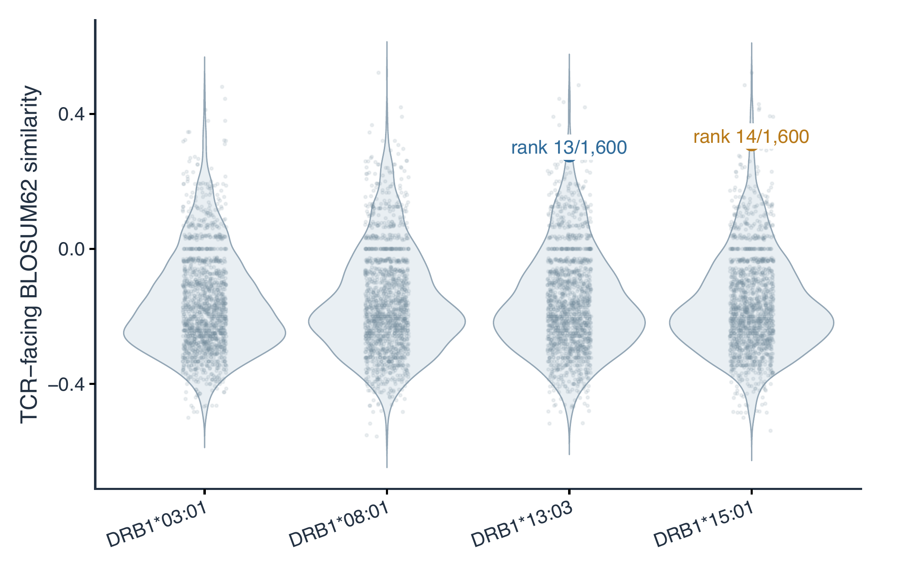
Figure S1. Within-allele distributions of TCR-facing BLOSUM62 similarity scores. Each point represents one EBV-human peptide comparison ($n=1,600$ per HLA allele); violin profiles summarize the allele-specific score distributions. Labels identify the BALF5-TALDO1 pairs selected for evidence review. Reported ranks are calculated within each allele, not across the combined 6,400-pair dataset.
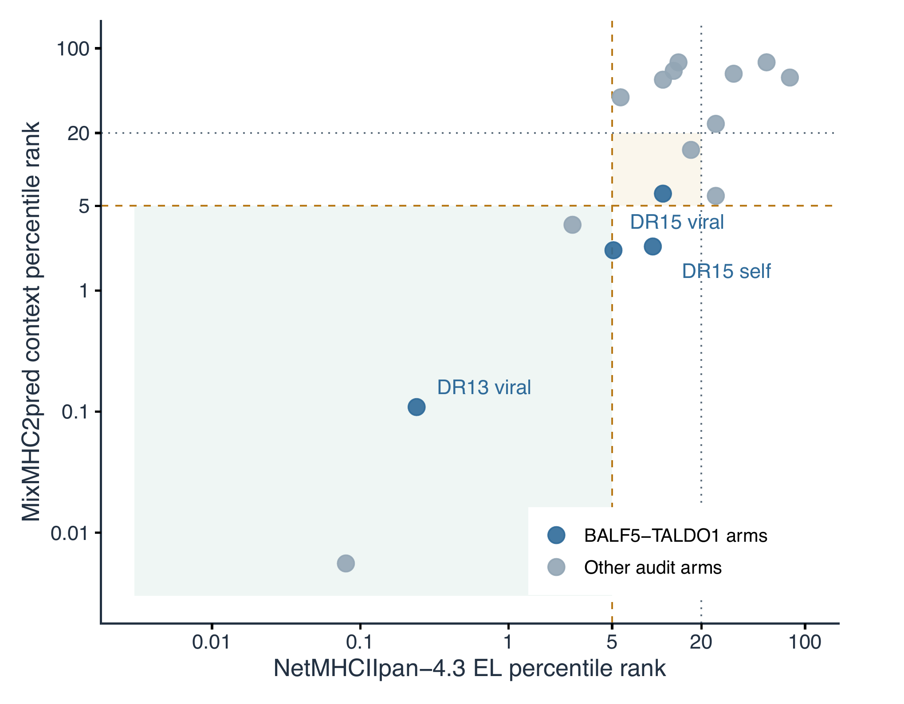
Figure S2. Concordance of peptide-HLA class II binding-percentile predictions in the initial eight-pair audit. Each point represents one peptide arm. NetMHCIIpan-4.3 EL and MixMHC2pred context percentile ranks are plotted on logarithmic axes; lower values indicate stronger predicted binding. Gold dashed lines mark the $≤5\%$ full-consensus threshold, gray dotted lines mark the $≤20\%$ lesser-support threshold, and the shaded region identifies arms below 5% in both predictors. Blue points are BALF5-TALDO1 arms; gray points are other audited arms.

Supplementary Tables
Table S1. Top sequence-ranked pairs within each allele.
Allele | Rank 1 | Rank 2 | Rank 3
*03:01 | EBNA2₁₃₆₋₁₅₀-MOG₉₇₋₁₀₉ (0.48) | BNRF1₃₇₋₅₁-CLDN11₁₉₃₋₂₀₇ (0.44) | BALF4₁₀₃₋₁₁₆-CRYAB₁₋₁₅ (0.41)
*08:01 | EBNA1₄₈₂₋₄₉₆-ANO2₇₉₋₉₃ (0.52) | BLLF1₆₅₋₇₅-PLP1₁₄₀₋₁₅₂ (0.42) | BZLF1₁₉₈₋₂₁₀-MAG₆₁₂₋₆₂₆ (0.391)
*13:03 | EBNA3B₁₃₉₋₁₅₃-MOG₂₂₁₋₂₃₅ (0.49) | BNRF1₃₇₋₅₁-CLDN11₁₉₃₋₂₀₇ (0.44) | BARF1₁₋₁₅-MAG₁₋₁₅ (0.44)
*15:01 | EBNA1₄₈₂₋₄₉₆-ANO2₇₉₋₉₃ (0.52) | EBNA3B₁₃₉₋₁₅₃-MOG₂₂₁₋₂₃₅ (0.49) | BALF4₅₇₅₋₅₈₉-CNP₁₋₁₅ (0.43)

Table S2. Initial eight-candidate evidence audit.
Candidate pair HLA context | Predicted support V / S | Register V / S | IEDB arms | Ligand arms | Audit status
EBNA2-MOG
HLA-DRB1*03:01 | No / Yes | Yes / Yes |  |  | Hold
BARF1-CRYAB
HLA-DRB1*03:01 | No / No | No / Yes |  |  | Hold
EBNA1-ANO2
HLA-DRB1*08:01 | No / No | Yes / Yes |  |  | Hold
EBNA-LP-MOG
HLA-DRB1*08:01 | No / No | No / Yes |  |  | Hold
EBNA3B-MOG
HLA-DRB1*13:03 | No / No | No / No |  |  | Hold
BALF5-TALDO1
HLA-DRB1*13:03 | Yes / No | Yes / Yes |  |  | Medium priority
BALF4-CRYAB
HLA-DRB1*15:01 | Yes / No | Yes / Yes |  |  | Hold
BALF5-TALDO1
HLA-DRB1*15:01 | No / No | Yes / Yes |  |  | Medium priority
Note. V/S, viral/self peptide arm. Predicted presentation support: both NetMHCIIpan-4.3 EL and MixMHC2pred output ranks $≤5\%$ for that arm; it is not measured affinity. Register: both outputs selected the same declared P1-P9 core. IEDB and ligand entries are numbers of peptide arms with exact-HLA supporting records (0-2); they are not numbers of studies or patients. These fields do not establish natural presentation or T-cell cross-reactivity.
Table S3. Experimental-routing classes in the 49-pair cohort. Class numbers organize downstream experiments; they are not biological-confidence grades.
Target allele | Viral-human pair | Status | Supporting factor | Limitation
DRB1*15:01 | BALF5₆₂₇₋₆₄₁-TALDO1₂₁₆₋₂₃₀ | Class 1 | Three selected outputs met 20% routing rule; viral IEDB binding | Permissive threshold; input-sensitive predicted placement; no self-arm elution record
DRB1*13:03 | BALF5₆₂₇₋₆₄₁-TALDO1₁₀₈₋₁₂₂ | Class 2 | Three selected outputs met 20% routing rule | Permissive threshold; unresolved geometry; no verified public record
DRB1*15:01 | EBNA1₄₈₂₋₄₉₆-MBP₂₁₇₋₂₃₃ | Class 2 | Declared register retained across calibrated PANDORA templates | Binding-predictor discrepancy; lower rank
DRB1*15:01 | BALF4₁₀₃₋₁₁₆-CRYAB₁₋₁₅ | Class 3 | Initial sequence similarity | Template-sensitive predicted placement
DRB1*03:01 | EBNA2₁₃₆₋₁₅₀-MOG₉₇₋₁₀₉ | Class 3 | Initial sequence rank | No same-allele PANDORA calibration
DRB1*08:01 | BHRF1₁₂₂₋₁₃₃-ANO2₁₀₄₋₁₁₈ | Class 3 | Initial sequence rank | No same-allele PANDORA calibration
DRB1*08:01 | EBNA1₄₈₂₋₄₉₆-ANO2₇₉₋₉₃ | Class 3 | Initial sequence rank | No same-allele PANDORA calibration
Various | Various | Untiered | Heterogeneous profiles | Incomplete consensus or evidence

Table S4. Constrained-null simulation results for the eight audited pairs. Ten thousand replicates were completed independently for each allele at random seed 20260914. The 95% null interval reports the 2.5th and 97.5th percentiles.
Target | Allele | Pair | Observed score (rank) | Null median | 95% null interval | Monte Carlo $p$ | BH $q$ | maxT $p$
HY03_SEQ_01 | DRB1*03:01 | EBNA2-MOG | 0.48000 (1) | -0.18519 | [-0.35714, 0.28000] | 0.00790 | 0.06319 | 0.83572
HY03_SEQ_02 | DRB1*03:01 | BARF1-CRYAB | 0.27273 (13) | -0.17949 | [-0.32500, 0.34375] | 0.08189 | 0.08189 | 1.00000
HY08_SEQ_01 | DRB1*08:01 | EBNA1-ANO2 | 0.52174 (1) | 0.00000 | [-0.32000, 0.52174] | 0.03420 | 0.07199 | 0.66483
HY08_SEQ_02 | DRB1*08:01 | EBNA-LP-MOG | 0.32000 (6) | -0.11538 | [-0.46154, 0.32000] | 0.06539 | 0.07634 | 1.00000
HY13_SEQ_01 | DRB1*13:03 | EBNA3B-MOG | 0.48485 (1) | -0.13514 | [-0.32432, 0.48485] | 0.03600 | 0.07199 | 0.82102
HY13_SEQ_02 | DRB1*13:03 | BALF5-TALDO1 | 0.28125 (13) | -0.15625 | [-0.33333, 0.25806] | 0.01720 | 0.06879 | 1.00000
HY15_SEQ_01 | DRB1*15:01 | BALF4-CRYAB | 0.41176 (5) | -0.10000 | [-0.30233, 0.47059] | 0.05559 | 0.07634 | 0.98260
HY15_SEQ_02 | DRB1*15:01 | BALF5-TALDO1 | 0.31429 (14) | 0.05714 | [-0.18919, 0.41176] | 0.06679 | 0.07634 | 1.00000
Sequence-score calibration only; not evidence of endogenous presentation, pMHC stability, TCR recognition, cross-reactivity, molecular mimicry, or an MS mechanism.
Table S5. Lead-pair sequences, frozen cores, and continuous computational-output percentiles. Values are percentile ranks; lower is more favorable within each output. They are retained for audit, not combined as independent evidence or interpreted as measured affinity.
Allele | Arm | Full 15-mer | Declared core | IEDB rec. | NetMHCIIpan EL | MixMHC2pred context
DRB1*13:03 | BALF5 | TGGVYHFVKKHVHES | YHFVKKHVH | 8.70 | 0.24 | 0.153
DRB1*13:03 | TALDO1 | DARLSFDKDAMVARA | LSFDKDAMV | 11.0 | 11.0 | 6.31
DRB1*15:01 | BALF5 | TGGVYHFVKKHVHES | VYHFVKKHV | 20.0 | 5.10 | 3.37
DRB1*15:01 | TALDO1 | SVTKIYNYYKKFSYK | IYNYYKKFS | 7.00 | 9.40 | 2.31
Note. The strict all-three-output, both-arm routing rule fails for both pairs at 10% and below; both pass only at 20%. The IEDB-recommended output is an archival service dependency whose internal version and tie behavior were not retained.
Table S6. Lead-specific rank and frozen-core sensitivity audit. Lexicographic rank follows the locked V3 key order. The alternative-key rank exchanges the physicochemical-mismatch and nominally exposed identity keys, and the surface-free rank omits the archival local-surface key; both leads are singleton primary-score values, so neither ablation changes their position. All-window values enumerate fully contained viral/self nine-mer combinations from the existing register-sensitivity record. They are score ranges, not a re-ranked discovery analysis, because those alternate windows were not evaluated as a fixed, validated register universe.
Allele | Pair | Frozen score | Primary-score block | Lex. rank | Alt./surface-free rank | All-window score range; status
DRB1*13:03 | BALF5-TALDO1₁₀₈₋₁₂₂ | 0.28125 | 13–13 ($n=1$) | 13 | 13 / 13 | $−0.37931$ to 0.28125; 49 windows, not robust
DRB1*15:01 | BALF5-TALDO1₂₁₆₋₂₃₀ | 0.31429 | 14–14 ($n=1$) | 14 | 14 / 14 | $−0.34375$ to 0.82143; 49 windows, not robust
Note. “Not robust” denotes the pre-existing sensitivity flag: the declared tier was not stable across the nine allowed window pairs. The V3 ranking remains conditional on its frozen declared cores. This audit does not claim that every enumerated window is a biologically plausible binding register.
Table S7. Declared P1–P9 cores for the two BALF5-TALDO1 sequence-prioritized comparisons. Bold residues are canonical positional anchors P1, P4, P6, and P9; unbolded residues are nominally TCR-exposed/core non-anchor positions P2, P3, P5, P7, and P8. This positional convention does not imply uniform anchor chemistry across alleles. These are frozen V3 input cores, not experimentally mapped registers.
Allele | Peptide arm | Declared core (P1–P9)
DRB1*13:03 | BALF5₆₂₇₋₆₄₁ | YHFVKKHVH
DRB1*13:03 | TALDO1₁₀₈₋₁₂₂ | LSFDKDAMV
DRB1*15:01 | BALF5₆₂₇₋₆₄₁ | VYHFVKKHV
DRB1*15:01 | TALDO1₂₁₆₋₂₃₀ | IYNYYKKFS

Table S8. Frozen-data ablations of ranking and routing. These are computational sensitivity analyses; they do not establish affinity, presentation, or cross-reactivity.
Ablation | Result
Normalized versus raw five-position BLOSUM62 | Within-allele rank correlations were 0.979–0.988; top-16 overlap was 12–14 pairs and top-80 overlap 71–77 pairs. DR13 BALF5–TALDO1 moved from rank 13 to 8 and DR15 BALF5–TALDO1 from rank 14 to 5 under raw sum (raw mean gives the same rank as raw sum).
Omit archival local-surface key | Top-16, top-40, and top-80 memberships were identical for every allele. Two of 49 panel rows changed ordinal rank, by at most two positions; both routed leads were unchanged.
Sequential tie-key accounting | Of 6,117 primary-score-tied rows, physicochemical mismatch resolved 4,688, identity 13 additional rows, local surface 1,406 additional rows, and lexical identifier the final 10 rows.
Leave one output out at strict 20%, exact-core rule | All three outputs: HP47 and HP36. Drop IEDB: HP47 and HP36. Drop NetMHCIIpan: HP47, HP36, HP43, HP21. Drop MixMHC2pred: HP47, HP36, HP06, HP17, HP49.

References
[1] Bjornevik K, Cortese M, Healy BC, et al. Longitudinal analysis reveals high prevalence of Epstein-Barr virus associated with multiple sclerosis. Science. 2022;375:296-301. https://doi.org/10.1126/science.abj8222
[2] National Institute of Neurological Disorders and Stroke. Multiple Sclerosis: Hope Through Research. https://www.ninds.nih.gov/health-information/disorders/multiple-sclerosis
[3] Lanz TV, Brewer RC, Ho PP, et al. Clonally expanded B cells in multiple sclerosis bind EBV EBNA1 and GlialCAM. Nature. 2022;603:321-327. https://doi.org/10.1038/s41586-022-04432-7
[4] Vita R, et al. The Immune Epitope Database (IEDB): 2024 update. Nucleic Acids Research. 2025;53:D436-D443. https://doi.org/10.1093/nar/gkae1092
[5] The UniProt Consortium. UniProt: the Universal Protein Knowledgebase in 2025. Nucleic Acids Research. 2025;53:D609-D617. https://doi.org/10.1093/nar/gkae1010
[6] Nilsson JB, Kaabinejadian S, Yari H, et al. Accurate prediction of HLA class II antigen presentation across all loci using tailored data acquisition and refined machine learning. Science Advances. 2023;9:eadj6367. https://doi.org/10.1126/sciadv.adj6367
[7] Racle J, Michaux J, Rockinger GA, et al. Robust prediction of HLA class II epitopes by deep motif deconvolution of immunopeptidomes. Nature Biotechnology. 2019;37:1283-1286. https://doi.org/10.1038/s41587-019-0289-6
[8] Racle J, Guillaume P, Schmidt J, et al. Machine learning predictions of MHC-II specificities reveal alternative binding mode of class II epitopes. Immunity. 2023;56:1359-1375.e13. https://doi.org/10.1016/j.immuni.2023.03.009
[9] Henikoff S, Henikoff JG. Amino acid substitution matrices from protein blocks. PNAS. 1992;89:10915-10919. https://doi.org/10.1073/pnas.89.22.10915
[10] Grantham R. Amino acid difference formula to help explain protein evolution. Science. 1974;185:862-864. https://doi.org/10.1126/science.185.4154.862
[11] Abramson J, Adler J, Dunger J, et al. Accurate structure prediction of biomolecular interactions with AlphaFold 3. Nature. 2024;630:493-500. https://doi.org/10.1038/s41586-024-07487-w
[12] Lang HLE, Jacobsen H, Ikemizu S, et al. A functional and structural basis for TCR cross-reactivity in multiple sclerosis. Nature Immunology. 2002;3:940-943. https://doi.org/10.1038/ni835
[13] Gauthier L, Smith KJ, Pyrdol J, et al. Expression and crystallization of the complex of HLA-DR2 (DRA, DRB1*1501) and an immunodominant peptide of human myelin basic protein. Proceedings of the National Academy of Sciences. 1998;95:11828-11833. https://doi.org/10.1073/pnas.95.20.11828
[14] Jurrus E, Engel D, Star K, et al. Improvements to the APBS biomolecular solvation software suite. Protein Science. 2018;27:112-128. https://doi.org/10.1002/pro.3280
[15] Basu S, Wallner B. DockQ: A quality measure for protein-protein docking models. PLOS ONE. 2016;11:e0161879. https://doi.org/10.1371/journal.pone.0161879
[16] Collins KW, Copeland MM, Brysbaert G, et al. CAPRI-Q: The CAPRI resource evaluating the quality of predicted structures of protein complexes. Journal of Molecular Biology. 2024;436:168540. https://doi.org/10.1016/j.jmb.2024.168540
[17] Yin R, Ribeiro-Filho HV, Lin V, et al. TCRmodel2: high-resolution modeling of T cell receptor recognition using deep learning. Nucleic Acids Research. 2023;51:W569-W576. https://doi.org/10.1093/nar/gkad356
[18] Perez-Riverol Y, et al. The PRIDE database at 20 years: 2025 update. Nucleic Acids Research. 2025;53:D543-D553. https://doi.org/10.1093/nar/gkae1011
[19] Parizi FM, Marzella DF, Ramakrishnan G, et al. PANDORA v2.0: Benchmarking peptide-MHC II models and software improvements. Frontiers in Immunology. 2023;14:1285899. https://doi.org/10.3389/fimmu.2023.1285899
[20] Sali A, Blundell TL. Comparative protein modelling by satisfaction of spatial restraints. Journal of Molecular Biology. 1993;234:779-815. https://doi.org/10.1006/jmbi.1993.1626
[21] Thomas OG, Rykaczewska U, Galešić M, et al. Anoctamin-2-specific T cells link Epstein-Barr virus to multiple sclerosis. Cell. 2026;189:585-602.e38. https://doi.org/10.1016/j.cell.2025.12.032
[22] Hansen BE, Rasmussen AH, Jakobsen BK, Ryder LP, Svejgaard A. Extraordinary cross-reactivity of an autoimmune T-cell receptor recognizing specific peptides both on autologous and on allogeneic HLA class II molecules. Tissue Antigens. 2007;70:42-52. https://doi.org/10.1111/j.1399-0039.2007.00849.x
[23] Brown JH, Jardetzky TS, Gorga JC, et al. Three-dimensional structure of the human class II histocompatibility antigen HLA-DR1. Nature. 1993;364:33-39. https://doi.org/10.1038/364033a0
[24] Sewell AK. Why must T cells be cross-reactive? Nature Reviews Immunology. 2012;12:669-677. https://doi.org/10.1038/nri3279
[25] Denzin LK, Cresswell P. HLA-DM induces CLIP dissociation from MHC class II alpha beta dimers and facilitates peptide loading. Cell. 1995;82:155-165. https://doi.org/10.1016/0092-8674(95)90061-6

