Smart Inventory Management System (With Prediction)

Module Breakdown (8 Modules)
Frontend Modules (3)
F1. Authentication & User Interface Module
- Secure login & registration
- Role-based UI rendering (Admin / Manager / Staff / Supplier)
- JWT-based session handling
- Responsive dashboards
F2. Inventory Dashboard & Monitoring Module
- Real-time stock visualization
- Stock status indicators (Healthy / Low / Critical)
- Product-wise inventory charts
- Search & filter inventory data
F3. Supplier & Purchase Order Module
- Supplier listing & management
- View auto-generated purchase orders
- Order approval / rejection
- Delivery status tracking

Backend Modules (5)
B1. Authentication & Authorization Service
- User authentication (JWT)
- Role-based access control (RBAC)
- Secure API access enforcement
B2. Inventory Management Service
- Product CRUD operations
- Stock IN / Stock OUT processing
- Stock history maintenance
- Threshold validation
B3. Prediction & Analytics Service
- Consumption pattern analysis
- Average Daily Consumption (ADC) calculation
- Stock depletion prediction
- Reorder quantity suggestion logic
B4. Alert & Notification Service
- Low-stock detection
- Prediction-based alert triggers
- Email / in-app notifications
- Asynchronous processing (queue-based)
B5. Database & Persistence Layer
- Product, supplier, and stock data storage
- Historical usage records
- Audit logs for traceability
- Transaction-safe persistence

System Requirements
Functional Requirements
- User authentication & role-based access
- Product and supplier management
- Real-time inventory tracking
- Automatic stock depletion prediction
- Smart reorder suggestion generation
- Purchase order creation & approval
- Inventory alerts & notifications
- Activity logs & audit trail

Non-Functional Requirements
- High availability during peak usage
- Low-latency dashboard updates
- Scalability for large inventories
- Secure data handling & access control
- Fault tolerance & consistency
- Maintainable and modular design

High-Level System Design

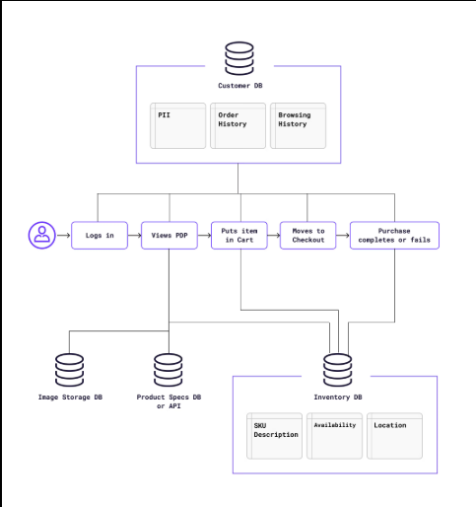

Architecture Overview
The system follows a modular, service-oriented architecture.
- Client Layer
  - Web application built with React
  - Communicates via REST APIs
- API Gateway
  - Central entry point
  - Handles authentication, routing, and rate limiting
- Backend Services
  - Authentication Service
  - Inventory Management Service
  - Prediction & Analytics Service
  - Notification Service
  - Supplier & Order Service
- Data Layer
  - Relational database (MySQL)
  - Redis (optional) for caching stock data
- Async Processing
  - Message queue for alerts & notifications

