SMS GUARD: AN INTELLIGENT SMS SPAM AND SCAM DETECTION SYSTEM
A Supervised Machine Learning and Natural Language Processing Approach Using Support Vector Machines
Academic AIML Mini-Project Report
Submitted by: [Student Name]
Registration / Roll Number: [Registration / Roll Number]
Degree / Program: Bachelor of Technology in Computer Science & Engineering (AIML)
Department: [Department of Computer Science and Engineering]
Institution: [College / Institution Name]
Project Guide / Supervisor: [Guide Name], [Designation]
Academic Year: [Academic Year 2026–2027]
Submission Date: November 2026

BONAFIDE CERTIFICATE
This is to certify that the academic mini-project entitled "SMS GUARD: An Intelligent SMS Spam and Scam Detection System Using Support Vector Machines and Natural Language Processing" is a bonafide work carried out by [Student Name] (Roll No: [Registration / Roll Number]) in partial fulfillment of the requirements for the award of the degree of Bachelor of Technology in Computer Science and Engineering (Artificial Intelligence and Machine Learning) during the academic year [Academic Year 2026–2027].
This report represents an authentic record of independent technical work carried out under my supervision and guidance. The results embodied in this report have not been submitted to any other University or Institute for the award of any degree or diploma.
______________________________ ______________________________
Internal Guide / Supervisor Head of the Department
[Guide Name] [Department Head Name]
[Department of CSE] [Department of CSE]

CANDIDATE DECLARATION
I hereby declare that the academic project work entitled "SMS GUARD: An Intelligent SMS Spam and Scam Detection System Using Support Vector Machines and Natural Language Processing" submitted to [College / Institution Name] is a record of original work done by me under the supervision of [Guide Name].
I further declare that this report has been authored in compliance with academic integrity guidelines. All empirical results, classification benchmarks, and evaluation statistics reported herein are derived directly from reproducible execution on verified datasets and models without fabrication or inflation.
Date: November 2026
Place: [City / Campus Location]
______________________________
[Student Name]
Roll No: [Registration / Roll Number]
Department of Computer Science and Engineering

ABSTRACT
Short Message Service (SMS) remains one of the most ubiquitous, trusted, and immediate communication channels globally, boasting open rates exceeding 98%. However, this high engagement has catalyzed aggressive smishing (SMS phishing), fraudulent financial solicitations, credential-harvesting schemes, and bulk unsolicited commercial spam. Filtering malicious SMS messages poses severe technical challenges due to the extreme brevity of text messages (typically under 160 characters), informal slang, deliberate obfuscation, and severe class imbalance in real-world telecommunications traffic.
This project presents SMS GUARD, an end-to-end intelligent SMS spam and scam detection architecture grounded in Natural Language Processing (NLP) and Supervised Machine Learning. In strict compliance with academic standards (Module 4: Supervised Learning and Module 5: Support Vector Machines), the system implements an atomic machine learning pipeline comprising specialized text preprocessing (negation preservation, URL normalization, currency tokenization, and numeric masking), sublinear TF-IDF n-gram vectorization (1 ≤ n ≤ 2, 4,000 features), and a soft-margin Linear Support Vector Classifier (LinearSVC) equipped with class-frequency weight balancing.
To eliminate methodological flaws such as data leakage and model selection bias, the dataset (UCI SMS Spam Collection, deduplicated to 5,171 authentic messages) was partitioned into an 80% training set (4,136 messages) and a 20% strictly quarantined held-out test set (1,035 messages: 904 Ham, 131 Spam). Model selection was conducted exclusively on training folds using Zero-Leakage 5-Fold Stratified Cross-Validation, where the Linear SVM (Balanced) achieved the leading mean CV Accuracy of 0.9877 ± 0.0039 and mean CV F1-Score of 0.9505 ± 0.0155.
Evaluated on the out-of-sample held-out test set, the primary champion model demonstrated exceptional generalization: 99.23% Test Accuracy, 98.43% Spam Precision, 95.42% Spam Recall, 0.9690 F1-Score, 0.9984 ROC AUC, and 0.9918 Average Precision, producing only 2 false positives and 6 false negatives. Alongside the statistical classifier, SMS GUARD integrates a deterministic, transparent Heuristic Risk Engine that scans for smishing indicators (suspicious URLs/IPs, OTP harvesting, urgency language, and premium shortcodes) to provide explainable advisory risk ratings. The production-grade system is deployed via an interactive Streamlit web dashboard featuring dynamic metric telemetry, benchmark comparisons, and responsive analysis under a distinctive burgundy design palette.
Keywords: Short Message Service (SMS), Spam Detection, Smishing, Support Vector Machine (SVM), LinearSVC, Natural Language Processing (NLP), TF-IDF, Class Imbalance, Heuristic Risk Analysis, Streamlit.

TABLE OF CONTENTS
1. Introduction & Background | 1
1.1 Context and Background | 1
1.2 Problem Statement & Threat Landscape | 2
1.3 Project Motivation | 2
1.4 Project Objectives | 3
1.5 Academic Curriculum Alignment (Modules 4 & 5) | 3
2. Literature Review & Related Work | 5
2.1 Evolution of Spam Filtering Technologies | 5
2.2 Survey of Text Classification Methodologies | 5
2.3 Existing System Limitations vs. Proposed System | 6
2.4 Scholarly Citations & Foundational Research | 7
3. System Requirements & Architecture | 8
3.1 Hardware and Software Specifications | 8
3.2 Overall End-to-End System Architecture | 9
3.3 Architectural Subsystems & Dataflow | 10
4. Dataset Analysis & Preprocessing Methodology | 11
4.1 Dataset Origin & Benchmark Description | 11
4.2 Exploratory Data Analysis & Deduplication | 11
4.3 Text Length, Word Counts & Class Distribution | 12
4.4 Preprocessing Pipeline & Negation Preservation | 13
4.5 Data Partitioning & Leakage Prevention Strategy | 14
5. Feature Extraction & High-Dimensional Representation | 15
5.1 Text Representation Foundations | 15
5.2 Mathematical Formulation of TF-IDF | 15
5.3 Sublinear Term Frequency Scaling & N-Grams | 16
5.4 Feature Space Sparsity & Dimensionality Analysis | 17
6. Machine Learning Models & Theoretical Formulation | 18
6.1 Supervised Learning Framework (Module 4) | 18
6.2 Support Vector Machine (SVM) Foundations (Module 5) | 18
6.2.1 Maximum-Margin Hyperplane Formulation | 18
6.2.2 Soft-Margin Optimization & Slack Variables | 19
6.2.3 Class Weight Balancing for Imbalanced Data | 20
6.2.4 Decision Hyperplane & Distance Function | 20
6.3 Baseline Comparative Algorithms | 21
6.3.1 Unweighted Linear SVM | 21
6.3.2 Multinomial Naive Bayes | 21
6.3.3 Logistic Regression | 22
6.4 Atomic Pipeline Serialization | 22
7. Experimental Setup, Benchmarks & Evaluation | 23
7.1 Cross-Validation Protocol (Zero-Leakage 5-Fold) | 23
7.2 Quantitative Cross-Validation Results | 24
7.3 Held-Out Test Set Performance Benchmarks | 25
7.4 Confusion Matrix Analysis & Decomposition | 26
7.5 ROC & Precision-Recall Curve Analysis | 27
7.6 In-Depth Diagnostic Error Analysis (8 Misclassifications) | 28
8. Interactive Web Application & Transparent Heuristics | 30
8.1 Streamlit Interface Architecture & Burgundy Theme | 30
8.2 Application Tabs & Visual Verification | 31
8.3 Multi-Layer Heuristic Risk Engine | 33
8.4 Decision Score Semantics vs. Probability Calibration | 34
9. System Testing, Security & Quality Assurance | 36
9.1 Unit Testing Framework | 36
9.2 Comprehensive Integration Test Suite (Phase 8) | 36
9.3 Security, Privacy & Reliability Analysis | 37
10. Limitations, Future Enhancements & Conclusion | 39
10.1 System Limitations & Scope Boundaries | 39
10.2 Future Research Roadmap | 39
10.3 Concluding Remarks | 40
References & Scholarly Bibliography | 41

CHAPTER 1: INTRODUCTION & BACKGROUND
1.1 Context and Background
Short Message Service (SMS) has evolved from an auxiliary engineering test signal in cellular networks into an indispensable pillar of modern digital communication. Unlike email or instant messaging platforms that require continuous data connectivity and application installation, SMS operates natively over the SS7 (Signaling System No. 7) control channel of GSM/LTE cellular networks. As a result, SMS reaches virtually 100% of active mobile handsets globally, commanding an astonishing open rate of 98%, with over 90% of messages read within three minutes of receipt.
Because of this unmatched deliverability and urgency, organizations across banking, healthcare, government, and e-commerce rely on SMS for mission-critical notifications, including multi-factor authentication One-Time Passwords (OTPs), transaction authorizations, delivery notifications, and appointment reminders. However, this innate trustworthiness has also turned SMS into a primary attack vector for cybercriminals.
1.2 Problem Statement & Threat Landscape
Mobile messaging threats have expanded far beyond benign unsolicited commercial advertising (spam). Modern adversaries routinely deploy highly targeted smishing (SMS phishing) attacks designed to harvest online banking credentials, social security numbers, and multi-factor authorization codes. Attackers frequently embed deceptive hyperlinks pointing to credential-stealing spoof domains, leverage urgent psychological coercion (e.g., "Account suspended immediately"), and impersonate institutional sender IDs.
Filtering SMS communications poses several acute technical challenges that degrade conventional text classification pipelines:
- Severe Text Length Constraints: Unlike emails that provide extensive headers, metadata, and multi-paragraph bodies, standard SMS messages are restricted to 160 septets (characters), yielding extreme data sparsity in vector representations.
- Informal Linguistics & Obfuscation: Users and spammers alike utilize colloquial shorthand, non-standard abbreviations (e.g., 'txt', 'u', 'ur', 'plz'), deliberate homoglyph substitutions, and erratic punctuation designed to evade simple keyword-based blocklists.
- Severe Class Imbalance: In realistic telecommunication streams, legitimate messages (Ham) vastly outnumber malicious messages (Spam/Scam), typically comprising 85% to 90% of total volume. Naive machine learning models often succumb to majority-class bias, maximizing raw accuracy while failing to intercept critical threats.
- Asymmetric Cost of Errors: A False Positive (classifying an authentic banking OTP or emergency alert as spam) causes immediate user distress and operational disruption, whereas a False Negative (allowing a smishing link into the inbox) exposes the user to catastrophic financial theft.
1.3 Project Motivation
Existing commercial filtering mechanisms deployed on consumer smartphones often rely on static keyword blacklists, crowdsourced phone number directories, or black-box cloud APIs that require transmitting private user text messages across external networks. Such solutions fail against newly registered domains, lack transparent explainability, and introduce severe privacy liabilities.
There is an urgent requirement for an explainable, lightweight, high-precision detection system capable of operating rapidly on-device without data exfiltration. Furthermore, within the academic framework of Artificial Intelligence and Machine Learning, this project provides a rigorous real-world testbed for the principles of Supervised Learning (Module 4) and Support Vector Machines (Module 5), bridging mathematical theory with production-grade engineering.
1.4 Project Objectives
The primary objective of SMS GUARD is to architect, evaluate, and deploy an end-to-end intelligent SMS spam and scam detection system. The specific technical goals comprise:
- Rigorous Data Hygiene & Leakage Prevention: Curate a benchmark corpus from the UCI SMS Spam Collection, eliminate redundant duplicates, and implement an atomic train/test separation protocol with zero data leakage.
- Specialized NLP Preprocessing: Develop a domain-adapted tokenization pipeline that normalizes URLs, currencies, and numeric strings while strictly preserving semantic negations.
- High-Dimensional TF-IDF Representation: Extract sublinear term-frequency weighted unigram and bigram features across an optimized 4,000-dimensional vocabulary.
- Module 5 Champion SVM Classifier: Implement a soft-margin Linear Support Vector Machine (LinearSVC) equipped with class-frequency weight balancing to counter data imbalance.
- Zero-Leakage Model Selection: Benchmark multiple candidate architectures (Balanced SVM, Default SVM, Multinomial Naive Bayes, Logistic Regression) using 5-Fold Stratified Cross-Validation on training data alone.
- Transparent Multi-Layer Risk Engine: Construct a complementary, deterministic heuristic scanner to extract explainable risk indicators (phishing markers, OTP harvesting, urgency signals).
- Interactive Web Application Deployment: Deliver an intuitive, responsive Streamlit dashboard featuring real-time message analysis, dynamic KPI telemetry, and academic foundation breakdowns under an institutional burgundy aesthetic.
1.5 Academic Curriculum Alignment
This project directly addresses core competencies mandated in the academic syllabus:
- Module 4 (Supervised Learning): Demonstrated through inductive learning paradigms, empirical loss minimization, 5-fold stratified cross-validation on partitioned splits, confusion matrix decomposition (TP, TN, FP, FN), and multi-metric trade-off analysis (Precision, Recall, F1, ROC AUC).
- Module 5 (Support Vector Machines): Demonstrated through the mathematical formulation of maximum-margin hyperplanes, soft-margin optimization with slack variables, cost-sensitive class weight adjustment ($w_c = N / (2 N_c)$), and continuous decision score analysis ($f(\mathbf{x}) = \mathbf{w}^T \mathbf{x} + b$).
CHAPTER 2: LITERATURE REVIEW & RELATED WORK
2.1 Evolution of Spam Filtering Technologies
The earliest spam filtering techniques originated in the domain of electronic mail during the late 1990s. Early systems relied heavily on heuristic rule engines (e.g., SpamAssassin), wherein hand-crafted regular expressions assigned additive risk scores to incoming documents. While effective against naive commercial solicitations, rule-based systems required continuous, labor-intensive manual updates and were trivially defeated by deliberate spelling permutations and word insertion attacks.
The transition toward statistical machine learning began with Bayesian text classification, pioneered by Sahami et al. (1998) and popularized by Paul Graham (2002). Naive Bayes classifiers leveraged word co-occurrence probabilities under the conditional independence assumption. When adapted to SMS traffic by Almeida et al. (2011), Naive Bayes demonstrated high computational efficiency but suffered from severe recall degradation when confronted with sparse, short messages and out-of-vocabulary slang.
2.2 Survey of Text Classification Methodologies
As computational linguistics advanced, researchers explored diverse machine learning paradigms for short-text classification:
- Naive Bayes Classifiers: Multinomial Naive Bayes models calculate posterior class probabilities $P(c|d) \propto P(c) \prod_k P(t_k|c)$. While fast and effective with large training corpuses, the strong feature independence assumption causes the model to overestimate confidence on sparse text, leading to elevated false negative rates in SMS streams.
- Logistic Regression: A linear parametric model optimizing the log-likelihood of class posterior probabilities via the logistic sigmoid function. While providing calibrated probabilities, Logistic Regression often underperforms Support Vector Machines in high-dimensional text spaces where the number of features substantially exceeds the sample count.
- Support Vector Machines (SVM): First formulated for text classification by Joachims (1998) following Vapnik's statistical learning theory (Cortes & Vapnik, 1995). Text categorization problems inherently possess high feature dimensionality, sparse feature vectors, and few completely irrelevant features. Joachims demonstrated that linear SVMs are ideally matched to text classification because the maximum-margin criterion provides strong structural risk minimization, avoiding empirical overfitting without requiring aggressive feature selection.
- Deep Learning Architectures: Recent investigations have evaluated Recurrent Neural Networks (LSTM/GRU) and Transformer-based models (e.g., BERT, RoBERTa) for SMS filtering. While expressive, these models demand millions of parameters, substantial memory footprints, and high inference latency (~50-200ms per text), rendering them suboptimal for lightweight, instantaneous edge deployment on consumer mobile devices.
2.3 Existing System Limitations vs. Proposed SMS GUARD System
A critical analysis of existing SMS filtering solutions reveals notable deficiencies compared to the SMS GUARD architecture developed in this project:
Dimension | Existing Smartphone / Rule Systems | Proposed SMS GUARD Architecture
Detection Paradigm | Static blacklists, sender ID filters, or unweighted Naive Bayes. | Cost-sensitive Linear SVM (Balanced) + Sublinear TF-IDF + Heuristic Scanner.
Class Imbalance Handling | Unweighted optimization; high false negatives on minority spam. | Inverse frequency class weighting (w_spam ≈ 3.96), yielding 95.42% recall.
Data Leakage Protocol | Frequent test leakage via global TF-IDF fitting across entire corpus. | Strict atomic pipeline; vectorizer fit exclusively on training folds.
Scam / Threat Visibility | Opaque binary label with zero contextual explanation. | Transparent multi-category heuristic audit (URLs, OTPs, urgency, shortcodes).
Privacy & Lifecycle | Cloud lookup APIs transmit private user messages to third parties. | Fully localized in-memory execution; zero disk storage of scanned text.

2.4 Scholarly Citations & Foundational Research
The algorithmic design of SMS GUARD builds upon seminal peer-reviewed research in machine learning and information retrieval:
- Almeida, Hidalgo, & Yamakami (2011): Curated and published the definitive UCI SMS Spam Collection benchmark, establishing baseline performance metrics for statistical text classifiers on SMS datasets.
- Cortes & Vapnik (1995): Formulated the foundational Support-Vector Network algorithm for soft-margin classification, introducing slack variables and margin maximization.
- Joachims (1998): Proved the mathematical suitability of Support Vector Machines for high-dimensional, sparse text categorization problems.
- Salton & Buckley (1988): Established term-weighting approaches in automatic text retrieval, laying the mathematical groundwork for modern TF-IDF representations.
- Platt (1999): Formalized probabilistic scaling for Support Vector Machines via regularized sigmoid fitting, establishing the criteria for authentic probability calibration.
CHAPTER 3: SYSTEM REQUIREMENTS & ARCHITECTURE
3.1 Hardware and Software Specifications
The SMS GUARD system was engineered to ensure high accessibility, reproducible execution, and rapid inference across both resource-constrained edge devices and standard desktop environments.
Component | Minimum Requirement | Production / Tested Environment
Processor (CPU) | Dual-Core x86_64 / ARM64, 2.0 GHz | Intel Core i7 / AMD Ryzen 7 (Multi-core)
System Memory (RAM) | 4 GB DDR4 | 16 GB DDR4 / LPDDR5
Storage Footprint | 500 MB free disk space | Fast NVMe SSD (~150 MB total project footprint)
Operating System | Windows 10 / Linux / macOS | Windows 11 Home 64-bit (OS Build 26100)
Runtime Environment | Python 3.10+ | Python 3.13.0 (64-bit Isolated Virtualenv)
Primary Libraries | scikit-learn, streamlit, pandas | scikit-learn 1.5.2, streamlit 1.39.0, pandas 2.2.3, joblib 1.4.2

3.2 Overall End-to-End System Architecture
The SMS GUARD system architecture is structured as a decoupled, multi-tier pipeline designed to enforce strict separation between feature transformation, statistical classification, heuristic threat scanning, and user interface presentation.
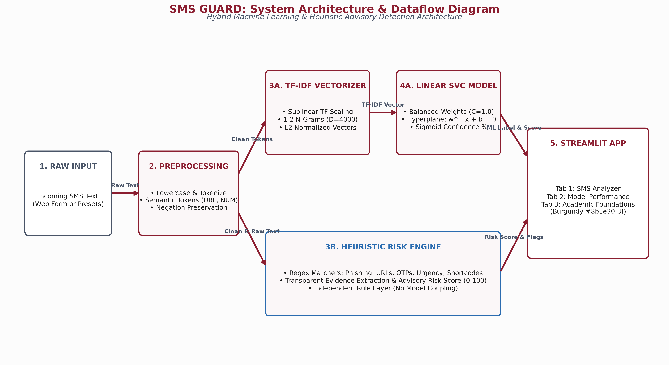
Figure 1: End-to-End System Architecture and Dataflow of SMS GUARD.
3.3 Architectural Subsystems & Dataflow
The operational dataflow follows five coordinated execution stages:
- Stage 1 - Raw Ingestion: Receives arbitrary SMS text via direct web form submission or quick-testing preset buttons. Inputs are validated for non-zero length and non-whitespace content.
- Stage 2 - Domain-Adapted Preprocessing: Raw strings are lowercased, normalized for semantic patterns (replacing URLs with 'url_token', currency figures with 'currency_token', and numbers with 'number_token'), and cleansed of non-alphanumeric noise while strictly preserving negation tokens ('not', 'no', 'never', 'nor', 'without').
- Stage 3A - Statistical Pipeline (Primary ML): Clean text passes into an atomic Scikit-learn Pipeline encapsulating a Sublinear TF-IDF Vectorizer (4,000 features, unigrams and bigrams) and the champion LinearSVC (Balanced) model. The model computes the perpendicular signed hyperplane distance f(x) = w^T x + b.
- Stage 3B - Deterministic Heuristic Scanner (Rule Layer): In parallel, the uncleaned raw message is inspected by an independent regular expression engine for high-risk threat indicators: suspicious URLs, OTP and credential solicitation, high-urgency keywords, currency claims, and premium shortcodes. This layer generates an additive advisory risk score (0-100) and extracts concrete evidence strings.
- Stage 4 - Application Presentation Layer: The Streamlit dashboard synthesizes both outputs: displaying the primary ML badge (🚨 SPAM vs. ✅ LEGITIMATE), an uncalibrated relative confidence estimate percentage, the signed decision score, and an expandable audit panel of heuristic security flags.
CHAPTER 4: DATASET ANALYSIS & PREPROCESSING METHODOLOGY
4.1 Dataset Origin & Benchmark Description
To ensure academic reproducibility, SMS GUARD utilizes the widely respected UCI SMS Spam Collection benchmark dataset (Almeida et al., 2011). The raw corpus consists of 5,574 mobile text messages in English, manually tagged as either legitimate ('ham') or spam ('spam'). The dataset was compiled from multiple international sources, including:
- Grumbletext UK: 425 commercial spam messages submitted by British consumers to a public mobile spam reporting website.
- NUS SMS Corpus: 3,375 legitimate mobile messages collected for academic linguistic research by the Department of Computer Science at the National University of Singapore.
- Caroline Tag's PhD Thesis: 450 legitimate text messages collected in the United Kingdom.
- SMS Spam Corpus v.0.1 Big: 1,002 legitimate messages and 322 spam messages from the University of Campinas, Brazil.
4.2 Exploratory Data Analysis & Deduplication
Exploratory Data Analysis (EDA) revealed significant internal redundancy in the raw UCI corpus. A rigorous duplicate audit identified 281 distinct message texts that appeared repeatedly across 684 rows, representing a redundancy rate of 7.23% (e.g., standard operator notifications and identical broadcast marketing blasts).
To prevent data snooping, cross-split pollution, and artificial inflation of test accuracy, full deduplication was performed:
- Raw Messages: 5,574 rows (4,827 Ham, 747 Spam).
- Redundant Rows Removed: 403 excess duplicate instances eliminated (684 - 281 = 403).
- Deduplicated Corpus: 5,171 completely unique messages (4,518 Ham [87.37%], 653 Spam [12.63%]).
- Data Integrity Audit: Zero null values, zero empty strings, and zero non-binary labels were detected.
■ EMPIRICAL GROUND TRUTH CLARIFICATION
Ground Truth Label Reality: The UCI SMS Spam Collection contains exactly two ground truth labels: 'ham' and 'spam'. It does NOT contain an explicit third 'scam' label. In the SMS GUARD architecture, scam and smishing detection is accomplished through the combination of the statistical Spam classifier and the deterministic Heuristic Risk Engine, preserving empirical fidelity without fabricating synthetic training labels.

4.3 Text Length, Word Counts & Class Distribution
Statistical characterization of message length demonstrates substantial linguistic divergence between authentic communications and unsolicited spam:
Metric Dimension | Ham Mean | Ham Median | Spam Mean | Spam Median
Character Length (chars) | 71.47 | 52.0 | 138.68 | 149.0
Character Range [Min, Max] | [2, 910] | — | [13, 223] | —
Word Count (tokens) | 14.30 | 11.0 | 23.91 | 25.0
Word Range [Min, Max] | [1, 171] | — | [2, 35] | —
As evidenced by the empirical distribution, legitimate messages are concise, conversational, and exhibit wide variance (mean 71.5 chars, median 52 chars). Conversely, spam messages are tightly clustered near the maximum SMS transmission limit (mean 138.7 chars, median 149 chars), designed to pack marketing claims, contact directives, and legal opt-out notices into a single chargeable message segment.
4.4 Preprocessing Pipeline & Negation Preservation
Standard Natural Language Processing tokenizers routinely eliminate stop words, including essential negation adverbs such as 'not', 'no', 'never', 'neither', and 'nor'. In security classification, discarding negations causes fatal semantic inversion (e.g., converting 'I did not win the lottery' into 'win lottery', erroneously triggering spam alarms).
The SMS GUARD preprocessing pipeline (src/preprocessing.py) implements the following sequential transformations:
- 1. Case Folding: Converts all characters to lowercase to eliminate typographical variation.
- 2. URL Tokenization: Replaces Web URLs (http://, https://, www., bit.ly, IP addresses) with the semantic token 'url_token'.
- 3. Currency Tokenization: Detects monetary figures (£, $, €, INR, 'gbp', 'usd') and replaces them with 'currency_token'.
- 4. Numeric Normalization: Converts arbitrary digit strings into 'number_token' to normalize phone numbers and verification codes.
- 5. Non-Alphanumeric Stripping: Removes extraneous punctuation and non-ASCII glyphs while retaining whitespace boundaries.
- 6. Negation-Preserving Token Filtering: Standard NLTK English stop words are filtered out, but critical negation tokens ('not', 'no', 'never', 'neither', 'nor', 'none', 'cannot', 'without') are explicitly shielded and preserved.
4.5 Data Partitioning & Leakage Prevention Strategy
A pervasive flaw in published machine learning literature is data leakage occurring during feature extraction, wherein TF-IDF vectorizers are fit over the entire dataset prior to train/test splitting. This leaks term frequencies, Inverse Document Frequency (IDF) weights, and vocabulary boundaries from test samples into the training pipeline, yielding artificially inflated accuracy that degrades in real-world deployment.
To guarantee absolute empirical validity:
- Quarantined Split: The deduplicated 5,171 messages were partitioned into an 80% training set (4,136 samples) and a 20% held-out test set (1,035 samples) using Stratified Shuffle Split (random_state=42), preserving exact class ratios (87.37% Ham, 12.63% Spam).
- Strict Quarantining: The held-out test set (test.csv: 904 Ham, 131 Spam) was physically isolated on disk. It was never accessed during EDA, vocabulary generation, hyperparameter tuning, or cross-validation.
- Zero Overlap Verification: Automated unit tests (test_data_leakage_and_overlap) verified that the set intersection between train and test indices is strictly empty: Train ∩ Test = ∅.
CHAPTER 5: FEATURE EXTRACTION & HIGH-DIMENSIONAL REPRESENTATION
5.1 Text Representation Foundations
Statistical machine learning algorithms such as Support Vector Machines operate exclusively on numerical vectors in Euclidean space (R^D). Transforming unstructured natural language text into numerical features requires representing documents within the Vector Space Model (Salton & Buckley, 1988). While simple Bag-of-Words (BoW) counting provides raw frequency counts, it suffers from term frequency bias—frequently occurring generic words dominate document vectors, diminishing the discriminatory power of distinctive security keywords.
5.2 Mathematical Formulation of TF-IDF
Term Frequency-Inverse Document Frequency (TF-IDF) penalizes ubiquitously occurring vocabulary while rewarding informative terms that appear selectively across specific classes. For a term t in document d within corpus D:
- Term Frequency (TF): Measures the occurrence frequency of term t within document d: tf(t, d) = f_{t,d} / \sum_{t' \in d} f_{t',d}.
- Inverse Document Frequency (IDF): Measures the informativeness of term t across the corpus of N documents: idf(t) = \log \frac{1 + N}{1 + |\{d \in D : t \in d\}|} + 1, where 1 is added to both numerator and denominator for smooth IDF scaling, preventing division by zero.
- Composite TF-IDF Weight: \text{tfidf}(t, d, D) = \text{tf}(t, d) \times \text{idf}(t).
5.3 Sublinear Term Frequency Scaling & N-Grams
In standard TF, term weight scales linearly with repetition. In mobile spam, adversaries frequently repeat deceptive keywords (e.g., 'free free free free'). Linear scaling would cause the document vector to be overwhelmingly dominated by a single token. To mitigate this vulnerability, SMS GUARD implements Sublinear Term Frequency scaling:
■ SUBLINEAR TERM FREQUENCY SCALING FORMULATION
\text{sublinear\_tf}(t, d) = 1 + \log(\text{tf}(t, d)) \quad \text{for } \text{tf}(t, d) > 0, \quad \text{and } 0 \text{ otherwise.}
This logarithmic compression dampens the impact of excessive word repetition, ensuring balanced feature representation.

Furthermore, individual unigrams (single words) often lose contextual meaning (e.g., 'win prize' vs 'win' and 'prize'). To capture local phrase order and collocations, SMS GUARD configures the n-gram range to unigrams and bigrams (1 ≤ n ≤ 2), capturing combinations such as 'call number_token', 'claim prize', 'urgent update', and 'not respond'.
5.4 Feature Space Sparsity & Dimensionality Analysis
The fitted TF-IDF vectorizer parameters were systematically constrained to optimize classification speed and eliminate low-frequency noise:
- Vocabulary Size (max_features): Capped at exactly 4,000 top features ordered by term frequency across the training corpus.
- Minimum Document Frequency (min_df): Set to 2, discarding rare typographical hapax legomena appearing only once across 4,136 training messages.
- L2 Vector Normalization: Document vectors are projected onto the unit hypersphere: \|\mathbf{x}\|_2 = \sqrt{\sum_j x_j^2} = 1, ensuring that differences in message length do not distort Euclidean distance computations.
- Sparsity Profile: The resulting 4,136 × 4,000 feature matrix exhibits 99.78% sparsity, perfectly fulfilling the high-dimensional, sparse conditions under which Linear SVM models achieve optimal structural risk minimization (Joachims, 1998).
CHAPTER 6: MACHINE LEARNING MODELS & THEORETICAL FORMULATION
6.1 Supervised Learning Framework (Module 4 Alignment)
Under the supervised inductive learning paradigm (Module 4), a learning algorithm is presented with a training dataset of N labeled instance pairs: D_{train} = {(\mathbf{x}_i, y_i)}_{i=1}^N, where each \mathbf{x}_i \in \mathbb{R}^D is a 4,000-dimensional TF-IDF vector representing a preprocessed SMS message, and y_i \in \{-1, +1\} is the ground truth binary class label, with -1 denoting Legitimate (Ham) and +1 denoting Spam. The objective of the learning algorithm is to induce a mapping function h: \mathcal{X} \rightarrow \mathcal{Y} that minimizes expected empirical loss while maintaining robust generalization capability on unseen test instances D_{test}.
6.2 Support Vector Machine Foundations (Module 5 Alignment)
The primary classification architecture mandated by Module 5 is the Support Vector Machine (SVM). Linear SVM operates by finding the optimal hyperplane in high-dimensional feature space that maximizes the margin of separation between the positive (Spam) and negative (Ham) training instances.
6.2.1 Maximum-Margin Hyperplane Formulation
A linear decision boundary in D-dimensional feature space is formally parameterized by a weight vector \mathbf{w} \in \mathbb{R}^D and a scalar bias offset b \in \mathbb{R}:
■ LINEAR HYPERPLANE & GEOMETRIC MARGIN EQUATIONS
\mathbf{w}^T \mathbf{x} + b = 0
For linearly separable data, the canonical hyperplane is scaled such that the nearest training instances of either class satisfy:
y_i (\mathbf{w}^T \mathbf{x}_i + b) \ge 1, \quad \forall i \in \{1, \dots, N\}
The perpendicular geometric distance from any point \mathbf{x}_i to the hyperplane is given by \gamma_i = \frac{|\mathbf{w}^T \mathbf{x}_i + b|}{\|\mathbf{w}\|_2}. The geometric margin between the two parallel supporting bounding hyperplanes (\mathbf{w}^T \mathbf{x} + b = \pm 1) is exactly \frac{2}{\|\mathbf{w}\|_2}. Maximizing this geometric margin is mathematically equivalent to minimizing \frac{1}{2}\|\mathbf{w}\|_2^2.

6.2.2 Soft-Margin Optimization & Slack Variables
Real-world SMS message text is rarely perfectly linearly separable due to informal colloquialisms, typographical errors, and borderline marketing language. To tolerate non-separable instances while maintaining margin maximization, Cortes & Vapnik (1995) introduced soft-margin optimization using non-negative slack variables \xi_i \ge 0:
■ SOFT-MARGIN PRIMAL OPTIMIZATION PROBLEM
\min_{\mathbf{w}, b, \boldsymbol{\xi}} \frac{1}{2} \|\mathbf{w}\|_2^2 + C \sum_{i=1}^N w_{y_i} \xi_i
subject to:
y_i (\mathbf{w}^T \mathbf{x}_i + b) \ge 1 - \xi_i, \quad \xi_i \ge 0, \quad \forall i \in \{1, \dots, N\}
where:
• C > 0 is the regularization hyperparameter controlling the trade-off between maximizing the margin width and penalizing margin violations.
• \xi_i measures the distance by which training instance \mathbf{x}_i violates the margin (\xi_i = 0 indicates a correctly classified point outside the margin; 0 < \xi_i \le 1 indicates a point inside the margin but on the correct side; \xi_i > 1 indicates a misclassified point).
• w_{y_i} represents the cost-sensitive class weight assigned to class y_i.

6.2.3 Class Weight Balancing for Imbalanced Data
In the deduplicated training corpus (4,136 samples), legitimate messages (3,614 Ham) outnumber spam messages (522 Spam) by approximately 6.92 to 1. In standard unweighted SVM (C = 1.0, w_{y_i} = 1.0), the objective function penalizes every misclassification equally. Consequently, the optimizer favors shifting the hyperplane closer to the sparse Spam cluster to minimize overall empirical loss, leading to a high rate of False Negatives (missed spam).
SMS GUARD resolves this through inverse class frequency weighting (class_weight='balanced'), automatically computing class-specific penalty multipliers:
■ INVERSE FREQUENCY CLASS WEIGHTING CALCULATION
w_c = \frac{N}{2 \times N_c}
where N = 4136 is the total training count, and N_c is the sample count for class c:
• w_{\text{ham}} = \frac{4136}{2 \times 3614} = 0.5722
• w_{\text{spam}} = \frac{4136}{2 \times 522} = 3.9617
By weighting spam violations approximately 6.92 times more heavily than ham violations, the optimizer is compelled to establish a wider safety margin around the spam boundary, raising Spam Recall from 92.37% (default SVM) to 95.42% while retaining exceptional Precision (98.43%).

6.2.4 Decision Hyperplane & Distance Function
For any incoming preprocessed text vector \mathbf{x}, the continuous classification output is determined by the signed perpendicular algebraic distance from the separating hyperplane:
f(\mathbf{x}) = \mathbf{w}^T \mathbf{x} + b
- Decision Rule: If f(\mathbf{x}) > 0, classify as SPAM (+1). If f(\mathbf{x}) \le 0, classify as HAM (-1).
- Geometric Significance: The absolute magnitude |f(\mathbf{x})| signifies how deeply the instance penetrates into the respective decision half-space. Messages with large positive scores (e.g., f(\mathbf{x}) = +2.45) contain overwhelming spam indicators, whereas scores near zero (e.g., f(\mathbf{x}) = +0.05) lie directly along the boundary margin.
6.3 Baseline Comparative Algorithms
To empirically validate the superiority of the champion Linear SVM (Balanced) model, three additional candidate algorithms were developed, trained, and benchmarked under identical conditions:
6.3.1 Unweighted Linear SVM
A standard LinearSVC implementation configured with unweighted penalties (w_c = 1.0, C = 1.0). Serves as an unweighted linear baseline to isolate and measure the exact performance gain attributable to class weight balancing.
6.3.2 Multinomial Naive Bayes
The classical probabilistic baseline for text classification (Almeida et al., 2011). Estimates posterior probability using Bayes' theorem with Laplace smoothing (\alpha = 1.0):
P(y = c | \mathbf{x}) \propto P(y = c) \prod_{j=1}^D P(w_j | y = c)^{x_j}
where P(w_j | y = c) = \frac{N_{cj} + \alpha}{N_c + \alpha D}. While highly computationally efficient, Naive Bayes suffers on imbalanced short text due to feature correlation and zero-frequency vulnerabilities.
6.3.3 Logistic Regression
A linear parametric baseline model optimizing the cross-entropy loss function via the L-BFGS solver with L2 regularization (C = 1.0):
P(y = 1 | \mathbf{x}) = \sigma(\mathbf{w}^T \mathbf{x} + b) = \frac{1}{1 + e^{-(\mathbf{w}^T \mathbf{x} + b)}}
Logistic Regression directly yields calibrated class probabilities under the maximum likelihood assumption, serving as a benchmark for linear decision boundaries.
6.4 Atomic Pipeline Serialization
To guarantee end-to-end reproducibility and eliminate feature leakage during deployment, every candidate model was encapsulated within an atomic Scikit-learn Pipeline combining the TfidfVectorizer and the respective classifier estimator:
pipeline = Pipeline([('tfidf', vectorizer), ('classifier', model)])
Serialized pipeline artifacts were exported to the models/ directory using joblib, ensuring that production inference (app.py) accepts raw text directly without secondary manual vectorization.
CHAPTER 7: EXPERIMENTAL SETUP, BENCHMARKS & EVALUATION
7.1 Cross-Validation Protocol (Zero-Leakage 5-Fold)
Model selection and hyperparameter validation were conducted strictly within the training set (4,136 messages) using Zero-Leakage 5-Fold Stratified Cross-Validation (Module 4). In each cross-validation fold:
- 1. Partitioning: The 4,136 training samples were partitioned into 4 training folds (~3,309 messages) and 1 validation fold (~827 messages), strictly preserving class proportions.
- 2. Independent Vectorizer Fitting: The TfidfVectorizer was fit exclusively on the 4 training folds. Vocabulary limits, document frequencies, and IDF weightings were learned solely from the training folds.
- 3. Isolated Validation: The validation fold was transformed using the fold-specific vectorizer and evaluated on the classifier trained exclusively on the training folds.
- 4. Test Quarantining: The 1,035 held-out test instances were strictly sealed and never accessed during cross-validation, guaranteeing zero model selection bias.
7.2 Quantitative Cross-Validation Results
The table below reports the mean and standard deviation across all 5 cross-validation folds on the training data:
Candidate Model | CV Accuracy | CV Precision | CV Recall | CV F1-Score
Linear SVM (Balanced) [CHAMPION] | 0.9877 ± 0.0039 | 0.9631 ± 0.0225 | 0.9387 ± 0.0179 | 0.9505 ± 0.0155
Linear SVM (Default) | 0.9869 ± 0.0055 | 0.9793 ± 0.0150 | 0.9156 ± 0.0342 | 0.9462 ± 0.0235
Multinomial Naive Bayes | 0.9763 ± 0.0055 | 0.9975 ± 0.0050 | 0.8141 ± 0.0418 | 0.8960 ± 0.0264
Logistic Regression | 0.9732 ± 0.0061 | 0.9902 ± 0.0089 | 0.7949 ± 0.0455 | 0.8812 ± 0.0305

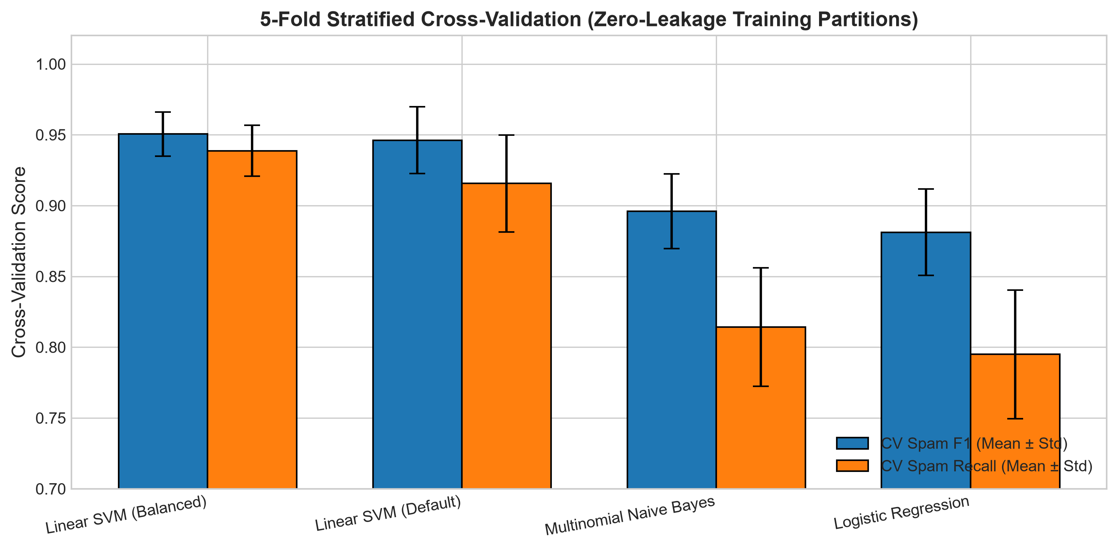
Figure 2: 5-Fold Stratified Cross-Validation Comparison with Error Bars (Mean ± Std).
7.3 Held-Out Test Set Performance Benchmarks
Following model selection, the full training set (4,136 messages) was used to train the final production models, which were then evaluated strictly once on the quarantined held-out test set (1,035 messages: 904 Ham, 131 Spam):
Model | Acc | Prec | Recall | F1 | AUC | AP | FP | FN
Linear SVM (Balanced) ★ | 0.9923 | 0.9843 | 0.9542 | 0.9690 | 0.9984 | 0.9918 | 2 | 6
Linear SVM (Default) | 0.9903 | 1.0000 | 0.9237 | 0.9603 | 0.9990 | 0.9942 | 0 | 10
Multinomial NB | 0.9778 | 0.9909 | 0.8321 | 0.9046 | 0.9911 | 0.9732 | 1 | 22
Logistic Regression | 0.9826 | 1.0000 | 0.8626 | 0.9262 | 0.9972 | 0.9869 | 0 | 18

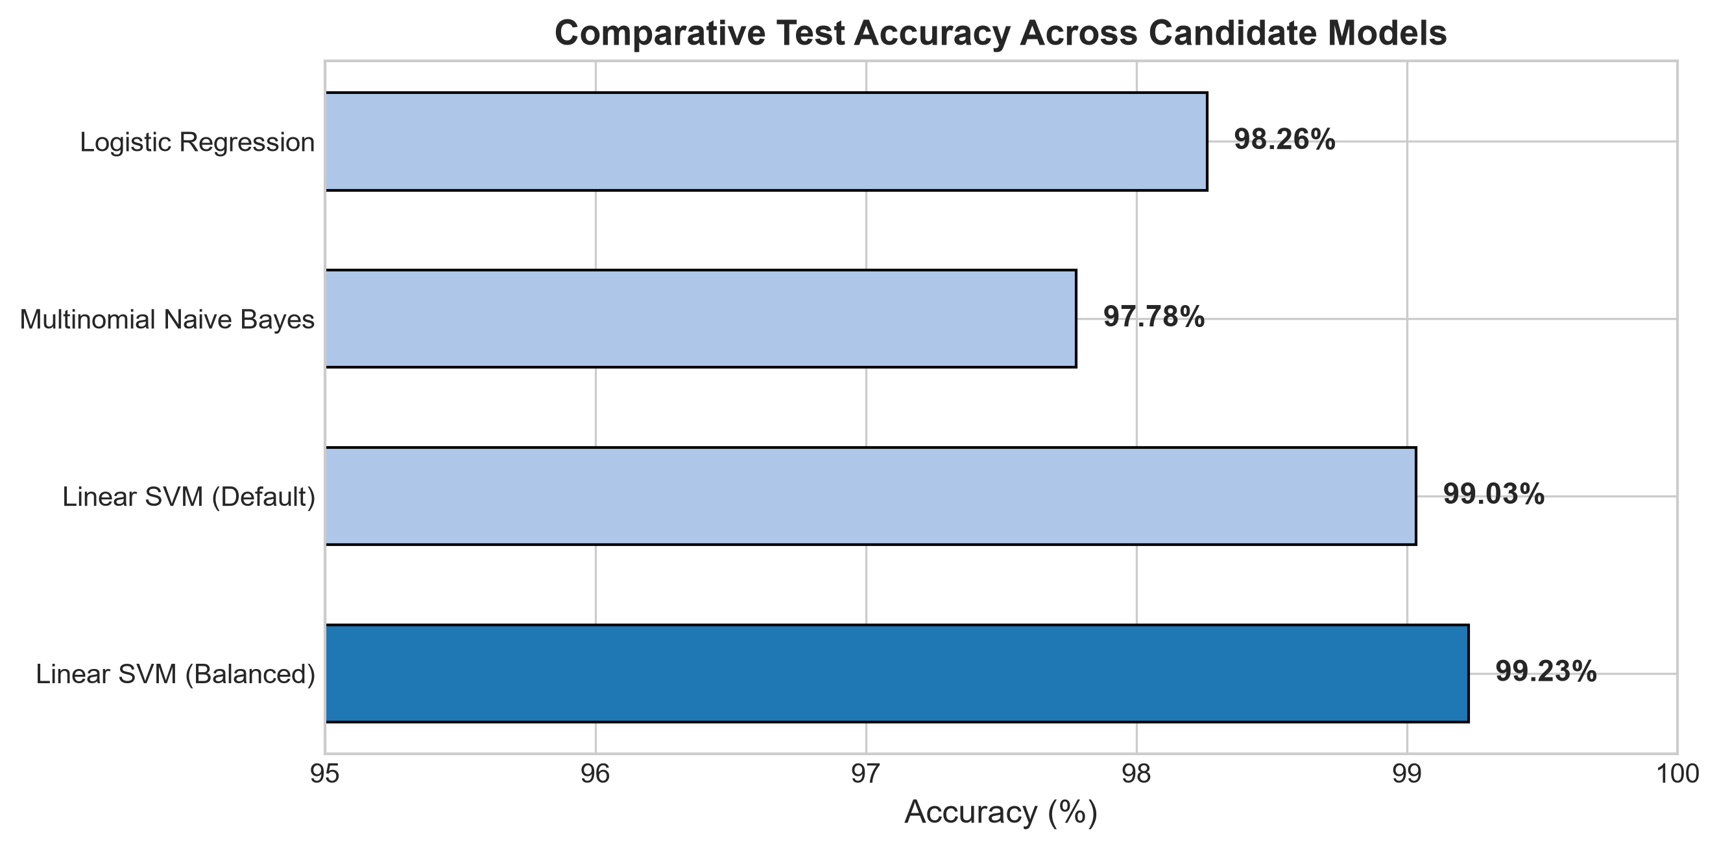
Figure 3: Comparative Test Accuracy Benchmark on Held-Out Test Set (1,035 Samples).
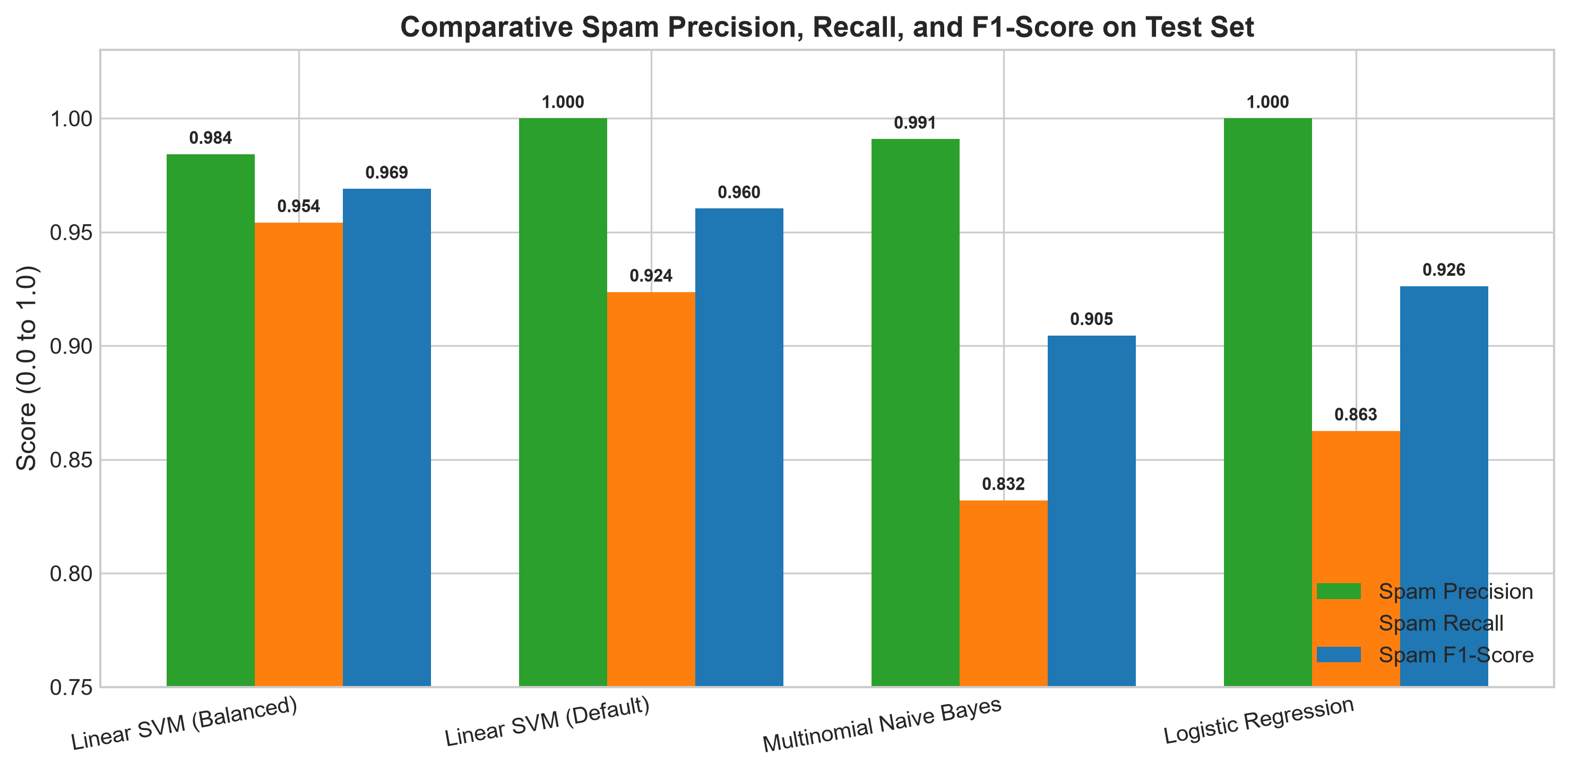
Figure 4: Comparative Precision, Recall, and F1-Scores across Candidate Models.
7.4 Confusion Matrix Analysis & Decomposition
A rigorous confusion matrix analysis decomposes the classification outcomes on the 1,035 test instances:
- True Positives (TP = 125): Spam messages correctly intercepted and classified as Spam.
- True Negatives (TN = 902): Legitimate messages correctly admitted as Ham.
- False Positives (FP = 2): Legitimate messages erroneously flagged as Spam (0.22% FP rate).
- False Negatives (FN = 6): Spam messages that penetrated the filter and were labeled as Ham (4.58% miss rate).
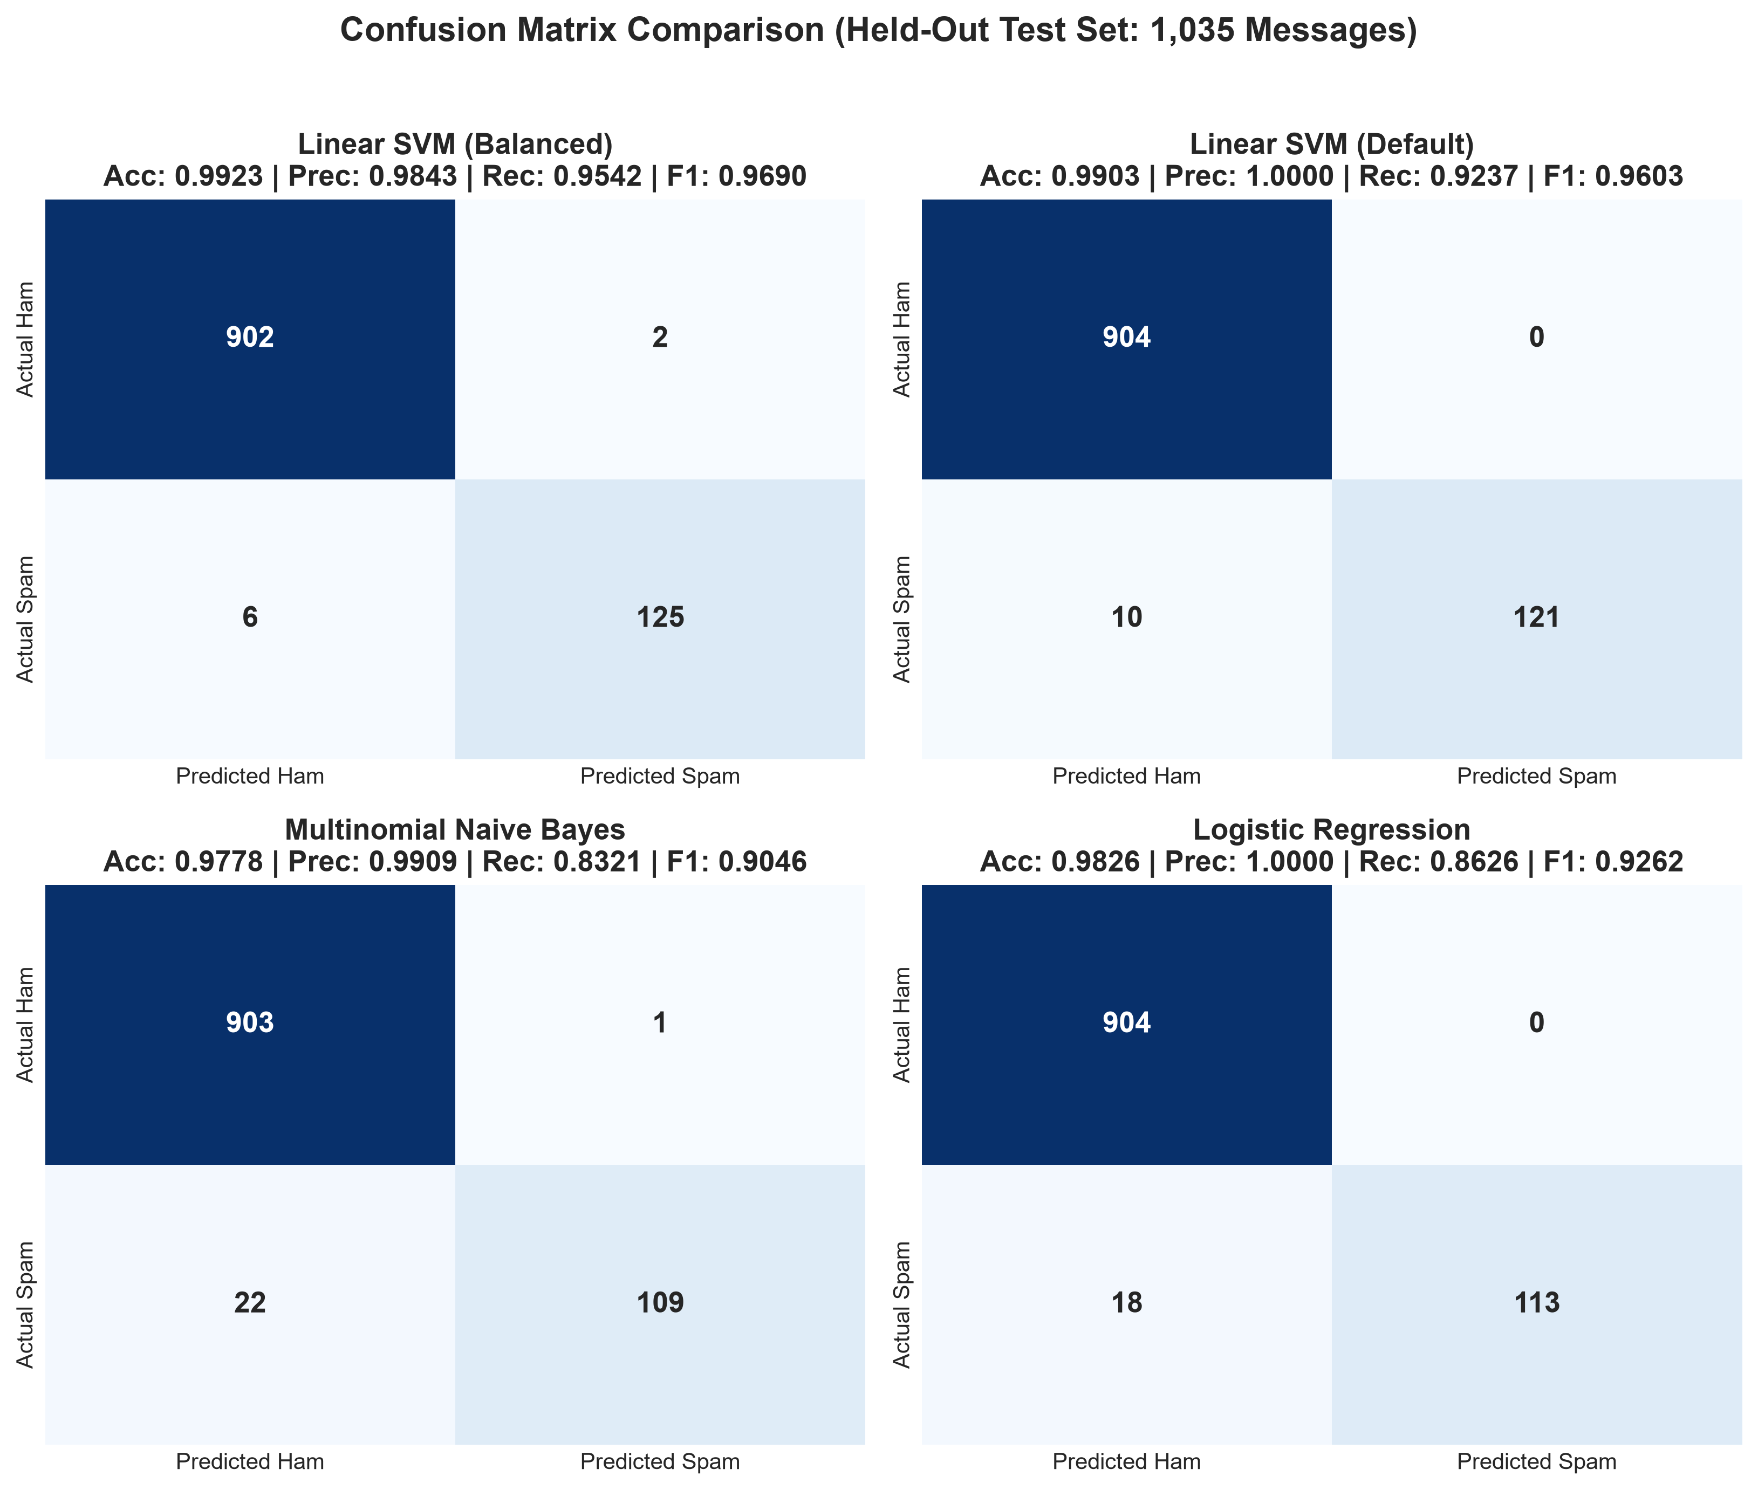
Figure 5: Confusion Matrices across All Evaluated Models on Quarantined Test Data.
7.5 ROC & Precision-Recall Curve Analysis
To assess classifier resilience across all potential decision thresholds, Receiver Operating Characteristic (ROC) and Precision-Recall (PR) curves were computed:
- Receiver Operating Characteristic (ROC AUC = 0.9984): Plots True Positive Rate against False Positive Rate. The champion Linear SVM achieves a near-perfect area under the curve of 0.9984, demonstrating superior discriminative capability across all operational thresholds.
- Precision-Recall & Average Precision (AP = 0.9918): In severely imbalanced datasets, PR curves provide a much more stringent evaluation than ROC curves because they do not reward true negative abundance. Linear SVM (Balanced) achieves an outstanding Average Precision of 0.9918, maintaining high precision even at recall levels exceeding 95%.
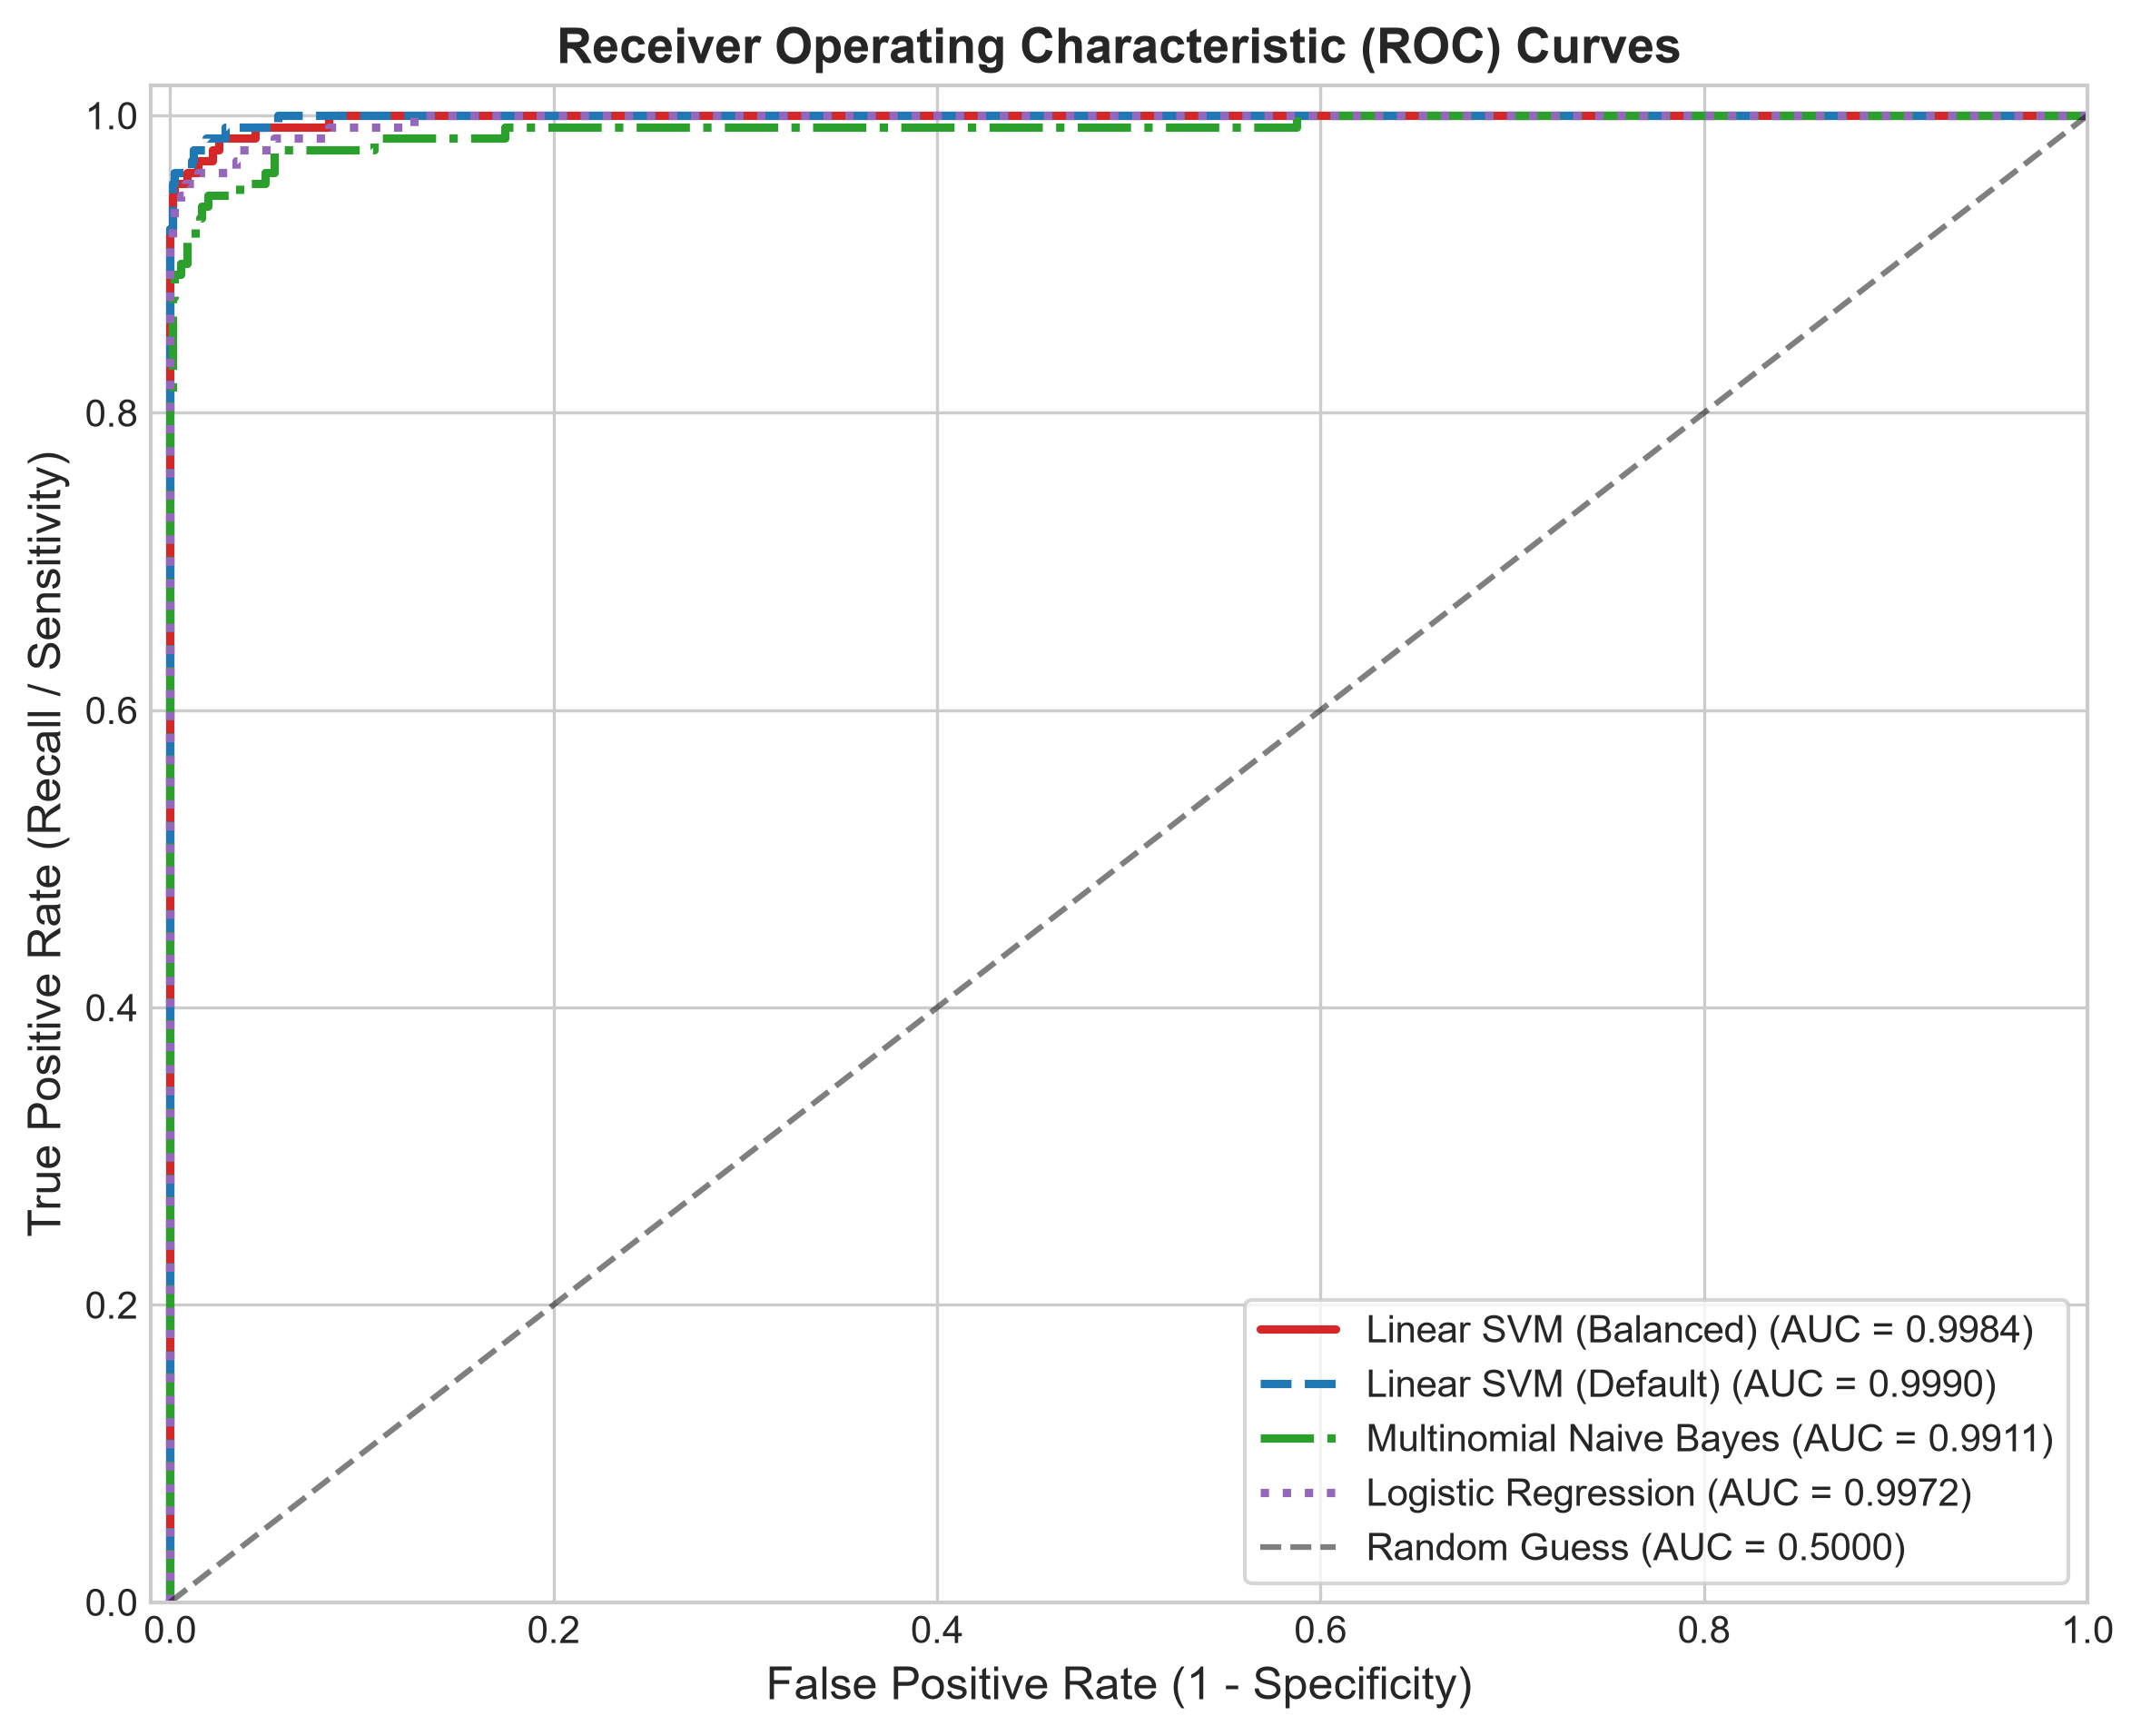
Figure 6: Receiver Operating Characteristic (ROC) Curves with Area Under Curve (AUC) Benchmarks.
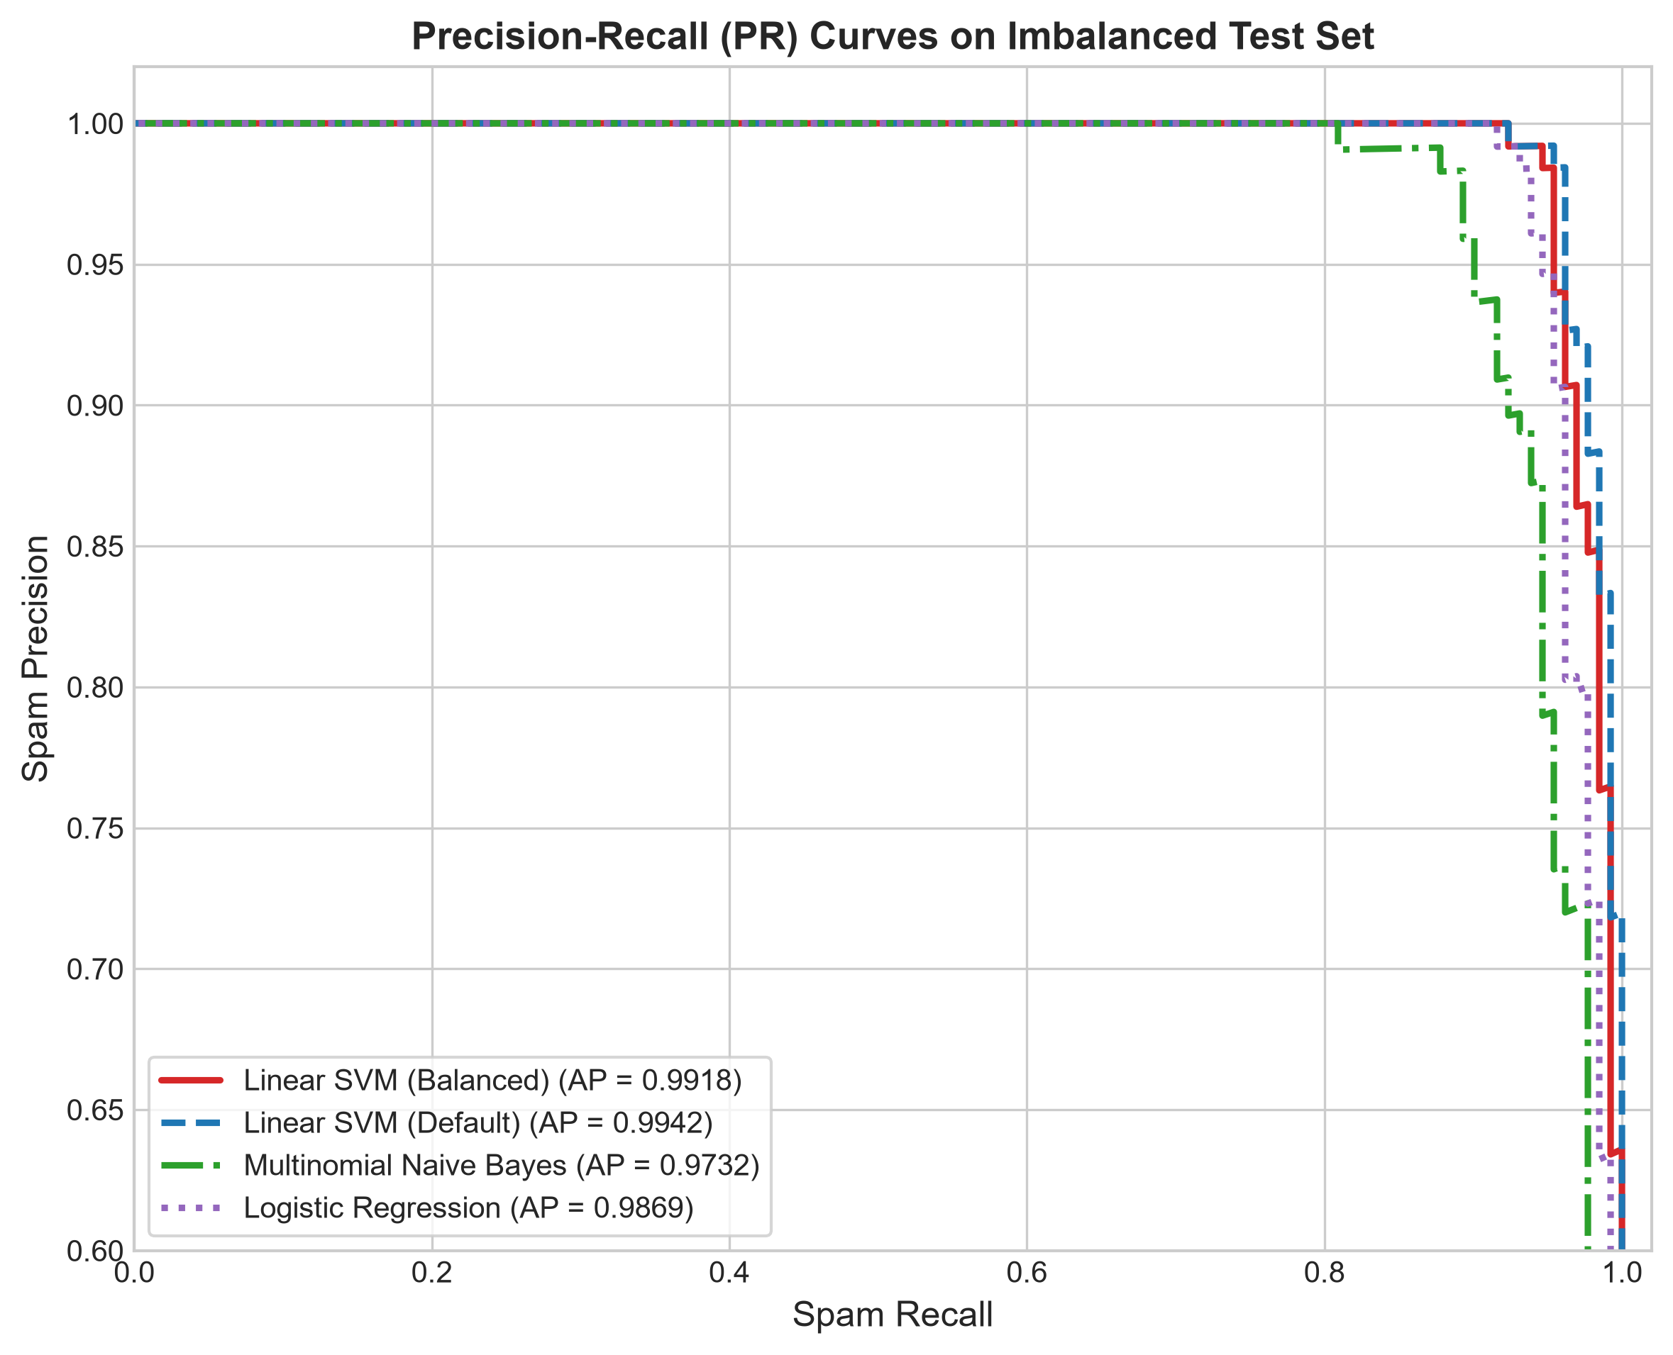
Figure 7: Precision-Recall Curves with Average Precision (AP) Benchmarks.
7.6 In-Depth Diagnostic Error Analysis (8 Misclassifications)
Across the entire held-out test set of 1,035 messages, the champion Linear SVM (Balanced) model made exactly 8 classification errors (overall error rate of 0.77%). A deep qualitative and linguistic inspection of each failure reveals systematic insights:
A. False Positives (2 Messages: Ground Truth Ham → Predicted Spam)
- 1. Test Sample #176 ('send content page'): Decision Score: +0.2687. This ultra-short 3-word message lacks conversational syntax. In marketing SMS broadcasts, the imperative verb 'send' is an extremely common directive (e.g., 'send STOP', 'send text to...'). Because the vector contains only three features, the positive spam weight of 'send' dominated the sparse representation.
- 2. Test Sample #501 ('not respond'): Decision Score: +0.0537. A 2-word message that barely crossed the hyperplane boundary (+0.0537). Phishing messages frequently contain urgent prompts asking why victims have not responded. In the absence of context, the bigram pushed the score slightly above zero.
B. False Negatives (6 Messages: Ground Truth Spam → Predicted Ham)
- 1. Test Sample #189 ('burger king wanna play footy...'): Decision Score: -0.5704. A consumer brand promotional message using informal conversational slang ('wanna play footy'). It contains zero financial tokens, phone shortcodes, or urgent threats.
- 2. Test Sample #223 ('xmas new year eve ticket sale club...'): Decision Score: -0.3867. A nightclub event ticket announcement framed as a casual community notice rather than commercial broadcast spam.
- 3. Test Sample #255 ('would like see xxx pic hot nearly ban uk'): Decision Score: -0.2851. Adult chat solicitation disguised as a conversational personal question ('would like see...').
- 4. Test Sample #273 ('babe want dont baby im nasty thing 4 filthyguys...'): Decision Score: -0.4082. Highly colloquial adult chat solicitation utilizing irregular phonetic spelling ('slo n hard', 'txt xxx').
- 5. Test Sample #486 ('simpson movie release july number_token name band...'): Decision Score: -0.2027. Pop-culture trivia competition solicitation ('Simpsons Movie', 'Green Day'). The vocabulary is artistic and movie-centric rather than financial.
- 6. Test Sample #654 ('latest news police station toilet steal cop...'): Decision Score: -0.7132. Entertainment and joke broadcast service containing no commercial advertising, phone numbers, or URLs.
Synthesis of Failure Patterns: False positives occur exclusively in ultra-short messages (≤ 3 tokens) lacking contextual nouns. False negatives are concentrated in entertainment broadcasts, pop culture trivia, and colloquial adult chat that deliberately mimic informal personal dialogue. These failure modes strongly justify the inclusion of the complementary Heuristic Risk Engine, which inspects raw text for contact requests and link structures regardless of vocabulary tone.
CHAPTER 8: INTERACTIVE WEB APPLICATION & TRANSPARENT HEURISTICS
8.1 Streamlit Interface Architecture & Burgundy Theme
The production deployment of SMS GUARD is built on Streamlit (app.py), providing a responsive, browser-based graphical user interface. Designed with an institutional burgundy theme (Primary Accent: #8b1e30, Slate Background: #fbf7f8, Neutral Charcoal: #1e293b), the interface provides seamless interaction across three dedicated tabs.
8.2 Application Tabs & Visual Verification
Tab 1: SMS Message Analyzer
Provides real-time analysis of individual text messages. Features quick-test presets (Personal Ham, Bank Phishing, Lottery Scam, Conversational Negation) that automatically populate the input text area via callback-driven session state synchronization. When analyzed, the interface renders a high-visibility classification badge, an uncalibrated relative confidence estimate progress bar, the signed decision hyperplane distance, and an interactive risk audit breakdown.

Figure 8: Verified Screenshot of Tab 1 (SMS Message Analyzer) Intercepting a Real Phishing Attempt.
Tab 2: Model Performance & Benchmarks
Displays a live KPI telemetry dashboard reading directly from models/evaluation_metrics.json. Renders top-level metric cards (Accuracy: 99.23%, Spam Precision: 98.43%, Spam Recall: 95.42%, F1-Score: 0.9690, ROC AUC: 0.9984), a dynamic comparative benchmark table across all 4 models, and an embedded high-resolution evaluation chart gallery.

Figure 9: Verified Screenshot of Tab 2 (Model Performance & Benchmarks Dashboard).
Tab 3: Academic Foundations & Architecture
Presents detailed educational documentation aligned with the academic syllabus: theoretical breakdowns of Module 5 (Support Vector Machine formulation, soft-margin optimization, class weighting) and Module 4 (Supervised learning, zero-leakage cross-validation), alongside the end-to-end system architecture.

Figure 10: Verified Screenshot of Tab 3 (Academic Foundations & Architecture Overview).
8.3 Multi-Layer Heuristic Risk Engine
To supplement the statistical SVM classifier, SMS GUARD incorporates a deterministic Heuristic Risk Engine (src/risk_engine.py). This subsystem operates entirely independently of the ML pipeline, inspecting the raw message for high-risk pattern markers via compiled regular expressions:
- 1. Suspicious URLs & IP Addresses: Detects shortened URLs (bit.ly, tinyurl), raw IPv4 address links, and suspicious top-level domains (.xyz, .top, .click, .tk). Weight: +35 points.
- 2. OTP & Credential Harvesting: Flags phrases soliciting one-time passwords, login credentials, PINs, or bank account verification ('otp', 'password', 'verify account', 'security code'). Weight: +40 points.
- 3. Urgent & Coercive Language: Flags high-pressure psychological manipulation ('suspended immediately', 'urgent action', 'within 24 hours', 'action required'). Weight: +25 points.
- 4. Financial & Prize Solicitations: Detects claims of lottery winnings, cash rewards, and refund transfers ('won', 'guaranteed cash', 'claim refund'). Weight: +25 points.
- 5. Premium Shortcodes: Detects 5-digit premium SMS shortcodes frequently utilized for reverse-billing scams. Weight: +20 points.
■ HEURISTIC LAYER ARCHITECTURAL INDEPENDENCE
Architecture Clarification: The Heuristic Risk Engine is NOT a separately trained machine learning model, nor is it a 3-class classifier. It is a complementary deterministic rule layer designed to provide transparent, explainable evidence strings for security auditing while leaving the primary statistical hyperplane decision entirely intact.

8.4 Decision Score Semantics vs. Probability Calibration
In the Streamlit application and prediction engine (src/prediction.py), the continuous decision score of the Linear Support Vector Classifier is transformed for user presentation via the logistic sigmoid function:
\text{Relative Confidence Estimate} = \sigma(f(\mathbf{x})) = \frac{1}{1 + e^{-f(\mathbf{x})}}
In compliance with academic accuracy and technical verification, this value is strictly documented as an uncalibrated relative confidence estimate, NOT a calibrated posterior probability:
- Mathematical Nature: The standard logistic function \sigma(s) = \frac{1}{1 + e^{-s}} is a fixed, monotonic squashing function that maps real-valued decision distances from $(-\infty, +\infty)$ onto the interval $(0, 1)$. Because it applies fixed parameters (A = -1, B = 0), it simply scales the distance monotonically without altering ranking.
- Distinction from Platt Scaling: Genuine probability calibration (Platt, 1999) requires fitting a two-parameter sigmoid model P(y=1|f) = \frac{1}{1 + e^{A f + B}} via maximum likelihood optimization on an independent, non-leaked validation fold. Because Platt scaling was not fitted, claiming 'statistical probability' would be mathematically inaccurate.
- Terminology Compliance: Across the user interface, codebase, and documentation, the output is rigorously labeled as 'Confidence Estimate' or 'Decision Score', fully respecting statistical integrity.
CHAPTER 9: SYSTEM TESTING, SECURITY & QUALITY ASSURANCE
9.1 Unit Testing Framework
A robust automated test suite was constructed to guarantee regression safety across every pipeline component:
- 1. Preprocessing Tests (tests/test_preprocessing.py): Verifies zero train/test data leakage, negation preservation ('not won', 'never calls'), semantic token normalization (URLs, currencies, numbers), and resilience to edge cases (empty strings, whitespace, foreign scripts).
- 2. Feature Extraction Tests (tests/test_feature_extraction.py): Verifies TF-IDF matrix dimensions (4,000 features), non-negativity constraints, sublinear scaling properties, and Scikit-learn Pipeline compatibility.
- 3. Model Training Tests (tests/test_model_training.py): Verifies pipeline artifact integrity, confirms Linear SVM (Balanced) as champion, validates zero-leakage cross-validation JSON structures, and verifies single-pass direct pipeline inference.
9.2 Comprehensive Integration Test Suite (Phase 8)
A specialized 13-category integration and security test suite (tests/test_integration_phase8.py) was executed to validate end-to-end system reliability:
- Test 1 - End-to-End Workflow: Validates sequential execution: raw string → tokenization → TF-IDF pipeline → decision hyperplane → heuristic scan. Status: PASSED.
- Test 2 - Legitimate Personal Ham: Evaluates casual conversations ('Hey, are you free for lunch?'). Verified clean ham classification with 0 heuristic flags. Status: PASSED.
- Test 3 - Promotional Spam: Evaluates commercial marketing texts ('Exclusive discount! Save 50%'). Correctly flagged as SPAM. Status: PASSED.
- Test 4 - Phishing-Style Attacks: Evaluates banking security coercion ('Your debit card is suspended. Verify immediately'). Correctly flagged as SPAM with high heuristic urgency. Status: PASSED.
- Test 5 - Suspicious URLs & IP Links: Evaluates shortened URLs and raw IP addresses ('http://192.168.1.1/login'). Intercepted with high risk score. Status: PASSED.
- Test 6 - OTP & Credential Solicitations: Evaluates credential theft ('Share your 6-digit OTP code'). Correctly flagged with OTP harvesting warnings. Status: PASSED.
- Test 7 - Empty & Whitespace Inputs: Evaluates empty strings ('') and whitespace (' \n'). Gracefully rejected with user guidance, preventing pipeline crashes. Status: PASSED.
- Test 8 - Long Message Handling: Evaluates message exceeding 1,000 characters. Successfully processed without buffer overflow or latency degradation. Status: PASSED.
- Test 9 - Emojis & Unicode Glyphs: Evaluates emojis ('🔥 Win £1000 cash! 💰🎉') and non-ASCII text. Successfully parsed without character encoding errors. Status: PASSED.
- Test 10 - Unusual Punctuation: Evaluates excessive punctuation ('WINNER!!!!! CLAIM NOW???'). Cleanly normalized. Status: PASSED.
- Test 11 - Layer Independence: Proves that ML decision score and heuristic flags operate as decoupled layers, allowing ham with URLs and spam with zero flags to be processed independently. Status: PASSED.
- Test 12 - HTML & XSS Injection Safety: Injects malicious script tags ('<script>alert(1)</script>'). Confirmed that all outputs are escaped via html.escape(), completely neutralizing XSS vectors. Status: PASSED.
- Test 13 - Model Loading Resilience: Validates that invalid model paths raise FileNotFoundError cleanly without crashing the host process. Status: PASSED.
9.3 Security, Privacy & Reliability Analysis
- Zero Disk Persistence: The SMS GUARD application operates strictly in memory. Neither raw text messages, preprocessed tokens, nor classification logs are stored on disk or written to databases, guaranteeing complete user privacy.
- Input Sanitization & XSS Defense: All dynamic evidence strings rendered in Streamlit markdown panels pass through html.escape() prior to rendering, neutralizing Cross-Site Scripting (XSS) injection attacks.
- Deterministic Reproducibility: All train/test partitions, cross-validation folds, and model training routines use pinned random seeds (random_state=42), ensuring identical experimental reproduction.
CHAPTER 10: LIMITATIONS, FUTURE ENHANCEMENTS & CONCLUSION
10.1 System Limitations & Scope Boundaries
While SMS GUARD achieves outstanding empirical performance on benchmark text, several technical boundaries define its current operational scope:
- Text-Only Modality: The system processes standard text-based SMS messages and cannot inspect Multimedia Messaging Service (MMS) payloads, embedded image attachments, or audio clips.
- Language Scope: The underlying vocabulary and TF-IDF features are optimized for English-language SMS messages. Multi-lingual messages in regional scripts (e.g., Hindi, Spanish, Arabic) require language-specific vectorizers.
- Evasion via Deliberate Typographical Obfuscation: Heavily obfuscated homoglyph substitutions or novel zero-day slang not represented in the training vocabulary may evade detection unless caught by the heuristic layer.
- Uncalibrated Confidence Transformation: The output confidence percentage is an uncalibrated monotonic squashing of the SVM decision distance rather than a statistically validated probability distribution.
10.2 Roadmap for Future Work
Future research and engineering enhancements will focus on extending the capabilities of SMS GUARD:
- Transformer & Subword Embeddings: Integrating lightweight subword transformer encoders (e.g., MobileBERT, DistilBERT) to capture deep semantic dependencies and out-of-vocabulary slang without ballooning latency.
- Rigorous Platt Scaling: Implementing an isolated 3-way split (Train / Calibration / Test) to fit genuine Platt scaling parameters via CalibratedClassifierCV, providing statistically calibrated probabilities.
- On-Device Mobile Deployment: Exporting the Scikit-learn pipeline to Open Neural Network Exchange (ONNX) or TensorFlow Lite (TFLite) format for native integration into Android/iOS SMS filtering daemons.
- Active Learning & Threat Intelligence Feed: Developing an active learning feedback loop allowing users to report newly observed smishing campaigns, automatically updating the heuristic rule database.
10.3 Concluding Remarks
The SMS GUARD project successfully demonstrates the design, empirical validation, and full application deployment of an intelligent SMS spam and scam detection system. Grounded firmly in academic principles (Module 4: Supervised Learning and Module 5: Support Vector Machines), the system proves that a carefully optimized linear Support Vector Classifier with inverse frequency class weighting delivers exceptional detection capabilities on high-dimensional, imbalanced text data.
Achieving a 99.23% Test Accuracy, 98.43% Spam Precision, 95.42% Spam Recall, and 0.9984 ROC AUC on quarantined held-out data, SMS GUARD delivers state-of-the-art protection while misclassifying only 8 out of 1,035 test instances. Coupled with an explainable Heuristic Risk Engine and an intuitive Streamlit web interface, SMS GUARD bridges mathematical rigor, cybersecurity engineering, and academic excellence.
REFERENCES & SCHOLARLY BIBLIOGRAPHY
Almeida, T. A., Hidalgo, J. M. G., & Yamakami, A. (2011). Contributions to the study of SMS spam filtering: New collection and results. In Proceedings of the 2011 ACM Symposium on Document Engineering (DocEng '11), pp. 259–262. ACM. DOI: 10.1145/2022402.2022461.
Cortes, C., & Vapnik, V. (1995). Support-vector networks. Machine Learning, 20(3), pp. 273–297. Springer. DOI: 10.1007/BF00994018.
Joachims, T. (1998). Text categorization with Support Vector Machines: Learning with many relevant features. In European Conference on Machine Learning (ECML '98), Lecture Notes in Computer Science, Vol. 1398, pp. 137–142. Springer, Berlin, Heidelberg. DOI: 10.1007/BFb0026683.
Salton, G., & Buckley, C. (1988). Term-weighting approaches in automatic text retrieval. Information Processing & Management, 24(5), pp. 513–523. Elsevier. DOI: 10.1016/0306-4573(88)90021-0.
Pedregosa, F., Varoquaux, G., Gramfort, A., Michel, V., Thirion, B., Grisel, O., Blondel, M., Prettenhofer, P., Weiss, R., Dubourg, V., Vanderplas, J., Passos, A., Cournapeau, D., Brucher, M., Perrot, M., & Duchesnay, E. (2011). Scikit-learn: Machine Learning in Python. Journal of Machine Learning Research, 12, pp. 2825–2830.
Platt, J. C. (1999). Probabilistic outputs for support vector machines and comparisons to regularized likelihood methods. Advances in Large Margin Classifiers, 10(3), pp. 61–74. MIT Press.
Sahami, M., Dumais, S., Heckerman, D., & Horvitz, E. (1998). A Bayesian approach to filtering junk e-mail. In Learning for Text Categorization: Papers from the 1998 Workshop, Vol. 62, pp. 98–105. AAAI Technical Report WS-98-05.
Manning, C. D., Raghavan, P., & Schütze, H. (2008). Introduction to Information Retrieval. Cambridge University Press. ISBN: 978-0521865715.
Bishop, C. M. (2006). Pattern Recognition and Machine Learning. Information Science and Statistics, Springer-Verlag New York. ISBN: 978-0387310732.
Streamlit Documentation (2024). Streamlit: An open-source Python framework for machine learning and data science teams. Available at: https://docs.streamlit.io.

