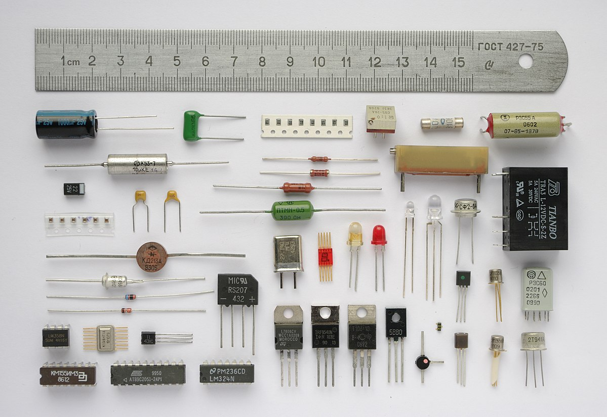

Clipper and Clamper Circuits

report for e-powertrain taskphase

SIDHARTH SEELA | MOTOMANIPAL | August 12, 2020

# Clipper Circuit:

A Clipper circuit uses combination of resistor, p-n diode, voltage source to make changes to the output waveform such as cutting the ends of the signal, cutting the negative part of a signal and so-on like these.

# Clamper Circuit:

A clamper circuit changes the baseline average for the voltage signal by using a capacitor with greater time period than the time period of the input signal. (and not a dc voltage source in series, which would be very inefficient. Ex- for ac signal with baseline as 2 volt we can either add a 2-volt battery in series or we could use a clamper circuit that with 0.7 volt battery with the diode.)

* The reason why it works is because the capacitor acts as an impedance due to which it doesn’t let the voltage drop in the negative cycle and retains the charged voltage till the next positive cycle. Due to which the new reference baseline for the signal becomes (V(in) – Vd + Voffset)/2.

# Capacitor equations:

CHARGING:

V=V0*(1-e^-t/rc)

I=Io*e^-t/rc

DISCHARGING:

V=V0* e^-t/rc

I = -I0*(1-e^-t/rc)

# MOSFET Dielectric:

Silicon oxide is used as the gate dielectric known as gate oxide.

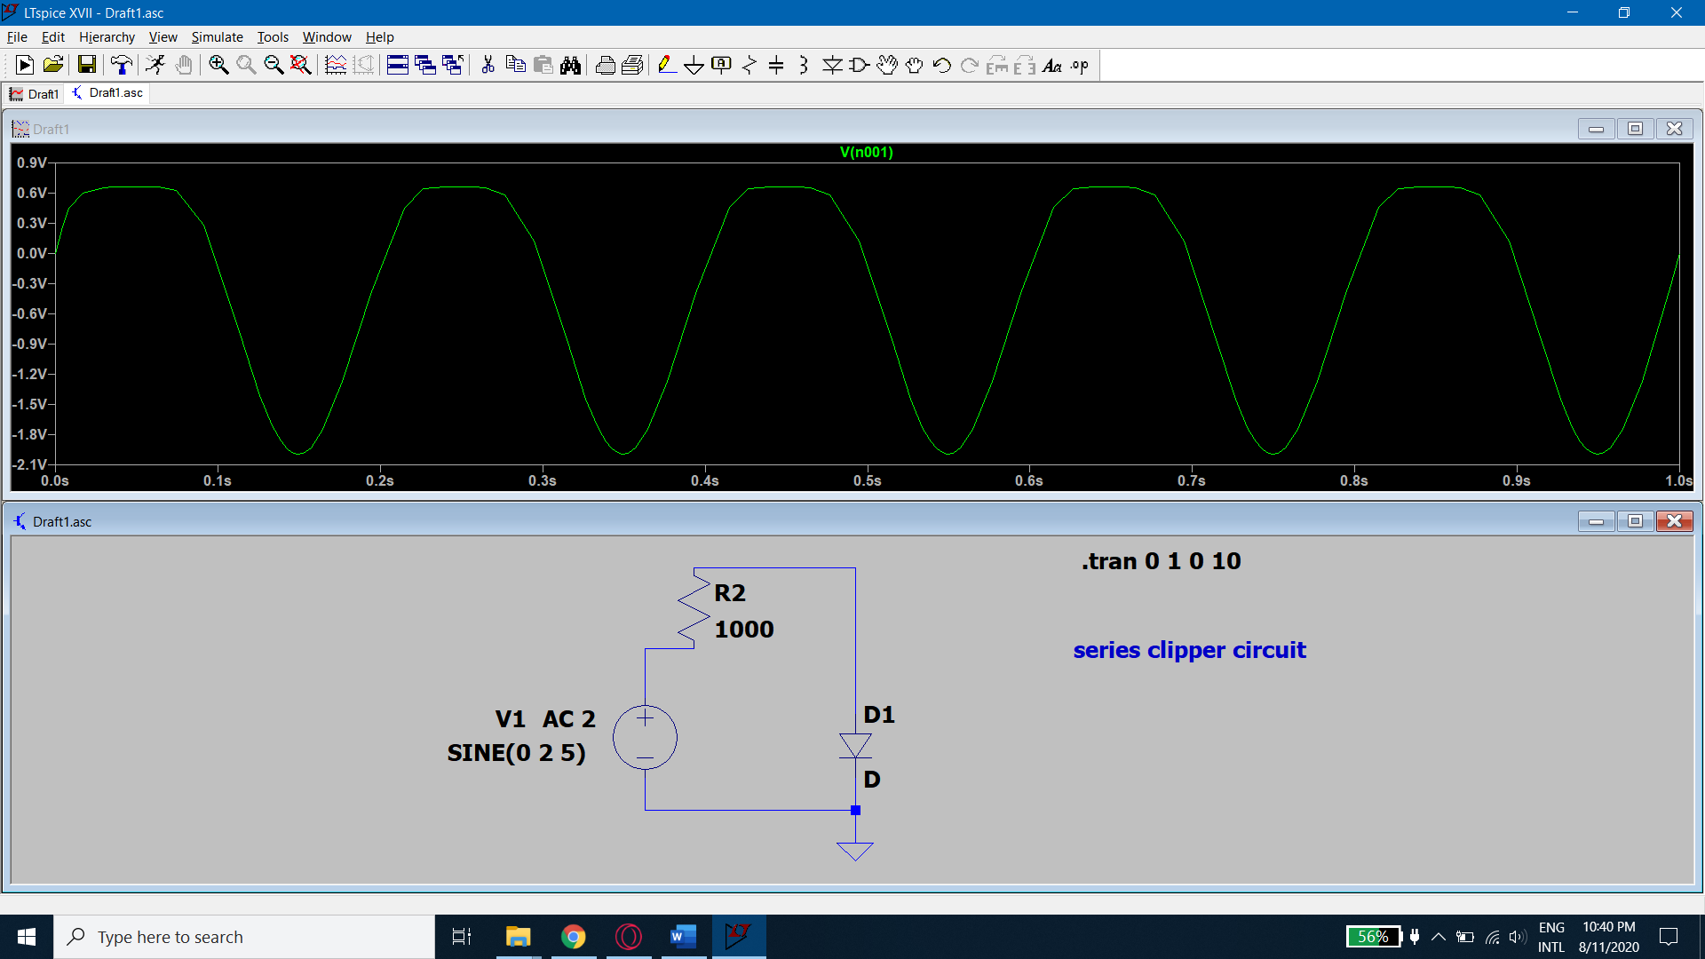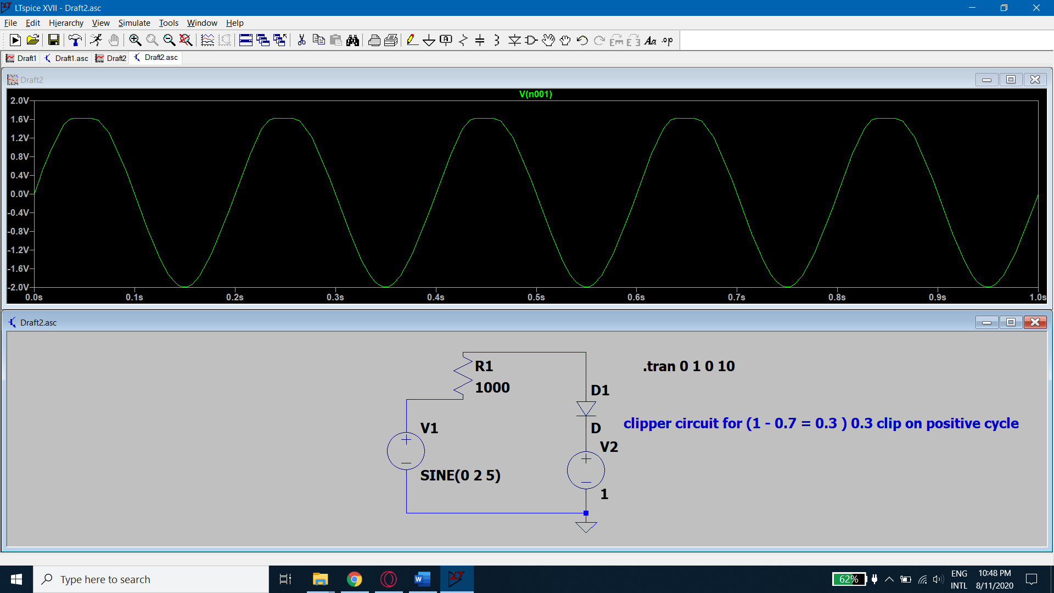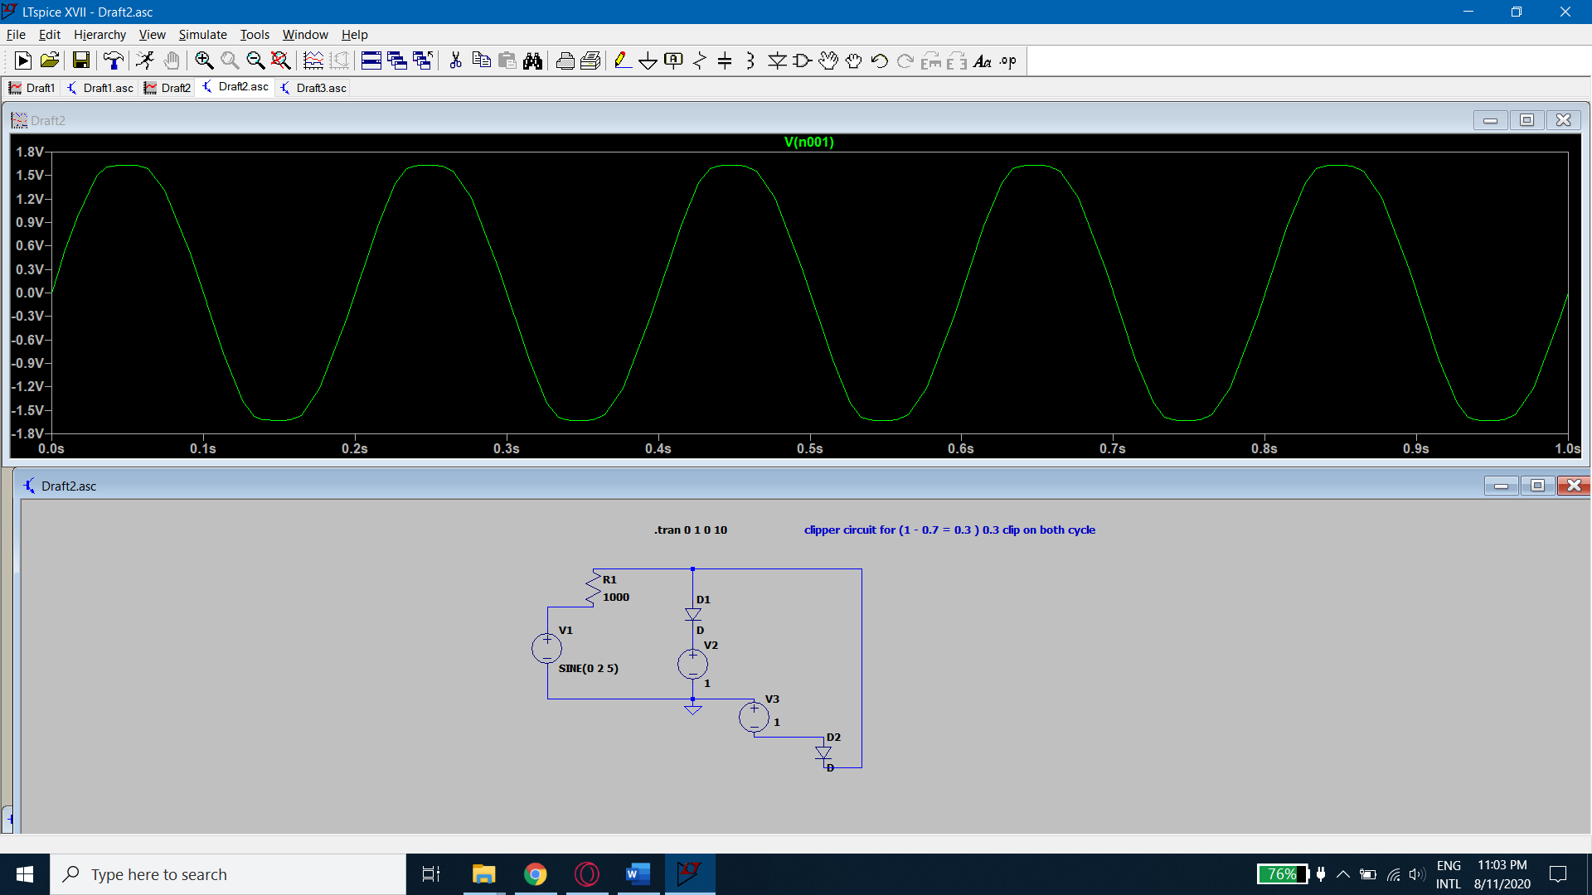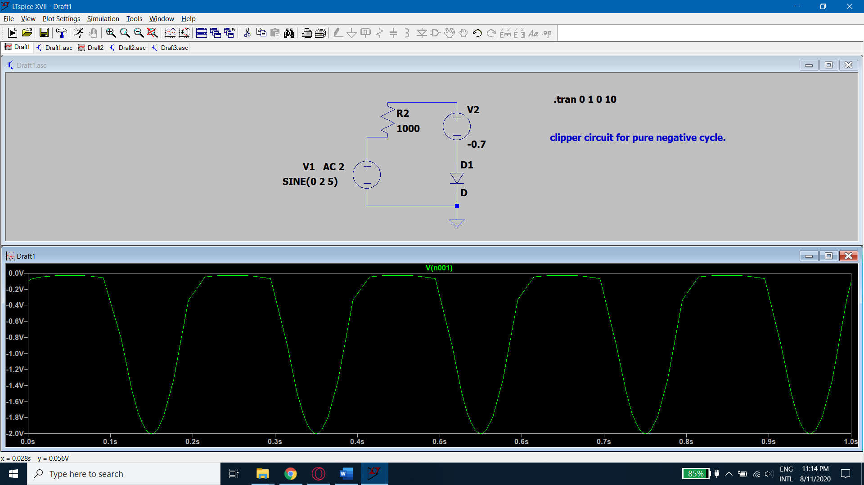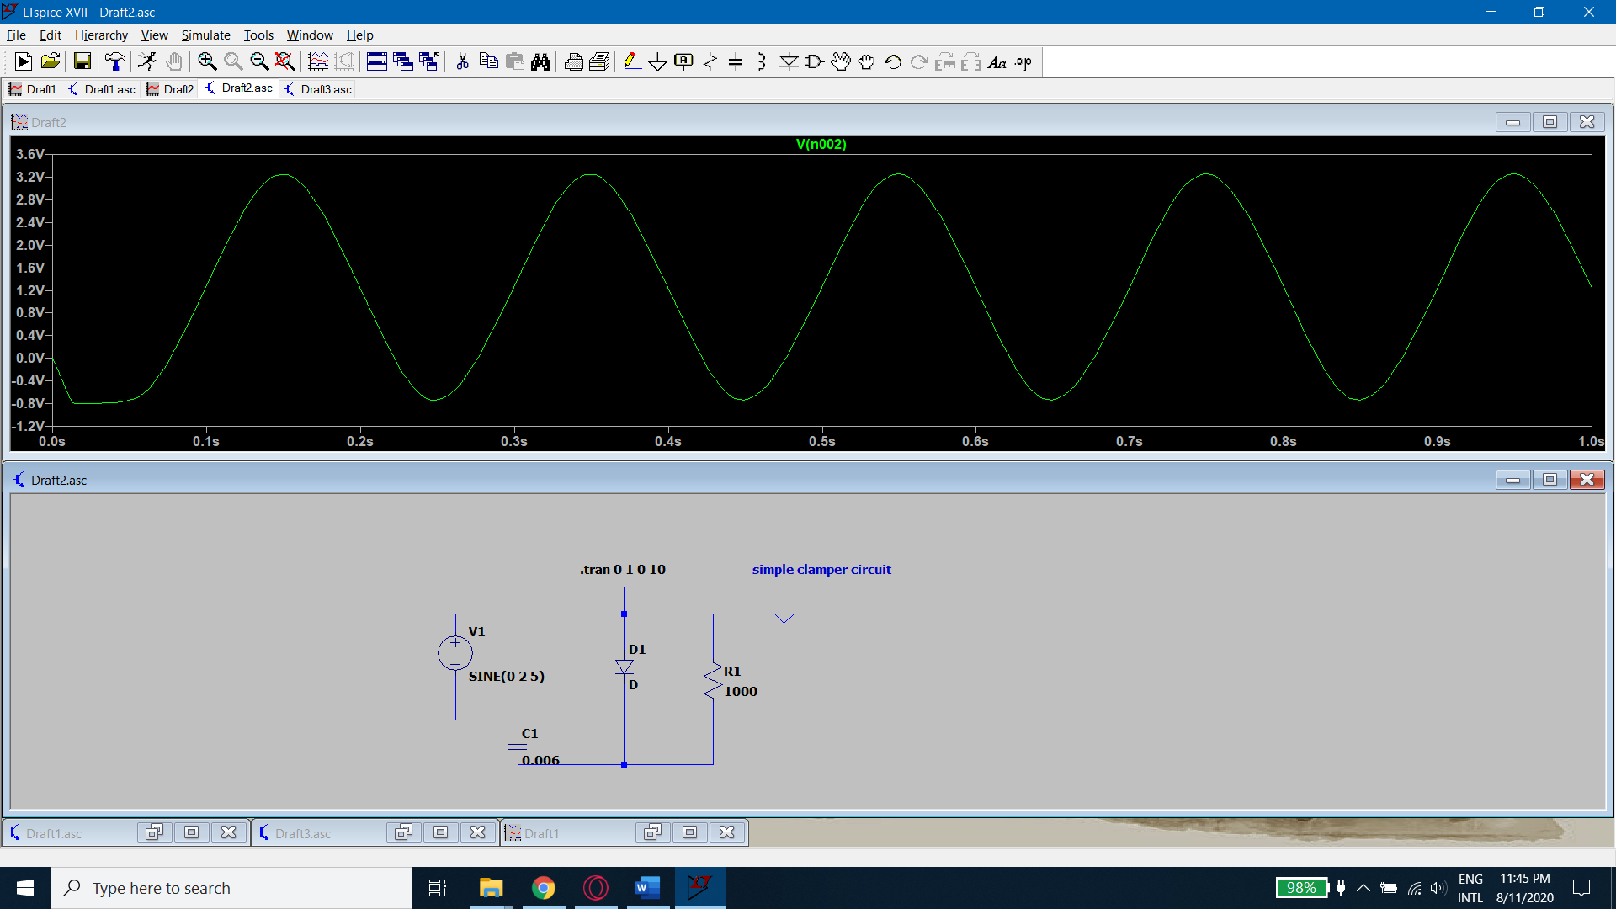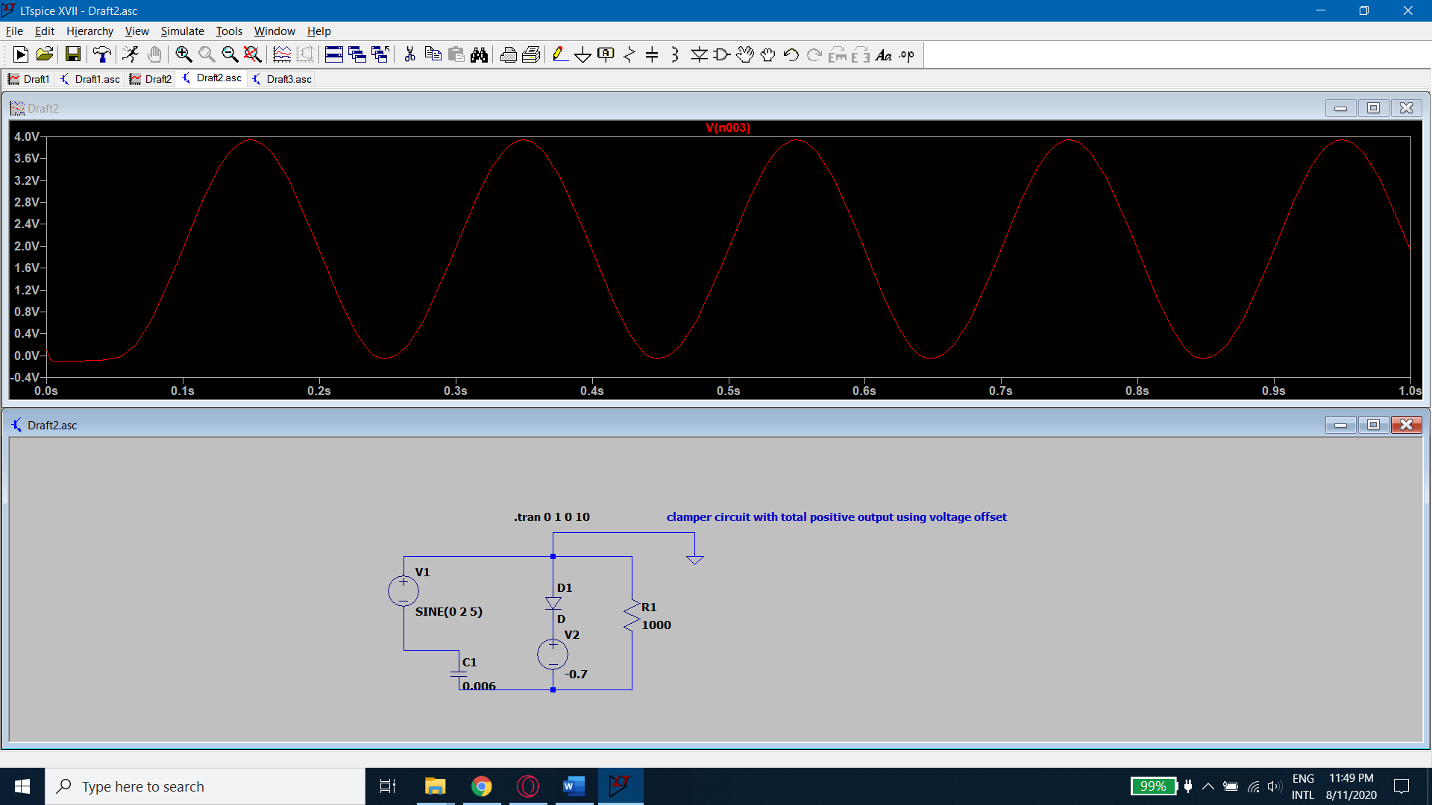

# Reference:

* LT Spice.
* Wikipedia
* NCERT