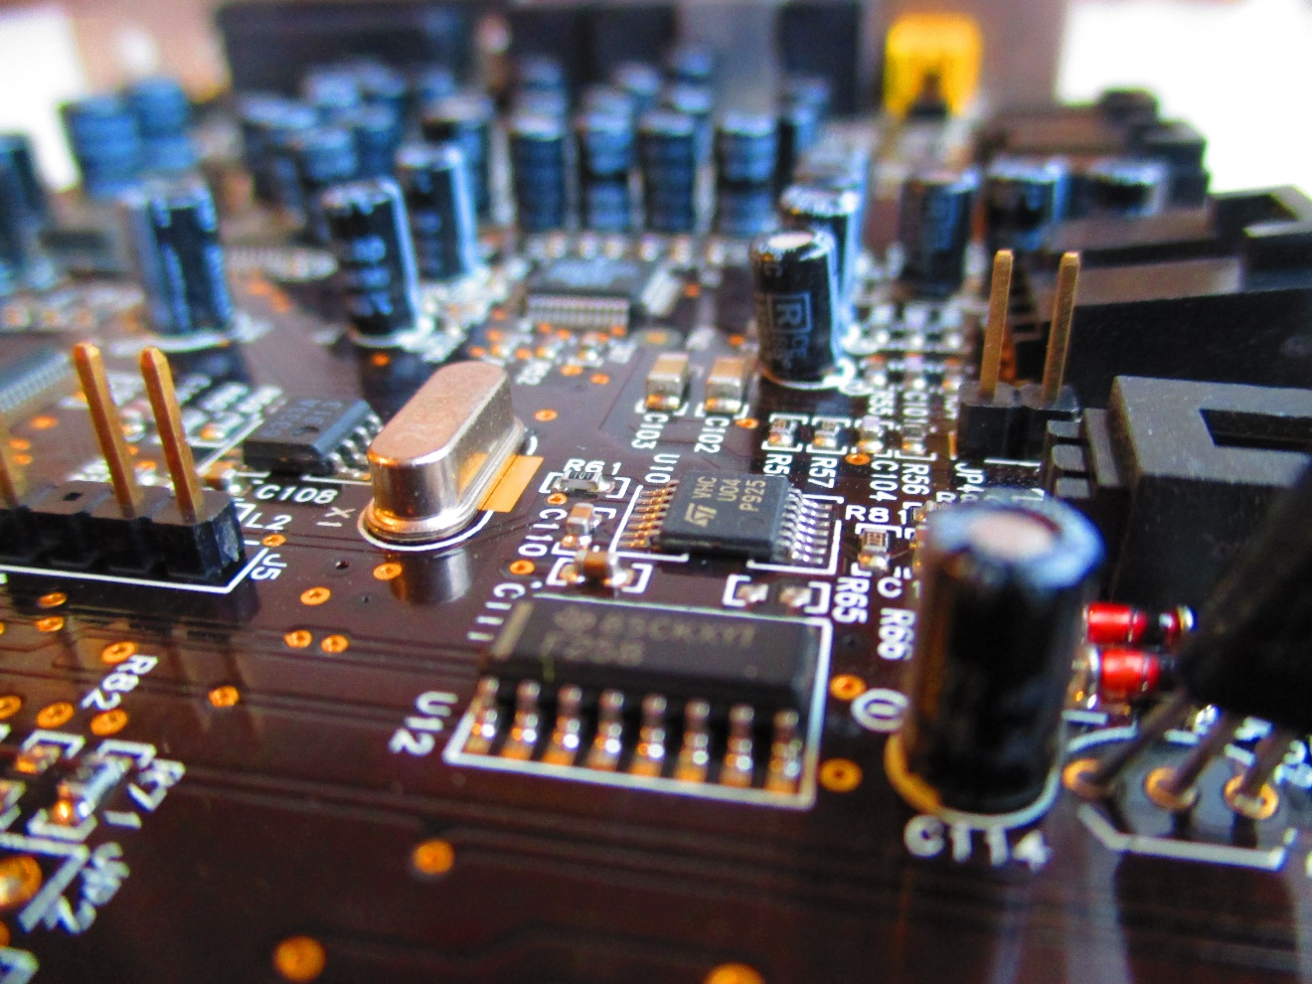

BJTs, Switches & Relays

task phase report

Sidharth Seela | E-Powertrain Task phase | August 18, 2020

# Relay:

Relays are electromechanical (usually) devices that control the on or off state of another circuit. They are used in place of normal switches so as to separate a high voltage circuit with the switch, because if a switch is used to turn on (think 500 V supply) then you run a risk of being electrocuted. So what a relay does is it uses some small dc voltage and a switch which when turned on sends current through the relay, it has a coil in which the current passes through, the current starts a magnetic field through the coil so as to pull the contact to close the circuit. A transistor can’t be used for high voltage appliances because of its voltage rating and the effect of leakage current. Although it can be used as a relay for smaller voltage appliances.

Relays are of these types.

Electromagnetic relays:

* Attraction type relays use a magnet attached to the contact to pull the magnet down with the contact when the relay is on. They are the mostly used ones.
* Induction type relay uses a spring coil and a rotating disc which is connected to the contact when the relay is on it produces 2 different voltages from the primary and secondary coil. These voltage lag by 50 degrees usually. These voltages produce a flux and the flux causes an eddy current to develop in the disc. The disc spins due when the current is more than what its rated for. This relay is used to save circuits by it being used as a automatic switch circuit breaker.

Solid state Relay:

* Use technologies like a pair of photo diode and led (optocoupler) or a MOSFET as a relay. Used in remotes.

Reed relay:

* Uses the inherent magnetism of the conductor. No armature or contact used. The conductor bends due to applied magnetic field and touches the 2nd conductor part. They are used in fast switching application such as for switching microwaves and radio frequencies.

# Switches:

There are basically two types of switches and their hybrids.

One, where we push to close the circuit and the other where when we push it is closed and we push again its open (it toggles).

* SPST (NO)- push to close. (bell)
* SPST(NC)- push to open. (dead man’s switch)
* SPDT- push to toggle between 2 position. (light switch)
* SPST 2x – push to open/close both the SPST switches simultaneously.
* DPDT – push to toggle both SPDT at the same time. (circuit breaker switch in the mains cabinet)

# Bipolar Junction Transistor:

Common Base Equations:

* Alpha = Ic/Ie.
* Ie= alphaIc + Icbo
* Iceo = Icbo /(1-alpha)

Common Emitter Equations:

* Vcc = IcRc +Vce
* Vce = Vcc -IcRc
* Vbb = Vcc – IcRc
* Vin = Vbb + vbb
* Vout = Vce
* Transfer characteristics is linear, Ib proportional to Ic.
* States are like half a bell curve. When Vi < Vth , Vo = high. (cut-off)
* Vi >vth and in the operating range then vo drops slowly. (active)
* Vi>operating range then v0 drops to almost zero
* The output wave is inverted. As the output junction can only be run in reverse bias hence we need the output to always be positive so what we do is attach a resistor in parallel. The output wave from ce flows through resistor to give a voltage drop. The voltage drop in the negative half cycle is positive due to the aid of Vcc. The voltage drop in the positive half cycle is negative due to the aid of resistor.
* The voltage gain depends on the product of current gain and Resistance gain.
* The load line is the line between vcc and vcc/rc.
* The variation in rc changes the slope. Increasing Rc reduces slope.
* The variation in Vcc shifts the load line according to the intercept vcc/rc.