

RLC, Filter, Buck, Boost circuits

SIDHARTH SEELA | MOTOMANIPAL E-POWERTRAIN TASKPHASE | August 21, 2020

# RLC:

There are two types: parallel, and series.

In series, the current is same throughout the circuit but the voltage drop across each component is different at an instant. Acts as frequency pass at w0. The impedance is usually higher.

In parallel, the voltage drop remains same but the current in any branch depends on the impedance of that branch. Acts as a frequency stop at wo. The impedance is usually lower.

# Filters:

For a capacitor, its frequency constant needs to be higher than input frequency only then it guaranteed that minimum 70.7 percent(-3 dB) of amplitude goes through. TIME CONST = RC

For an inductor it vice-versa. TIME CONST = L/R

All circuits below have cut off frequencies off 79hz.

LOW PASS FILTER:

Continue to next page…..

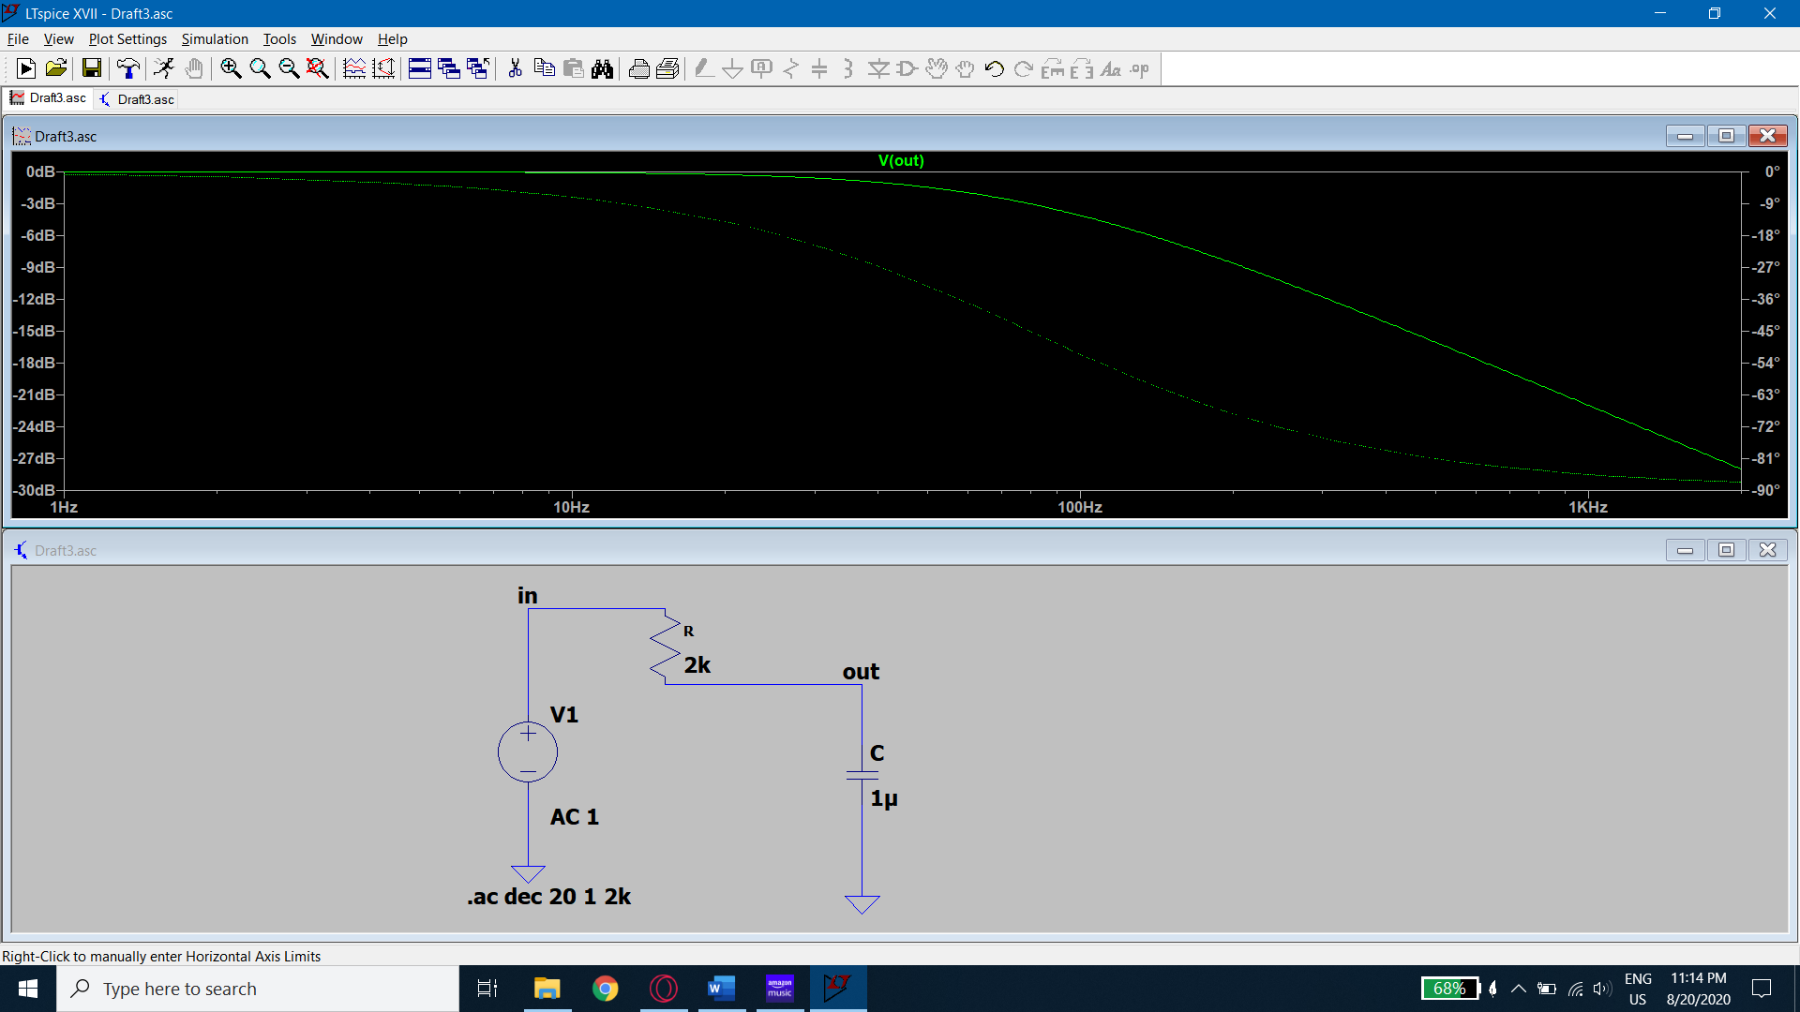 USING RC

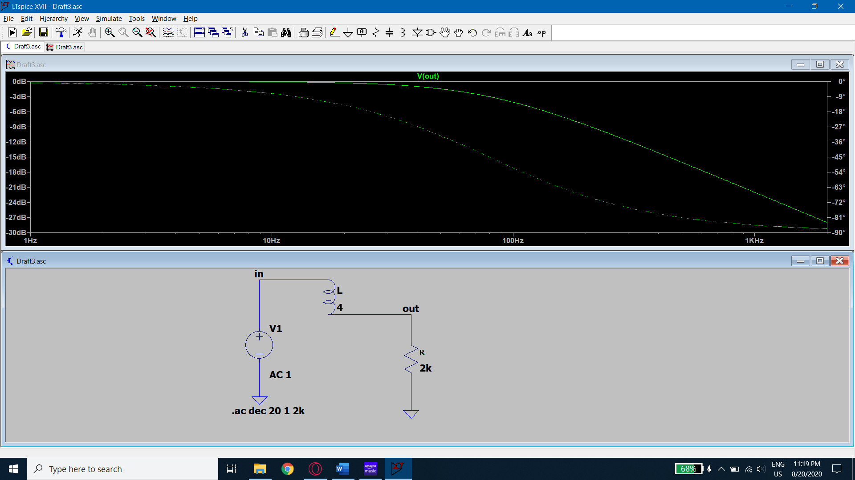 USING RL

HIGH PASS FILTER:

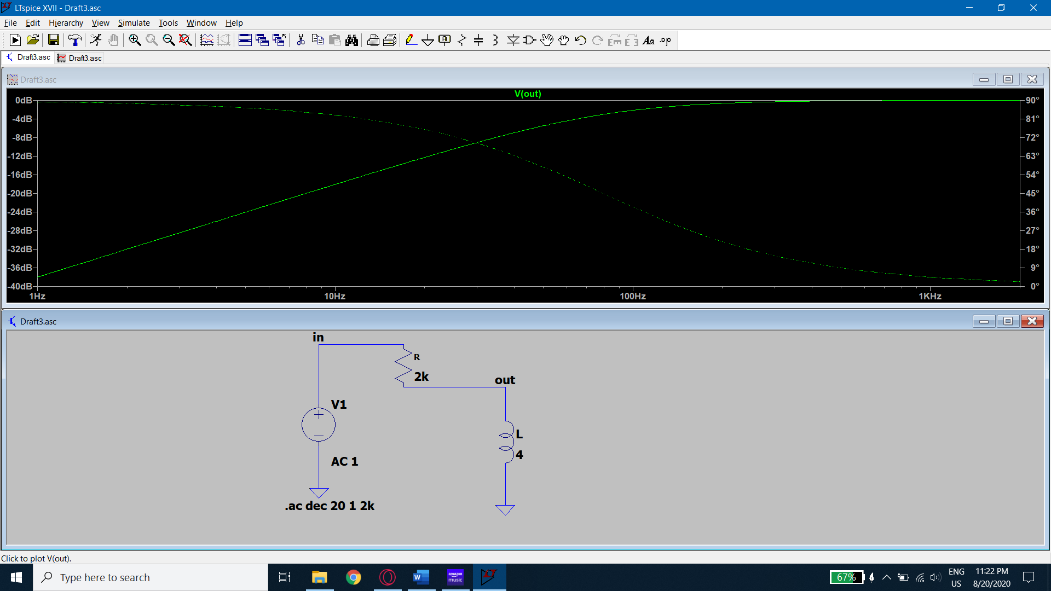 USING RL

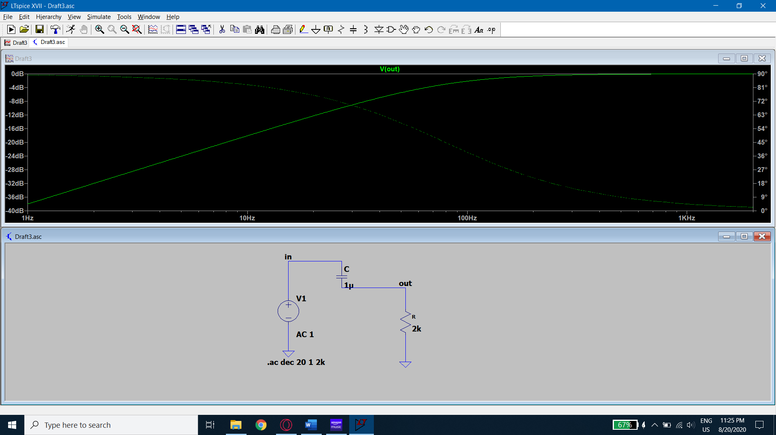 USING RC

BAND STOP FILTER :

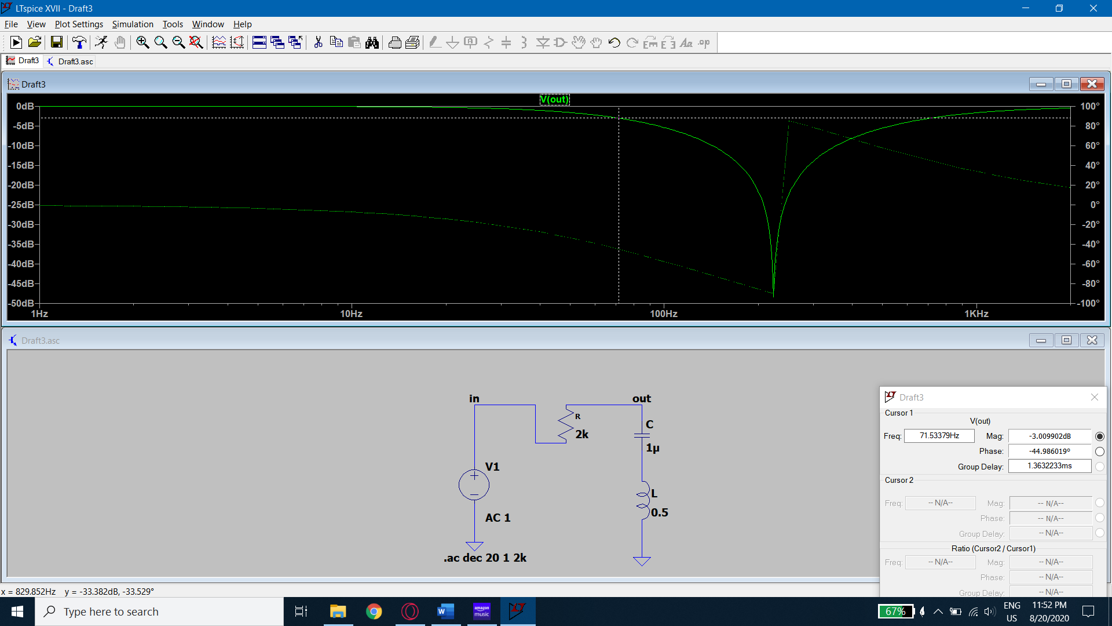 FROM 79 TO 636 HZ RLC BANDSTOP.

BAND PASS FILTER:

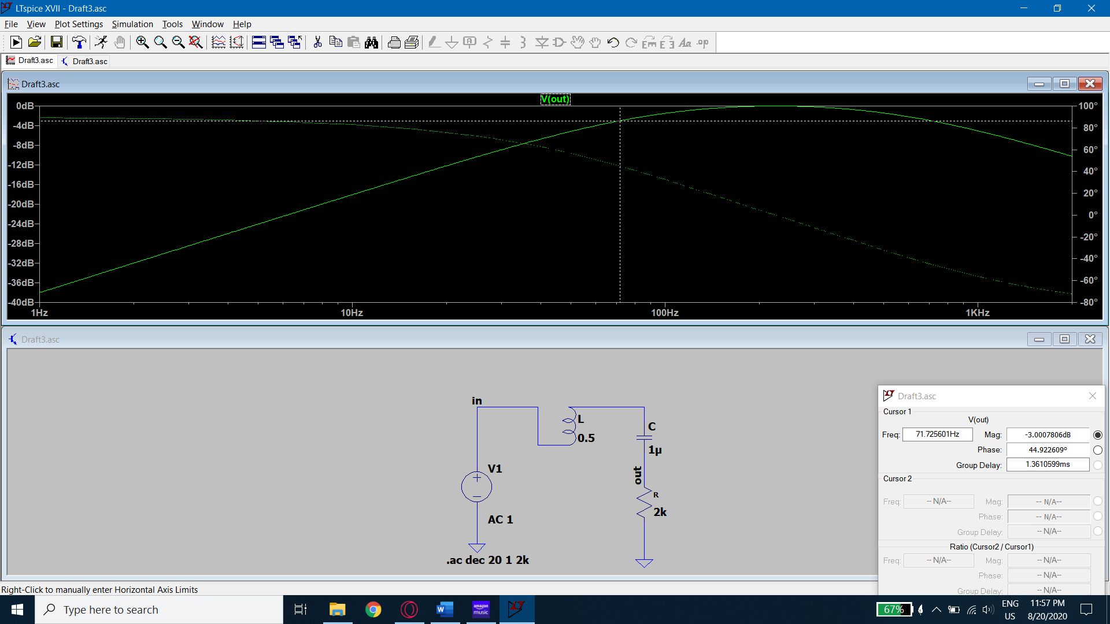bandpass RLC (79 to 636hz)

we can form any of these circuits using just rl or rc or rlc.

# Booster circuit:

This circuit uses a small ac signal to switch a mosfet on and off very fast so that an inductor charges up and discharges the self-induced voltage to the capacitor. The capacitor voltage gains until the charging current and discharging current reach equilibrium. The voltage increase comes with current loss so as to conserve energy. The equation for v out is V0 = Vin/(1-duty ratio). Continued…..

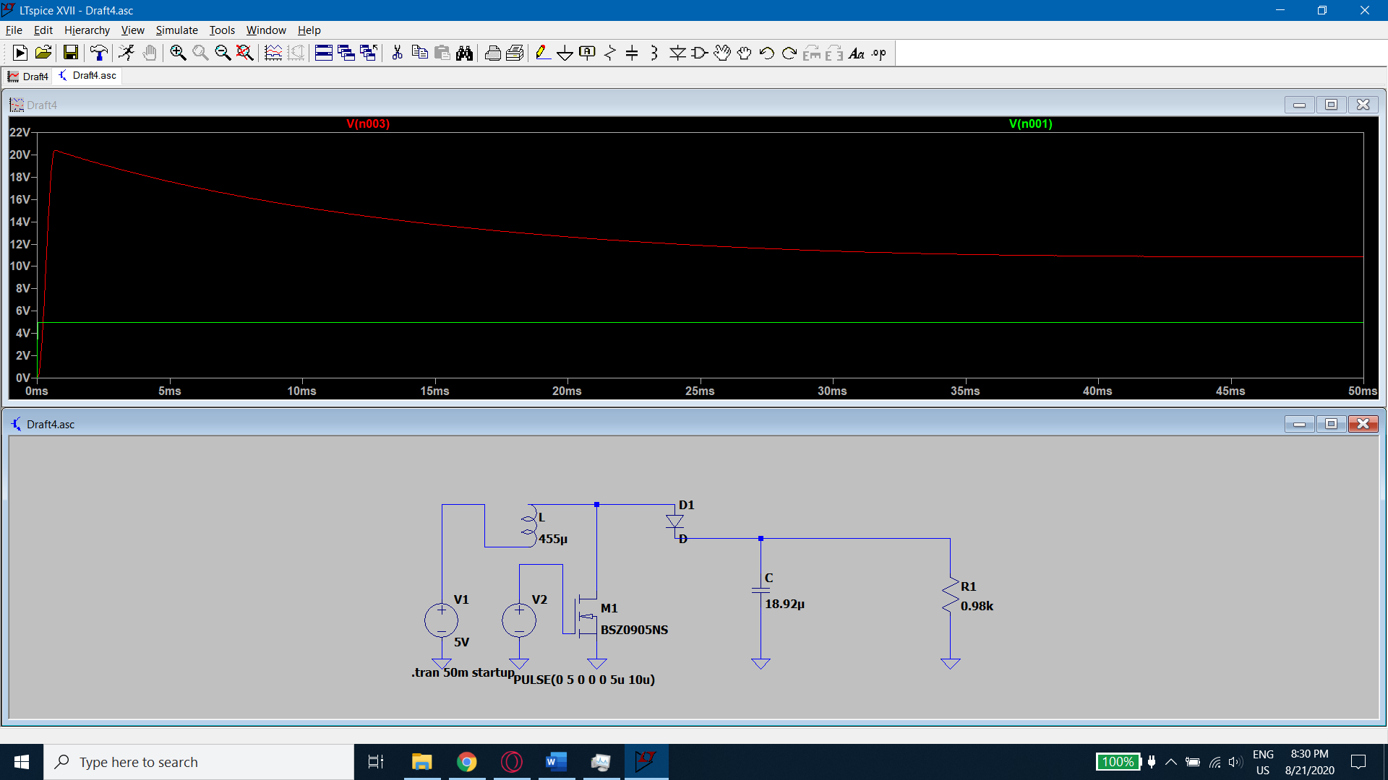

# Buck circuit:

When the switch is on the current flows through the inductor and capacitor charging both but when it is off the inductor reverses the polarity and discharges the current into capacitor causing the output to be the difference in voltages of capacitor and inductor. The reduction in voltage is accompanied by increase of current due to the current stored by the impedance of the inductor. V0 = Vin * duty ratio. Continued….

