*NOTE: DOUBTS ON PICTURES HAVE BEEN HIGHLIGHTED WITH A RED BOX*

**Q1**: As we use Kelly controller 8080I 96601, it runs on 2 types of voltages **96** volt (***PIN B+***: as supply to the motor) and **12** Volt (***PIN7 PWR***:for motor controller **inner HV isolated** circuitry- due to opto-isolation technology). Now if we are to use a different LV source to give supply to 12 Volt motor-controller pin and use a secondary LV source for disconnection circuit and GLVS system is that allowed.

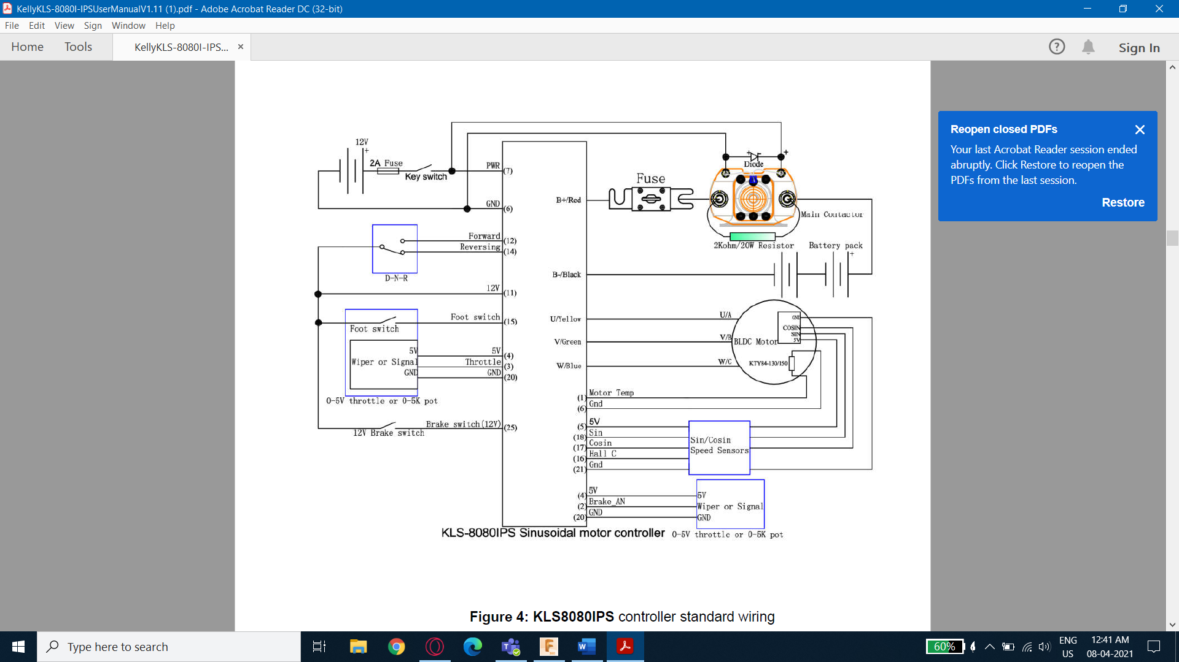

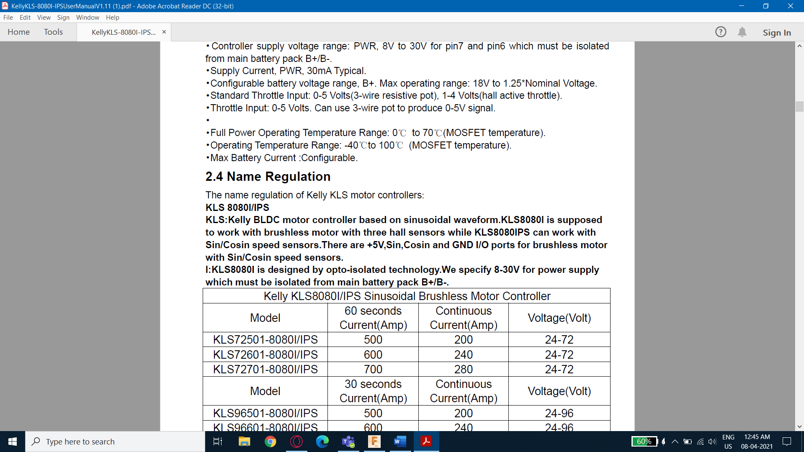

So can we follow this circuit shown below:

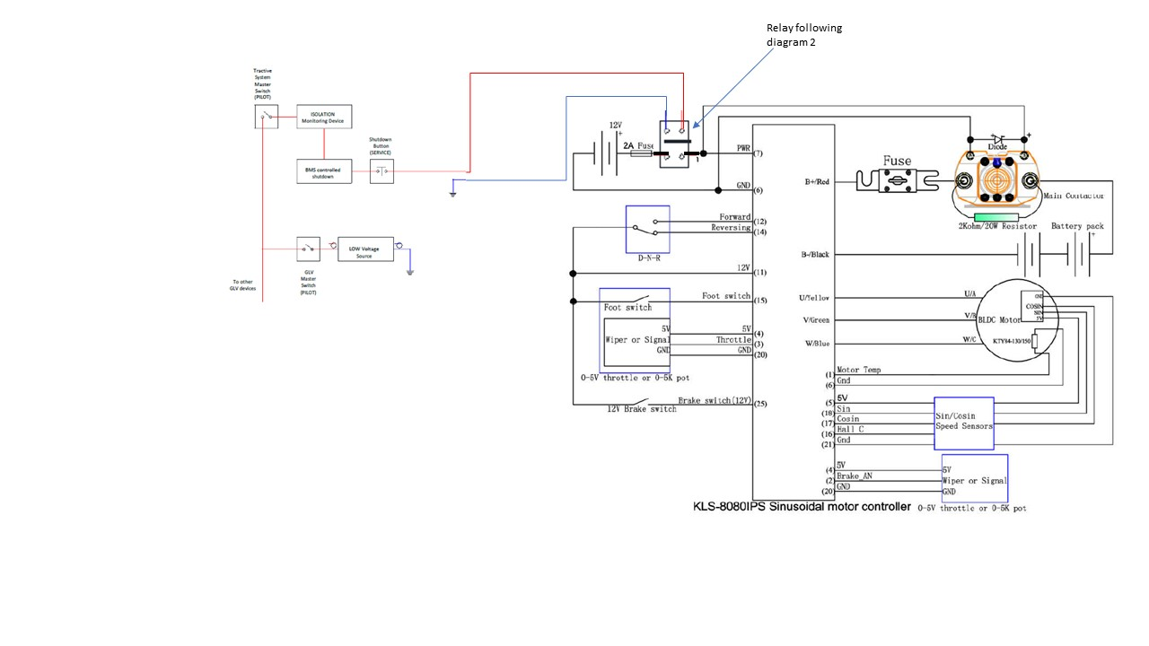

**Q2**: The rule book shows that the main contactor needs to be inside the accumulator pack (reference to Diagram 1- page39 ;and Diagram 2- page 40) but earlier answer regarding a question had a different suggestion:

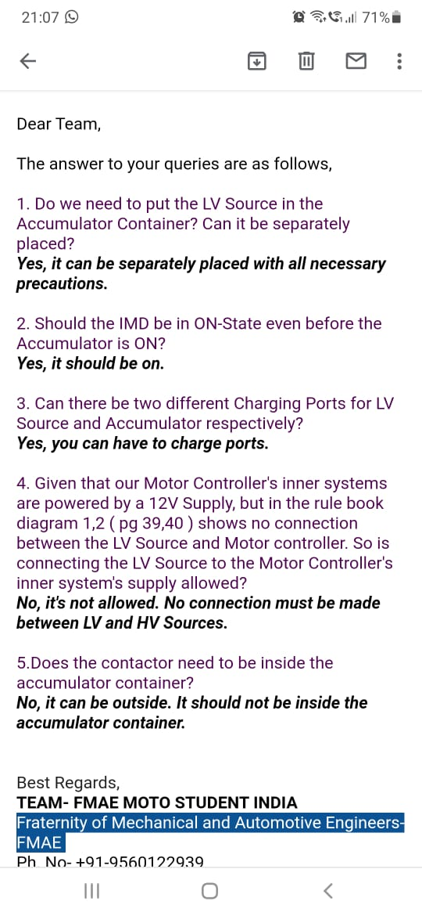

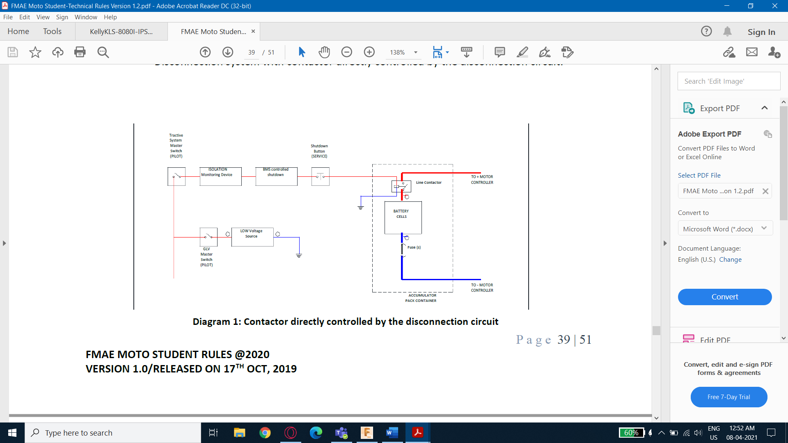

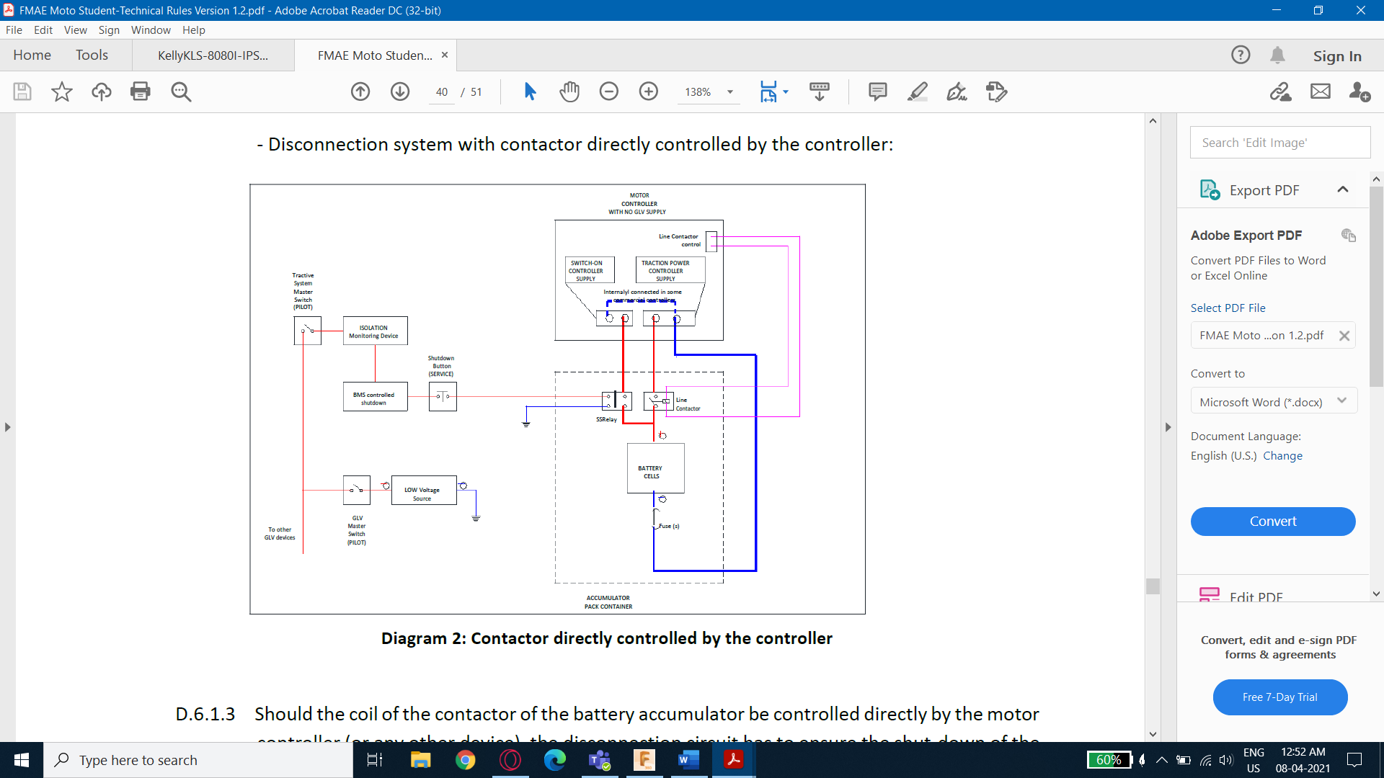

**Q3**: As IMD is a High voltage device and also BMS is high voltage device is it assumed that they are connected to GLVS source.

**Q4**: if motor-controller is HV then is throttle connected to controller also HV.