This is an end to end ml project including deployment from Krish Naik Youtube channel…

https://youtube.com/playlist?list=PLZoTAELRMXVPS-dOaVbAux22vzqdgoGhG&si=eXjmoUjjJKUDgf0K

End to End Data Science Project includes:

1. Business Understanding
2. Data Collection and Preparation
3. Building the Machine Learning Model
4. Model Optimization
5. Model Deployment
6. Model Monitoring

Steps followed in this project: (Hope I can complete it…😊 )

1. **Create a GitHub repo**

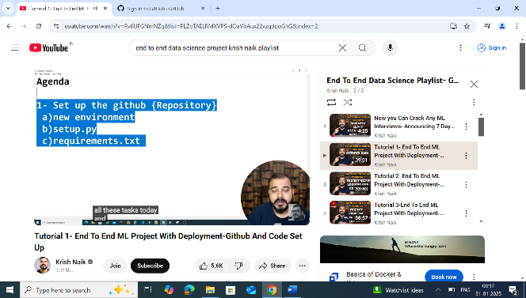 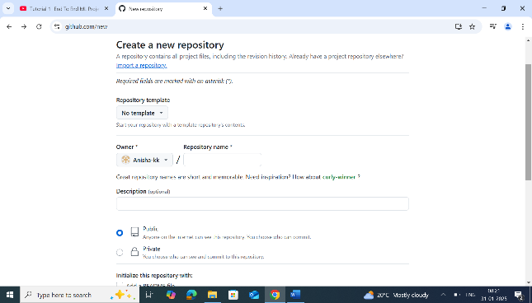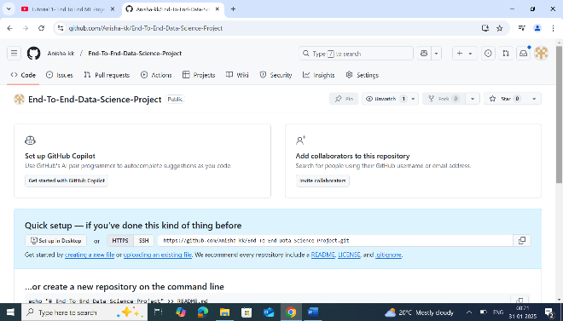 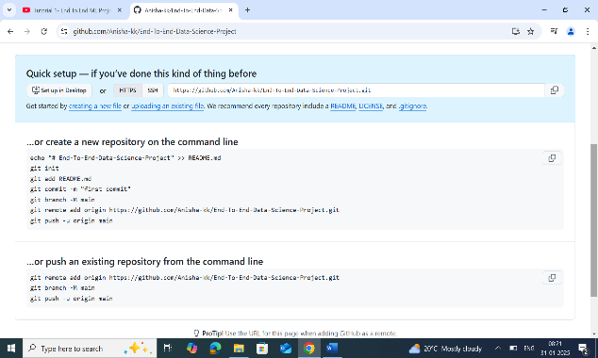

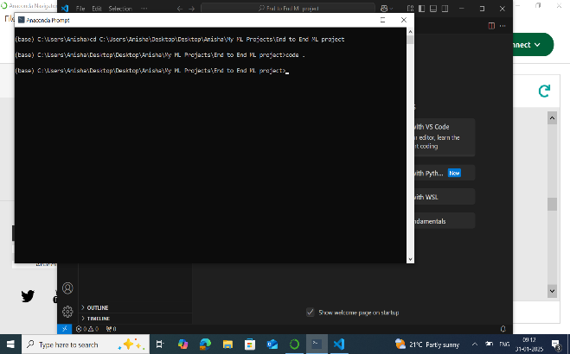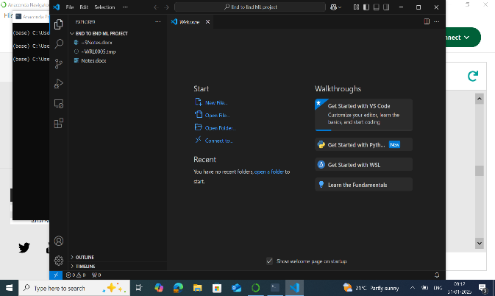

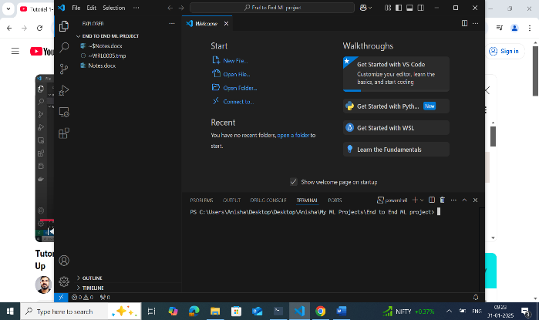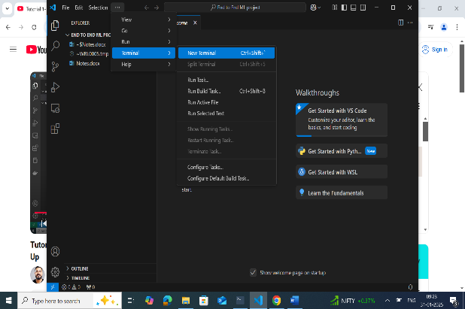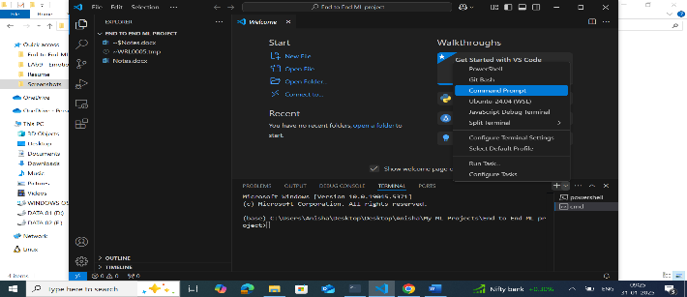

**Next, we need to create an environment inside the folder(This ensure that if I don’t require the packages, I just need to deactivate this env). All packages etc will be installed in this environment.**

**conda create -p venv python==3.8 -y**

**Here, -y is to prevent the system asking Do you want to install y/n**

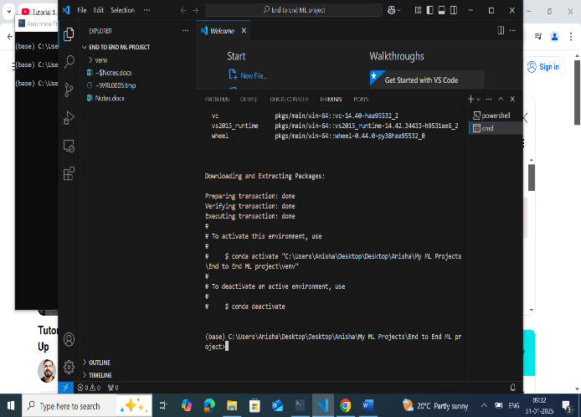 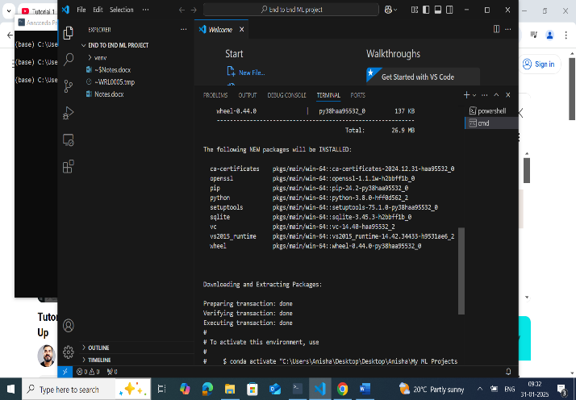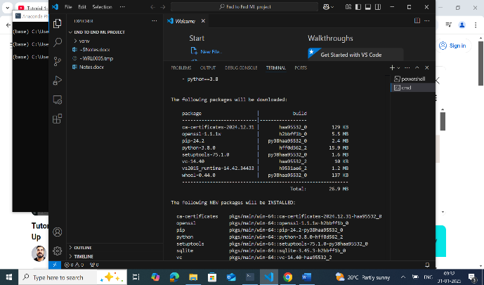 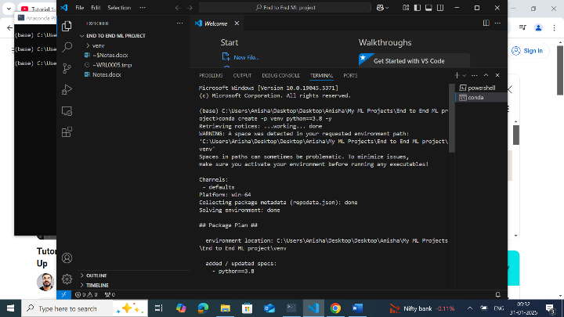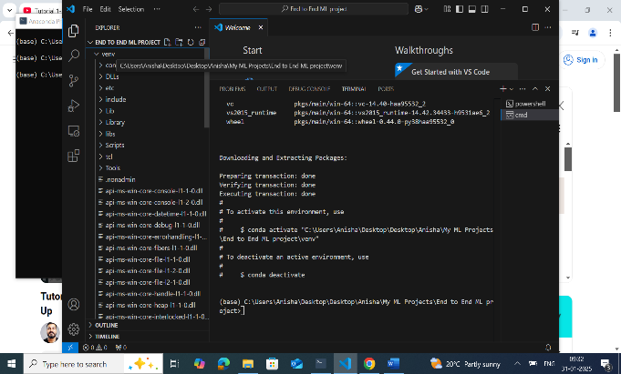

**Next, activate the env using the command conda activate venv/**

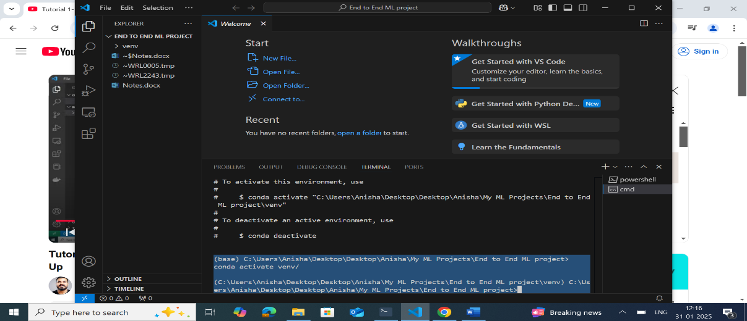

**Now, create a README.md file**

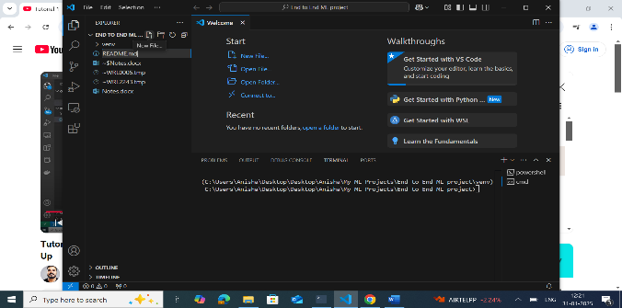 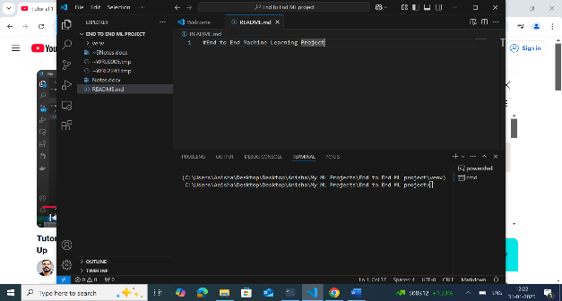

**Now, Create a git repo in the system and clone and sync with the github repo**

git init – creates an empty repo in the system

git add README.md – add the readme file to the repo

git commit -m "first commit" – To commit

git status – To see the current status

To push this repo to the GitHub repo:

git branch -M main –> Change to main branch

git remote add origin <https://github.com/Anisha-kk/End-To-End-Data-Science-Project.git> -> accessing the GitHub repo (in my screenshot, there is error only because I have already done it once…)

git config –-global user.name “Anisha-kk”

git config –-global user.email “akk30272419@gmail.com” -> Only the first time – also had to give access to Git Credential Manager for secure access

git push -u origin main -> Push the system repo to GitHub repo

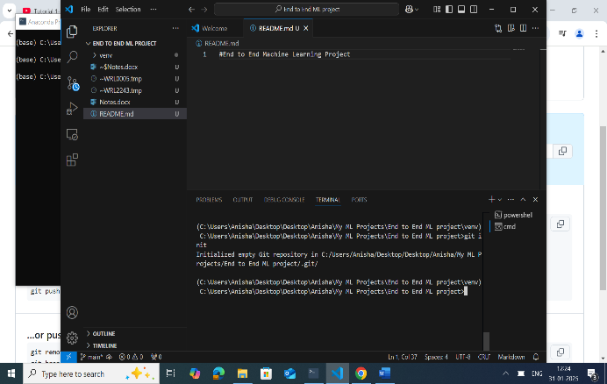 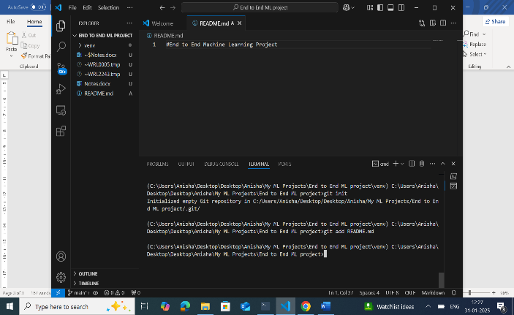 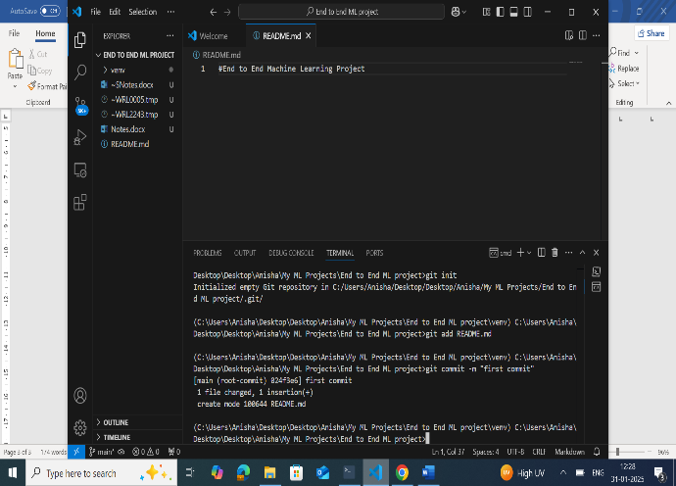 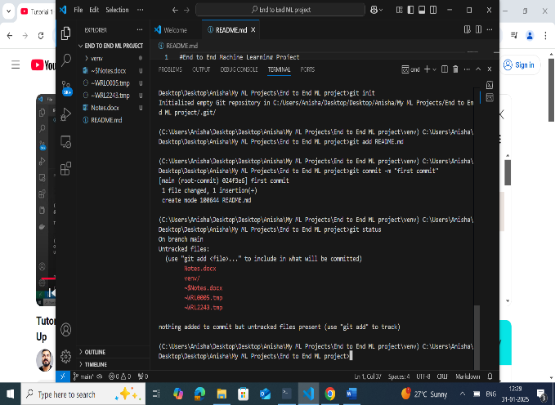

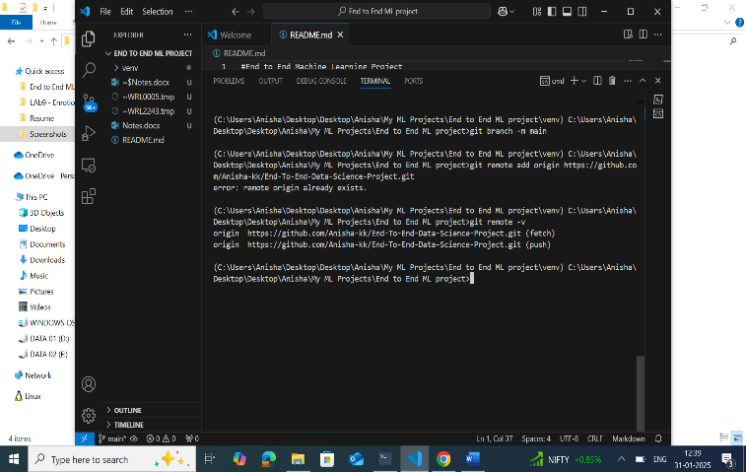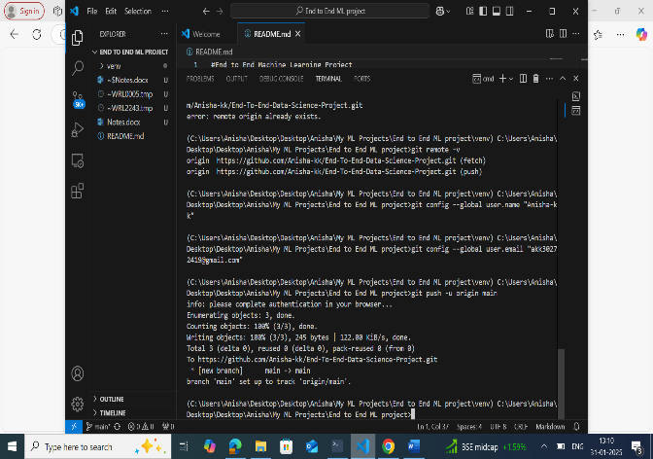 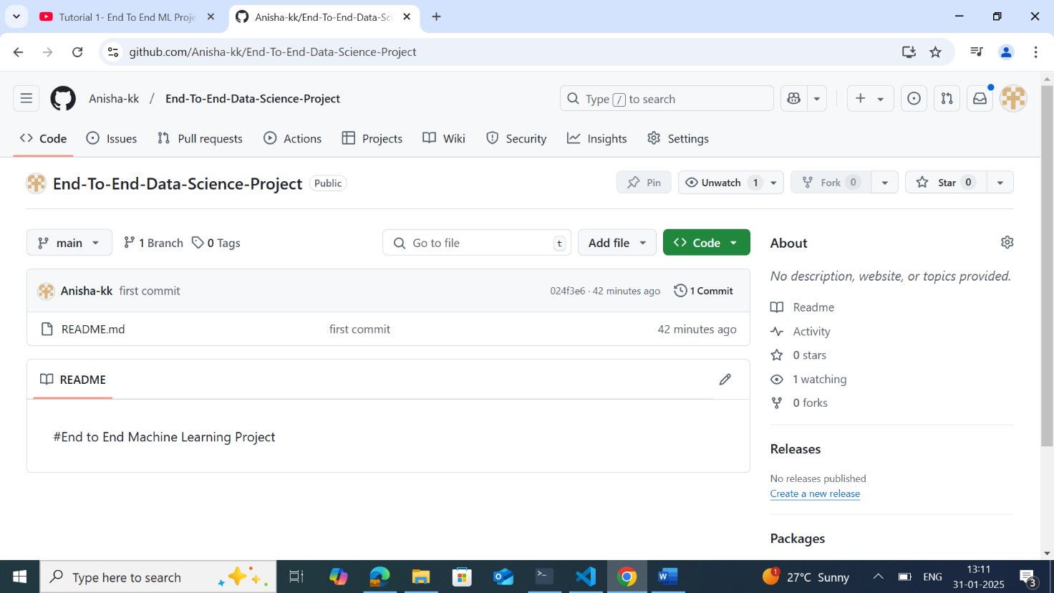

Create a .gitignore file in the GitHub repo to ensure that non committed files are deleted.

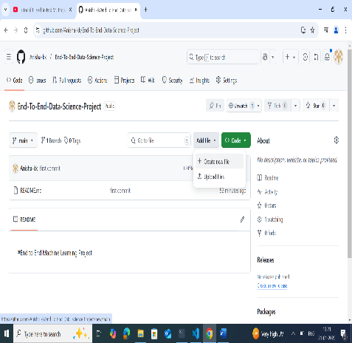 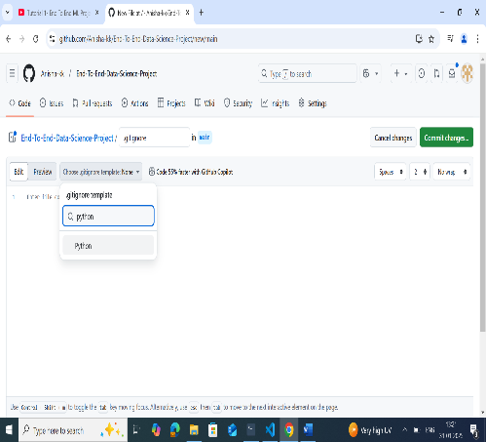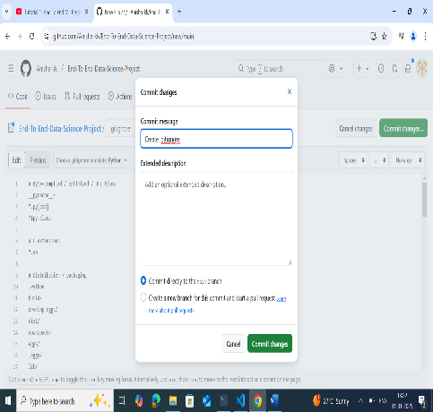

**To ensure that the local repo is also up to date, pull remote repo using** git pull

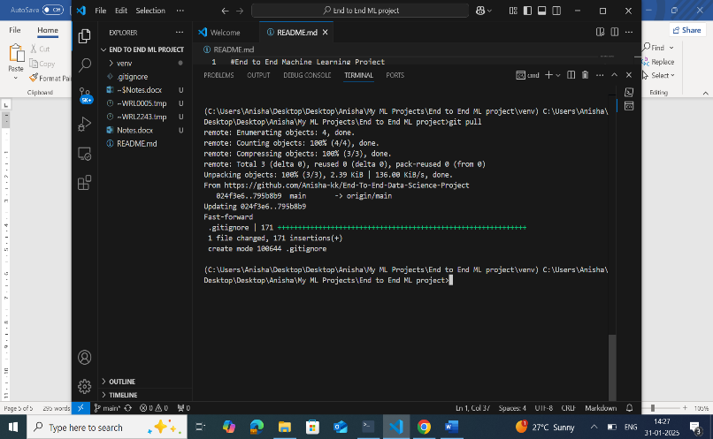

1. **Setup.py and requirements.txt**

requirements.txt – Contains all packages that need to be installed while implementing the ML app.

setup.py – responsible for creating my ML app as a package. The find_packages package automatically finds all the packages used in our application.

-e . in requirements.txt is to automatically trigger setup.py

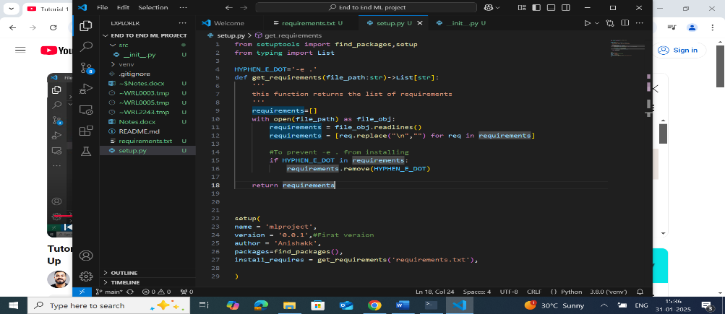 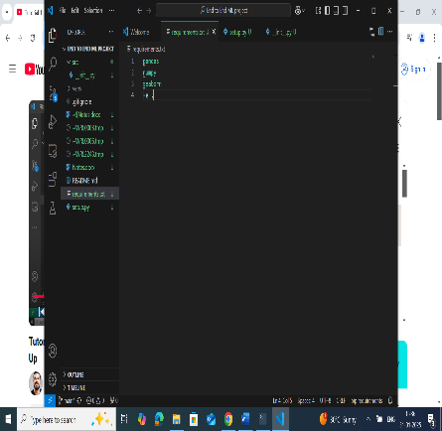

1. **Creating src folder and __init__.py**