1. To visualize a distance matrix

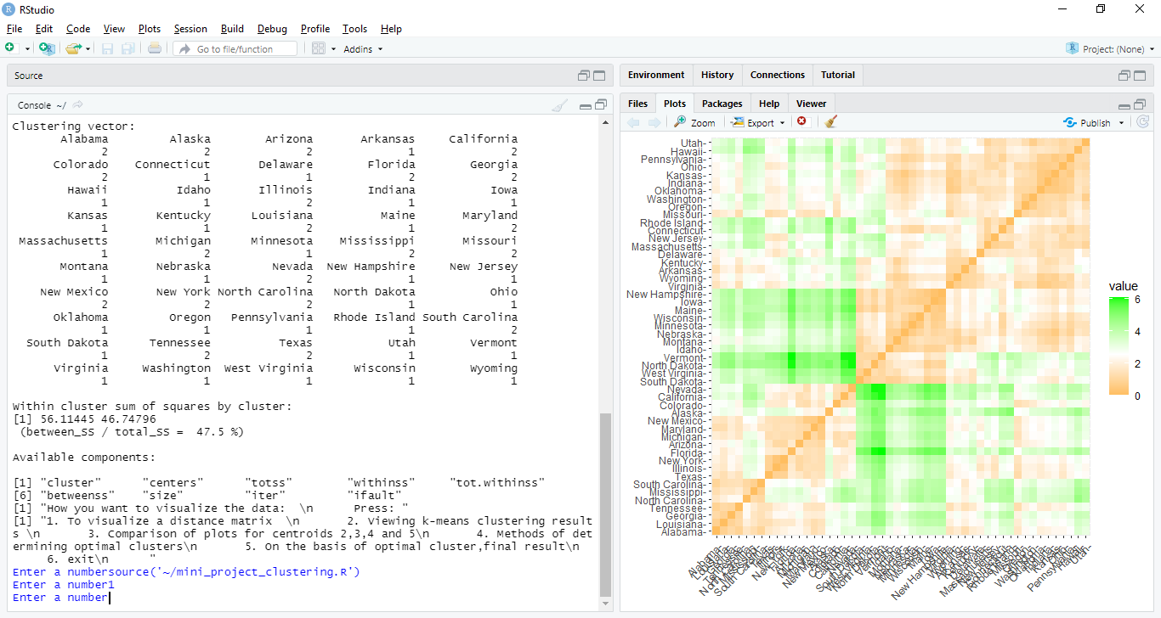

2. Viewing k-means clustering results

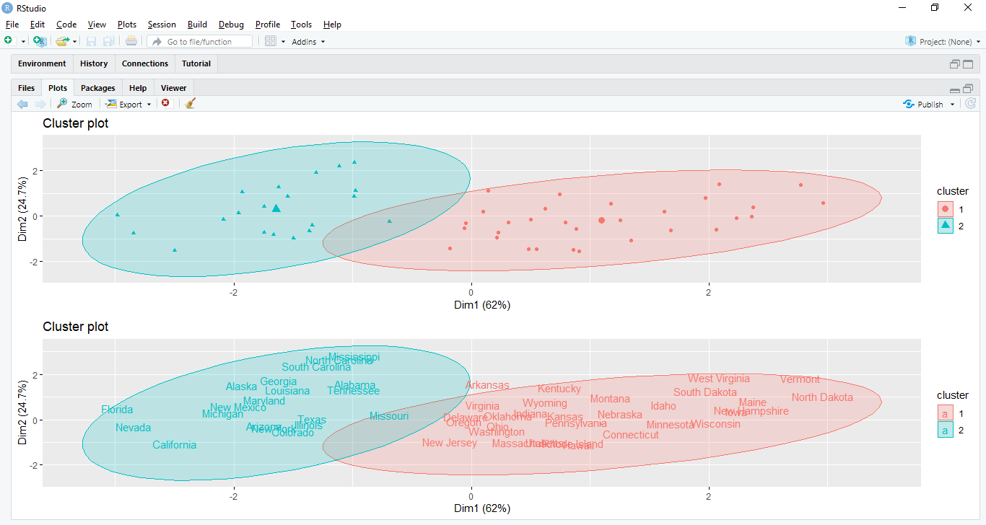

3. Comparison of plots for centroids 2,3,4 and 5

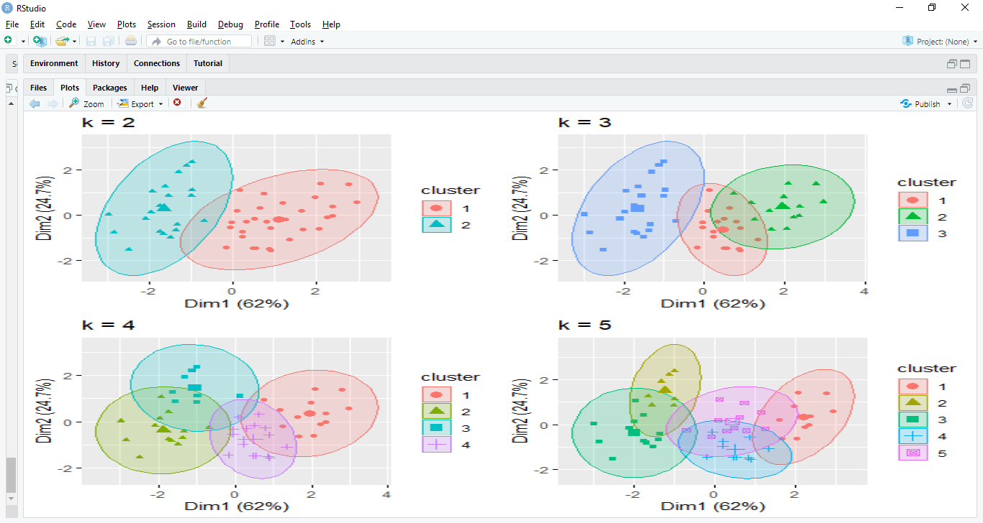

4. Methods of determining optimal clusters

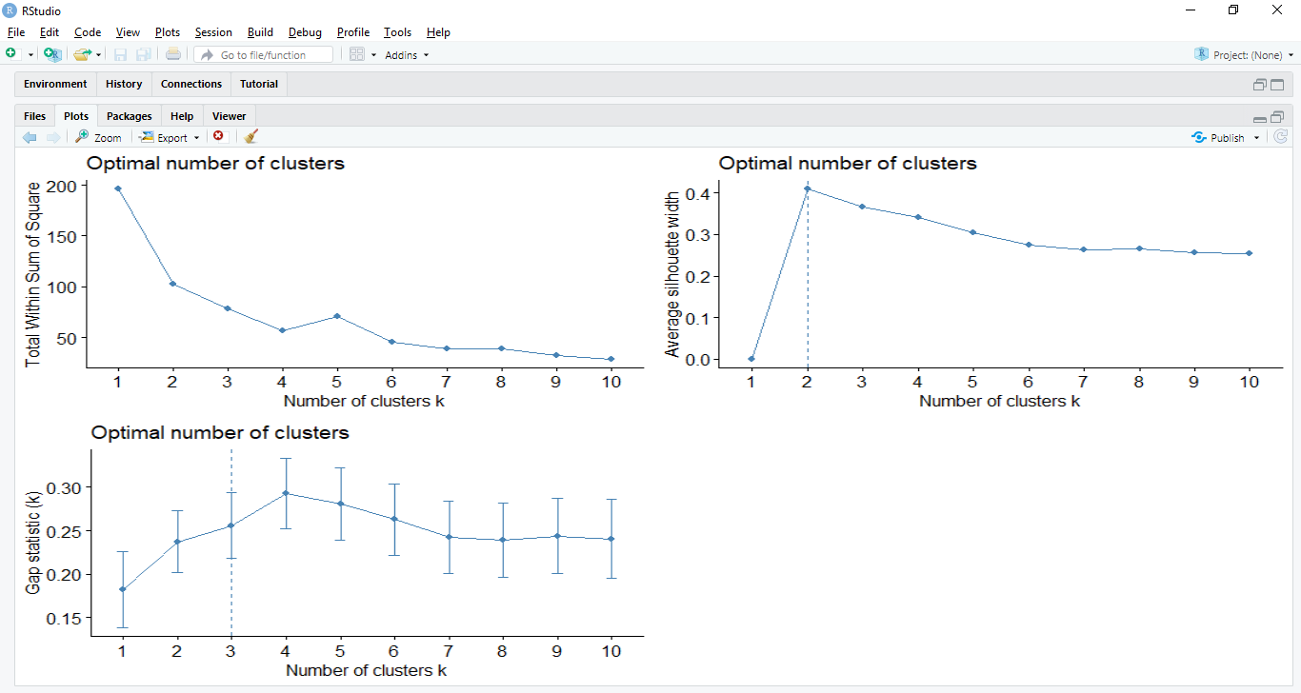

5. On the basis of optimal cluster,final result

