PROJECT DOCUMENTATION



POCKETSMART AI
Your Smart Budget & Recommendation Assistant

PROJECT DOCUMENTATION

Project Title | PocketSmart AI: Your Smart Budget & Recommendation Assistant
Project Type | GenAI-Powered Web Application
Programme | B.Sc. Computer Science
Institution | SOKA IKEDA COLLEGE OF ARTS AND SCIENCE FOR WOMEN
College Code | UNM1485  UNM
Department | Department of Computer Science
Team Leader | - ANISHA (REG.NO:unm1485222508824;  NM ID:F9D887CA922D6398B09454564D46763C)
Team Members | S.Bhuvaneshree (REG.NO:unm1485222508826;  NM ID:565DCAE087B2D7EA81B4291EF3269AAA)  B.Keerthana (REG.NO:unm1485222508834;  NM ID: 2385EEE22A28D80B5FC4509364039995)  S Jayasree (REG.NO: unm1485222508832;  NM ID:DB740A9F58DD04190044B4E858D1841E)
Project Guide | D.Malathy
Academic Year | 2026–2027

CERTIFICATE

This is to certify that the project entitled “PocketSmart AI – Your Smart Budget & Recommendation Assistant”
is a student project developed as part of the academic project work. The project presents a web-based
GenAI-powered assistant for budget planning and recommendations. The work has been prepared for submission under the guidance of the project faculty/mentor.

. DECLARATION
We declare that the project report titled “PocketSmart AI – Your Smart Budget & Recommendation Assistant” has been prepared for academic purposes based on the project implementation and supporting project materials. The report is intended to describe the system, its requirements, design, implementation, testing and outcomes in a structured manner.

Team Leader: N.ANISHA (REG.NO:unm1485222508824; NM ID:F9D887CA922D6398B09454564D46763C)

Team Members: S.Bhuvaneshree (REG.NO:unm1485222508826;NM ID:565DCAE087B2D7EA81B4291EF3269AAA)
B.Keerthana (REG.NO:unm1485222508834; NM ID: 2385EEE22A28D80B5FC4509364039995)
S Jayasree (REG.NO: unm1485222508832;NM ID:DB740A9F58DD04190044B4E858D1841E)

DATE: 28.09.2026

. ACKNOWLEDGEMENT
We express our sincere gratitude to our project guide, department faculty members and the institution for providing the opportunity and guidance needed to complete this project. We also thank our team members for their cooperation in planning, development, testing and documentation. The project helped us gain practical experience in web application development, REST APIs, database management, authentication and GenAI integration.

ABSTRACT
PocketSmart AI is a GenAI-powered budget recommendation assistant designed as a web application. The system provides three major planning areas: Home Interior Planner, Party Budget Planner and Jewelry Planner. Users can register and log in, enter planning information, receive AI-assisted recommendations, and access recommendation history. The Jewelry Planner also supports an optional outfit image upload. The application uses a FastAPI REST backend, SQLite database, JWT-based authentication and Gemini AI integration. A fallback recommendation engine is included to support recommendations when the AI service is not available. The project also includes a responsive frontend, Swagger API documentation and automated tests.
Keywords: GenAI, Budget Planning, Recommendation System, FastAPI, SQLite, JWT, Gemini AI, Web Application

. TABLE OF CONTENTS

No. | Chapter / Section
1 | Abstract
2 | Introduction
3 | Project Profile
4 | Problem Definition
5 | Objectives
6 | Scope
7 | Existing System
8 | Proposed System
9 | Features
10 | Requirement Analysis
11 | Technology Stack
12 | System Design
13 | System Modules
14 | System Workflow
15 | Database Design
16 | API Design
17 | Implementation
18 | Security
19 | Testing
20 | Results & Screenshots
21 | Advantages
22 | Limitations
23 | Future Enhancements
24 | Conclusion
25 | References

INTRODUCTION

Background
Planning a budget for different personal activities can require users to collect information, compare options and decide how to distribute available money. PocketSmart AI is designed to bring these planning tasks into one web application and use GenAI-based assistance to produce recommendations from user-provided requirements.

Purpose of the Project
    - Provide a single web interface for selected budget-planning activities.
    - Accept user requirements and generate structured recommendations.
    - Maintain authenticated user access to the application.
    - Store recommendation history using a SQLite database.
    - Provide an AI-based recommendation path with a fallback mechanism.

Working Overview
A typical user flow begins with registration or login. After authentication, the user selects a planning area, enters the required information, and submits the request. The backend processes the request and uses the configured recommendation logic and Gemini AI integration to produce the response. Relevant history can then be accessed through the application.
High-Level User Flow
Register / Login
Select Planner
Enter Budget & Details
AI / Fallback Engine
Recommendation & History

PROJECT PROFILE

Item | Details
Project Title | PocketSmart AI
Subtitle | Your Smart Budget & Recommendation Assistant
Project Type | GenAI-Powered Web Application
Primary Purpose | Budget planning and recommendation assistance
Main Planners | Home Interior, Party Budget, Jewelry
Backend | FastAPI REST API
Database | SQLite with SQLAlchemy
Authentication | JWT-based authentication
AI Integration | Gemini AI / google-genai
Frontend | Responsive web frontend using HTML/CSS/JavaScript
Testing | pytest and HTTPX
API Documentation | Swagger API documentation

Project Description
PocketSmart AI combines user authentication, budget-planning modules, AI-assisted recommendations and history management within a single web application. The design separates the user-facing interface, API/backend logic, database operations and AI recommendation service so that each responsibility can be maintained independently.

PROBLEM DEFINITION
Users may need different forms of budget guidance for home arrangements, parties and jewelry-related choices. Handling each planning activity separately can make the process less organized. The project addresses this by providing a unified interface where planning information can be submitted and recommendations can be generated and stored for later reference.

Problem Statement
To develop a web-based intelligent budget recommendation assistant that accepts user requirements, applies AI-assisted recommendation logic, stores relevant history, and provides a simple interface for multiple planning scenarios.

OBJECTIVES
- Develop a user-friendly web application for budget recommendation tasks.
- Implement user registration, login and logout functionality.
- Use JWT-based authentication for protected application access.
- Provide Home Interior, Party Budget and Jewelry planning modules.
- Integrate Gemini AI for recommendation generation.
- Provide a fallback recommendation engine.
- Store recommendation history in SQLite.
- Support optional outfit image upload in the Jewelry Planner.
- Provide REST APIs and Swagger documentation.
- Test the application using automated testing tools.

SCOPE

Included Scope
    - Web-based access to budget recommendation functionality.
    - Authenticated user sessions.
    - Three planning modules: Home Interior, Party Budget and Jewelry.
    - AI-assisted recommendations through Gemini integration.
    - Fallback recommendation processing.
    - Recommendation history.
    - Optional image upload for jewelry planning.
    - REST API interface and automated testing.

Out of Scope / Not Specified in the Project Materials
The supplied project materials do not specify production deployment, payment processing, multi-role administration, mobile application packaging, or a live analytics dashboard. These should therefore be treated as possible future work rather than current implemented features.

EXISTING SYSTEM
A general manual approach to budget planning may require a user to collect requirements, estimate costs, compare alternatives and prepare recommendations independently. Such an approach does not provide a single application flow for the three planning areas addressed by PocketSmart AI.

Challenges Addressed
    - Planning information can be scattered across different sources or notes.
    - Recommendation preparation can require repeated manual comparison.
    - Previous recommendations may be difficult to organize without history storage.
    - Different planning tasks may require different input structures.

PROPOSED SYSTEM
The proposed system provides one web application for selected budget-planning activities. It combines a responsive frontend, FastAPI REST backend, SQLite database, JWT authentication, Gemini AI integration and a fallback recommendation engine.
Proposed System Architecture
Responsive Frontend
FastAPI Backend
Authentication & Validation
Recommendation Engine
SQLite / History

FEATURES

Feature | Description
User Registration | Allows a new user to create an account.
User Login | Authenticates users before protected operations.
Logout | Ends the active application session.
JWT Authentication | Provides token-based authenticated access.
Session Information | Provides session-related information through backend endpoints.
Home Interior Planner | Generates budget-oriented recommendations for home interior planning.
Party Budget Planner | Generates recommendations based on party planning requirements.
Jewelry Planner | Generates jewelry recommendations using supplied planning information.
Outfit Image Upload | Supports an optional outfit image for jewelry planning.
Gemini AI | Provides the AI-assisted recommendation path.
Fallback Engine | Provides an alternate recommendation mechanism.
Recommendation History | Stores and retrieves previous recommendations.
Responsive Frontend | Supports a web interface designed for different screen sizes.
Swagger Documentation | Documents and exposes the REST API interface.
Automated Tests | Supports automated testing using pytest and HTTPX.

REQUIREMENT ANALYSIS

Functional Requirements
    - The system shall allow users to register.
    - The system shall allow registered users to log in.
    - The system shall support logout.
    - The system shall authenticate protected operations using JWT-based authentication.
    - The system shall accept inputs for Home Interior planning.
    - The system shall accept inputs for Party Budget planning.
    - The system shall accept inputs for Jewelry planning.
    - The system shall optionally accept an outfit image for Jewelry planning.
    - The system shall generate recommendations using the configured AI/fallback logic.
    - The system shall maintain recommendation history.
    - The system shall expose REST endpoints for supported operations.

Non-Functional Requirements
    - Usability: the interface should be understandable and simple to navigate.
    - Maintainability: backend, database and recommendation responsibilities should remain organized.
    - Reliability: a fallback recommendation path should be available when AI generation cannot be used.
    - Security: authenticated access should protect user-specific operations.
    - Responsiveness: the frontend should adapt to supported screen sizes.
    - Testability: core application behaviour should be verifiable using automated tests.

Hardware Requirements
    - Computer or laptop capable of running Python and a modern web browser.
    - Sufficient storage for the project source, Python environment and SQLite database.
    - Internet connectivity for AI-service integration when Gemini AI is enabled.

Software Requirements
    - Python environment.
    - FastAPI and Uvicorn.
    - Jinja2 and python-multipart.
    - Pydantic and pydantic-settings.
    - email-validator.
    - passlib[bcrypt] and PyJWT.
    - SQLAlchemy.
    - google-genai.
    - Pillow.

    - pytest and HTTPX.
    - Modern web browser.

TECHNOLOGY STACK

Technology / Tool | Role in the Project
Python | Primary backend programming language.
FastAPI | Web framework for REST API development.
Uvicorn | ASGI server used to run the FastAPI application.
Jinja2 | Server-side HTML templating support.
HTML / CSS / JavaScript | Frontend structure, styling and interaction.
SQLite | Local relational database.
SQLAlchemy | Database interaction and ORM layer.
PyJWT | JWT token handling.
Passlib / bcrypt | Password hashing support.
Google GenAI | Gemini AI integration.
Pillow | Image processing support for uploaded images.
pytest | Automated testing framework.
HTTPX | HTTP client support for API testing.
Swagger / OpenAPI | Interactive REST API documentation.

SYSTEM DESIGN

Architectural View
The system can be viewed as a layered web application. The frontend collects and displays information. The FastAPI backend handles requests, authentication and business logic. The recommendation layer communicates with Gemini AI and can use the fallback engine. SQLAlchemy manages access to the SQLite database for user and history data.
Logical Architecture
User / Browser
Frontend
FastAPI REST API
AI + Business Logic
SQLite Database

Request Flow
    - User opens the web application.
    - User registers or logs in.
    - Authenticated request is sent to the appropriate planner endpoint.
    - Backend validates the request and prepares the recommendation input.
    - Gemini AI is used where configured; otherwise the fallback mechanism can provide a response.
    - The recommendation is returned to the frontend.
    - Relevant recommendation history is stored and can later be retrieved.

Use Case Summary
Actor | Use Case | Purpose
User | Register | Create an application account.
User | Login | Authenticate and access protected functionality.
User | Plan Home Interior | Submit home-related budget requirements.
User | Plan Party | Submit party-related budget requirements.
User | Plan Jewelry | Submit jewelry requirements and optionally an outfit ima
User | View History | Access previous recommendation records.
System | Generate Recommendation | Use AI/fallback recommendation logic.

ge.

SYSTEM MODULES

User Authentication Module
This module manages registration, login and logout. JWT-based authentication is used to protect authenticated application operations.

Home Interior Planner
This module accepts home interior planning information and produces budget-oriented recommendations through the application's recommendation engine.

Party Budget Planner
This module handles party planning requirements and produces recommendations based on the supplied budget and related inputs.

Jewelry Planner
This module supports jewelry-related recommendations. The project also supports an optional outfit image upload for this planner.

AI Recommendation Module
This module connects the application to Gemini AI through the Google GenAI package. It prepares the request and returns the generated recommendation.

Fallback Recommendation Module
This module provides an alternate recommendation path when AI generation is unavailable or cannot be used.

Recommendation History Module
This module stores and retrieves previous recommendation records through the SQLite database.

API Documentation Module
The project exposes its REST API through FastAPI and provides Swagger/OpenAPI documentation for available endpoints.

SYSTEM WORKFLOW

General Workflow
Application Workflow
Open Application
Register / Login
Choose Planner
Submit Inputs
Generate Recommendation
View / Save History

Authentication Workflow
    - New users register with the application.
    - Registered users submit login credentials.
    - The backend authenticates the user and issues JWT-based authentication information.
    - Protected requests use the authenticated context.
    - Logout ends the active session flow.

Recommendation Workflow
    - The user chooses one of the available planning modules.
    - The user supplies the information requested by that planner.
    - For Jewelry Planner, an outfit image may also be supplied.
    - The backend validates and processes the request.
    - The AI recommendation path is used where available.
    - The fallback recommendation engine provides an alternate path when required.
    - The recommendation is returned and relevant history can be stored.

DATABASE DESIGN
The project uses SQLite as its database and SQLAlchemy for database interaction. The supplied project materials explicitly identify SQLite database support and recommendation history. The exact final table and column definitions should match the implemented source code.
Logical Data Area | Purpose
User Account | Stores information required for user registration and authentication.
Authentication Data | Supports authenticated session/token handling.
Recommendation History | Stores previous recommendation information for later retrieval.
Planner Request Data | Represents information submitted to the planning modules where persisted

by the implementation.

Data Dictionary — High-Level

Data Item | Description | Type / Nature
User Identity | Identifies the application user. | User/account field
Password Credential | Credential processed through authentication/password-ha | shPirnogteloctgeicd. credential
JWT Token | Token used for authenticated API access. | Authentication token
Planner Type | Identifies Home Interior, Party or Jewelry planning. | Categorical value
Budget / Inputs | User-supplied planning information. | Request data
Recommendation | Generated output returned by the recommendation engine | . Text / structured response
History Record | Stored record of a previous recommendation. | Database record
Outfit Image | Optional image supplied for Jewelry Planner. | Uploaded image

API DESIGN
The project provides a FastAPI REST API. The following endpoint groups are documented by the supplied project materials.

Endpoint | Purpose
/register | User registration.
/login | User login.
/logout | Logout/session termination.
/token | Authentication token handling.
/session-info | Session information.
/session-data | Session-related data.
/generate-home | Generate Home Interior recommendation.
/generate-party | Generate Party Budget recommendation.
/generate-jewelry | Generate Jewelry recommendation.
/history | Access recommendation history.

API Processing Pattern
    - Client sends a request to the FastAPI endpoint.
    - Request data is validated.
    - Authentication is checked where required.
    - The relevant planner/service is selected.
    - AI or fallback recommendation logic processes the request.
    - The response is returned to the client.
    - History is stored or retrieved where applicable.

IMPLEMENTATION

Project Structure
PocketSmart AI/
■■■ Application source files
■■■ Templates / frontend resources
■■■ Database configuration
■■■ Authentication and utility modules
■■■ AI / recommendation services
■■■ Test files
■■■ requirements.txt
■■■ README.md

Dependency Configuration

Package | Purpose
fastapi | REST API framework
uvicorn[standard] | ASGI server
jinja2 | Template rendering
python-multipart | Form/file upload handling
python-dotenv | Environment configuration
pydantic / pydantic-settings | Data validation and settings
email-validator | Email validation
passlib[bcrypt] | Password hashing
PyJWT | JWT authentication
SQLAlchemy | Database ORM
google-genai | Gemini AI integration
Pillow | Image processing
pytest | Testing
httpx | HTTP/API test client

Implementation Notes
    - Backend functionality is implemented through FastAPI.
    - Database access is handled through SQLAlchemy and SQLite.
    - Authentication uses JWT and password-hashing support.
    - Gemini AI is accessed through the Google GenAI package.
    - Image handling is supported through Pillow.
    - The project includes a fallback recommendation mechanism.
    - The README identifies Swagger API documentation and automated tests as project features.

SECURITY

Authentication and Credential Protection
    - User authentication is implemented using JWT-based authentication.
    - Password handling uses passlib[bcrypt] support.
    - Protected functionality should be accessed only through the authenticated application flow.

Input and File Handling
    - Request data should be validated before business processing.
    - Uploaded images should be checked for acceptable file type and size before processing.
    - AI-service credentials should be kept in environment configuration rather than exposed in frontend code.

Data Protection Considerations
The project materials establish authentication and database features but do not provide a complete production security audit. For deployment, additional controls such as secure secret management, HTTPS, rate limiting, logging and database backup should be evaluated.

TESTING
Testing is included as part of the project technology stack through pytest and HTTPX. The following test cases provide a professional documentation format for the implemented functionality. Actual execution status should be filled from the project's test run when submitting the final report.

Test ID | Test Case | Expected Result | Status
TC-01 | Register with valid details | Account is created successfully. | To be verified
TC-02 | Register with invalid/incomplete details | Validation error is returned. | To be verified
TC-03 | Login with valid credentials | Authentication succeeds. | To be verified
TC-04 | Login with invalid credentials | Authentication fails safely. | To be verified
TC-05 | Access protected endpoint without authentic | aRtieoqnuest is rejected. | To be verified
TC-06 | Generate Home Interior recommendation | Recommendation is returned. | To be verified
TC-07 | Generate Party Budget recommendation | Recommendation is returned. | To be verified
TC-08 | Generate Jewelry recommendation | Recommendation is returned. | To be verified
TC-09 | Jewelry request with outfit image | Image is accepted and processed where supported. | To be verified
TC-10 | AI service unavailable | Fallback recommendation path is used. | To be verified
TC-11 | Retrieve history | Previous recommendation records are returned. | To be verified
TC-12 | Logout | Session is terminated. | To be verified
TC-13 | Invalid request data | Validation error is returned. | To be verified
TC-14 | API documentation access | Swagger/OpenAPI documentation is available. | To be verified

Testing Approach
    - Unit-level checks for individual functions where available.
    - API testing using HTTPX.
    - Automated test execution using pytest.
    - Authentication and validation testing.
    - Planner endpoint testing.
    - Fallback recommendation testing.
    - Regression testing after changes.

RESULTS & SCREENSHOTS
The project is designed to provide a complete flow from authentication to planner selection, recommendation generation and history access. Screenshots from the actual running application should be inserted in this section before final submission.

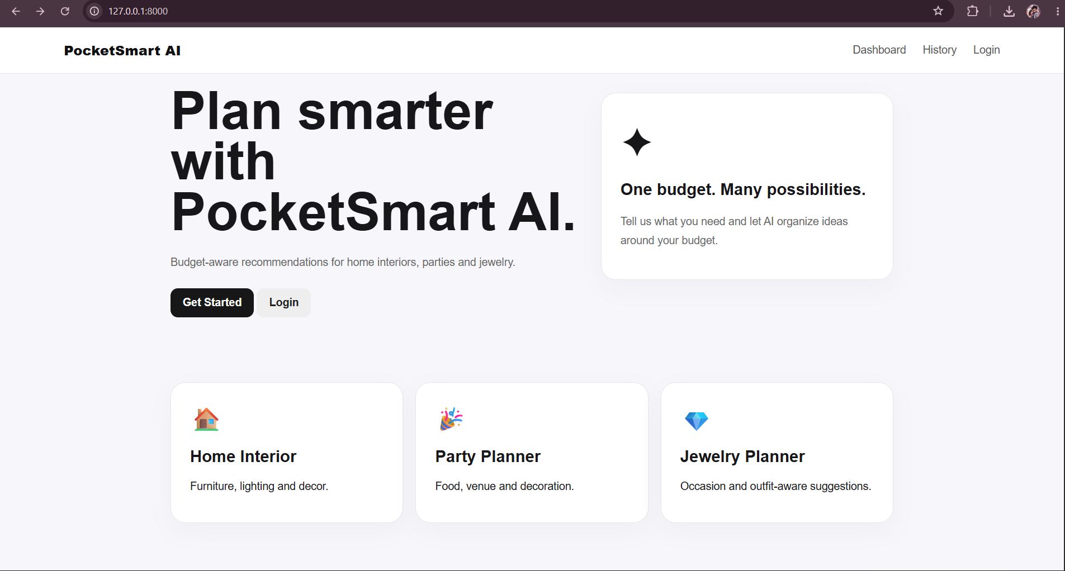

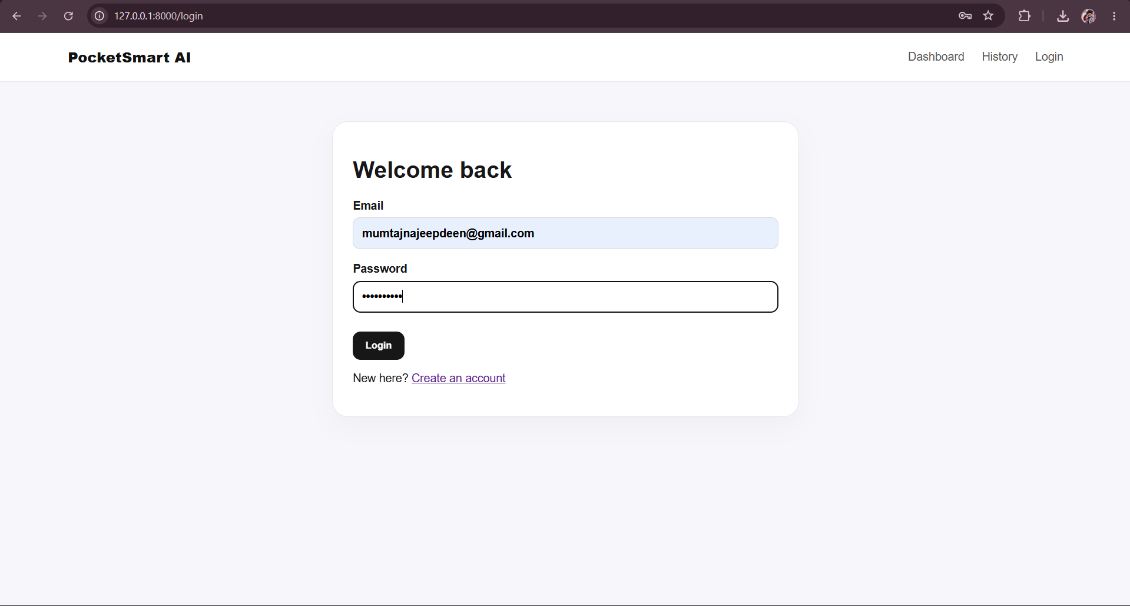

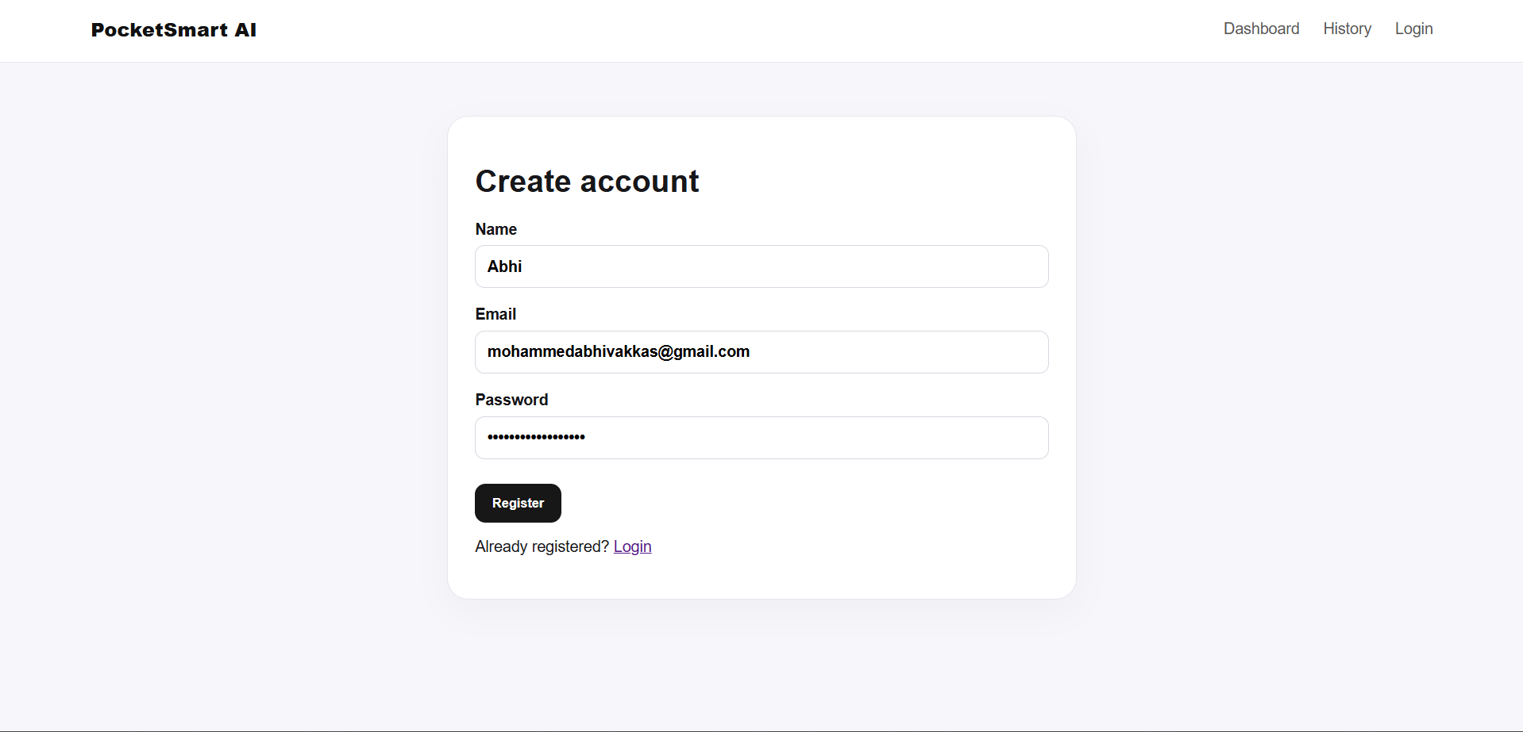

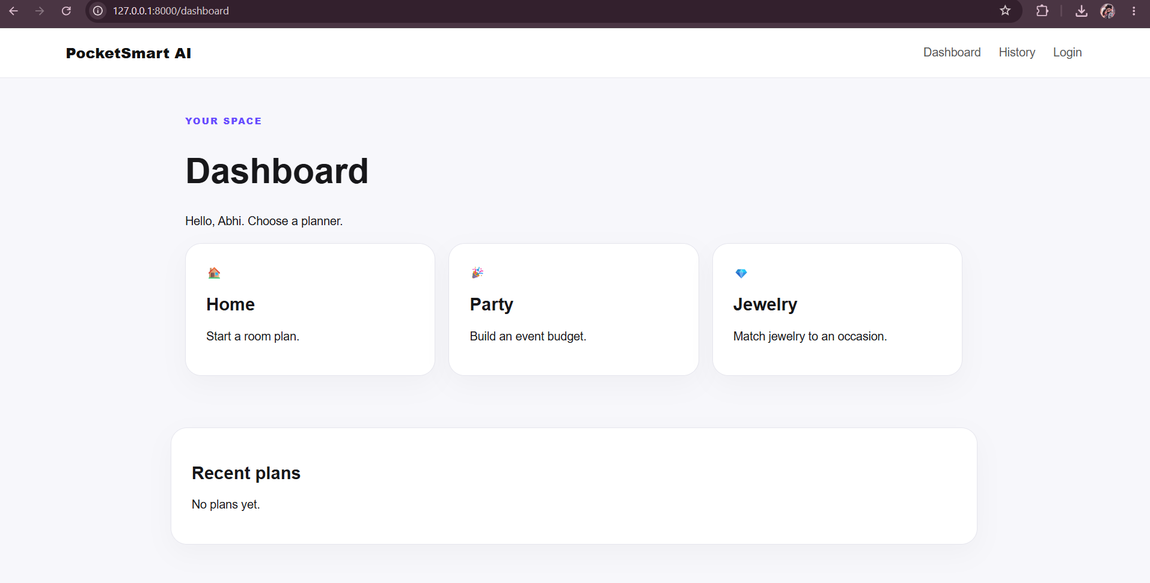

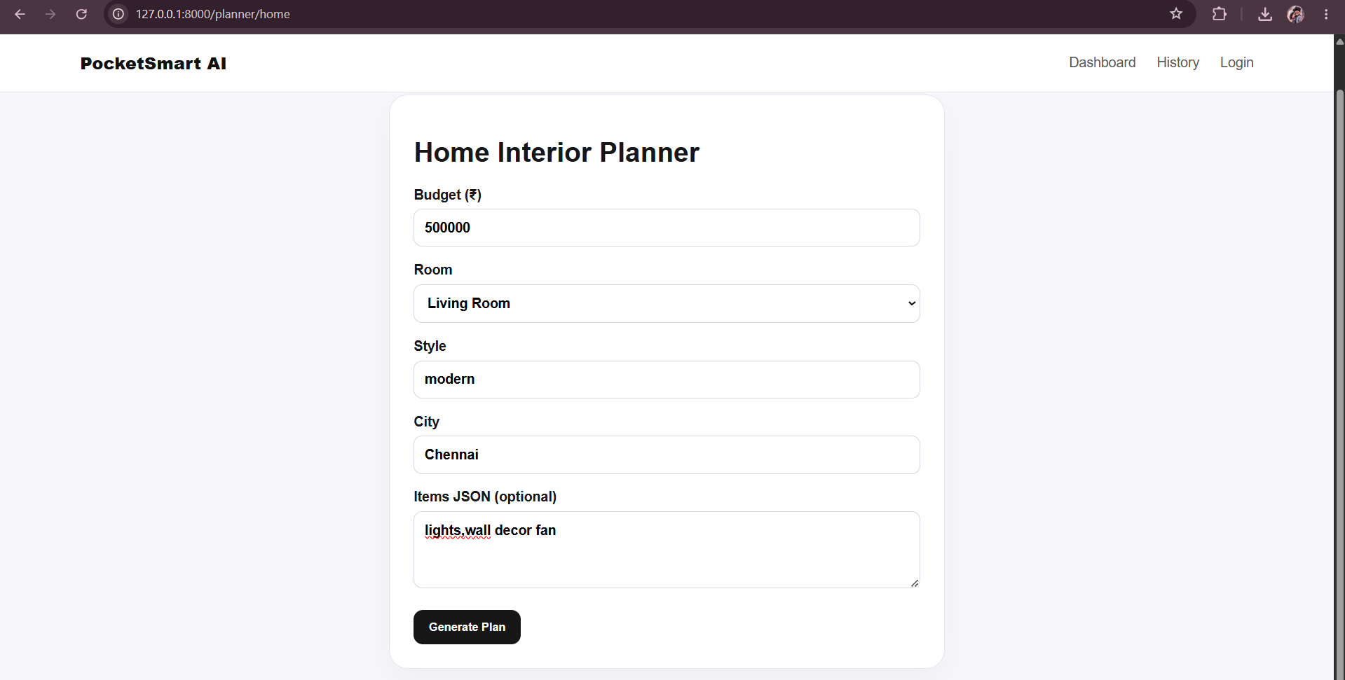

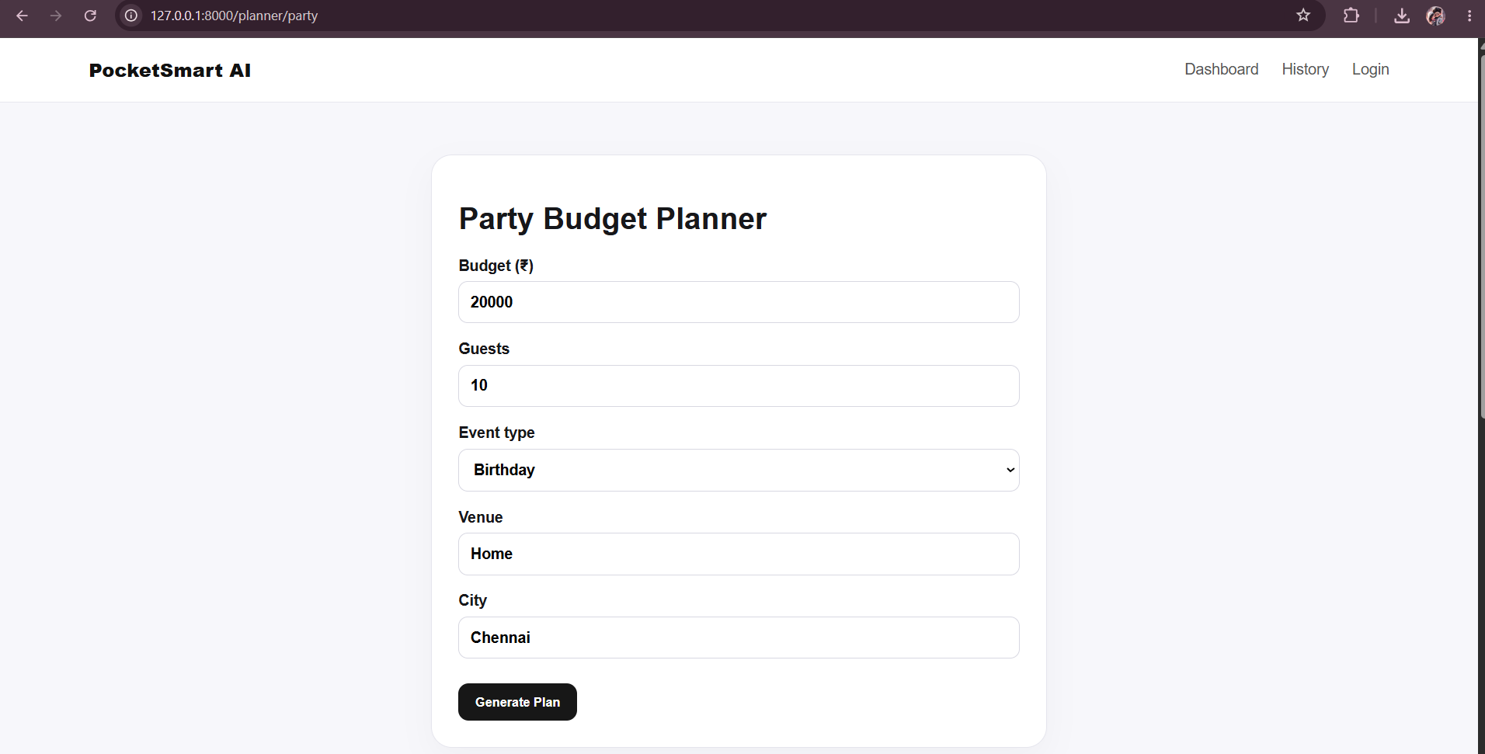
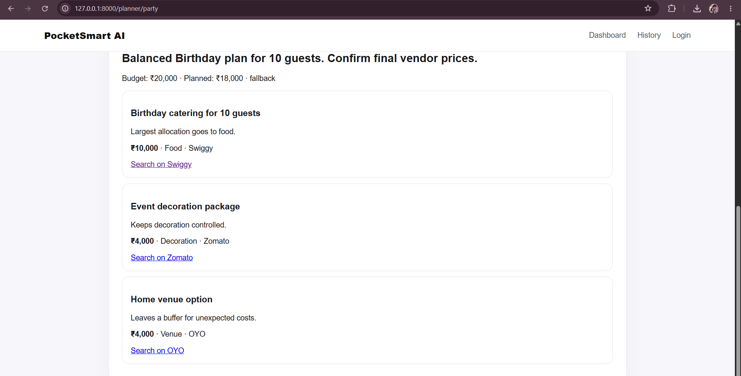
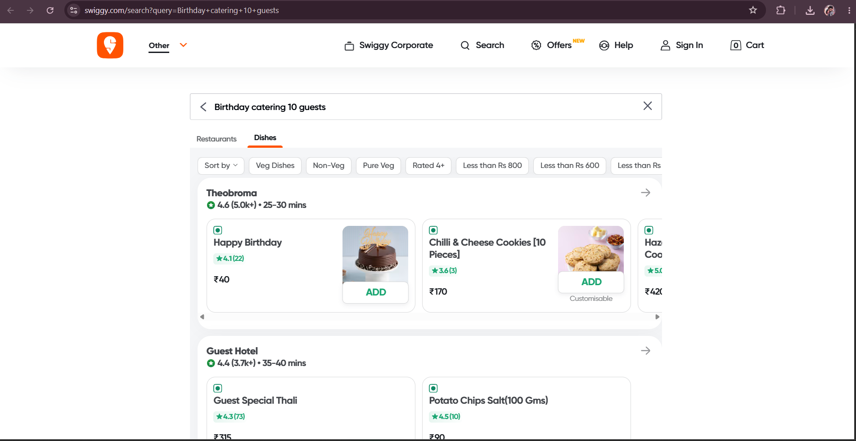
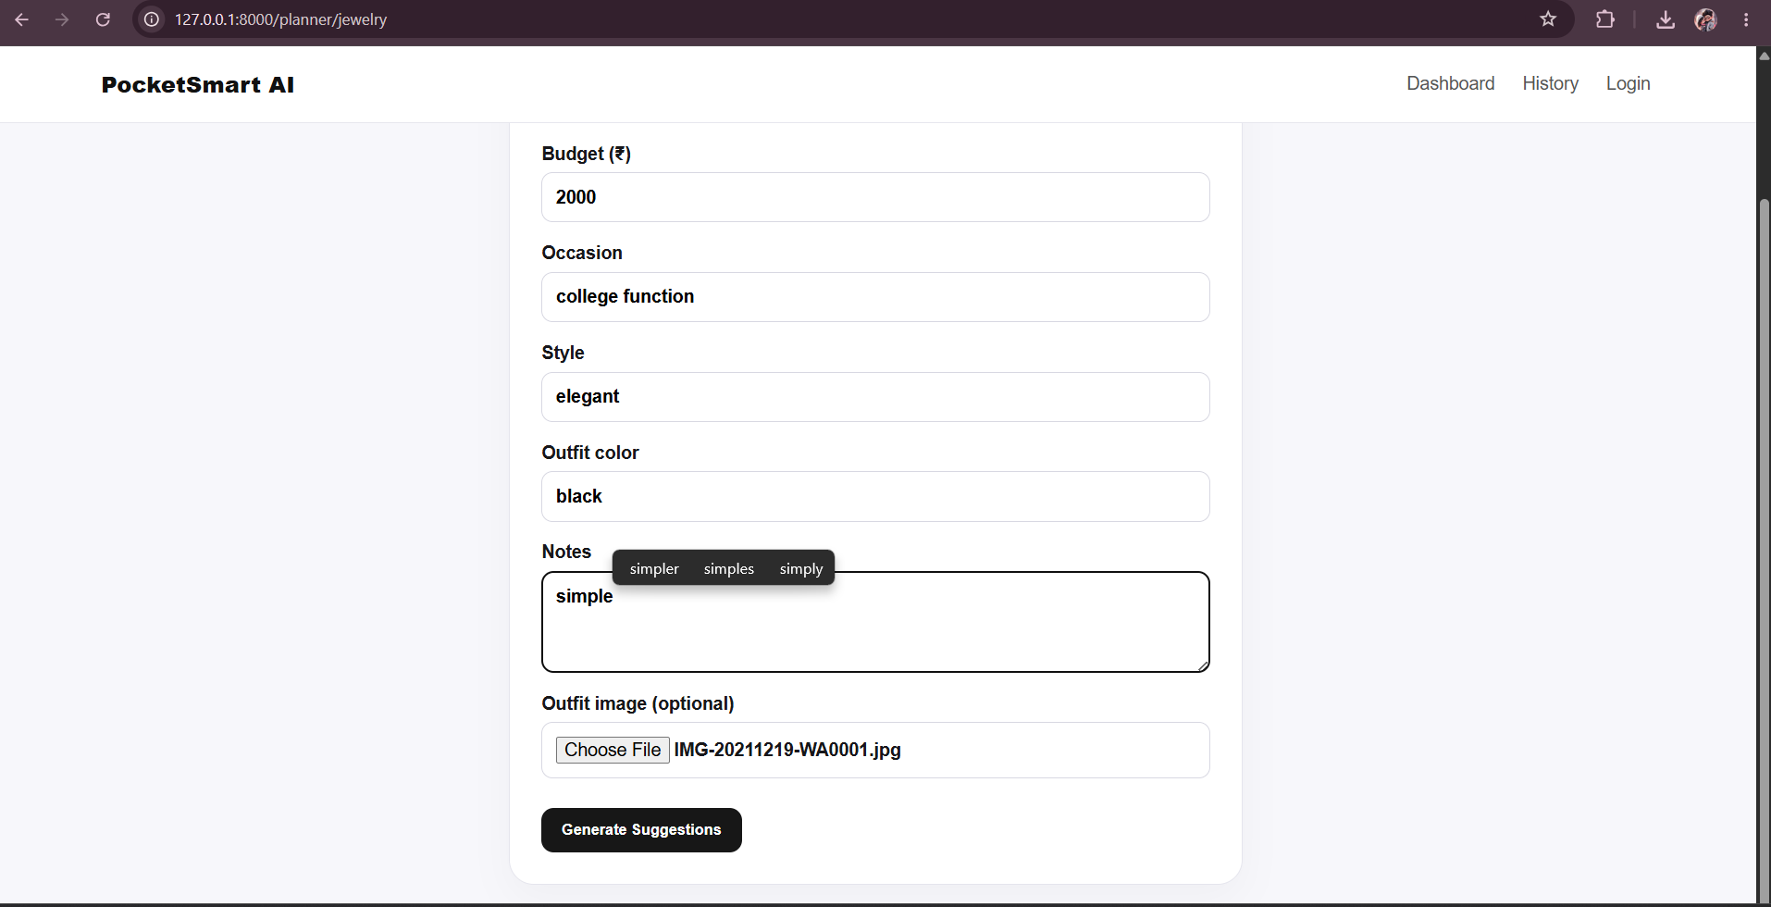
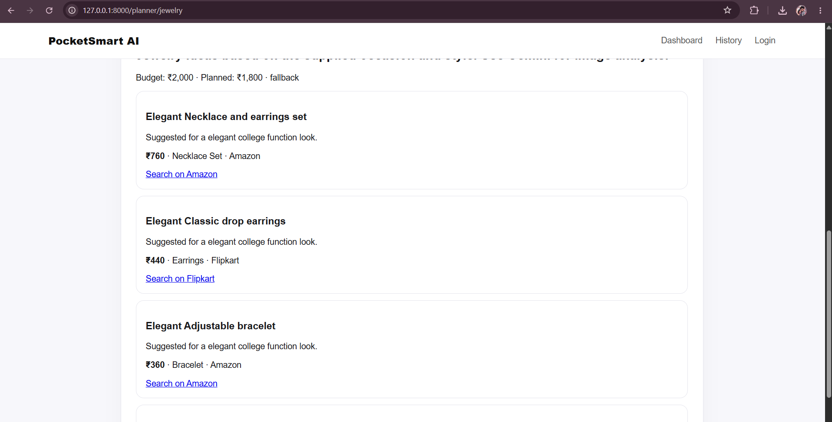

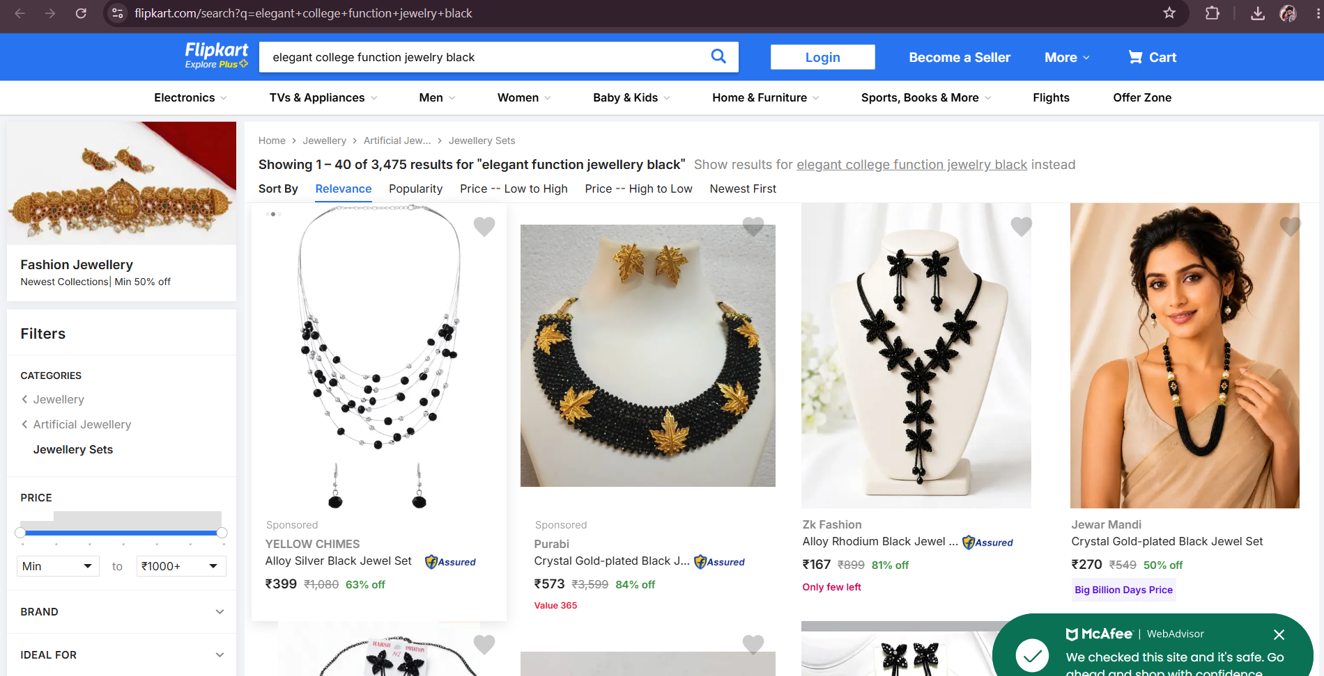
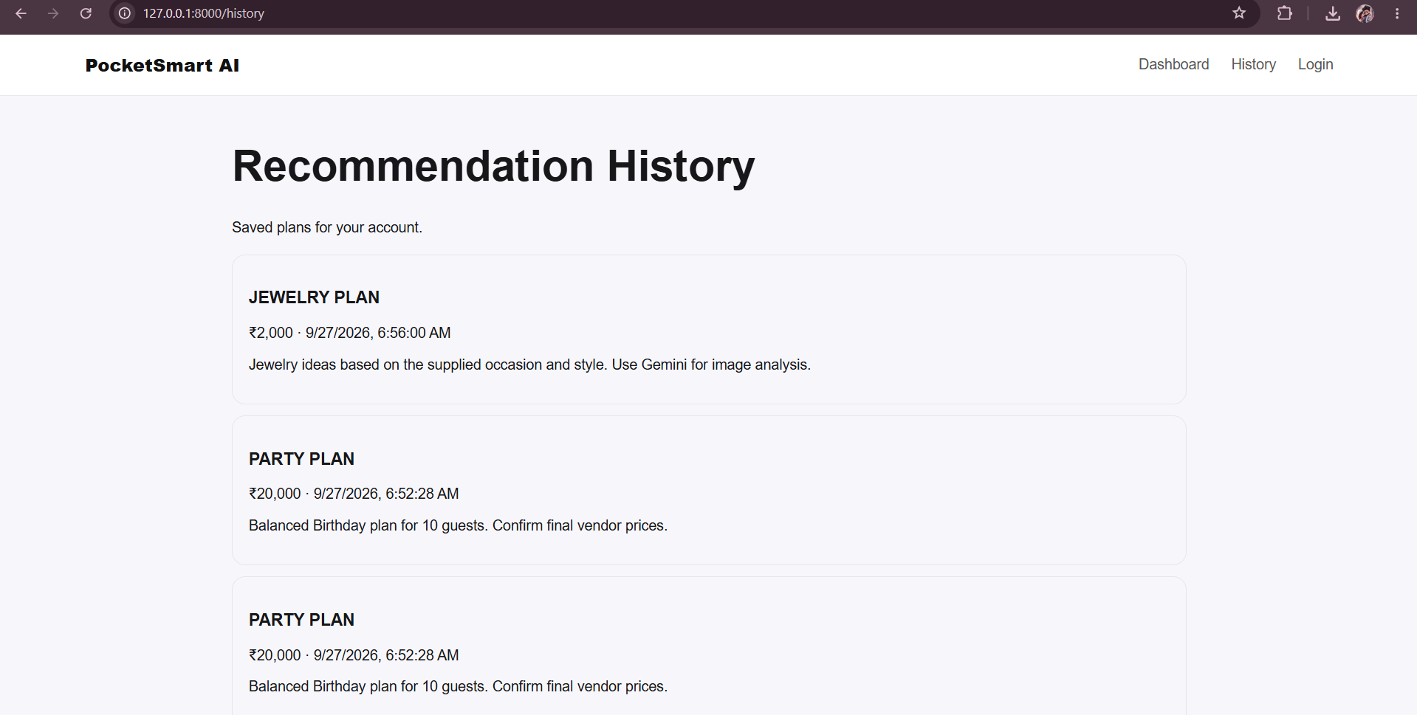
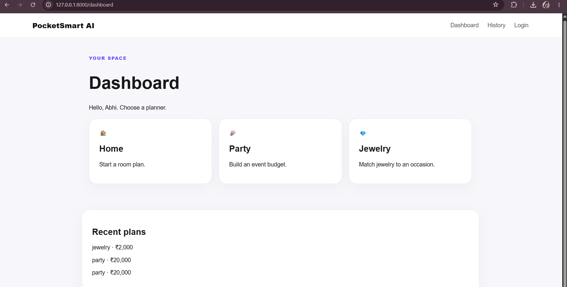

20.9 Result Summary
- The project combines multiple budget-planning functions in one web application.
- Authentication and session-related API support are included.
- AI and fallback recommendation paths are included.
- Recommendation history is supported through SQLite.
- The project provides REST API documentation and automated testing support.

ADVANTAGES
- Provides multiple planning modules in one application.
- Uses GenAI to support personalized recommendation generation.
- Includes a fallback recommendation mechanism.
- Maintains recommendation history.
- Supports optional image input for jewelry planning.
- Uses JWT-based authentication.
- Uses SQLite for a lightweight database setup.
- Provides FastAPI REST APIs and Swagger documentation.
- Includes automated testing support.
- Can be extended with additional planning modules.

LIMITATIONS
- Recommendation quality depends on the supplied user information and AI-service availability.
- The current project materials do not describe a production-grade deployment environment.
- The supplied documentation does not specify a complete analytics or reporting dashboard.
- The project currently focuses on the three documented planner categories.
- The exact final database schema and UI screenshots depend on the implemented source version.

FUTURE ENHANCEMENTS
- Add more budget-planning categories such as travel, shopping and event planning.
- Add richer recommendation history filters and search.
- Add downloadable recommendation reports.
- Add user preference profiles for more personalized recommendations.
- Improve image-based recommendation capabilities.
- Add production deployment and monitoring.
- Add stronger security controls such as rate limiting and centralized secret management.
- Add dashboards for usage and recommendation statistics.
- Provide a mobile-friendly packaged application if required.
- Expand automated test coverage and continuous integration.

CONCLUSION
PocketSmart AI is a GenAI-powered web application developed to support budget planning and recommendation tasks through a single interface. The project brings together user authentication, three planning modules, Gemini AI integration, a fallback recommendation engine, recommendation history, SQLite storage, REST APIs and automated testing support.
The project demonstrates how modern web technologies and GenAI services can be combined to create an application that accepts structured user requirements and returns useful recommendations. The architecture also provides a foundation for future enhancements such as additional planners, stronger personalization, richer history and production deployment.

Overall Project Outcome
- A unified budget recommendation application concept has been implemented.
- Multiple planner modules are supported.
- Authentication, database and history capabilities are included.
- AI and fallback recommendation paths are incorporated.
- The project is structured for further development and academic demonstration.

REFERENCES

Project-Supplied References
- PocketSmart AI project README supplied with the project materials.
- Project dependency list (requirements.txt) supplied with the project materials.
- Project source files and implementation materials supplied for the PocketSmart AI project.
- Education Website project documentation supplied as a formatting/reference model only; its project content is not used as PocketSmart AI functionality.

Technical Documentation / Tools
- FastAPI — REST API framework documentation.
- Python — programming language documentation.
- SQLAlchemy — database ORM documentation.
- Google GenAI / Gemini integration documentation.
- pytest — Python testing framework documentation.
- HTTPX — HTTP client documentation.

Submission Note: Before final college submission, replace all blank cover-page fields, insert actual project screenshots, confirm the final database/schema details against the source code, and update the testing table with the actual execution results.

