## 1)Mi 4X 108 cm (43 inch) Ultra HD (4K) LED Smart Android TV

₹28,999

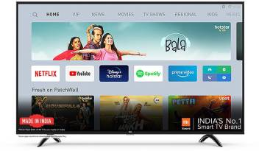

## 2)Realme 108 cm (43 inch) Full HD LED Smart Android TV  (TV 43)

₹22,999

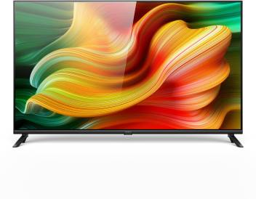

## 3)Samsung 80 cm (32 inch) HD Ready LED Smart TV 2020 Edition  (UA32T4340AKXXL)

₹15,999

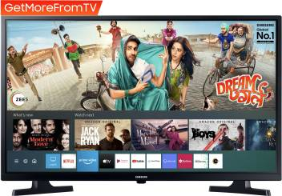

## 4)Huidi 80 cm (32 inch) HD Ready LED TV  (HD32D1M19)

₹10,199

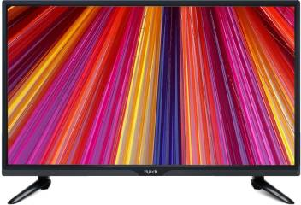

## 5)LG 80 cm (32 inch) HD Ready LED Smart TV 2020 Edition  (32LM565BPTA)

₹15,999

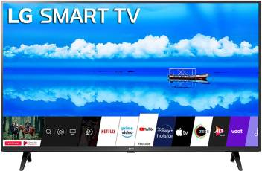

## 6)Panasonic 100 cm (40 inch) Full HD LED Smart Android TV  (TH-40HS450DX)

₹26,999

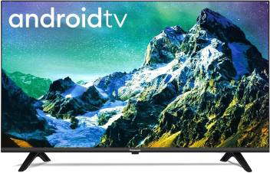

## 7)OnePlus Y Series 108 cm (43 inch) Full HD LED Smart Android TV  (43FA0A00)

₹23,999

