**1. What is Data Science?**

[**Data Science**](https://intellipaat.com/blog/what-is-data-science/) is a field of computer science that explicitly deals with turning data into information and extracting meaningful insights out of it. The reason why Data Science is so popular is that the kind of insights it allows us to draw from the available data has led to some major innovations in several products and companies.

**2. Differentiate between Data Analytics and Data Science**

|  |  |
| --- | --- |
| **Data Analytics** | **Data Science** |
| Data Analytics is a subset of Data Science. | Data Science is a broad technology that includes various subsets such as Data Analytics, Data Mining, Data Visualization, etc. |
| The goal of data analytics is to illustrate the precise details of retrieved insights. | The goal of data science is to discover meaningful insights from massive datasets and derive the best possible solutions to resolve business issues. |
| Requires just basic programming languages. | Requires knowledge in advanced programming languages. |
| It focuses on just finding the solutions. | Data Science not only focuses on finding the solutions but also predicts the future with past patterns or insights. |
| A data analyst’s job is to analyse data in order to make decisions. | A data scientist’s job is to provide insightful data visualizations from raw data that are easily understandable. |

**3. What do you understand about linear regression?**

[Linear regression](https://intellipaat.com/blog/what-is-linear-regression/) helps in understanding the linear relationship between the dependent and the independent variables. Linear regression is a supervised learning algorithm, which helps in finding the linear relationship between two variables. One is the predictor or the independent variable and the other is the response or the dependent variable. In Linear Regression, we try to understand how the dependent variable changes w.r.t the independent variable. If there is only one independent variable, then it is called simple linear regression, and if there is more than one independent variable then it is known as multiple linear regression.

Bottom of Form

**4. What do you understand by logistic regression?**

[Logistic regression](https://intellipaat.com/blog/what-is-logistic-regression/) is a classification algorithm that can be used when the dependent variable is binary. Let’s take an example. Here, we are trying to determine whether it will rain or not on the basis of temperature and humidity.

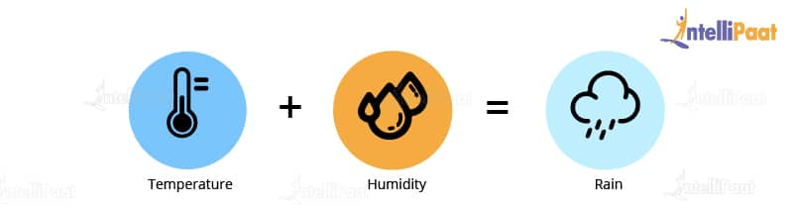

Temperature and humidity are the independent variables, and rain would be our dependent variable. So, the logistic regression algorithm actually produces an S shape curve.

Now, let us look at another scenario: Let’s suppose that x-axis represents the runs scored by Virat Kohli and the y-axis represents the probability of the team India winning the match. From this graph, we can say that if Virat Kohli scores more than 50 runs, then there is a greater probability for team India to win the match. Similarly, if he scores less than 50 runs then the probability of team India winning the match is less than 50 percent.

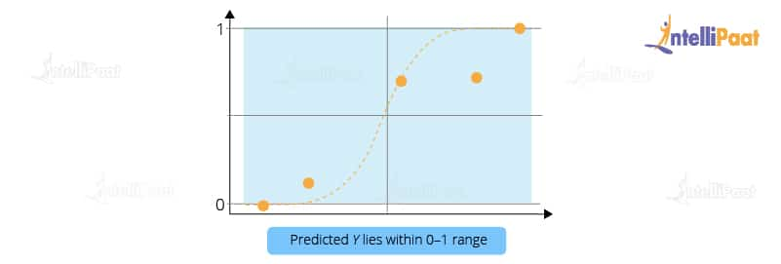

So, basically in logistic regression, the Y value lies within the range of 0 and 1. This is how logistic regression works.

**5. What is a confusion matrix?**

The [confusion matrix](https://intellipaat.com/blog/confusion-matrix-python/) is a table that is used to estimate the performance of a model. It tabulates the actual values and the predicted values in a 2×2 matrix.

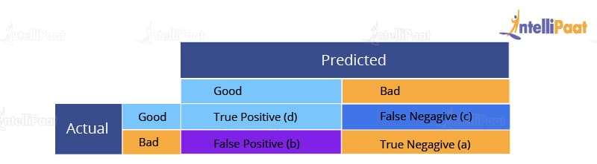

True Positive (d): This denotes all of those records where the actual values are true and the predicted values are also true. So, these denote all of the true positives. False Negative (c): This denotes all of those records where the actual values are true, but the predicted values are false. False Positive (b): In this, the actual values are false, but the predicted values are true. True Negative (a): Here, the actual values are false and the predicted values are also false. So, if you want to get the correct values, then correct values would basically represent all of the true positives and the true negatives. This is how the confusion matrix works.

**6. What do you understand about the true-positive rate and false-positive rate?**

True positive rate: In Machine Learning, true-positive rates, which are also referred to as sensitivity or recall, are used to measure the percentage of actual positives which are correctly identified. Formula: True Positive Rate = True Positives/Positives False positive rate: False positive rate is basically the probability of falsely rejecting the null hypothesis for a particular test. The false-positive rate is calculated as the ratio between the number of negative events wrongly categorized as positive (false positive) upon the total number of actual events. Formula: False-Positive Rate = False-Positives/Negatives.

**7. How is Data Science different from traditional application programming?**

Data Science takes a fundamentally different approach in building systems that provide value than traditional application development.

In traditional programming paradigms, we used to analyze the input, figure out the expected output, and write code, which contains rules and statements needed to transform the provided input into the expected output. As we can imagine, these rules were not easy to write, especially, for data that even computers had a hard time understanding, e.g., images, videos, etc.

Data Science shifts this process a little bit. In it, we need access to large volumes of data that contain the necessary inputs and their mappings to the expected outputs. Then, we use Data Science algorithms, which use mathematical analysis to generate rules to map the given inputs to outputs.

This process of rule generation is called training. After training, we use some data that was set aside before the training phase to test and check the system’s accuracy. The generated rules are a kind of a black box, and we cannot understand how the inputs are being transformed into outputs.

However, If the accuracy is good enough, then we can use the system (also called a model).

As described above, in traditional programming, we had to write the rules to map the input to the output, but in Data Science, the rules are automatically generated or learned from the given data. This helped solve some really difficult challenges that were being faced by several companies.

***Interested to learn Data Science skills? Check our***[***Data Science course in Kottayam***](https://intellipaat.com/data-scientist-course-training-kottayam/)***Now!***

**8. Explain the differences between supervised and unsupervised learning.**

Supervised and unsupervised learning are two types of Machine Learning techniques. They both allow us to build models. However, they are used for solving different kinds of problems.

|  |  |
| --- | --- |
| **Supervised Learning** | **Unsupervised Learning** |
| Works on the data that contains both inputs and the expected output, i.e., the labeled data | Works on the data that contains no mappings from input to output, i.e., the unlabeled data |
| Used to create models that can be employed to predict or classify things | Used to extract meaningful information out of large volumes of data |
| Commonly used supervised learning algorithms: Linear regression, decision tree, etc. | Commonly used unsupervised learning algorithms: K-means clustering, [**Apriori algorithm**](https://intellipaat.com/blog/data-science-apriori-algorithm/), etc. |

**9. What is the difference between the long format data and wide format data?**

|  |  |
| --- | --- |
| **Long Format Data** | **Wide Format Data** |
| A long format data has a column for possible variable types and a column for the values of those variables. | Whereas, Wide data has a column for each variable. |
| Each row in the long format represents one time point per subject. As a result, each topic will contain many rows of data. | The repeated responses of a subject will be in a single row, with each response in its own column, in the wide format. |
| This data format is most typically used in R analysis and for writing to log files at the end of each experiment. | This data format is most widely used in data manipulations, stats programmes for repeated measures ANOVAs and is seldom used in R analysis. |
| A long format contains values that do repeat in the first column. | A wide format contains values that do not repeat in the first column. |
| Use df.melt() to convert wide form to long form | use df.pivot().reset_index() to convert long form into wide form |

**10. Mention some techniques used for sampling. What is the main advantage of sampling?**

Sampling is defined as the process of selecting a sample from a group of people or from any particular kind for research purposes. It is one of the most important factors which decides the accuracy of a research/survey result.

**Mainly, there are two types of sampling techniques:**

**Probability sampling:**It involves random selection which makes every element get a chance to be selected. Probability sampling has various subtypes in it, as mentioned below:

* Simple Random Sampling
* Stratified sampling
* Systematic sampling
* Cluster Sampling
* Multi-stage Sampling
* **Non- Probability Sampling:** Non-probability sampling follows non-random selection which means the selection is done based on your ease or any other required criteria. This helps to collect the data easily. The following are various types of sampling in it:
  + Convenience Sampling
  + Purposive Sampling
  + Quota Sampling
  + Referral /Snowball Sampling

**11. What is bias in Data Science?**

Bias is a type of error that occurs in a Data Science model because of using an algorithm that is not strong enough to capture the underlying patterns or trends that exist in the data. In other words, this error occurs when the data is too complicated for the algorithm to understand, so it ends up building a model that makes simple assumptions. This leads to lower accuracy because of underfitting. Algorithms that can lead to high bias are linear regression, logistic regression, etc.==

**12. What is dimensionality reduction?**

Dimensionality reduction is the process of converting a dataset with a high number of dimensions (fields) to a dataset with a lower number of dimensions. This is done by dropping some fields or columns from the dataset. However, this is not done haphazardly. In this process, the dimensions or fields are dropped only after making sure that the remaining information will still be enough to succinctly describe similar information.

**13. Why is Python used for Data Cleaning in DS?**

Data Scientists have to clean and transform the huge data sets in a form that they can work with. It is important to deal with the redundant data for better results by removing nonsensical outliers, malformed records, missing values, inconsistent formatting, etc.

Python libraries such as  Matplotlib, Pandas, Numpy, Keras, and SciPy are extensively used for [Data cleaning](https://intellipaat.com/blog/tutorial/data-science-tutorial/data-extraction/) and analysis. These libraries are used to load and clean the data and do effective analysis. For example, a CSV file named “Student” has information about the students of an institute like their names, standard, address, phone number, grades, marks, etc.

*Learn more about Data Cleaning in a*[*Data Science Tutorial*](https://intellipaat.com/blog/tutorial/data-science-tutorial/)*!*

**Career Transition**

[[](javascript:void(0);)](javascript:void(0);)

[[](javascript:void(0);)](javascript:void(0);)

[[](javascript:void(0);)](javascript:void(0);)

**14. Why is R used in Data Visualization?**

R provides the best ecosystem for data analysis and visualization with more than 12,000 packages in Open-source repositories. It has huge community support, which means you can easily find the solution to your problems on various platforms like StackOverflow.

It has better data management and supports distributed computing by splitting the operations between multiple tasks and nodes, which eventually decreases the complexity and execution time of large datasets.

**15. What are the popular libraries used in Data Science?**

Below are the popular libraries used for data extraction, cleaning, visualization, and deploying DS models:

* TensorFlow: Supports parallel computing with impeccable library management backed by Google.
* SciPy: Mainly used for solving differential equations, multidimensional programming, data manipulation, and visualization through graphs and charts.
* Pandas: Used to implement the ETL(Extracting, Transforming, and Loading the datasets) capabilities in business applications.
* Matplotlib: Being free and open-source, it can be used as a replacement for MATLAB, which results in better performance and low memory consumption.
* PyTorch: Best for projects which involve Machine Learning algorithms and Deep Neural Networks.

***Interested to learn more about Data Science, check out our***[***Data Science Course in New York***](https://intellipaat.com/data-scientist-course-training-new-york/)***!***

**16. What is variance in Data Science?**

Variance is a type of error that occurs in a Data Science model when the model ends up being too complex and learns features from data, along with the noise that exists in it. This kind of error can occur if the algorithm used to train the model has high complexity, even though the data and the underlying patterns and trends are quite easy to discover. This makes the model a very sensitive one that performs well on the training dataset but poorly on the testing dataset, and on any kind of data that the model has not yet seen. Variance generally leads to poor accuracy in testing and results in overfitting.

**17. What is pruning in a decision tree algorithm?**

Pruning a decision tree is the process of removing the sections of the tree that are not necessary or are redundant. Pruning leads to a smaller decision tree, which performs better and gives higher accuracy and speed.

**18. What is entropy in a decision tree algorithm?**

In a decision tree algorithm, entropy is the measure of impurity or randomness. The entropy of a given dataset tells us how pure or impure the values of the dataset are. In simple terms, it tells us about the variance in the dataset.  
For example, suppose we are given a box with 10 blue marbles. Then, the entropy of the box is 0 as it contains marbles of the same color, i.e., there is no impurity. If we need to draw a marble from the box, the probability of it being blue will be 1.0. However, if we replace 4 of the blue marbles with 4 red marbles in the box, then the entropy increases to 0.4 for drawing blue marbles.

**19. What information is gained in a decision tree algorithm?**

When building a decision tree, at each step, we have to create a node that decides which feature we should use to split data, i.e., which feature would best separate our data so that we can make predictions. This decision is made using information gain, which is a measure of how much entropy is reduced when a particular feature is used to split the data. The feature that gives the highest information gain is the one that is chosen to split the data.

***Explore this***[***Data Science Course in Delhi***](https://intellipaat.com/data-scientist-course-training-delhi/)***and master decision tree algorithm.***

**20. What is k-fold cross-validation?**

In k-fold cross-validation, we divide the dataset into k equal parts. After this, we loop over the entire dataset k times. In each iteration of the loop, one of the k parts is used for testing, and the other k − 1 parts are used for training. Using k-fold cross-validation, each one of the k parts of the dataset ends up being used for training and testing purposes.

**21. Explain how a recommender system works.**

A recommender system is a system that many consumer-facing, content-driven, online platforms employ to generate recommendations for users from a library of available content. These systems generate recommendations based on what they know about the users’ tastes from their activities on the platform.

For example, imagine that we have a movie streaming platform, similar to Netflix or Amazon Prime. If a user has previously watched and liked movies from action and horror genres, then it means that the user likes watching the movies of these genres. In that case, it would be better to recommend such movies to this particular user. These recommendations can also be generated based on what users with a similar taste like watching.

**22. What is a normal distribution?**

Data distribution is a visualization tool to analyze how data is spread out or distributed. Data can be distributed in various ways. For instance, it could be with a bias to the left or the right, or it could all be jumbled up.

Data may also be distributed around a central value, i.e., mean, median, etc. This kind of distribution has no bias either to the left or to the right and is in the form of a bell-shaped curve. This distribution also has its mean equal to the median. This kind of distribution is called a [normal distribution](https://intellipaat.com/blog/tutorial/statistics-and-probability-tutorial/the-normal-distribution/).

**23. What is Deep Learning?**

Deep Learning is a kind of Machine Learning, in which neural networks are used to imitate the structure of the human brain, and just like how a brain learns from information, machines are also made to learn from the information that is provided to them.

[Deep Learning](https://intellipaat.com/blog/tutorial/machine-learning-tutorial/introduction-deep-learning/) is an advanced version of neural networks to make the machines learn from data. In Deep Learning, the neural networks comprise many hidden layers (which is why it is called ‘deep’ learning) that are connected to each other, and the output of the previous layer is the input of the current layer.

**Courses you may like**

[](https://intellipaat.com/data-science-architect-masters-program-training/)

[](https://intellipaat.com/advanced-certification-data-science-artificial-intelligence-iit-madras/)

[](https://intellipaat.com/pg-certification-data-science-machine-learning-mnit/)

**24. What is an RNN (recurrent neural network)?**

A [recurrent neural network](https://intellipaat.com/blog/tutorial/artificial-intelligence-tutorial/recurrent-neural-network/), or RNN for short, is a kind of Machine Learning algorithm that makes use of the artificial neural network. RNNs are used to find patterns from a sequence of data, such as time series, stock market, temperature, etc. RNNs are a kind of feedforward network, in which information from one layer passes to another layer, and each node in the network performs mathematical operations on the data. These operations are temporal, i.e., RNNs store contextual information about previous computations in the network. It is called recurrent because it performs the same operations on some data every time it is passed. However, the output may be different based on past computations and their results.

**25. Explain selection bias.**

Selection bias is the bias that occurs during the sampling of data. This kind of bias occurs when a sample is not representative of the population, which is going to be analyzed in a statistical study.

**Intermediate Data Science Interview Questions**

**26. What is the ROC curve?**

It stands for [**Receiver Operating Characteristic**](https://intellipaat.com/blog/roc-curve-in-machine-learning/). It is basically a plot between a true positive rate and a false positive rate, and it helps us to find out the right tradeoff between the true positive rate and the false positive rate for different probability thresholds of the predicted values. So, the closer the curve to the upper left corner, the better the model is. In other words, whichever curve has greater area under it that would be the better model. You can see this in the below graph: 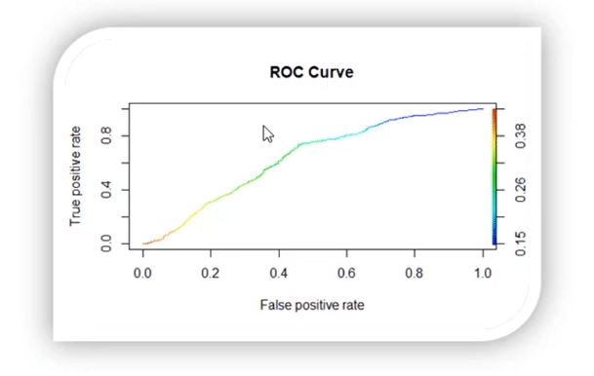

**27. What do you understand by a decision tree?**

A [decision tree](https://intellipaat.com/blog/decision-tree-algorithm-in-machine-learning/) is a supervised learning algorithm that is used for both classification and regression. Hence, in this case, the dependent variable can be both a numerical value and a categorical value. 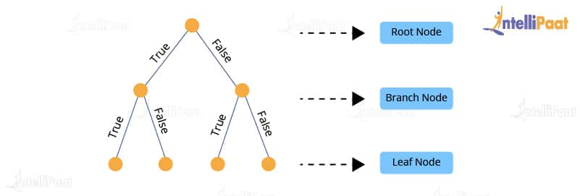 Here, each node denotes the test on an attribute, and each edge denotes the outcome of that attribute, and each leaf node holds the class label. So, in this case, we have a series of test conditions which give the final decision according to the condition.

***Are you interested in learning Data Science from experts? Enroll in our***[***Data Science Course in Bangalore***](https://intellipaat.com/data-scientist-course-training-bangalore/)***now!***

**28. What do you understand by a random forest model?**

It combines multiple models together to get the final output or, to be more precise, it combines multiple decision trees together to get the final output. So, decision trees are the building blocks of the random forest model.

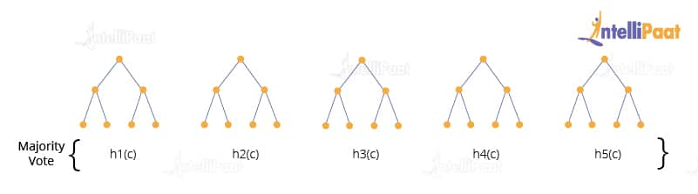

**29. Two candidates, Aman and Mohan appear for a Data Science Job interview. The probability of Aman cracking the interview is 1/8 and that of Mohan is 5/12. What is the probability that at least one of them will crack the interview?**

The probability of Aman getting selected for the interview is 1/8

P(A) = 1/8

The probability of Mohan getting selected for the interview is 5/12

P(B)=5/12

Now, the probability of at least one of them getting selected can be denoted at the Union of A and B, which means

P(A U B) =P(A)+ P(B) – (P(A ∩ B)) ………………………(1)

Where P(A ∩ B) stands for the probability of both Aman and Mohan getting selected for the job.

To calculate the final answer, we first have to find out the value of P(A ∩ B)

So, P(A ∩ B) = P(A) * P(B)

1/8 * 5/12

5/96

Now, put the value of P(A ∩ B) into equation (1)

P(A U B) =P(A)+ P(B) – (P(A ∩ B))

1/8 + 5/12 -5/96

So, the answer will be 47/96.

**30. How is Data modeling different from Database design?**

Data Modeling: It can be considered as the first step towards the design of a database. Data modeling creates a conceptual model based on the relationship between various data models. The process involves moving from the conceptual stage to the logical model to the physical schema. It involves the systematic method of applying data modeling techniques.

Database Design: This is the process of designing the database. The database design creates an output which is a detailed data model of the database. Strictly speaking, database design includes the detailed logical model of a database but it can also include physical design choices and storage parameters.

**31. What is precision?**

**Precision**: When we are implementing algorithms for the classification of data or the retrieval of information, precision helps us get a portion of positive class values that are positively predicted. Basically, it measures the accuracy of correct positive predictions. Below is the formula to calculate precision:

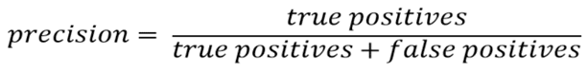

**32. What is a recall?**

**Recall**: It is the set of all positive predictions out of the total number of positive instances. Recall helps us identify the misclassified positive predictions. We use the below formula to calculate recall:

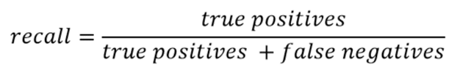

**33. What is the F1 score and how to calculate it?**

F1 score helps us calculate the harmonic mean of precision and recall that gives us the test’s accuracy. If F1 = 1, then precision and recall are accurate. If F1 < 1 or equal to 0, then precision or recall is less accurate, or they are completely inaccurate. See below for the formula to calculate the F1 score: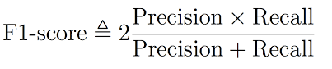

**34. What is a p-value?**

P-value is the measure of the statistical importance of an observation. It is the probability that shows the significance of output to the data. We compute the p-value to know the test statistics of a model. Typically, it helps us choose whether we can accept or reject the null hypothesis.

**35. Why do we use p-value?**

We use the p-value to understand whether the given data really describes the observed effect or not. We use the below formula to calculate the p-value for the effect ‘E’ and the null hypothesis ‘H0’ is true:

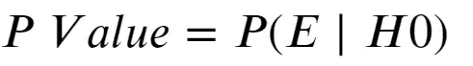

**36. What is the difference between an error and a residual error?**

An error occurs in values while the prediction gives us the difference between the observed values and the true values of a dataset. Whereas, the residual error is the difference between the observed values and the predicted values. The reason we use the residual error to evaluate the performance of an algorithm is that the true values are never known. Hence, we use the observed values to measure the error using residuals. It helps us get an accurate estimate of the error.

**37. Why do we use the summary function?**

The summary function in R gives us the statistics of the implemented algorithm on a particular dataset. It consists of various objects, variables, data attributes, etc. It provides summary statistics for individual objects when fed into the function. We use a summary function when we want information about the values present in the dataset. It gives us the summary statistics in the following form: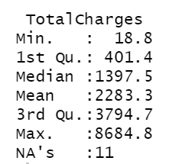Here, it gives the minimum and maximum values from a specific column of the dataset. Also, it provides the median, mean, 1st quartile, and 3rd quartile values that help us understand the values better.

**38. How are Data Science and Machine Learning related to each other?**

Data Science and [Machine Learning](https://intellipaat.com/blog/what-is-machine-learning/) are two terms that are closely related but are often misunderstood. Both of them deal with data. However, there are some fundamental distinctions that show us how they are different from each other.

Data Science is a broad field that deals with large volumes of data and allows us to draw insights out of this voluminous data. The entire process of Data Science takes care of multiple steps that are involved in drawing insights out of the available data. This process includes crucial steps such as data gathering, data analysis, data manipulation, data visualization, etc.

Machine Learning, on the other hand, can be thought of as a sub-field of Data Science. It also deals with data, but here, we are solely focused on learning how to convert the processed data into a functional model, which can be used to map inputs to outputs, e.g., a model that can expect an image as an input and tell us if that image contains a flower as an output.

In short, Data Science deals with gathering data, processing it, and finally, drawing insights from it. The field of Data Science that deals with building models using algorithms is called Machine Learning. Therefore, Machine Learning is an integral part of Data Science.

**39. Explain univariate, bivariate, and multivariate analyses.**

When we are dealing with data analysis, we often come across terms such as univariate, bivariate, and multivariate. Let’s try and understand what these mean.

* Univariate analysis: Univariate analysis involves analyzing data with only one variable or, in other words, a single column or a vector of the data. This analysis allows us to understand the data and extract patterns and trends out of it. Example: Analyzing the weight of a group of people.
* Bivariate analysis: Bivariate analysis involves analyzing the data with exactly two variables or, in other words, the data can be put into a two-column table. This kind of analysis allows us to figure out the relationship between the variables. Example: Analyzing the data that contains temperature and altitude.
* Multivariate analysis: Multivariate analysis involves analyzing the data with more than two variables. The number of columns of the data can be anything more than two. This kind of analysis allows us to figure out the effects of all other variables (input variables) on a single variable (the output variable).

Example: Analyzing data about house prices, which contains information about the houses, such as locality, crime rate, area, the number of floors, etc.

**40. How can we handle missing data?**

To be able to handle missing data, we first need to know the percentage of data missing in a particular column so that we can choose an appropriate strategy to handle the situation.

For example, if in a column the majority of the data is missing, then dropping the column is the best option, unless we have some means to make educated guesses about the missing values. However, if the amount of missing data is low, then we have several strategies to fill them up.

One way would be to fill them all up with a default value or a value that has the highest frequency in that column, such as 0 or 1, etc. This may be useful if the majority of the data in that column contains these values.

Another way is to fill up the missing values in the column with the mean of all the values in that column. This technique is usually preferred as the missing values have a higher chance of being closer to the mean than to the mode.

Finally, if we have a huge dataset and a few rows have values missing in some columns, then the easiest and fastest way is to drop those columns. Since the dataset is large, dropping a few columns should not be a problem anyway.

**41. What is the benefit of dimensionality reduction?**

Dimensionality reduction reduces the dimensions and size of the entire dataset. It drops unnecessary features while retaining the overall information in the data intact. Reduction in dimensions leads to faster processing of the data.

The reason why data with high dimensions is considered so difficult to deal with is that it leads to high time consumption while processing the data and training a model on it. Reducing dimensions speeds up this process, removes noise, and also leads to better model accuracy.

**42. What is a bias-variance trade-off in Data Science?**

When building a model using Data Science or Machine Learning, our goal is to build one that has low bias and variance. We know that bias and variance are both errors that occur due to either an overly simplistic model or an overly complicated model. Therefore, when we are building a model, the goal of getting high accuracy is only going to be accomplished if we are aware of the tradeoff between bias and variance.  
Bias is an error that occurs when a model is too simple to capture the patterns in a dataset. To reduce bias, we need to make our model more complex. Although making the model more complex can lead to reducing bias, and if we make the model too complex, it may end up becoming too rigid, leading to high variance. So, the tradeoff between bias and variance is that if we increase the complexity, the bias reduces and the variance increases, and if we reduce complexity, the bias increases and the variance reduces. Our goal is to find a point at which our model is complex enough to give low bias but not so complex to end up having high variance.

**43. What is RMSE?**

RMSE stands for the root mean square error. It is a measure of accuracy in regression. RMSE allows us to calculate the magnitude of error produced by a regression model. The way RMSE is calculated is as follows:

First, we calculate the errors in the predictions made by the regression model. For this, we calculate the differences between the actual and the predicted values. Then, we square the errors.

After this step, we calculate the mean of the squared errors, and finally, we take the square root of the mean of these squared errors. This number is the RMSE, and a model with a lower value of RMSE is considered to produce lower errors, i.e., the model will be more accurate.

**44. What is a kernel function in SVM?**

In the [SVM algorithm](https://intellipaat.com/blog/tutorial/machine-learning-tutorial/svm-algorithm-in-python/), a kernel function is a special mathematical function. In simple terms, a kernel function takes data as input and converts it into a required form. This transformation of the data is based on something called a kernel trick, which is what gives the kernel function its name. Using the kernel function, we can transform the data that is not linearly separable (cannot be separated using a straight line) into one that is linearly separable.

**45. How can we select an appropriate value of k in k-means?**

Selecting the correct value of *k* is an important aspect of k-means clustering. We can make use of the elbow method to pick the appropriate k value. To do this, we run the k-means algorithm on a range of values, e.g., 1 to 15. For each value of k, we compute an average score. This score is also called inertia or the inter-cluster variance.

This is calculated as the sum of squares of the distances of all values in a cluster. As k starts from a low value and goes up to a high value, we start seeing a sharp decrease in the inertia value. After a certain value of k, in the range, the drop in the inertia value becomes quite small. This is the value of k that we need to choose for the k-means clustering algorithm.

**46. How can we deal with outliers?**

Outliers can be dealt with in several ways. One way is to drop them. We can only drop the outliers if they have values that are incorrect or extreme. For example, if a dataset with the weights of babies has a value 98.6-degree Fahrenheit, then it is incorrect. Now, if the value is 187 kg, then it is an extreme value, which is not useful for our model.

**In case the outliers are not that extreme, then we can try:**

* A different kind of model. For example, if we were using a linear model, then we can choose a non-linear model
* Normalizing the data, which will shift the extreme values closer to other data points
* Using algorithms that are not so affected by outliers, such as random forest, etc.

**47. How to calculate the accuracy of a binary classification algorithm using its confusion matrix?**

In a binary classification algorithm, we have only two labels, which are True and False. Before we can calculate the accuracy, we need to understand a few key terms:

* True positives: Number of observations correctly classified as True
* True negatives: Number of observations correctly classified as False
* False positives: Number of observations incorrectly classified as True
* False negatives: Number of observations incorrectly classified as False

To calculate the accuracy, we need to divide the sum of the correctly classified observations by the number of total observations. This can be expressed as follows:

**48. What is ensemble learning?**

When we are building models using Data Science and Machine Learning, our goal is to get a model that can understand the underlying trends in the training data and can make predictions or classifications with a high level of accuracy.

However, sometimes some datasets are very complex, and it is difficult for one model to be able to grasp the underlying trends in these datasets. In such situations, we combine several individual models together to improve performance. This is what is called ensemble learning.

**49. Explain collaborative filtering in recommender systems.**

Collaborative filtering is a technique used to build recommender systems. In this technique, to generate recommendations, we make use of data about the likes and dislikes of users similar to other users. This similarity is estimated based on several varying factors, such as age, gender, locality, etc.

If User A, similar to User B, watched and liked a movie, then that movie will be recommended to User B, and similarly, if User B watched and liked a movie, then that would be recommended to User A.

In other words, the content of the movie does not matter much. When recommending it to a user what matters is if other users similar to that particular user liked the content of the movie or not.

**50. Explain content-based filtering in recommender systems.**

Content-based filtering is one of the techniques used to build recommender systems. In this technique, recommendations are generated by making use of the properties of the content that a user is interested in.

For example, if a user is watching movies belonging to the action and mystery genre and giving them good ratings, it is a clear indication that the user likes movies of this kind. If shown movies of a similar genre as recommendations, there is a higher probability that the user would like those recommendations as well.

In other words, here, the content of the movie is taken into consideration when generating recommendations for users.

**51. Explain bagging in Data Science.**

Bagging is an ensemble learning method. It stands for bootstrap aggregating. In this technique, we generate some data using the bootstrap method, in which we use an already existing dataset and generate multiple samples of the *N* size. This bootstrapped data is then used to train multiple models in parallel, which makes the bagging model more robust than a simple model.

Once all the models are trained, when it’s time to make a prediction, we make predictions using all the trained models and then average the result in the case of regression, and for classification, we choose the result, generated by models, that have the highest frequency.

**52. Explain boosting in Data Science.**

Boosting is one of the ensemble learning methods. Unlike bagging, it is not a technique used to parallelly train our models. In boosting, we create multiple models and sequentially train them by combining weak models iteratively in a way that training a new model depends on the models trained before it.

In doing so, we take the patterns learned by a previous model and test them on a dataset when training the new model. In each iteration, we give more importance to observations in the dataset that are incorrectly handled or predicted by previous models. Boosting is useful in reducing bias in models as well.

**53. Explain stacking in Data Science.**

Just like bagging and boosting, stacking is also an ensemble learning method. In bagging and boosting, we could only combine weak models that used the same learning algorithms, e.g., logistic regression. These models are called homogeneous learners.

However, in stacking, we can combine weak models that use different learning algorithms as well. These learners are called heterogeneous learners. Stacking works by training multiple (and different) weak models or learners and then using them together by training another model, called a meta-model, to make predictions based on the multiple outputs of predictions returned by these multiple weak models.

**54. Explain how Machine Learning is different from Deep Learning.**

A field of computer science, Machine Learning is a subfield of Data Science that deals with using existing data to help systems automatically learn new skills to perform different tasks without having rules to be explicitly programmed.

Deep Learning, on the other hand, is a field in Machine Learning that deals with building Machine Learning models using algorithms that try to imitate the process of how the human brain learns from the information in a system for it to attain new capabilities. In Deep Learning, we make heavy use of deeply connected neural networks with many layers.

**55. What does the word ‘Naive’ mean in Naive Bayes?**

Naive Bayes is a Data Science algorithm. It has the word ‘Bayes’ in it because it is based on the Bayes theorem, which deals with the probability of an event occurring given that another event has already occurred.

It has ‘naive’ in it because it makes the assumption that each variable in the dataset is independent of the other. This kind of assumption is unrealistic for real-world data. However, even with this assumption, it is very useful for solving a range of complicated problems, e.g., spam email classification, etc.

***To learn more about Data Science, check out our***[***Data Science Course in Hyderabad***](https://intellipaat.com/data-scientist-course-training-hyderabad/)***.***

**Advanced Data Science Interview Questions**

**56. From the below given ‘diamonds’ dataset, extract only those rows where the ‘price’ value is greater than 1000 and the ‘cut’ is ideal.**

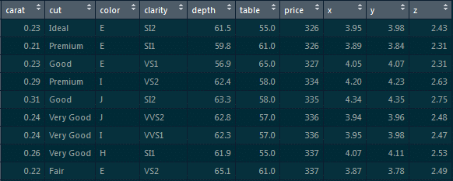

First, we will load the **ggplot2** package:

library(ggplot2)

Next, we will use the **dplyr** package:

library(dplyr)// It is based on the grammar of data manipulation.

To extract those particular records, use the below command:

diamonds %>% filter(price>1000 & cut==”Ideal”)-> diamonds_1000_idea

**57. Make a scatter plot between ‘price’ and ‘carat’ using ggplot. ‘Price’ should be on the y-axis, ’carat’ should be on the x-axis, and the ‘color’ of the points should be determined by ‘cut.’**

We will implement the scatter plot using **ggplot**.

The ggplot is based on the grammar of data visualization, and it helps us stack multiple layers on top of each other.

So, we will start with the data layer, and on top of the data layer we will stack the aesthetic layer. Finally, on top of the aesthetic layer we will stack the geometry layer.

**Code**:

>ggplot(data=diamonds, aes(x=caret, y=price, col=cut))+geom_point()

**58. Introduce 25 percent missing values in this ‘iris’ dataset and impute the ‘Sepal.Length’ column with ‘mean’ and the ‘Petal.Length’ column with ‘median.’**

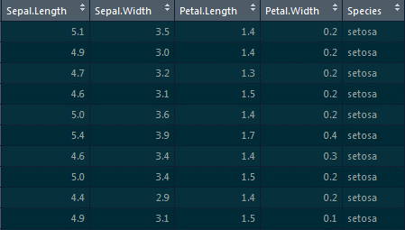

To introduce missing values, we will be using the **missForest** package:

library(missForest)

Using the prodNA function, we will be introducing 25 percent of missing values:

Iris.mis<-prodNA(iris,noNA=0.25)

For imputing the ‘Sepal.Length’ column with ‘mean’ and the ‘Petal.Length’ column with ‘median,’ we will be using the Hmisc package and the impute function:

library(Hmisc)

iris.mis$Sepal.Length<-with(iris.mis, impute(Sepal.Length,mean))

iris.mis$Petal.Length<-with(iris.mis, impute(Petal.Length,median))

**59. Implement simple linear regression in R on this ‘mtcars’ dataset, where the dependent variable is ‘mpg’ and the independent variable is ‘disp.’**

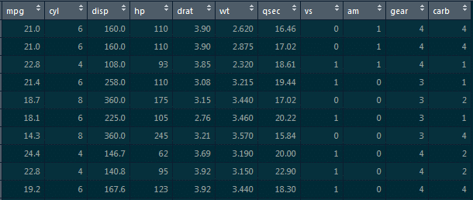

Here, we need to find how ‘mpg’ varies w.r.t displacement of the column.

We need to divide this data into the training dataset and the testing dataset so that the model does not overfit the data.

So, what happens is when we do not divide the dataset into these two components, it overfits the dataset. Hence, when we add new data, it fails miserably on that new data.

Therefore, to divide this dataset, we would require the **caret** package. This caret package comprises the **createdatapartition()** function. This function will give the true or false labels.

Here, we will use the following code:

library(caret)

split_tag<-createDataPartition(mtcars$mpg, p=0.65, list=F)

mtcars[split_tag,]->train

mtcars[-split_tag,]->test

lm(mpg-data,data=train)->mod_mtcars

predict(mod_mtcars,newdata=test)->pred_mtcars

>head(pred_mtcars)

**Explanation**:

**Parameters of the createDataPartition function**: First is the column which determines the split (it is the mpg column).

Second is the split ratio which is 0.65, i.e., 65 percent of records will have true labels and 35 percent will have false labels. We will store this in a split_tag object.

Once we have **split_tag** object ready, from this entire **mtcars dataframe,** we will select all those records where the split tag value is **true** and store those records in the **training** set.

Similarly, from the mtcars dataframe, we will select all those record where the split_tag value is **false** and store those records in the**test** set.

So, the split tag will have true values in it, and when we put ‘-’ symbol in front of it, ‘-split_tag’ will contain all of the false labels. We will select all those records and store them in the test set.

We will go ahead and build a model on top of the training set, and for the simple linear model we will require the **lm function**.

lm(mpg-data,data=train)->mod_mtcars

Now, we have built the model on top of the train set. It’s time to predict the values on top of the test set. For that, we will use the **predict** function that takes in two parameters: first is the model which we have built and second is the dataframe on which we have to predict values.

Thus, we have to predict values for the test set and then store them in pred_mtcars.

predict(mod_mtcars,newdata=test)->pred_mtcars

**Output**:

These are the predicted values of mpg for all of these cars.

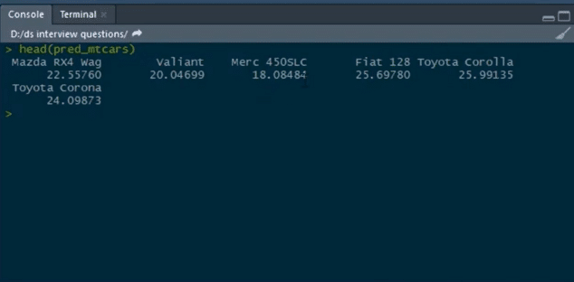

So, this is how we can build a simple linear model on top of this mtcars dataset.

**60. Calculate the RMSE values for the model building.**

When we build a regression model, it predicts certain *y* values associated with the given *x* values, but there is always an error associated with this prediction. So, to get an estimate of the average error in prediction, RMSE is used. **Code:**

cbind(Actual=test$mpg, predicted=pred_mtcars)->final_data

as.data.frame(final_data)->final_data

error<-(final_data$Actual-final_data$Prediction)

cbind(final_data,error)->final_data

sqrt(mean(final_data$error)^2)

**Explanation**: We have the actual and the predicted values. We will bind both of them into a single dataframe. For that, we will use the **cbind** function:

cbind(Actual=test$mpg, predicted=pred_mtcars)->final_data

Our actual values are present in the **mpg** column from the test set, and our predicted values are stored in the **pred_mtcars** object which we have created in the previous question. Hence, we will create this new column and name the column **actual.**Similarly, we will create another column and name it **predicted** which will have predicted values and then store the predicted values in the new object which is**final_data**. After that, we will convert a matrix into a dataframe. So, we will use the **as.data.frame** function and convert this object (predicted values) into a dataframe:

as.data.frame(final_data)->final_data

We will pass this object which is final_data and store the result in final_data again. We will then calculate the error in prediction for each of the records by subtracting the predicted values from the actual values:

error<-(final_data$Actual-final_data$Prediction)

Then, store this result on a new object and name that object as **error**. After this, we will bind this error calculated to the same final_data dataframe:

cbind(final_data,error)->final_data //binding error object to this final_data

Here, we bind the error object to this final_data, and store this into final_data again. **Calculating RMSE**:

Sqrt(mean(final_data$error)^2)

**Output**:

[1] 4.334423

**Note**: Lower the value of RMSE, the better the model. ***R and Python are two of the most important programming languages for***[***Machine Learning Algorithms***](https://intellipaat.com/blog/tutorial/machine-learning-tutorial/machine-learning-algorithms/)***.***

**61. Implement simple linear regression in Python on this ‘Boston’ dataset where the dependent variable is ‘medv’ and the independent variable is ‘lstat.’**

**Simple Linear Regression**

import pandas as pd

data=pd.read_csv(‘Boston.csv’)     //loading the Boston dataset

data.head()  //having a glance at the head of this data

data.shape

Let us take out the dependent and the independent variables from the dataset:

data1=data.loc[:,[‘lstat’,’medv’]]

data1.head()

**Visualizing Variables**

import matplotlib.pyplot as plt

data1.plot(x=’lstat’,y=’medv’,style=’o’)

plt.xlabel(‘lstat’)

plt.ylabel(‘medv’)

plt.show()

Here, ‘medv’ is basically the median values of the price of the houses, and we are trying to find out the median values of the price of the houses w.r.t to the lstat column.

We will separate the dependent and the independent variable from this entire dataframe:

data1=data.loc[:,[‘lstat’,’medv’]]

The only columns we want from all of this record are ‘lstat’ and ‘medv,’ and we need to store these results in data1.

Now, we would also do a visualization w.r.t to these two columns:

import matplotlib.pyplot as plt

data1.plot(x=’lstat’,y=’medv’,style=’o’)

plt.xlabel(‘lstat’)

plt.ylabel(‘medv’)

plt.show()

**Preparing the Data**

X=pd.Dataframe(data1[‘lstat’])

Y=pd.Dataframe(data1[‘medv’])

from sklearn.model_selection import train_test_split

X_train, X_test, y_train, y_test = train_test_split(X, y, test_size=0.2, random_state=100)

from sklearn.linear_model import LinearRegression

regressor=LinearRegression()

regressor.fit(X_train,y_train)

print(regressor.intercept_)

Output :

34.12654201

print(regressor.coef_)//this is the slope

Output :

[[-0.913293]]

By now, we have built the model. Now, we have to predict the values on top of the test set:

y_pred=regressor.predict(X_test)//using the instance and the predict function and pass the X_test object inside the function and store this in y_pred object

Now, let’s have a glance at the rows and columns of the actual values and the predicted values:

Y_pred.shape, y_test.shape

Output :

((102,1),(102,1))

Further, we will go ahead and calculate some metrics so that we can find out the Mean Absolute Error, Mean Squared Error, and RMSE.

from sklearn import metrics import NumPy as np

print(‘Mean Absolute Error: ’, metrics.mean_absolute_error(y_test, y_pred))

print(‘Mean Squared Error: ’, metrics.mean_squared_error(y_test, y_pred))

print(‘Root Mean Squared Error: ’, np.sqrt(metrics.mean_absolute_error(y_test, y_pred))

Output:

**Mean Absolute Error**: 4.692198

**Mean Squared Error**: 43.9198

**Root Mean Squared Error**: 6.6270

[](https://intellipaat.com/data-science-architect-masters-program-training/)

**62. Implement logistic regression on this ‘heart’ dataset in R where the dependent variable is ‘target’ and the independent variable is ‘age.’**

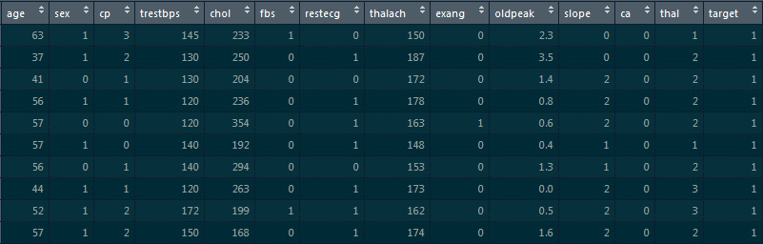

For loading the dataset, we will use the **read.csv** function:

read.csv(“D:/heart.csv”)->heart

str(heart)

In the structure of this dataframe, most of the values are integers. However, since we are building a logistic regression model on top of this dataset, the final **target column is supposed to be categorical**. It cannot be an integer. So, we will go ahead and convert them into a factor.  
Thus, we will use the **as.factor** function and convert these integer values into categorical data.  
We will pass on **heart$target** column over here and store the result in **heart$target**as follows:

as.factor(heart$target)->heart$target

Now, we will build a logistic regression model and see the different probability values for the person to have heart disease on the basis of different age values.

To build a logistic regression model, we will use the **glm**function:

glm(target~age, data=heart, family=”binomial”)->log_mod1

Here, **target~age**indicates that the target is the dependent variable and the age is the independent variable, and we are building this model on top of the dataframe.

**family=”binomial”** means we are basically telling R that this is the logistic regression model, and we will store the result in **log_mod1**.

We will have a glance at the summary of the model that we have just built:

summary(log_mod1)

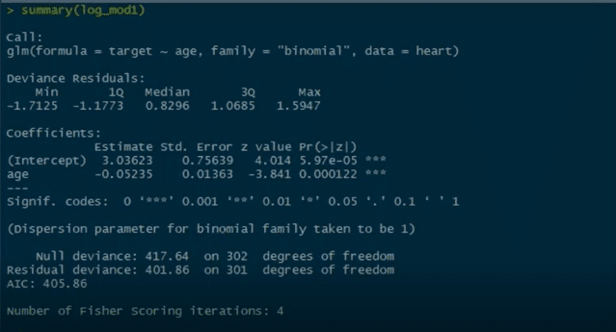

We can see **Pr** value here, and there are three stars associated with this Pr value. This basically means that we can reject the null hypothesis which states that there is no relationship between the age and the target columns. But since we have three stars over here, this null hypothesis can be rejected. There is a strong relationship between the age column and the target column.

Now, we have other parameters like null deviance and residual deviance. Lower the deviance value, the better the model.

This null deviance basically tells the deviance of the model, i.e., when we don’t have any independent variable and we are trying to predict the value of the target column with only the intercept. When that’s the case, the null deviance is 417.64.

Residual deviance is wherein we include the independent variables and try to predict the target columns. Hence, when we include the independent variable which is age, we see that the residual deviance drops. Initially, when there are no independent variables, the null deviance was 417. After we include the age column, we see that the null deviance is reduced to 401.

This basically means that there is a strong relationship between the age column and the target column and that is why the deviance is reduced.

As we have built the model, it’s time to predict some values:

predict(log_mod1, data.frame(age=30), type=”response”)

predict(log_mod1, data.frame(age=50), type=”response”)

predict(log_mod1, data.frame(age=29:77), type=”response”)

Now, we will divide this dataset into train and test sets and build a model on top of the train set and predict the values on top of the test set:

>library(caret)

Split_tag<- createDataPartition(heart$target, p=0.70, list=F)

heart[split_tag,]->train

heart[-split_tag,]->test

glm(target~age, data=train,family=”binomial”)->log_mod2

predict(log_mod2, newdata=test, type=”response”)->pred_heart

range(pred_heart)

**63. Build an ROC curve for the model built**

The below code will help us in building the ROC curve:

library(ROCR)

prediction(pred_heart, test$target)-> roc_pred_heart

performance(roc_pred_heart, “tpr”, “fpr”)->roc_curve

plot(roc_curve, colorize=T)

**Graph:**

***Go through this***[***Data Science Course in London***](https://intellipaat.com/data-scientist-course-training-london/)***to get a clear understanding of Data Science!***

**64. Build a confusion matrix for the model where the threshold value for the probability of predicted values is 0.6, and also find the accuracy of the model.**

Accuracy is calculated as:

**Accuracy = (True positives + true negatives)/(True positives+ true negatives + false positives + false negatives)**

To build a confusion matrix in R, we will use the table function:

table(test$target,pred_heart>0.6)

Here, we are setting the probability threshold as 0.6. So, wherever the probability of pred_heart is greater than 0.6, it will be classified as 0, and wherever it is less than 0.6 it will be classified as 1.

Then, we calculate the accuracy by the formula for calculating **Accuracy**.

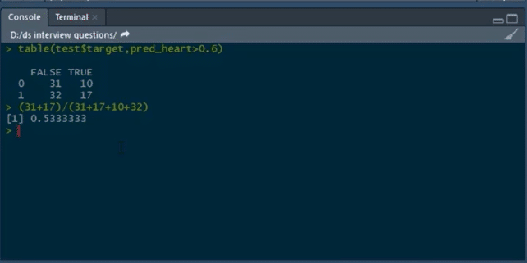

**65. Build a logistic regression model on the ‘customer_churn’ dataset in Python. The dependent variable is ‘Churn’ and the independent variable is ‘MonthlyCharges.’ Find the log_loss of the model.**

First, we will load the pandas dataframe and the customer_churn.csv file:

customer_churn=pd.read_csv(“customer_churn.csv”)

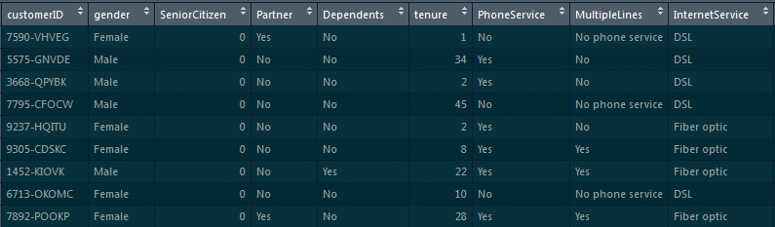

After loading this dataset, we can have a glance at the head of the dataset by using the following command:

customer_churn.head()

Now, we will separate the dependent and the independent variables into two separate objects:

x=pd.Dataframe(customer_churn[‘MonthlyCharges’])

y=customer_churn[‘ Churn’]

#Splitting the data into training and testing sets

from sklearn.model_selection import train_test_split

x_train, x_test, y_train, y_test=train_test_split(x,y,test_size=0.3, random_state=0)

Now, we will see how to build the model and calculate **log_loss**.

from sklearn.linear_model, we have to import LogisticRegression

l=LogisticRegression()

l.fit(x_train,y_train)

y_pred=l.predict_proba(x_test)

As we are supposed to calculate the log_loss, we will import it from **sklearn.metrics**:

from sklearn.metrics import log_loss

print(log_loss(y_test,y_pred)//actual values are in y_test and predicted are in y_pred

**Output**:

0.5555020595194167

***Become a master of Data Science by going through this online***[***Data Science Course in Toronto***](https://intellipaat.com/data-scientist-course-training-toronto/)***!***

**66. Build a decision tree model on ‘Iris’ dataset where the dependent variable is ‘Species,’ and all other columns are independent variables. Find the accuracy of the model built.**



To build a decision tree model, we will be loading the **party**package:

#party package

library(party)

#splitting the data

library(caret)

split_tag<-createDataPartition(iris$Species, p=0.65, list=F)

iris[split_tag,]->train

iris[~split_tag,]->test

#building model

mytree<-ctree(Species~.,train)

Now we will plot the model

plot(mytree)

**Model:**  
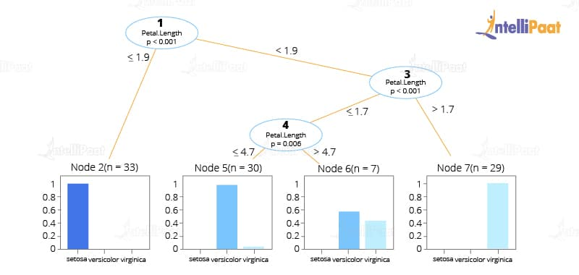

#predicting the values

predict(mytree,test,type=’response’)->mypred

After this, we will predict the confusion matrix and then calculate the accuracy using the table function:

table(test$Species, mypred)

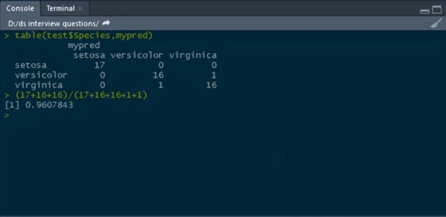

**67. Build a random forest model on top of this ‘CTG’ dataset, where ‘NSP’ is the dependent variable and all other columns are independent variables.**

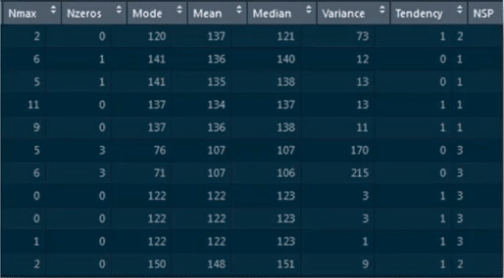

We will load the CTG dataset by using **read.csv**:

data<-read.csv(“C:/Users/intellipaat/Downloads/CTG.csv”,header=True)

str(data)

Converting the integer type to a factor

data$NSP<-as.factor(data$NSP)

table(data$NSP)

#data partition

set.seed(123)

split_tag<-createDataPartition(data$NSP, p=0.65, list=F)

data[split_tag,]->train

data[~split_tag,]->test

#random forest -1

library(randomForest)

set.seed(222)

rf<-randomForest(NSP~.,data=train)

rf

#prediction

predict(rf,test)->p1

Building confusion matrix and calculating accuracy:

table(test$NSP,p1)

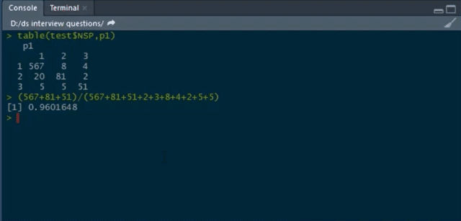

**68. Write a function to calculate the Euclidean distance between two points.**

The formula for calculating the Euclidean distance between two points (x1, y1) and (x2, y2) is as follows:

√(((x1 - x2) ^ 2) + ((y1 - y2) ^ 2))

Code for calculating the Euclidean distance is as given below:

def euclidean_distance(P1, P2):

return (((P1[0] - P2[0]) ** 2) + ((P1[1] - P2[1]) ** 2)) ** .5

**69. Write code to calculate the root mean square error (RMSE) given the lists of values as actual and predicted.**

To calculate the root mean square error (RMSE), we have to:

1. Calculate the errors, i.e., the differences between the actual and the predicted values
2. Square each of these errors
3. Calculate the mean of these squared errors
4. Return the square root of the mean

The code in Python for calculating RMSE is given below:

def rmse(actual, predicted):

  errors = [abs(actual[i] - predicted[i]) for i in range(0, len(actual))]

  squared_errors = [x ** 2 for x in errors]

  mean = sum(squared_errors) / len(squared_errors)

  return mean ** .5

***Check out this***[***Machine Learning Course***](https://intellipaat.com/machine-learning-certification-training-course/)***to get an in-depth understanding of Machine Learning.***

**70. Mention the different kernel functions that can be used in SVM.**

**In SVM, there are four types of kernel functions:**

* Linear kernel
* Polynomial kernel
* Radial basis kernel
* Sigmoid kernel

**71. How to detect if the time series data is stationary?**

Time series data is considered stationary when variance or mean is constant with time. If the variance or mean does not change over a period of time in the dataset, then we can draw the conclusion that, for that period, the data is stationary.

**72. Write code to calculate the accuracy of a binary classification algorithm using its confusion matrix.**

We can use the code given below to calculate the accuracy of a binary classification algorithm:

def accuracy_score(matrix):

  true_positives = matrix[0][0]

  true_negatives = matrix[1][1]

  total_observations = sum(matrix[0]) + sum(matrix[1])

  return (true_positives + true_negatives) / total_observations

**73. What does root cause analysis mean?**

Root cause analysis is the process of figuring out the root causes that lead to certain faults or failures. A factor is considered to be a root cause if, after eliminating it, a sequence of operations, leading to a fault, error, or undesirable result, ends up working correctly. Root cause analysis is a technique that was initially developed and used in the analysis of industrial accidents, but now, it is used in a wide variety of areas.

**74. What is A/B testing?**

A/B testing is a kind of statistical hypothesis testing for randomized experiments with two variables. These variables are represented as A and B. A/B testing is used when we wish to test a new feature in a product. In the A/B test, we give users two variants of the product, and we label these variants as A and B.

The A variant can be the product with the new feature added, and the B variant can be the product without the new feature. After users use these two products, we capture their ratings for the product.

If the rating of product variant A is statistically and significantly higher, then the new feature is considered an improvement and useful and is accepted. Otherwise, the new feature is removed from the product.

***Check out this***[***Python Course***](https://intellipaat.com/python-certification-training-online/)***to get deeper into Python programming.***

**75. Out of collaborative filtering and content-based filtering, which one is considered better, and why?**

Content-based filtering is considered to be better than collaborative filtering for generating recommendations. It does not mean that collaborative filtering generates bad recommendations.

However, as collaborative filtering is based on the likes and dislikes of other users we cannot rely on it much. Also, users’ likes and dislikes may change in the future.

For example, there may be a movie that a user likes right now but did not like 10 years ago. Moreover, users who are similar in some features may not have the same taste in the kind of content that the platform provides.

In the case of content-based filtering, we make use of users’ own likes and dislikes that are much more reliable and yield more positive results. This is why platforms such as Netflix, Amazon Prime, Spotify, etc. make use of content-based filtering for generating recommendations for their users.

**76. In the following confusion matrix, calculate precision and recall.**

|  |  |  |  |
| --- | --- | --- | --- |
| **Total = 510** | **Actual** | | |
| **Predicted** |  | P | N |
| P | 156 | 11 |
| N | 16 | 327 |

The formulae for precision and recall are given below.

Precision:

(True Positive) / (True Positive + False Positive)

Recall:

(True Positive) / (True Positive + False Negative)

Based on the given data, precision and recall are:

Precision: 156 / (156 + 11) = 93.4

Recall: 156 / (156 + 16) = 90.7

**77. Write a function that when called with a confusion matrix for a binary classification model returns a dictionary with its precision and recall.**

We can use the below for this purpose:

def calculate_precsion_and_recall(matrix):

  true_positive  = matrix[0][0]

  false_positive  = matrix[0][1]

  false_negative = matrix[1][0]

  return {

    'precision': (true_positive) / (true_positive + false_positive),

    'recall': (true_positive) / (true_positive + false_negative)

  }

**78. What is reinforcement learning?**

[Reinforcement learning](https://intellipaat.com/blog/what-is-reinforcement-learning/) is a kind of Machine Learning, which is concerned with building software agents that perform actions to attain the most number of cumulative rewards.

A reward here is used for letting the model know (during training) if a particular action leads to the attainment of or brings it closer to the goal. For example, if we are creating an ML model that plays a video game, the reward is going to be either the points collected during the play or the level reached in it.

Reinforcement learning is used to build these kinds of agents that can make real-world decisions that should move the model toward the attainment of a clearly defined goal.

**79. Explain TF/IDF vectorization.**

The expression ‘TF/IDF’ stands for Term Frequency–Inverse Document Frequency. It is a numerical measure that allows us to determine how important a word is to a document in a collection of documents called a corpus. TF/IDF is used often in text mining and information retrieval.

**80. What are the assumptions required for linear regression?**

**There are several assumptions required for linear regression. They are as follows:**

* The data, which is a sample drawn from a population, used to train the model should be representative of the population.
* The relationship between independent variables and the mean of dependent variables is linear.
* The variance of the residual is going to be the same for any value of an independent variable. It is also represented as X.
* Each observation is independent of all other observations.
* For any value of an independent variable, the independent variable is normally distributed.

**81. What happens when some of the assumptions required for linear regression are violated?**

These assumptions may be violated lightly (i.e., some minor violations) or strongly (i.e., the majority of the data has violations). Both of these violations will have different effects on a linear regression model.

Strong violations of these assumptions make the results entirely redundant. Light violations of these assumptions make the results have greater bias or variance.