**WEEK 1**

SUPERSET ID-6362542

NAME- ANISHA RAJ

DOMAIN-DOTNET

**1.E-COMMMERCE PLATFORM SEARCH FUNCTION.**

**CODE:-**

using System;

using System.Collections.Generic;

using System.Linq;

class EcommerceSearch

{

public static void RunEcommerceSearch()

{

var items = new List<(string Name, List<string> Tags)>

{

("NoiseFit Halo", new List<string> { "watch", "fitness" }),

("Asus Laptop", new List<string> { "electronics", "gaming" }),

("Canon Camera", new List<string> { "dslr", "photography" }),

("Boat Airdopes", new List<string> { "audio", "bluetooth" })

};

Console.WriteLine("E-Commerce Product Search");

while (true)

{

Console.Write("\nSearch (or type 'exit'): ");

string? input = Console.ReadLine();

if (string.IsNullOrWhiteSpace(input)) continue;

if (input.ToLower() == "exit") break;

var keywords = input.Split(' ', StringSplitOptions.RemoveEmptyEntries);

var matches = items.Where(item =>

keywords.Any(k =>

item.Name.Contains(k, StringComparison.OrdinalIgnoreCase) ||

item.Tags.Any(tag => tag.Contains(k, StringComparison.OrdinalIgnoreCase))

)).ToList();

if (matches.Count == 0)

Console.WriteLine("No matching items found.");

else

{

Console.WriteLine("Matching items:");

foreach (var match in matches)

Console.WriteLine($"- {match.Name} (Tags: {string.Join(", ", match.Tags)})");

}

}

}

}

class Program

{

static void Main() // ✅ Required entry point

{

EcommerceSearch.RunEcommerceSearch();

}

}

**OUTPUT:-**

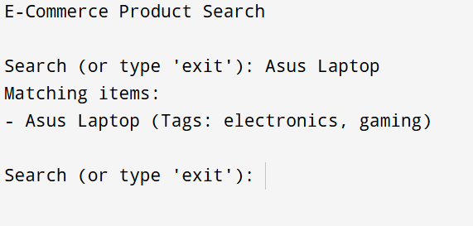

**2.FINANCIAL FORECASTING .**

**CODE:-**

using System;

class MoneyGrowth

{

public static void Start()

{

Console.Write("How much money are you investing? Rs. ");

if (!double.TryParse(Console.ReadLine(), out double money))

{

Console.WriteLine("Please enter a valid amount.");

return;

}

Console.Write("What's the yearly growth rate (in %)? ");

if (!double.TryParse(Console.ReadLine(), out double rate))

{

Console.WriteLine("Please enter a valid percentage.");

return;

}

Console.Write("For how many years do you want to invest? ");

if (!int.TryParse(Console.ReadLine(), out int time))

{

Console.WriteLine("Please enter a valid number of years.");

return;

}

double finalAmount = money * Math.Pow(1 + rate / 100, time);

Console.WriteLine($"\nIf you invest Rs.{money:N2} for {time} years at {rate}% yearly growth, you'll have Rs.{finalAmount:N2}.");

}

}

class Program

{static void Main()

{

MoneyGrowth.Start();

}

}

**OUTPUT:-**

