NPOL-USHUS2

Firmware Upgrade User Manual

Document Information:

Document Name | MS_NPOL_USHUS2_FW_UM | Date | 19/01/2017
Author | Rakkumuthu R | Approved by | Ravi G Patil

Mistral Contact Info
Name | Telephone | e-mail
Ravi G Patil | 080-30731619 | ravigp@mistralsolutions.com

 |  | CHANGE HISTORY
Version No. | Date |  | Change Description | Author | Reviewer | Approver | Remarks
0.01 | 19/01/2017 |  | Created | Rakkumuthu R | Ravi G Patil | Sridhar T S

Table of Contents

1 INTRODUCTION 4
1.1 Purpose and Scope 4
1.2 Acronyms 4
1.3 References 4
1.4 Hardware Setup 5
2 LOAD FPGA BINARY IMAGE 6
3 LOAD PPC SREC IMAGE 9
4 Hyper Terminal setup 13
5 Switching between Firmware Revision 14
6 API reference 15

Table of Figure

Figure 1: HARDWARE SETUP FOR FIRMWARE UPDATE 5
Figure 2: GUI SETUP 6
Figure 3: Firmware binary Image Selection 7
Figure 4: Flash Firmware binary Image 8
Figure 5: Firmware binary Image Upgrade 9
Figure 6: GUI SETUP 10
Figure 7: Firmware srec Image Selection 11
Figure 8: Flash Firmware SREC Image 12
Figure 9: Hyper terminal setup 13

Table of Tables
Table 1 : Acronyms 4

INTRODUCTION

Purpose and Scope
This document describes usage of BPI flash for upgrading FPGA and VxWorks images SYSCONV3 boards

Acronyms

Acronyms | Description
HWICAP | Hardware Internal Configuration Access Port
BPI | Byte Peripheral Interface
API | Application Programming Interface
BIN | Binary
SREC | S-Record
GUI | Graphical User Interface
PC | Personal Computer
PPC | Power PC
FPGA | Field Programmable Grid Array
SYSCONV3 | System Controller card Version 3

Table 1 : Acronyms

References

Ug191.pdf document for HWICAP

Hardware Setup

MGT PORT
SYSCONV3

POWER SUPPLY

UART

Figure 1: HARDWARE SETUP FOR FIRMWARE UPDATE

Note: Make sure that configuration modes set to Master BPI - UP in SYSCONV3 hardware.

LOAD FPGA BINARY IMAGE

After board boots up, Open labview USHUS2_CONTROL GUI (Version 4.6) in PC. Follow below steps,
- Press Start button. Select the system type and press Enter button.
- Go to Configuration parameters tab. Select Flash commands -> Load SREC file option.
- Select the File (Image) type to BIN File and Browse the FPGA .bin image.
- Press Send button. Send button shall be hidden once it starts transfer the image through management Ethernet interface. Srec Progress shall indicate the file transfer status.

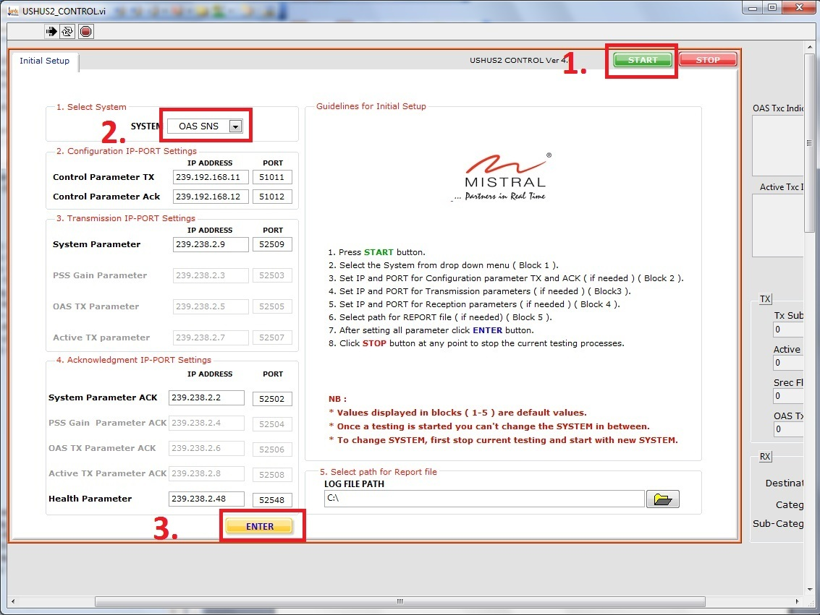

Figure 2: GUI SETUP

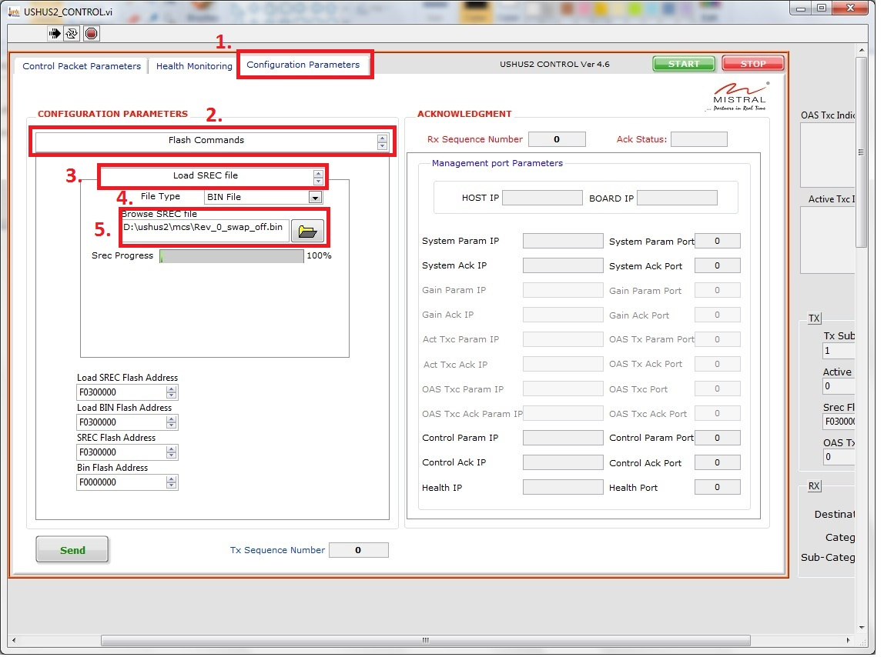

Figure 3: Firmware binary Image Selection

- Send button shall be enabled once the file transfer is completed. Select Flash SREC file -> File Format as BIN.
- User shall provide the flash address where to update the binary image in Bin Flash Address control in GUI.
- Press Send button.

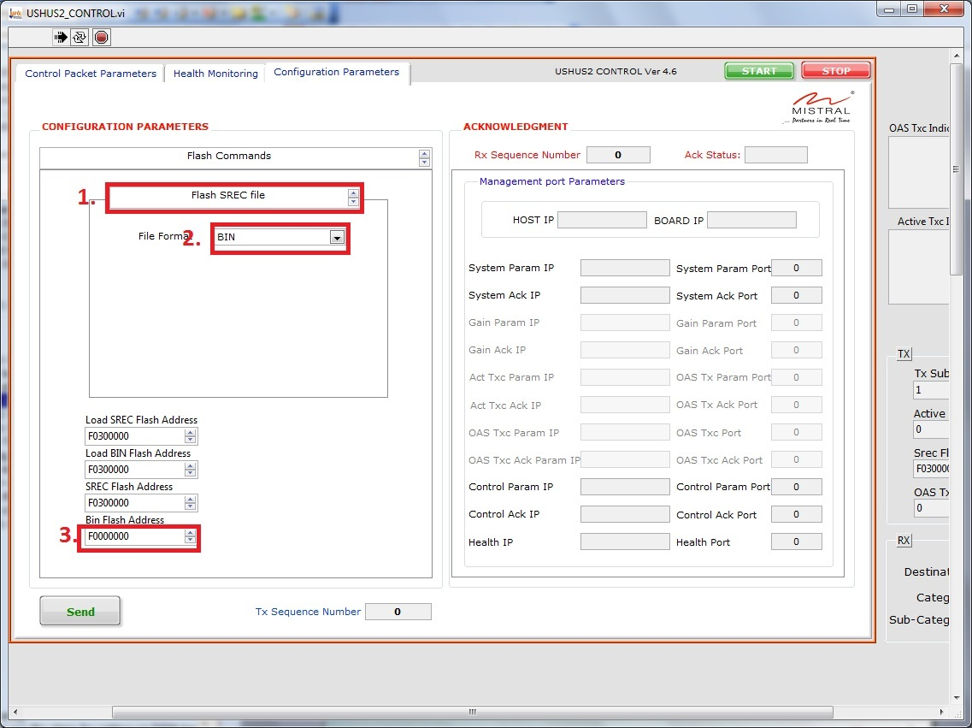

Figure 4: Flash Firmware binary Image
- Wait until it completes writing image into NOR-Flash location as shown in below figure.

Figure 5: Firmware binary Image Upgrade

- Provide Firmware selection command in hyper terminal to test your application.

LOAD PPC SREC IMAGE
After board boots up, Open labview USHUS2_CONTROL GUI (Version 4.6) in PC. Follow below steps,
- Press Start button. Select the system type and press Enter button.
- Go to Configuration parameters tab. Select Flash commands -> Load SREC file option.
- Select the File (Image) type to SREC File and Browse the PPC .srec image.
- Press Send button. Send button shall be hidden once it starts transfer the image through management Ethernet interface. Srec Progress shall indicate the file transfer status.

Figure 6: GUI SETUP

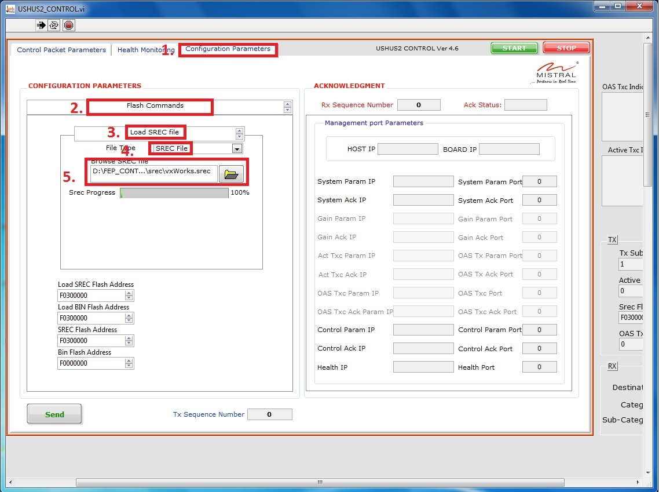

Figure 7: Firmware srec Image Selection

- Send button shall be enabled once the file transfer is completed. Select Flash SREC file -> File Format as SREC.
- User shall provide the flash address where to update the srec image in SREC Flash Address control in GUI.
- Press Send button.

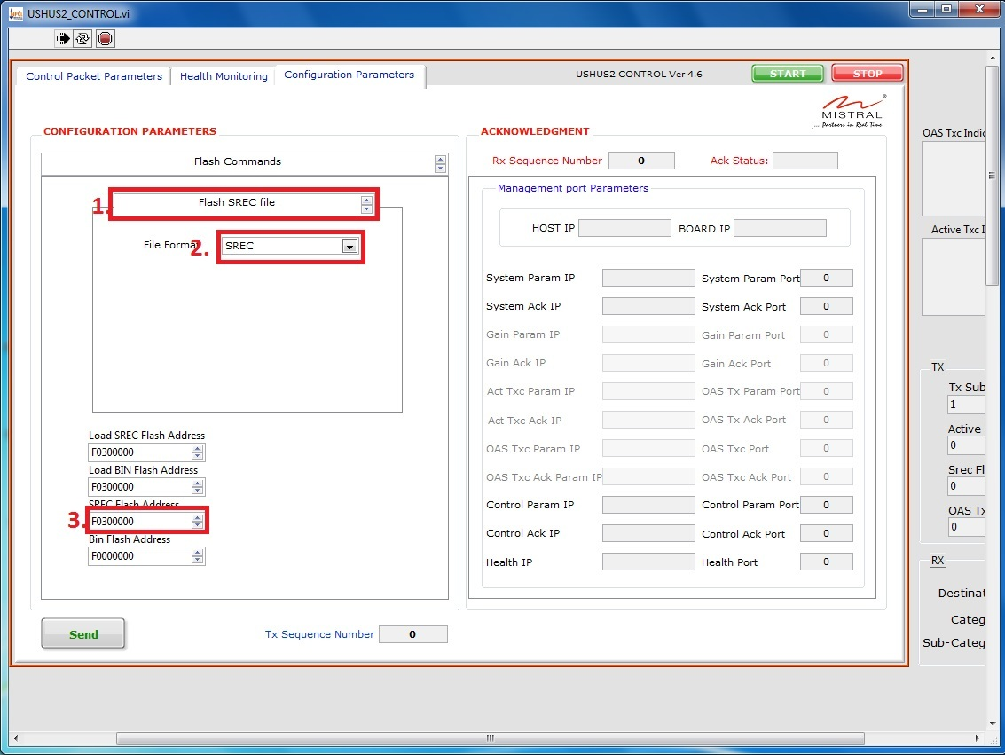

Figure 8: Flash Firmware SREC Image

- Wait until it completes writing the srec image into NOR-Flash location as shown in below image.
- Provide the Firmware Selection command to test your application.

Hyper Terminal setup
Following are the steps for the setting up hyper terminal on windows.
- Start menu->All Programs ->Accessories ->communications -> Hyper-Terminal.
- File -> new connection (enter the connection name and press ok button).
- Press the Restore Defaults button and press ok button.
- Don’t close the hyper terminal.

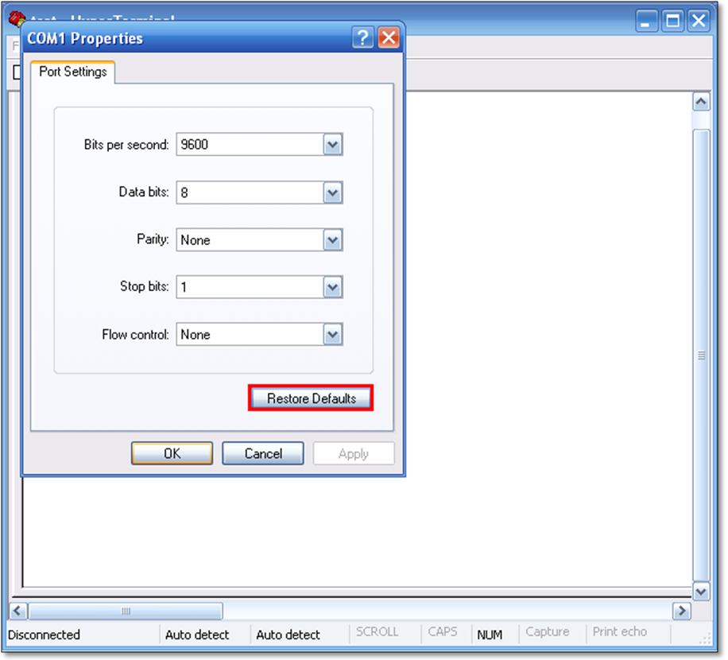

Figure 9: Hyper terminal setup

Switching between Firmware Revision
To switching from one Revision to another image revision user shall issue the command at run time. Follow the below mentioned steps.
  - Flash Golden FPGA Image at 0xF0000000 and PPC SREC image at 0xF0B00000
  - Flash required Revision 1 FPGA Image at 0xF2000000 and PPC SREC image at 0xF2B00000
  - Flash required Revision 2 FPGA image at 0xF4000000 and PPC SREC image at 0xF4B00000.
  - Flash required Revision 3 FPGA image at 0xF60000000 and PPC SREC image at 0xF6B00000.
  - User shall provide the HwIcap_FirmwareSelection 1 command in hyper terminal to load revision 1 images. Likewise user shall provide different revision selection.

API reference
This section describes the definition of the each API’s.
- HwIcapInit - Initialize the HWICAP driver instance.

SINT32 HwIcapInit
(
UINT16 u16HwIcapDeviceId /* HWICAP Device ID */
)
- HwIcapSelfTest - Verify the HWICAP IP core.

SINT32 HwIcapSelfTest
(
UINT16 u16HwIcapDeviceId, /* HWICAP Device ID */
UINT32 u32ConfigCode /* Register offset address to read */
)

- XHwIcap_CommandWrite - Fill the IPROG command data into a buffer

SINT32 XHwIcap_CommandWrite
(
XHwIcap *InstancePtr, /* HWICAP driver instance pointer*/
UINT8 u8RevSelect /* Revision selection */
)
- HwIcap_FirmwareSelection - Select the user defined revision.

SINT32 HwIcap_FirmwareSelection
(
UINT8 u8RevSelect /* Revision selection */
)

