AWS Assignment 2

1. Create an instance, install apache server(using start-up script) and add an index.html file. Create a robust web server with the use of auto scaling and load balancing.
Deliverable :- start-up script, security group rules, Listener configuration

start-up script:

#!/bin/bash

apt install -y apache2

systemctl start apache2

Security group rules:
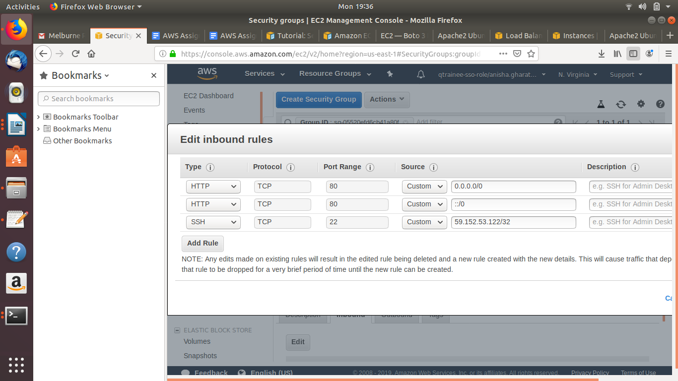

Listener Configuration:
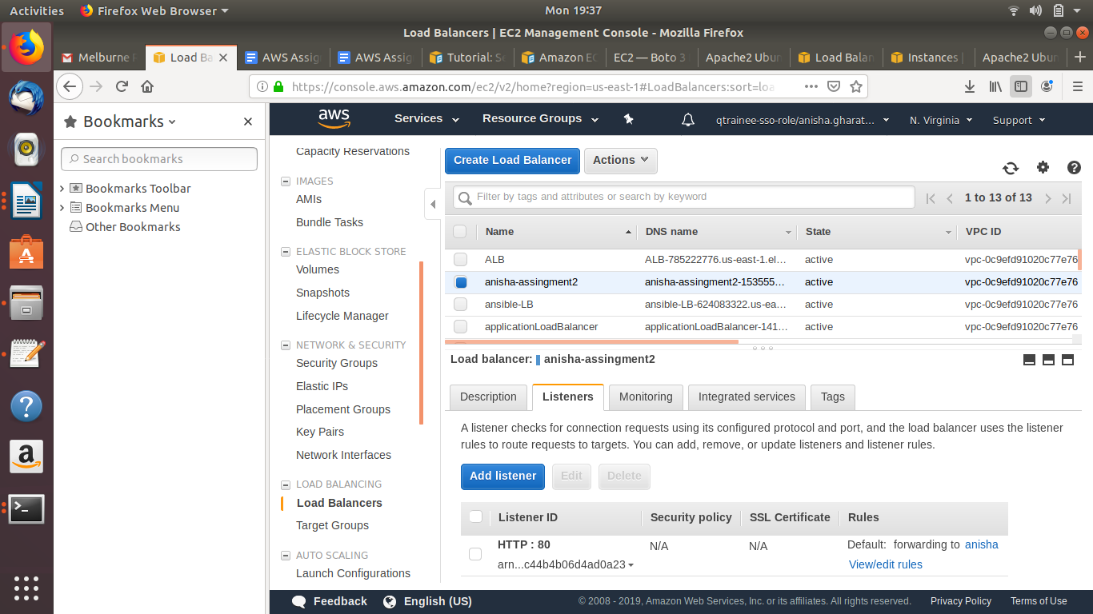

Steps:

1) Configure the Auto-Scaling Group with a launch configuration and 2 instances

2) Create a target group and register the instances of the auto-scaling group in the target-group

3) Create a load balancer and add the target group created in the step above to the load balancer

4)Launch the DNS of the load balancer

Output:

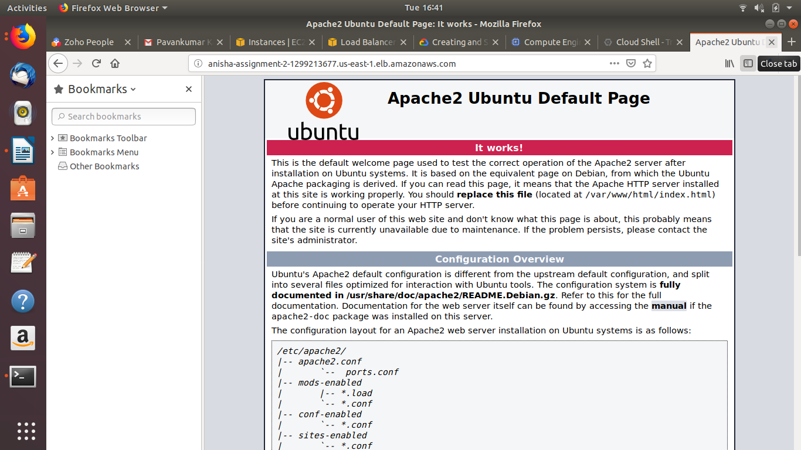

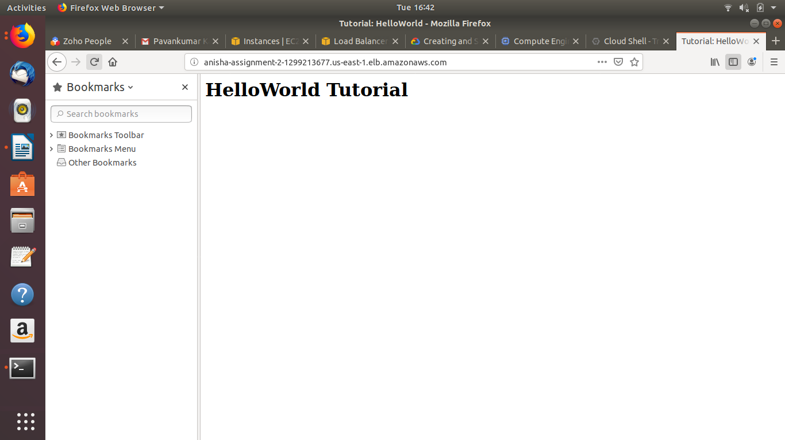

5. Automate the process of setting up passwordless SSH between two AWS EC2 instances.
Deliverable :- Steps for setting up passwordless SSH

Pre-requisites:
1) Launch two EC2 instances in the same VPC subnet (Default)
2) Add the security groups of each instance in the inbound of another

Step 1:
Generating public and private keys in the source instance
Command : ssh-keygen -t rsa
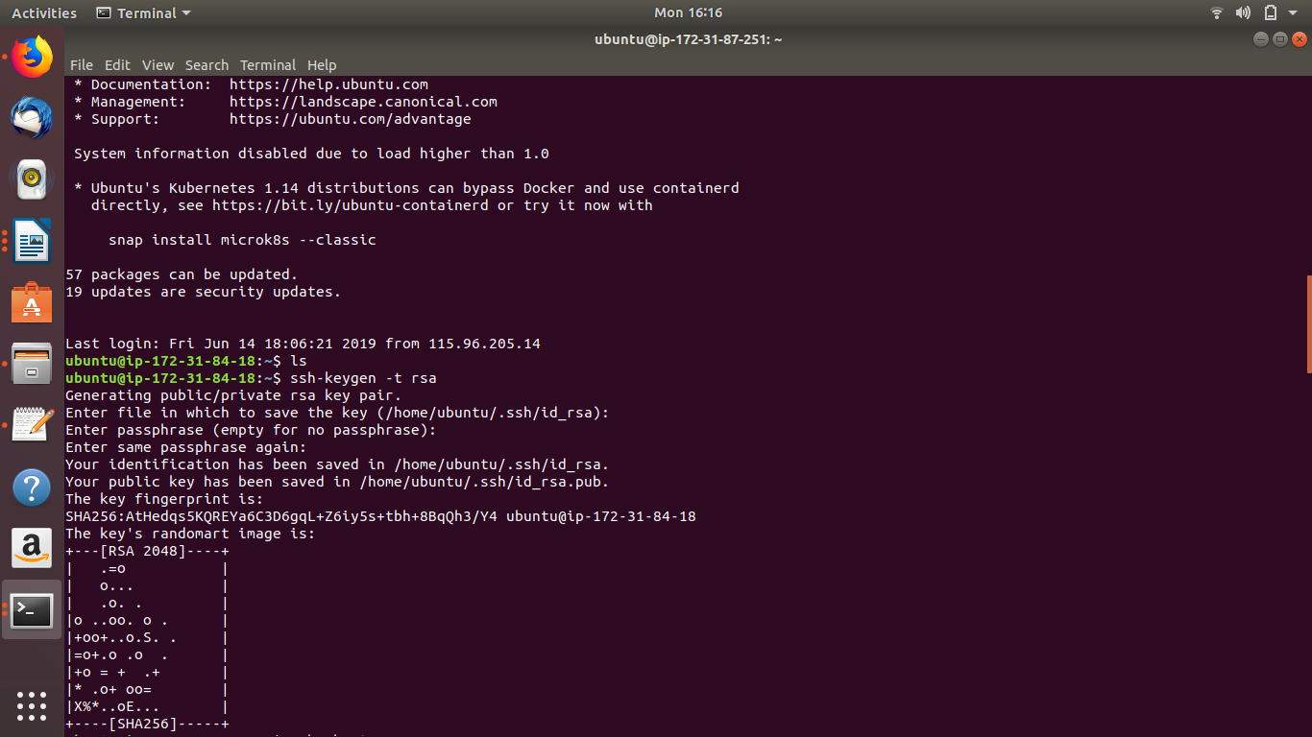
Step 2:
Copy the contents of the public key(id_rsa.pub) from .ssh directory to the destination authorized_keys file

Step 3:
ssh from the source instance to the destination instance
Command: ssh ubuntu@ec2-3-87-259-253.compute-1-amazonaws.com (destination hostname)
