- Create an instance, install apache server and add an index.html file and view that file in the browser. Take snapshot of this instance and deploy it in another region.
Deliverable: Mention the steps for achieving this

Step 1:
Create an instance and give HTTP and HTTPS security groups while creating the instance
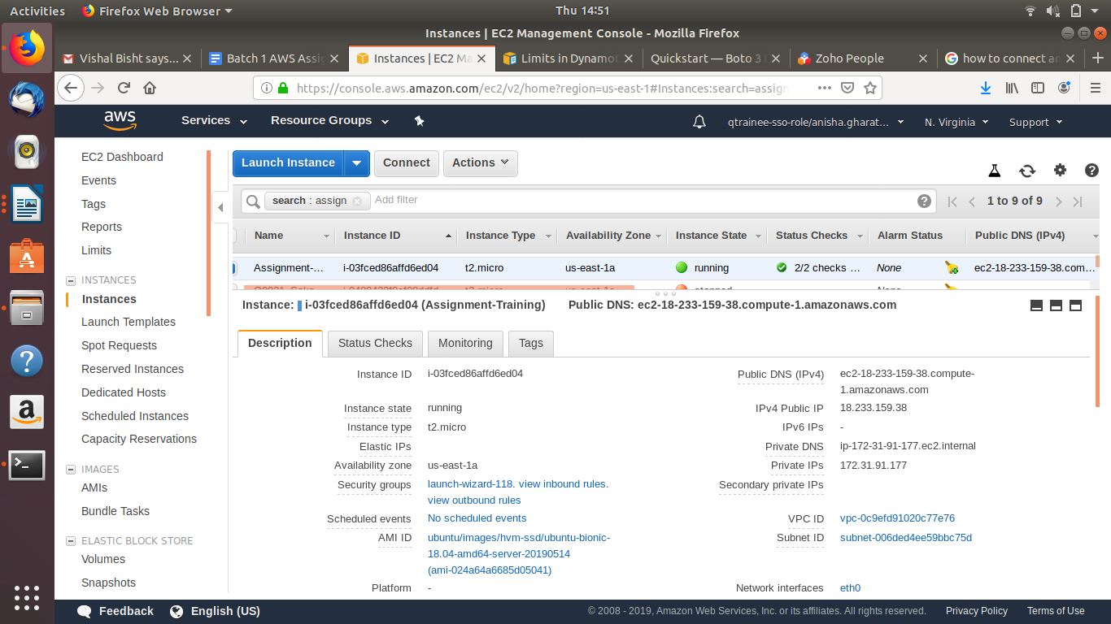
Instance is created with the required tags and security groups

Step 2:
SSH into the terminal to access the instance
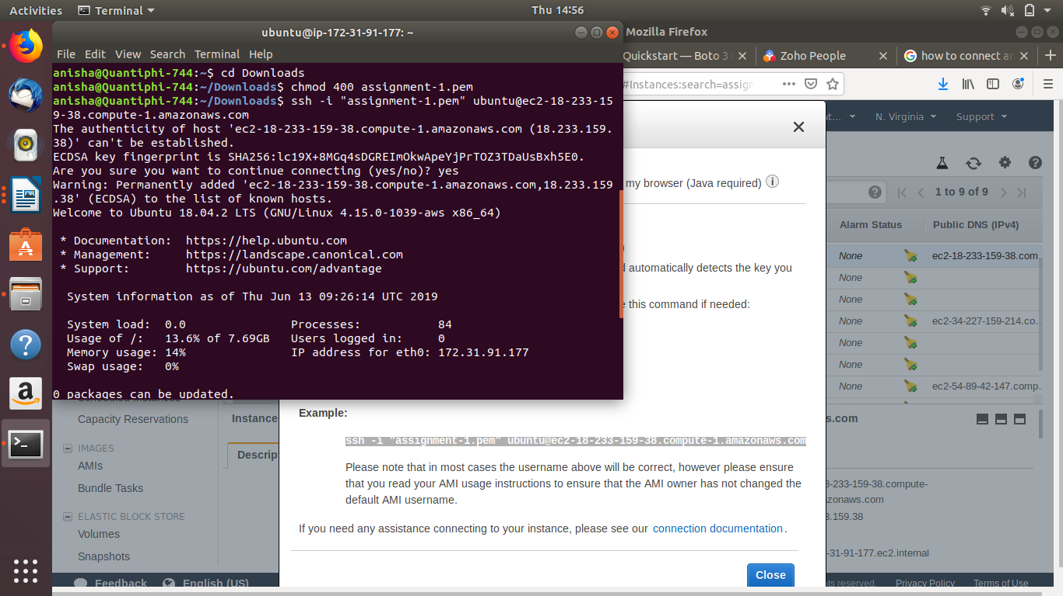

Step 3:
Install Apache on the instance

Command : sudo apt update
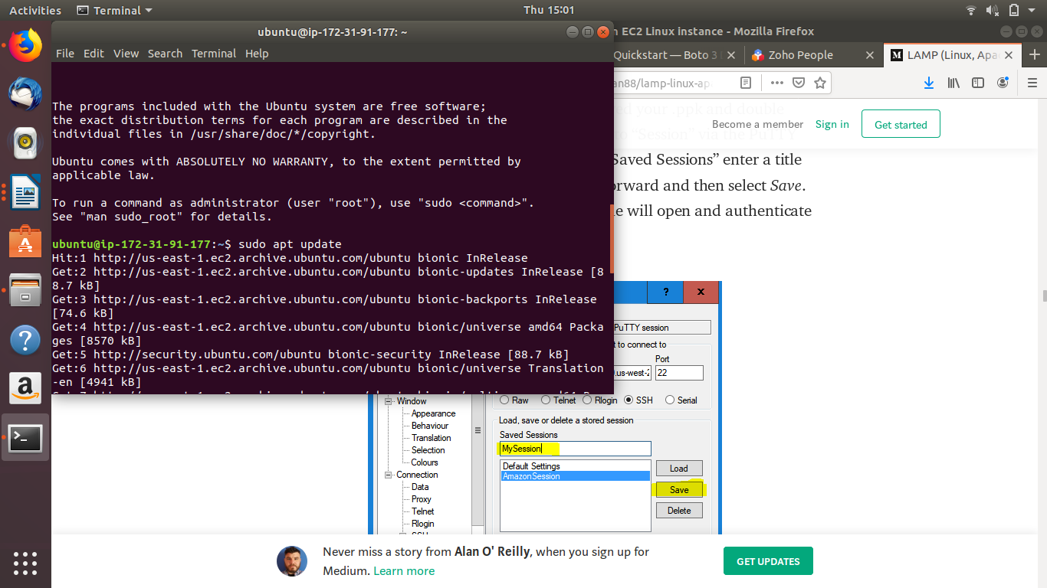

Command: sudo apt install apache2
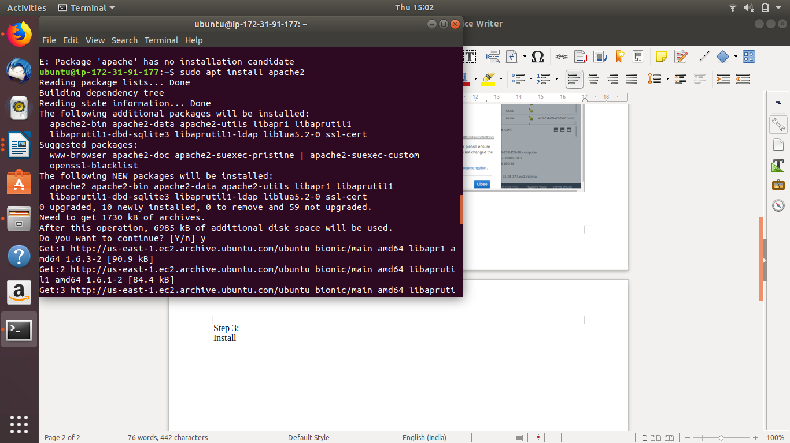

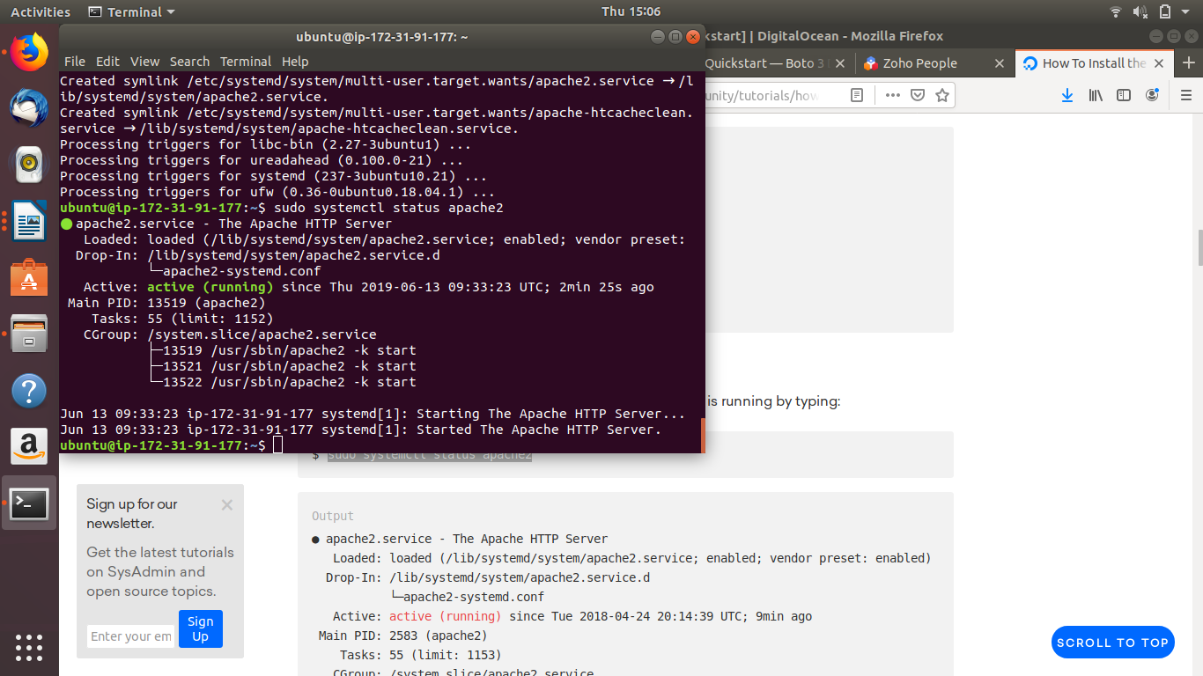
Command : sudo systemctl status apache2

Step 4:

Configure the html file by specifying the path in the directory

Command : sudo nano index.html (in the directory /var/www/html)
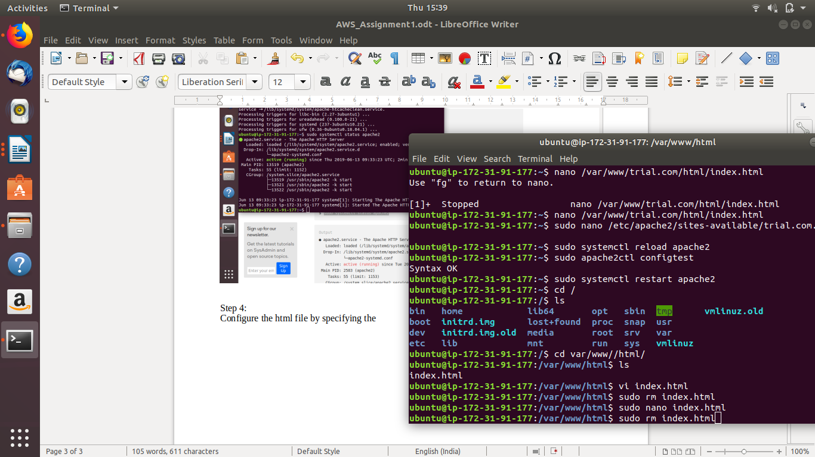

Step 5:
Copy the Public DNS of the ECS to launch the the html page on the browser

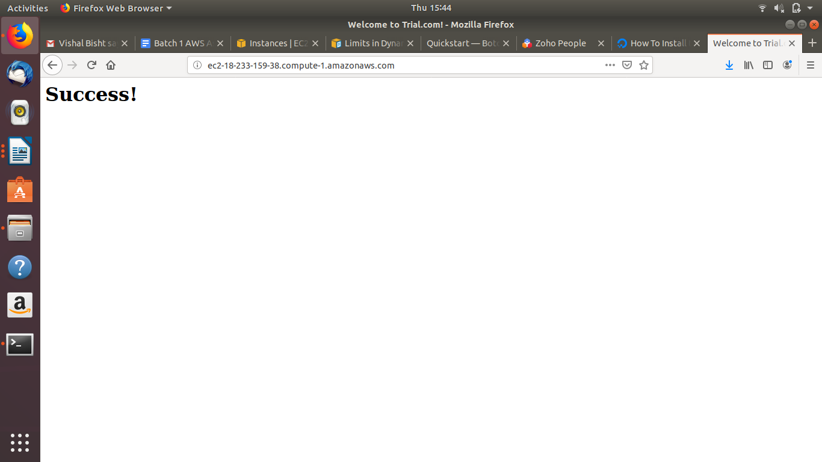

Step 6:

Snapshots of the instance
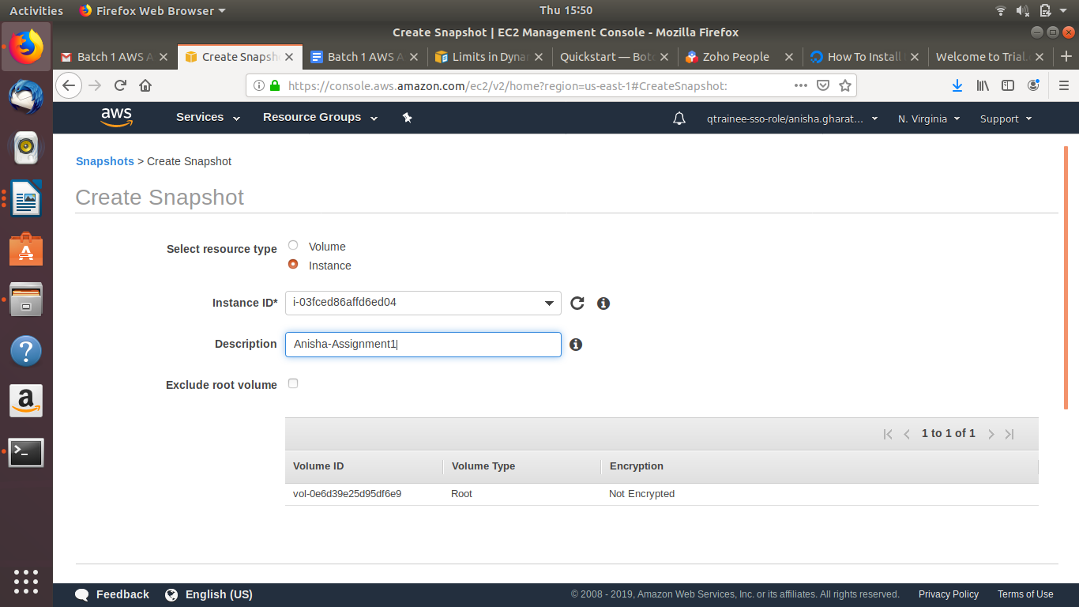

Step 7:
Deploy the snapshot of the instance in another region
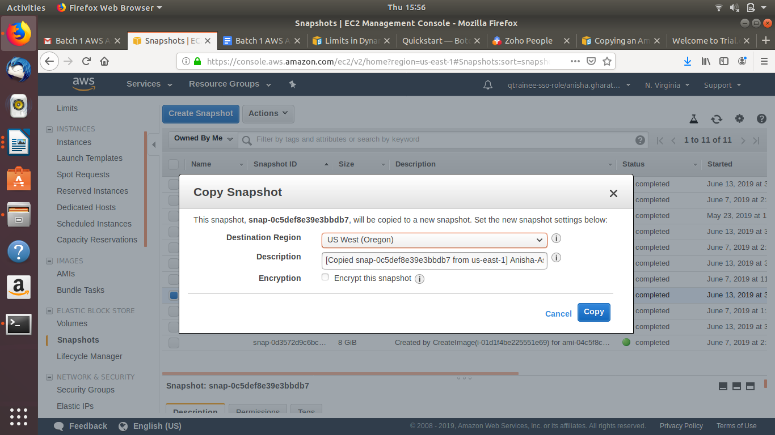
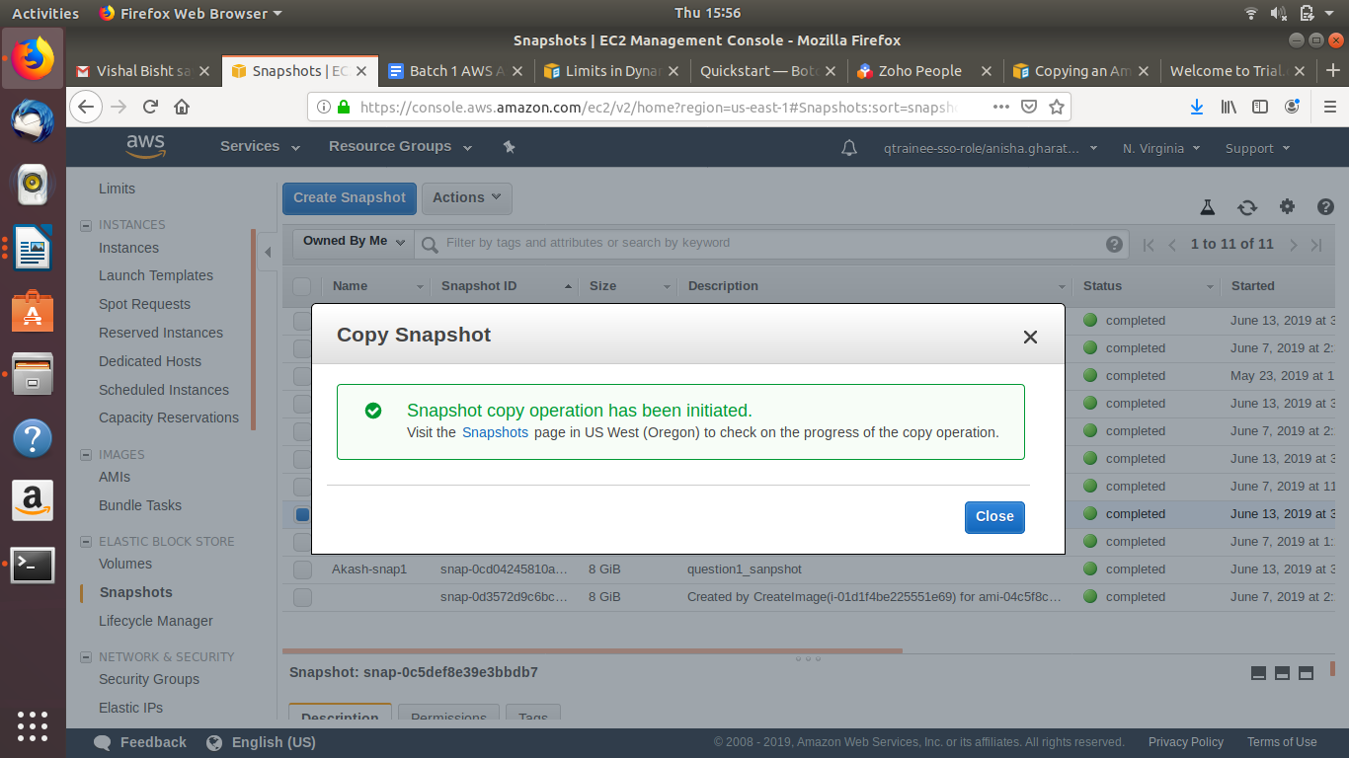

2. Assuming you have a versioning enabled S3 bucket and multiple versions of the same object, Write a python script which takes the bucket name and object path as parameters and downloads the 2nd latest version of this object i.e the one prior to the latest version.
Deliverable: Python script
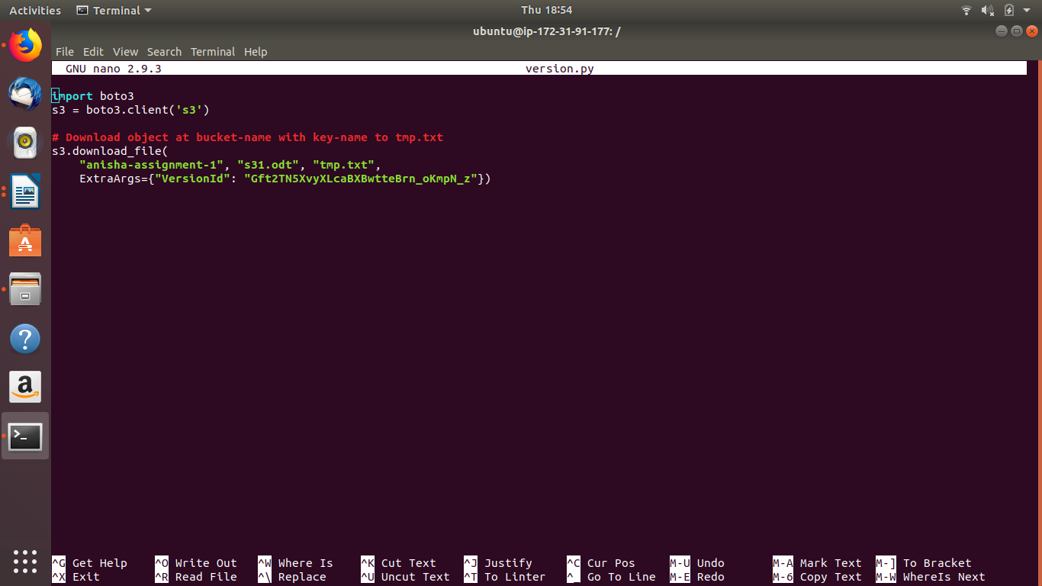
3.
Create bucket MyBucket and folder MySecretFolder. Write a bucket policy which allows all users to retrieve any object in MyBucket except those in the MySecretFolder. It also grants put and delete permission to the root user of AWS account.
Deliverable: Bucket policy
{
"Version": "2012-10-17",
"Statement": [
{
"Sid": "Anisha1",
"Effect": "Allow",
"Principal": "*",
"Action": "s3:GetObject",
"Resource": "arn:aws:s3:::mybucket-anisha/*"
},
{
"Sid": "Anisha2",
"Effect": "Deny",
"Principal": "*",
"Action": "s3:GetObject",
"Resource": "arn:aws:s3:::mybucket-anisha/MySecretFolder/*"
},
{
"Sid": "Anisha3",
"Effect": "Allow",
"Principal": {
"CanonicalUser": "1efb697283f3b3aa937af1618d0de6e0007a16710698dc4fc79901f632597eee"
},
"Action": [
"s3:DeleteObject",
"s3:PutObject"
],
"Resource": "arn:aws:s3:::mybucket-anisha/*"
}
]
}

4. Create API Gateway which triggers lambda Function and prints the name of the user passed in the request.
Deliverable: Python Code.

#Python Code
import json
def lambda_handler(event, context):
return {
'statusCode': 200,
'body': json.dumps(event["User"])
}
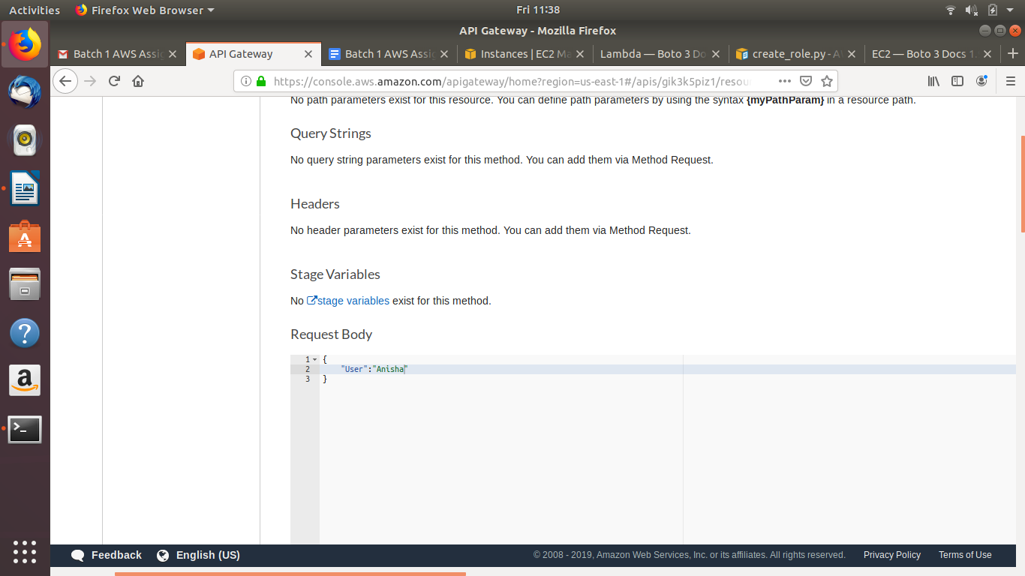

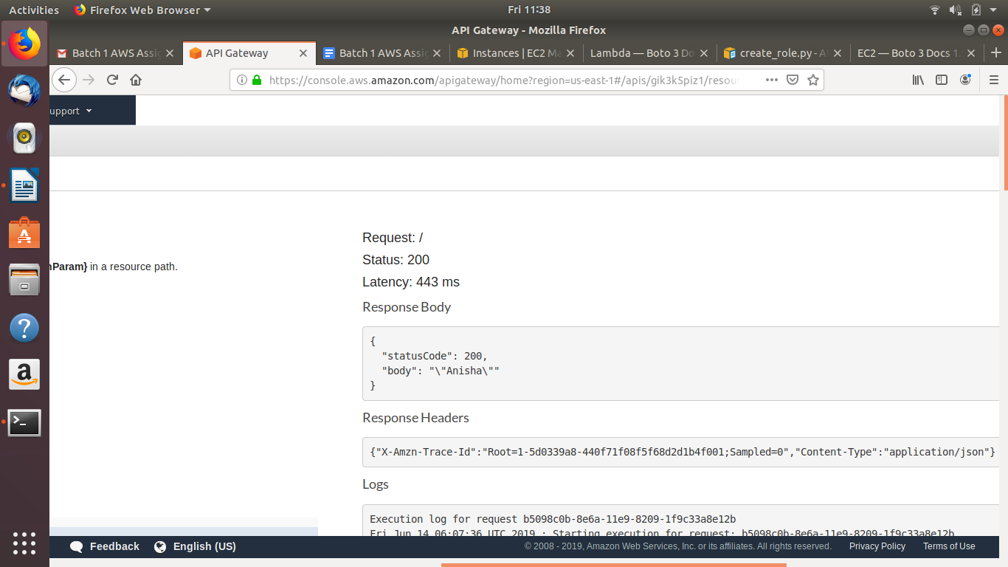

5. Write a lambda function to copy an object from one s3 bucket to another.
Deliverable: Python Code.

#Python Code

import json
import boto3

def lambda_handler(event, context):
s3 = boto3.resource('s3')
copy_source = {
'Bucket': 'anisha-assignment-1',
'Key': 'bs1.sh'
}
bucket = s3.Bucket('mybucket-anisha')
bucket.copy(copy_source, 'bs1-copy.sh')

return {
'statusCode': 200,
'body': json.dumps('Hello from Lambda!')
}

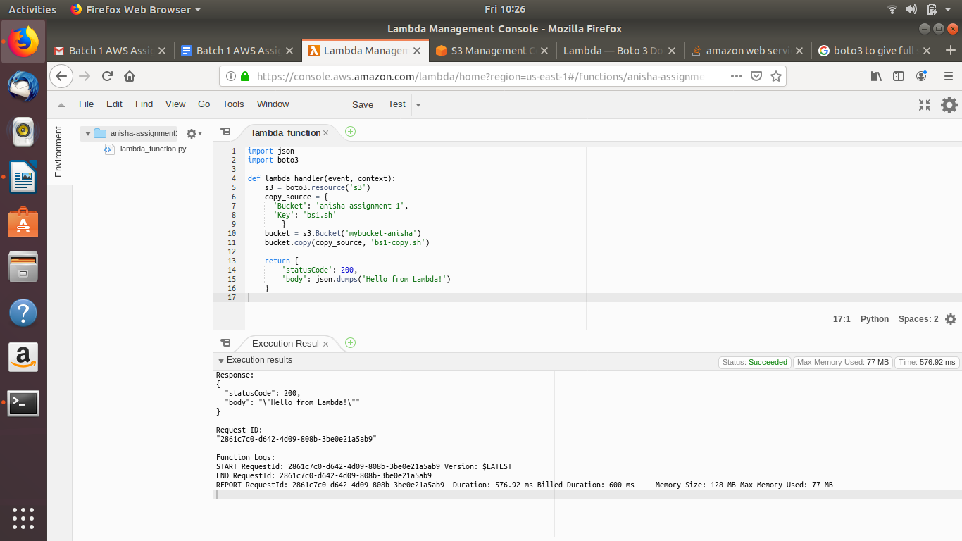
6.
Your company has recently hired a group of 10 freelancers for a specific project for a short period of time. Your manager wants them to access the AWS account only when they are within the organization’s network. Design an IAM policy to achieve this following the best practices.
Deliverable: Description of your strategy and IAM policy

Step 1:
Create a policy and choose service as “Account”

Step 2:
Select actions as “All account actions”

Step 3:
Add request conditions to specify an IP range to allow requests for the same

IAM Policy
{
"Version": "2012-10-17",
"Statement": [
{
"Sid": "VisualEditor0",
"Effect": "Allow",
"Action": "account:*",
"Resource": "*",
"Condition": {
"IpAddress": {
"aws:SourceIp": "210.75.12.75/16"
}
}

7. Write a python program to create and attach an IAM role to a EC2 instance to provide full access of S3
Deliverable: Python code

#PythonCode (Creating a role)

import boto3
import json

# Create IAM client
iam = boto3.client('iam')

path='/'
role_name='S3Role2'
description='S3 full Access'

trust_policy={

"Version": "2012-10-17",
"Statement": [

{
"Sid": "AllObjectActions",
"Effect": "Allow",
"Action": "sts:AssumeRole",
"Principal":{
"Service": "ec2.amazonaws.com"
}
}
]

}

tags=[
{
'Key': 'Environment',
'Value': 'Production'
}
]

try:
response = iam.create_role(
Path=path,
RoleName=role_name,
AssumeRolePolicyDocument=json.dumps(trust_policy),
Description=description,
MaxSessionDuration=3600,
Tags=tags
)

print(response)
except Exception as e:
print(e)

#PythonCode (Attaching policy to the role)
import boto3
client = boto3.client(‘iam’)

response = client.attach_role_policy(

RoleName='S3Role1', PolicyArn='arn:aws:iam::aws:policy/AmazonS3FullAccess')
#PythonCode (Creating instance profile)
import boto3
iam = boto3.client('iam')

instance_profile = iam.create_instance_profile(
InstanceProfileName='Anisha-Profile1',
Path='/'
)
print(instance_profile)

#AWSCLI(Attach role to the profile instance)

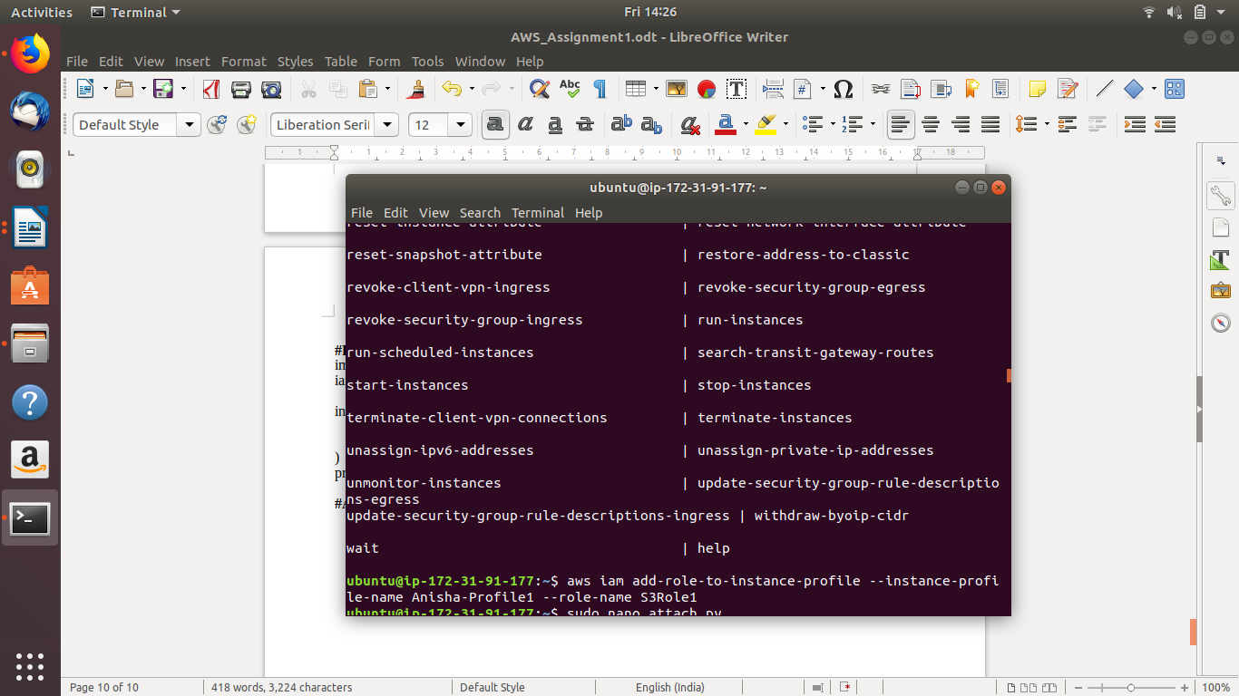
8.
Create an RDS MySQL instance and connect to it from an EC2 instance. Perform crud operations using python.
Deliverable: Python Script

import pymysql

def connection():
try:
conn = pymysql.connect(host="rds-demo.csaruqlxxway.us-east-1.rds.amazonaws.com",user="root",passwd="Borkar21",port=3306, db="Game" )
print("connected.")
return conn
except Exception as e:
print(e)

# prepare a cursor object using cursor() method
db = connection()
cursor = db.cursor()
cursor.execute("DROP TABLE IF EXISTS EMPLOYEE")
# Create table as per requirement
sql = """CREATE TABLE ASSIGNMENT (
FIRST_NAME CHAR(20) NOT NULL,
LAST_NAME CHAR(20),
AGE INT,
SEX CHAR(1),
INCOME FLOAT )"""

cursor.execute(sql)
print("created table")

#Performing CRUD operations

#Inserting items in the table (Create)
cursor.execute("INSERT INTO ASSIGNMENT(FIRST_NAME, LAST_NAME, AGE, SEX, INCOME) VALUES ('Sam', 'Jake', 65, 'M', 20000)")
cursor.execute("INSERT INTO ASSIGNMENT(FIRST_NAME, LAST_NAME, AGE, SEX, INCOME) VALUES ('Blake', 'Brown', 20, 'M', 20500)")
cursor.execute("INSERT INTO ASSIGNMENT(FIRST_NAME, LAST_NAME, AGE, SEX, INCOME) VALUES ('Sela', 'Harding', 25, 'F', 26000)")

#Retrieving items from the table(Retrieve)
cursor.execute("Select * from ASSIGNMENT")
results = cursor.fetchall()
print(results)

#Updating a value based on certain conditions(Update)
cursor.execute("UPDATE ASSIGNMENT SET AGE = AGE + 1 WHERE FIRST_NAME = 'Sam'")

#select to see the update
cursor.execute("Select * from ASSIGNMENT")
results = cursor.fetchall()
print(results)

#Deleting an item based on certain conditions(Delete)
cursor.execute("DELETE FROM ASSIGNMENT WHERE AGE > 60 ")

print(cursor.execute("Select * from ASSIGNMENT"))
results = cursor.fetchall()
print(results)

db.commit()
db.close()

9. Write a program that creates your table “Games” in your AWS DynamoDB and adds certains items in the dynamo db. Example schema:
Schema “Games” :
gid {Number}
gname {String}
publisher {String}
rating {Number}
release_date {String}
genres {String Set}
Deliverable: Script

import boto3

# Get the service resource.
dynamodb = boto3.resource('dynamodb',region_name="us-east-1")

# Create the DynamoDB table.
table = dynamodb.create_table(
TableName='AnishaGames1',
KeySchema=[
{
'AttributeName': 'gid',
'KeyType': 'HASH'
},
{
'AttributeName': 'gname',
'KeyType': 'RANGE'
}

],
AttributeDefinitions=[
{
'AttributeName': 'gid',
'AttributeType': 'N'
},
{
'AttributeName': 'gname',
'AttributeType': 'S'
}
],
ProvisionedThroughput={
'ReadCapacityUnits': 5,
'WriteCapacityUnits': 5
}
)

# Wait until the table exists.
table.meta.client.get_waiter('table_exists').wait(TableName='AnishaGames1')

dynamodb= boto3.resource("dynamodb", region_name="us-east-1")

table = dynamodb.Table("AnishaGames1")

response = table.put_item( Item={ 'gid':1, 'gname':'Mario', 'rating':9})

response1 = table.put_item( Item = {'gid':2, 'gname':'GTA', 'rating':8})

response2 = table.put_item( Item= {'gid':3, 'gname':'Pokemon', 'rating':10 })

10.
Write a program that reads your table “Games” from your AWS DynamoDB and
Returns only the game where ‘gid=2’ (“Query” Feature DynamoDB).
Prints out the ‘gname’ and the ‘rating’ only.
Deliverable: Script

import boto3
from boto3.dynamodb.conditions import Key, Attr
dynamodb = boto3.resource("dynamodb", region_name="us-east-1")

table = dynamodb.Table('AnishaGames1')

print("Game Description")

response = table.query(
KeyConditionExpression=Key('gid').eq(2)
)

for i in response['Items']:
print(i['gid'], ":", i['gname'], i['rating'])

