CONTAINERIZATION ASSIGNMENT

Dockerfile & Docker Hub
1. Create your own NGINX docker image(not using official image)
- Create a Dockerfile for NGINX image
- Edit file /usr/share/nginx/html/index.html and add a custom index.html through docker file
- Create a container from Nginx image and publish port 8080
- Exec bash on it and install nano
- Check on localhost:8080 changes
- Push image to docker hub in your docker registry, ECR, GCR

Step 1:
Create a Dockerfile with all the specifications (File attached)

Step 2:
Building the image using this Dockerfile
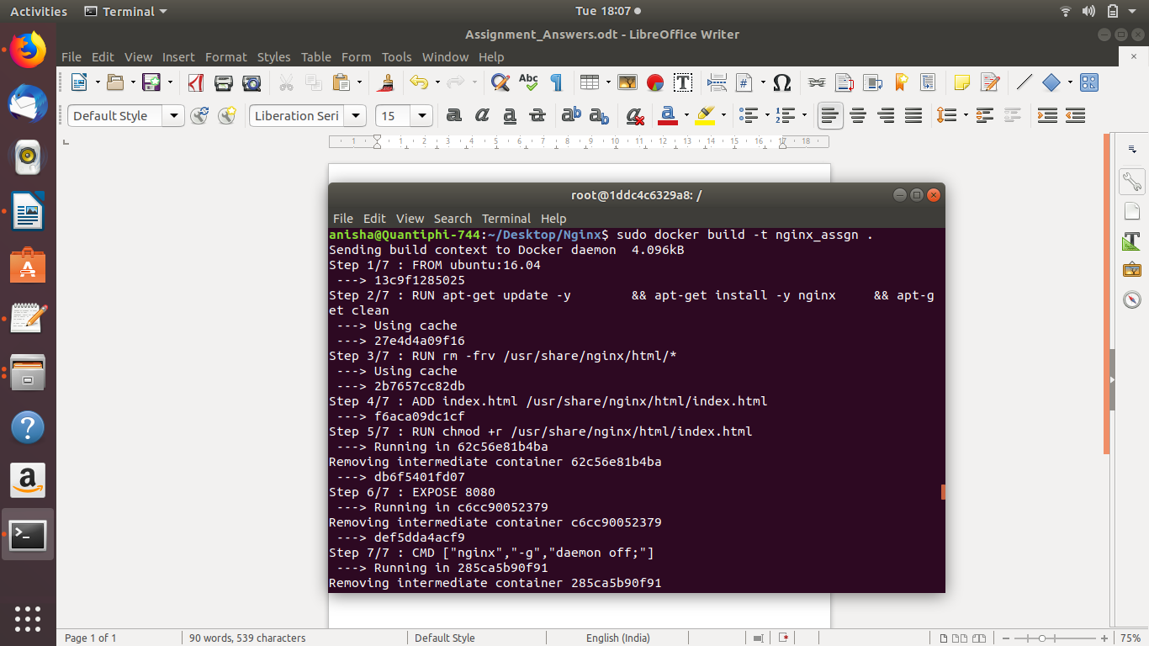
Step 3:
Checking if the image has successfully got created
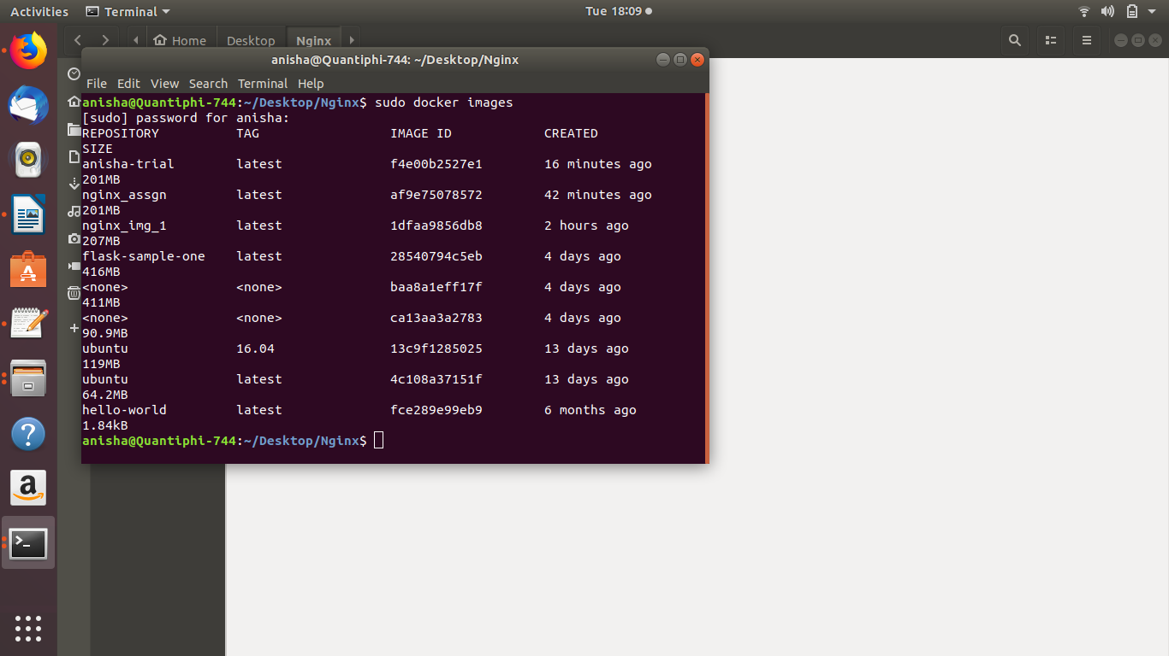

Step 4:
Run the image and check if the container got created
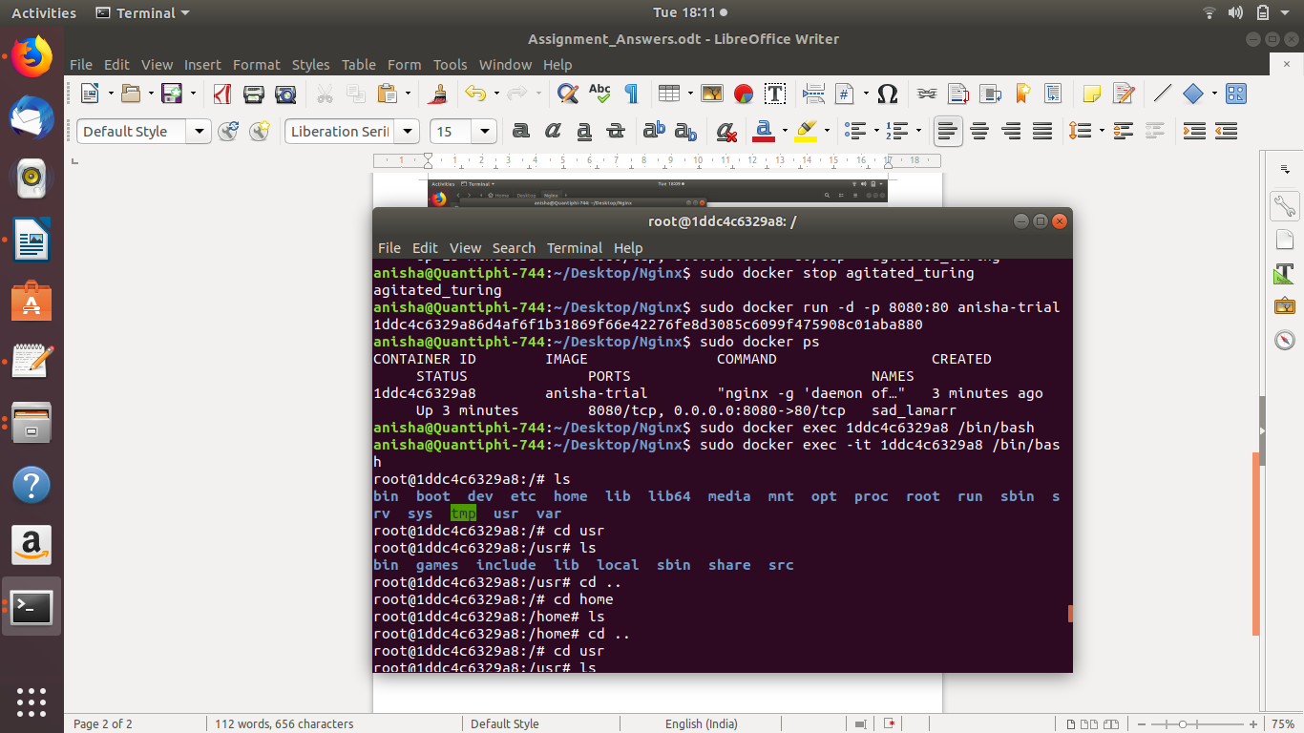
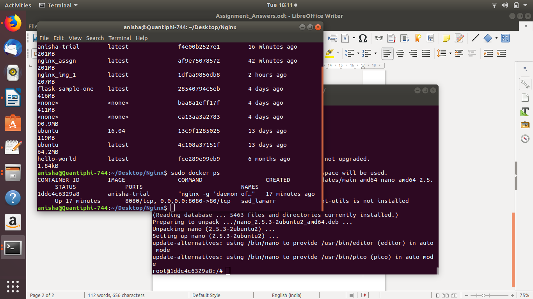

Step 6:
Run the local host on 8080:80 to check the nginx server
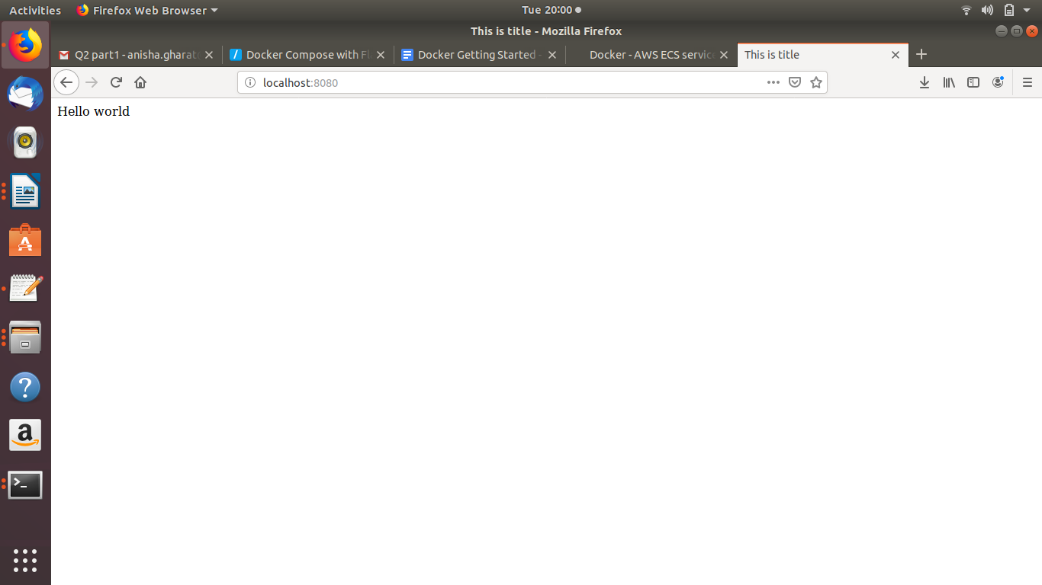
Step 5:
Exec into the container and install nano
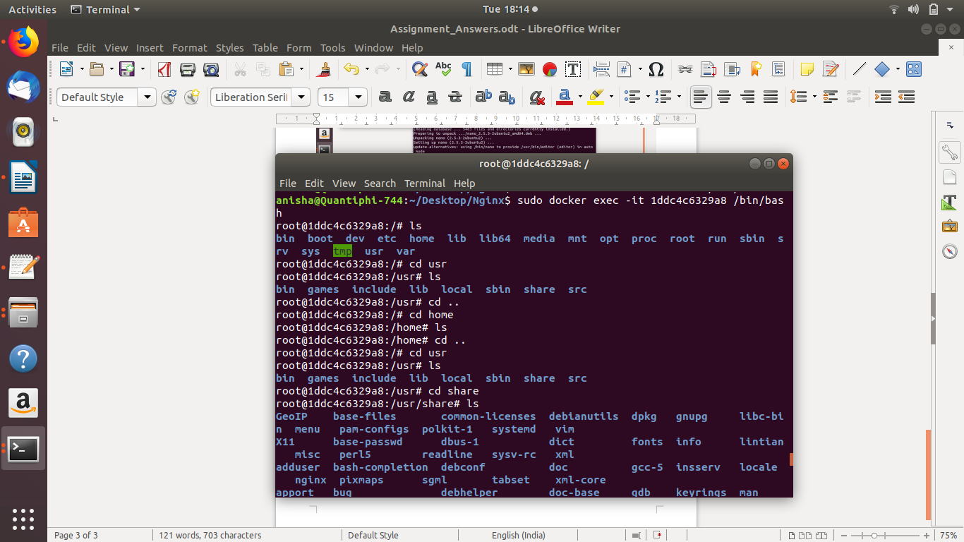

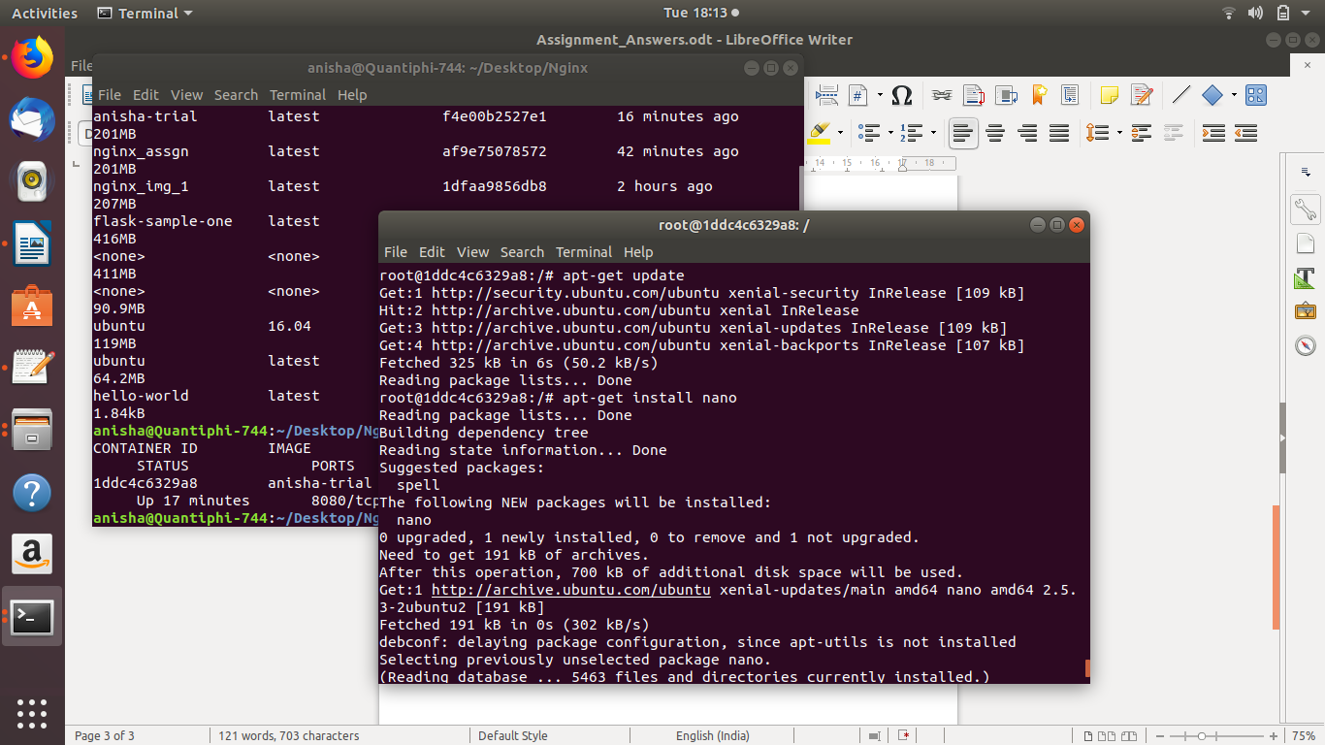
Step 6:
Pushing the image in the Docker registry
