CONTAINERIZATION ASSIGNMENT

Docker compose
1: Create a web application in Flask which maintains a hit counter in redis, as whenever user hits the page counter increments and gets updated in redis. Build this environment using docker compose

2: Create a volume, mount the volume and configure it in docker-compose.yaml file such that the code can be edited inside the container without having to rebuild the docker image. Use the same Web application created in Task 1 to test.

(All files attached)

Step 1:
Create app.py to configure flask and redis

Step 2:
Create the Dockerfile specifying the base image and other configurations

Step 3:
Specify the requirements : Flask and Redis in the requirements.txt file

Step 4:
Create the docker-compse.yaml file to define the services

Step 5:
Build and run the docker compose
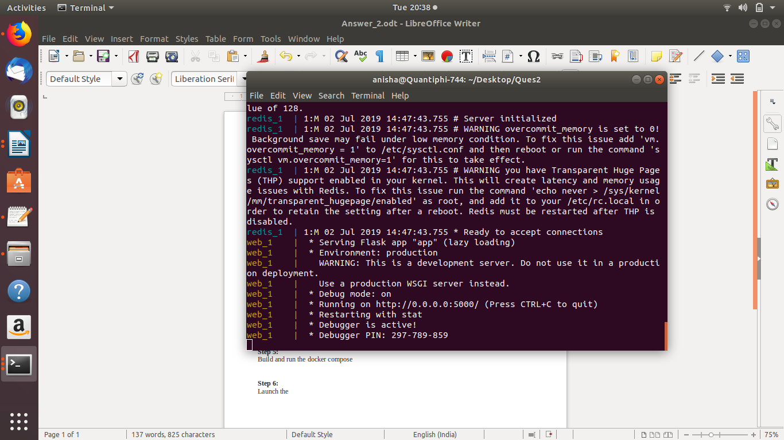

Step 6:
Launch the http://.. specified during the build and run
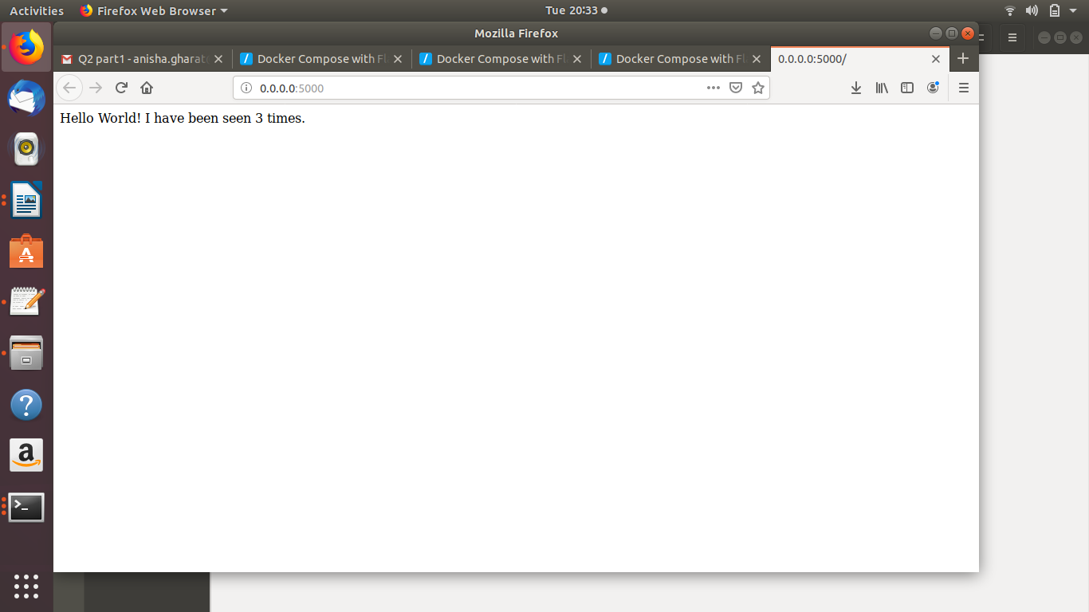
On refreshing the redis increments the counter on every hit
