GCP Assignment-2

- Launch instance with only private ip and configure NAT so instance can access Internet. (Need to use network tags)

Step1:
Create VPC with a private and public subnet
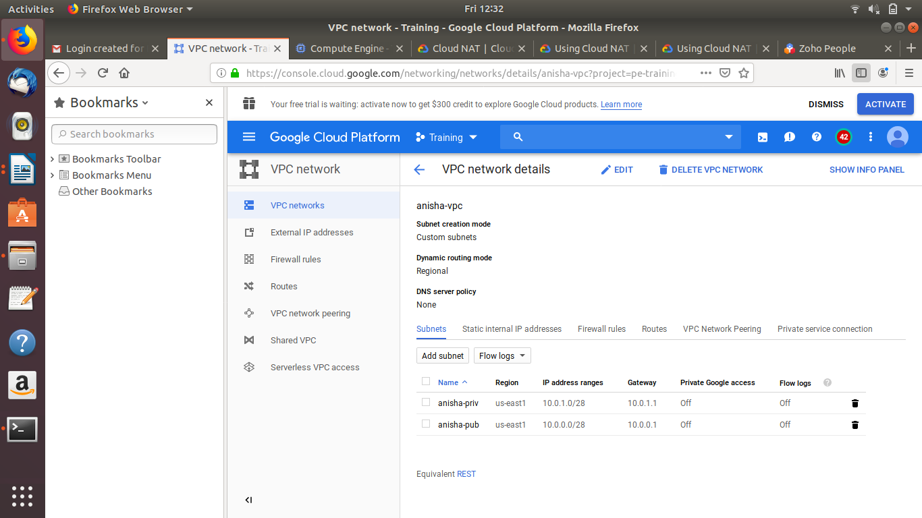

Step2: Create a bastion host for testing

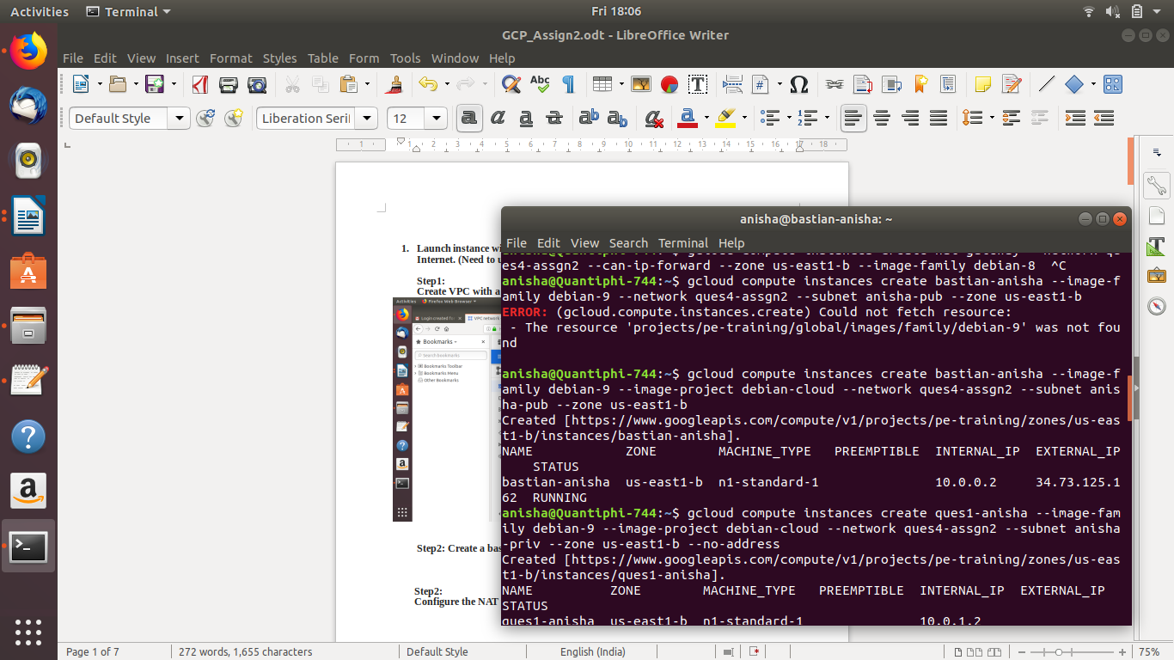
Step3: Create a VM instance with no external IP address

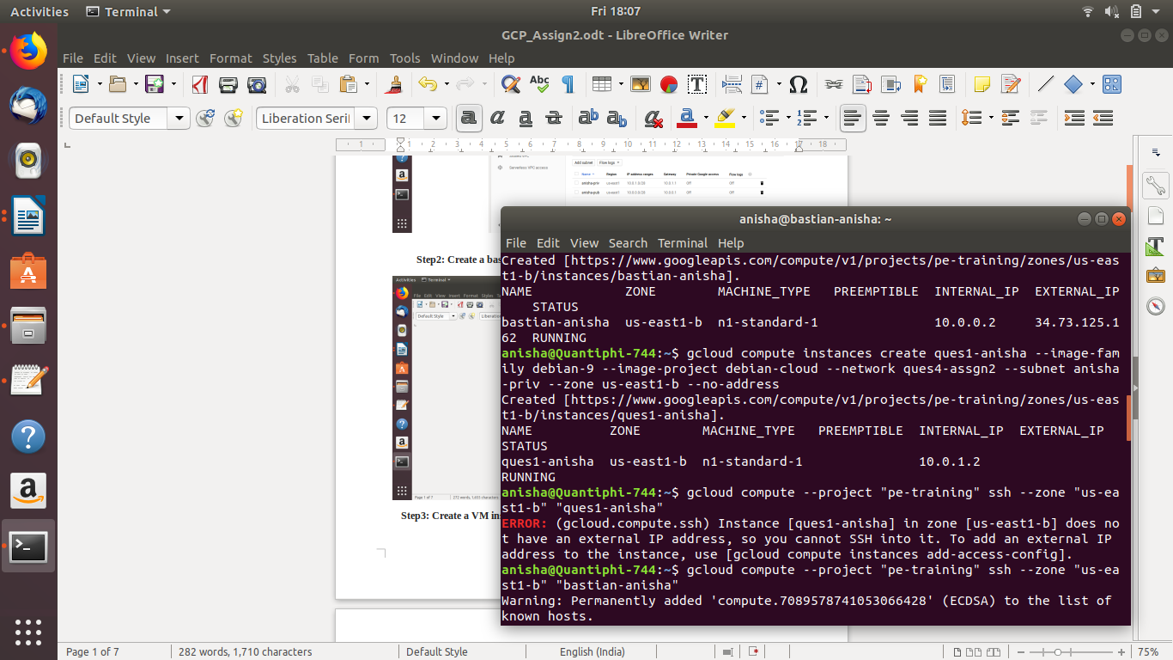
Step4:
Create a firewall rule that allows SSH connections
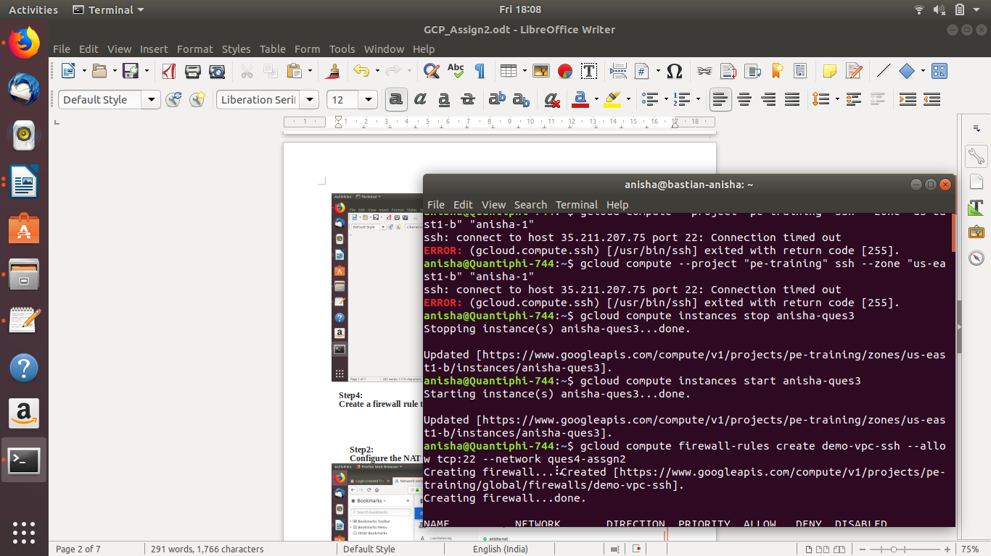

Step5:
Log into the nat instance and confirm that it can reach the internet

Step6:
SSH into the Bastion
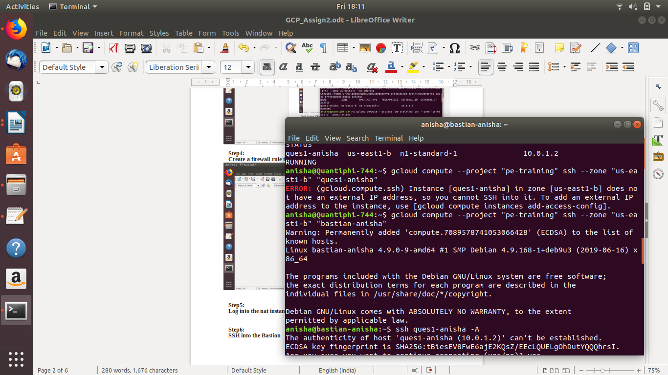
Step7:
SSH into the nat-instance from the bastion host

Step8:
Connect to the internet. It should allow access

3.
Create an instance with Linux OS of your choice. The instance should run apache server that displays your name when the webpage is accessed via a browser. The task should be completed without accessing the instance via SSH. Stop the instance (using CLI) and restart the instance (again using CLI) and check again if the apache server is running. View the log file of the server startup.

Step1:
Creating an instance with a start up script and installing apache2 (Start-up attached)
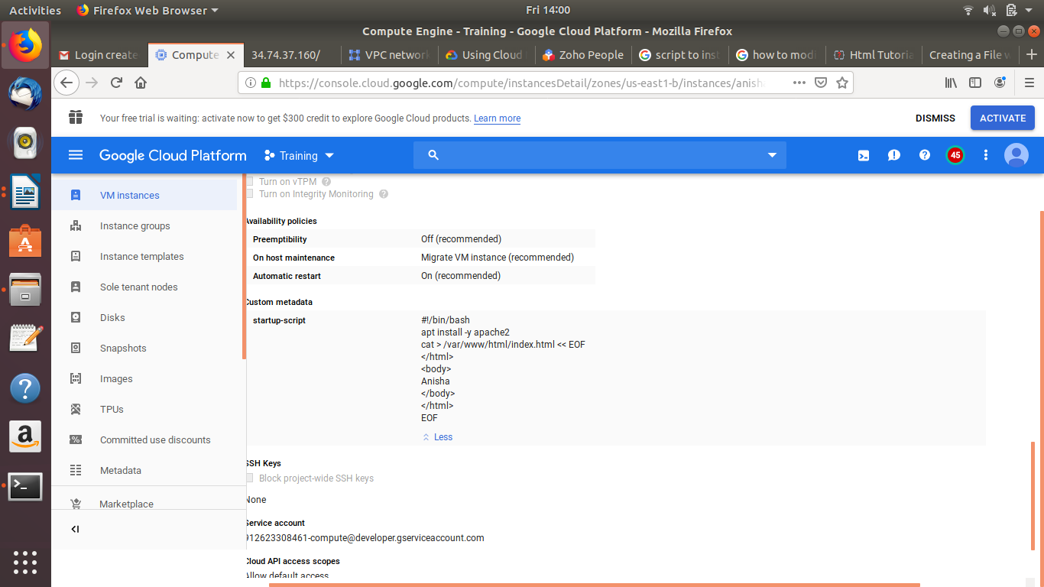
Step2:
Launching the instance
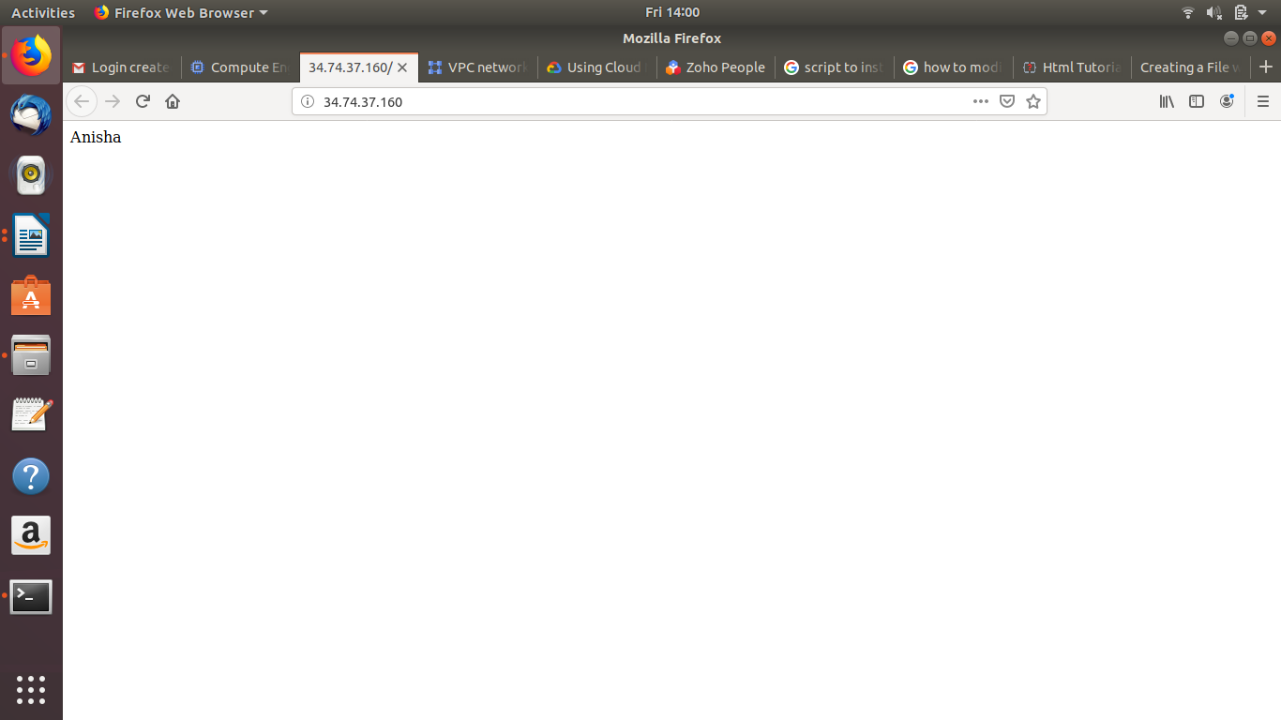

Step3:
Running CLI commands to stop and restart the instance
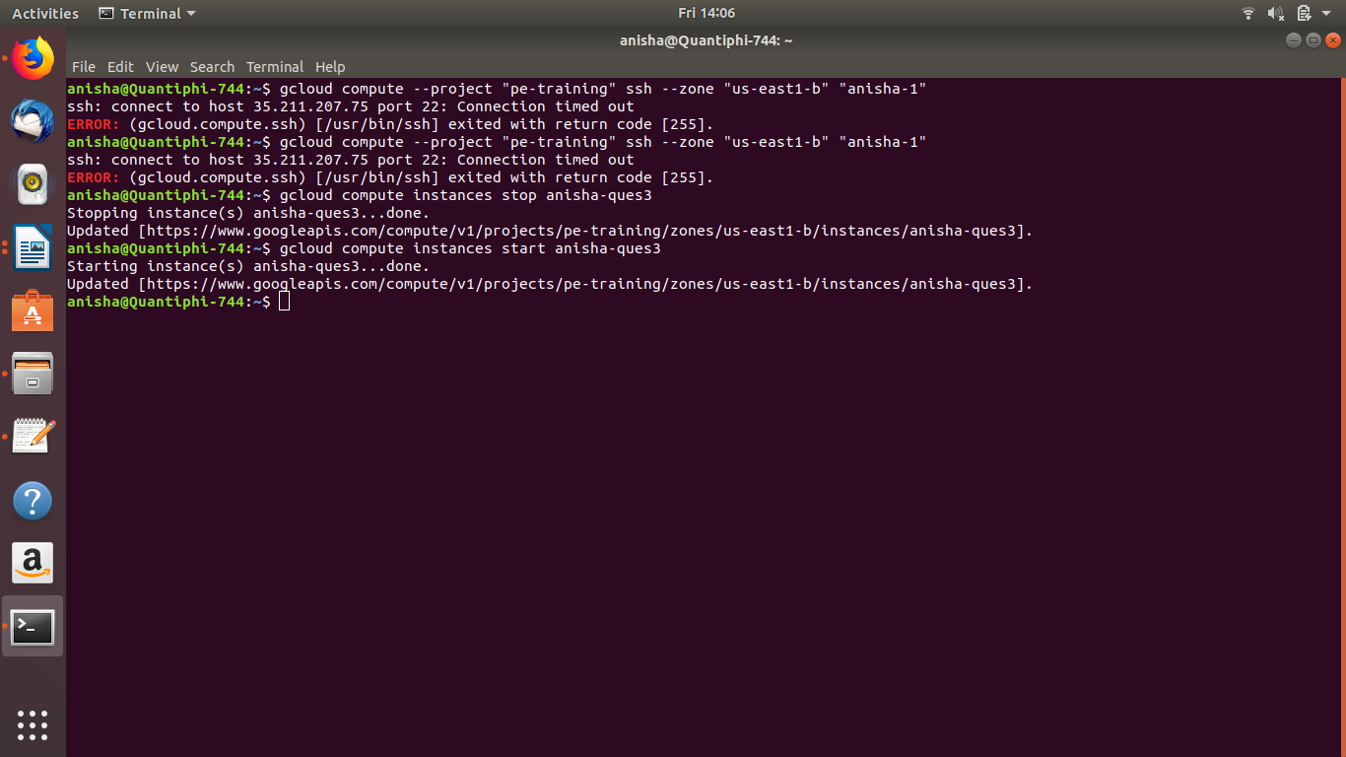

Step4:
Logfile of the startup server
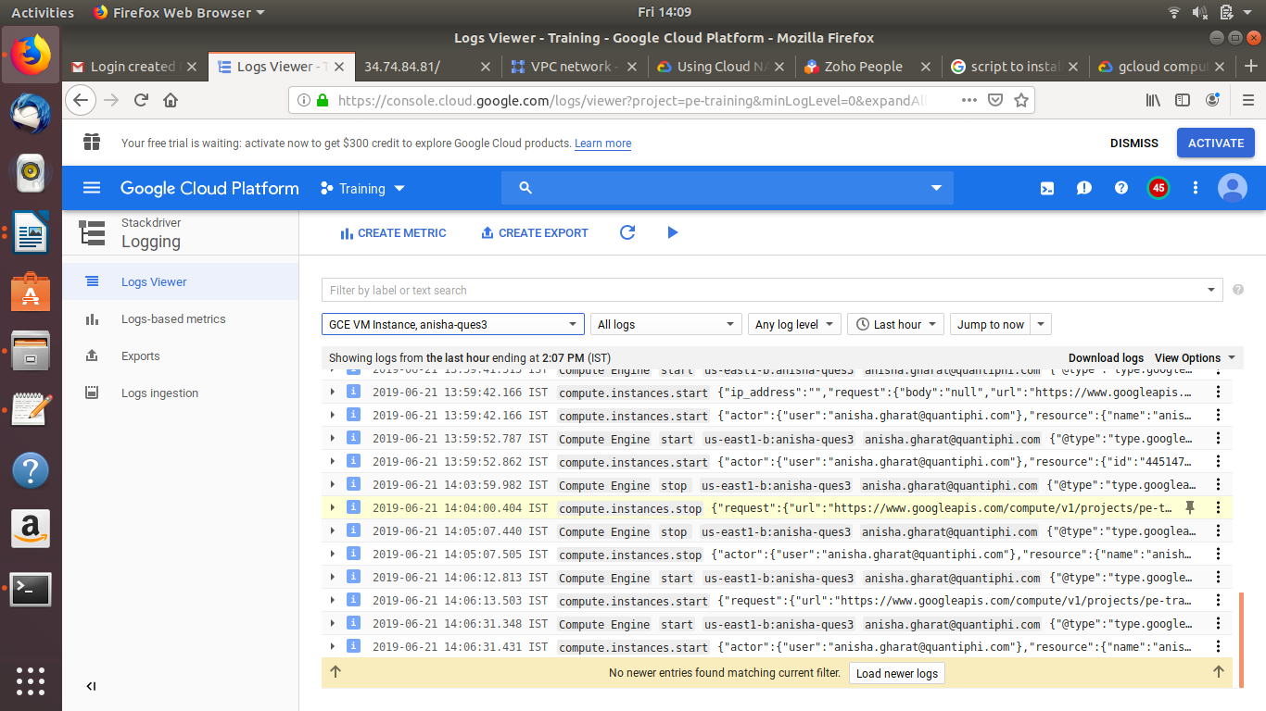

4.
Create a scalable serverless architecture to detect objects from the images immediately after being uploaded to a GCS bucket. The extracted information about the objects should be logged [optional: stored to datastore database]. The designed architecture should also have error handling.

Step1:
Create a bucket to upload the file

Step2:
Create a cloud function using Storage as a trigger (Attached function)

Step2:
Upload a file and check the logs for the cloud functions
