GCP Assignment-1

- Setup the gcloud sdk and provide the commands to check which of the gcloud components are installed. Install the components [gsutil, kubectl, bq, gcloud Alpha commands, gcloud beta commands] if not already installed.

Setting up gcloud:

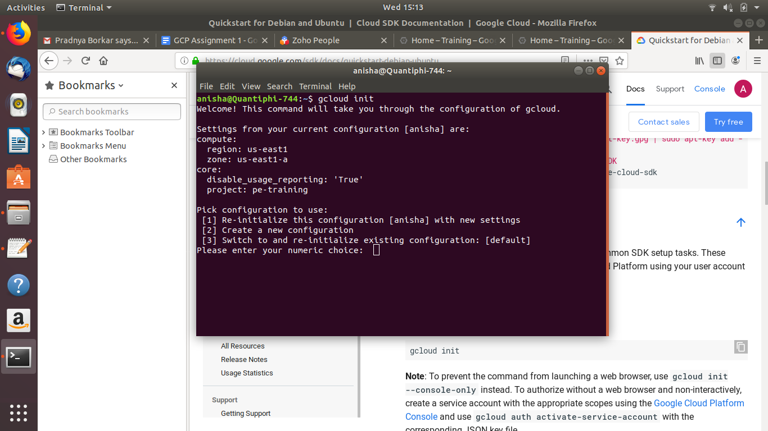
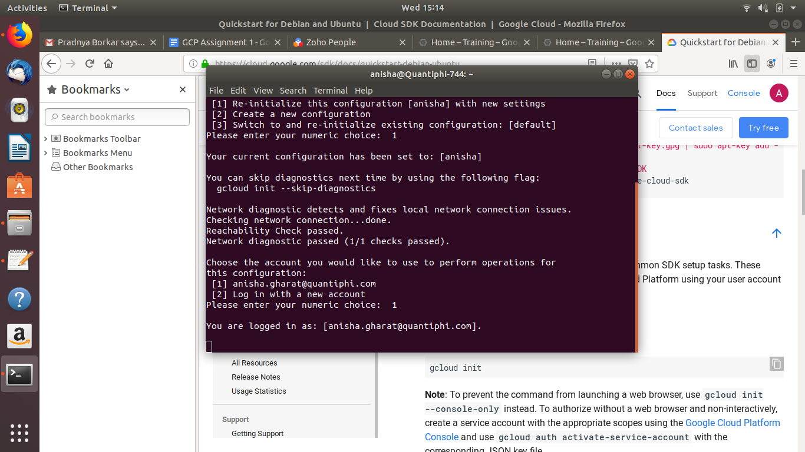

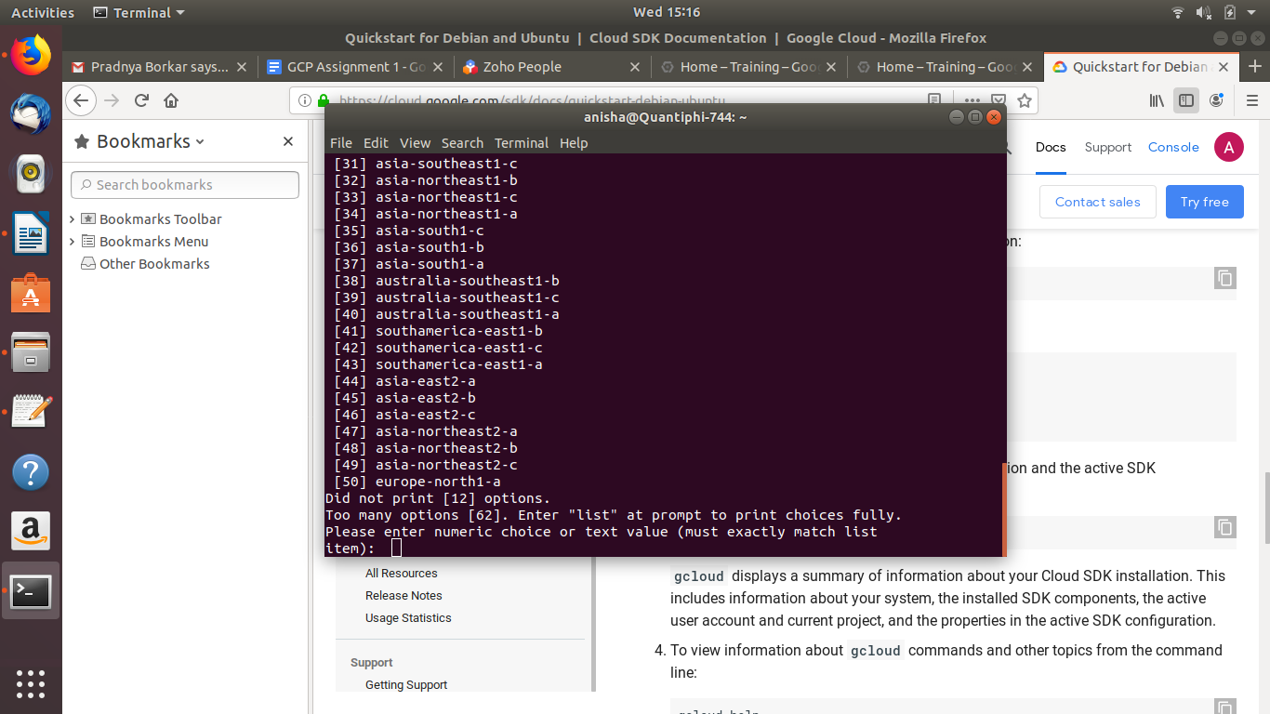
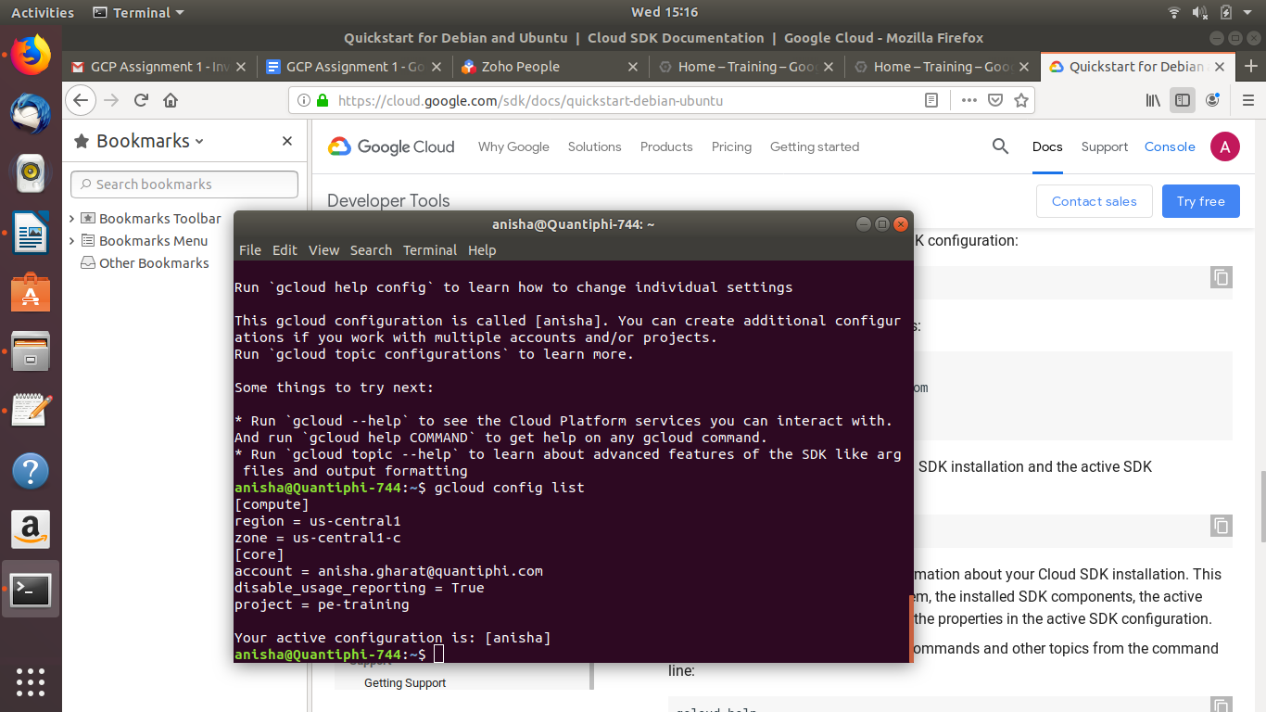

Checking the installed gcloud components:
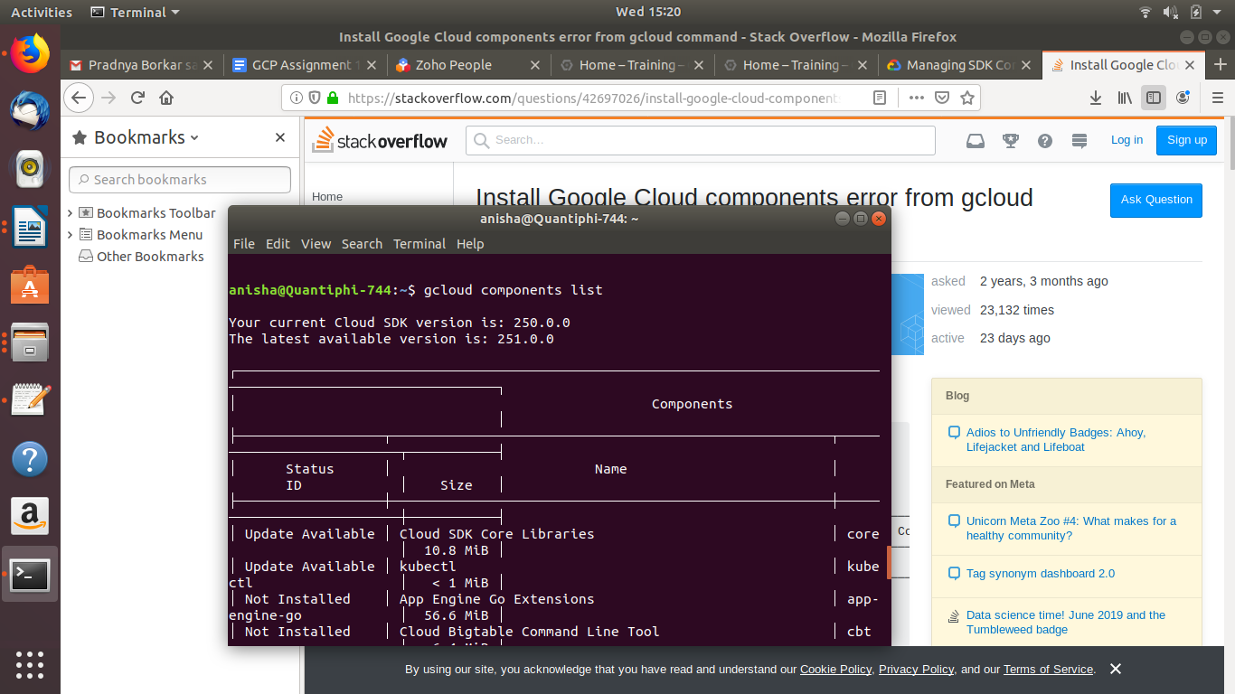

All components mentioned above are installed

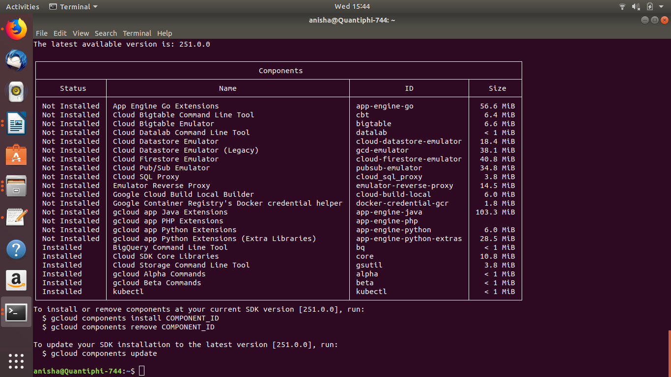

- Create multiple gcloud configurations with different configurations such as different email id’s or different projects etc. and list the commands to switch between two accounts

Creating multiple configurations

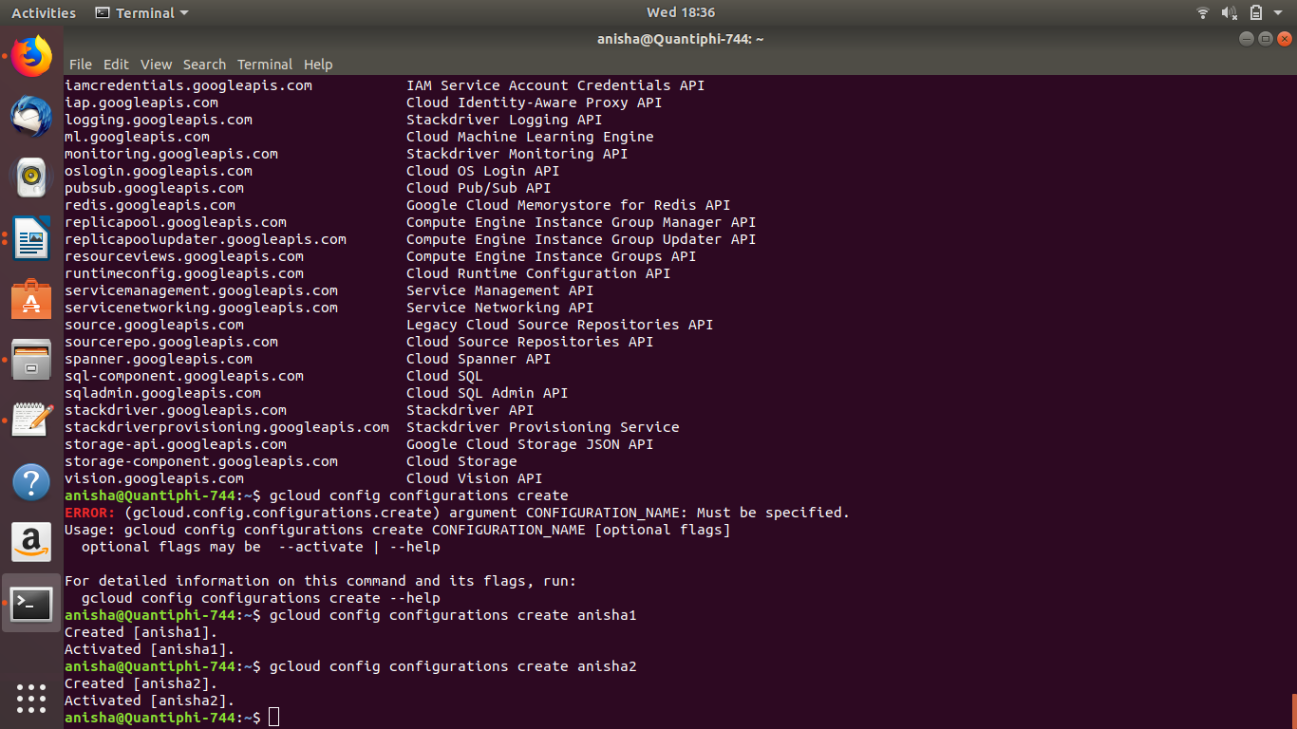

Setting up different configurations for each configuration (Account-email)
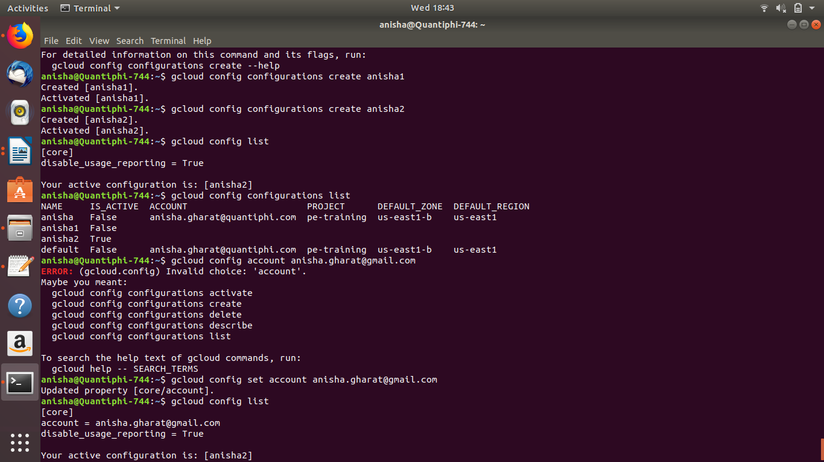

Switching between accounts:
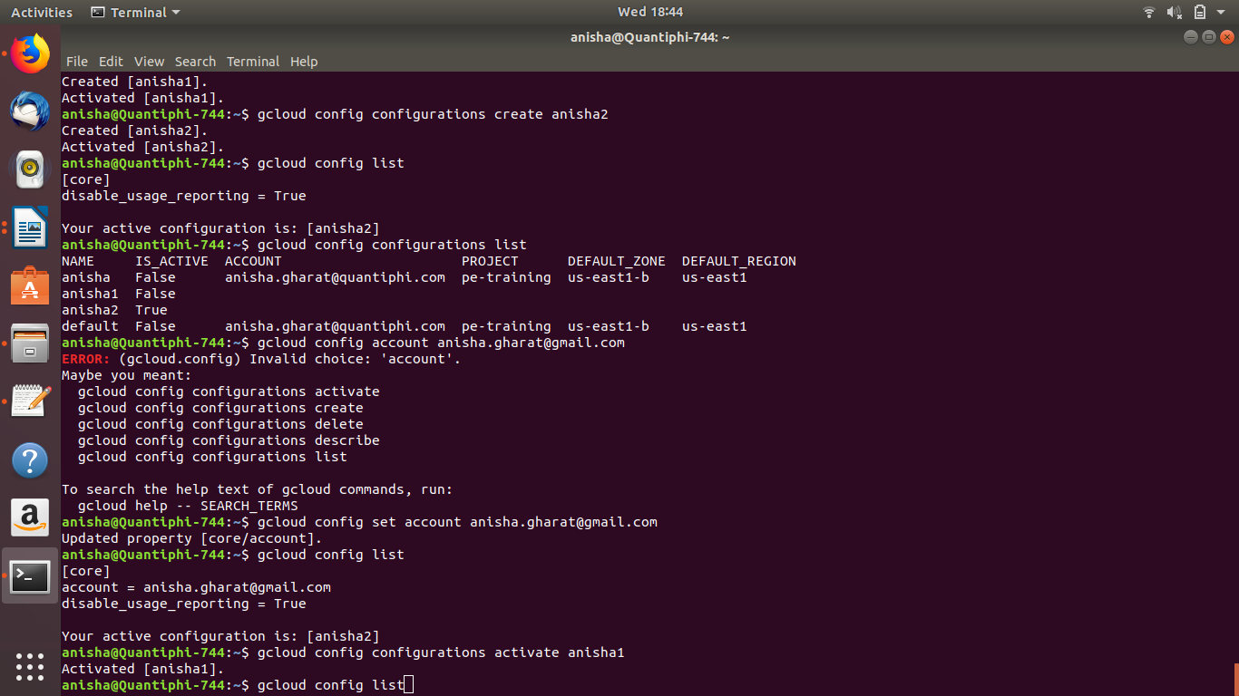

- Write commands to list out the available API Services and enabled API services

List Available API services:
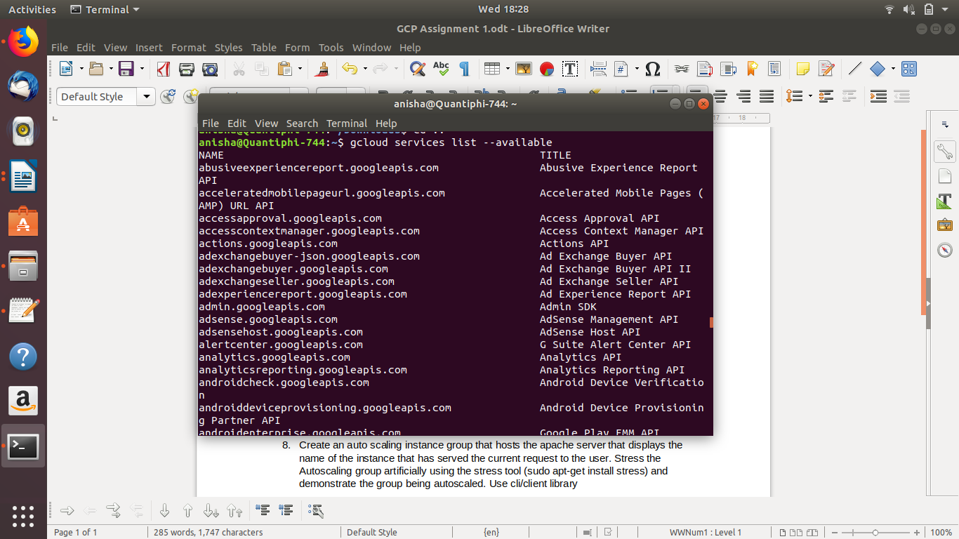

List Enables API services

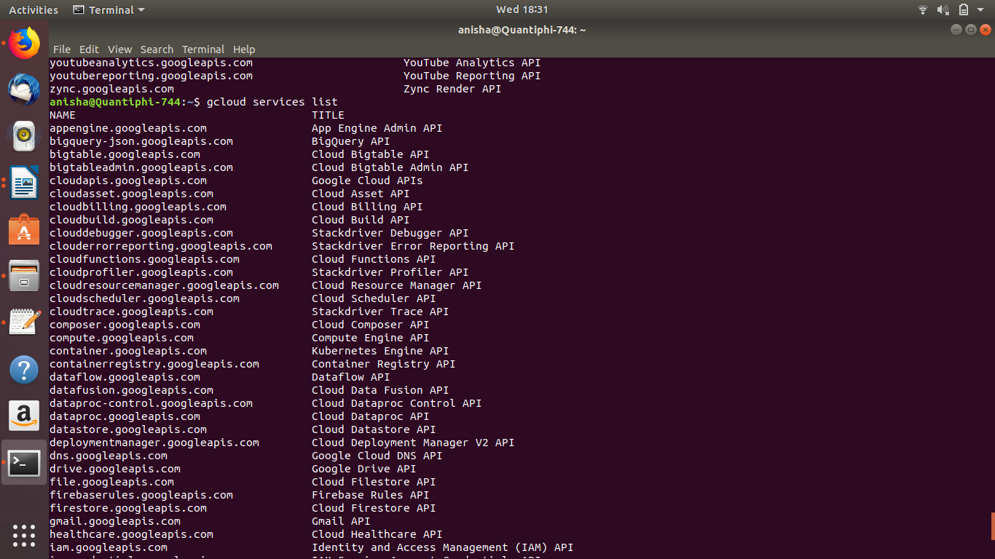

4. Create a GCE VM instance with a custom service account that has only read permissions to the cloud storage.

Step 1: Creating the service account:

Step 2: Attaching a the required role to service account (Storage Object Viewer)
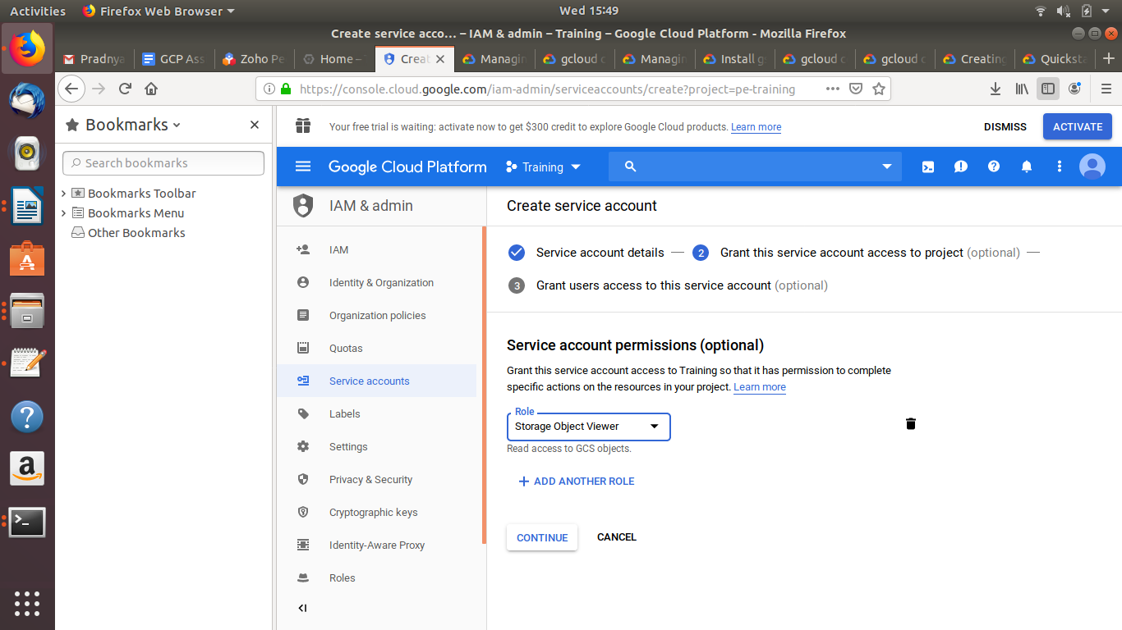

Service Account created
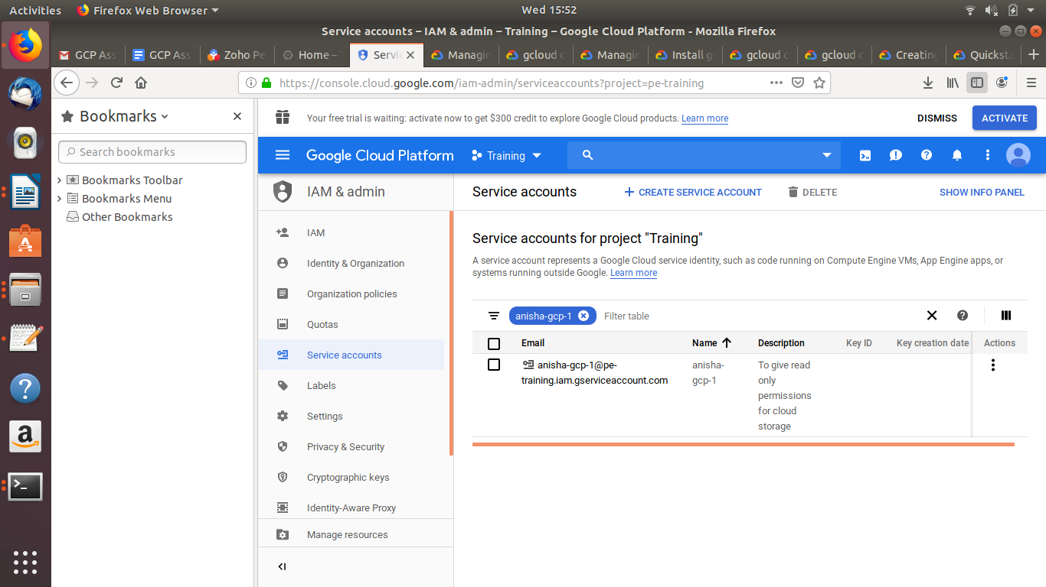

Step 3: Creating a VM instance with the service account created above

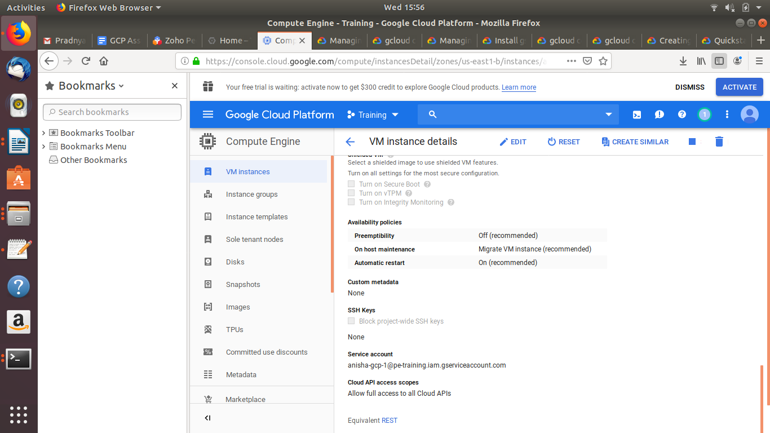

Testing: Copying a file from the local system to the Bucket from the VM instance:

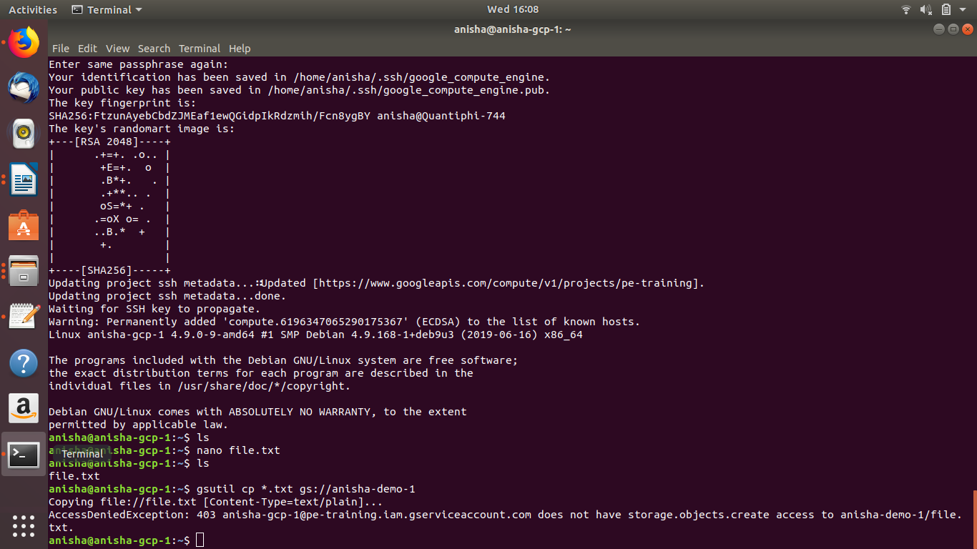

- Perform all basic kind of operations of objects (copy | move| upload | download | delete) using gsutil sdk and python client library

Through gsutil sdk:

Copy:

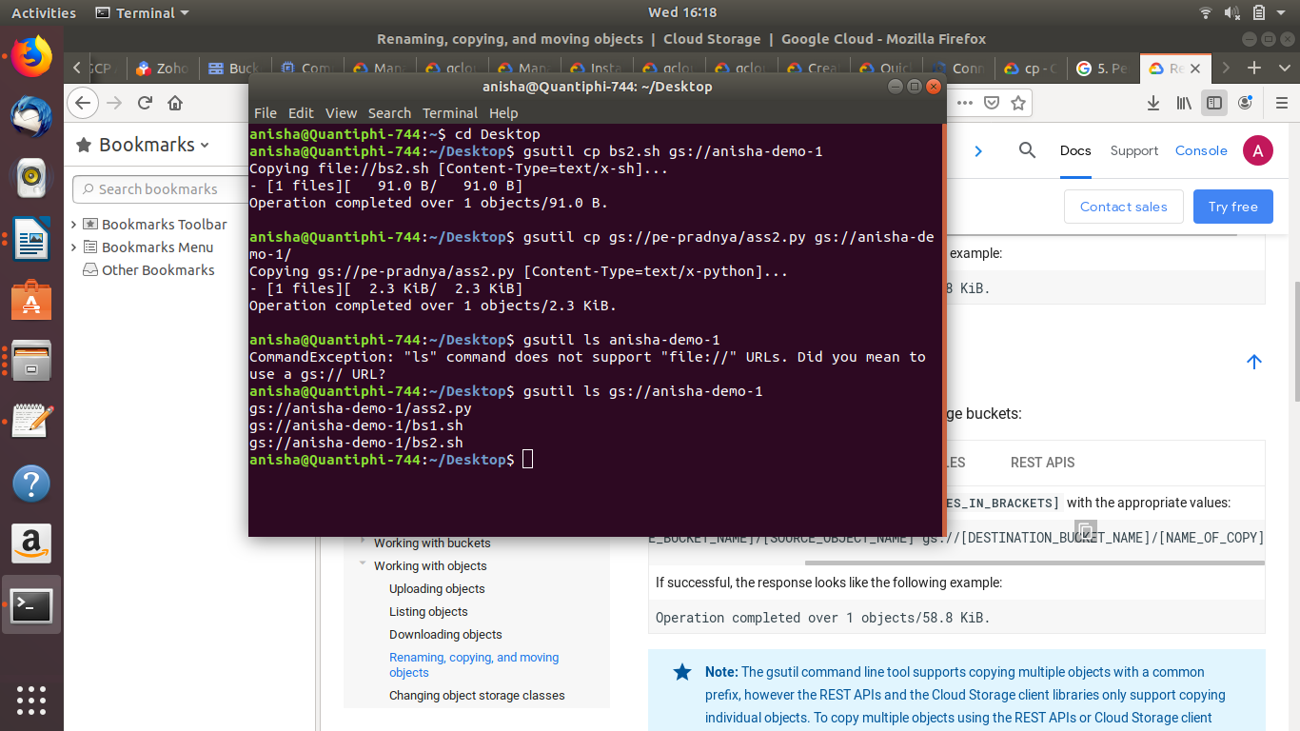

Move:
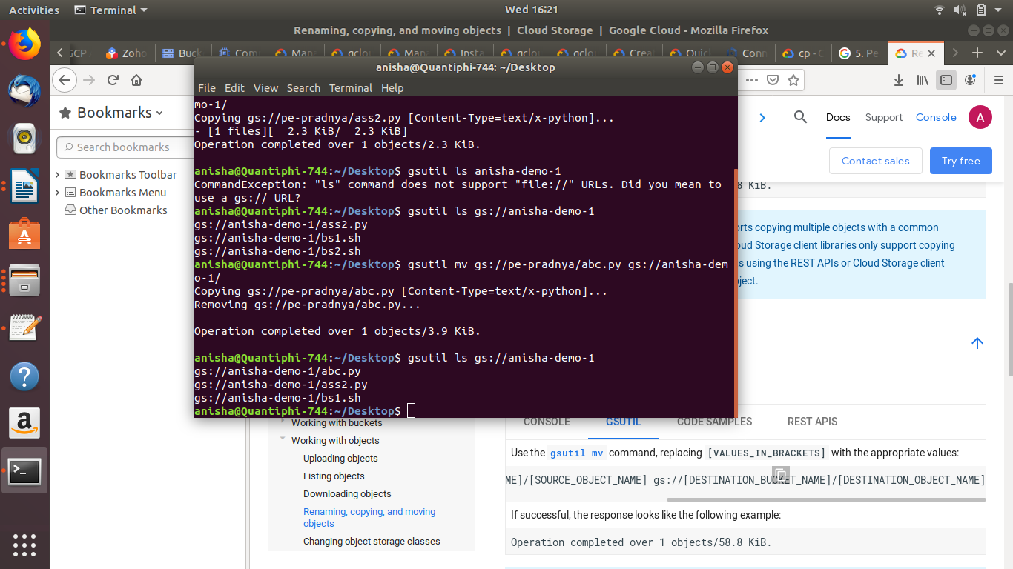

Download:
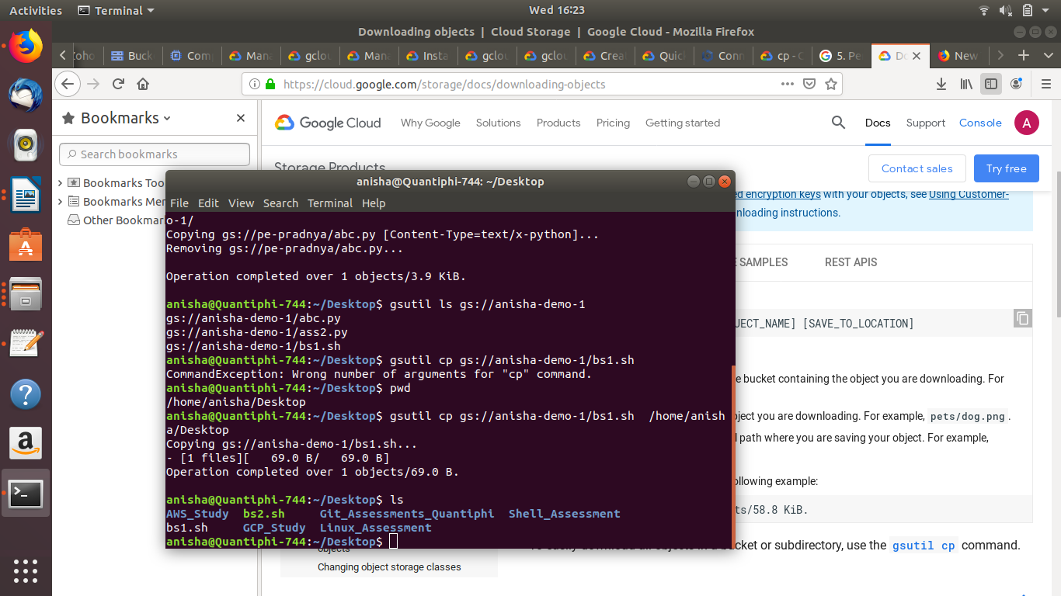

Delete:
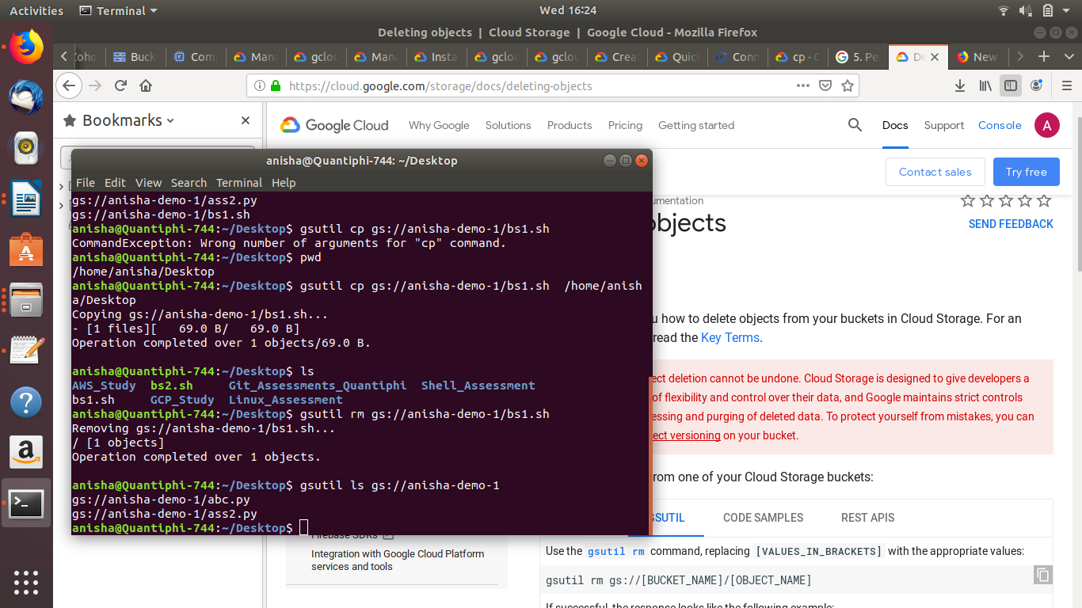

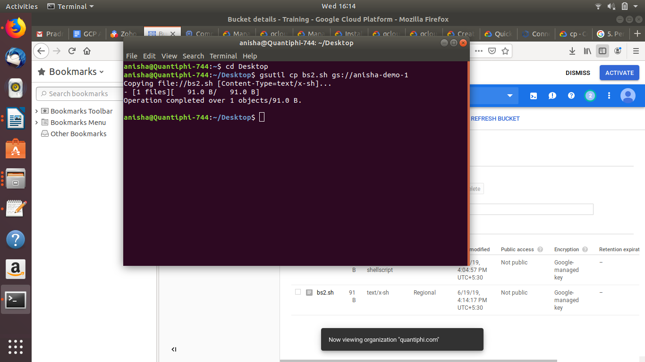

Upload

Through Python Client Library:
upload.py (attached)
copy.py
move.py
download.py
delete.py

6. Create new VPC network with automatic subnets. Configure the firewall rule to allow ssh access from only Quantiphi's IP. Use Console

Step 1 : Create a VPC
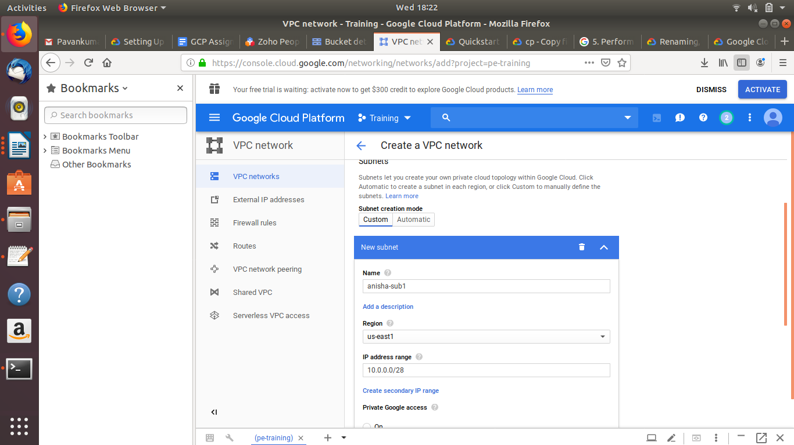
Step 2: Setting up the firewall rules

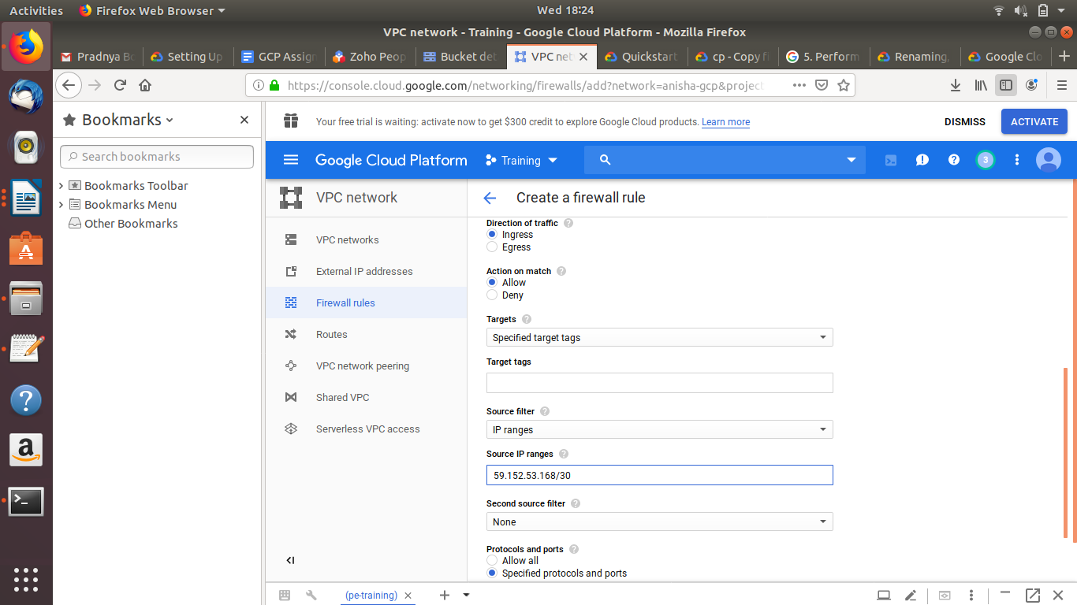

7. Steps to export all the logs related to firewall rules to BigQuery for further analysis. Use console

Step 1: Filter the log for only Firewalls Rules
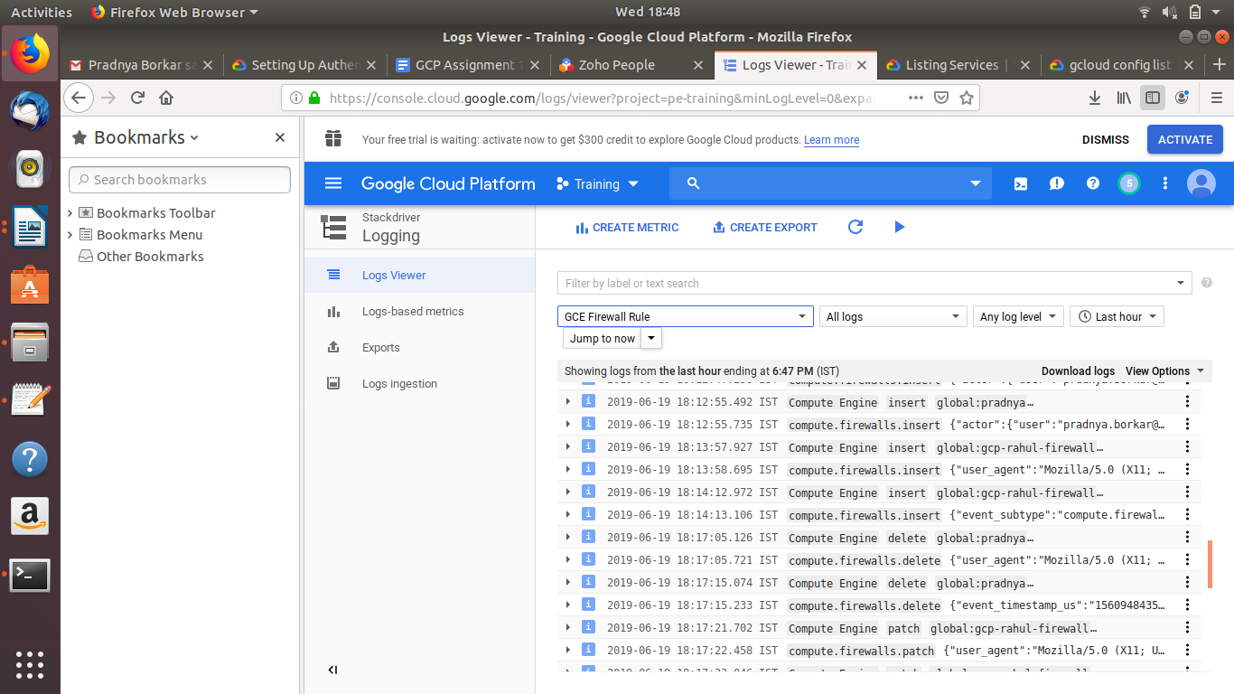
Step 2: Export logs selecting bigquery as sink service

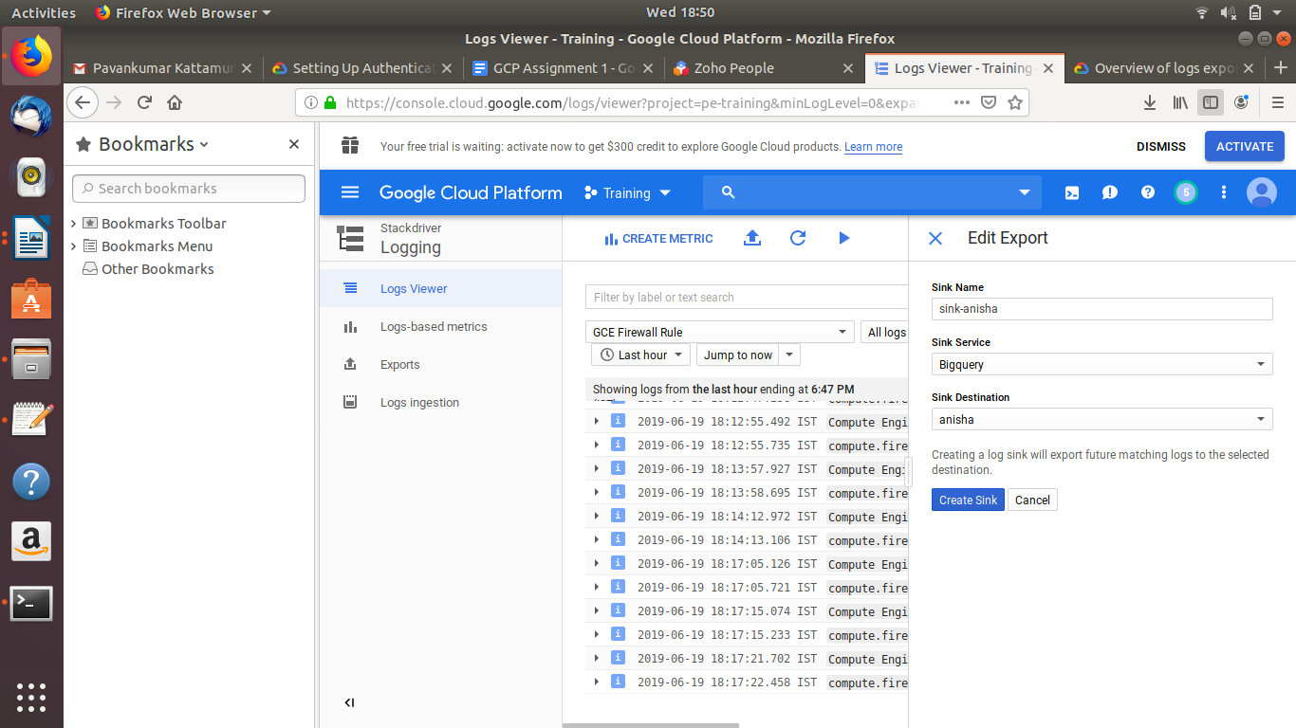
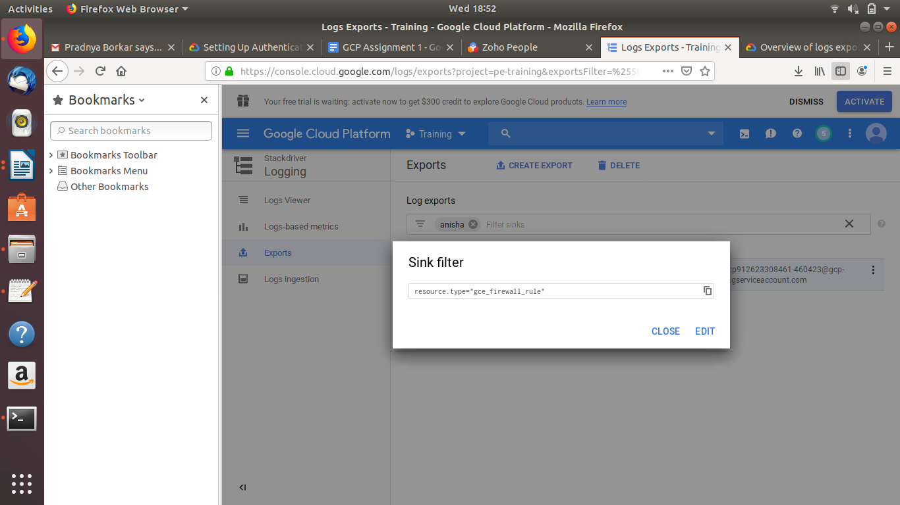

8.
Create an auto scaling instance group that hosts the apache server that displays the name of the instance that has served the current request to the user. Stress the Autoscaling group artificially using the stress tool (sudo apt-get install stress) and demonstrate the group being autoscaled. Use cli/client library

Step1 :
Create an instance template installing apache server in the boot disk
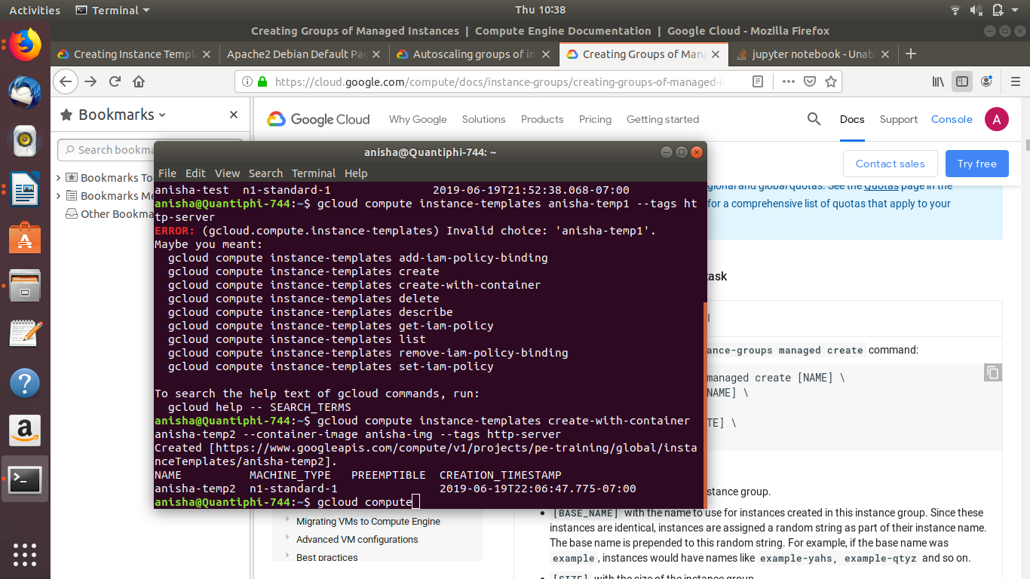

Step2:
Create an instance-group using using the above created instance template
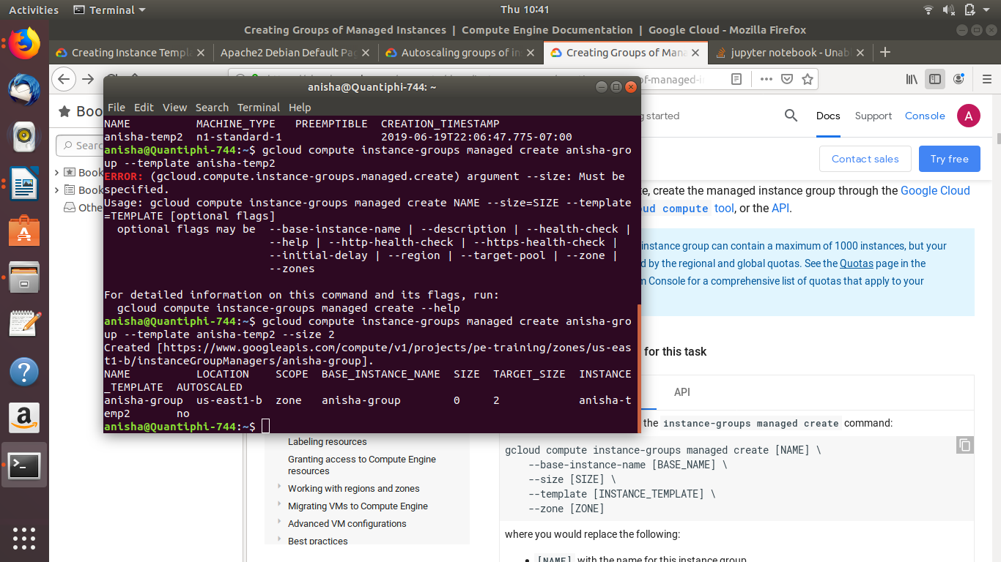
Step3:
Autoscale the instance-group and configure it with a load balancer
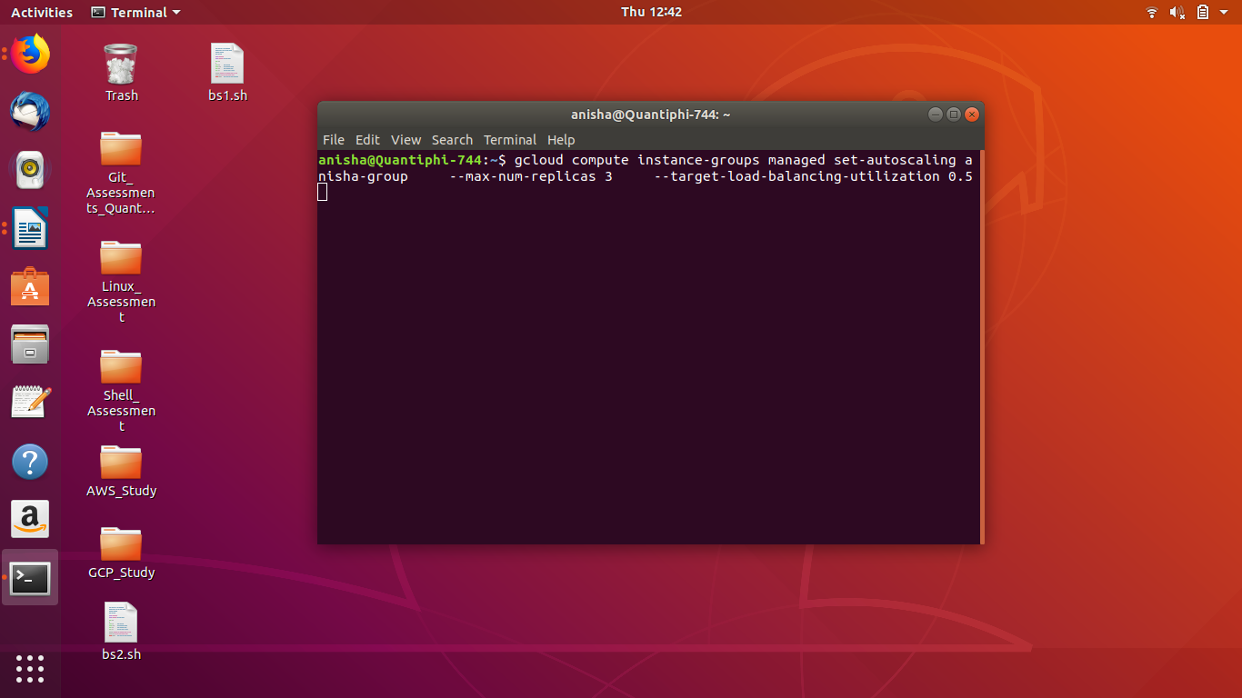
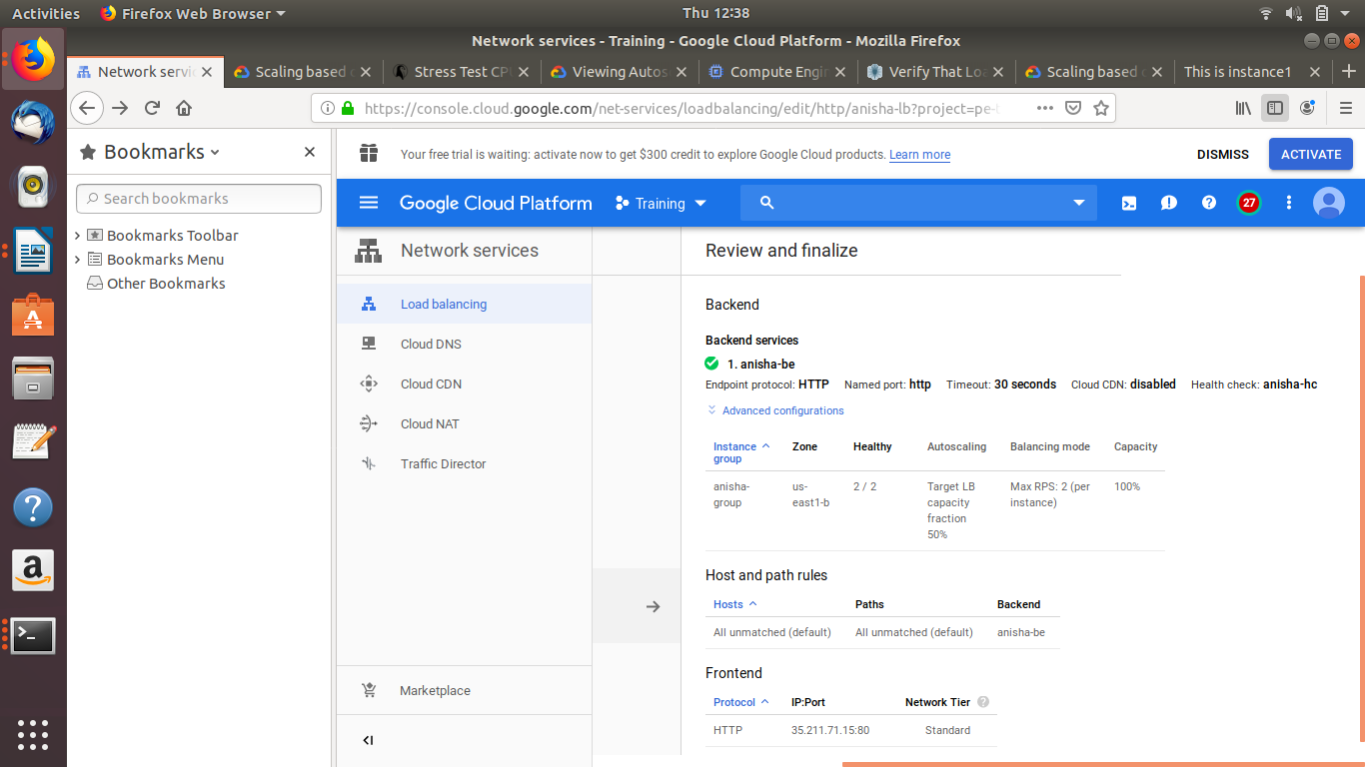

Step4: Check if the load is balancing based on the specified condition
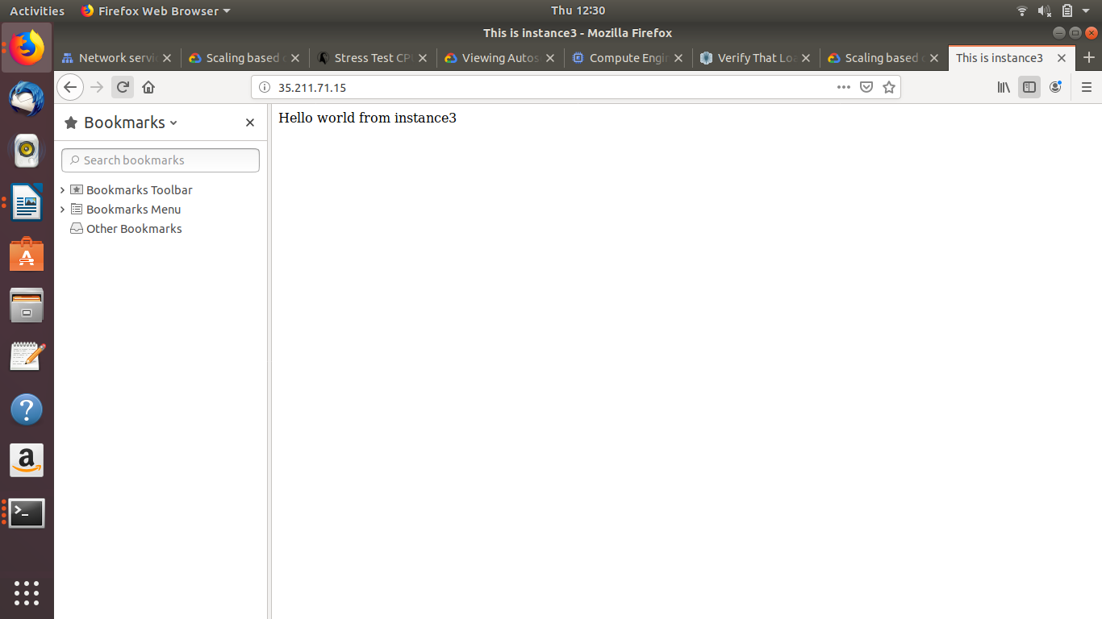

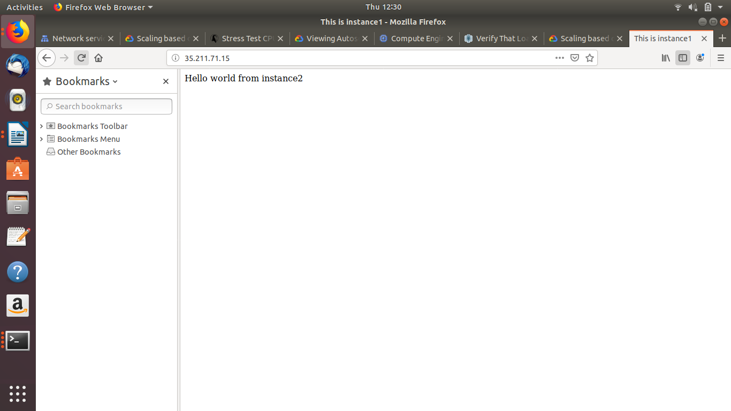

9.
Create a Cloud Function which reads the messages from Pub/Sub subscription. The pubsub message contains the bucket name and object path of a json file. The Cloud Function should store the contents of the json file into an appropriate database. Use console
Example contents of an object file(sample.json):
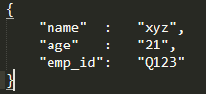

Step1:
Create a topic
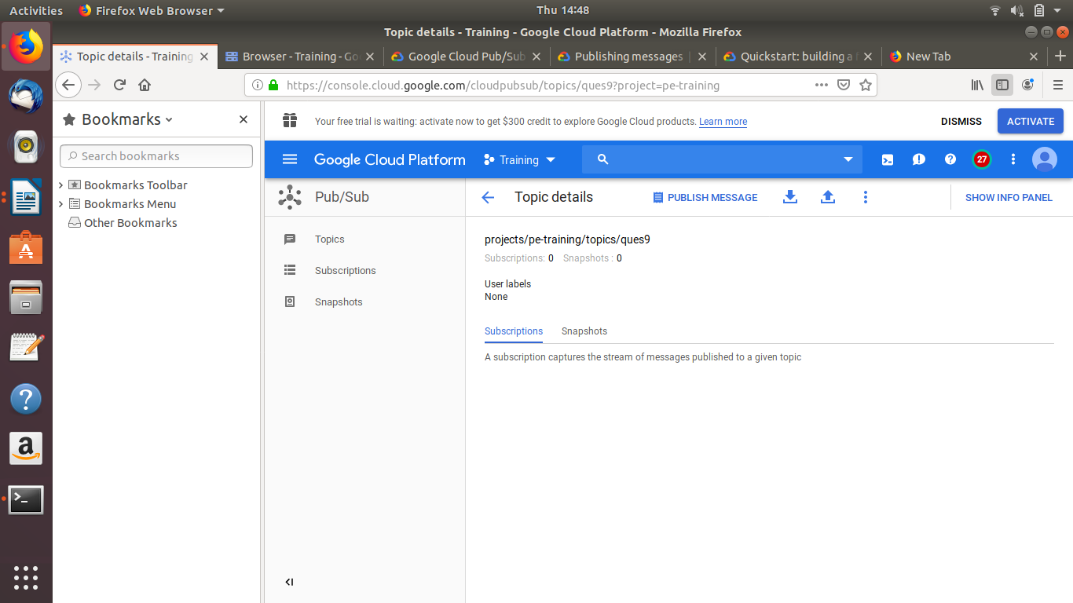

Step2:
Create a Cloud Function to load the contents of an object from a bucket and view it in the logs

python code(attached)
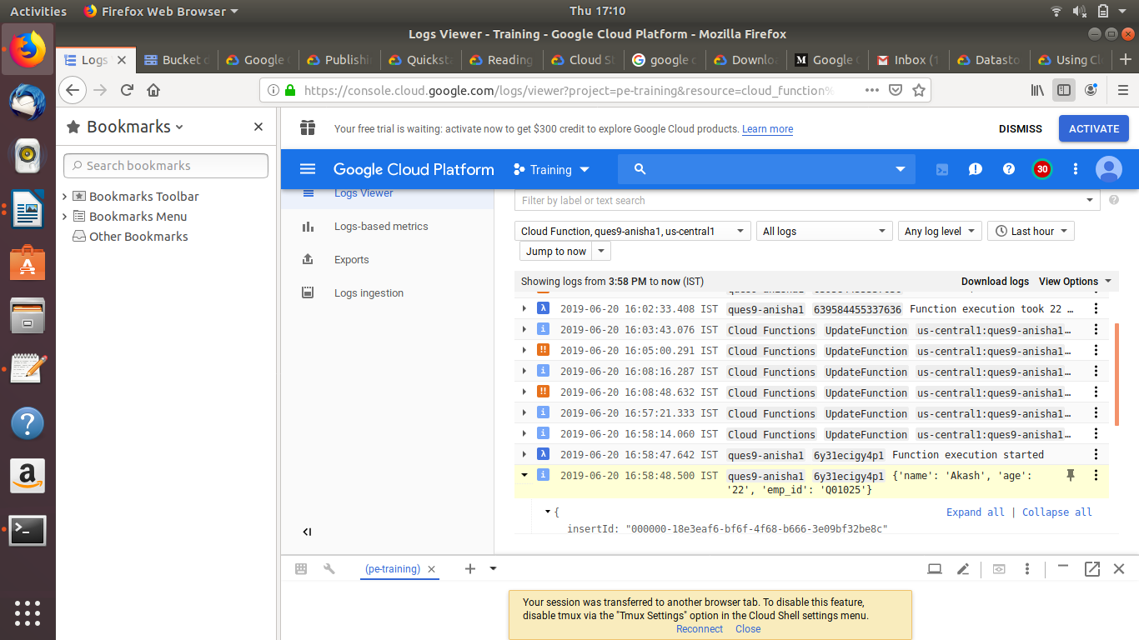

10
Configure Apache2 HTTP server on a GCE VM instance and setup an email alert notification which triggers when the health check of the instance fails. Use console



