Git Assessment

Create a Distributed version control system, and put files into it.
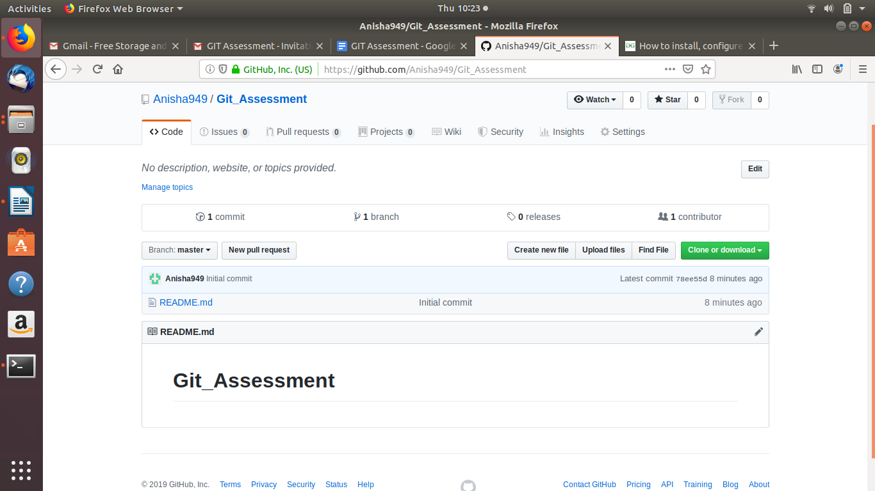
Connecting the Desktop terminal to my git account:
Command : git config –global user.email “email”
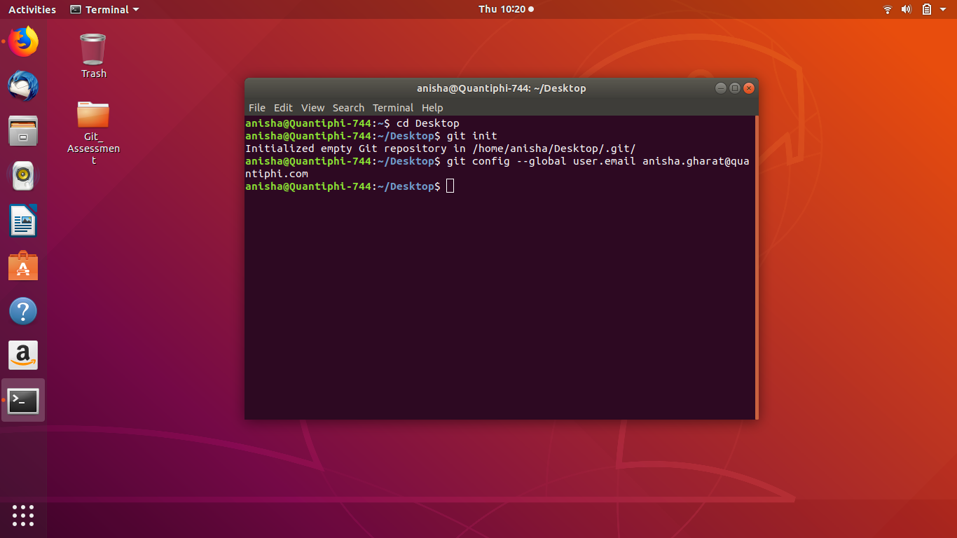
Creating a directory for the project on the Desktop:
Command : mkdir “Folder name”
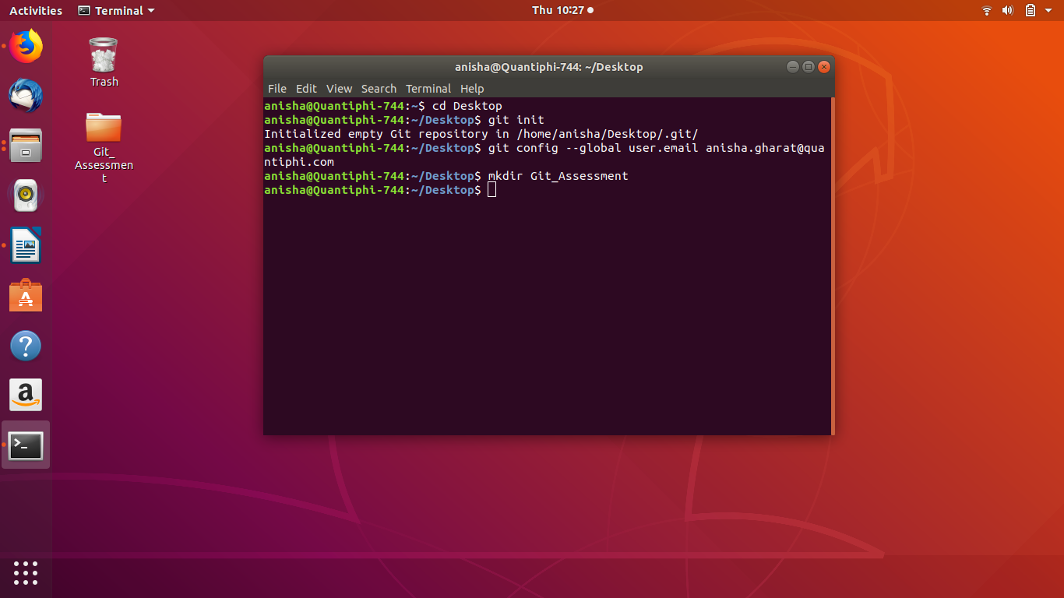

Changing the home directory to the project directory:
Command : cd “Directory name”

Initializing Git for this folder:
Command: git init
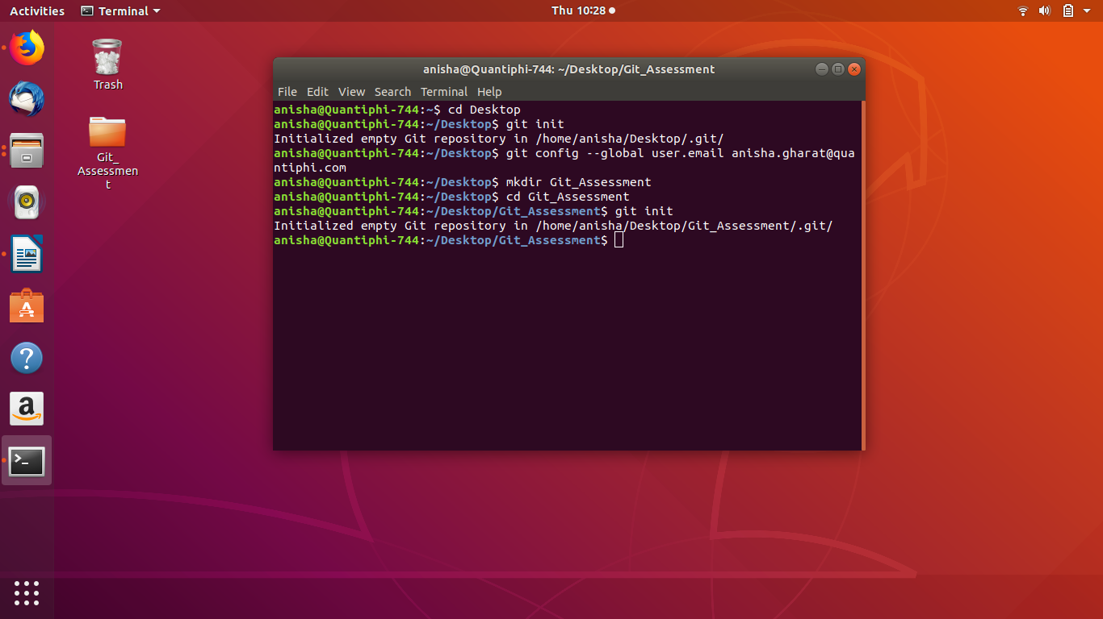
Setting up remote to locate where my repository is located:
Command: git remote add origin “repository location”
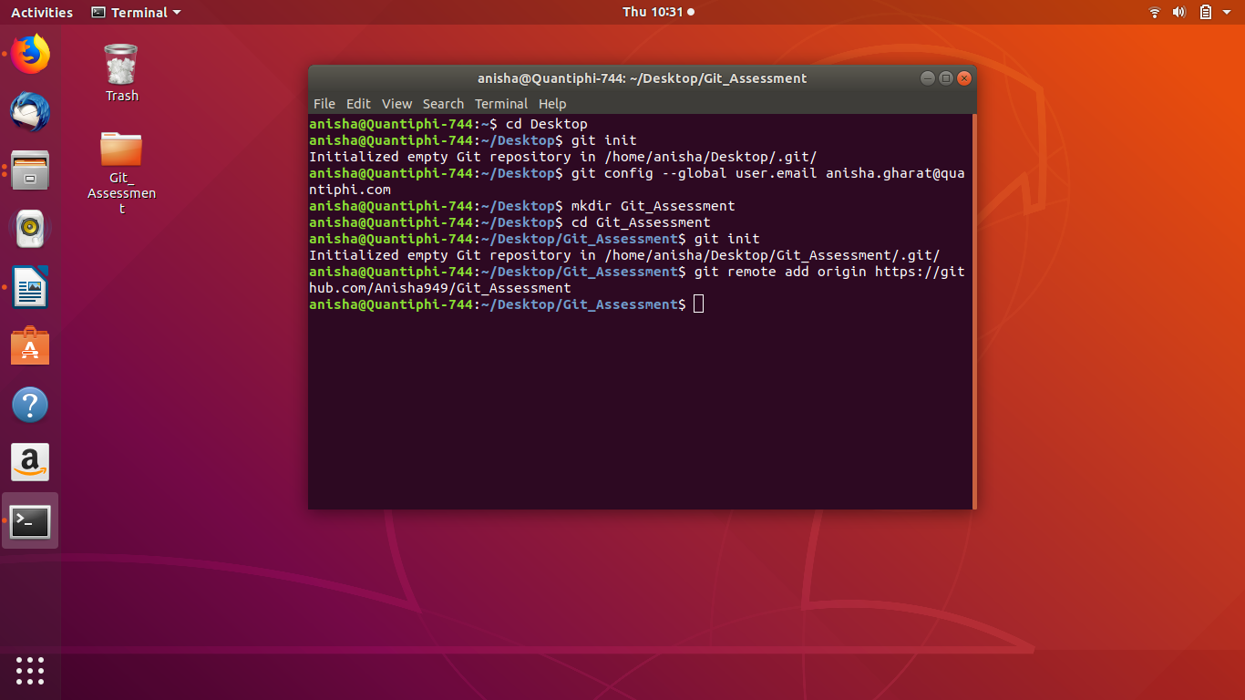
Adding files to the git repository after creating them:
Command: git add “filename”

Checking the status of the git :
Command: git status

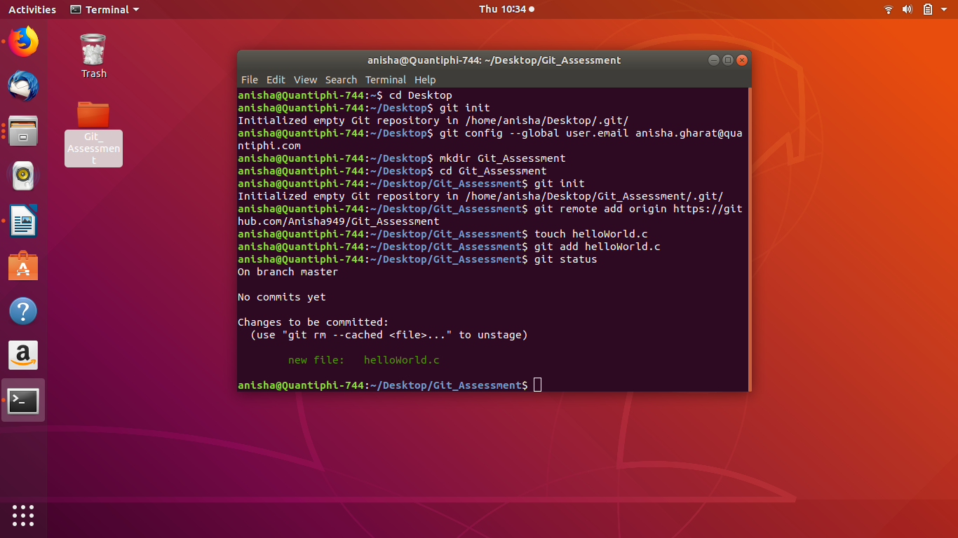
After adding multiple files to the git :
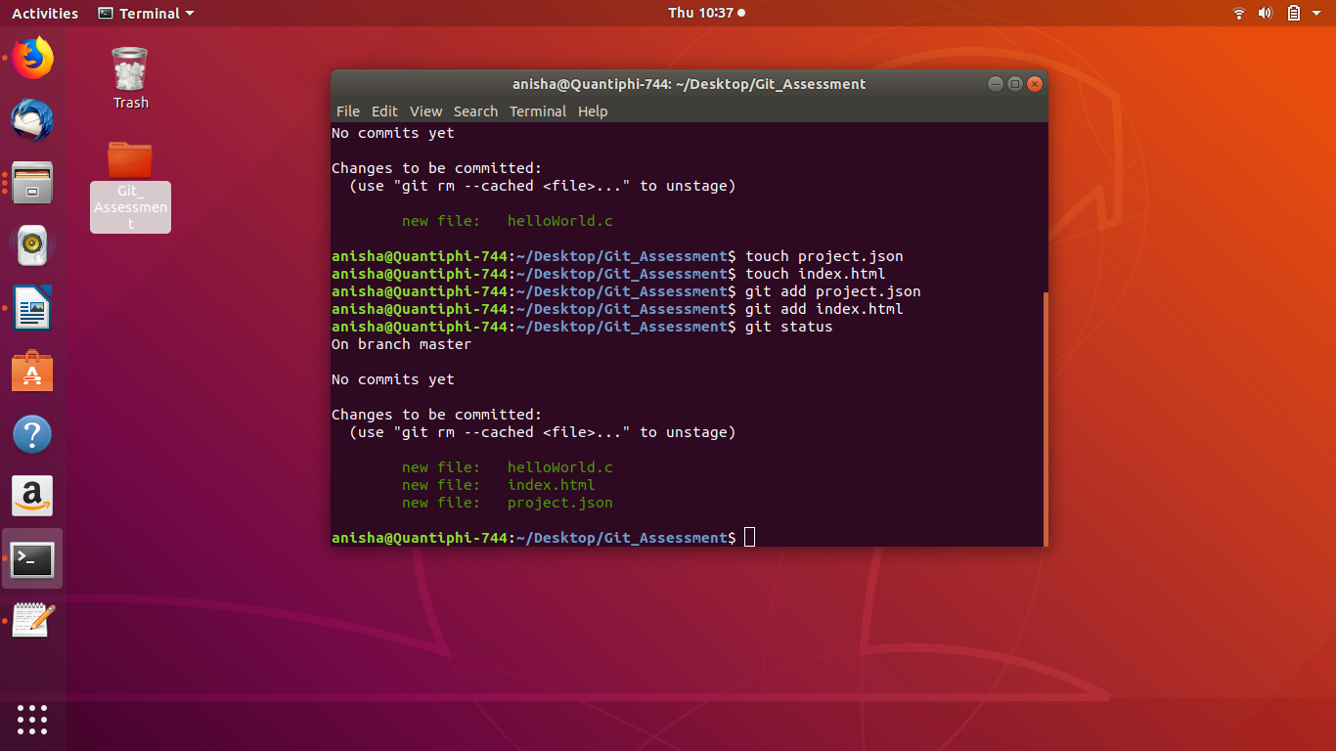
Commiting the changes of added files to the git
Command: git commit -m “Message”
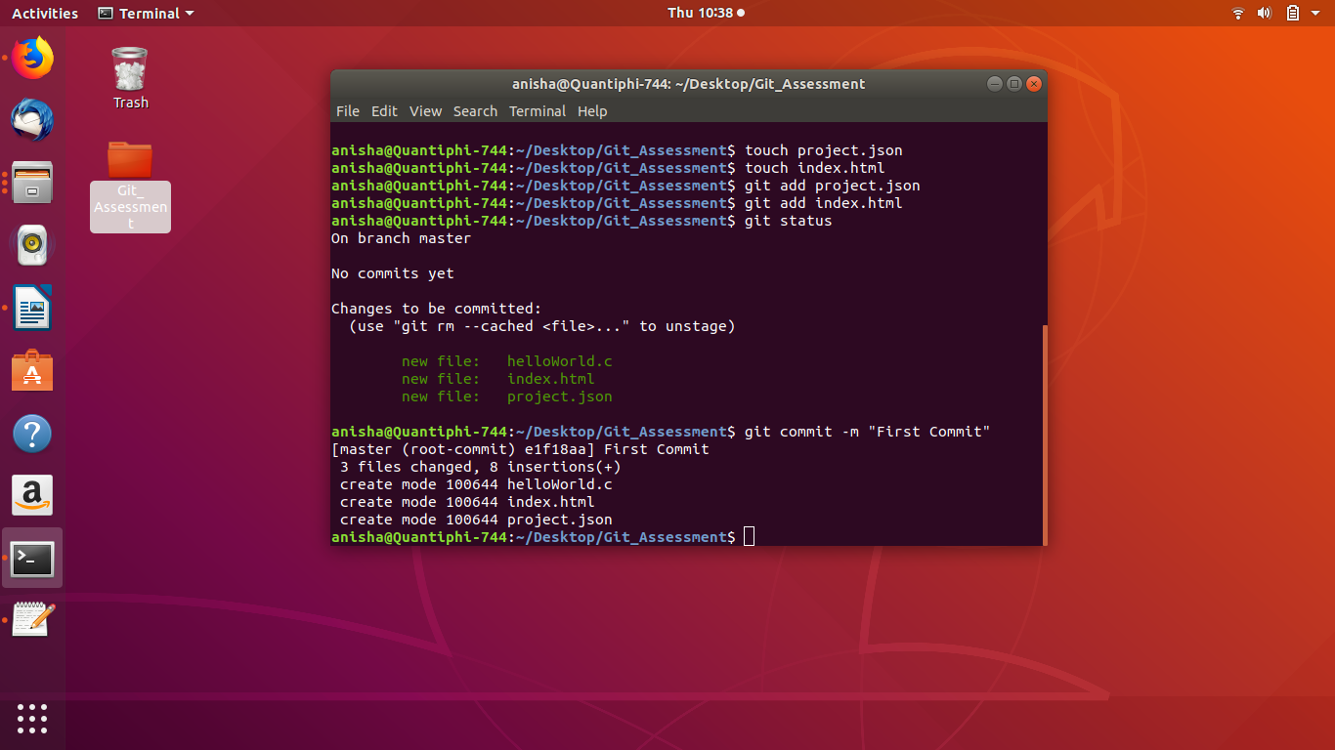
Adding files to the git repository:
Cloning the files in your home directory:
Command : git clone “repository link”
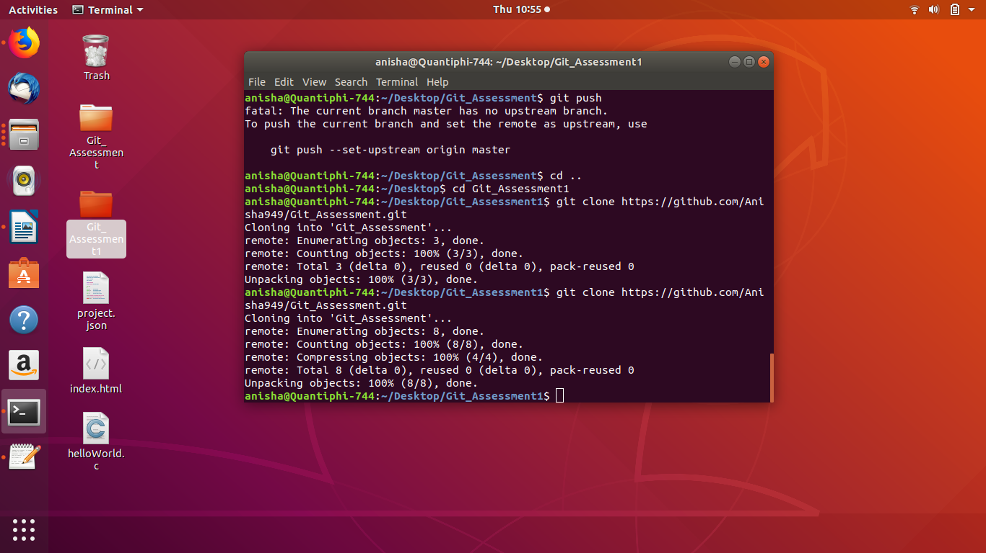

Making changes in the files on the local system and commiting the changes again:
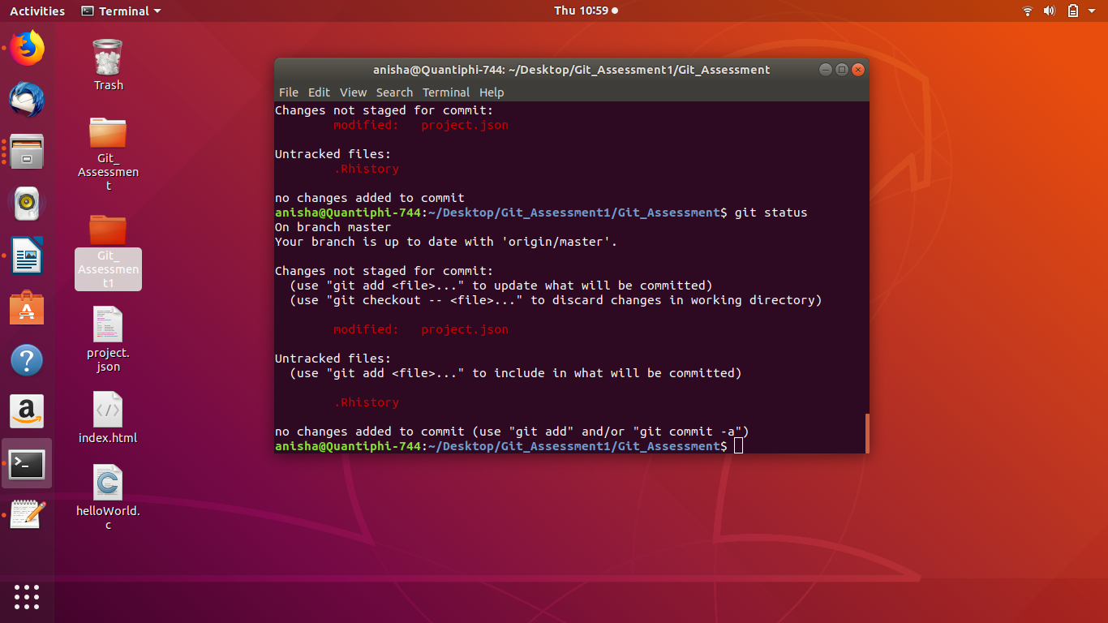
Commitng the changes to the main repository after the changes:
Command: git push
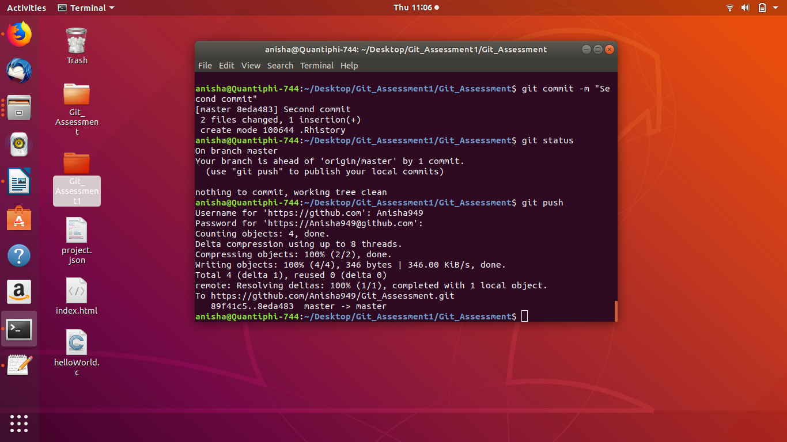

Files changed before the last commit:
project.json
Changes:
“This is a json file”
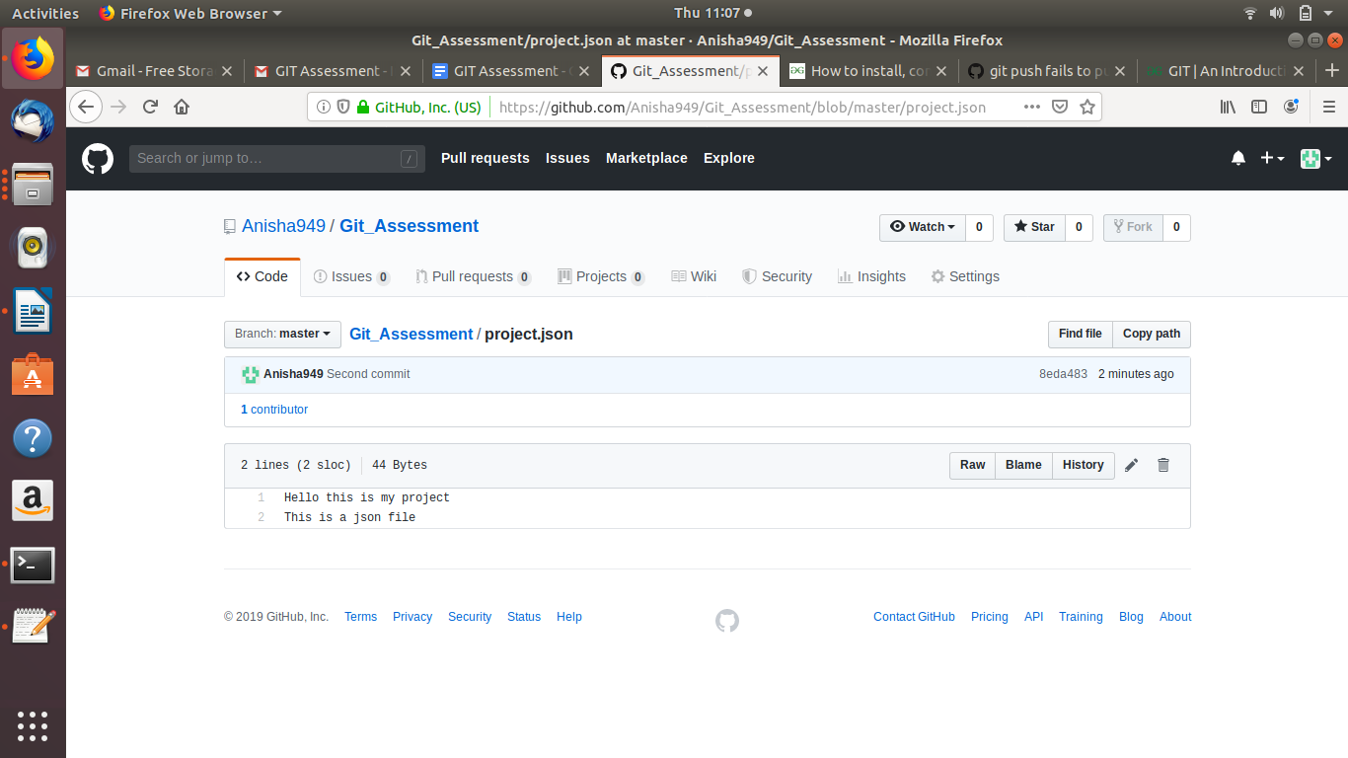
Deleting a file from the main repository but not the local machine:
Command: git rm –cached “Filename”
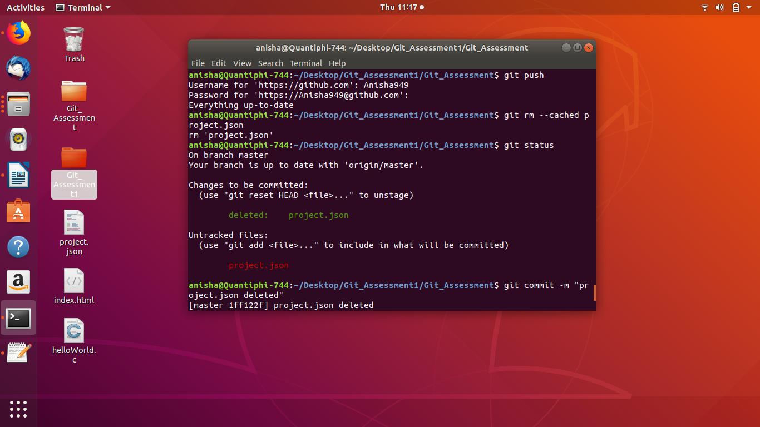
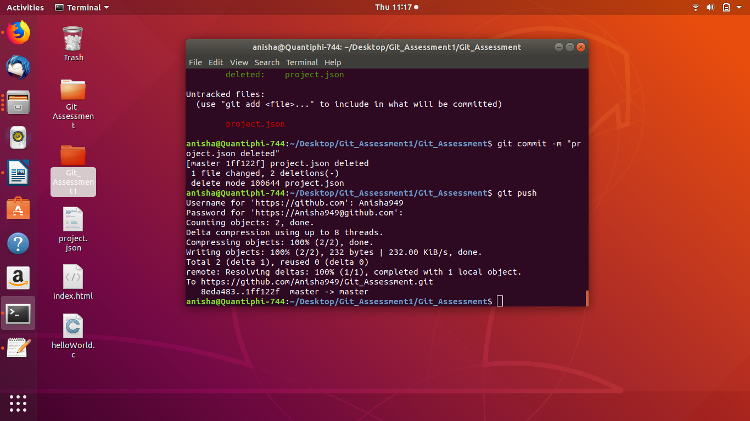

Using git logs getting the hash of the commit
Command: git log
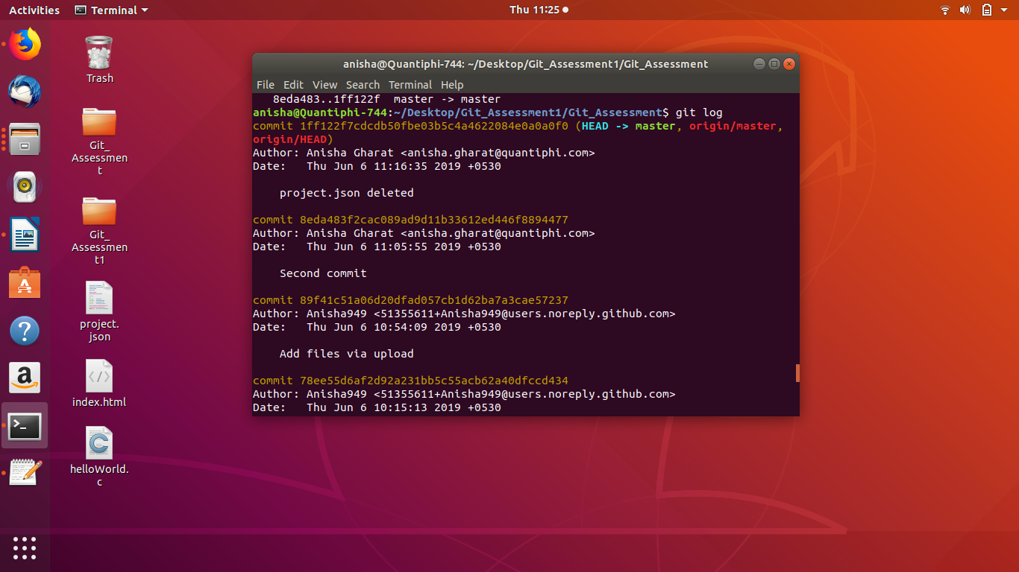

Reverting the last delete file operation:
Command : git revert “hash”

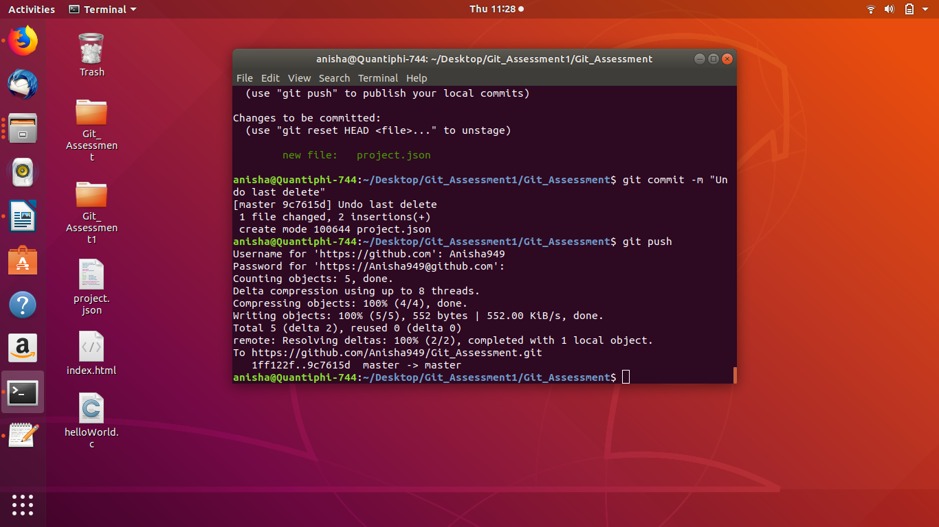
Checking the revert operation:
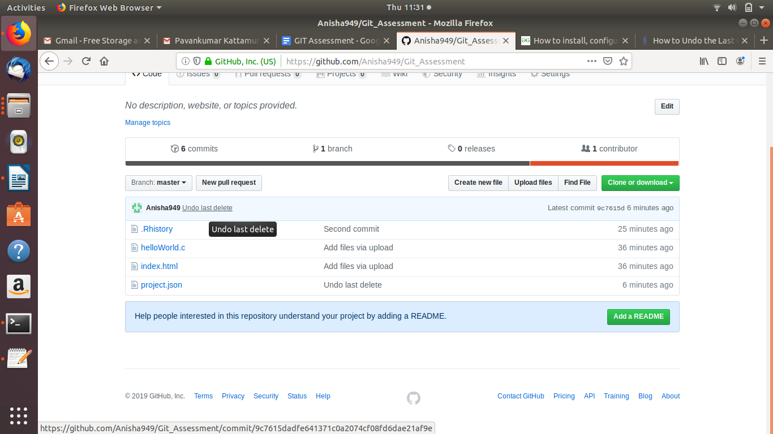

Result: project.json got added again in the git repository

Creating two similar environments:
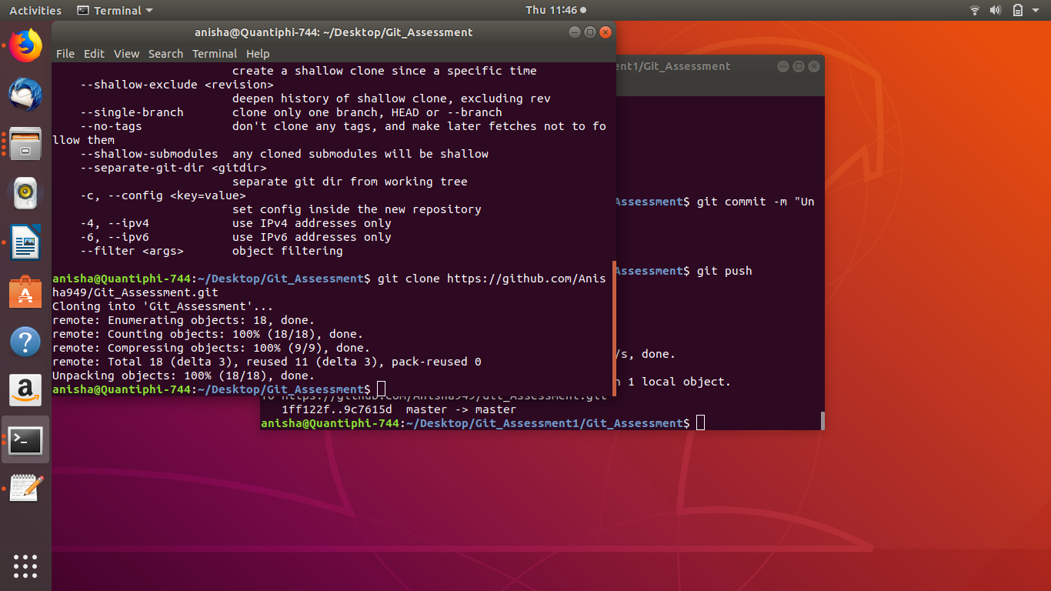
Making changes in index.html in both the environments:

Commit Error:

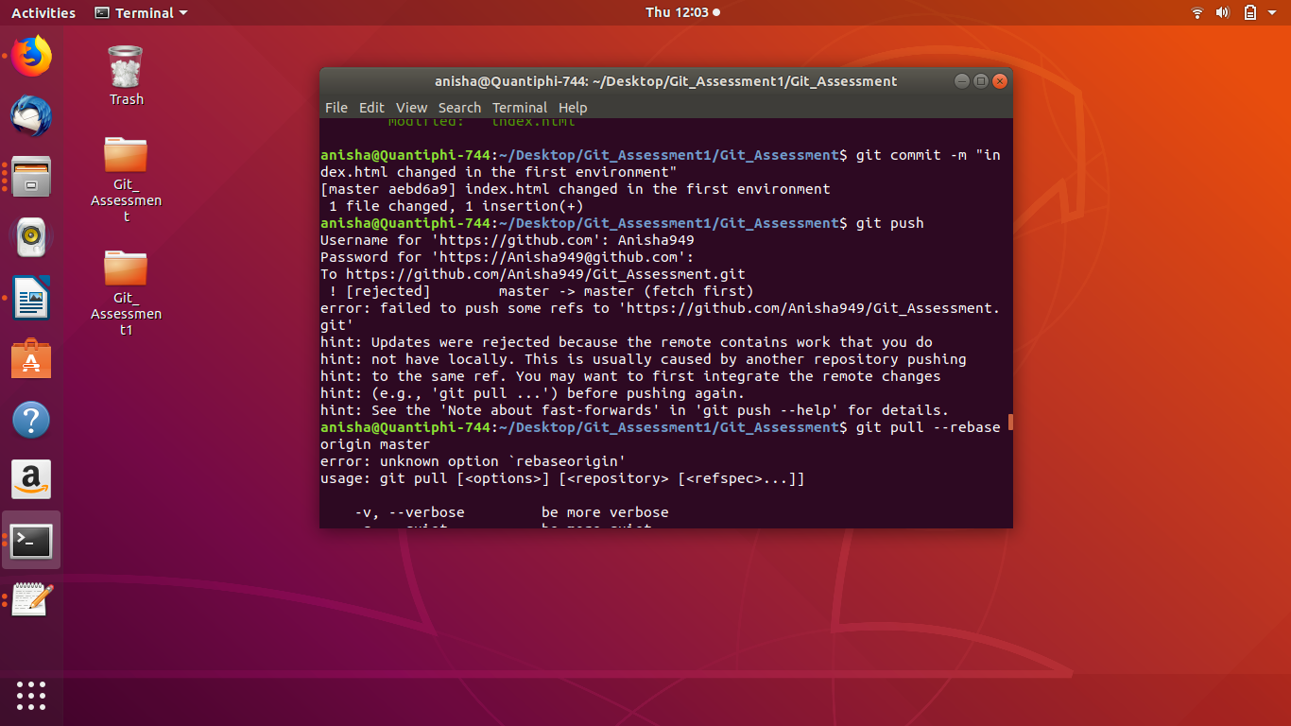
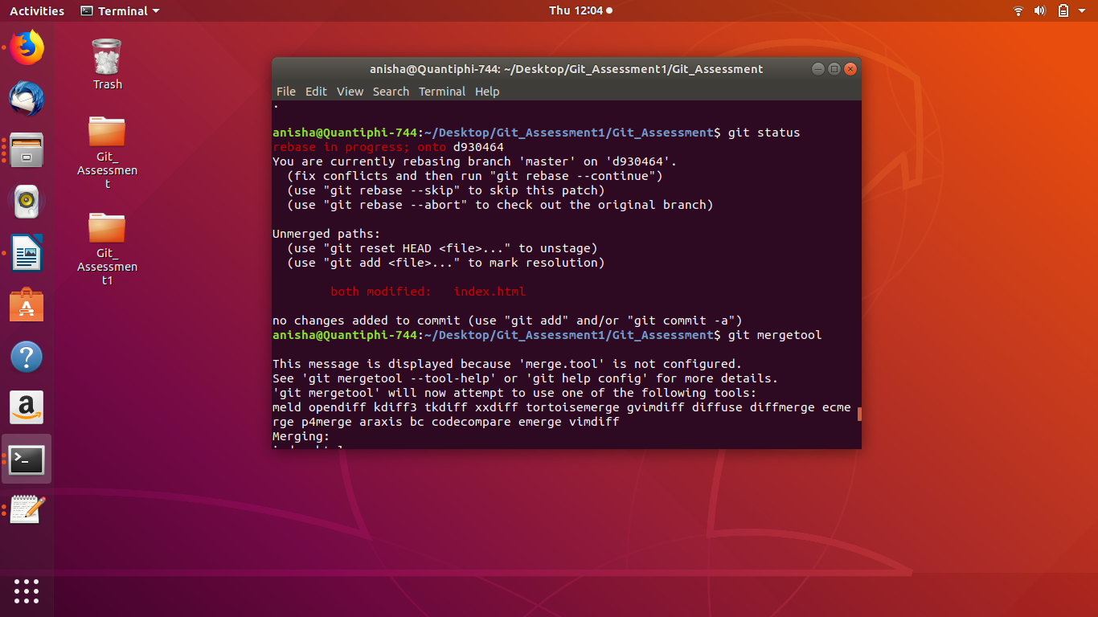
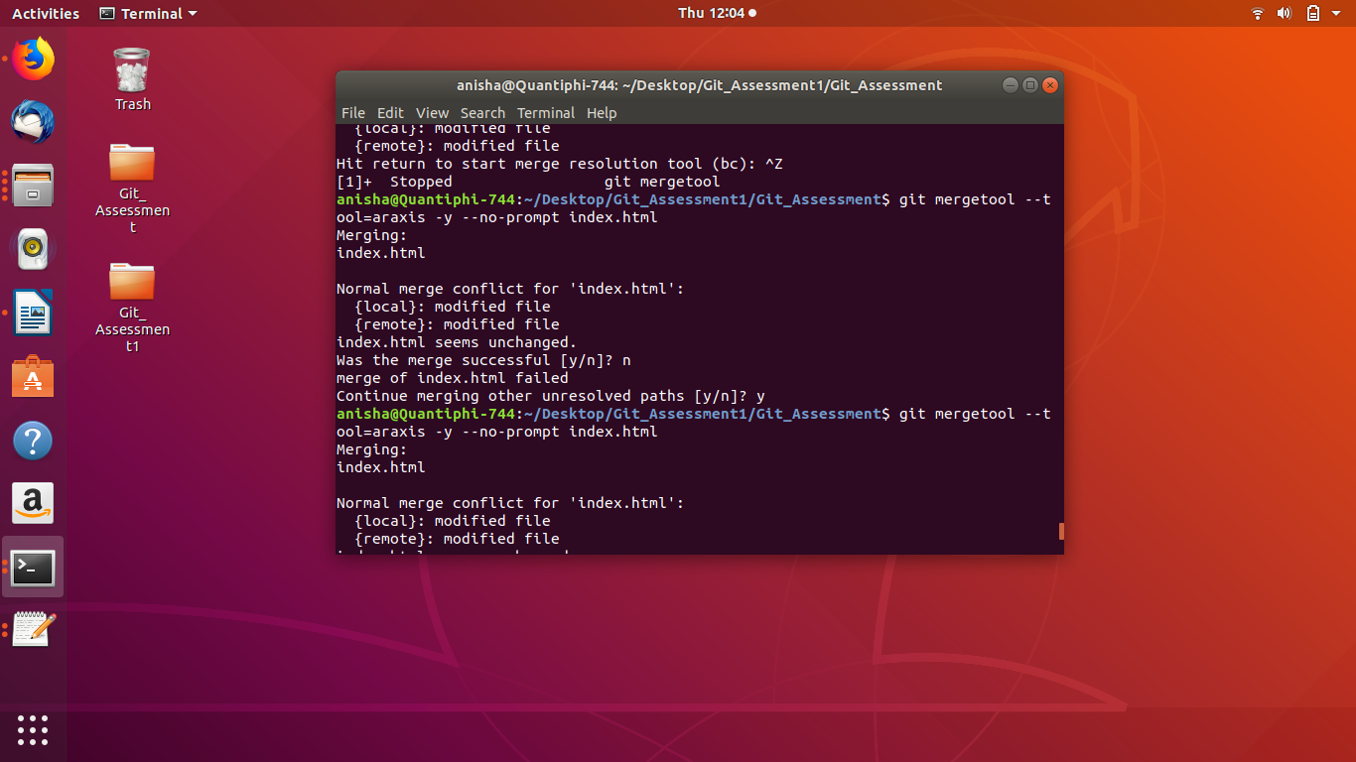

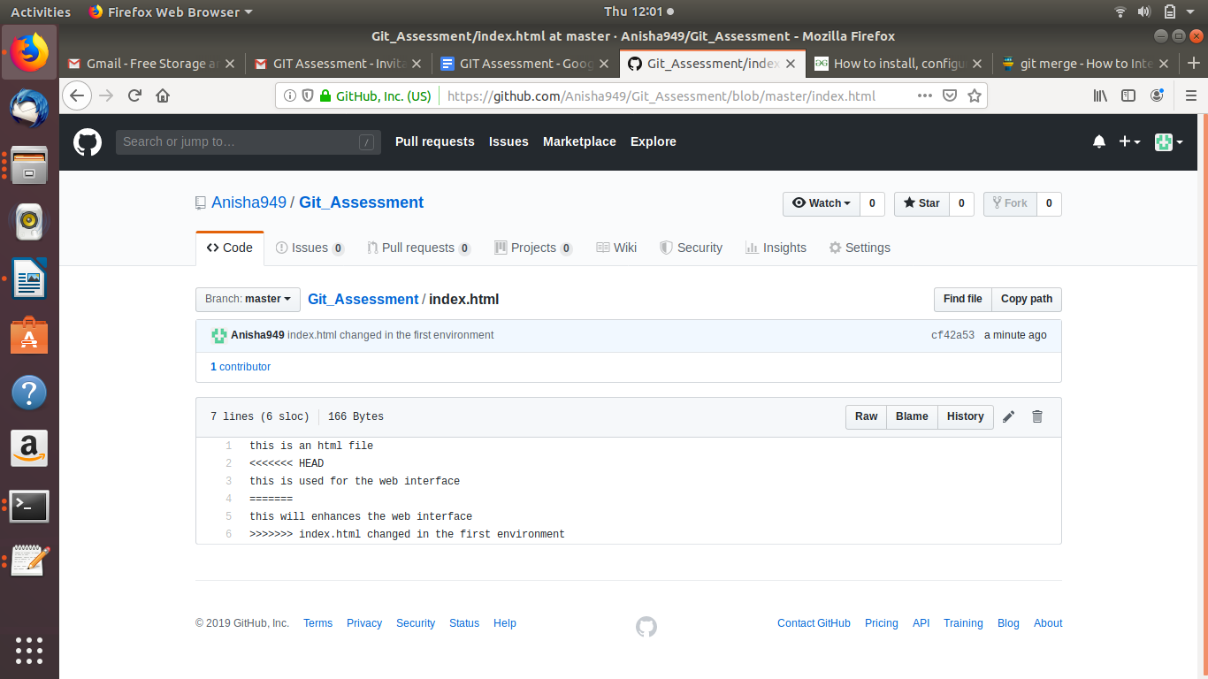

Creating a branch of one environment:
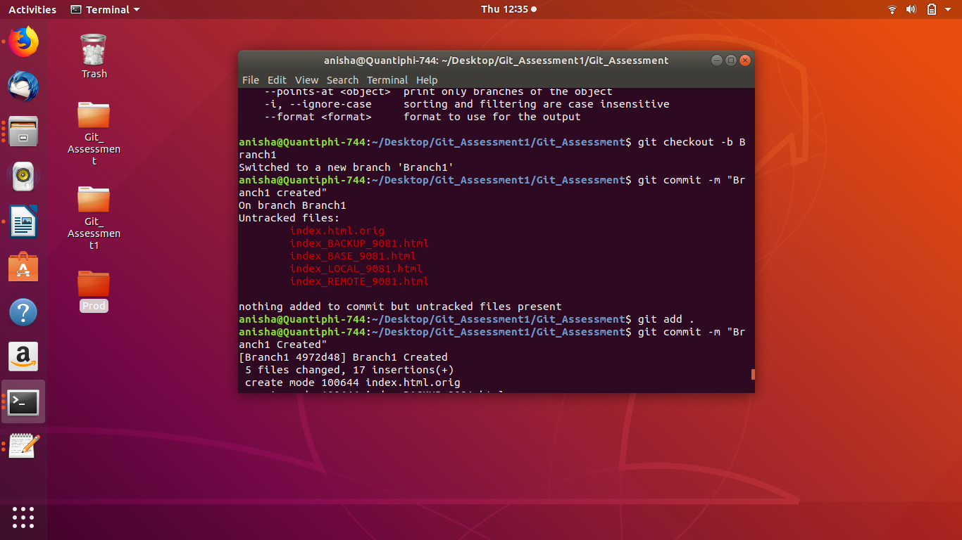
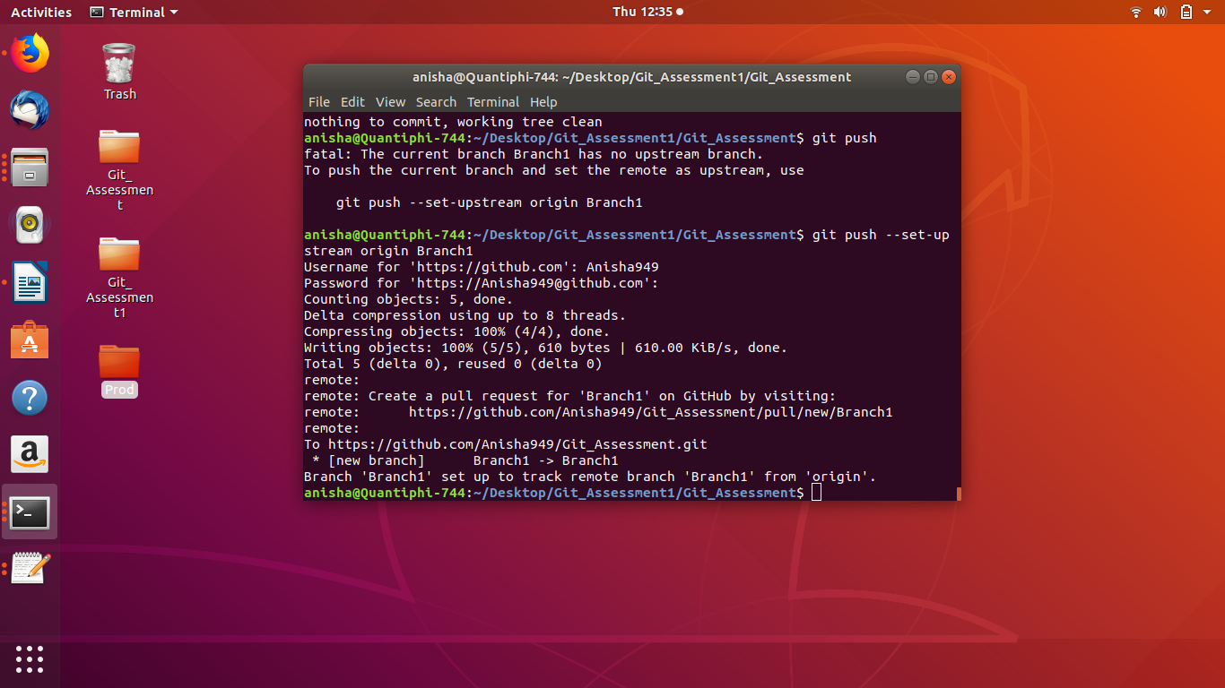

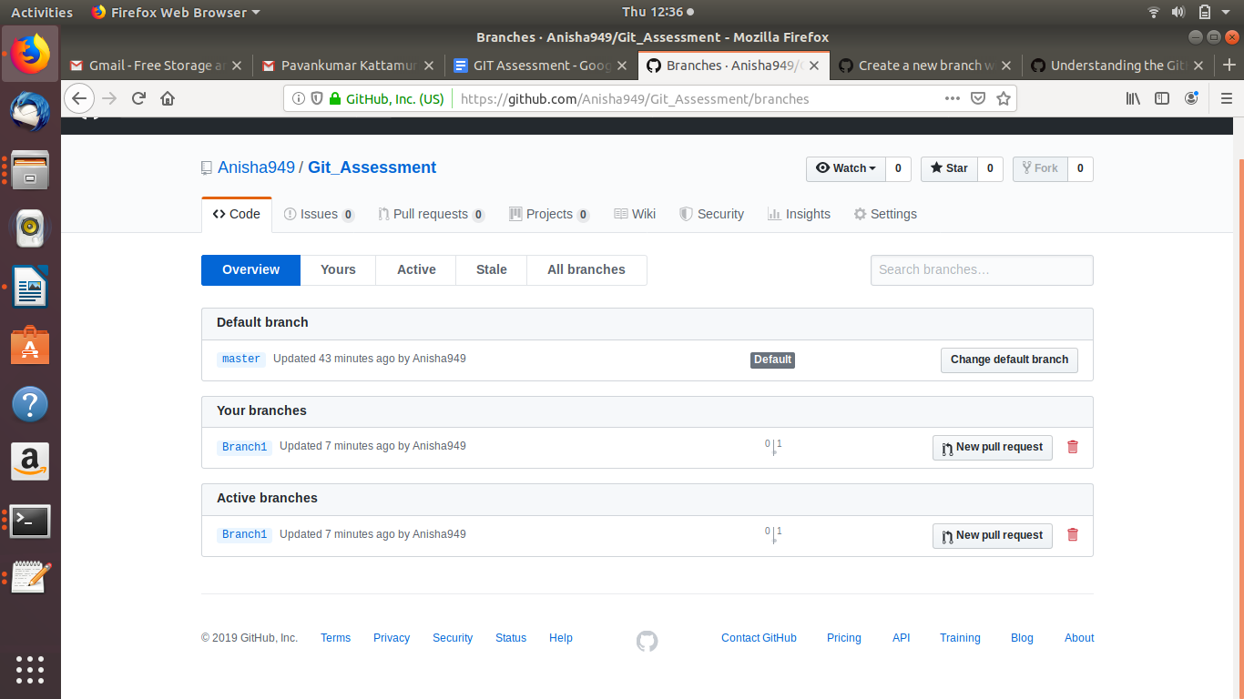

Creating the prod environment:
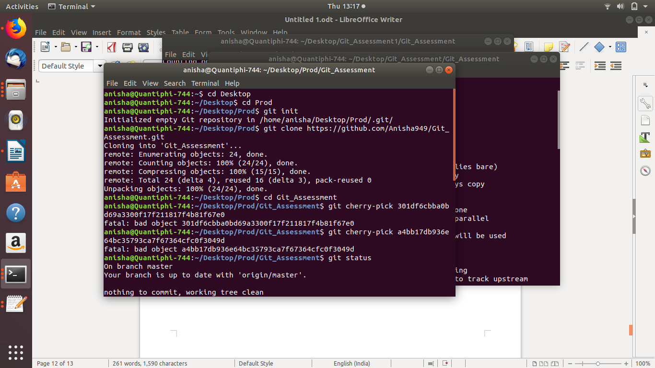

Making changes in the branch and commiting the changes only to the branch:
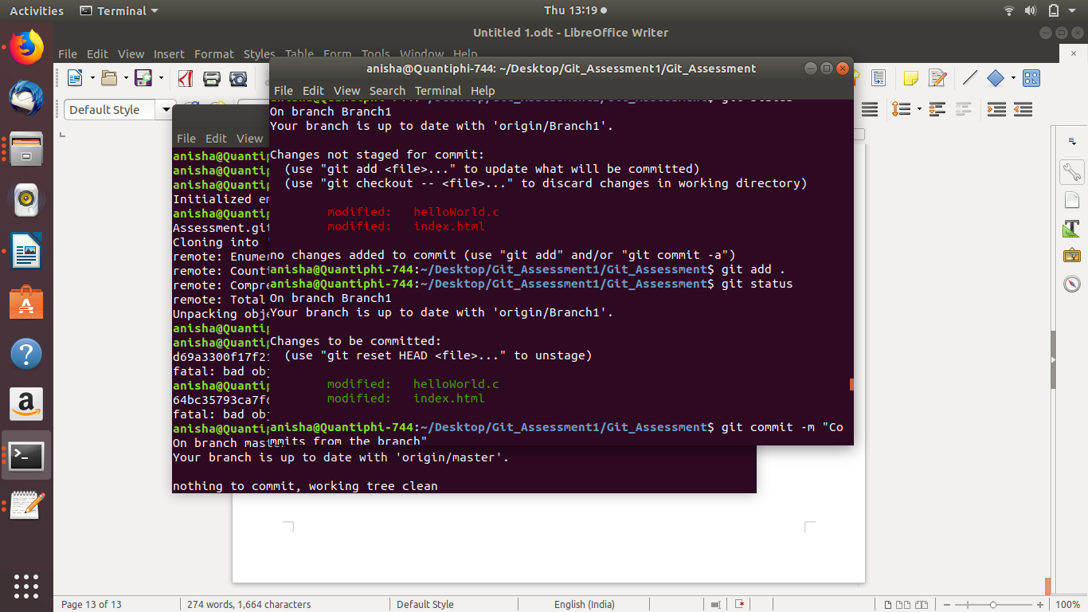

Merging only one change in the master to the branch:
Command : git cherry-pick “hash of the commits to be merged”
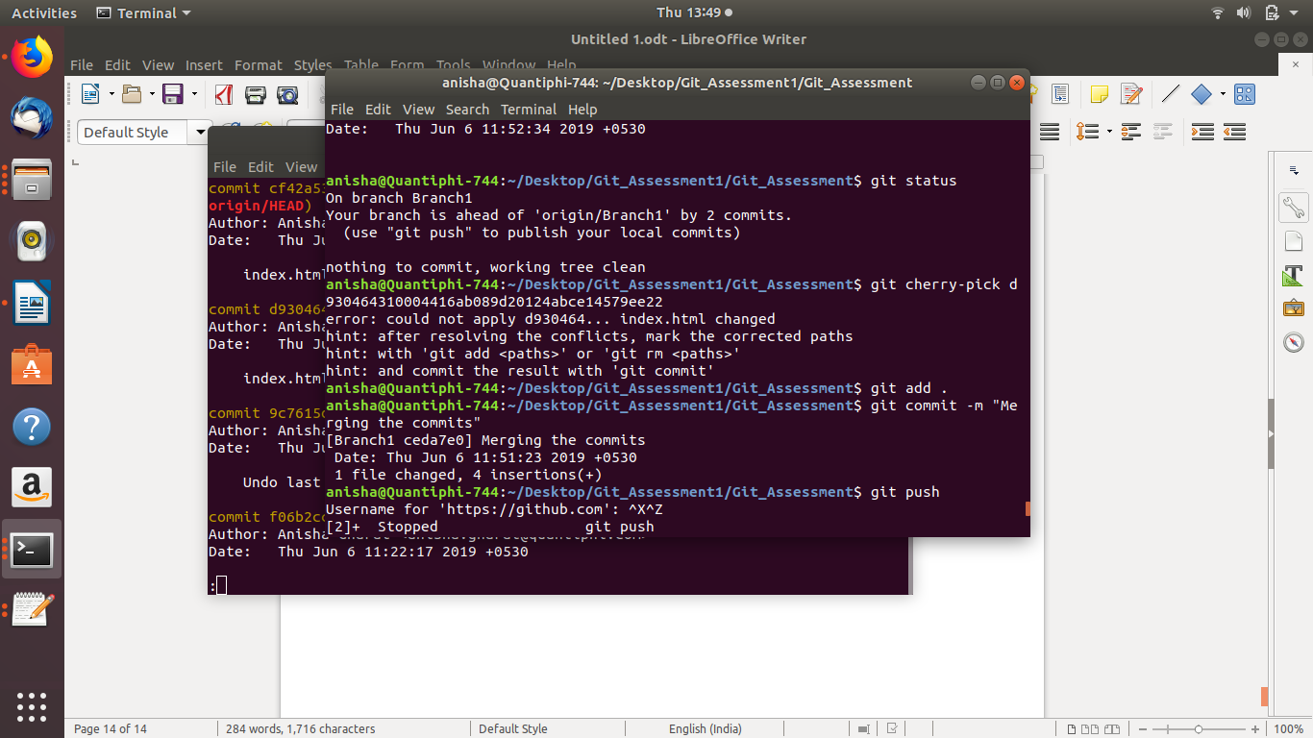

Commits merged in Branch1 from the master:


