Linux Assessment

Consider a text file which has multi-lines text, output all the lines which has a specific word and also output the total number of occurrences of that word.

Command : cat filename

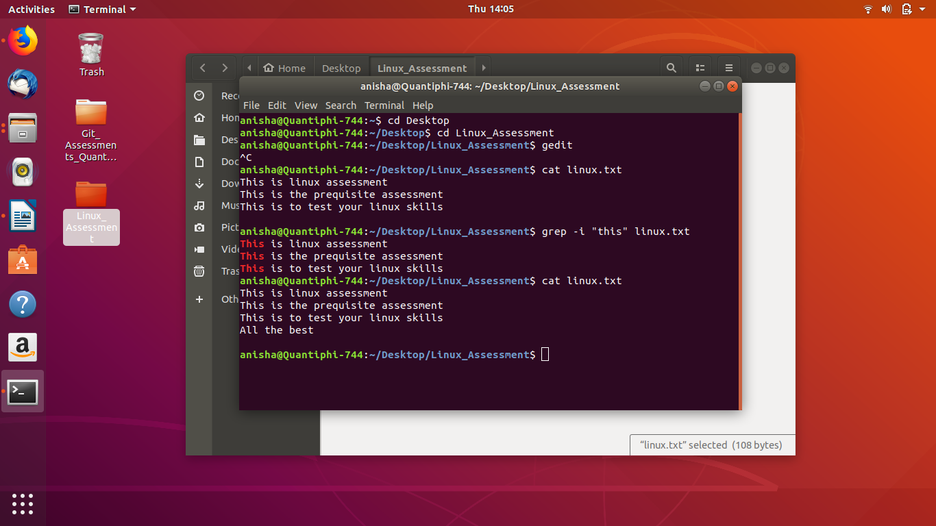

Command: grep -i “word to be found” filename
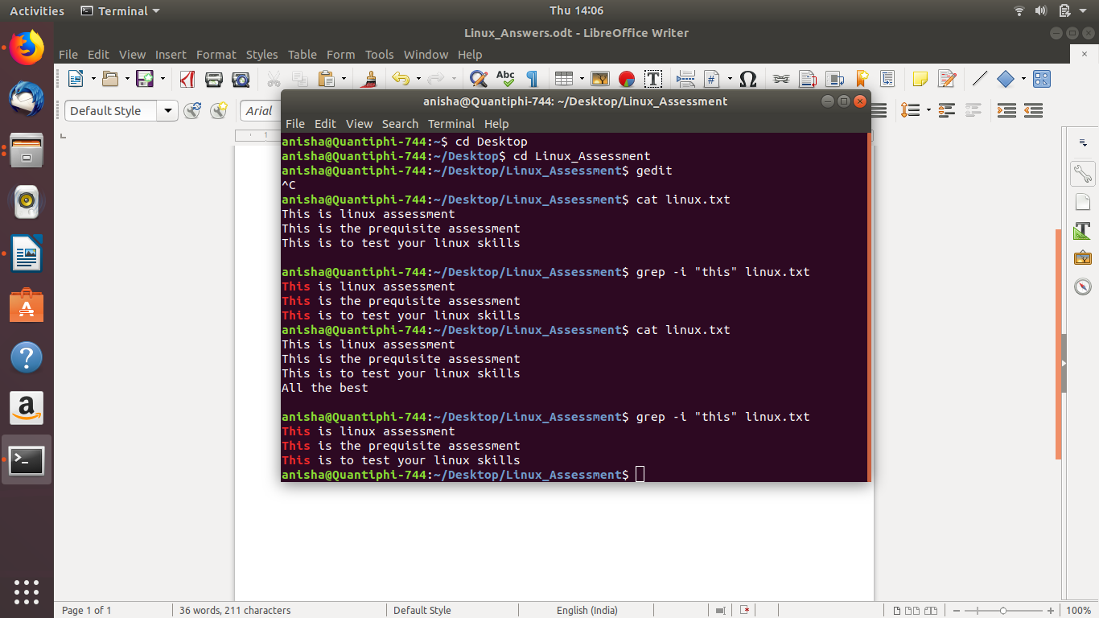
Command : grep -c “word to be counted” filename
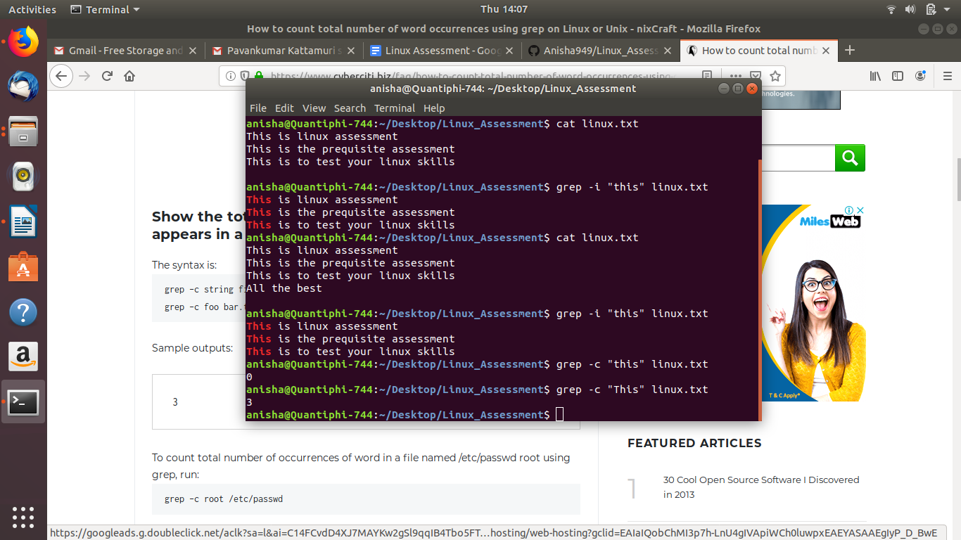

Search for all the files that have a ‘.txt’ extension in the current working directory.

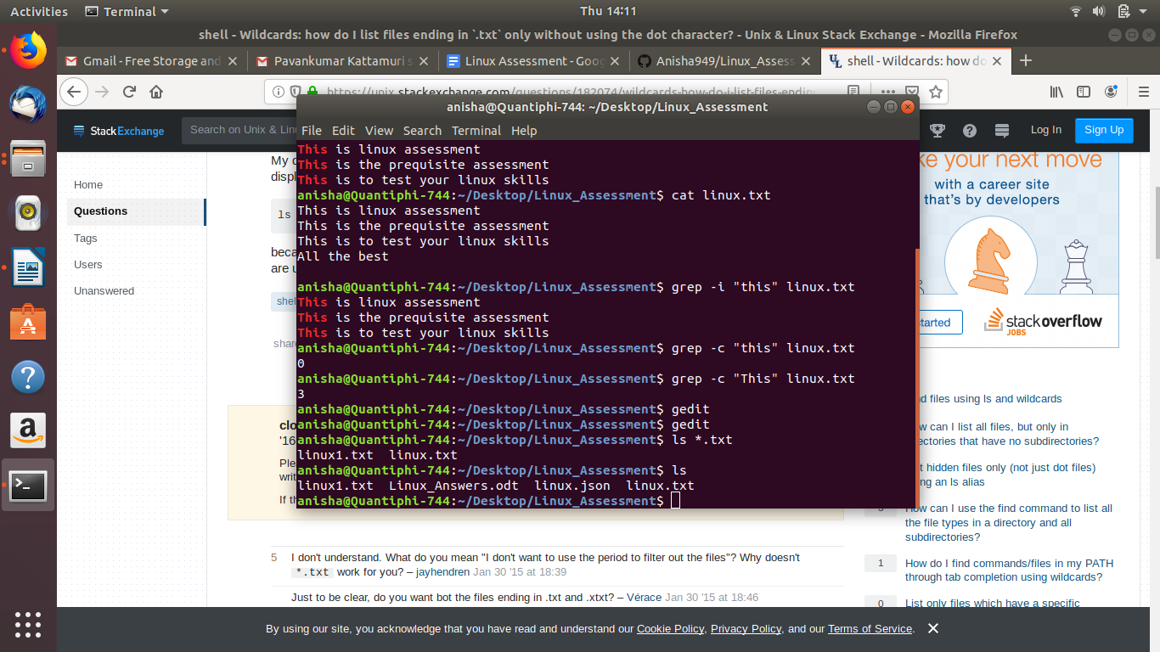

Execute a specific command in all the subdirectories whose names starts with “aws”. For example, your sub-directories are “aws_1”, “aws_2”, “gcp_1”, “aws_3”., Execute “pwd” command in the directories “aws_1”, “aws_2” and “aws_3”.

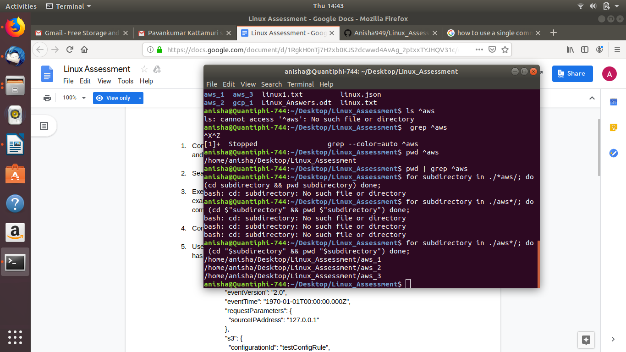

Consider a text file and replace a specific word with any word of your choice.

Command: sed s/word to be replaced/replacing word/g filename
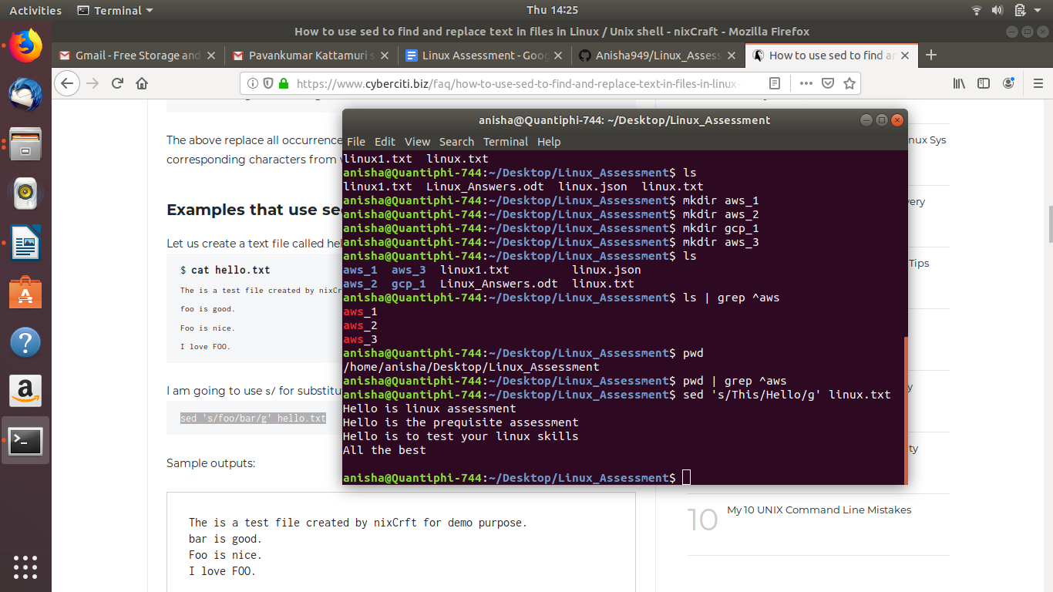

Use jq command line tool to get the arn of the s3 bucket from the file “s3_info.txt” which has the below content

{
"Records": [
{
"eventVersion": "2.0",
"eventTime": "1970-01-01T00:00:00.000Z",
"requestParameters": {
"sourceIPAddress": "127.0.0.1"
},
"s3": {
"configurationId": "testConfigRule",
"object": {
"eTag": "0123456789abcdef0123456789abcdef",
"sequencer": "0A1B2C3D4E5F678901",
"key": "HappyFace.jpg",
"size": 1024
},
"bucket": {
"arn": "arn:aws:s3:::mybucket",
"name": "sourcebucket",
"ownerIdentity": {
"principalId": "EXAMPLE"
}
},
"s3SchemaVersion": "1.0"
},
"responseElements": {

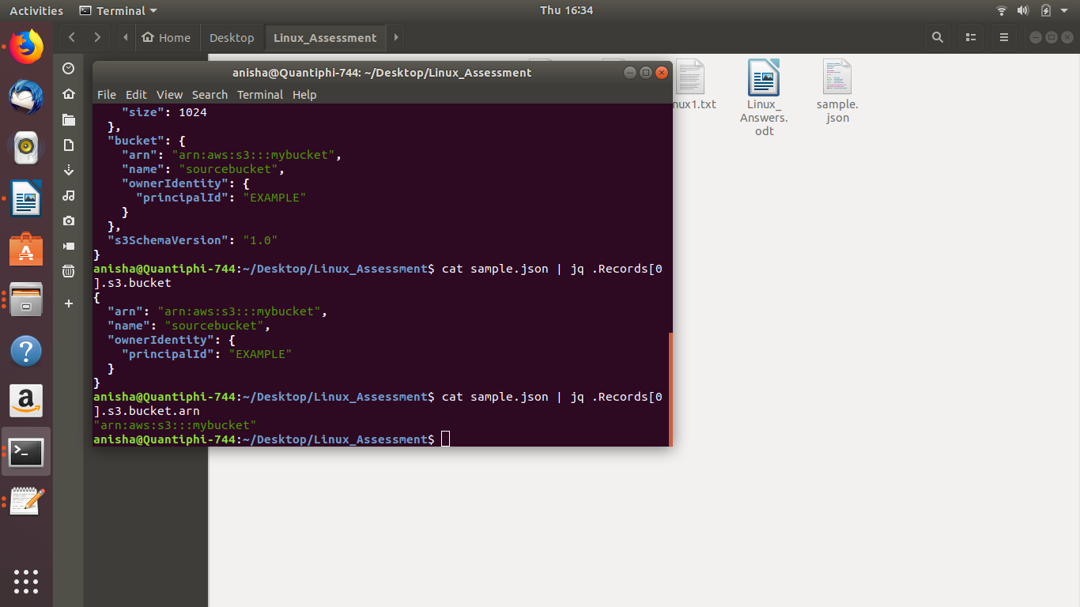
Command: cat sample.json | jq .Records[0].s3.bucket.arn

