Array Spectrum 1.3
Release Notes

Purpose: The document describes the issues addressed in Array Spectrum Ver 1.3 (FPD SA165 instrument Prototype II)

Mail Reference:

Build Sent on date: 18th December 2015

Requirement:
-> Need to notify whether certain threshold at a particular wavelength is reached or Not.
User Input's
-> Wavelength Number(Question: Tolerance of +0.5?)
-> Milli Volts limit values
If the sample records more than specified "Milli Volts" at a specific wavelength we need to notify the user.
By default in the ideal state we should show "OFF"(Grayed button in a floating window)
If excedded the "Milli Volts" limit set "ON"(Set a Green button in a floating window)

-> Need a floating window which show 4 different elements concentration bar indicators with reference to the user inputs provide by the user for each element.
-> Wavelength Number(with tolerance value +/- 0.5)
-> The bar is divided into different segments. Each segment is related to the specific "Milli Volts" range.
If the sample reading at a specificed wavelength falls in the segment range, then we need to color that segment(Highlight).
By default all seagments are grey out.

-> Peak peaking, smoothing and other algorithm applicable to this series need to be implemented.
2nd Derivative.(need to apply on the peak)

-> Show the abs value is bar format at four different wavelengths.

-> Software needs to pick the peak values from the spectrum scan readings at the runtime.

Implementation:
- Calibration Information are stored in “Calib_Config.ini”. In this we store pixel versus wavelength mapped data. Curve Fit Equation Coefficient values are also stored.
Typical Data stored in Calib_Config.ini file
[Calib]
PIXEL_WL_MAP=1376,546.10#1253,435.80#1219,404.70#1175,365.40#1144,334.00#1120,312.50#
a=0.0000007046479742
b=-0.0028062739333485
c=4.5819686805698403
d=-2286.4262867122902000
- A new member variable named m_strConfigIniPath of CString datatype added in ArraySpectrum Header File. Ini file is copied into Application folder during installation.
- A new method added to find linear equation to given x and y values passed a function paramter and returned coefficient values in pointer variables paramter function.
In CArraySpectrumApp class
void GetLinearCoefficient(double* ptrdblXVals,double* ptrdblYVals,int nStartIndex, int nSize,double* ptrdblSlope,double* ptrdblIntercept)
- A new method added in CArraySpectrumDoc class has been implemented to convert the given pixel numbers versus wavelength numbers based on the polynominal co-efficients ontained during calibration. The method is returned buffer containing the converted wavelength numbers.
In CArraySpectrumDoc class
double* CArraySpectrumDoc::ConvertPixelNumbersToWL()
- A new method added in CArraySpectrumDoc class has been implemented to find the nearest given value in an array by using binary search algorithm principle if the provided value found in the given array then, ptrbExtractMatchFound is set to true and the found index information is in ptrNearestIndex.Else the value is not found in the given array then, ptrExtractMatchFound is set to false and the nearest index information is in ptrnNearestIndex it can be greater or lessthan value.
In CArraySpectrumDoc class
void CArraySpectrumDoc::FindNeareastIndex(double* dblArray, int nSize,double value,bool* ptrbExactMatchFound,int* ptrnNearestIndex)
- A new member variable named m_objSettings of type CSetting class is added in CArraySpectrumDoc class.
- A new member variable named m_strSelectedCommPortName of type CString is added in CArraySpectrumDoc class to store the connected instrument serial communication port name.
- Calibration curve fit equation co-efficient values are stored in specific member variables added in CArraySpectrumDoc.
In CArraySpectrumDoc class
double m_dblCoeffA,m_dblCoeffB,m_dblCoeffC,m_dblCoeffD
- There are four compound named Sulphur(S), Phoshorus(P), Arsenic(As) and Nitroxyl(HNO) concentration values are analyzed.
- Each Compound Peak Area are collected and stored in the m_arrdblCompoundPeakArea buffer. This variable is added as member variable in CArraySpectrumDoc.
- To retrive polynomial co-efficient from calib_config.ini file uisng a method added in CArraySpectrumDoc class.
In CArraySpectrumDoc class
void CArraySpectrumDoc::RetrievePolyCoEfficients(void);
- To retrive converted wavelength number with respect to pixel number using a method added in CArraySpectrumDoc class.
In CArraySpectrumDoc class
void CArraySpectrumDoc::RetrievePolyCoEfficients(void);
- We store all the flame settings and compound settings are stored in application registry key using method SerializeSettingsData added in CArraySpectrumDoc class.
In CArraySpectrumDoc class
void SerializeSettingsData(bool bSave);
- To find the nearest given value in an array by using binary search algorithm principle using a method added in CArraySpectrumDoc class.
In CArraySpectrumDoc class
void FindNeareastIndex(double* dblArray, int nSize,double value,bool* ptrbExactMatchFound,int* ptrnNearestIndex);

Settings Dialog
- A new class named CSettingsDlg added to the ArraySpectrum Project as per the requirements provided during Minutes of Meeting.
- OnClick event of control id with “ID_DISPLAY_SETTINGS” button we shown the CSettingsDlg.
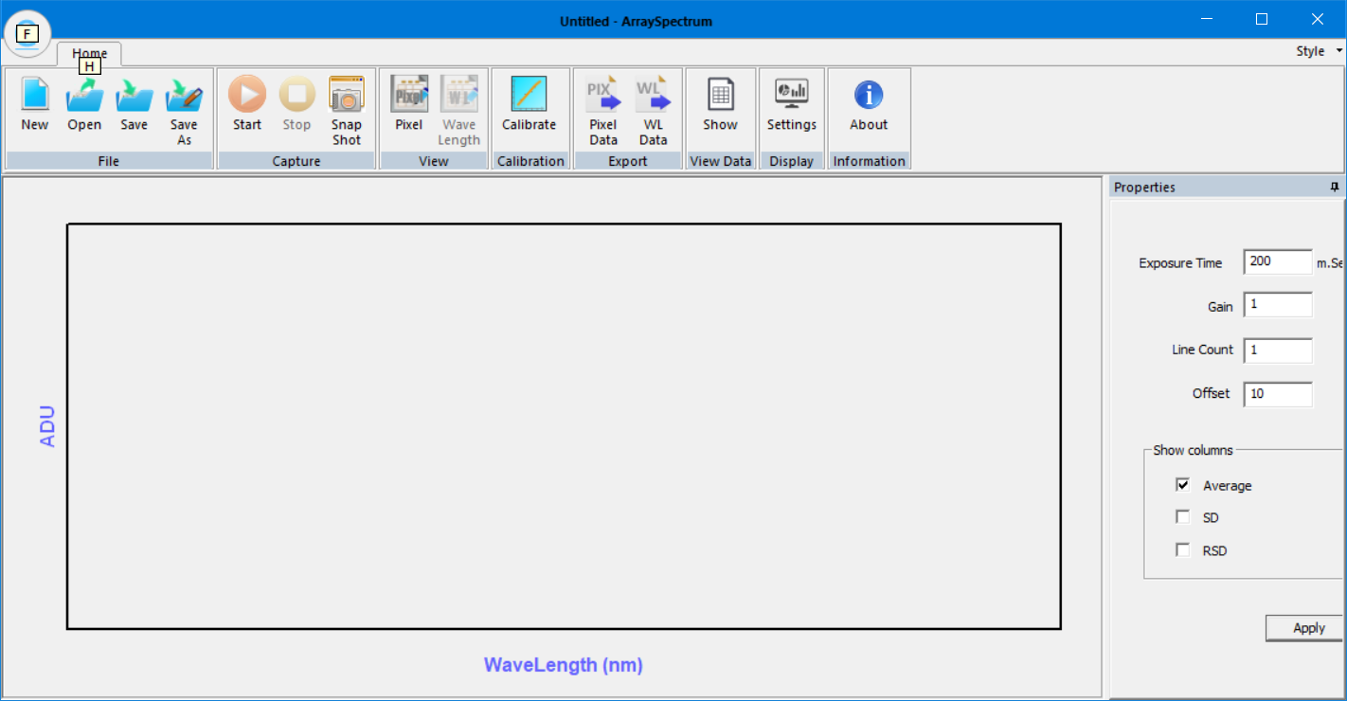
- A Typical CSettingsDlg is shown in the below figure.
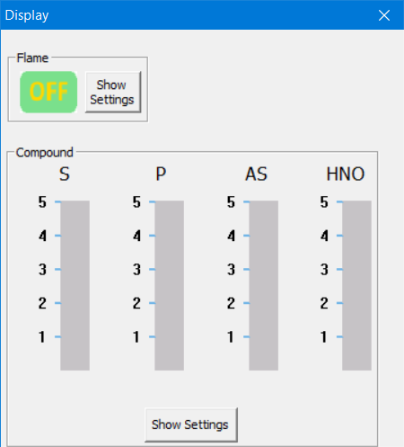
- On Click Flame Group Show Settings show of the related controls are made visible for user to take input from user.
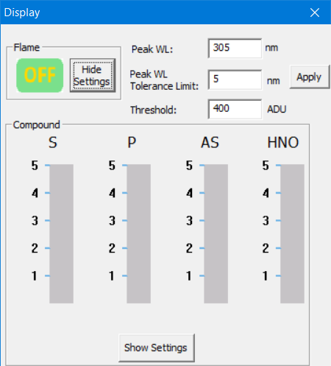
- On Click Compound Group Show Settings show of the related controls are made visible for user to take input from user.
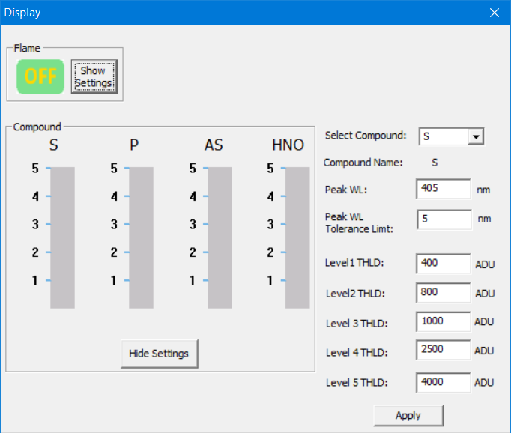
- A new class named CFlameSettings which is derived from CObject has been added into the project. This class stores the details provided by user in Flame Group Category of CSettingsDlg Dialog. These information are serialized for later use.
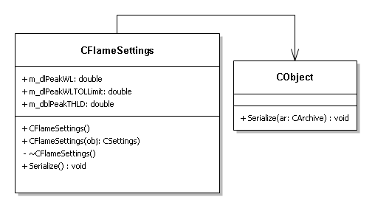
- A new class named CCompoundSettings which is derived from CObject has been added into the project. This class stores the details provided by user in Compound Group Category of CSettingsDlg Dialog. These information are serialized for later use.
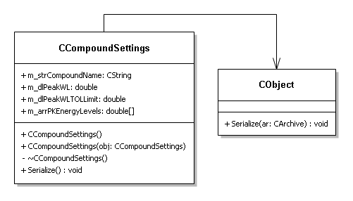
- A new class named CLevelIndicator which is derived from CStatic MFC Class has been added into the project. This represent the different levels of each compound energy has been generated at the specific peak wavelength by calculating the peak area and matching the each threshold level ADU values provided by user.
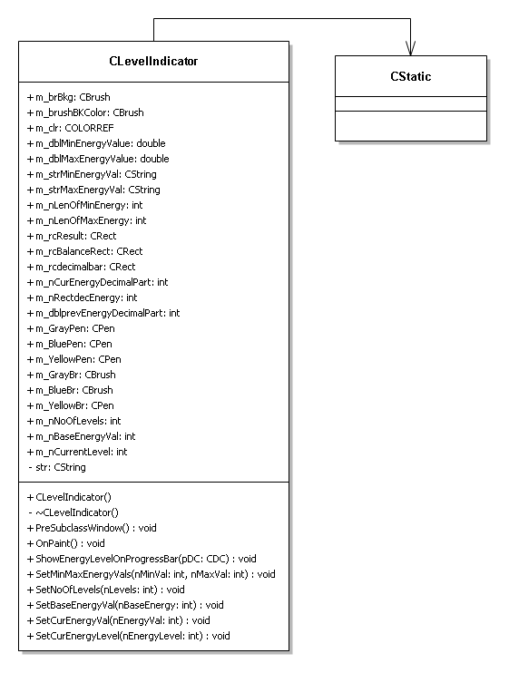
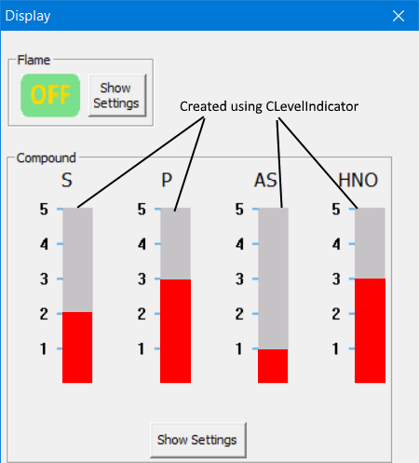

- A Simple class diagram of CSettingsDlg is shown in the below figure.
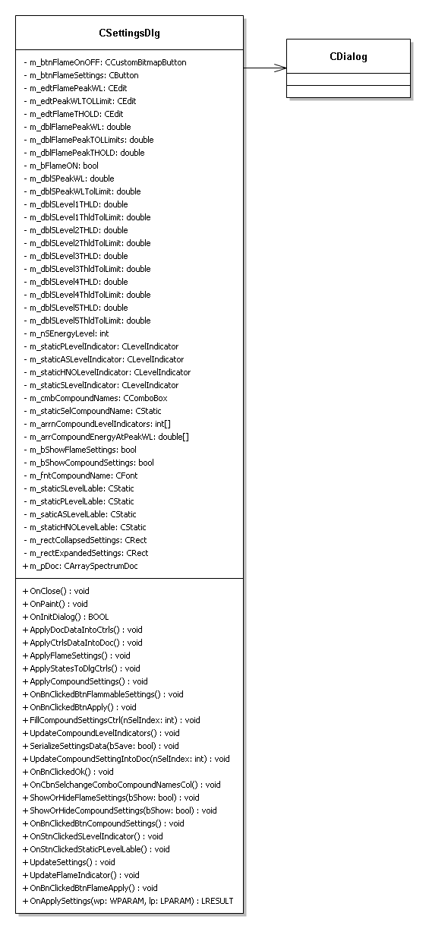
- Settings provided during minutes of meetings are listed below.
Flame Settings
->Flame Settings Peak WL: 305 nm
->Flame Settings Peak WL Tolerance Limit: 5 nm
->Flame Settings Peak THLD: 400 ADU

Sulphur Compound Settings
->Compound Name: Sulphur Compound(S)
->Peak WL: 405 nm
->Peak WL Tol Limit: 5 nm
->PK Energy Level 1: 400 ADU
->PK Energy Level 2: 800 ADU
->PK Energy Level 3: 1000 ADU
->PK Energy Level 4: 2500 ADU
->PK Energy Level 5: 4000 ADU

Phosphorus Compound Settings
->Compound Name: Phosphorus Compound(P)
->Peak WL: 526 nm
->Peak WL Tol Limit: 5 nm
->PK Energy Level 1: 50 ADU
->PK Energy Level 2: 80 ADU
->PK Energy Level 3: 120 ADU
->PK Energy Level 4: 250 ADU
->PK Energy Level 5: 600 ADU

Arsenic Compound Settings
->Compound Name: Arsenic Compound(As)
->Peak WL: 500 nm
->Peak WL Tol Limit: 5 nm
->PK Energy Level 1: 50 ADU
->PK Energy Level 2: 80 ADU
->PK Energy Level 3: 120 ADU
->PK Energy Level 4: 250 ADU
->PK Energy Level 5: 600 ADU

Nitroxyl Compound Settings
->Compound Name: Nitroxyl Compound(HNO)
->Peak WL: 689 nm
->Peak WL Tol Limit: 5 nm
->PK Energy Level 1: 50 ADU
->PK Energy Level 2: 80 ADU
->PK Energy Level 3: 90 ADU
->PK Energy Level 4: 100 ADU
->PK Energy Level 5: 150 ADU

Dcam-USB is an application software that is provided with Multi Channel Detector Head and Driver Circuit for Image Sensor Control:
-> The new CCD Driver has been used.
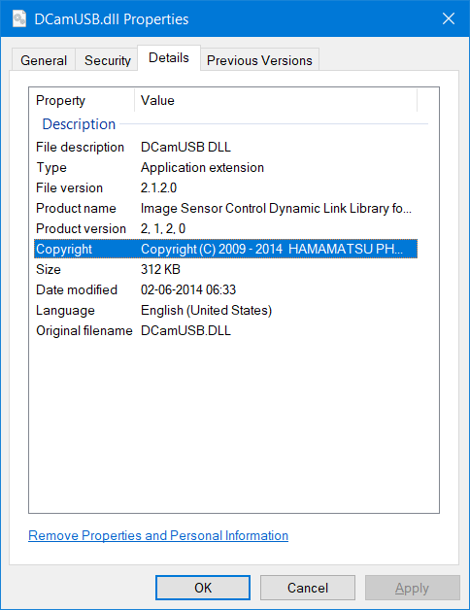
Modifications in Elico Advanced Graph Control:
-> New exposed methods are added to the exisiting activex control.
-> void FindArea(LONG lngGraphID, DOUBLE dblStartPointXVal,DOUBLE dblStartPointYVal, DOUBLE dblEndPointXVal,DOUBLE dblEndPointYVal,LONG nStartIndex,LONG nEndIndex,DOUBLE* dblArea)
-> void GetArea(LONG lngGraphID, DOUBLE dblStartPointXVal,DOUBLE dblStartPointYVal, DOUBLE dblEndPointXVal,DOUBLE dblEndPointYVal,LONG nStartIndex,LONG nEndIndex,DOUBLE* dblArea)

