Lightweight Publish-Subscribe Messaging Protocol
with QoS 0 and QoS 1 over TCP
Performance evaluation under emulated message loss
Computer Networks project report
Team members: add names and roll numbers here
Implementation: Python 3 and asyncio, plain TCP sockets

Contents
Abstract
1 Introduction
2 Background
3 Protocol design
4 System architecture
5 Implementation
6 The QoS 1 mechanism
7 Experimental setup
8 Results and analysis
9 Testing
10 Limitations and future work
11 Conclusion
References
Appendix A Message examples
Appendix B Project files

Abstract
Publish-subscribe messaging lets programs talk to each other without knowing who is on the other end. Publishers send messages to a named topic, and a broker passes each message on to everyone who has subscribed to a matching topic. This project builds a small version of such a system from scratch, using plain TCP sockets and Python's asyncio library, and then measures how it behaves when the network loses messages.
The protocol uses length-prefixed JSON frames. It supports wildcard topic filters (+ for one level, # for many), retained messages, and two delivery guarantees. QoS 0 sends a message once and never checks. QoS 1 requires an acknowledgement and retransmits until one arrives, so the message is delivered at least once. Because every network on one laptop is nearly lossless, we also wrote a lossy proxy that sits between clients and the broker and drops whole PUBLISH and PUBACK frames at a chosen rate.
We ran four experiments, each repeated three times with 300 messages per run. With 20% loss, QoS 0 delivered only 64% of messages, while QoS 1 still delivered 100%. The price was time and traffic: mean latency rose from 2 ms to 109 ms, and about 336 retransmissions were needed to deliver 300 messages. QoS 1 also produced duplicate copies on the wire, which the subscriber's client library filtered out. With no loss, latency grew with the number of subscribers (9 ms at 10, 80 ms at 100) and with payload size (1.7 ms at 64 bytes, 3.9 ms at 16 KB).

1 Introduction

1.1 Motivation
Many networked systems have one source of data and several consumers. A temperature sensor may feed a display, a logger and an alarm. If the sensor talked to each of them directly, adding a new consumer would mean changing the sensor. A broker removes that coupling. The sensor publishes to a topic such as sensor/room1/temp, and anything that cares about that topic subscribes to it.
Protocols like MQTT are built around this idea and are widely used in small devices and unreliable networks. Their most interesting design choice is the quality of service level, because it lets an application decide how much reliability it is willing to pay for. We wanted to understand that trade-off by building it ourselves and measuring it, instead of only reading about it.

1.2 Objectives
- Design a simple application-layer protocol on top of TCP, including how messages are framed.
- Build a broker that routes messages by topic, with wildcard subscriptions and retained messages.
- Implement QoS 0 (at most once) and QoS 1 (at least once) with acknowledgements, retransmission and duplicate handling.
- Build a client library and a lossy proxy so that message loss can be created on demand.
- Measure delivery ratio, latency, retransmissions, duplicates, scalability and the effect of payload size.

1.3 Scope
The whole system runs on one laptop. We implemented QoS 0 and QoS 1 only. QoS 2, keep-alive and last-will messages, TLS, authentication and a live dashboard are not part of this work and are listed as future work in Section 10.

2 Background

2.1 Publish-subscribe
In a publish-subscribe system there are three roles. A publisher produces messages and tags each with a topic. A subscriber registers interest in one or more topic filters. The broker keeps the list of subscriptions and forwards every incoming message to each subscriber whose filter matches. Publishers and subscribers never open connections to each other.

2.2 TCP is a byte stream
TCP delivers bytes in order and without loss, but it does not preserve message boundaries. If a client sends two messages of 100 bytes each, the receiver might get them as one read of 200 bytes, or as three reads of 70, 60 and 70 bytes. Any protocol on top of TCP therefore needs its own way to find where one message ends and the next begins. We use a length prefix: every message starts with four bytes giving the size of the body that follows.

2.3 Quality of service
TCP itself never loses data while a connection is healthy, yet messaging systems still talk about lost messages. A message can be lost between the application and the socket, when a connection drops and is re-established, or when a process restarts. Delivery guarantees at the messaging layer are meant to cover these cases. MQTT defines three levels, and we implement the first two.
Level | Name | Behaviour
QoS 0 | At most once | Send once, do not check. A lost message is gone.
QoS 1 | At least once | Receiver acknowledges. Sender retransmits until acknowledged. Duplicates are possible.
QoS 2 | Exactly once | Four-step handshake. Not implemented in this project.

3 Protocol design

3.1 Framing
Every message is a JSON object. On the wire it is sent as a 4-byte big-endian unsigned length followed by the UTF-8 JSON text. The receiver first reads exactly four bytes, decodes the length n, then reads exactly n more bytes. Python's readexactly does the waiting for us, so partial reads are never a problem.
Length (4 bytes) | JSON body (as many bytes as the length says)
Big-endian unsigned integer | UTF-8 encoded JSON object

We chose JSON over a binary format because it is easy to read in a debugger and easy to extend. The cost is a larger message size, which we discuss in Section 10.

3.2 Message types
Type | Direction | Fields | Purpose
CONNECT | client to broker | client_id | Open a session
CONNACK | broker to client | none | Session accepted
SUBSCRIBE | client to broker | topic, qos | Register a topic filter
SUBACK | broker to client | topic | Subscription is active
PUBLISH | both directions | topic, payload, qos, id, retain, ts | Carry a message
PUBACK | both directions | id | Acknowledge a QoS 1 PUBLISH
STATS | both directions | stats (in the reply) | Ask for broker counters

CONNACK and SUBACK were not in our first draft. We added them after seeing that a client could publish before the broker had processed another client's SUBSCRIBE, since those requests arrive on different connections. With SUBACK, a client knows its subscription is live before it carries on.

3.3 Topic filters
Topics are strings with levels separated by a slash, for example sensor/room1/temp. A subscription filter uses the same form with two wildcards.
- + matches exactly one level. sensor/+/temp matches sensor/room1/temp and sensor/room2/temp, but not sensor/room1/humidity and not sensor/a/b/temp.
- # matches everything from that level onward. sensor/# matches sensor/room1/temp and sensor/room1/humidity. A lone # matches every topic.
The matching function splits both strings on the slash and compares level by level. It returns true as soon as it meets a #, and otherwise requires the two to have the same number of levels.

3.4 Retained messages
If a PUBLISH has retain set to true, the broker keeps the latest such message for that topic. When a new subscriber's filter matches, the broker sends it the stored message right after the SUBACK. This means a new display does not have to wait for the next sensor reading. Publishing a retained message with an empty payload clears the stored one.

3.5 Timing constants
Constant | Value | Where used
Retransmit timeout | 0.2 seconds | Publisher waiting for PUBACK, and broker waiting for a subscriber's PUBACK
Maximum retries | 5 | After the first send, up to 5 more attempts
Broker port | 1883 | Direct connection
Proxy port | 1884 | Connection through the lossy proxy

4 System architecture
Figure 1 shows the pieces. Clients connect to the broker, either directly on port 1883 or through the lossy proxy on port 1884. The proxy opens its own connection to the broker for each client and copies frames in both directions, dropping some of them. A separate monitor client always connects directly, so the statistics request itself can never be lost.
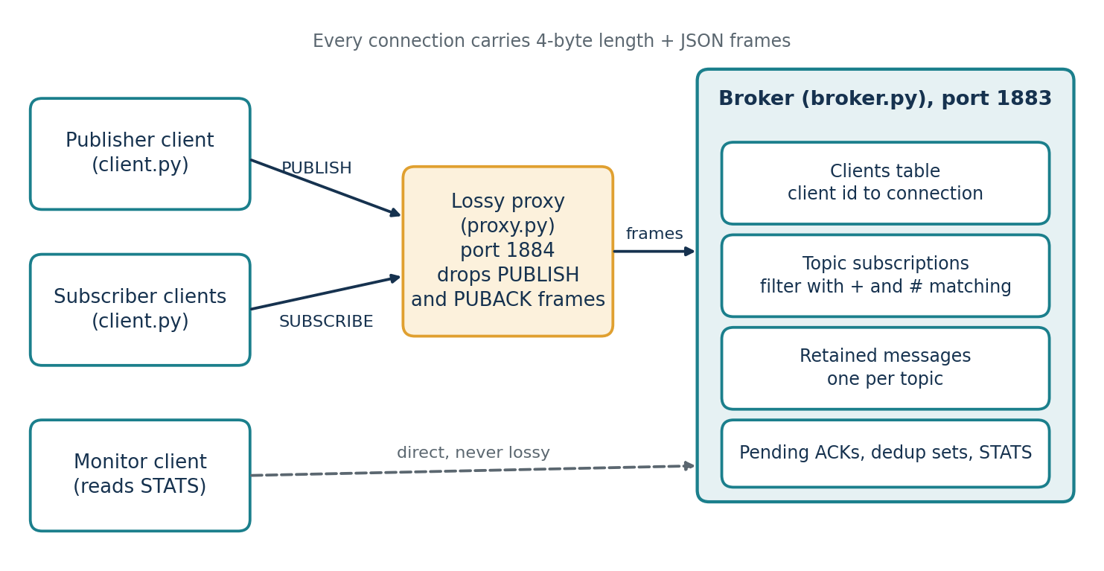
Figure 1. Components and connections
The broker keeps four kinds of state, all in memory:
- a table from client id to its connection,
- a list of subscriptions, each holding the client id, the topic filter and the subscribed QoS,
- a dictionary of retained messages, one per topic,
- for QoS 1, a set of publisher message ids already routed (per client) and a table of deliveries still waiting for an acknowledgement.

5 Implementation
The code is about 700 lines of Python 3 and uses only the standard library, apart from matplotlib for the graphs. Everything runs on asyncio, so one process can handle many connections without threads.

5.1 Broker
broker.py starts a TCP server and runs one handle coroutine per connection. The coroutine reads frames in a loop and reacts to each type. When the connection ends, by a clean close or a reset, the client and its subscriptions are removed.
Routing works like this. For each incoming PUBLISH, the broker walks the subscription list and calls the matching function. For every match it starts a separate asyncio task to deliver the message. Using a task per delivery matters for QoS 1, because a delivery can wait several hundred milliseconds for an acknowledgement, and that wait must not hold up delivery to other subscribers. Each connection also has a lock so that frames sent by different tasks never interleave on the same socket.
The delivery QoS is the smaller of the QoS the message was published with and the QoS the subscriber asked for. A QoS 1 message sent to a QoS 0 subscriber is therefore delivered at QoS 0.

5.2 Client library
client.py provides a Client class with connect, subscribe, publish, stats and disconnect. A background task reads frames and dispatches them. Incoming messages go to a callback that receives the message and its latency, calculated as the receive time minus the timestamp the publisher put in the message. This is valid because every program in our tests runs on the same machine and shares one clock.
publish returns the number of retries it used, which the benchmark adds up. The same file also works as a command line tool for manual testing.

5.3 Lossy proxy
proxy.py accepts a client connection, opens a second connection to the broker, and runs two pipes, one in each direction. Each pipe reads a complete frame, looks at the message type, and for PUBLISH and PUBACK frames throws the frame away with the configured probability. It never drops CONNECT, SUBSCRIBE, their acknowledgements, or STATS, because losing those would break the setup rather than test the protocol. An optional delay can be added to every frame.
The proxy must drop whole frames. If it dropped random bytes, the length prefix would no longer match the data, and every later frame on that connection would be read wrongly. Since TCP underneath is reliable, what we emulate is loss at the level of application messages. This is a limitation we state again in Section 10.

5.4 Benchmark
benchmark.py starts a fresh broker (and a proxy when loss is above zero) for every run, so earlier runs cannot affect later ones. It connects the subscribers to bench/#, connects one publisher, and publishes 300 messages in batches of 20 using asyncio.gather. Publishing one by one at QoS 1 would be far too slow, because each message could wait 0.2 seconds for a retry. After publishing it waits up to two more seconds for late messages and then reads the broker's counters through the direct connection.
File | What it does
protocol.py | Framing and topic matching, shared by every other file
broker.py | The broker
client.py | Client library and command line tool
proxy.py | Lossy proxy
benchmark.py | Runs the experiments and writes results.json
plots.py | Draws the graphs from results.json
demo.py | Scripted demonstration
tests/ | Unit tests for topic matching, end-to-end tests for routing, retained messages and QoS 1 under loss

6 The QoS 1 mechanism
QoS 1 has two separate hops, and each one is protected on its own. The publisher is responsible for the first hop. The broker is responsible for the second.

6.1 Publisher to broker
- The publisher gives the message an increasing id, sends it and waits up to 0.2 seconds for a PUBACK with the same id.
- If nothing arrives, it sends the same message again, up to five more times.
- The broker answers every copy with a PUBACK, even a repeated one, because the earlier PUBACK may be the thing that was lost.
- The broker remembers which (client, id) pairs it has already routed. A repeated copy increments the dup_pub counter and is not routed a second time.

6.2 Broker to subscriber
- For each matching QoS 1 subscription, the broker creates a fresh delivery id from its own counter. It does not reuse the publisher's id, because two publishers could easily use the same number.
- It sends the PUBLISH and waits on an event for the subscriber's PUBACK. After 0.2 seconds it sends again, counting each repeat as a retransmission, up to five times.
- The subscriber acknowledges every copy it receives. It keeps the delivery ids it has already seen, and a repeated id is counted as a duplicate and not passed to the application.
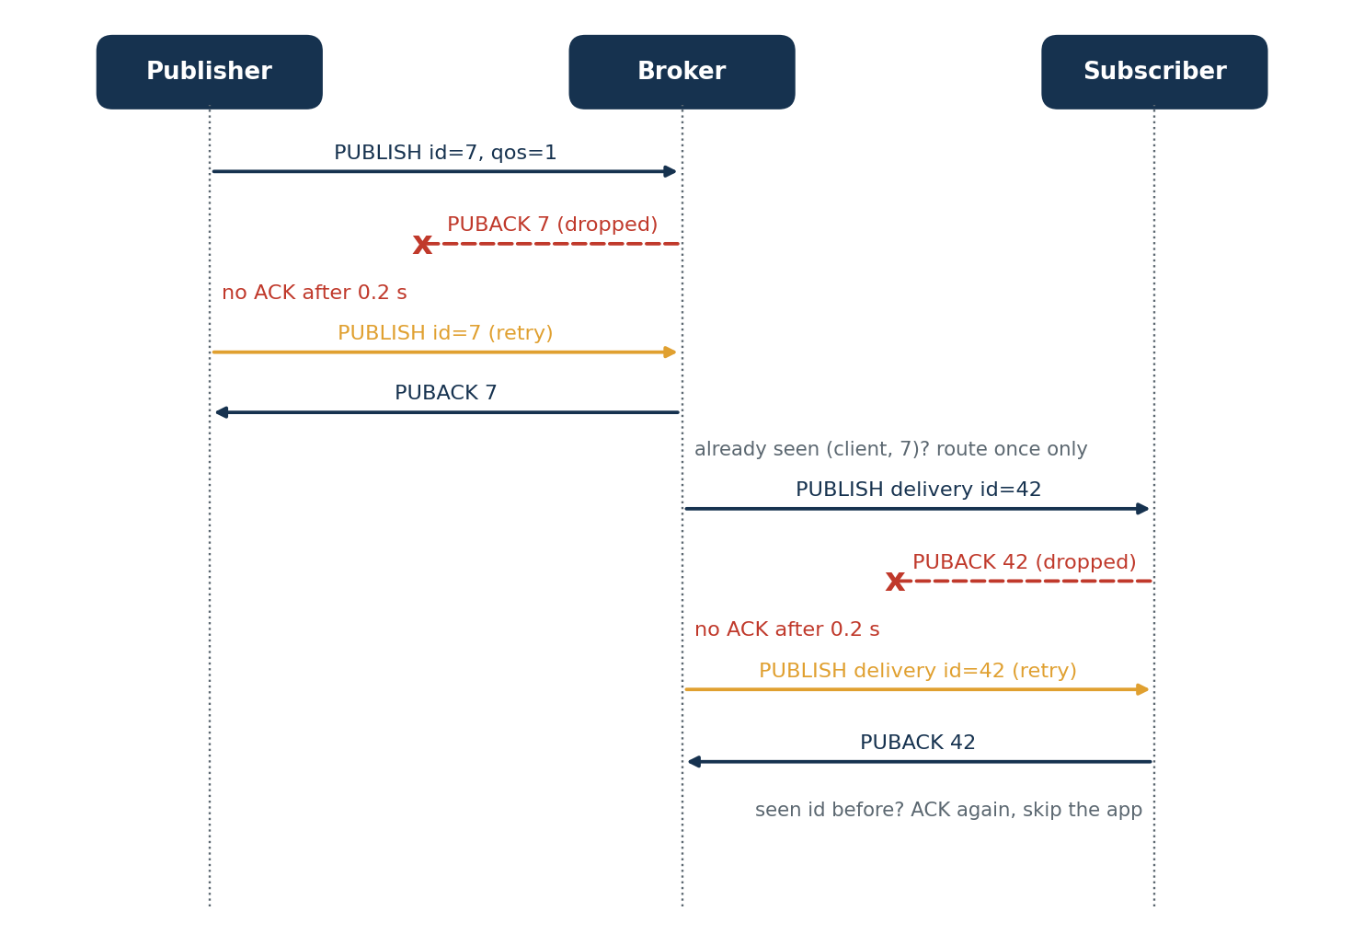
Figure 2. QoS 1 with a lost PUBACK on each hop

6.3 Why duplicates exist
Suppose the broker's PUBLISH reaches the subscriber, but the subscriber's PUBACK is lost. From the broker's side this looks identical to the PUBLISH itself being lost, so it sends the message again. The subscriber now holds two copies. QoS 1 cannot tell these cases apart, and that is the reason it promises at least once rather than exactly once. Our client library hides the duplicates from the application by remembering delivery ids, but they still use bandwidth, and we count them in the results.

7 Experimental setup

7.1 Environment
All programs ran on one Windows laptop with Python 3.12. The broker, the proxy and the benchmark were separate processes, and everything used the loopback interface. Because all components share one machine, latency numbers are small and mostly reflect processing time, so they should be read as relative comparisons instead of absolute figures for a real network.

7.2 Parameters
Parameter | Value
Messages per run | 300, published in batches of 20
Repetitions | 3 runs per setting, results averaged
Subscription filter | bench/#
Retransmit timeout and retries | 0.2 s and 5
Wait for late messages | up to 2 s after the last publish

7.3 Metrics
- Delivery ratio: distinct messages received by subscribers divided by messages sent times the number of subscribers.
- Latency: mean of (receive time minus publish timestamp) over all received messages. For a retransmitted message the timestamp is that of the first send, so the retry delay is included.
- Throughput: messages received per second, measured from the first publish to the last receive.
- Retransmissions: the publisher's retries plus the broker's retransmissions to subscribers.
- Duplicates: repeated copies seen by subscribers.

7.4 Experiments
No. | Experiment | Settings
1 | Effect of message loss | QoS 0 and QoS 1, loss 0, 5, 10 and 20%, one subscriber, 64-byte payload. The 0% points give the plain QoS 0 against QoS 1 baseline.
2 | Scalability | QoS 1, no loss, 10, 50 and 100 subscribers
3 | Payload size | QoS 1, no loss, one subscriber, 64 B, 1 KB and 16 KB

8 Results and analysis

8.1 Effect of message loss
Loss | QoS 0 delivered | QoS 1 delivered | QoS 0 latency | QoS 1 latency
0% | 100.0% | 100.0% | 0.6 ms | 2.0 ms
5% | 89.3% | 100.0% | 1.6 ms | 24.5 ms
10% | 82.1% | 100.0% | 1.4 ms | 48.1 ms
20% | 64.2% | 100.0% | 1.8 ms | 109.4 ms
Table 1. Delivery and latency against loss (mean of 3 runs)
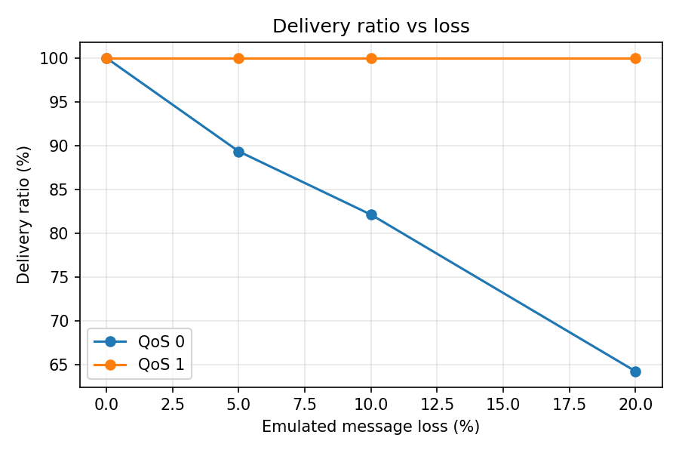
Figure 3. Delivery ratio against loss
QoS 0 falls with loss. A message sent at QoS 0 has to survive two lossy hops, publisher to broker and broker to subscriber. With loss rate p, the chance of arriving is (1 - p) squared. At 20% that is 0.64, and we measured 64.2%. At 10% the formula gives 0.81 and we measured 82.1%, so the results follow the expected curve closely.
QoS 1 stays at 100%. In all runs every message was delivered. With five retries, there are six attempts in total, and a message is truly lost only if every PUBLISH copy is dropped. At 20% loss that has probability 0.2 to the power six, about 0.006% per hop. A lost PUBACK does not lose the message, it only causes a repeat. This is small enough that we saw no failed delivery in these runs.
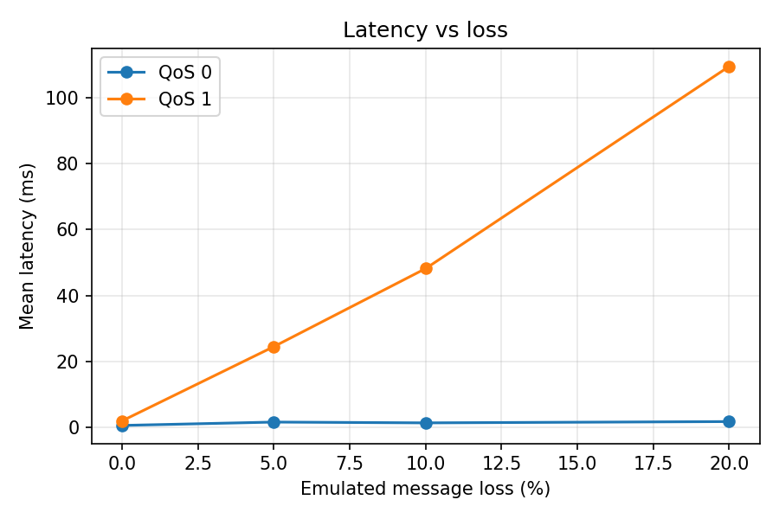
Figure 4. Mean latency against loss
Latency rises for QoS 1. The message that arrives on the first try is as quick as at QoS 0, but one that needs a retry waits at least 0.2 seconds. At 20% loss, about a fifth of publishes and a fifth of deliveries need a retry, which adds roughly 0.2 seconds times 0.25 expected retries on each hop. That comes to around 100 ms, close to the 109 ms we measured. The QoS 0 latency stays flat because a lost message is never counted.
Loss | Publisher retries | Broker retransmits | Total | Duplicates at subscriber | Duplicate PUBLISH at broker
5% | 32.3 | 31.3 | 63.7 | 13.7 | 15.3
10% | 71.3 | 72.7 | 144.0 | 35.3 | 35.0
20% | 164.3 | 171.3 | 335.7 | 66.3 | 73.7
Table 2. QoS 1 retransmissions and duplicates per 300 messages
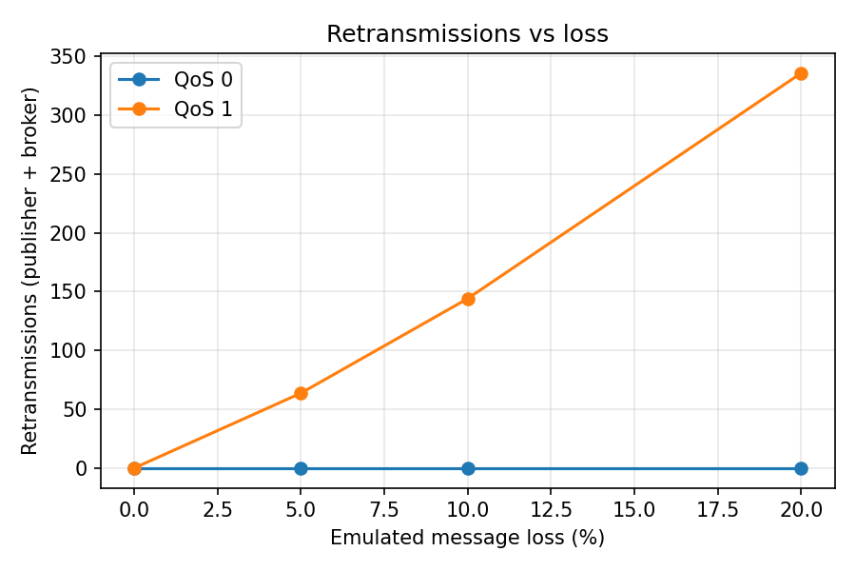
Figure 5. Retransmissions against loss
Retransmissions grow faster than the loss rate. Each hop needs on average 1 / 0.64 = 1.56 attempts at 20% loss, which is 0.56 retries per message, or about 168 retries for 300 messages. We measured 164 on the publisher side and 171 on the broker side. The numbers at 5% and 10% match the same calculation.
Duplicates appear whenever a PUBACK is lost. The 66 duplicates at 20% loss, and the 74 repeated publishes that the broker had to recognise and ignore, are the cost of at-least-once delivery. Without the id checks on both sides, subscribers would have seen about a fifth of the messages twice.
Throughput. In these runs QoS 1 throughput dropped from about 7,300 messages per second with no loss to about 30 at 20% loss. The cause is our batch design: the publisher sends 20 messages, then waits for all of them to be acknowledged before starting the next batch, so a single message needing a 0.2 second retry holds up the whole batch. The figure therefore measures the retry timeout more than the capacity of the broker.

8.2 Scalability
Subscribers | Mean latency | Deliveries per second
10 | 8.6 ms | 19,700
50 | 39.3 ms | 25,300
100 | 80.0 ms | 25,700
Table 3. QoS 1, no loss
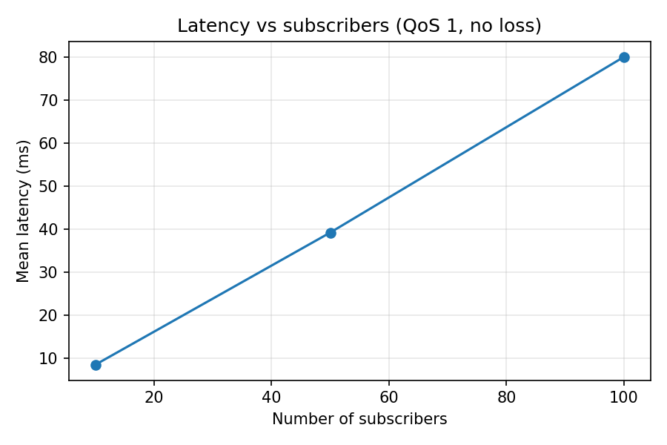
Figure 6. Latency against number of subscribers
Every subscriber still received all 300 messages. Latency grows roughly in proportion to the subscriber count, because for each published message the broker has to create one delivery task, build and send one frame, and process one PUBACK per subscriber, all on a single thread. The number of deliveries per second levels off near 25,000, which suggests that the broker's single event loop is the limit rather than the network.

8.3 Payload size
Payload | Mean latency | Messages per second
64 B | 1.7 ms | 7,460
1 KB | 2.0 ms | 6,660
16 KB | 3.9 ms | 2,530
Table 4. QoS 1, no loss, one subscriber
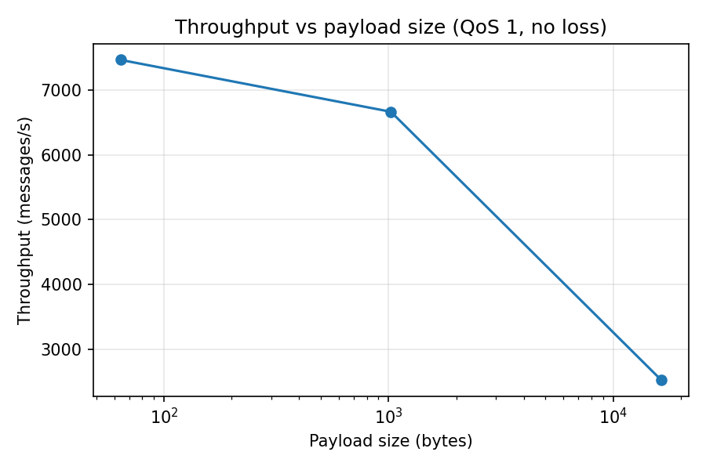
Figure 7. Throughput against payload size
Small payloads cost almost the same as tiny ones, because the fixed work per message (JSON encoding, task creation, acknowledgement) dominates. At 16 KB the encoding and copying start to matter, and throughput falls by about two thirds. A binary format would shrink this cost, since JSON has to escape and re-encode the payload on both sides.

8.4 Summary of findings
- QoS 0 is the fastest and cheapest, and its delivery ratio follows (1 - loss) squared.
- QoS 1 kept delivery at 100% in every run, at the cost of added latency, extra traffic and duplicate copies that must be filtered.
- Measured retransmission counts agree with a simple model of independent frame loss, which gives us some confidence in both the implementation and the proxy.
- On one machine, the broker scales to 100 subscribers, with latency growing about in line with the subscriber count.

9 Testing
There are two kinds of tests, both run with python -m unittest discover -s tests.
- Unit tests check topic matching for exact topics, the + wildcard, the # wildcard and mismatched lengths.
- End-to-end tests start a real broker and check that wildcard routing delivers the right topics, that a late subscriber receives a retained message with the retain flag set, and that at 10% loss a QoS 1 subscriber receives all 100 messages exactly once while a QoS 0 subscriber loses some.
We also wrote demo.py, which runs the same scenarios in a readable sequence for the presentation. In the demo run at 20% loss, QoS 0 received 140 of 200 messages and QoS 1 received all 200.

10 Limitations and future work

10.1 Limitations
- Loss is emulated at the message level. The proxy removes whole frames while TCP stays reliable underneath. This represents an application or connection-level fault, not packet loss as TCP itself would see it, where TCP would retransmit and show up as delay instead.
- One machine. Latency was measured over the loopback interface with a shared clock. Absolute numbers will differ on a real network.
- Small sample. Each setting was run three times with 300 messages. The trends are clear, but the exact values carry some noise.
- No persistence. Subscriptions, retained messages and unacknowledged deliveries live in memory. A broker restart loses them, and a reconnecting client has to subscribe again.
- Memory growth. The set of seen publisher ids grows with every QoS 1 message in a session.
- Single event loop. The broker uses one thread, which limits throughput as the number of subscribers grows.
- Text format. JSON is easy to debug but adds overhead, especially for large payloads.

10.2 Not implemented
The following were left out because of the time available, and we do not claim them as working features: QoS 2 with the four-step handshake, keep-alive pings and automatic disconnection of silent clients, last-will messages, TLS, authentication, and a live web dashboard.

10.3 Future work
- Implement QoS 2 and compare its cost to QoS 1.
- Add keep-alive and last-will, then test them by killing a client.
- Add optional TLS and measure its overhead.
- Replace JSON with a compact binary encoding and repeat the payload experiment.
- Test across two machines, and add real packet loss and delay with a tool such as tc netem on Linux.
- Persist retained messages and subscriptions to disk.

11 Conclusion
We built a working publish-subscribe system with wildcard topics, retained messages and two delivery guarantees, and a lossy proxy to test it. The experiments show the central trade-off clearly. Without acknowledgements, delivery drops in step with the loss rate. With acknowledgements and retransmission, every message arrived even at 20% loss, but latency went up by a factor of about fifty, the number of frames sent increased, and duplicates had to be suppressed at both ends. The measured retransmission counts matched a simple probability model, which supports the correctness of the implementation. The project also showed us, in a hands-on way, why message framing, separate delivery ids and idempotent acknowledgement handling are needed in a protocol built on TCP.

References
- OASIS. MQTT Version 3.1.1. OASIS Standard, 29 October 2014.
- M. Eddy. Transmission Control Protocol (TCP) Specification, RFC 9293, IETF, 2022.
- Python Software Foundation. asyncio: Asynchronous I/O, Python 3 documentation.
- J. F. Kurose and K. W. Ross. Computer Networking: A Top-Down Approach, Pearson.

Appendix A Message examples
{"type":"CONNECT","client_id":"c1"}
{"type":"SUBSCRIBE","topic":"sensor/+/temp","qos":1}
{"type":"PUBLISH","topic":"sensor/room1/temp","payload":"23.5",
"qos":1,"id":7,"retain":false,"ts":1730000000.1}
{"type":"PUBACK","id":7}
{"type":"STATS"}
{"type":"STATS","stats":{"pub_in":370,"delivered":370,"retransmits":124,
"dup_pub":47,"delivery_failed":0}}

Appendix B Project files
Path | Description
protocol.py, broker.py, client.py, proxy.py | The system
benchmark.py, plots.py, results.json, graphs/ | Experiments and their output
demo.py | Scripted demonstration
tests/ | Unit and end-to-end tests
README.md | Short usage notes
docs/ | This report, slides, viva guide and run guide

