Confidence Calibration and Hallucination Reduction in Small Language Models through Controlled Abstention Fine-Tuning
Anisha Dhoot¹ and Yash Hirani¹
¹ School of Computer Science and Engineering, Vellore Institute of Technology, Vellore, India
Abstract. Small language models (SLMs) suit on-device and low-resource deployment, but they are often over-confident and fill gaps in their knowledge with fluent, fabricated answers, which is costly in student-facing assistants. Retrieval and post-hoc detectors cannot help when the needed information exists in no corpus or act only after a wrong answer is produced, and abstention training has mostly been studied on models of seven billion parameters or more. This paper asks whether the composition of the fine-tuning data alone can make an SLM better calibrated and less prone to hallucination. Phi-3-mini (3.8B) is fine-tuned with QLoRA on a 4 GB consumer GPU, using question answering over Vellore Institute of Technology (VIT) curriculum documents with a controlled share of unanswerable queries mapped to one canonical "I don't know" response. The base model, a standard fine-tune and an abstention-aware fine-tune (15% abstention data) are compared on 449 held-out queries, 79 of them unanswerable. Standard fine-tuning doubles answerable accuracy (0.227 to 0.451) but raises the hallucination rate from 0.506 to 1.000. Abstention-aware fine-tuning lowers it to 0.139 (IDK F1 0.840) at a cost of 4.1% false refusals. It also reduces expected calibration error from 0.622 (base) and 0.408 (standard) to 0.304, and raises the AUROC for detecting incorrect responses from 0.557 and 0.764 to 0.810, with no calibration-specific loss. All systems remain over-confident, and part of the gain comes from confident, correct abstentions rather than better answers. Controlled abstention data is a cheap and effective lever for small models.
Keywords: Small language models, Hallucination, Confidence calibration, Abstention, Parameter-efficient fine-tuning.
- Introduction
Small language models (SLMs) with a few billion parameters can now be fine-tuned and served on a single consumer GPU or an on-premises server. This makes them an attractive basis for institutional assistants, on-device tools and other settings where cost, latency or data privacy rule out large hosted models [1,13]. The same compactness limits how much factual knowledge they retain. When asked about something they do not know, SLMs tend to produce a plausible answer rather than admit ignorance, and the confidence they attach to such answers is rarely informative [14,20]. Two failures therefore matter in practice: the model hallucinates, and its confidence does not tell the user when it has done so.
These two failures are closely linked. A confidence score that tracks correctness lets a system withhold an answer when confidence is low, and a model that has learned to abstain removes the most damaging class of errors at their source. Theoretical work supports the connection. A language model calibrated to its training distribution must hallucinate on rarely seen facts [23], and hallucination persists in part because training and evaluation reward guessing over abstaining [22]. Empirical work points the same way. Fine-tuning on new knowledge can increase hallucination [12], and domain-adapted models answer fluently on queries they cannot actually resolve [38]. Standard supervised fine-tuning on question–answer pairs contains no example of a question that should not be answered, so it never teaches the model that declining is a valid output.
A growing line of work teaches models to say "I don't know" by training on refusal examples [48,5,46,42]. Most of it evaluates models of seven billion parameters or more, treats abstention as the end goal, and does not examine whether it improves probability-based confidence. It also leaves open how much a small model gives up on answerable questions when it is taught to abstain, a cost the survey of Wen et al. [42] identifies as a central open problem (over-abstention). This paper studies these questions jointly, for a sub-4B model trained under a 4 GB memory budget.
Research questions. The study is organised around three questions.
- RQ1. Does controlled abstention supervision reduce hallucination?
- RQ2. Does it improve confidence calibration and the ability of confidence to separate correct from incorrect responses?
- RQ3. What is the cost to answerable questions, that is, how often does the model refuse queries it could have answered?
Approach. Phi-3-mini-4k-instruct [1] is fine-tuned with QLoRA [8,16] on a corpus of question–answer pairs derived from VIT's curriculum documents. Two training mixtures are built from the same pool of answerable examples. One contains no abstention examples (standard fine-tuning), and the other contains a controlled 15% share of unanswerable queries, all paired with one canonical refusal (abstention-aware fine-tuning). Because everything else is held fixed, differences between the two models can be attributed to the abstention data. Each response receives a sequence-level confidence score, the length-normalised probability of the generated tokens, and hallucination and calibration are evaluated on the same held-out queries with a correctness label that rewards abstaining on unanswerable queries and answering correctly on answerable ones.
Contributions.
1. A refusal-aware formulation that defines hallucination as an answer attempt on an unanswerable query and gives a single correctness label for both query types, so that calibration, discrimination and hallucination can be measured on the same responses.
2. A controlled-mixing protocol that sets the abstention share explicitly and uses one canonical refusal string, so the effect of abstention data is isolated from other factors.
3. An empirical comparison of a base model, a standard fine-tune and an abstention-aware fine-tune of a 3.8B model on a 4 GB GPU. The standard fine-tune doubles answerable accuracy but hallucinates on every unanswerable query. The abstention-aware fine-tune cuts the hallucination rate to 0.139 and improves ECE, Brier score and AUROC at a 4.1% false-refusal cost.
4. An analysis of where the calibration gain comes from, showing that much of it arises from high-confidence correct abstentions rather than better factual answers, together with the limits of this mechanism.
Organisation. Section 2 reviews related work. Section 3 formalises the task, the definition of hallucination and the calibration objective. Section 4 describes the data, the abstention mixing, the fine-tuning procedure and the confidence estimate. Section 5 gives the experimental setup and metrics. Section 6 reports the results, Section 7 discusses them and their limitations, and Section 8 concludes.
- Related Work
  - Hallucination in Language Models
The term hallucination refers to fluent model output that is unsupported by the input or inconsistent with established facts. Ji et al. [19] provide a comprehensive survey of the phenomenon in natural language generation, and Huang et al. [18] extend this analysis to large language models (LLMs), distinguishing factuality hallucinations, which contradict real-world knowledge, from faithfulness hallucinations, which contradict the user's prompt or the supplied context. The present study is concerned primarily with factuality hallucinations: a student queries the model about a course, a deadline, or a personal record, and the model either possesses the relevant knowledge from training or does not. Benchmarks such as TruthfulQA [30] have demonstrated that increased model scale does not by itself ensure truthfulness, and that larger models may reproduce common misconceptions more fluently than smaller ones.
A complementary body of work seeks to explain the origins of hallucination. Kalai and Vempala [23] show that a language model calibrated to its training distribution must hallucinate at a non-zero rate on facts that appear infrequently in its training data. Kalai et al. [22] further attribute hallucination to prevailing training and evaluation practices: when benchmarks award full credit for correct guesses and no credit for abstention, models are implicitly rewarded for guessing under uncertainty. Of particular relevance to this study, Gekhman et al. [12] show that fine-tuning an LLM on knowledge it did not previously possess proceeds slowly and is accompanied by an increased tendency to hallucinate on other queries. Porwal et al. [38] report a consistent pattern in the context of domain adaptation, where a Llama-2 model fine-tuned on domain-specific question answering performed well on queries resembling its training data but exhibited limited recall of, and reasoning about, new domain information, resulting in hallucinated responses. These findings motivate the standard fine-tuning baseline examined in this work.
Existing mitigation strategies include retrieval augmentation, which grounds generation in external documents [28], and post-hoc detection methods such as SelfCheckGPT [32], which identify hallucinations through inconsistency across sampled responses. Although effective in many settings, neither approach alters the model's intrinsic behaviour when the required knowledge is absent. Retrieval cannot compensate for information that is not present in the underlying corpus, as is the case for personal records or real-time schedules, and post-hoc detection identifies a fabricated response only after it has been generated. The present work adopts a complementary, training-time approach that targets both the frequency of hallucination and the reliability of the model's confidence signal.
  - Confidence Estimation and Calibration
A model is said to be calibrated when its predicted confidence corresponds to its empirical accuracy; for example, among responses produced with 80% confidence, approximately 80% should be correct. Guo et al. [14] demonstrated that modern deep neural networks are frequently miscalibrated, established Expected Calibration Error [34] as a standard evaluation metric, and proposed temperature scaling as an effective post-hoc correction. The Brier score [4] provides an earlier, binning-independent alternative that jointly reflects calibration and sharpness.
Estimating confidence in generative language models is more involved, since the output is a token sequence rather than a single class label. The most direct approach derives confidence from the model's own token probabilities. Malinin and Gales [31] analyse length-normalised sequence likelihood as an uncertainty measure for autoregressive models, and it remains a widely used baseline owing to its negligible computational overhead. Jiang et al. [20] showed that pre-trained language models such as T5, BART, and GPT-2 are poorly calibrated in question answering, and that fine-tuning and post-hoc adjustment only partially remedy this. Kadavath et al. [21] reported that large models are reasonably well calibrated on multiple-choice tasks and can be trained to predict whether they know the answer to a question. The GPT-4 technical report [35], however, documented a degradation of calibration following reinforcement learning from human feedback. Alternative approaches estimate uncertainty from semantic variability across sampled responses [26] or elicit verbalised confidence directly from the model [41,45]. These methods can be effective, but they require multiple generations per query or a large instruction-following model, both of which are costly for a small model operating under constrained hardware.
Recent studies indicate that calibration can be improved through training rather than only measured after the fact. Kapoor et al. [25] demonstrated that fine-tuning on a modest set of graded examples, including through LoRA, yields better-calibrated uncertainty estimates than prompting alone. Hu et al. [17] examined the effect of parameter-efficient fine-tuning (PEFT) on hallucination detection and found that PEFT consistently improves the AUROC of several unsupervised detectors, including confidence- and entropy-based methods. They attribute this improvement primarily to changes in how uncertainty is represented rather than to the acquisition of new factual knowledge. Zhang et al. [47] employ calibrated confidence for model routing, whereby a small model answers first and defers low-confidence queries to a larger model. The present study builds on this line of work by examining whether the composition of the fine-tuning data, specifically the controlled inclusion of abstention examples, improves calibration and discrimination beyond the gains achieved by standard domain fine-tuning.
  - Selective Prediction and Abstention
The principle that a model should be permitted to withhold a prediction dates back at least to Chow's analysis [6] of the trade-off between error and rejection. Selective classification formalises this principle by pairing a predictor with a rejection rule and evaluating the trade-off between coverage, the proportion of inputs answered, and risk, the error rate on those inputs [9]. Geifman and El-Yaniv [11] extended this framework to deep neural networks. In question answering, SQuAD 2.0 [39] introduced unanswerable questions, requiring extractive QA systems to determine when no valid answer exists. Kamath et al. [24] showed that a separately trained calibrator enables QA models to abstain more reliably under domain shift.
More recent work on LLMs incorporates abstention directly into the model during training rather than applying a threshold at inference. R-Tuning [48] identifies questions the model answers incorrectly and fine-tunes it to express uncertainty on them, and shows that this refusal ability generalises to unseen tasks. Cheng et al. [5] construct model-specific "I don't know" datasets and compare supervised fine-tuning with preference optimisation for teaching assistants to recognise the limits of their knowledge. Yang et al. [46] frame the same objective as alignment for honesty, rewarding refusal on unknown questions without penalising correct answers. Feng et al. [10] instead identify knowledge gaps through collaboration among multiple LLMs. Wen et al. [42] survey this area and identify over-abstention, the refusal of questions the model could have answered correctly, as a central open problem. Brahman et al. [3] extend the scope to contextual non-compliance more broadly.
The present study is most closely related to R-Tuning [48] and Cheng et al. [5], but differs in three respects. First, abstention is treated not as an end in itself but as a mechanism for achieving the two principal objectives of this work, namely improved confidence calibration and reduced hallucination, and the proportion of abstention examples is controlled explicitly rather than determined by data availability. Second, the study targets a small model fine-tuned in 4-bit precision on a 4 GB consumer GPU, rather than models of 7–70 billion parameters trained on server-grade hardware. Third, hallucination behaviour and probability-based calibration are evaluated jointly within a single institutional domain, and the over-abstention cost identified by Wen et al. [42] is quantified explicitly through the false refusal rate.
  - Parameter-Efficient Fine-Tuning of SLMs
Full fine-tuning of a model with several billion parameters is impractical without substantial computational resources. Parameter-efficient fine-tuning methods address this by training a small number of additional parameters while keeping the base model frozen. Representative approaches include bottleneck adapters [15], prefix tuning [29], prompt tuning [27], and Low-Rank Adaptation (LoRA) [16]. LoRA learns low-rank updates to selected weight matrices and has become the most widely adopted of these methods, in part because it introduces no additional inference latency. QLoRA [8] extends LoRA by storing the frozen base model in 4-bit NormalFloat precision, applying double quantisation, and employing paged optimisers, thereby enabling large models to be fine-tuned on a single GPU. In combination with 8-bit optimiser states [7], these techniques make the 4 GB training configuration used in this study feasible. Biderman et al. [2] found that LoRA acquires less new information than full fine-tuning but also forgets less of the base model's existing knowledge, a property well suited to domain adaptation, where general capabilities must be preserved.
Small language models (SLMs) have emerged as a credible alternative to substantially larger models for focused applications, owing in large part to carefully curated training data [13]. Phi-3-mini [1], with 3.8 billion parameters, reports benchmark performance competitive with considerably larger models while remaining deployable on consumer hardware, which motivated its selection for this study. SLMs are well suited to institutional assistants because they are inexpensive to serve, can be hosted on-premises, and can be adapted rapidly. Their reduced capacity, however, limits the factual knowledge they retain and increases their tendency to fill knowledge gaps with plausible but unsupported content, making both hallucination and miscalibration particularly pressing concerns. Since most of the hallucination, calibration, and abstention studies cited above employ models of seven billion parameters or more, the present work examines whether comparable improvements can be obtained for a sub-4B model trained under strict resource constraints.
- Problem Formulation
  - Task Definition
This study addresses closed-book question answering within a single institutional domain. The model is required to respond to student queries about VIT's academic programmes using only the knowledge acquired during fine-tuning, without access to retrieval or supporting documents at inference time. Let 𝒟 denote the source material that the assistant is intended to cover, namely VIT's official curriculum documents and academic regulations. Every incoming query q belongs to exactly one of two disjoint sets:
$𝒬 = 𝒬_{A} ∪ 𝒬_{U}, 𝒬_{A} ∩ 𝒬_{U} = ∅$ (1)
A query is answerable (q ∈ 𝒬_{A}) if a correct answer can be derived from 𝒟, in which case it is associated with a reference answer r. A query is unanswerable* (q ∈ 𝒬_{U}) if 𝒟 does not support any correct answer. Unanswerable queries in this study fall into five categories: requests concerning an individual student's records, queries requiring real-time information, requests for specific details not stated in the documents, references to non-existent entities (such as invented course codes), and queries outside the institutional domain. The answerability label is denoted z(q) = 𝟙[q ∈ 𝒬_{U}].
Answerability is defined relative to the scope of the assistant rather than to the full extent of the model's parametric knowledge. A pre-trained model may correctly answer an out-of-domain general-knowledge question, yet such a question is nonetheless labelled unanswerable, since a response falls outside the source material for which the assistant can be held accountable. From the user's perspective, an unverifiable answer issued with confidence is indistinguishable from a fabricated one.
For a given query, the model f_{θ} produces a response r = f_{θ}(q) and an associated scalar confidence c(q) ∈ [0, 1], as defined in Section 4.4. Each response is either an answer attempt or an abstention. The abstention indicator a(r) ∈ {0, 1} takes the value 1 when r declines to answer. During training, every abstention target is the canonical string r∅ (Section 4.2). During evaluation, a(r) is determined by a lexical refusal detector, so that abstentions expressed in the model's own wording are also recognised.
The study pursues two principal objectives: reducing hallucination and improving confidence calibration. The desired behaviour follows directly from these objectives. The model should answer correctly when q ∈ 𝒬_{A}, decline to answer when q ∈ 𝒬_{U}, and assign a confidence score that accurately reflects the likelihood that its response is correct. The answerability label z(q) is not available to the model, which must therefore infer from the query alone whether a reliable answer lies within its knowledge. Abstention thus serves as the behavioural mechanism through which hallucination is avoided, while confidence provides a continuous signal of response reliability.
  - Defining Hallucination and Correctness
Combining the answerability of a query with the model's decision to answer or abstain yields four possible outcomes:
 | a(r) = 1 (abstains) | a(r) = 0 (answers)
q ∈ 𝒬_{U} | correct abstention | hallucination
q ∈ 𝒬_{A} | false refusal | answer attempt (correct or incorrect)

Hallucination. A hallucination is defined as an answer attempt on an unanswerable query:
$hallucination\left(q, r\right) = z\left(q\right)\left(1 − a\left(r\right)\right)$ (2)
This definition is intentionally conservative. For q ∈ 𝒬_{U}, the source material contains no correct answer, so any substantive response must be fabricated, regardless of how it is phrased. An incorrect response to an answerable query is more ambiguous: it may be fabricated, but it may also be a valid paraphrase not recognised by lexical metrics, or a partially correct answer. Such responses are therefore counted as errors in the correctness evaluation but are not classified as hallucinations. The hallucination rate is accordingly defined as the proportion of unanswerable queries that receive an answer attempt:
$HR = \frac{\sum_{q}{z\left(q\right)\left(1 − a\left(r\right)\right)}}{\sum_{q}{z\left(q\right)}}$ (3)
Refusal-aware correctness. Relating confidence to outcomes requires a single binary correctness label that applies to both answerable and unanswerable queries. This label is defined as
$y\left(q, r\right) = \left\{\begin{aligned}a\left(r\right), if q ∈ 𝒬_{U} \\ \left(1 − a\left(r\right)\right) · 𝟙\left[F1\left(r, r^{*}\right) ≥ τ\right], if q ∈ 𝒬_{A}\end{aligned}\right.$ (4)
where F1(r, r∗) denotes the token-level F1 score between the response and the reference after normalisation (Section 5.2), and τ = 0.5. For an unanswerable query, abstention is the only correct response. For an answerable query, abstention is incorrect, and an answer attempt is considered correct only if its overlap with the reference meets the threshold.
This formulation precludes both degenerate strategies. A model that always abstains attains y = 1 on every unanswerable query and y = 0 on every answerable query, so its accuracy equals the proportion of unanswerable queries (17.6% on the test set used in this study). A model that never abstains can at most attain the proportion of answerable queries and receives no credit on unanswerable ones. High accuracy is achievable only by deciding correctly, on a per-query basis, whether to answer. A token-overlap threshold is preferred to exact string matching because the models generate free-form text, and correct answers phrased differently from the reference would otherwise be marked as incorrect.
  - Calibration Objective
Confidence calibration is a primary objective of this study. A model is perfectly calibrated with respect to the correctness label y if
$n_{idk} = \left\lfloor N_{reg} · \frac{ρ}{1 − ρ}\right\rfloor$ (5)
that is, among all responses produced with confidence 0.8, exactly 80% are correct. Calibration alone, however, is not sufficient. A model that assigns a constant confidence equal to its overall accuracy to every response is perfectly calibrated yet provides no basis for distinguishing reliable responses from unreliable ones. Confidence must therefore also be discriminative, in that correct responses should receive higher confidence than incorrect ones:
$c\left(q\right) = exp\left(\frac{1}{T}\sum_{t=1}^{T}{log p_{θ}\left(r_{t} | r_{<t}, q\right)}\right)$ (6)
which is the quantity estimated by AUROC. When both properties are satisfied, a deployed system can apply a confidence threshold below which it withholds its answer or refers the user to an authoritative source, providing a second safeguard against hallucination in addition to the abstentions the model learns to produce.
The overall objective of this study is to obtain adapter parameters θ that jointly:
1. improve confidence calibration, as measured by lower ECE and Brier score;
2. improve confidence discrimination, as measured by higher AUROC;
3. reduce hallucination, as measured by a lower hallucination rate on 𝒬_{U}; and
4. preserve utility, as measured by a low false refusal rate and high answer quality on 𝒬_{A}.
None of these objectives is optimised directly. Training employs only the standard next-token cross-entropy loss over each templated training sequence x (Section 4.3):
$Pr\left(y\left(q, r\right) = 1 | c\left(q\right) = p\right) = p, ∀ p ∈ [0, 1]$ (7)
with only the LoRA parameters updated. The sole experimental variable is the composition of 𝒟_{train}, specifically the proportion of unanswerable queries paired with the canonical abstention r∅. The central research question is therefore whether a change to the training data alone, without a calibration-specific loss, temperature scaling, or post-hoc recalibration, can improve calibration and reduce hallucination simultaneously, and at what cost to utility. Objectives 3 and 4 are in tension, since a higher proportion of abstention examples is expected to reduce hallucination while increasing the risk of false refusals. This trade-off is examined in Sections 6.1 and 6.4.
- Methodology
This study investigates whether the confidence calibration of a small instruction-tuned language model can be improved, and its tendency to hallucinate reduced, through the composition of its fine-tuning data. The intervention examined is the controlled inclusion of abstention examples, which teach the model to decline queries that fall outside its knowledge base while continuing to answer those within it. To this end, a domain-specific question-answering corpus covering the academic programmes of Vellore Institute of Technology (VIT) was constructed. Two training mixtures were derived from this corpus, differing solely in the proportion of abstention examples (0% and 15%). Phi-3-mini was fine-tuned on each mixture using QLoRA, and every generated response was assigned a sequence-level confidence score, enabling hallucination behaviour and calibration to be assessed jointly. Each stage of this pipeline is described in the following subsections.
  - Dataset Construction and Splits
The corpus is drawn from two sources. The first, referred to as the core QA set, comprises 2,349 question–answer pairs derived from VIT's official curriculum documents. These documents specify programme credit structures, course codes and credit values, category-wise credit distributions (e.g., Discipline Core, Discipline Elective, Open Elective, and Projects and Internship), and the academic regulations governing undergraduate and postgraduate programmes. The questions vary in complexity, from direct factual retrieval (e.g., "How many credits are allotted to Professional Elective Courses in the M.Tech in Applied Computational Fluid Dynamics program?") to cross-programme comparisons and student-style requests (e.g., "I want a Discipline Elective that combines lecture and lab work on computer vision for medical use. Which course code should I register for?"). Questions have a mean length of 18.9 words, and answers a mean length of 16.7 words (median 14). Answers were intentionally kept concise and factual so that generated responses can be reliably compared against a reference.
The second source is a supplementary set of 980 pairs constructed specifically to represent queries that the curriculum documents cannot answer. These queries fall into five principal categories:
- Personal or record-specific queries, which depend on an individual student's data (e.g., attendance, re-FAT application status, or examination seating) and can be resolved only through the institutional portal (VTOP) or a faculty proctor.
- Time-sensitive queries, which require real-time information (e.g., whether the FAT schedule has been released at the time of asking, or the library's closing time on a given day).
- Unsupported specifics, which request plausible but undocumented details (e.g., the exact notice period for an outing pass, or the research group associated with a particular elective).
- Non-existent entities, which refer to course codes or courses absent from all curricula and are intended to elicit fabricated responses.
- Out-of-domain queries, which bear no relation to the institution.
The supplementary set also contains a number of answerable pairs, predominantly cross-programme comparisons, which are treated as standard QA data.
Abstention examples were separated from answerable examples using a case-insensitive lexical pattern that matches common refusal expressions (e.g., "don't know", "I cannot", "cannot verify", "real-time", and "not in my knowledge"). Applied to both sources, the pattern identifies 3 core pairs and 789 supplementary pairs as abstentions, yielding an answerable pool of 2,537 pairs and an abstention pool of 792 pairs. Because the pattern is deliberately conservative, a small number of hedged responses expressed in other terms (e.g., "That is specific to your own record, and I have no way to check it…") are not detected and remain in the answerable pool with their original wording. This is acknowledged as a limitation of the present study.
Each mixture constructed from these pools (Section 4.2) is shuffled using a fixed random seed (42) and partitioned into training, validation, and test sets in a 70/15/15 ratio. Prior to partitioning, an exact-match check confirmed that no question appears in both the training and test sets of either mixture and that all questions within each mixture are unique. The resulting partition sizes are reported in Table 1.
Table 1. Partition sizes for the two training mixtures. The number of abstention examples in each partition is given in parentheses.
Mixture | ρ (target) | Total | Train | Validation | Test
IDK-0 | 0.00 | 2,537 | 1,775 (0) | 380 (0) | 382 (0)
IDK-15 | 0.15 | 2,984 | 2,088 (312) | 447 (56) | 449 (79)

Since the target ratio is enforced over the complete mixture prior to partitioning, the proportion within each individual partition varies slightly. For IDK-15, abstention examples constitute 14.9% of the training set, 12.5% of the validation set, and 17.6% of the test set. Random rather than stratified partitioning was retained so that both mixtures are processed identically. To prevent this variation from distorting aggregate measures, refusal behaviour is evaluated separately over answerable and unanswerable queries (Section 5.2).
  - Controlled Abstention Data Mixing
Abstention examples are the mechanism through which this study seeks to reduce hallucination and improve calibration. Exposure to explicit examples of declining unanswerable queries is intended both to suppress fabricated answers and to provide the model with a learned response for low-knowledge situations, thereby sharpening the relationship between its confidence and its correctness. A straightforward approach would be to include all available refusal examples in the training data. However, this makes the effective abstention rate dependent on the number of such examples that happen to have been collected. In the present work, the abstention rate is therefore treated as an explicitly controlled variable. For a target ratio ρ, the number of abstention examples sampled is
$Pr\left(c\left(q_{i}\right) > c\left(q_{j}\right) | y_{i} = 1, y_{j} = 0\right) → 1$ (8)
where N_{reg} = 2,537 denotes the size of the answerable pool. This ensures that abstention examples constitute exactly a fraction ρ of the combined dataset. The examples are sampled without replacement from the 792-example abstention pool using a fixed random seed. For ρ = 0.15, this yields 447 abstention examples, which lies well within the available pool, so the target ratio is achieved exactly. The value of 15% was selected so that abstention examples form a sufficiently large share of the data for the behaviour to be learned, without outweighing the answerable examples on which the model must retain its accuracy.
Prior to mixing, all abstention targets are normalised to a single canonical response:
"I don't have enough information in my knowledge base to answer this question accurately."
The original supplementary answers exhibited considerable variation in phrasing, and several redirected the user to external resources (e.g., "please check VTOP" or "contact your proctor"). Although varied phrasing may appear more natural, it introduces two difficulties in a controlled experimental setting. First, it reduces the reliability of refusal detection during evaluation, introducing noise into every refusal-dependent metric. Second, it allows the model to acquire multiple loosely defined hedging styles that may carry over into responses to legitimate queries. A single canonical string defines abstention as one well-specified behaviour that can be measured precisely. The corresponding trade-off is that the model may learn abstention as a fixed phrase rather than as a graded expression of uncertainty. The implications of this for confidence estimation are discussed in Section 4.4.
A separate adapter is trained for each mixture. IDK-0 contains no abstention examples and serves as the standard fine-tuning baseline, while IDK-15 constitutes the proposed abstention-aware configuration. All other factors are held constant across the two conditions, namely the answerable pool, the random seed, the partition proportions, and the training hyperparameters. Observed differences in hallucination behaviour and calibration can therefore be attributed to the inclusion of abstention data.
  - QLoRA Fine-Tuning of Phi-3-mini
Phi-3-mini-4k-instruct [1], a 3.8-billion-parameter model, is adopted as the base model. Its size permits fine-tuning on consumer-grade hardware, and its prior instruction tuning enables it to follow a conversational format without additional alignment. All experiments were conducted within a 4 GB VRAM budget on an NVIDIA RTX 3050 Ti laptop GPU, and this constraint informed most of the configuration choices described below.
Quantisation. Following QLoRA [8], the base model is loaded in 4-bit NormalFloat (NF4) precision with double quantisation, and computation is performed in bfloat16. The quantised base weights remain frozen throughout training, and gradients are propagated only to the low-rank adapter parameters.
Adapter configuration. LoRA [16] adapters with rank r = 8, scaling factor α = 16, and dropout 0.05 are applied to all attention and feed-forward projection layers (qkv_proj, o_proj, gate_up_proj, and down_proj). Adapting the feed-forward blocks in addition to the attention layers increases the model's capacity to alter the content of its outputs, not only the distribution of its attention. This capacity is relevant when the target behaviour involves deciding between answering and abstaining. The resulting configuration contains 12,582,912 trainable parameters, corresponding to 0.33% of the model's 3.83 billion total parameters.
Input formatting. Each question–answer pair is formatted using the native Phi-3 chat template:
<|user|>
{question}<|end|>
<|assistant|>
{answer}<|end|>
Adopting the template used during the model's original instruction tuning avoids any discrepancy between training-time and inference-time prompt formats. Sequences exceeding 512 tokens are truncated, although in practice almost no examples approach this limit given the brevity of the answers. Any example whose answer begins with the placeholder "NOT FOUND", a marker introduced during dataset construction for facts that could not be sourced, is excluded. Training on such examples would encourage the model to produce an uninformative, refusal-like string unrelated to the query.
Optimisation. Training is performed for three epochs with a per-device batch size of 1 and eight gradient-accumulation steps, giving an effective batch size of 8. A learning rate of 2 × 10⁻⁴ with linear decay is used together with the paged 8-bit AdamW optimiser [7,8]. Gradient checkpointing is enabled, with the key–value cache disabled during training, in order to keep activation memory within the available budget. Ten percent of each mixture's training partition is held out using a fixed seed to compute validation loss at the end of each epoch, and a checkpoint is saved after every epoch. For IDK-15, this corresponds to approximately 235 optimiser steps per epoch. The base model, adapter configuration, and hyperparameters are identical for both mixtures, so the two training runs differ only in their training data.
  - Sequence-Level Confidence Estimation
Assessing whether fine-tuning alters the extent to which the model knows what it knows requires a confidence score for every generated response that can be compared against that response's correctness. The model's own token probabilities are used for this purpose, since they are obtained at no additional computational cost and do not require an auxiliary model or repeated sampling.
Given a query q, the model generates a response r = (r₁, …, r_T) by greedy decoding, with a maximum of 64 new tokens. At each decoding step, the log-probability assigned to the emitted token is recorded. The confidence score is defined as the exponentiated mean of these log-probabilities:
$ℒ\left(θ\right) = − \sum_{x ∈ 𝒟_{train}}{\sum_{t}{log p_{θ}\left(x_{t} | x_{<t}\right)}}$ (9)
which corresponds to the geometric mean of the per-token probabilities, a standard length-normalised likelihood measure for autoregressive models [31]. Length normalisation is necessary because the unnormalised sequence probability ∏ₜ p_{θ}(r_{t} | r_{<t}, q) decreases monotonically with each additional token. Without normalisation, a correct multi-sentence answer could receive a lower score than an incorrect single-word answer, reflecting response length rather than model certainty. The normalised score lies in [0, 1] and is comparable across responses of different lengths, including the fixed-length canonical refusal.
Each confidence score is paired with the refusal-aware correctness label y(q, r) defined in Section 3.2. Under this definition, abstention is counted as correct for an unanswerable query and as a false refusal for an answerable query, and an answer attempt on an answerable query is counted as correct when its token-level F1 score against the reference is at least 0.5. The resulting (confidence, correctness) pairs form the input to the calibration metrics described in Section 5.3. As a complementary, generation-independent measure, the teacher-forced negative log-likelihood of the reference answer is also computed for each model. This quantifies the probability mass the model assigns to the correct answer, irrespective of whether the model would generate that answer itself.
An interaction with the design choice described in Section 4.2 should be noted. Because all abstention targets share a single canonical string, a model trained on this data may reproduce the refusal with very high token probabilities. A high-confidence refusal therefore indicates that the model has learned the phrase reliably. It does not, on its own, demonstrate that the model has recognised a gap in its knowledge. For this reason, the aggregate calibration metrics are interpreted alongside the refusal analysis, which distinguishes correct abstentions from false refusals (Section 6).
- Experimental Setup
  - Configurations and Baselines
Three systems are compared. All three share identical base weights, the same 4-bit quantisation, and the same inference-time prompt format.
1. Base model. Phi-3-mini-4k-instruct evaluated zero-shot without an adapter. Each query is presented in the standard chat template, with no system prompt, retrieved context, or in-context examples. This baseline characterises the model's calibration and hallucination behaviour on institution-specific queries when it relies solely on knowledge acquired during pre-training and instruction tuning.
2. Standard fine-tuning (Normal FT). The IDK-0 adapter, trained exclusively on answerable queries (Section 4.2). This model acquires domain knowledge but is never exposed to abstention as a valid response. It serves to determine whether domain fine-tuning alone improves calibration and reduces hallucination, or whether it merely increases the model's fluency and confidence on queries it cannot answer.
3. Abstention-aware fine-tuning (IDK FT). The IDK-15 adapter, trained on the same answerable queries with 15% canonical abstention examples included. This is the proposed configuration.
The comparison between the base model and Normal FT isolates the effect of domain adaptation, while the comparison between Normal FT and IDK FT isolates the effect of abstention data on calibration and hallucination, since these two adapters were trained under identical conditions and differ only in their training mixture.
All three systems are evaluated on the IDK-15 test partition, which comprises 449 queries: 370 answerable and 79 unanswerable. This partition is used for all systems because the IDK-0 test partition contains no unanswerable queries and therefore cannot be used to measure hallucination on such queries. Because the two mixtures were shuffled independently, 15 of the 449 test queries, all of them answerable, also appear in the IDK-0 training data. This overlap affects approximately 3% of the test set and, if anything, favours the Normal FT baseline.
  - Hallucination Metrics
The hallucination analysis assesses whether each model answers the queries it should answer and declines those it cannot reliably answer. For every test query, it is recorded whether the model abstained, using the same lexical refusal pattern applied to the reference answers (Section 4.1). Each query is thereby assigned to one of four outcome categories:
 | Model abstains | Model answers
Unanswerable | True positive (TP) | Missed abstention (FN)
Answerable | False refusal (FP) | Answer attempt (TN)

The following metrics are derived from these counts.
Hallucination rate. The primary hallucination metric is the proportion of unanswerable queries for which the model produced an answer (Section 3.2):
$HR = \frac{FN}{TP + FN}$ (10)
As established in Section 3.2, each such response constitutes a hallucination by construction. Although HR is equal to 1 − IDK recall, it is reported separately because it most directly reflects the deployment risk of the system, namely the frequency with which a user would receive a fabricated answer.
IDK precision, recall, and F1. The model's decision to abstain is further evaluated as a binary classification task:
$P_{IDK} = \frac{TP}{TP + FP}$
$R_{IDK} = \frac{TP}{TP + FN}$
${F1}_{IDK} = \frac{2 P_{IDK}R_{IDK}}{P_{IDK} + R_{IDK}}$ (11)
Precision reflects over-caution, decreasing when the model refuses answerable queries, whereas recall reflects under-caution, decreasing when the model answers unanswerable queries. Since either measure can be maximised trivially in isolation (a model that always refuses attains perfect recall, and one that never refuses produces no false refusals), F1 is used as the summary measure. The raw counts of false refusals and missed abstentions, together with the overall refusal rate, are also reported, since models with similar F1 scores may exhibit markedly different error profiles.
Answer quality on answerable queries. A reduction in hallucination is of practical value only if answer quality on answerable queries is maintained. Token-level F1 between each generated response and its reference is therefore reported, computed as in SQuAD [40]: both strings are lower-cased, punctuation is removed, the text is tokenised on whitespace, and F1 is computed as the harmonic mean of token-level precision and recall over the shared bag of tokens. Token-level F1 is preferred to exact match because the models generate free-form text; a response such as "The MSB programme requires 80 credits in total" is correct but would receive a score of zero under exact matching against a differently worded reference. Exact match is nevertheless reported for completeness. The hallucination analysis additionally reports answerable accuracy, under which an answer attempt is considered correct if it covers more than 40% of the distinct words in the reference. This coverage-based criterion does not penalise responses that include additional explanation.
  - Calibration Metrics
The calibration analysis assesses whether each model's confidence score (Section 4.4) is informative, that is, whether higher confidence corresponds to a higher likelihood of correctness. All metrics in this section are computed from the confidence score c_{i} of each response and the refusal-aware correctness label y_{i} ∈ {0, 1} defined in Section 3.2, under which a correct abstention is treated as a correct response and a false refusal as an error.
Expected Calibration Error (ECE) [14,34]. The confidence interval [0, 1] is partitioned into M = 10 equal-width bins B₁, …, B_M, and the mean confidence in each bin is compared with the empirical accuracy:
$ECE = \sum_{m=1}^{M}{\frac{|B_{m}|}{N} · |acc\left(B_{m}\right) − conf\left(B_{m}\right)|}$ (12)
A perfectly calibrated model, which is correct 70% of the time when it reports a confidence of 0.7, attains an ECE of zero. Reliability diagrams plotting per-bin accuracy against mean confidence are also presented, since ECE summarises the full calibration curve in a single value and does not indicate whether a model is over- or under-confident.
Brier score [4]. The mean squared error between confidence and correctness:
$Brier = \frac{1}{N}\sum_{i=1}^{N}{{\left(c_{i} − y_{i}\right)}^{2}}$ (13)
Unlike ECE, the Brier score is independent of the choice of bins. It also rewards sharpness in addition to calibration: a model that uniformly reports a confidence of 0.5 may obtain a low ECE but will nonetheless receive a poor Brier score.
AUROC. The area under the receiver operating characteristic curve obtained when confidence is used to discriminate correct from incorrect responses. AUROC equals the probability that a randomly selected correct response is assigned a higher confidence than a randomly selected incorrect one, so a value of 0.5 indicates that confidence carries no information about correctness. Calibration and discrimination are distinct properties: a model may be well calibrated on average while assigning nearly identical confidence to its correct and incorrect responses. AUROC therefore determines whether a confidence threshold would be practically effective for filtering hallucinated responses at deployment time.
The mean teacher-forced negative log-likelihood (NLL) of the reference answers (Section 4.4) is reported as a supplementary measure.
  - Implementation Details
The pipeline is implemented in Python using PyTorch [36] and the Hugging Face ecosystem: transformers [44] for model loading and generation, peft [33] for the LoRA adapters, trl [43] (SFTTrainer) for supervised fine-tuning, bitsandbytes [7,8] for 4-bit quantisation and 8-bit paged optimisation, and datasets for data handling. AUROC is computed with scikit-learn [37], while ECE, the Brier score, token-level F1, and the abstention confusion counts are computed using custom implementations. Figures are produced with Matplotlib.
All training and evaluation were performed on a single NVIDIA RTX 3050 Ti laptop GPU with 4 GB of VRAM. Since two 4-bit instances of Phi-3-mini cannot be accommodated in this memory simultaneously, models are evaluated sequentially: each model is loaded, evaluated on the complete test set, and released, and the CUDA cache is cleared before the next model is loaded. Adapters are maintained separately from the frozen base model and attached at load time, ensuring that all systems share identical quantised base weights. Base-model outputs are cached per test file so that subsequent adapter evaluations do not require the base model to be re-run.
At inference time, each model receives the query in the training-time chat template (<|user|>\n{question}<|end|>\n<|assistant|>\n) and decodes greedily without sampling, so all outputs are deterministic. The hallucination analysis (Section 5.2) permits up to 100 new tokens to avoid truncating longer answers before scoring. The calibration analysis (Section 5.3) limits generation to 64 new tokens and records per-token log-probabilities during decoding in order to compute the confidence score. The refusal pattern used to label model outputs is consistent with that used to label the reference answers; on the IDK-15 test set, the patterns used during data preparation and evaluation identify the same 79 unanswerable queries.
All stochastic operations, including dataset shuffling, abstention sampling, the train/validation/test partitioning, and the internal validation hold-out, use a fixed random seed of 42. Given the two source files, the provided scripts reproduce every partition reported in Table 1 exactly.
- Results and Analysis
This section reports the effect of each configuration on the two principal objectives of the study, hallucination reduction (Section 6.1) and confidence calibration (Sections 6.2 and 6.3), followed by an analysis of the associated cost in false refusals (Section 6.4) and an ablation isolating the contribution of the abstention data (Section 6.5). All results are obtained on the IDK-15 test partition, comprising 449 queries (370 answerable and 79 unanswerable). Refusal-based metrics are drawn from the 100-token hallucination analysis, and calibration metrics from the 64-token calibration analysis (Section 5.4).
  - Hallucination Reduction
Table 2 summarises the refusal behaviour of each system, and Fig. 1 presents the same metrics graphically.
Table 2. Hallucination and refusal metrics on the IDK-15 test set. HR denotes the hallucination rate (missed abstentions divided by the 79 unanswerable queries). Answerable accuracy is computed using the >40% reference-coverage criterion (Section 5.2).
System | Refusal rate | IDK precision | IDK recall | IDK F1 | HR ↓ | Missed abstentions (FN) | False refusals (FP) | Answerable acc.
Base | 0.345 | 0.252 | 0.494 | 0.333 | 0.506 | 40 | 116 | 0.227
Normal FT | 0.000 | 0.000 | 0.000 | 0.000 | 1.000 | 79 | 0 | 0.451
IDK FT | 0.185 | 0.819 | 0.861 | 0.840 | 0.139 | 11 | 15 | 0.408

The most notable finding concerns the effect of standard fine-tuning on hallucination. Prior to fine-tuning, the base model declines approximately half of the unanswerable queries (HR = 0.506). After fine-tuning on answerable domain data alone, it declines none: the Normal FT model did not refuse any of the 449 test queries. It produced an answer to all 79 unanswerable queries, including those concerning individual student records, real-time schedules, and non-existent courses, each of which is necessarily fabricated. Domain adaptation therefore improved the model's domain knowledge, approximately doubling answerable accuracy from 0.227 to 0.451, while simultaneously conditioning it to answer every query regardless of whether a reliable answer was available. With respect to hallucination on unanswerable queries, standard fine-tuning produced a worse outcome than no fine-tuning at all.
The inclusion of 15% abstention data reverses this effect. The IDK FT model abstains on 68 of the 79 unanswerable queries, reducing the hallucination rate to 0.139, which corresponds to a relative reduction of 86% compared with Normal FT and 73% compared with the base model. Its refusals are also well targeted: 68 of its 83 refusals occur on queries that warrant abstention (precision 0.819), yielding an IDK F1 of 0.840. The overall refusal rate of 18.5% closely approximates the true proportion of unanswerable queries in the test set (17.6%), indicating that the model has learned not only the form of an abstention but also an appropriate frequency of abstaining.
The base model's apparent recall of 0.494 should not be interpreted as evidence of knowledge-aware behaviour. Of its 155 refusals, 116 occur on answerable queries, so three out of every four refusals are misplaced. These refusals consist largely of generic disclaimers regarding access to institution-specific information and are issued with little regard to whether a query is in fact answerable. Fig. 2 contrasts the error profiles of the three systems: the base model errs predominantly through over-caution, Normal FT exclusively through hallucination, and IDK FT exhibits a small number of both error types (15 false refusals and 11 missed abstentions).
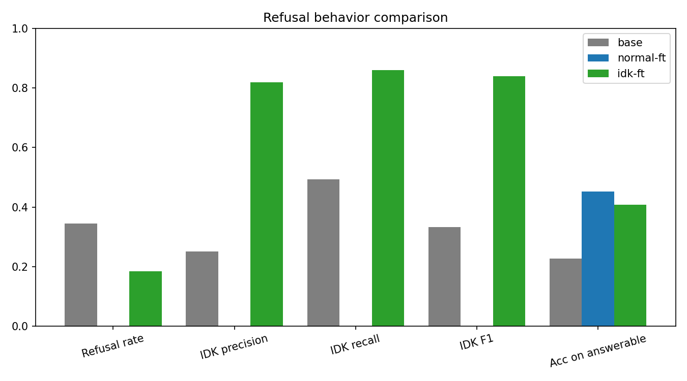
Fig. 1. Comparison of refusal behaviour (refusal rate, IDK precision, recall, F1, and answerable accuracy) for the base model, Normal FT, and IDK FT.
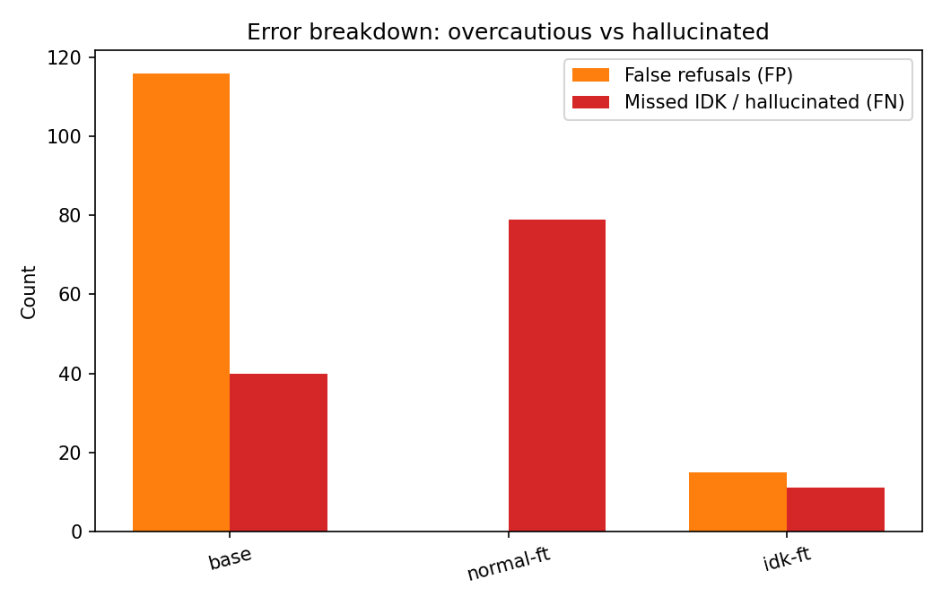
Fig. 2. Error breakdown showing false refusals (over-caution) and missed abstentions (hallucinations) for each system.
  - Calibration Improvement
Table 3 reports the calibration metrics together with the answer-quality measures obtained in the same evaluation.
Table 3. Calibration and answer quality on the IDK-15 test set, using refusal-aware correctness with a token-F1 threshold of 0.5.
Metric | Base | Normal FT | IDK FT
Accuracy (refusal-aware) ↑ | 0.100 | 0.327 | 0.477
Exact match ↑ | 0.000 | 0.051 | 0.189
Token F1 ↑ | 0.168 | 0.391 | 0.515
ECE ↓ | 0.622 | 0.408 | 0.304
Brier score ↓ | 0.480 | 0.351 | 0.285
Reference NLL ↓ | 2.405 | 1.663 | 0.965
AUROC ↑ | 0.557 | 0.764 | 0.810

Calibration improves at each stage. ECE decreases from 0.622 for the base model to 0.408 following standard fine-tuning and to 0.304 following abstention-aware fine-tuning, an overall reduction of 51%, of which a 25% reduction relative to Normal FT is attributable to the abstention data alone. The Brier score follows the same trend (0.480 → 0.351 → 0.285), confirming that the improvement is not an artefact of the binning scheme.
The reliability diagram in Fig. 3 clarifies the source of these gains. All three curves lie below the diagonal across the full confidence range, indicating that every system remains over-confident and that no configuration eliminates over-confidence entirely. The shape of the curves, however, differs considerably. The base model's curve is essentially flat: its accuracy remains between 0 and 0.15 whether it reports a confidence of 0.57 or 0.93, and its highest-confidence bin has an accuracy of zero, so its confidence is largely uninformative. The Normal FT curve increases with confidence but plateaus at an accuracy of approximately 0.55 above a confidence of 0.8, meaning that the model remains incorrect in almost half of its most confident responses. The IDK FT curve increases monotonically across the full range and reaches an accuracy of 0.80 at a mean confidence of approximately 0.97, placing its highest-confidence bin closest to the diagonal among the three systems. A substantial gap nonetheless persists in the mid-range; at a confidence of approximately 0.65, IDK FT is correct in only about 19% of cases.
Two qualifications are necessary when interpreting these results. First, part of the aggregate improvement arises from the unanswerable queries themselves. Because IDK FT reproduces the canonical abstention verbatim, each correct abstention constitutes an exact match, achieves a near-perfect token F1, and is produced with high confidence. This accounts for most of the increase in exact match (from 23 to 85 of 449 responses) and contributes to the reduction in reference NLL, since all 79 unanswerable references share a single string that the model has learned to predict. Second, the gain in refusal-aware accuracy (0.327 → 0.477, approximately 67 additional correct responses) corresponds closely to the number of unanswerable queries that IDK FT handles correctly. Assuming that IDK FT behaves on unanswerable queries in this evaluation as it does in the hallucination analysis, its accuracy on answerable queries under the F1 criterion is approximately 0.39, essentially equivalent to the 0.40 obtained by Normal FT. Abstention-aware training therefore improves calibration primarily by converting confidently incorrect answers into confidently correct abstentions, rather than by improving the quality of the model's factual answers.
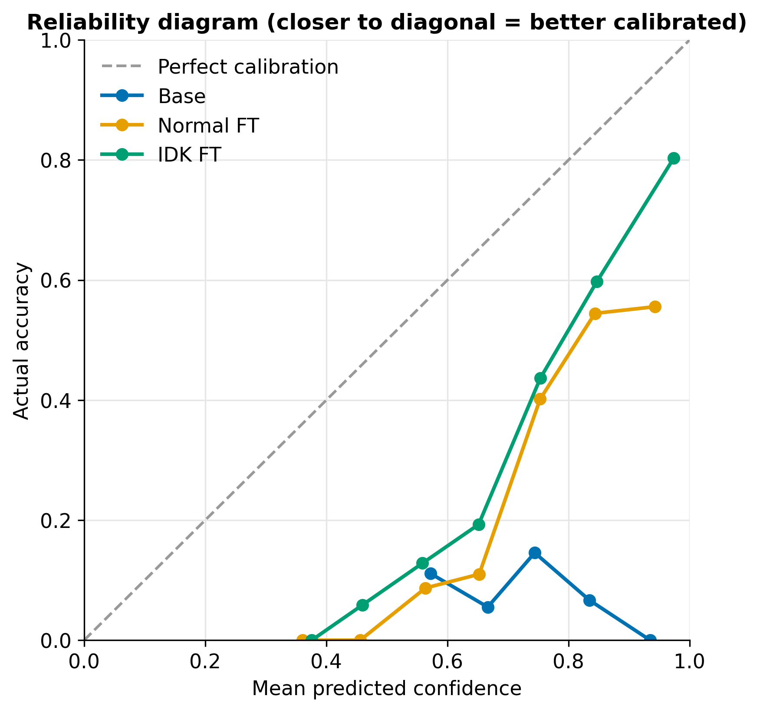
Fig. 3. Reliability diagram for the base model, Normal FT, and IDK FT (10 equal-width bins). The dashed diagonal denotes perfect calibration.
  - Confidence Separation
Whereas calibration measures whether confidence is accurate on average, deployment additionally requires that confidence separate correct from incorrect responses sufficiently well to support a threshold. Fig. 4 shows the confidence distributions for correct and incorrect responses, and Fig. 5 shows the corresponding ROC curves.
For the base model, the two distributions overlap almost entirely. Both correct and incorrect responses fall within a narrow band between approximately 0.55 and 0.85, and the small number of correct responses (approximately 45) is indistinguishable from the roughly 400 incorrect ones. No threshold separates the two groups, which is reflected in an AUROC of 0.557, only marginally above chance.
Fine-tuning separates the two distributions. For Normal FT, correct responses shift predominantly into the 0.7–1.0 range, whereas incorrect responses peak between 0.55 and 0.75. The incorrect distribution nevertheless retains a long tail extending to 0.95, consisting of confidently incorrect responses that include the model's fabricated answers to unanswerable queries. Its AUROC is 0.764.
IDK FT achieves the clearest separation (AUROC 0.810). Its incorrect responses are concentrated around a confidence of 0.6, whereas its correct responses lie predominantly above 0.7, with a pronounced peak of more than 80 correct responses in the 0.95–1.0 bin, consisting largely of canonical abstentions. This peak is of practical significance. The IDK FT ROC curve rises almost vertically from the origin, reaching a true-positive rate of approximately 0.28 at a false-positive rate close to zero. In other words, roughly a quarter of IDK FT's correct responses can be accepted at a high confidence threshold while admitting almost no incorrect responses, compared with approximately 0.05 for Normal FT at the same operating point. The advantage persists throughout the low false-positive region: at a false-positive rate of 0.1, IDK FT retains approximately 43% of its correct responses, compared with approximately 25% for Normal FT. Beyond a false-positive rate of about 0.4, the two curves converge. The improvement is therefore concentrated in the high-confidence region, which is precisely where a practical acceptance threshold would be set.
The same peak also contains a small number of incorrect responses (approximately 15 in the 0.95–1.0 bin), a count that coincides with the 15 false refusals reported in Table 2. This observation is consistent with the concern raised in Section 4.4: because the canonical abstention is a fixed phrase, the model can produce it with high confidence even when abstention is inappropriate. Such errors cannot be identified through confidence alone.
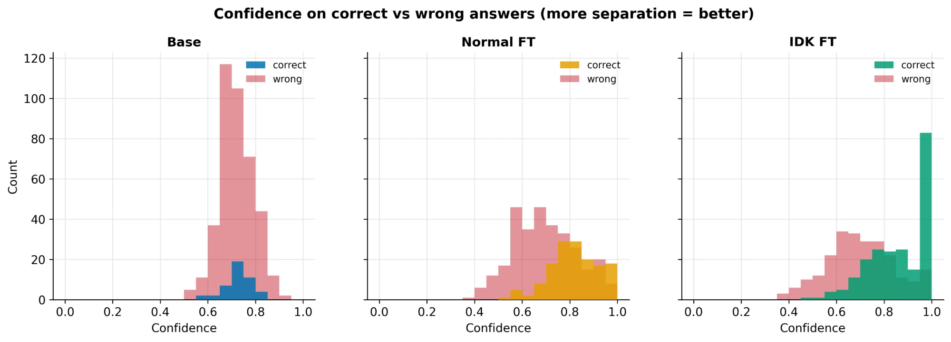
Fig. 4. Confidence distributions for correct and incorrect responses for each system.
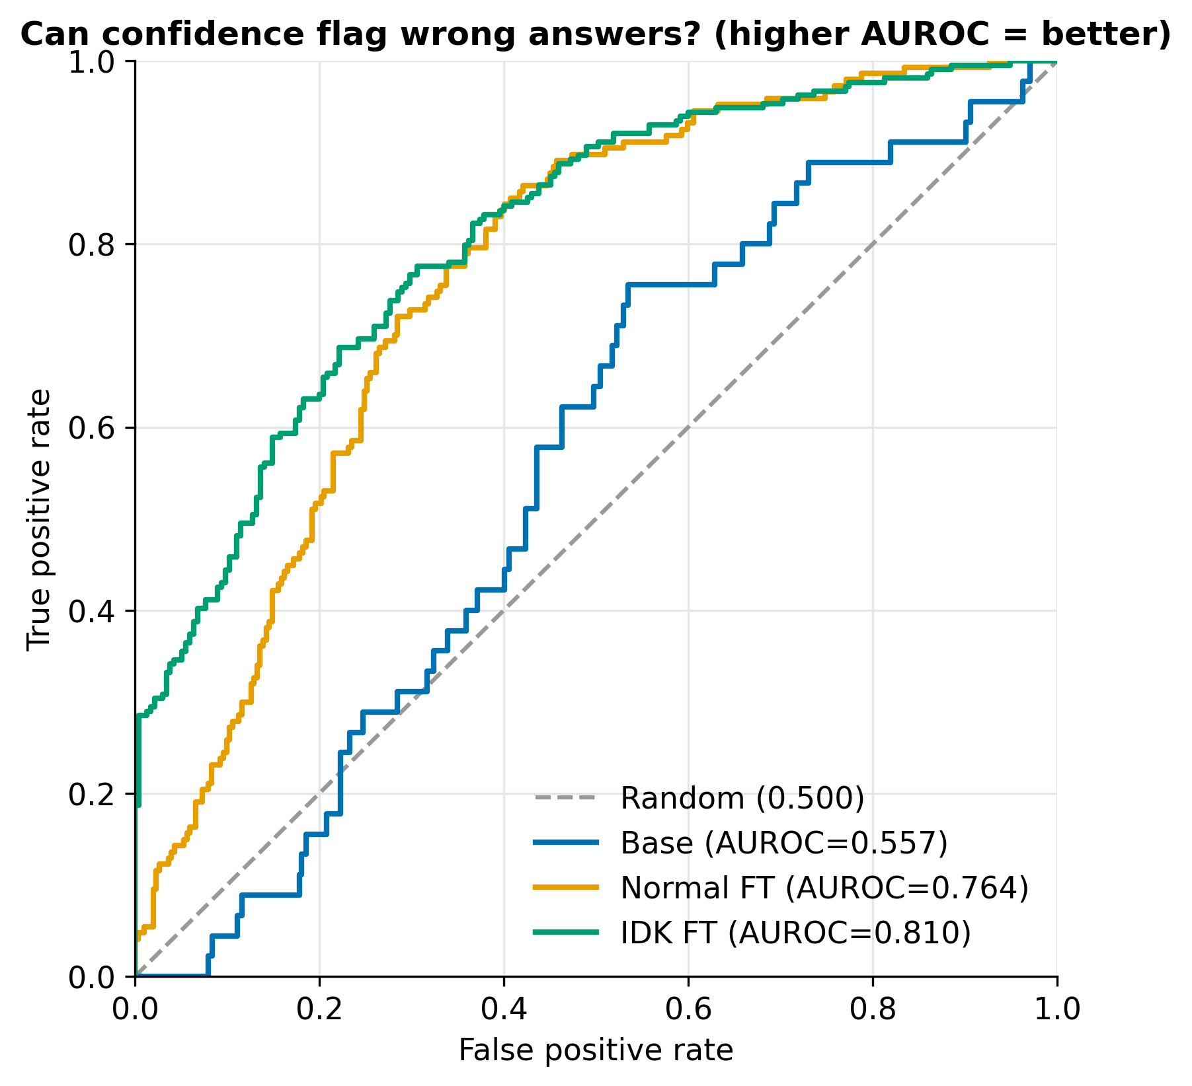
Fig. 5. ROC curves for discriminating correct from incorrect responses using sequence-level confidence.
  - Cost of Abstention: False Refusals
Training a model to abstain introduces a corresponding risk that it will also decline queries it is able to answer. This cost is quantified directly.
IDK FT refuses 15 of the 370 answerable queries, a false refusal rate of 4.1%. This is substantially lower than the base model's rate of 31.4% (116 false refusals) and only marginally higher than the 0% observed for Normal FT. Under the coverage criterion, answerable accuracy decreases from 0.451 to 0.408, a reduction of 4.3 percentage points corresponding to 16 fewer correct answers (167 → 151).
The magnitude of this reduction is informative, since the 16 lost correct answers closely match the number of false refusals. When only the answerable queries actually attempted by each model are considered, IDK FT is correct on 151 of 355 (42.5%) and Normal FT on 167 of 370 (45.1%). The similarity of these figures indicates that the cost arises predominantly from the model declining a small number of answerable queries, rather than from any general degradation in answer quality. The inclusion of abstention data therefore does not appear to have impaired the domain knowledge acquired during fine-tuning.
On balance, the trade-off strongly favours abstention-aware training. In exchange for 16 fewer correct answers, IDK FT avoids 68 fabricated ones, preventing approximately four hallucinations for every correct answer forgone. In a student-facing assistant, a fabricated answer regarding examination dates, credit requirements, or registration status may lead to consequential errors, whereas an unnecessary abstention at most redirects the student to VTOP or their proctor. The latter is a considerably less costly failure mode.
One factor marginally favours the baseline in this comparison. As noted in Section 5.1, 15 of the answerable test queries also appear in the training data of Normal FT but not in that of IDK FT. Normal FT's answerable accuracy may therefore be slightly overstated, and the true difference between the two systems may be smaller than 4.3 percentage points.
  - Ablation: Effect of Abstention Data
Since Normal FT and IDK FT share the same base model, answerable data, hyperparameters, and random seed, the comparison between them isolates the effect of the abstention data. Similarly, the comparison between the base model and Normal FT isolates the effect of domain adaptation. Table 4 presents both comparisons.
Table 4. Changes attributable to each stage. Arrows indicate the direction of improvement.
Metric | Domain adaptation (Base → Normal FT) | Abstention data (Normal FT → IDK FT)
Hallucination rate ↓ | +0.494 (0.506 → 1.000) | −0.861 (1.000 → 0.139)
IDK F1 ↑ | −0.333 | +0.840
False refusal rate ↓ | −0.314 | +0.041
Answerable accuracy ↑ | +0.224 | −0.043
Token F1 ↑ | +0.223 | +0.124
ECE ↓ | −0.214 | −0.104
Brier ↓ | −0.129 | −0.066
AUROC ↑ | +0.207 | +0.046

The two stages make complementary contributions. Domain adaptation accounts for most of the improvement in domain knowledge: it approximately doubles answerable accuracy, eliminates the base model's indiscriminate refusals, and yields the largest individual improvements in ECE, Brier score, and AUROC. In isolation, however, it eliminates abstention entirely and results in hallucination on every unanswerable query. The abstention data addresses precisely this deficiency, reducing the hallucination rate from 1.000 to 0.139 and providing further improvements in calibration and discrimination beyond those achieved through domain adaptation, at a cost of 4.1 percentage points in false refusals and 4.3 percentage points in answerable accuracy. Neither stage alone produces a model that is both knowledgeable and appropriately calibrated, whereas their combination does.
Two limitations of this ablation should be noted. First, only a single abstention ratio was evaluated, so the optimality of 15% cannot be established. A lower ratio might further reduce false refusals while retaining most of the reduction in hallucination, whereas a higher ratio might increase IDK recall at the cost of greater over-caution. Second, each configuration was trained with a single random seed. Characterising this trade-off across multiple ratios and estimating variance across seeds are natural directions for future work.
- Discussion
  - Interpretation
The results separate two effects that are easily conflated. Domain adaptation supplies knowledge: answerable accuracy doubles, the base model's indiscriminate refusals disappear, and most of the first-stage gain in ECE, Brier score and AUROC appears here. It also removes the one behaviour that protects a user from a fabricated answer. Supervised fine-tuning on question–answer pairs never shows the model a query that should be declined, so the learned policy is to answer every query. This is the training-time analogue of the guessing incentive described by Kalai et al. [22], and it is consistent with the reports that fine-tuning on new knowledge can raise hallucination [12,38]. Hence the standard fine-tune is better than the base model on every answerable-query metric and worse on the metric that matters most for safety.
Abstention data restores the missing behaviour with a small change to the training set. At a 15% share, the model refuses 18.5% of test queries, close to the true unanswerable share of 17.6%, so it has learned an appropriate frequency of refusal as well as the refusal itself. The 4.3-point drop in answerable accuracy is almost entirely explained by the 15 false refusals, and accuracy on the answerable queries that were attempted is essentially unchanged (42.5% against 45.1%). In this study, then, abstention training did not erode the knowledge acquired during domain adaptation.
The calibration gains should be read with the mechanism in mind. Abstention-aware training improves calibration mainly by turning confidently wrong answers into confidently correct abstentions (Section 6.2), not by improving the quality of the factual answers. This is still useful. Confidence becomes more informative exactly where a deployment threshold would be set: roughly a quarter of correct responses can be accepted at a high threshold with almost no incorrect ones, against about 5% for the standard fine-tune. But it is a different claim from "the model knows what it knows". The model reproduces a fixed phrase with near-certain token probabilities, so a high confidence on a refusal shows that the phrase was learned, not that a knowledge gap was recognised. Several unanswerable categories (personal records, real-time information, out-of-domain queries) can be recognised from surface features of the question, whereas non-existent entities and unsupported specifics require sensitivity to what the model actually knows. This study does not report results by category, so how much of the learned behaviour is surface pattern matching remains untested.
Finally, every system stays over-confident. Even IDK FT is correct in only about 19% of cases at a confidence near 0.65, and ECE remains 0.304. Abstention data improves calibration and discrimination, but it does not replace post-hoc recalibration. The two are complementary, since calibration of the remaining confidence mass can be fitted on a validation set once the model abstains sensibly.
For the application, the practical reading is as follows. A student-facing assistant that declines one in twenty-five answerable queries and fabricates on about one in seven unanswerable ones is a considerably safer system than one that answers everything, and its failure mode (redirecting the student to VTOP or a proctor) is cheap compared with a fabricated deadline or credit requirement.
  - Qualitative Error Analysis
The error profile of each system (Fig. 2) is more informative than any single aggregate, and the three systems fail in different ways.
Base model: over-caution without discrimination. Of its 155 refusals, 116 fall on answerable queries. These are generic disclaimers about access to institution-specific information, issued with little regard for whether the query can be answered, and the model's confidence on them is uninformative (AUROC 0.557). Its apparent recall on unanswerable queries is a by-product of refusing frequently, not of recognising what it cannot answer.
Standard fine-tune: uniform confident fabrication. All 79 unanswerable queries receive an answer, including those about individual student records, real-time schedules and non-existent courses, for which any specific answer is invented. The long tail of incorrect responses at confidence up to 0.95 (Section 6.3) is where these fabrications sit. A confidence threshold cannot remove them, because they look like correct answers to the model.
Abstention-aware fine-tune: two small, different error classes. The 11 missed abstentions are fabrications of the same kind as the standard fine-tune's, but their confidence is concentrated around 0.6, well below the peak of correct responses, so a moderate threshold can intercept many of them. The 15 false refusals behave differently. Because the refusal is one fixed phrase, it is emitted with very high confidence even when it is wrong. The roughly 15 incorrect responses in the 0.95–1.0 confidence bin match this count, and such errors cannot be found through confidence alone. They are better addressed through training (for example, a lower abstention share or hard answerable negatives) than through thresholding.
Answer quality on attempted queries. Of the 355 answerable queries that IDK FT attempted, 151 meet the coverage criterion, which leaves 204 attempts (57.5%) judged incorrect by lexical overlap. This figure combines several causes that the lexical metrics cannot separate: genuinely wrong facts (such as a wrong credit value or course code), partially correct answers, and valid paraphrases that the metric does not recognise. No manual annotation was carried out, so the split among these causes is not known. It should be understood as an upper bound on factual error and as the main motivation for retrieval and for stronger correctness checks.
  - Limitations
Several limitations qualify the conclusions.
- Single abstention ratio and single seed. Only the 0% and 15% mixtures were trained, each with one random seed. The optimality of 15% is not established, and differences of a few percentage points (such as the 4.3-point accuracy drop) cannot be separated from seed variance. No confidence intervals are reported.
- One model and one institution. All results come from Phi-3-mini and a single university's curriculum data. Generality to other small models, domains or languages is untested.
- Canonical abstention. Using one refusal string makes refusals easy to detect and measure, but it encourages the model to learn a phrase rather than a graded expression of uncertainty, and it inflates the confidence, exact-match and NLL figures of IDK FT for the reasons given in Section 6.2.
- Lexical correctness and refusal detection. Correctness relies on token-level F1 and a reference-coverage criterion, which mislabel valid paraphrases, and refusals are detected with a lexical pattern that misses some hedged responses. Hallucination is moreover defined only on unanswerable queries, so fabrication on answerable queries is not counted as hallucination.
- Unstratified split and test overlap. The partitions were random rather than stratified, so the unanswerable share varies across splits (14.9% in training, 17.6% in test), and 15 answerable test queries also appear in the standard fine-tune's training data, which slightly favours that baseline.
- Small test set. The test set contains 449 queries (79 unanswerable). ECE with ten bins is noisy at this size, and the reliability curves in sparsely populated bins should be read with care.
- Confidence signal. Only length-normalised token probability was evaluated. Sampling-based, verbalised and probe-based confidence were not compared, and no post-hoc recalibration was applied.
- Analysis protocol. The refusal metrics use 100 generated tokens and the calibration metrics 64, and the base model was prompted without a system prompt or in-context examples, which may understate what prompting alone could achieve.
- Conclusion and Future Work
This study examined whether the confidence calibration of a small language model can be improved, and its hallucination rate reduced, through the composition of its fine-tuning data alone. Phi-3-mini was fine-tuned with QLoRA for institutional question answering under a 4 GB VRAM budget, and three systems were compared: the base model, a standard domain fine-tune, and an abstention-aware fine-tune in which 15% of the training data consisted of abstention examples sharing a single canonical response.
Three principal conclusions emerge. First, standard domain fine-tuning is insufficient and, on unanswerable queries, increases hallucination. Fine-tuning on answerable data alone approximately doubled accuracy on answerable queries but eliminated the model's capacity to decline: the standard fine-tune answered all 79 unanswerable test queries, raising the hallucination rate from 0.506 for the base model to 1.000. Second, the controlled inclusion of abstention data substantially reduces hallucination. With 15% abstention examples, the hallucination rate fell to 0.139 and IDK F1 reached 0.840. The associated cost was limited to 15 false refusals among 370 answerable queries (4.1%) and a 4.3-percentage-point reduction in answerable accuracy, almost entirely attributable to those refusals rather than to degraded answer quality. Third, the same modification to the training data improved calibration and discrimination without any calibration-specific objective. ECE decreased from 0.622 (base) to 0.408 (standard fine-tuning) and 0.304 (abstention-aware fine-tuning), while AUROC increased from 0.557 to 0.764 and 0.810, with the largest gains concentrated in the high-confidence region where a deployment threshold would typically be set.
The analysis also identifies the limits of these findings. All systems remain over-confident across the full confidence range. Part of the calibration improvement derives from the model reproducing a fixed abstention phrase with high confidence, and the same mechanism renders some false refusals highly confident. The results are based on a single abstention ratio, a single random seed, one base model, and data from a single institution, and correctness is assessed using lexical-overlap measures that cannot always distinguish a valid paraphrase from an error.
These limitations suggest several directions for future work:
- Characterising the abstention-ratio trade-off. Training at a range of ratios (e.g., 5–30%), each with multiple random seeds, would establish how calibration, hallucination rate, and false refusals vary with the proportion of abstention data, and whether 15% lies near the optimum.
- Varied versus canonical abstentions. Training with varied, context-specific abstentions (e.g., directing the user to VTOP or a proctor) would indicate whether abstention can be learned as a graded expression of uncertainty rather than a memorised phrase, and how this affects the confidence assigned to refusals.
- Post-hoc recalibration and selective prediction. Temperature scaling fitted on the validation partition could reduce the residual over-confidence. A confidence threshold could then be tuned and evaluated using risk–coverage curves, establishing confidence-based filtering as an explicit second safeguard against hallucination.
- Alternative uncertainty signals. Comparing token-probability confidence with sampling-based semantic consistency, verbalised confidence, and lightweight probes of hidden representations would identify which signal is most effective for small models under strict computational constraints.
- More robust correctness assessment. NLI-based or LLM-as-judge evaluation, complemented by human assessment of a subset of responses, would reduce reliance on token overlap and clarify the proportion of responses marked incorrect that are in fact acceptable paraphrases.
- Integration with retrieval. Combining the abstention-aware model with retrieval over the curriculum documents could improve accuracy on answerable queries while preserving the ability to decline queries that no document addresses.
- Broader evaluation. Replicating the study with other small models (e.g., sub-4B variants of Llama, Qwen, or Gemma) and with data from other institutions would assess the generality of the findings, and examining calibration as curricula are revised across academic years would inform long-term maintenance of such systems.
Overall, the results indicate that a small, inexpensive model can be made measurably better calibrated and substantially less prone to hallucination within a narrow domain through a modest change to its training data, without modification of the training procedure. In student-facing applications, where a confident but incorrect answer regarding credits or deadlines can have real consequences, ensuring that a model's confidence reflects the reliability of its answers, and that it declines when it lacks the requisite knowledge, deserves as much attention as improving the answers themselves.
Acknowledgments. The authors thank their project guide and the School of Computer Science and Engineering, Vellore Institute of Technology, for guidance and for access to the curriculum documents used in this study.
Disclosure of Interests. The authors have no competing interests to declare that are relevant to the content of this article.

References
- Abdin, M., et al.: Phi-3 technical report: A highly capable language model locally on your phone. arXiv preprint arXiv:2404.14219 (2024)
- Biderman, D., et al.: LoRA learns less and forgets less. Transactions on Machine Learning Research (2024)
- Brahman, F., et al.: The art of saying no: Contextual noncompliance in language models. In: Advances in Neural Information Processing Systems (Datasets and Benchmarks Track) (2024)
- Brier, G.W.: Verification of forecasts expressed in terms of probability. Monthly Weather Review 78(1), 1–3 (1950)
- Cheng, Q., Sun, T., Liu, X., Zhang, W., Yin, Z., Li, S., Li, L., He, Z., Chen, K., Qiu, X.: Can AI assistants know what they don't know? In: Proceedings of the 41st International Conference on Machine Learning (ICML) (2024)
- Chow, C.K.: On optimum recognition error and reject tradeoff. IEEE Transactions on Information Theory 16(1), 41–46 (1970)
- Dettmers, T., Lewis, M., Shleifer, S., Zettlemoyer, L.: 8-bit optimizers via block-wise quantization. In: International Conference on Learning Representations (ICLR) (2022)
- Dettmers, T., Pagnoni, A., Holtzman, A., Zettlemoyer, L.: QLoRA: Efficient finetuning of quantized LLMs. In: Advances in Neural Information Processing Systems (NeurIPS) (2023)
- El-Yaniv, R., Wiener, Y.: On the foundations of noise-free selective classification. Journal of Machine Learning Research 11, 1605–1641 (2010)
- Feng, S., Shi, W., Wang, Y., Ding, W., Balachandran, V., Tsvetkov, Y.: Don't hallucinate, abstain: Identifying LLM knowledge gaps via multi-LLM collaboration. In: Proceedings of the 62nd Annual Meeting of the Association for Computational Linguistics (ACL) (2024)
- Geifman, Y., El-Yaniv, R.: Selective classification for deep neural networks. In: Advances in Neural Information Processing Systems (NeurIPS) (2017)
- Gekhman, Z., Yona, G., Aharoni, R., Eyal, M., Feder, A., Reichart, R., Herzig, J.: Does fine-tuning LLMs on new knowledge encourage hallucinations? In: Proceedings of the 2024 Conference on Empirical Methods in Natural Language Processing (EMNLP) (2024)
- Gunasekar, S., et al.: Textbooks are all you need. arXiv preprint arXiv:2306.11644 (2023)
- Guo, C., Pleiss, G., Sun, Y., Weinberger, K.Q.: On calibration of modern neural networks. In: Proceedings of the 34th International Conference on Machine Learning (ICML). PMLR, vol. 70, pp. 1321–1330 (2017)
- Houlsby, N., Giurgiu, A., Jastrzebski, S., Morrone, B., de Laroussilhe, Q., Gesmundo, A., Attariyan, M., Gelly, S.: Parameter-efficient transfer learning for NLP. In: Proceedings of the 36th International Conference on Machine Learning (ICML). PMLR, vol. 97, pp. 2790–2799 (2019)
- Hu, E.J., Shen, Y., Wallis, P., Allen-Zhu, Z., Li, Y., Wang, S., Wang, L., Chen, W.: LoRA: Low-rank adaptation of large language models. In: International Conference on Learning Representations (ICLR) (2022)
- Hu, X., Zhang, Y., Wei, S., Zhao, C., Li, Q., Li, B., Chen, F.: Small updates, big doubts: Does parameter-efficient fine-tuning enhance hallucination detection? arXiv preprint arXiv:2602.11166 (2026)
- Huang, L., et al.: A survey on hallucination in large language models: Principles, taxonomy, challenges, and open questions. ACM Transactions on Information Systems 43(2) (2025)
- Ji, Z., et al.: Survey of hallucination in natural language generation. ACM Computing Surveys 55(12), 1–38 (2023)
- Jiang, Z., Araki, J., Ding, H., Neubig, G.: How can we know when language models know? On the calibration of language models for question answering. Transactions of the Association for Computational Linguistics 9, 962–977 (2021)
- Kadavath, S., et al.: Language models (mostly) know what they know. arXiv preprint arXiv:2207.05221 (2022)
- Kalai, A.T., Nachum, O., Vempala, S.S., Zhang, E.: Why language models hallucinate. arXiv preprint arXiv:2509.04664 (2025)
- Kalai, A.T., Vempala, S.S.: Calibrated language models must hallucinate. In: Proceedings of the 56th Annual ACM Symposium on Theory of Computing (STOC) (2024)
- Kamath, A., Jia, R., Liang, P.: Selective question answering under domain shift. In: Proceedings of the 58th Annual Meeting of the Association for Computational Linguistics (ACL) (2020)
- Kapoor, S., et al.: Large language models must be taught to know what they don't know. In: Advances in Neural Information Processing Systems (NeurIPS) (2024)
- Kuhn, L., Gal, Y., Farquhar, S.: Semantic uncertainty: Linguistic invariances for uncertainty estimation in natural language generation. In: International Conference on Learning Representations (ICLR) (2023)
- Lester, B., Al-Rfou, R., Constant, N.: The power of scale for parameter-efficient prompt tuning. In: Proceedings of the 2021 Conference on Empirical Methods in Natural Language Processing (EMNLP) (2021)
- Lewis, P., et al.: Retrieval-augmented generation for knowledge-intensive NLP tasks. In: Advances in Neural Information Processing Systems (NeurIPS) (2020)
- Li, X.L., Liang, P.: Prefix-tuning: Optimizing continuous prompts for generation. In: Proceedings of the 59th Annual Meeting of the Association for Computational Linguistics (ACL), pp. 4582–4597 (2021)
- Lin, S., Hilton, J., Evans, O.: TruthfulQA: Measuring how models mimic human falsehoods. In: Proceedings of the 60th Annual Meeting of the Association for Computational Linguistics (ACL), pp. 3214–3252 (2022)
- Malinin, A., Gales, M.: Uncertainty estimation in autoregressive structured prediction. In: International Conference on Learning Representations (ICLR) (2021)
- Manakul, P., Liusie, A., Gales, M.J.F.: SelfCheckGPT: Zero-resource black-box hallucination detection for generative large language models. In: Proceedings of the 2023 Conference on Empirical Methods in Natural Language Processing (EMNLP) (2023)
- Mangrulkar, S., Gugger, S., Debut, L., Belkada, Y., Paul, S., Bossan, B.: PEFT: State-of-the-art parameter-efficient fine-tuning methods. https://github.com/huggingface/peft (2022)
- Naeini, M.P., Cooper, G.F., Hauskrecht, M.: Obtaining well calibrated probabilities using Bayesian binning. In: Proceedings of the AAAI Conference on Artificial Intelligence, vol. 29 (2015)
- OpenAI: GPT-4 technical report. arXiv preprint arXiv:2303.08774 (2023)
- Paszke, A., et al.: PyTorch: An imperative style, high-performance deep learning library. In: Advances in Neural Information Processing Systems (NeurIPS) (2019)
- Pedregosa, F., et al.: Scikit-learn: Machine learning in Python. Journal of Machine Learning Research 12, 2825–2830 (2011)
- Porwal, S., Prasath S, S., Bi, X., Scandlen, M.: Evaluating hallucinations in domain-adapted large language models. arXiv preprint arXiv:2606.07521 (2026)
- Rajpurkar, P., Jia, R., Liang, P.: Know what you don't know: Unanswerable questions for SQuAD. In: Proceedings of the 56th Annual Meeting of the Association for Computational Linguistics (ACL), pp. 784–789 (2018)
- Rajpurkar, P., Zhang, J., Lopyrev, K., Liang, P.: SQuAD: 100,000+ questions for machine comprehension of text. In: Proceedings of the 2016 Conference on Empirical Methods in Natural Language Processing (EMNLP), pp. 2383–2392 (2016)
- Tian, K., Mitchell, E., Zhou, A., Sharma, A., Rafailov, R., Yao, H., Finn, C., Manning, C.D.: Just ask for calibration: Strategies for eliciting calibrated confidence scores from language models fine-tuned with human feedback. In: Proceedings of the 2023 Conference on Empirical Methods in Natural Language Processing (EMNLP) (2023)
- Wen, B., Yao, J., Feng, S., Xu, C., Tsvetkov, Y., Howe, B., Wang, L.L.: Know your limits: A survey of abstention in large language models. Transactions of the Association for Computational Linguistics (2025)
- von Werra, L., et al.: TRL: Transformer reinforcement learning. https://github.com/huggingface/trl (2020)
- Wolf, T., et al.: Transformers: State-of-the-art natural language processing. In: Proceedings of the 2020 Conference on Empirical Methods in Natural Language Processing: System Demonstrations, pp. 38–45 (2020)
- Xiong, M., Hu, Z., Lu, X., Li, Y., Fu, J., He, J., Hooi, B.: Can LLMs express their uncertainty? An empirical evaluation of confidence elicitation in LLMs. In: International Conference on Learning Representations (ICLR) (2024)
- Yang, Y., Chern, E., Qiu, X., Neubig, G., Liu, P.: Alignment for honesty. In: Advances in Neural Information Processing Systems (NeurIPS) (2024)
- Zhang, C., Zhu, Z., Wei, Y., Tian, B., Liu, J., Wang, H., Wang, X., Liu, Y.: Confidence-calibrated small-large language model collaboration for cost-efficient reasoning. arXiv preprint arXiv:2603.03752 (2026)
- Zhang, H., Diao, S., Lin, Y., Fung, Y.R., Lian, Q., Wang, X., Chen, Y., Ji, H., Zhang, T.: R-Tuning: Instructing large language models to say 'I don't know'. In: Proceedings of the 2024 Conference of the North American Chapter of the Association for Computational Linguistics (NAACL) (2024)

