Phase-2: Org Setup & Configuration

**Project Title**:

**Expense On a Page: An expense approval & insight system.  
*Industry:*** Finance / Corporate Expense Management.  
***Target User:*** Employees, Managers, and Finance Teams.

**Salesforce Editions**

-*Salesforce Developer Edition*

**Company Profile Setup**

Setting up the org for the following company and giving the important information

* 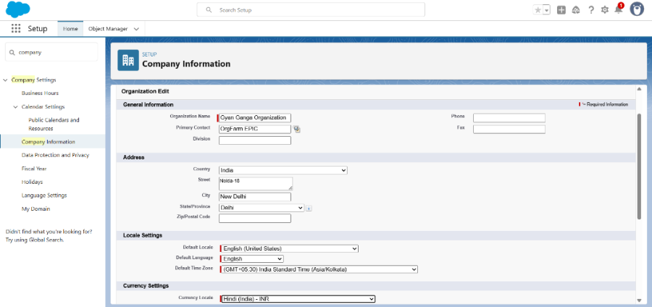Adding Company information such as *Company Name, address, Default currency, primary contact.*

**Business Hours & Holidays**

Setting up the working hours for the user and holidays for them.

* 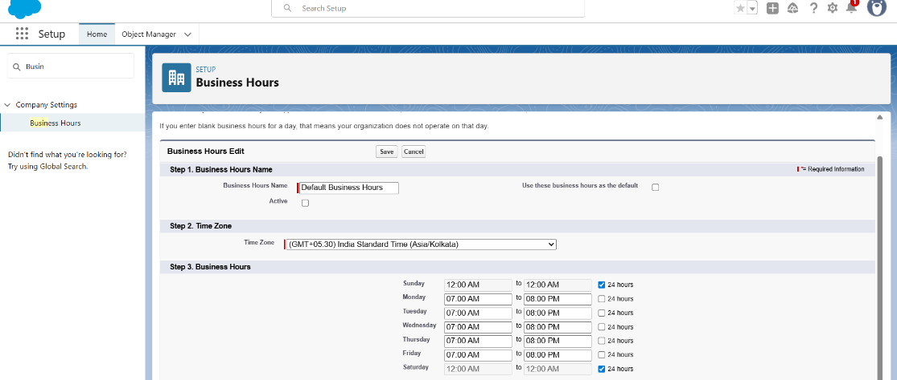Adding the business hours with Name: Default Business Hours.
* 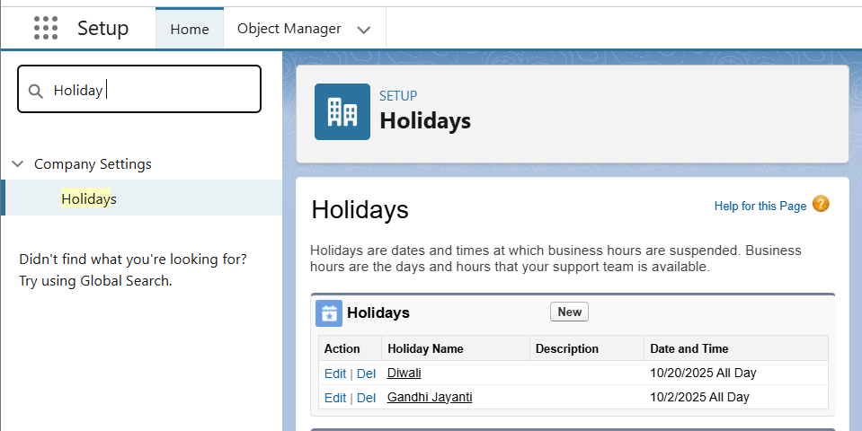Adding Important public Holidays from time to time.

**Fiscal Year Settings**

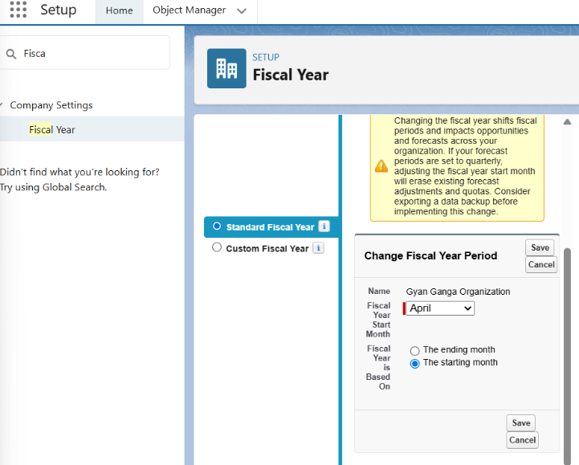Setting up the fiscal year for the company (in this case keeping it default).

**Profile:**

Creating the necessary profile needed

* Cloning Standard User to make a profile *Expense User Profile*.

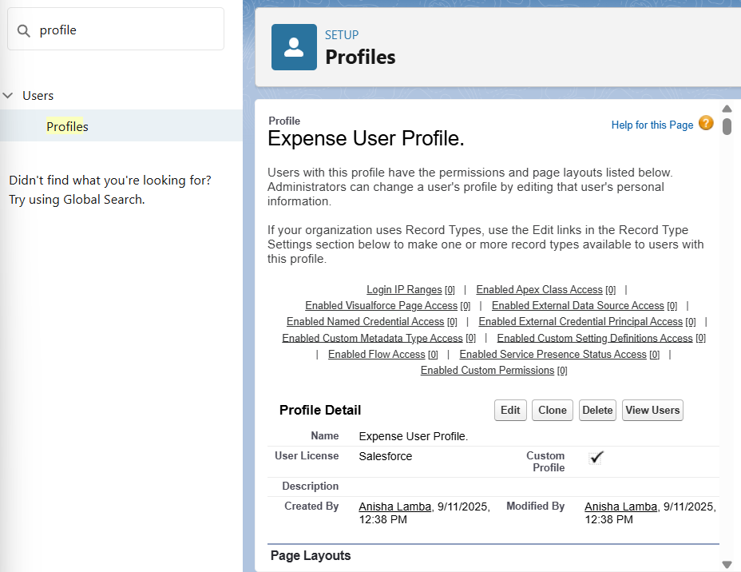

* 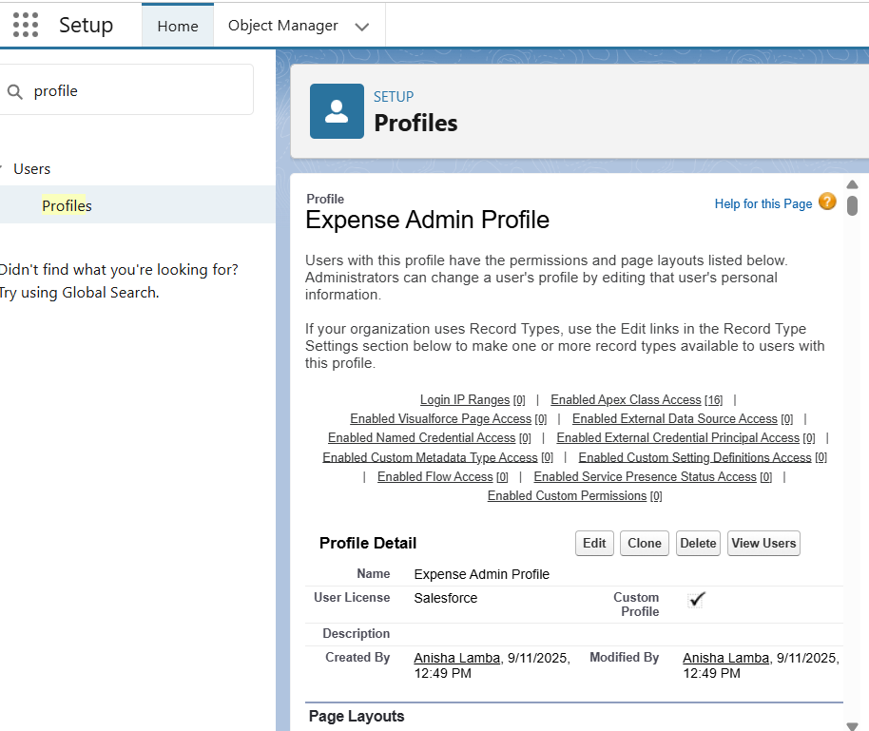Cloning System Administrator to make a profile *Expense Admin Profile.*

**Role**

Entering the Role Hierarchy by *CEO >> Regional Head >> Manager >> Employee*

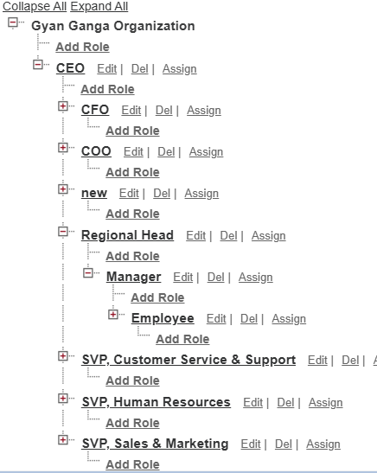

**User Setup & Licenses**

Adding the necessary users i.e. all the stakeholder.

* 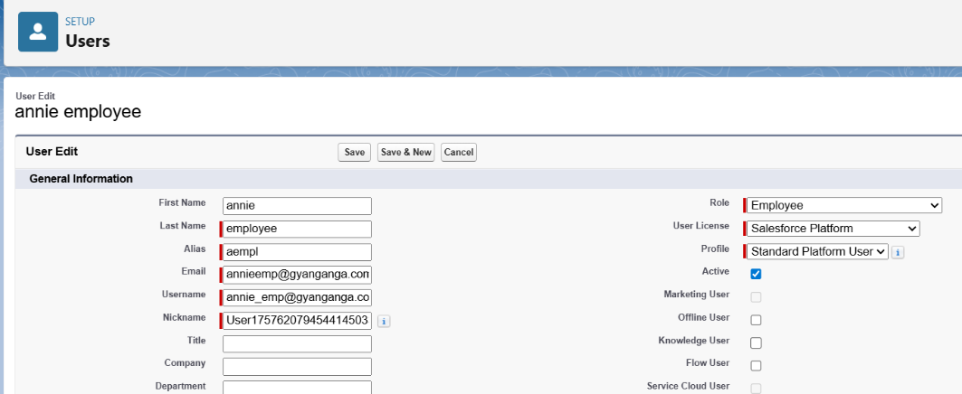Adding an employee user: [annie_emp@gyanganga.com](mailto:annie_emp@gyanganga.com)
* 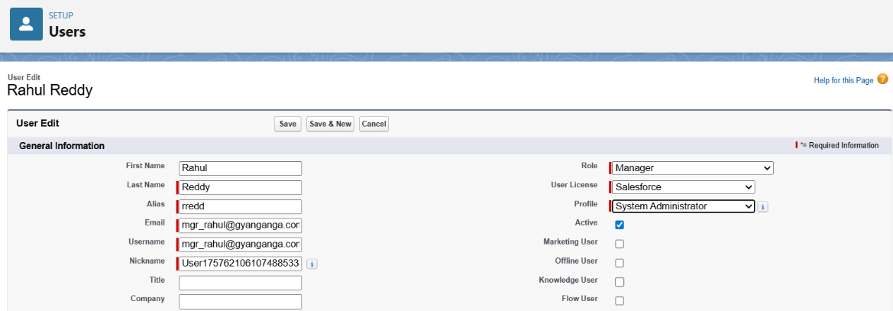Adding a manager user: mgr_Rahul@gyanganga.com
* 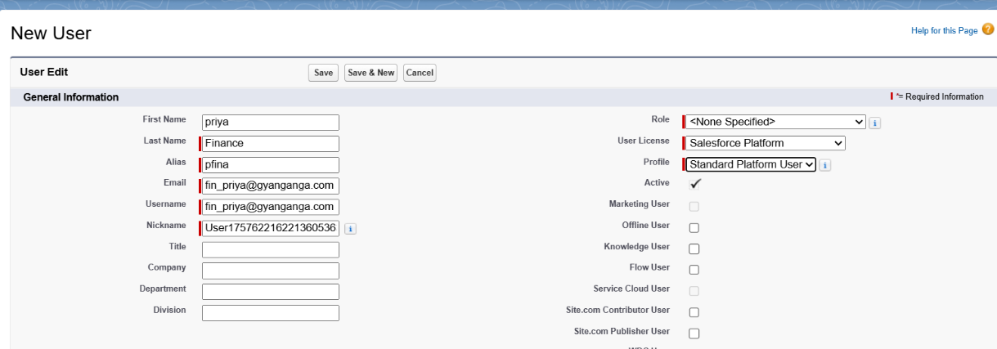Adding a Finance User: [fin_priya@gyanganga.com](mailto:fin_priya@gyanganga.com)

**Permission Sets**

Creating a new permission set in the org that give permission to *Manager* and *Finance Team* only to approve.  
Name: *Expense_Approver*

* 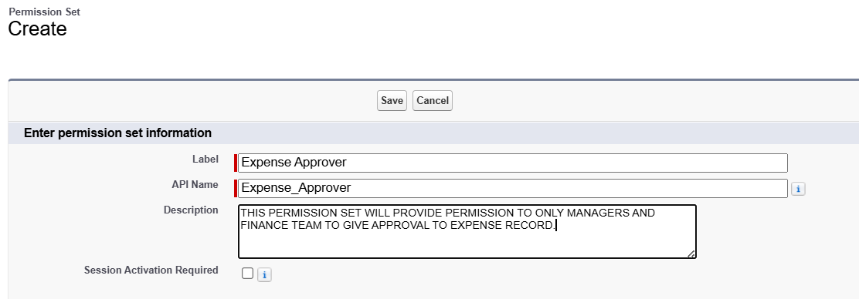Creating a Permission Set.
* 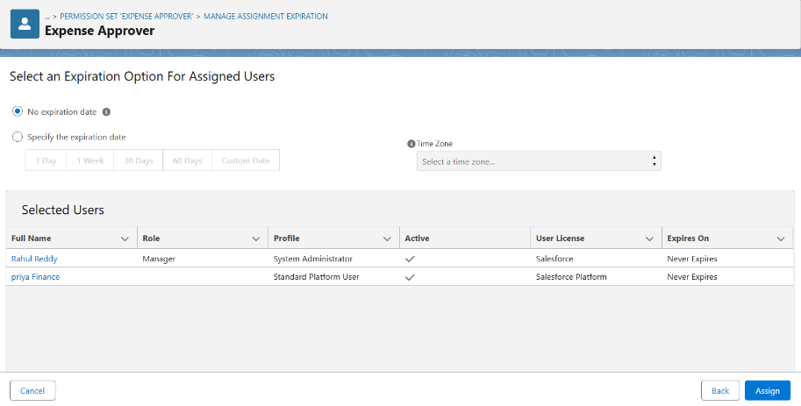Assigning the Managers and Finance team to the Permission Set.

**OWD (Org Wide Default)**

This has to be done in the Phase 3, as the OWD setting are needed to be applied on an object which will be implemented in next phase of the project.

**Sharing Rule**

This has to be done in the Phase 3 as well considering it has to be implemented on an object.

**Login Access Policies**

Setting up the same Login hours for each of the Profile same to-

* prevent them from accessing the org after and before login.
* 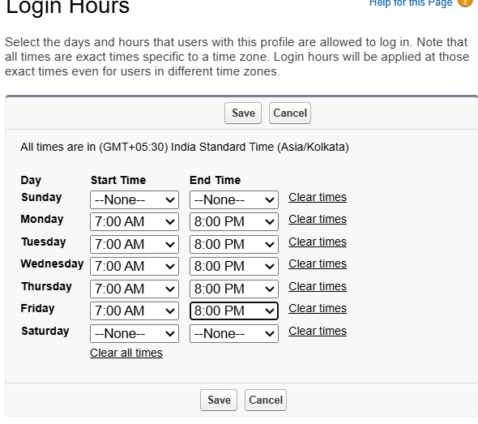in order to maintain the privacy of the data and keep the org secure.

**Dev Org Setup**

* To implement the following project a *Salesforce Developer Edition org* was setup.
* Made a *GitHub Repository for source control.*
* Setting up the *VS Code and SFDX* for the implementation of *the LWC Component for development.*