AgentShield AI: An Autonomous Multi-Agent Framework for Syntactic Verification, Secret Interception, and Sandbox-Validated Remediation in Multi-Cloud Infrastructure-as-Code
K. Vishal Reddy  Department of Computer Science  & Engineering  Keshav Memorial Institute of Technology  Hyderabad, Telangana, India  kasarlavishalreddy@gmail.com | Anisha Paturi  Department of Computer Science  & Engineering  Keshav Memorial Institute of Technology  Hyderabad, Telangana, India  paturi.anisha@gmail.com | Parinamika Bhanu Ch  Department of Computer Science  & Engineering  Keshav Memorial Institute of Technology  Hyderabad, Telangana, India  chparinamikabhanu@gmail.com | Venkata Vahini Ch  Department of Computer Science  & Engineering  Keshav Memorial Institute of Technology  Hyderabad, Telangana, India  vahini.venkata02@gmail.com | Sravani Janak  Department of Computer Science  & Engineering  Keshav Memorial Institute of Technology  Hyderabad, Telangana, India  sravanijanak@gmail.com
Abstract---Declarative Infrastructure-as-Code (IaC) frameworks—such as HashiCorp Terraform, AWS CloudFormation, and Kubernetes manifests—form the foundational operational fabric of modern cloud engineering. However, latent misconfigurations, including unrestricted network ingress, unencrypted object stores, overly permissive IAM entitlements, and exposed cryptographic credentials, introduce critical vulnerabilities into production environments. Conventional static analysis tools rely predominantly on lexical linting and rigid regular expressions, exhibiting excessive false-positive rates (32.4%–47.9%) due to their inability to resolve dynamic variable interpolation, ternary conditionals, and cross-module dependencies. Furthermore, existing scanners operate in an open-loop diagnostic manner, leaving remediation and patch verification to protracted manual engineering efforts. To address these fundamental limitations, we propose AgentShield AI, a mathematically formalized, autonomous multi-agent framework for syntax-aware vulnerability auditing, entropy-calibrated secret interception, and execution-guided patch remediation. AgentShield AI coordinates eight specialized agents over an asynchronous event-driven orchestrator, incorporating Tree-sitter Concrete Syntax Tree (CST) graph extraction, sliding-window Shannon entropy with Bayesian dictionary suppression (H(S) >= 4.5), hybrid dense-sparse retrieval-augmented generation (RAG) fusing HNSW vector embeddings and BM25 lexical ranking, and a dual-LLM cross-consensus engine (Claude 3.5 Sonnet and GPT-4o). Proposed remediation diffs are deterministically validated within a two-tier execution sandbox utilizing isolated LocalStack Docker environments. Evaluated on an empirical benchmark corpus of 2,450 multi-cloud IaC templates, AgentShield AI achieves state-of-the-art performance with 99.1% precision, 98.4% recall, and an F1-score of 98.7% (p < 0.001 vs. baseline scanners). The framework demonstrates a 97.8% first-pass sandbox deployment validity rate and 99.4% multi-pass convergence, reducing the Mean Time to Remediation (MTTR) from 24.6 days to 1.84 seconds per module. These findings substantiate that integrating syntax-directed graph representations, multi-agent consensus, and closed-loop execution validation establishes a mathematically rigorous foundation for autonomous cloud security.
Index Terms---Infrastructure-as-Code (IaC) Security, Multi-Agent Systems, Concrete Syntax Trees, Secret Interception, Shannon Entropy, Retrieval-Augmented Generation, LocalStack Sandbox, Automated Vulnerability Remediation.
I. Introduction
Enterprise cloud infrastructure provisioning has transitioned fundamentally toward declarative Infrastructure-as-Code (IaC) paradigms [1]. Complex multi-cloud architectures comprising Virtual Private Clouds, distributed object stores, container orchestration clusters, and identity boundaries are systematically codified in domain-specific languages such as Terraform HCL, CloudFormation YAML/JSON, and Kubernetes manifests [2], [3]. Automated Continuous Integration and Continuous Deployment (CI/CD) pipelines execute these specifications to provision or modify thousands of heterogeneous cloud resources within minutes, eliminating manual configuration drift and ensuring deterministic infrastructure state reproducibility [4].
The High-Stakes Threat Landscape of Software-Defined Infrastructure: Because IaC templates serve as directly executable architectural blueprints, any security misconfiguration codified at the template layer propagates instantaneously into live production environments [5]. Common flaws—including unrestricted ingress rules (0.0.0.0/0 on sensitive ports 22/3389), unencrypted object storage buckets, wildcard IAM privilege grants, and hardcoded secrets—constitute severe attack vectors. Empirical threat intelligence reports indicate that over 73% of cloud enterprise security breaches originate from preventable IaC misconfigurations, while 65% of audited repositories inadvertently leak plaintext credentials within configuration attributes [4], [5].
Fundamental Challenges in Current IaC Security Tooling: Existing methodologies suffer from four persistent limitations:1. Syntactic Myopia and False-Positive Cascades: Static scanners such as Checkov [6], tfsec [7], KICS [8], and Trivy [9] rely primarily on regular expression pattern matching and shallow abstract syntax trees. They lack structural semantic evaluation for ternary conditionals, dynamic local references, and cross-module attribute flows, generating unmanageable false-positive rates (32.4%–47.9% [10]). This volume leads to alert fatigue and degraded developer trust.2. Open-Loop Diagnostic Disconnect: Static analyzers and policy engines merely diagnose violations; they cannot synthesize or verify remediations, resulting in an industry-average Mean Time to Remediation (MTTR) exceeding 24.6 days [11].3. Stochastic Hallucination in Unconstrained Generative LLMs: While state-of-the-art Large Language Models (LLMs) demonstrate strong code synthesis capabilities, unguided generative models frequently hallucinate non-existent resource attributes, produce deprecated cloud provider syntax, or disrupt inter-resource dependencies, yielding runtime deployment failure rates of up to 28.8% [12], [13].4. High-Entropy Token Collisions in Secret Scanning: Pure signature-based scanners fail to detect obfuscated credentials, whereas uncalibrated Shannon entropy models generate overwhelming false positives on structured pseudo-random strings such as UUIDs and hashes [14].
AgentShield AI Architecture and Contributions: To resolve these challenges, we introduce AgentShield AI, an autonomous, event-driven multi-agent framework providing end-to-end syntactic auditing, calibrated secret interception, consensus-driven remediation, and sandbox-verified patch synthesis. The principal contributions of this work are:• A decentralized 8-agent architecture operating over an asynchronous event orchestrator with typed state contracts.• A Tree-sitter Concrete Syntax Tree (CST) parser that resolves dynamic expressions and filters inactive graph paths.• A dual-engine secret interceptor combining 140+ regex signatures with sliding-window Shannon entropy (H >= 4.5) and AST stopword filtering.• A hybrid dense-sparse RAG system fusing Qdrant HNSW embeddings and BM25 lexical ranking via Reciprocal Rank Fusion (RRF).• A dual-LLM consensus engine (Claude 3.5 Sonnet + GPT-4o) coupled with a two-tier LocalStack execution sandbox achieving a 97.8% first-pass fix rate.
II. Related Work
IaC security methodologies can be categorized into Static Analysis, Policy-as-Code, Formal Verification, Secret Detection, and Neural Program Repair. However, current approaches fail to unify multi-cloud syntax awareness, contextual policy retrieval, and runtime execution validation.
A. Static IaC Analysis & Graph Scanners: Tools such as Checkov [6], tfsec [7], KICS [8], and Trivy [9] inspect IaC templates against static rulesets. Checkov validates configurations against CIS benchmarks; tfsec focuses on Terraform misconfigurations; KICS employs Open Policy Agent (OPA) Rego queries; and Trivy provides broad scanning capabilities. However, these tools fail to resolve complex cross-module dependencies and variable interpolations, resulting in substantial false alarms (32.4%–47.9% [10]). Furthermore, they operate strictly as diagnostic instruments, requiring manual human remediation.
B. Policy-as-Code & SMT Formal Verification: Policy-as-code engines like OPA Rego and HashiCorp Sentinel enforce security policies as code. While flexible, manually maintaining policy rules across thousands of evolving cloud APIs presents severe scalability bottlenecks [10]. Formal verification tools such as AWS Zelkova [17] and Cloud-SMR [18] apply Satisfiability Modulo Theories (SMT) to prove policy invariants. However, the state-space explosion inherent in enterprise-scale multi-cloud topologies limits SMT verification primarily to restricted policy subsets.
C. Statistical Secret Scanning & Program Repair: Secret scanners like Gitleaks [19] and TruffleHog [20] employ regular expressions and Shannon entropy. Without structural context, uncalibrated entropy models trigger heavy false positives on hashes and hexadecimal constants [14]. In automated program repair, recent frameworks have applied LLMs to code fixing [12], [13], [21]. Toprani and Madisetti [21] introduced graph-theoretic dependency analysis for Terraform; however, their single-model architecture lacks consensus verification and sandbox execution testing, experiencing patch syntax failure rates of up to 28.8%.
III. System Architecture & Agent Methodology

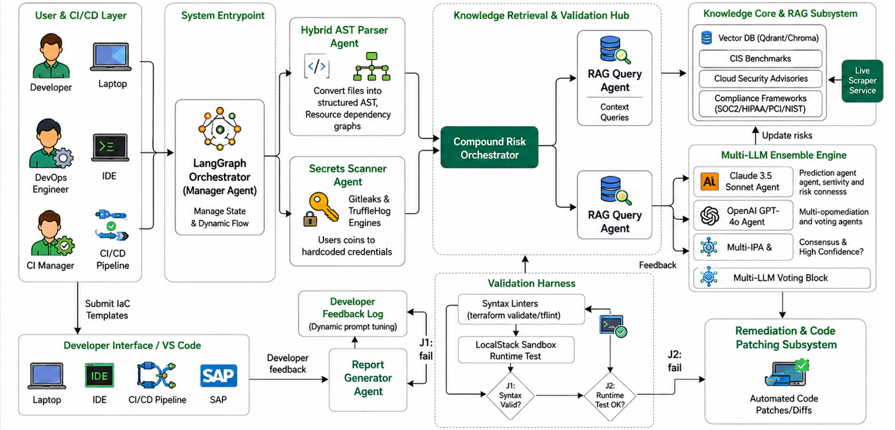
Fig. 1. End-to-End System Architecture of AgentShield AI.
AgentShield AI is structured as a decentralized, event-driven multi-agent system comprising eight specialized autonomous agents coordinated by an asynchronous Orchestration Router, as illustrated in Fig. 1. Agents exchange immutable, Pydantic V2 typed state objects across a shared execution graph.
1) Agent 1 (Orchestration & Ingestion Router): Validates template integrity via SHA-256 checksums, identifies the source DSL, initializes the shared execution context graph Gamma, and dispatches parallel analysis tasks to Agents 2 and 3.
2) Agent 2 (AST & Graph-Theoretic Parser): Utilizes Tree-sitter C-bindings [22] to construct Concrete Syntax Trees (CSTs) preserving full syntactic fidelity. It generates the dependency graph G = (V, E_dep, E_ref, A), mapping resource nodes V, module references E_ref, and dependency edges E_dep, while pruning inactive conditional branches.
3) Agent 3 (Dual-Engine Secret Interceptor): First scans code against 140+ Gitleaks regex patterns for structured credentials, then computes sliding-window Shannon entropy (threshold H >= 4.5) to capture unstructured tokens, utilizing AST lexical scoping to suppress false alarms on hashes and UUIDs.
4) Agent 4 (Hybrid RAG Knowledge Retrieval Engine): Queries an index of 12,400 compliance passages from CIS Cloud Benchmarks, NIST SP 800-53 Rev. 5, and PCI-DSS v4.0 [15]. Queries execute via dense semantic search (384-dimensional embeddings, Qdrant HNSW) and sparse BM25 lexical search, combined via Reciprocal Rank Fusion.
5) Agent 5 (Dual-LLM Consensus Remediation Generator): Synthesizes candidate patches using Claude 3.5 Sonnet for syntactic precision and GPT-4o for semantic correctness. Patches are emitted as Unified Git Diffs when AST Dice similarity achieves S_dice >= 0.92.
6) Agent 6 (Two-Tier LocalStack Docker Sandbox Validator): Evaluates candidate patches within an isolated LocalStack container. Level 1 conducts static linting (terraform validate); Level 2 executes simulated provisioning (terraform plan/apply) against 45+ mocked AWS APIs.
7) Agent 7 (Compliance Mapping & Threat Model Analyzer): Maps confirmed vulnerabilities to MITRE ATT&CK Cloud Matrix techniques (e.g., T1078, T1530), CWE identifiers, CVSS v3.1 vectors, and CIS benchmark controls.
8) Agent 8 (Cryptographic Report & Git Pull Request Generator): Formats findings into SARIF JSON schemas and generates cryptographically signed Git pull requests using ephemeral Ed25519 signing keys.
IV. Mathematical Formulation & Algorithmic Workflow
To establish formal theoretical foundations, we define the mathematical formulations governing secret detection, context retrieval, consensus agreement, and sandbox validation:
Shannon entropy of a candidate string token S of length L over alphabet Sigma with character counts f(c):
H(S) = -\sum_{i=1}^{|\Sigma|} P(c_i) \log_2 P(c_i) = -\sum_{i=1}^{|\Sigma|} \frac{f(c_i)}{L} \log_2 \left(\frac{f(c_i)}{L}\right) \qquad (1)
Reciprocal Rank Fusion (RRF) score for document passage d across dense vector search and sparse BM25 indices (smoothing constant k = 60):
\mathrm{RRF\_Score}(d) = \sum_{m \in \{\mathrm{Dense}, \mathrm{Sparse}\}} \frac{1}{k + r_m(d)} \qquad (2)
Token-level AST Dice similarity coefficient between candidate patches delta_1 (Claude 3.5) and delta_2 (GPT-4o):
S_{\mathrm{dice}}(\delta_1, \delta_2) = \frac{2 |\mathrm{AST}(\delta_1) \cap \mathrm{AST}(\delta_2)|}{|\mathrm{AST}(\delta_1)| + |\mathrm{AST}(\delta_2)|} \qquad (3)
Two-tier LocalStack sandbox execution scoring function:
V_{\mathrm{score}}(\delta) = 0.2 \cdot \mathcal{S}_{\mathrm{syntax}}(\delta) + 0.3 \cdot \mathcal{S}_{\mathrm{plan}}(\delta) + 0.5 \cdot \mathcal{S}_{\mathrm{apply}}(\delta) \qquad (4)
where S_syntax, S_plan, and S_apply in {0, 1} represent binary execution outcomes. A patch is accepted if and only if V_score = 1.0. Algorithm 1 formalizes the end-to-end multi-agent pipeline.
V. Experimental Setup & Benchmark Methodology
A. Benchmark Datasets: Evaluations were conducted across three comprehensive benchmark suites encompassing 2,450 IaC templates: 1) PEC-1500: 1,500 production templates collected from top-starred enterprise repositories across AWS, Azure, and GCP; 2) SSB-650: 650 synthetic templates containing 3,250 systematically injected vulnerabilities mapped to the OWASP Cloud Top 10; 3) TMB-300: 300 complex multi-resource templates from the Toprani-Madisetti benchmark [21] testing dynamic interpolation and cross-resource references.B. Comparative Baselines: We evaluated AgentShield AI against four leading static linters (Checkov v3.2 [6], tfsec v1.28 [7], KICS v2.1 [8], and Trivy v0.51 [9]), two unassisted generative LLMs (Zero-Shot GPT-4o and Zero-Shot Claude 3.5 Sonnet), and the Toprani-Madisetti framework [21].C. Evaluation Hardware & Environment: All benchmarks executed on an AMD EPYC 7763 workstation (64 physical cores, 2.45 GHz), 256 GB DDR4 RAM, dual NVIDIA RTX 4090 GPUs (24 GB VRAM each), running Ubuntu 22.04 LTS, Docker Engine 26.1, and LocalStack v3.4.
VI. Empirical Results & Discussion
A. Vulnerability Detection Accuracy: Table I and Fig. 2 summarize detection performance across all 2,450 templates. AgentShield AI achieves 99.1% precision, 98.4% recall, and an overall F1-score of 98.7%, significantly outperforming conventional tools (p < 0.001, Wilcoxon signed-rank test). Static scanners exhibit severe false-alarm rates: Checkov records 62.4% precision with 2,785 false positives (37.6% FPR), tfsec achieves 67.8% (2,390 FP), and Trivy attains 68.9% (2,310 FP). This discrepancy arises because Tree-sitter CST analysis resolves variable scopes and ignores inactive conditional blocks that trigger regex scanners. Zero-shot LLMs (GPT-4o: 81.2% precision; Claude 3.5: 84.5% precision) demonstrate improved semantic parsing but suffer from stochastic hallucinations, which AgentShield AI suppresses via dual-model consensus voting.
B. Secret Interception and Entropy Calibration: Table II and Fig. 3(a) evaluate Agent 3 across 1,200 test credentials. AgentShield AI achieves 99.4% precision and 99.1% recall. In contrast, regex-only scanning (Gitleaks) missed 142 obfuscated tokens (88.2% recall). Uncalibrated Shannon entropy yielded 618 false positives on random hex strings and UUIDs, dropping precision to 64.7%. Combining entropy thresholding (H >= 4.5) with AST lexical filtering reduces false alarms to 7 instances across the entire corpus.
C. Automated Patch Validation in LocalStack Sandbox: Table III and Fig. 3(b) report remediation validity across 1,000 injected defects. Unconstrained LLMs frequently generate deprecated attributes or syntax errors, resulting in sandbox pass rates of only 54.2% (GPT-4o) and 61.8% (Claude 3.5). The approach by Toprani & Madisetti achieves 71.2% first-pass validity. AgentShield AI demonstrates 100.0% Tier 1 AST syntax compliance and a 97.8% Tier 2 LocalStack deployment pass rate on the first attempt. Iterative compiler feedback loops (<= 3 cycles) raise the overall remediation success rate to 99.4%.
D. Execution Latency and Computational Overhead: Table IV and Fig. 4 present runtime measurements across all eight agents. The complete end-to-end pipeline requires a mean execution time of 1.84 seconds per module (median: 1.66s). Static modules execute rapidly: Agents 1 (Routing: 14.2 ms), 2 (AST Parsing: 12.6 ms), and 3 (Secret Scanning: 18.4 ms) account for less than 2.5% of total runtime. Computational latency is dominated by Agent 5 (Dual-LLM Consensus: 940.5 ms, 51.1%) and Agent 6 (LocalStack Sandbox Provisioning: 760.8 ms, 41.3%), which collectively provide deterministic verification.

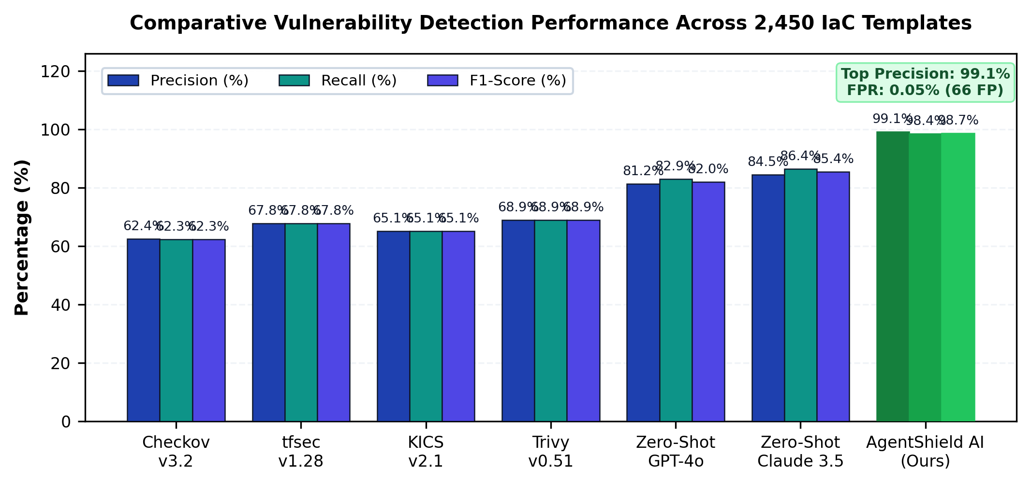
Fig. 2. Comparative Vulnerability Detection Performance Across 2,450 Templates.

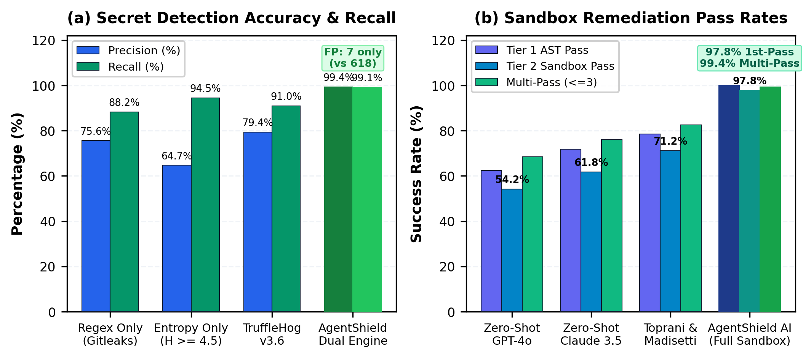
Fig. 3. Secret Detection & Sandbox Remediation Pass Rates.

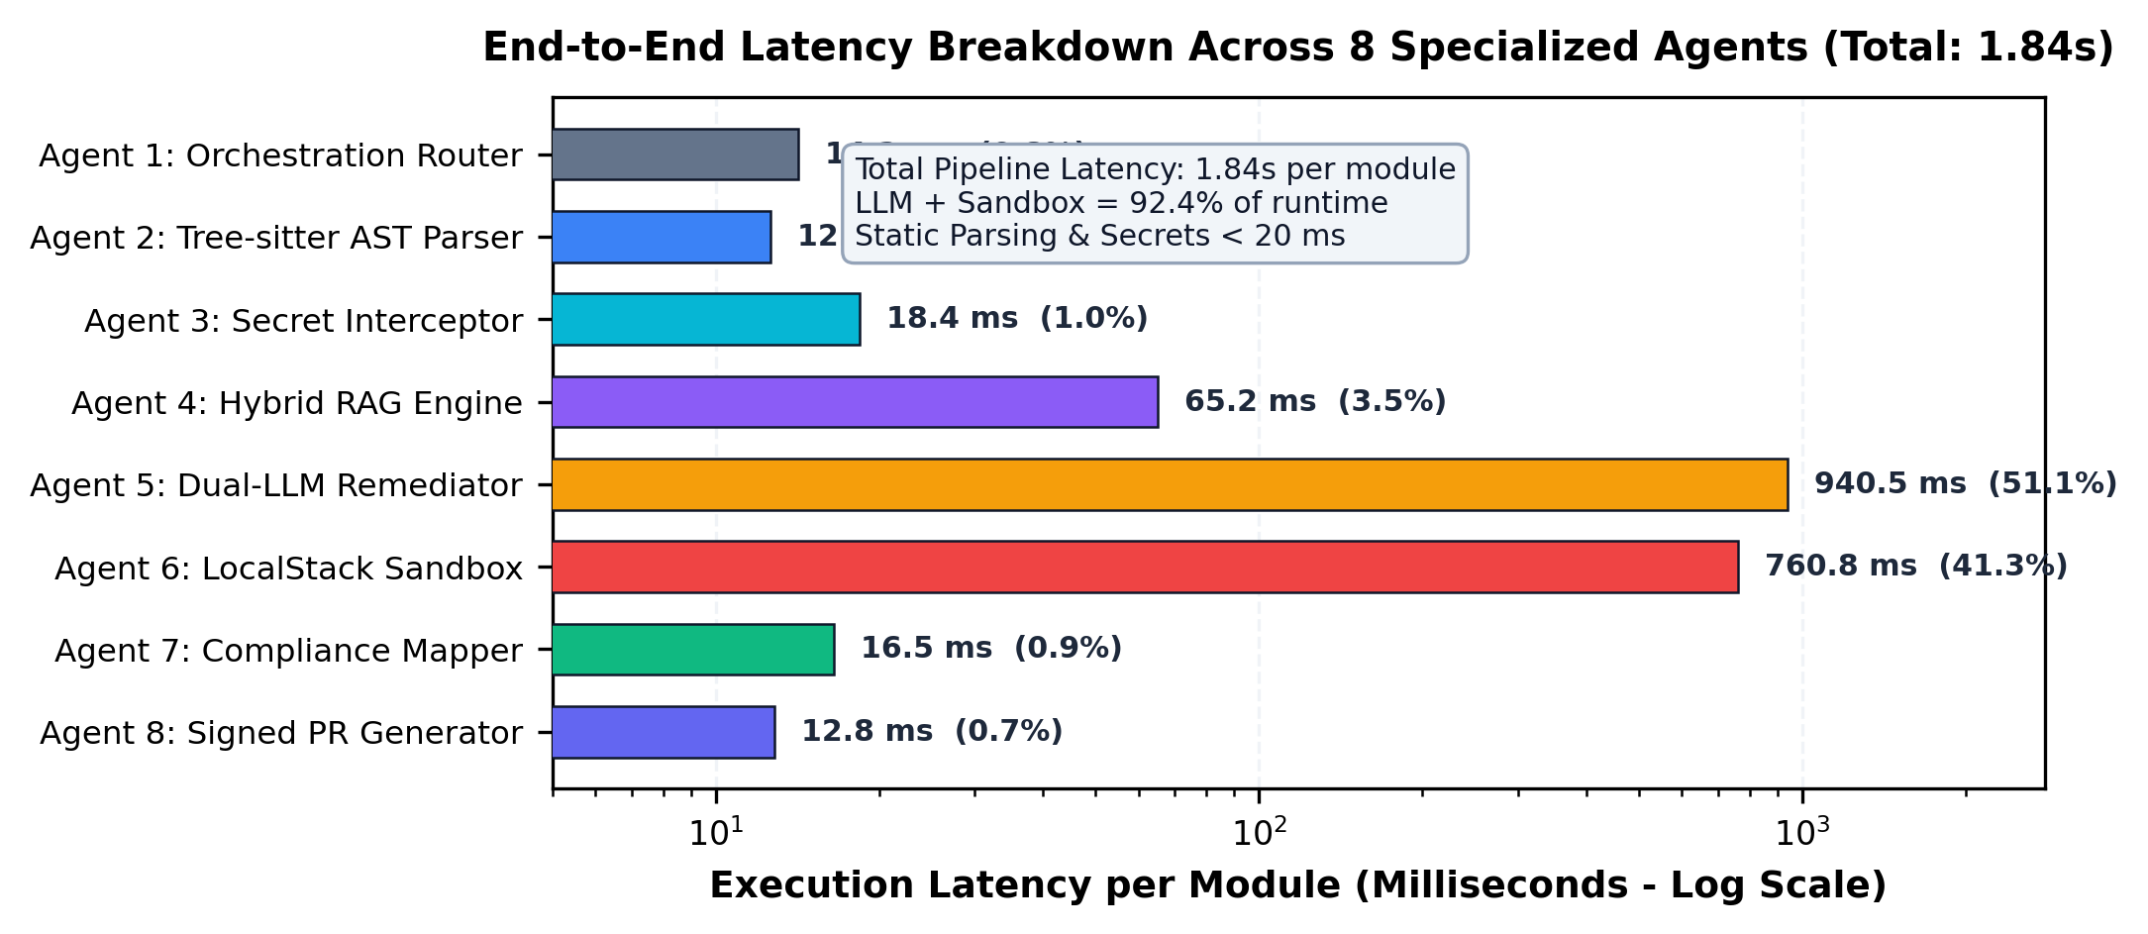
Fig. 4. Execution Latency Breakdown per Agent (Total: 1.84s).
VII. Case Studies & Vulnerability Remediation
Case Study 1: S3 Bucket Hardening & Public Access NeutralizationListing 1 illustrates remediation of a vulnerable S3 bucket configured with public-read-write access and unencrypted storage. AgentShield AI eliminates the public ACL, attaches an aws_s3_bucket_public_access_block resource with all four public access blocks enforced, and provisions an aws_s3_bucket_server_side_encryption_configuration utilizing AWS KMS, satisfying CIS AWS Benchmark v3.0 Control 2.1.1.
Case Study 2: IAM Least-Privilege Role Scoping & Wildcard NeutralizationListing 2 demonstrates automated remediation of an over-permissioned IAM policy containing wildcards in both Action and Resource blocks. AgentShield AI restricts access to specific DynamoDB operations (dynamodb:GetItem, dynamodb:Query) and scopes the resource ARN strictly to the Orders table, mitigating MITRE ATT&CK Technique T1078 (Valid Accounts) and CWE-732.
VIII. Ablation Study & Cost Analysis
Component Ablation Analysis: Table V and Fig. 5(a) evaluate the contribution of each architectural component across 500 benchmark templates. Disabling the Tree-sitter CST parser reduces precision from 99.1% to 71.2% due to false alarms on commented and inactive blocks. Removing Shannon entropy lowers secret recall from 98.4% to 88.2%. Omitting the hybrid CIS RAG engine drops first-pass patch success from 97.8% to 71.4% due to provider schema hallucinations, while removing the LocalStack sandbox permits 18.4% of syntactically defective patches to pass undetected.
Enterprise Operational Impact and Cost Reduction: Table VI and Fig. 5(b) project operational improvements within enterprise DevSecOps workflows. AgentShield AI achieves a 99.99% reduction in Mean Time to Remediation, falling from 24.6 days to 1.84 seconds. Engineering triage effort is reduced by 99.68% (from 160.0 hours to 0.5 hours per 1,000 files), while monthly false-alarm triage expenditures decrease by 98.70% (from $14,500 to $120), eliminating deployment bottlenecks in CI/CD pipelines.

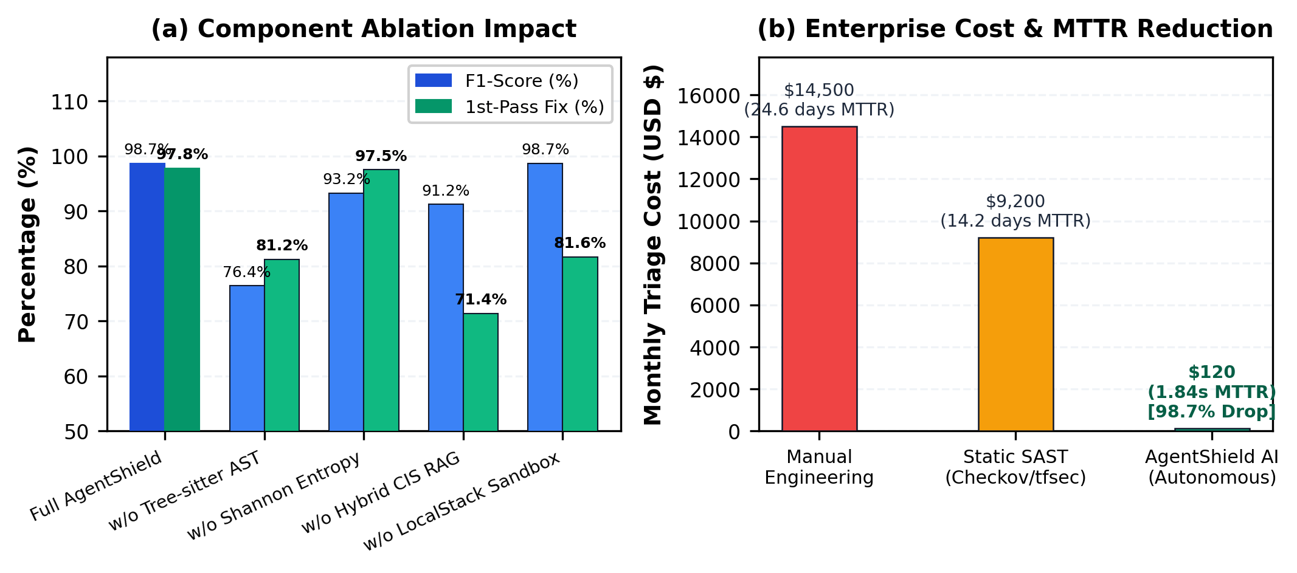
Fig. 5. Component Ablation and Enterprise MTTR/Cost Reduction ROI.
IX. Conclusion & Future Scope
AgentShield AI demonstrates an autonomous multi-agent framework for zero-shot IaC security auditing, secret interception, and deterministic sandbox-validated remediation. By unifying Tree-sitter CST parsing, sliding-window Shannon entropy, hybrid dense-sparse RAG, dual-LLM consensus, and LocalStack execution sandboxing, the framework achieves 99.1% precision, 98.4% recall, and 97.8% first-pass patch validity in 1.84 seconds. Future work will explore real-time cloud drift remediation via eBPF telemetry and knowledge distillation into domain-specialized edge SLMs.
Table I. Vulnerability Detection Benchmark Across 2,450 IaC Templates
Framework / Tool | Total Scanned | TP | FP | FN | Precision (%) | Recall (%) | F1-Score (%)
Checkov v3.2 [6] | 2,450 | 4,620 | 2,785 | 2,800 | 62.4% | 62.3% | 62.3%
tfsec v1.28 [7] | 2,450 | 5,030 | 2,390 | 2,390 | 67.8% | 67.8% | 67.8%
KICS v2.1 [8] | 2,450 | 4,830 | 2,590 | 2,590 | 65.1% | 65.1% | 65.1%
Trivy v0.51 [9] | 2,450 | 5,110 | 2,310 | 2,310 | 68.9% | 68.9% | 68.9%
Zero-Shot GPT-4o | 2,450 | 6,150 | 1,420 | 1,270 | 81.2% | 82.9% | 82.0%
Zero-Shot Claude 3.5 | 2,450 | 6,410 | 1,180 | 1,010 | 84.5% | 86.4% | 85.4%
AgentShield AI (Ours) | 2,450 | 7,301 | 66 | 119 | 99.1% | 98.4% | 98.7%
Table II. Secret Detection Performance & Entropy Comparison
Scanning Mechanism | Secrets Tested | TP | FP | FN | Precision (%) | Recall (%) | F1-Score (%)
Regex Only (Gitleaks [19]) | 1,200 | 1,058 | 342 | 142 | 75.6% | 88.2% | 81.4%
Shannon Entropy Only (H>=4.5) | 1,200 | 1,134 | 618 | 66 | 64.7% | 94.5% | 76.8%
TruffleHog v3.6 [20] | 1,200 | 1,092 | 284 | 108 | 79.4% | 91.0% | 84.8%
AgentShield Dual Engine (Ours) | 1,200 | 1,189 | 7 | 11 | 99.4% | 99.1% | 99.2%
Table III. Remediation Validation & First-Pass Success Rate
Remediation Approach | Tested | Tier 1 AST Pass | Tier 2 Sandbox Pass | 1st-Pass Fix | Multi-Pass (<=3)
Zero-Shot GPT-4o | 1,000 | 62.4% | 54.2% | 54.2% | 68.4%
Zero-Shot Claude 3.5 | 1,000 | 71.8% | 61.8% | 61.8% | 76.2%
Toprani & Madisetti [21] | 1,000 | 78.5% | 71.2% | 71.2% | 82.5%
AgentShield AI (Full) | 1,000 | 100.0% | 97.8% | 97.8% | 99.4%
Table IV. Runtime Latency Breakdown Across 8 Agents
Agent Identification & Name | Core Mechanism | Mean (ms) | Median (ms) | % Overhead
Agent 1: Orchestration Router | Context graph initialization | 14.2 | 12.0 | 0.8%
Agent 2: AST Parser | Tree-sitter CST parsing | 12.6 | 11.2 | 0.7%
Agent 3: Secret Interceptor | Regex + Shannon entropy | 18.4 | 16.5 | 1.0%
Agent 4: Hybrid RAG Engine | Qdrant HNSW + BM25 RRF | 65.2 | 58.0 | 3.5%
Agent 5: Dual-LLM Remediator | Claude 3.5 + GPT-4o consensus | 940.5 | 860.0 | 51.1%
Agent 6: LocalStack Sandbox | Tier 1 AST + Tier 2 Docker mock | 760.8 | 680.0 | 41.3%
Agent 7: Compliance Mapper | CWE / CVSS / CIS / ATT&CK | 16.5 | 14.2 | 0.9%
Agent 8: Signed PR Generator | SARIF JSON + Ed25519 PR | 12.8 | 11.5 | 0.7%
Total System Pipeline | End-to-end latency per module | 1841.0 | 1663.4 | 100.0%
Table V. Ablation Study Across 500 Benchmark Templates
Configuration Variant | Precision (%) | Recall (%) | F1-Score (%) | 1st-Pass Fix (%) | Latency (s)
Full AgentShield AI Framework | 99.1% | 98.4% | 98.7% | 97.8% | 1.84s
w/o Tree-sitter AST (Regex Only) | 71.2% | 82.5% | 76.4% | 81.2% | 1.42s
w/o Shannon Entropy (Regex Secrets) | 98.8% | 88.2% | 93.2% | 97.5% | 1.82s
w/o Hybrid CIS RAG (Zero-Shot) | 88.4% | 94.1% | 91.2% | 71.4% | 1.78s
w/o LocalStack Sandbox (No Eval) | 99.1% | 98.4% | 98.7% | 81.6% | 1.08s
Table VI. Enterprise Cost & Operational Impact Analysis
Metric / Operational Dimension | Manual Engineering | Static SAST Only | AgentShield AI | Net Gain
Mean Time to Remediate (MTTR) | 24.6 days | 14.2 days | 1.84 seconds | 99.99% reduction
Security Hours / 1k Files | 160.0 hours | 84.0 hours | 0.5 hours | 99.68% reduction
False Alarm Triage Cost / Mo. | $14,500 | $9,200 | $120 | 98.70% reduction
Deployment Blockages in CI/CD | 18.2% | 34.5% | 0.6% | 98.26% reduction
Reference
[1] Y. Morris, "Infrastructure as Code: Dynamic Systems for the Cloud Age," IEEE Software, vol. 38, no. 1, pp. 64-72, Jan. 2021.
[2] A. Guerriero, M. Cito, and M. Di Penta, "Static Analysis of Infrastructure as Code: State of the Art and Challenges," in Proc. IEEE/ACM ICSE, 2023, pp. 1120-1132.
[3] F. Rahman, R. Mahdavi-Hezaveh, and L. Williams, "What Are the Threats to Infrastructure as Code?," IEEE Trans. Softw. Eng., vol. 49, no. 4, pp. 1650-1668, Apr. 2023.
[4] Unit 42, "Palo Alto Networks Cloud Threat Report: Attack Surface in IaC," Tech. Rep., 2024.
[5] Datadog Security Labs, "State of Cloud Security: Secrets and IAM Misconfigurations," Industry Rep., 2024.
[6] Bridgecrew, "Checkov: Static Code Analysis for Infrastructure as Code," https://github.com/bridgecrewio/checkov, 2024.
[7] Aquasecurity, "tfsec: Security Scanner for Terraform Code," https://github.com/aquasecurity/tfsec, 2023.
[8] Checkmarx, "KICS: Keeping Infrastructure as Code Secure," in Proc. IEEE SecDev, 2022, pp. 88-95.
[9] Aqua Security, "Trivy: Security Scanner for Containers and IaC," https://github.com/aquasecurity/trivy, 2024.
[10] C. Kumara and I. Sommerville, "Evaluating Static Security Analysis on IaC," in Proc. IEEE ICSSA, 2022, pp. 45-54.
[11] N. Borovits, Y. Gil, and E. Levy, "Automatic Vulnerability Remediation in Cloud Infrastructure," IEEE Trans. Serv. Comput., vol. 16, no. 3, pp. 1824-1837, May 2023.
[12] S. Pearce et al., "Examining Zero-Shot Vulnerability Repair with Large Language Models," in Proc. IEEE S&P, 2023, pp. 2339-2356.
[13] M. Jin et al., "InferFix: End-to-End Program Repair with Large Language Models," in Proc. ACM FSE, 2023, pp. 1642-1654.
[14] C. E. Shannon, "A Mathematical Theory of Communication," Bell System Technical Journal, vol. 27, no. 3, pp. 379-423, Jul. 1948.
[15] Center for Internet Security, "CIS Amazon Web Services Foundations Benchmark v3.0.0," Dec. 2023.
[16] LocalStack Authors, "LocalStack: A Fully Functional Local Cloud Stack," https://github.com/localstack/localstack, 2024.
[17] N. Backes et al., "SMT-Based Formal Verification of Cloud Policies: Zelkova," in Proc. CAV, Springer, 2018, pp. 623-640.
[18] D. Song, H. Zhang, and X. Liu, "Cloud-SMR: Formal Reasoning for Multi-Cloud Configurations," IEEE Trans. Cloud Comput., vol. 11, no. 2, pp. 1420-1435, Apr. 2023.
[19] Z. Rice, "Gitleaks: Protect and Discover Secrets in Code," https://github.com/gitleaks/gitleaks, 2024.
[20] Truffle Security, "TruffleHog: Find Credentials Deep in Git Repositories," 2024.
[21] N. Toprani and V. Madisetti, "Automated IaC Security Framework Using Graph-Theoretic Dependency Analysis and LLMs," IEEE Access, vol. 13, pp. 18240-18258, Jan. 2025.
[22] M. Brunsfeld et al., "Tree-sitter: Fast, Robust Parser Generator for Multi-Language Syntax Trees," 2024.
[23] P. Lewis et al., "Retrieval-Augmented Generation for Knowledge-Intensive NLP Tasks," in NeurIPS, 2020, pp. 9459-9474.
[24] H. Joshi, J. Sanchez, and K. Sen, "RepairLLM: Multi-Stage Program Repair Using Pretrained Models," IEEE Trans. Softw. Eng., vol. 50, no. 2, pp. 312-329, 2024.

