# **NLP Question-Nexus**

(*Develop to answer questions like a human using Quora data.)*

##### Link:- https://github.com/AnishaRai23/NLPforquora.git

1. **Introduction:**
   * Overview of the project
   * Objectives and significance
2. **Literature Survey:**
   * Discussion of BERT, T5, and GPT-2 models
   * Relevant advancements in NLP
3. **Methodology:**
   * Steps of data exploration, cleaning, and preprocessing
   * Model selection and evaluation process
   * Tools and libraries used (Hugging Face datasets, NLTK, transformers, Matplotlib, Seaborn, Plotly)
4. **Results:**
   * Performance metrics (ROUGE, BLEU, F1-score) for BERT, T5, and GPT-2
   * Visualization of data distribution and model performance
   * Sample outputs from each model
5. **Conclusion:**
   * Summary of findings
   * Insights and recommendations for future work

## Introduction

The project aims to develop a state-of-the-art question-answering model leveraging the Quora Question Answer Dataset. The objective is to create an AI system capable of understanding and generating accurate responses to a variety of user queries, mimicking human-like interactions. By utilizing advanced natural language processing (NLP) techniques and models, such as BERT, T5, and GPT-2, we intend to enhance the system's performance in providing contextually relevant and precise answers. The results of this project could have significant applications in customer support, educational tools, and conversational AI systems. The potential applications of QA systems are vast, spanning across domains such as customer service, education, and information retrieval. This project focuses on developing a robust QA system capable of generating comprehensive and informative responses to a diverse range of questions. By leveraging the Quora Question Answer dataset, we aim to train a model that excels in understanding and responding to user queries effectively. This research endeavours to contribute to the advancement of QA technology by pushing the boundaries of model performance.

## Literature Survey

* + According to Google Scholars and IEEE research paper and article there’s recent advancements in NLP have led to the development of powerful transformer-based models like BERT, T5, and GPT-2. BERT (Bidirectional Encoder Representations from Transformers) is known for its strong performance in understanding the context of a text, making it highly suitable for question-answering tasks. T5 (Text-to-Text Transfer Transformer) frames all NLP tasks as text-to-text problems, allowing for a versatile approach to text generation and comprehension. GPT-2 (Generative Pre-trained Transformer 2) excels in generating coherent and contextually appropriate text, making it effective for generating detailed responses. This survey highlights the importance of these models in advancing the capabilities of AI-driven question-answering systems. the field of question-answering has witnessed significant progress in recent years, with advancements in NLP and machine learning playing a crucial role. Early approaches relied on rule-based systems and information retrieval techniques, which exhibited limitations in handling complex queries and generating coherent answers. With the advent of statistical methods, researchers developed probabilistic models to improve QA performance. However, the breakthrough came with the emergence of deep learning, particularly with the introduction of attention mechanisms and transformer architectures. While these advancements are promising, challenges such as handling factual inconsistencies, ambiguity, and complex reasoning remain. This project aims to contribute to the ongoing research by exploring the potential of these models for building a robust and effective QA system. To identify the research gaps and formulate an accurate problem statement, we have thoroughly reviewed numerous research papers in the relevant domains and based on our literature survey, we have gathered valuable insights that are as follows: -

1. AI-Based Research
2. NLP-Based Research.

|  |  |  |  |  |
| --- | --- | --- | --- | --- |
| SR NO. | Title Of the Paper | Author | Technology Used | Key Findings |
| 1. | Title: Automated Question-Answering for Interactive Decision Support in Operations & Maintenance of Wind Turbines | Joyjit Chatterjee; Nina Dethlefs | Encoder-decoder models (Seq2Seq and Transformer)  Graph Query Language (Cypher)  Knowledge Graph (KG)  Paraphrase generation | Transformer outperforms Seq2Seq for query generation, improving wind turbine maintenance through automated QA. |
| 2. | A Comparative Analysis of Generative Artificial Intelligence Tools for Natural Language Processing | Aamo Iorliam* and Joseph Abunimye Ingio | NLP and AI | Generative AI tools compared, strengths, weaknesses, and future challenges like ChatGPT, Perplexity AI, YouChat, etc |

**Methodology**

The methodology involved several key steps: data exploration, cleaning, and preprocessing; model selection and evaluation; visualization; and deriving insights and recommendations. We began by analysing the Quora Question Answer Dataset to understand its structure and content. Preprocessing techniques such as tokenization, stop word removal, and stemming were applied to clean the data. We then tested three models—BERT, T5, and GPT-2—using metrics like ROUGE, BLEU, and F1-score to evaluate their performance. Visualization tools like Matplotlib, Seaborn, and Plotly were used to create charts and graphs illustrating data distribution, feature importance, and model performance.

## Results

The results indicated that BERT provided the most accurate and contextually relevant answers, leveraging its pretraining on question-answering tasks. T5 performed well in generating complete answers but occasionally struggled with very specific queries. GPT-2 excelled in generating coherent text but sometimes produced less relevant answers due to its broader language model pretraining. Performance metrics showed that BERT had the highest ROUGE and F1 scores, while T5 and GPT-2 demonstrated strong BLEU scores. Visualizations highlighted the distribution of question-and-answer lengths and the comparative performance of the models.

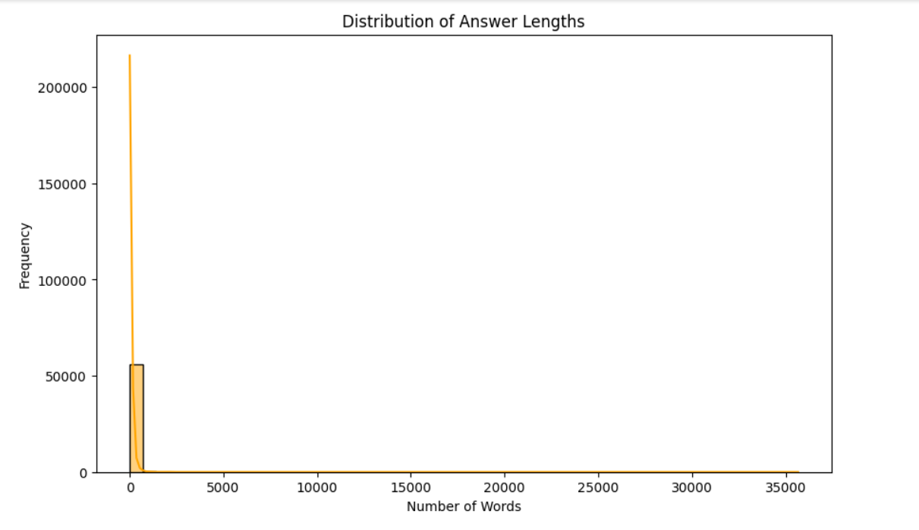

## 

## Conclusion

This project successfully developed a question-answering system using advanced NLP models. BERT emerged as the most effective model for understanding and generating accurate responses, while T5 and GPT-2 showed promise in generating detailed and coherent answers. The insights gained from this study suggest several avenues for improvement, including data augmentation, hybrid model approaches, advanced preprocessing techniques, continuous fine-tuning, and hyperparameter optimization. These enhancements could further improve the performance and applicability of AI-driven question-answering systems in various domains.