# Create Tables for Customer & Country

CREATE TABLE Customer (

[Customer Name] varchar(255) NOT NULL,

[Customer ID] varchar(18) NOT NULL,

[Customer Open Date] varchar(8) NOT NULL,

[Last Consulted Date] varchar(8) null,

[Vaccination Type] char(5) null,

[Doctor Consulted] char(255) null,

[State] char(5) null,

[Country] char(5) null,

[Post Code] int null,

[Date Of Birth] varchar(8)null,

[Active Customer] char(1) null,

PRIMARY KEY ([Customer Name])

);

CREATE TABLE Country (

[Country Name] char(5) NOT NULL,

[Country Code] int not null,

PRIMARY KEY ([Country Name])

);

# SQL Query BLOCK to load data into tables, one table per Country

/*Declaring variables to hold Country name, loop start and end values*/

DECLARE @v_CountryName char(5),

@v_start int = 1,

@v_end int= (select max([Country Code]) from Country)

/* Looping through each Country dataset to create (if table not exists) and insert data to respective country table */

WHILE @v_start<=@v_end

SELECT @v_CountryName=[Country Name] FROM Country where [Country Code]=@v_start

BEGIN

DECLARE @CountryName char(5) = @v_CountryName,

@query1 varchar(max),

@query2 varchar(max)

BEGIN

set @query1= 'CREATE TABLE '+@CountryName+' (

[Customer Name] varchar(255) NOT NULL,

[Customer ID] varchar(18) NOT NULL,

[Customer Open Date] varchar(8) NOT NULL,

[Last Consulted Date] varchar(8) null,

[Vaccination Type] char(5) null,

[Doctor Consulted] char(255) null,

[State] char(5) null,

[Country] char(5) null,

[Post Code] int null,

[Date Of Birth] varchar(8)null,

[Active Customer] char(1) null,

PRIMARY KEY ([Customer Name])

); '

set @query2='INSERT INTO '+@CountryName+

' ([Customer Name] ,[Customer ID],[Customer Open Date] ,[Last Consulted Date],[Vaccination Type],[Doctor Consulted],[State],[Country],[Post Code] ,

[Date Of Birth] ,[Active Customer])

SELECT [Customer Name] ,[Customer ID],[Customer Open Date] ,[Last Consulted Date],[Vaccination Type],[Doctor Consulted],[State] ,[Country],[Post Code]

,[Date Of Birth] ,[Active Customer]

FROM Customer where Country = '+''''+@CountryName+''''

/*Checking if the particular country table exists, otherwise creates that country's table*/

IF (OBJECT_ID(@CountryName,'U') IS NULL)

EXEC(@query1)

/*Inserts data in the respective country fetched from Customer Table*/

EXEC(@query2)

END

SET @v_start = @v_start + 1;

END

# Screenshots

## Data transfer from Pipe delimited File to SQL table

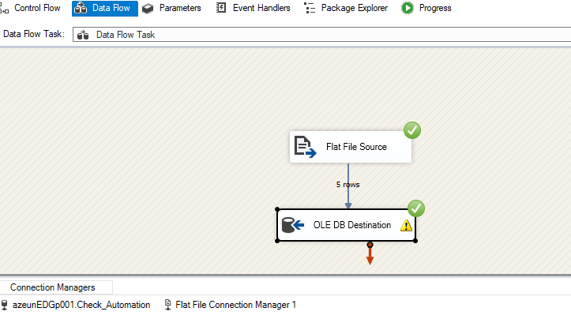

## Data in Customer Table

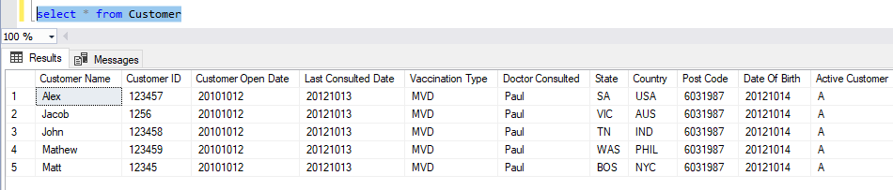

## Data in Country Table

