**Anisha Jain**

**C14-65**

**EXPERIMENT 5**

**Genetics Algorithm :**

import random# Step 1: Determine the number of chromosomes, generation, mutation rate, and crossover rate valuedef genetic_algorithm(num_chromosomes, mutation_rate, crossover_rate, num_variables): # Step 2: Generate chromosome population with random initialization population = generate_population(num_chromosomes, num_variables) i = int(1) while True: # Step 3: Evaluation of fitness value of chromosomes fitness_values = [fitness_function(chromosome) for chromosome in population] # Step 8: Solution (Best Chromosomes) best_chromosome = population[fitness_values.index(min(fitness_values))] print(f"Generation {i}: solution: {best_chromosome}, Fitness: {min(fitness_values)}") if min(fitness_values) == 0: print(f"\nGeneration {i}: Best solution: {best_chromosome}, Fitness: {min(fitness_values)}") print(f"Optimal Solution after {i} Generations") break i = i + 1 next_generation = [] # Step 5: Chromosomes selection selected_population = selection(population, fitness_values) for _ in range(num_chromosomes // 2): parent1, parent2 = selected_population[random.randint(0, len(selected_population) - 1)], selected_population[random.randint(0, len(selected_population) - 1)] # Step 6: Crossover child1, child2 = crossover(parent1, parent2, crossover_rate) # Step 7: Mutation child1 = mutation(child1, mutation_rate) child2 = mutation(child2, mutation_rate) next_generation.extend([child1, child2]) population = next_generation return best_chromosome# Step 2: Generate initial populationdef generate_population(size, num_variables): population = [] for _ in range(size): individual = [random.randint(0, 10) for _ in range(num_variables)] population.append(individual) return population# Step 4: Fitness function evaluationdef fitness_function(variables): x, y, z, w = variables return abs((x + 2*y + 3*z + 4*w) - 30)# Step 5: Chromosome selection using roulette wheel selectiondef selection(population, fitness_values): selected_population = [] total_fitness = sum(fitness_values) probabilities = [fitness / total_fitness for fitness in fitness_values] for _ in range(len(population)): selected = random.choices(population, probabilities)[0] selected_population.append(selected) return selected_population# Step 6: Crossoverdef crossover(parent1, parent2, crossover_rate): if random.random() < crossover_rate: crossover_point = random.randint(1, len(parent1) - 1) child1 = parent1[:crossover_point] + parent2[crossover_point:] child2 = parent2[:crossover_point] + parent1[crossover_point:] return child1, child2 return parent1, parent2# Step 7: Mutationdef mutation(individual, mutation_rate): if random.random() < mutation_rate: index = random.randint(0, len(individual) - 1) new_value = random.randint(0, 10) individual[index] = new_value return individual# Get input from the userdef get_input(): num_chromosomes = int(input("Enter the number of chromosomes: ")) mutation_rate = float(input("Enter the mutation rate: ")) crossover_rate = float(input("Enter the crossover rate: ")) num_variables = 4 # Assuming 4 variables (x, y, z, w) for the given equation return num_chromosomes, mutation_rate, crossover_rate, num_variables# Main programdef main(): num_chromosomes, mutation_rate, crossover_rate, num_variables = get_input() best_chromosome = genetic_algorithm(num_chromosomes, mutation_rate, crossover_rate, num_variables) print("Best solution:", best_chromosome)if __name__ == "__main__": main()

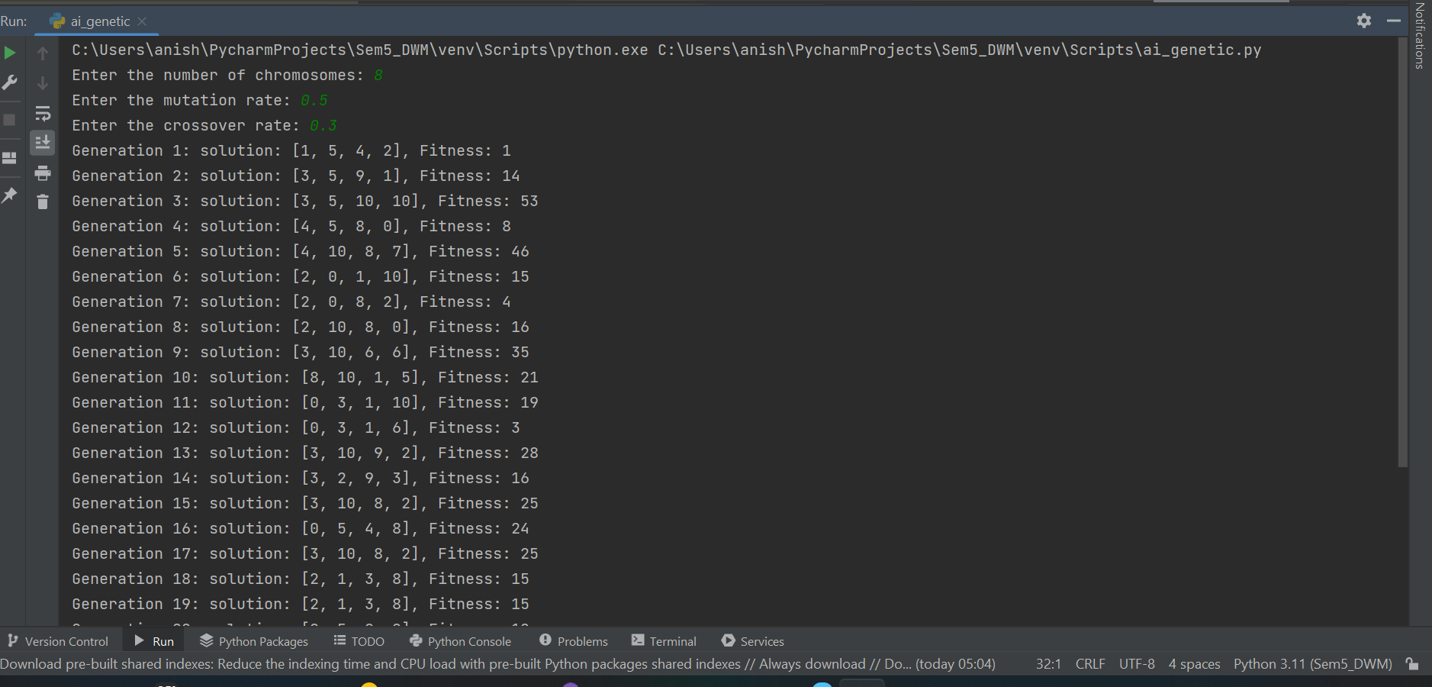

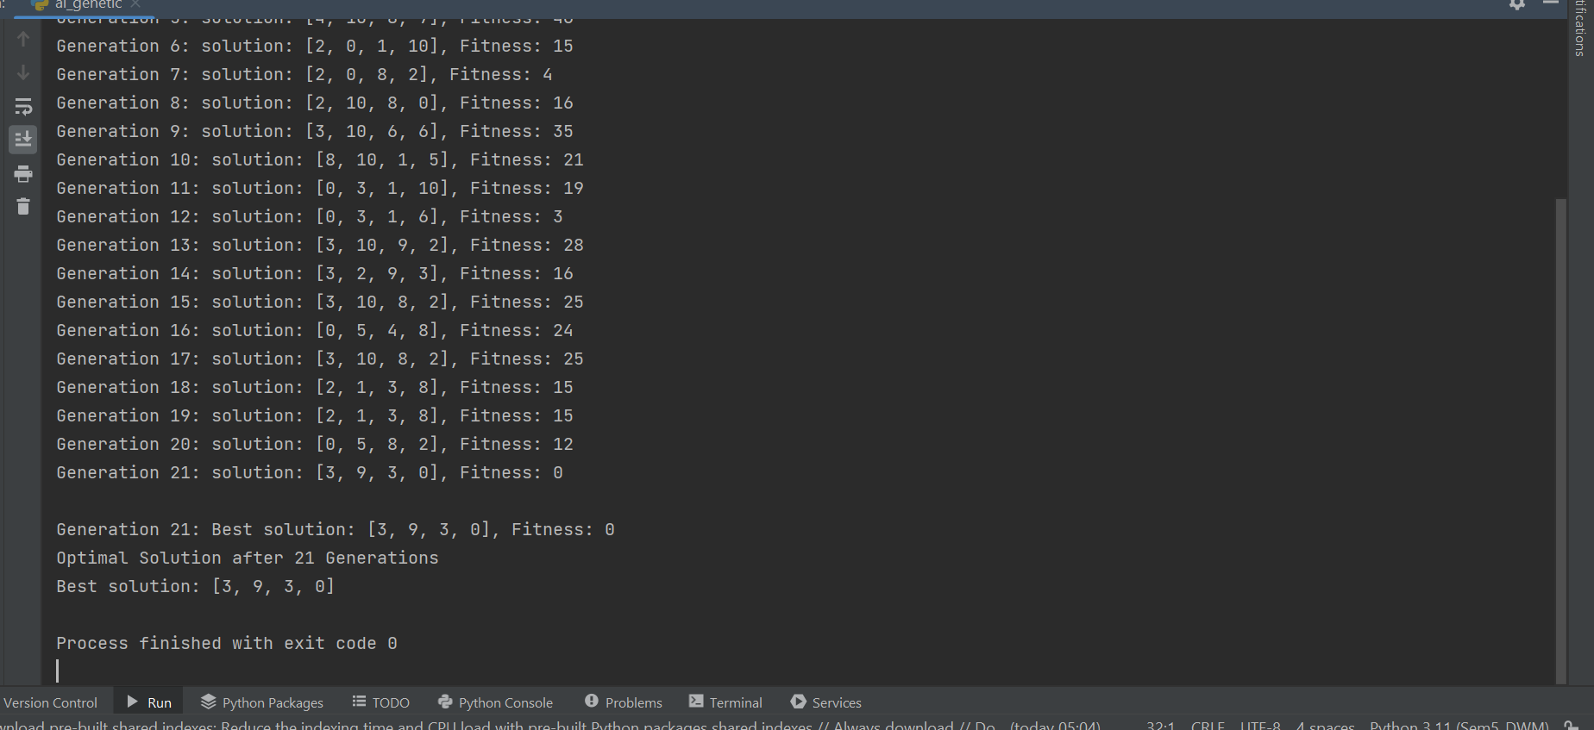

**Hill Climbing Algorithm :**

import randomdef obj_function(x): return -(4*x ** 4)+(4*x)+1def random_neighbor(current): return current + random.uniform(-0.5, 0.5)def hill_climbing(max_iterations): current_solution = random.uniform(-10, 10) for _ in range(max_iterations): neighbor = random_neighbor(current_solution) if obj_function(neighbor) > obj_function(current_solution): current_solution = neighbor return current_solutionbest_solution = hill_climbing(1000)print("Best solution found:", best_solution)print("Objective value at best solution:", obj_function(best_solution))

