C++ PROGRAMMING
Console-Based Snake Game using C++

Abstract
This project implements a console-based Snake Game using C++ and Windows API functions. The game features real-time keyboard input, smooth rendering without screen flickering, score tracking, adjustable speed, and collision detection.

Problem Statement
To design and develop an interactive Snake Game that runs in the Windows console using C++, demonstrating real-time logic, modular programming, and system-level console control.

Tools & Technologies
- Language: C++
- Compiler: Dev-C++
- Platform: Windows
- Libraries: <conio.h>, <windows.h>

System Design
- Input Module
- Logic Module
- Rendering Module
- Control Module

Algorithm (Summary)
- Initialize game variables
- Draw static board
- Repeat until game over:
  - Read input
  - Update logic
  - Render changes
- Display final score

Features
- Flicker-free rendering
- Adjustable speed
- Wrap-around movement
- Self-collision detection
- Score tracking
SOURCE CODE :
#include <iostream>
#include <conio.h>
#include <windows.h>
using namespace std;

bool gameOver;
const int width = 40;
const int height = 20;
int x, y, fruitX, fruitY, score;
int tailX[100], tailY[100];
int nTail;
enum eDirection { STOP = 0, LEFT, RIGHT, UP, DOWN };
eDirection dir;

// Function to set cursor position
void gotoxy(int x, int y) {
COORD coord;
coord.X = x;
coord.Y = y;
SetConsoleCursorPosition(GetStdHandle(STD_OUTPUT_HANDLE), coord);
}

// Function to hide cursor
void hideCursor() {
CONSOLE_CURSOR_INFO cursorInfo;
GetConsoleCursorInfo(GetStdHandle(STD_OUTPUT_HANDLE), &cursorInfo);
cursorInfo.bVisible = false;
SetConsoleCursorInfo(GetStdHandle(STD_OUTPUT_HANDLE), &cursorInfo);
}

void Setup() {
gameOver = false;
dir = STOP;
x = width / 2;
y = height / 2;
fruitX = rand() % width;
fruitY = rand() % height;
score = 0;
nTail = 0;
}

void DrawInitial() {
system("cls");
hideCursor();

// Top wall
for (int i = 0; i < width + 2; i++)
cout << "#";
cout << endl;

// Game area
for (int i = 0; i < height; i++) {
cout << "#";
for (int j = 0; j < width; j++) {
cout << " ";
}
cout << "#" << endl;
}

// Bottom wall
for (int i = 0; i < width + 2; i++)
cout << "#";
cout << endl;

cout << "Score: 0" << endl;
cout << "Controls: W=Up, A=Left, S=Down, D=Right, X=Exit" << endl;
cout << "Speed: Press 1(Slow), 2(Medium), 3(Fast)" << endl;
}

void Draw() {
// Draw snake head
gotoxy(x + 1, y + 1);
cout << "O";

// Draw snake tail
for (int i = 0; i < nTail; i++) {
gotoxy(tailX[i] + 1, tailY[i] + 1);
cout << "o";
}

// Draw fruit
gotoxy(fruitX + 1, fruitY + 1);
cout << "F";

// Update score
gotoxy(0, height + 2);
cout << "Score: " << score << " ";
}

void ClearPosition(int px, int py) {
gotoxy(px + 1, py + 1);
cout << " ";
}

void Input(int &gameSpeed) {
if (_kbhit()) {
switch (_getch()) {
case 'a':
case 'A':
if (dir != RIGHT)
dir = LEFT;
break;
case 'd':
case 'D':
if (dir != LEFT)
dir = RIGHT;
break;
case 'w':
case 'W':
if (dir != DOWN)
dir = UP;
break;
case 's':
case 'S':
if (dir != UP)
dir = DOWN;
break;
case 'x':
case 'X':
gameOver = true;
break;
case '1':
gameSpeed = 200; // Slow
break;
case '2':
gameSpeed = 100; // Medium
break;
case '3':
gameSpeed = 50; // Fast
break;
}
}
}

void Logic() {
int prevX = tailX[0];
int prevY = tailY[0];
int prev2X, prev2Y;
tailX[0] = x;
tailY[0] = y;

for (int i = 1; i < nTail; i++) {
prev2X = tailX[i];
prev2Y = tailY[i];
tailX[i] = prevX;
tailY[i] = prevY;
prevX = prev2X;
prevY = prev2Y;
}

// Clear last tail position
if (nTail > 0) {
ClearPosition(prevX, prevY);
}

// Clear old head position
ClearPosition(x, y);

switch (dir) {
case LEFT:
x--;
break;
case RIGHT:
x++;
break;
case UP:
y--;
break;
case DOWN:
y++;
break;
default:
break;
}

// Wall collision (wrap around)
if (x >= width) x = 0;
else if (x < 0) x = width - 1;
if (y >= height) y = 0;
else if (y < 0) y = height - 1;

// Self collision
for (int i = 0; i < nTail; i++)
if (tailX[i] == x && tailY[i] == y)
gameOver = true;

// Fruit collision
if (x == fruitX && y == fruitY) {
score += 10;
fruitX = rand() % width;
fruitY = rand() % height;
nTail++;
}
}

int main() {
int gameSpeed = 150; // Default speed (slower)

Setup();
DrawInitial();

while (!gameOver) {
Input(gameSpeed);
Logic();
Draw();
Sleep(gameSpeed);
}

gotoxy(0, height + 4);
cout << "\n\nGame Over! Final Score: " << score << endl;
cout << "Press any key to exit...";
_getch();
return 0;
}

OUTPUT:

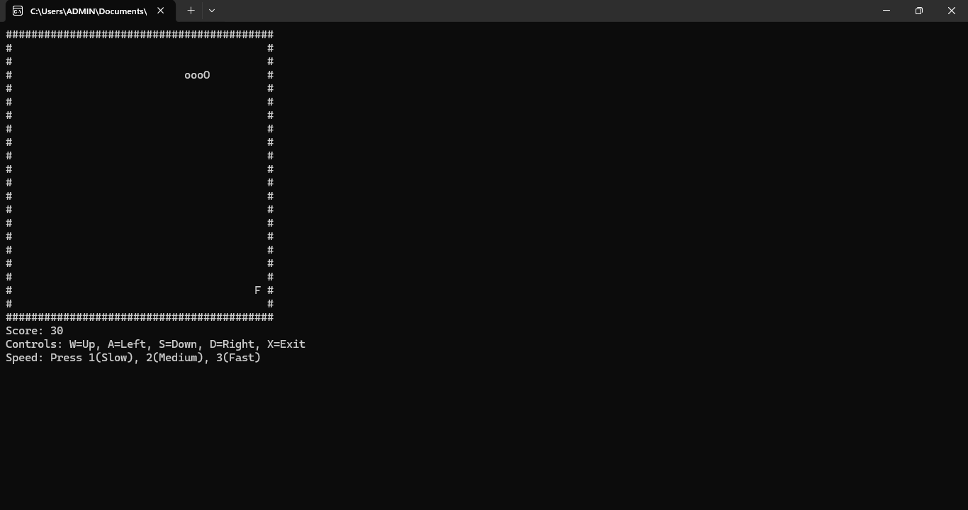

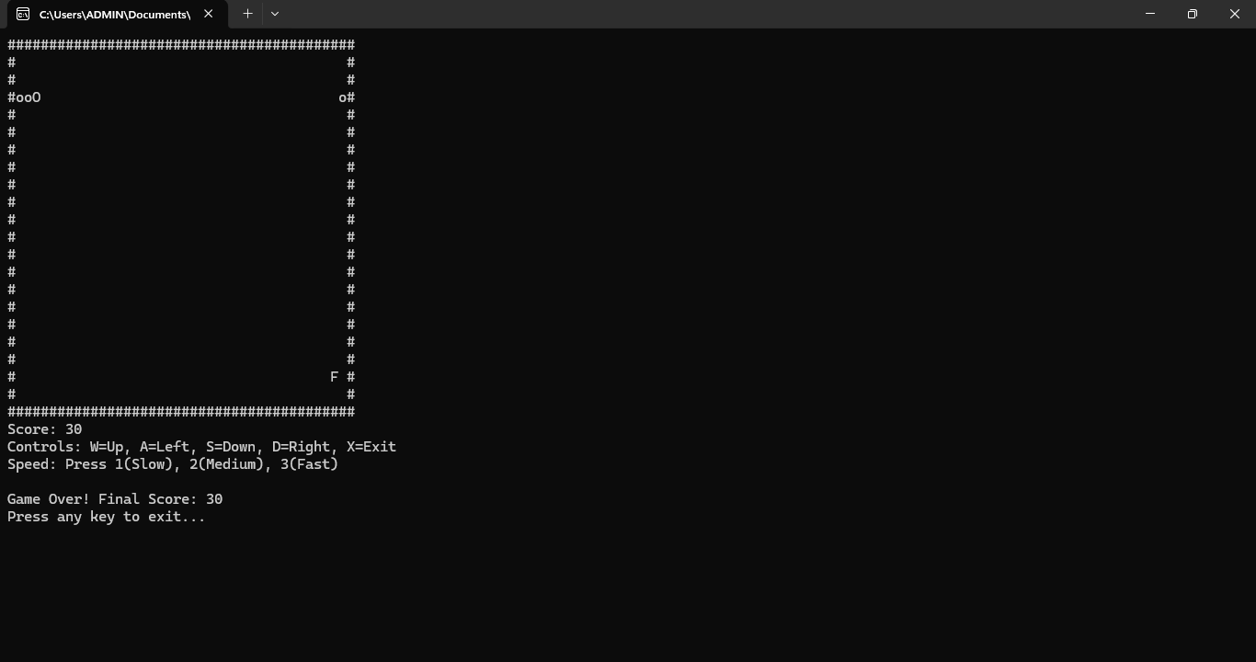

CONCEPTS USED:
- C++ Programming Language
Used for its speed, structured syntax, and ability to interact with system-level features.
- Modular Programming (Functions)
The program is divided into functions such as Setup(), Input(), Logic(), and Draw() to improve readability, reusability, and maintenance.
- Global Variables
Used to store game state (snake position, score, game status) so that all functions can access and update them easily.
- Constants (const)
Used to define fixed game boundaries (width, height) to prevent accidental modification.
- Enumeration (enum)
Used to represent snake directions clearly (UP, DOWN, LEFT, RIGHT), improving code readability and logic control.
- Arrays
Used to store the snake’s tail positions, enabling growth and movement tracking.
- Game Loop
A continuous loop runs until the game ends, handling input, logic processing, and screen updates in real time.
- Real-Time Keyboard Input
Implemented using _kbhit() and _getch() to allow immediate user control without pressing Enter.
- Conditional and Switch Statements
Used for movement control, collision detection, speed selection, and game termination.
- Collision Detection Logic
Used to detect self-collision and fruit consumption to update score and end the game when required.
- Windows Console Programming
Windows API functions (gotoxy, cursor hiding) are used to control cursor position and avoid screen flickering.
- Delay Control (Sleep)
Used to control game speed and difficulty level.

Conclusion
The project successfully demonstrates real-time game development using C++ and Windows console control, enhancing both problem-solving and system-level programming skills.

