DAIRY SECTOR

Introduction

The dairy sector is a cornerstone of the Indian agricultural economy, driven by hyper-local production and multi-channel distribution networks. Managing a perishable inventory with strict temperature configurations and localized dynamic demand poses significant operational challenges.
This project establishes a relational database management framework to evaluate the dairy supply chain using actual transaction registers. By mapping production metrics, storage variables, dynamic shelf lives, and fulfillment paths, this pipeline extracts data structures optimized for real-time inventory management, predictive reordering scripts, and state-wise revenue optimization models.

Data Description

The underlying repository contains operational parameters detailing the lifecycle of dairy products from farm yield to regional target fulfillment. The schema consists of 23 explicit variables partitioned into three logical entities:
Farm & Production Infrastructure
- Location: The regional geographic point of raw material origination (e.g., Telangana, Uttar Pradesh, Tamil Nadu).
- Total Land Area (acres): Explains structural capital and farm capacity metrics.
- Number of Cows: Represents raw material generation capital.
- Farm Size: Categorical operational grouping index based on cow count and footprint (Small, Medium, Large).

Product Logistical Matrix
- Product ID / Product Name: Unique identifiers for items including raw milk, value-added products like ghee, paneer, and frozen treats.
- Brand: Corporate production houses handling regional processing (e.g., Amul, Sudha, Mother Dairy).
- Quantity (liters/kg) / Price per Unit: Production volumetric values paired with wholesale baseline valuations.
- Total Value / Storage Condition: Total manufactured cost baseline against strict climate demands (Ambient, Refrigerated, Frozen, Tetra Pack).
- Production Date / Expiration Date / Shelf Life (days): Temporal metrics calculating degradation windows and stock freshness limits.
Sales & Inventory Intercept
- Quantity Sold / Price per Unit (sold): Actual demand volumes paired with dynamic market clearing prices.
- Approx. Total Revenue (INR): Total income realized from market completion.
- Customer Location / Sales Channel: Geo-targeted demand vectors distributed through Retail, Wholesale, or Online fulfillment routes.
- Quantity in Stock / Minimum Stock Threshold / Reorder Quantity: Warehouse values tracking active holding reserves against stockout variables.

Objectives

The objective of this database engine is to convert raw operational logs into actionable structural insights through targeted analytical SQL tasks:
- Inventory Safety Monitoring: Construct flags to capture items where Quantity in Stock falls below the safety barrier (Minimum Stock Threshold), generating automated values for Reorder Quantity requirements.

- Dynamic Revenue Realization Analysis: Evaluate variances between processing costs (Price per Unit) and actual selling values (Price per Unit (sold)) across different Sales Channels to maximize operating margins.
- Perishability Mitigation Pipeline: Build an expiration tracking matrix to flag unsold batch stocks close to their Expiration Date, prioritizing fast fulfillment paths for low Shelf Life components.
- Geographical Supply-Demand Modeling: Map production sources against Customer Location vectors to uncover cross-state trade lanes and optimize freight costs.

Insights

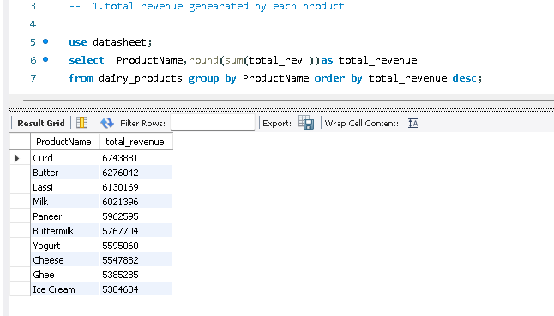
- total revenue generated by each product

- give brand with hightest total revenue
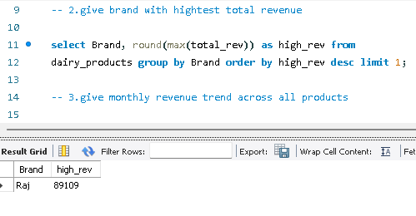

- give monthly revenue trend across all products
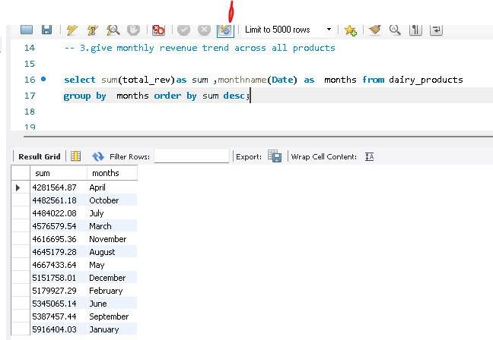
- products below the minimum stock threshold

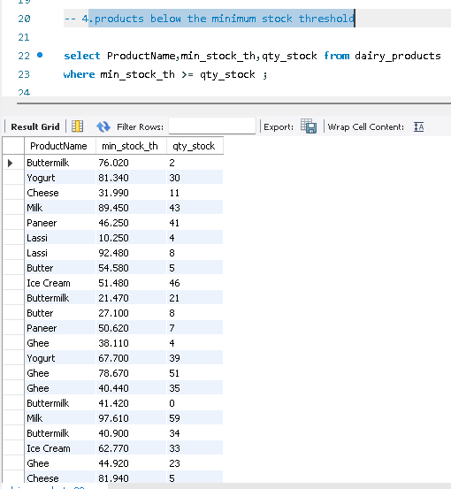

- total reorder quantity required per product
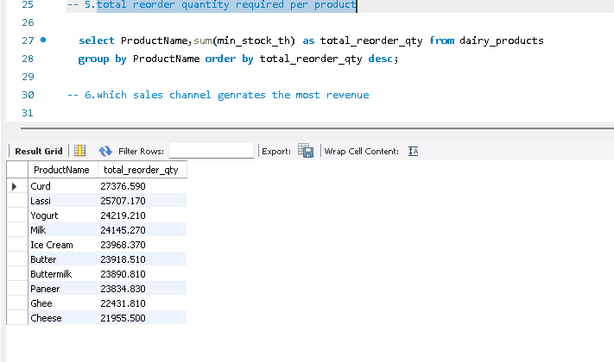

- which sales channel generated the most revenue

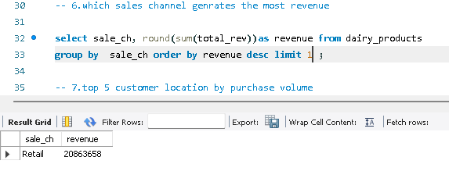

- top 5 customer location by purchase volume

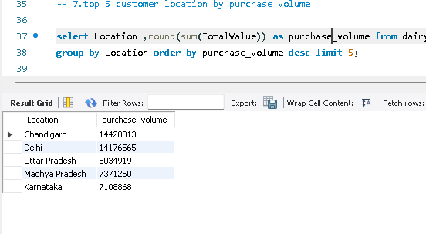

- Average selling price per product

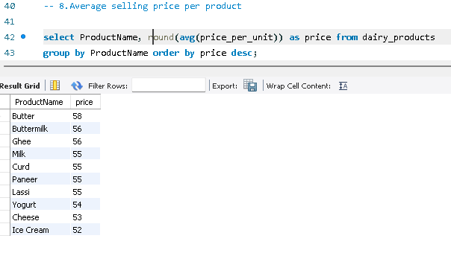

- Compare selling price with listed price

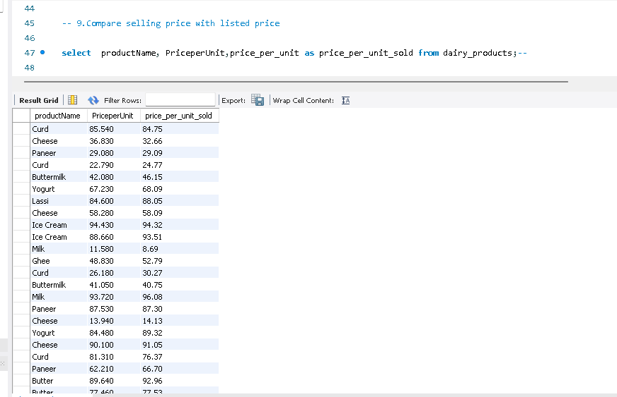

- products with less than 10 days shelf life remaining

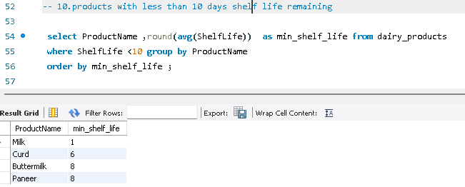

- average shelf life by product category
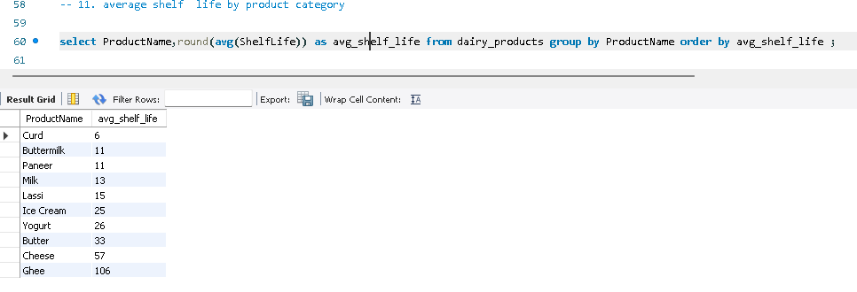

- Average number of cows per farm size category
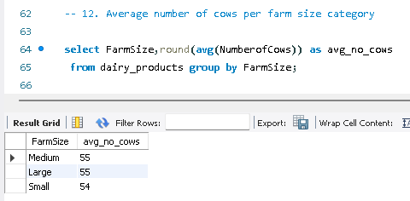
- location with the largest total land area
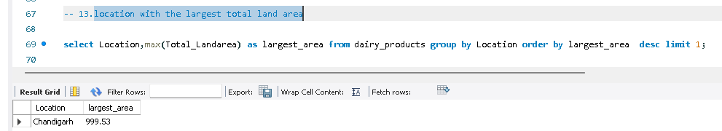

- top 3 location by average production quantity
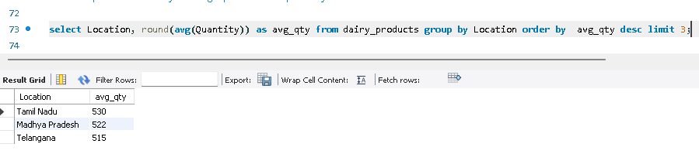

- calculate profit for each product
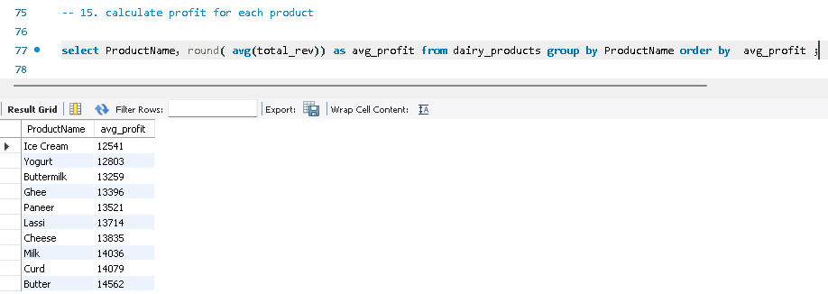

- Most profitable brand overall

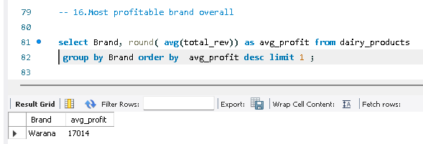

- Yearly revenue growth
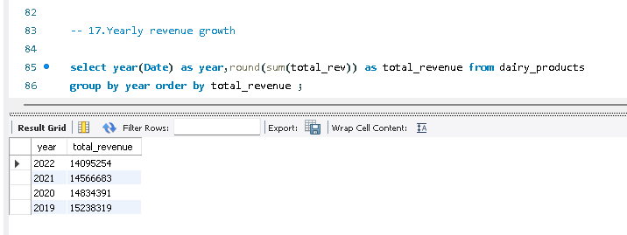

- best-selling product each year

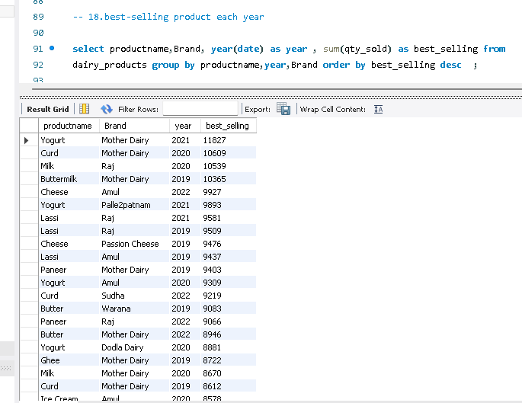

- Product that need the immediate restock

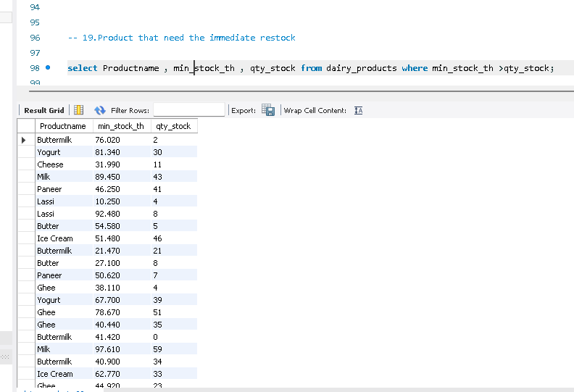

- Identify expired product still in stock

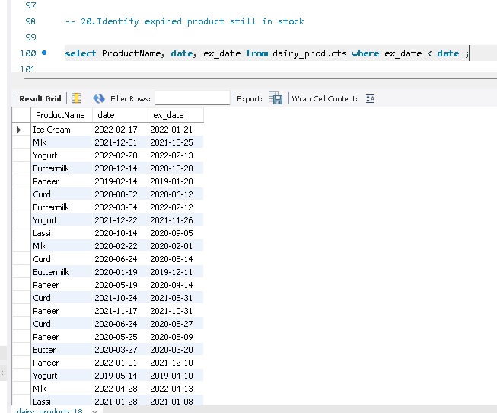

- Average shelf life per brand
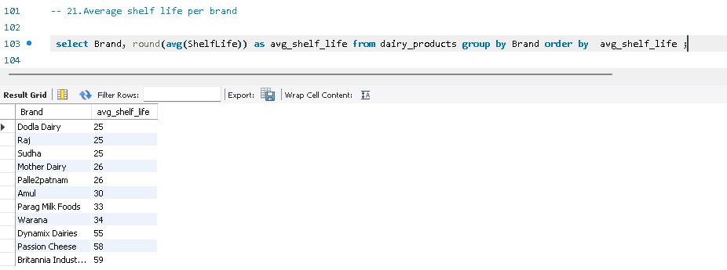

- Most popular product in each customer location
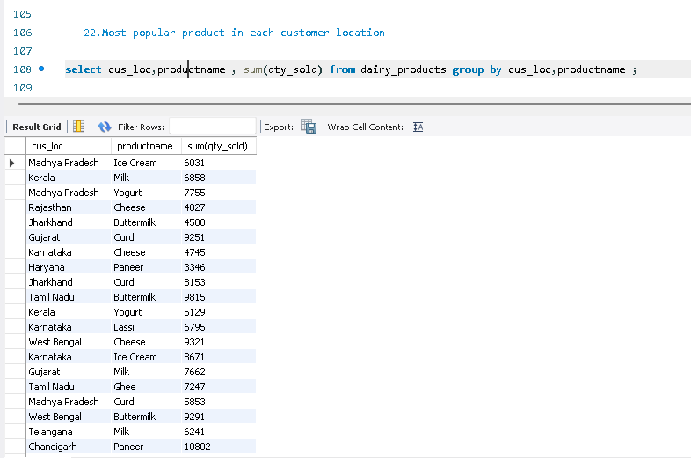

Conclusion

💰 Revenue & Profitability
- Product Revenue & Profit: Generates 45L to 50L per product; profit is 14L to 15L per product.
- Annual Trends: 2019 was highest (15Cr); 2022 was lowest (14Cr).
- Top Performers: Retail channel, brand Raj (highest revenue), and brand Warana (most profitable).

📦 Inventory & Lifecycle
- Reorders & Restock: Reorder quantity is 2.0k per product. Restock needed for Butter, Yogurt, Cheese, Milk.
- Shelf-Life: Ghee is highest (106 days); Curd is lowest (6 days); others average 25 days.
- Critical Risks: Under 10 days shelf-life for Milk, Curd, Buttermilk, Paneer. Expired stock risk for Ice cream, Yogurt, Milk, Butter.

🗺️ Logistics & Regional Demand
- Top Demand Locations: Chandigarh (also has largest land area), Delhi, UP, MP, Karnataka.
- Top Volumetric Regions: Tamil Nadu, Madhya Pradesh, Telangana.
- Regional Preferences: MP (Ice cream, Yogurt), Kerala (Milk).

🐄 Pricing & Supply Chain
- Pricing: Average selling price is ₹50 to ₹60. Max difference between selling price and list price is ₹5.
- Farm Size (Average Cows): Medium (55), Large (55), Small (54).
- Brand Lifespan: Average shelf life per brand is 22.60 curd have the shortest life spam (6) and ghee have the longest one (106)

