Experiment 2: Understanding Algorithms, Flowcharts & VS Code Setup

Aim:
To understand the concepts of algorithms, flowcharts, and setup of Visual Studio Code.

Problem:
Write a C program to print the largest of two numbers entered by the user and also print their sum.

Algorithm:
1. Start
2. Declare two variables num1 and num2.
3. Input two numbers from the user.
4. Compare num1 and num2.
5. If num1 > num2, then num1 is the largest; otherwise, num2 is the largest.
6. Calculate the sum = num1 + num2.
7. Display the largest number and the sum.
8. Stop.

Flowchart :
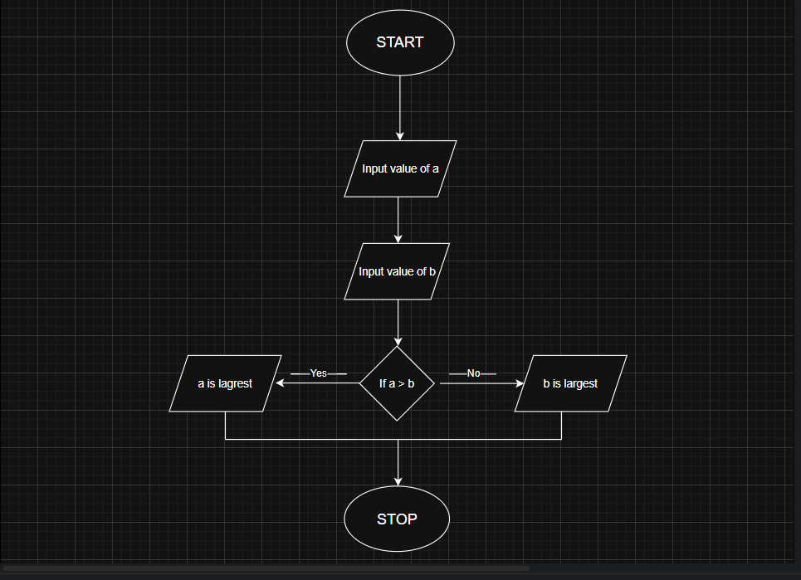

C Program:
#include <stdio.h>
int main() {
int num1, num2;
printf("Enter first number: ");
scanf("%d", &num1);
printf("Enter second number: ");
scanf("%d", &num2);
if (num1 > num2) {
printf("Largest number: %d\n", num1);
} else {
printf("Largest number: %d\n", num2);
}
int sum = num1 + num2;
printf("Sum of two numbers: %d\n", sum);
return 0;
}
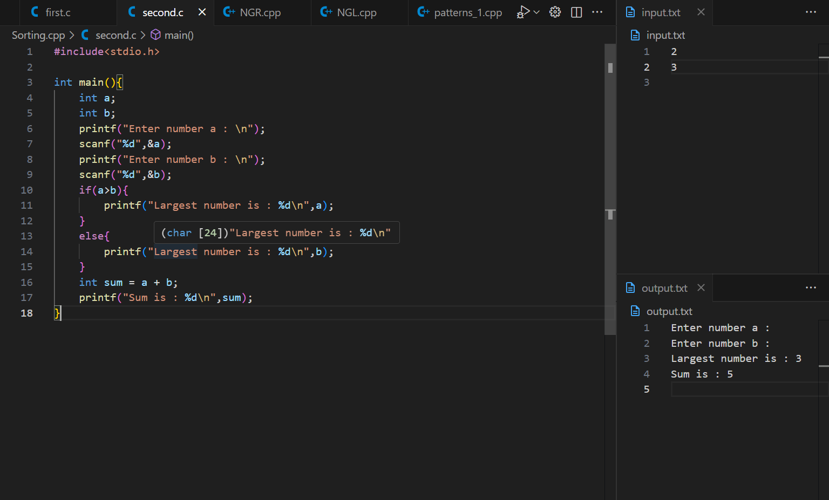
Output :

Important VS Code Shortcuts:
• Ctrl + ` : Open integrated terminal
• Ctrl + S : Save current file
• Ctrl + / : Comment or uncomment a line
• Ctrl + Shift + N : New window
• Ctrl + Shift + P : Command Palette
• Alt + ↑ / ↓ : Move line up or down
• Ctrl + Space : Trigger IntelliSense suggestions
• Ctrl + K + C : Add block comment
• Ctrl + K + U : Remove block comment

