PaddleOCR:

* Developed by Chinese company Baidu
* PaddleOCR is a state-of-the-art Optical Character Recognition
* Base: DeepLearning network CRNN
* Light weight – run on CPU and GPU

In this video you'll be able to leverage it to extract prescription medication labels using PaddleOCR. This has a range of applications and could be used as part of a broader deep learning pipeline. It could be integrated with a Text to Speech system to make it easier for people with accessibility issues to interpret their medications.

Get the code: https://github.com/nicknochnack/DrugL...

In this video, you'll learn:

1. How to install PaddleOCR for Python

2. Applying OCR to images

3. Extracting prescription medication labels using PaddleOCR

* from paddleocr import PaddleOCR, draw_ocr # main OCR dependencies
* 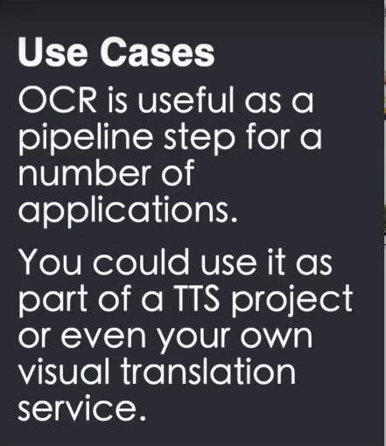paddleocr – instantiate the mode
* draw OCR is to visualize the model

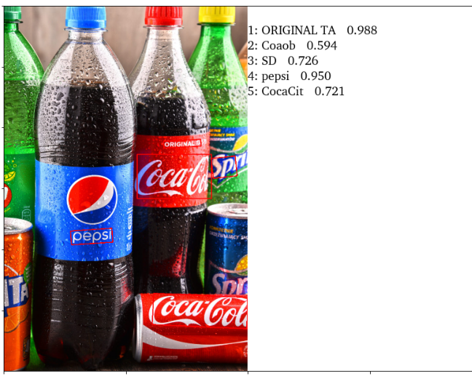

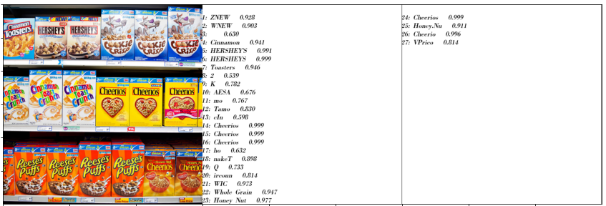

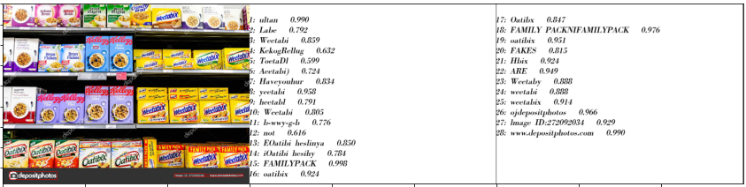

Links:

Paper: <https://arxiv.org/pdf/2009.09941v3.pdf>

GitHub: <https://github.com/PaddlePaddle/PaddleOCR>

Source:

<https://www.youtube.com/watch?v=t5xwQguk9XU&list=RDCMUCHXa4OpASJEwrHrLeIzw7Yg&start_radio=1>

Colab: <https://colab.research.google.com/drive/158yL5MsE9cibPgu38LkUsRMdSAbNlaJz?authuser=1#scrollTo=mXYv3pt8kV3R>