Outputs

1. Two Sum II - Input array is sorted  
   Given a sorted array of integers, return the indices of the two numbers such that they add up to a specific target.

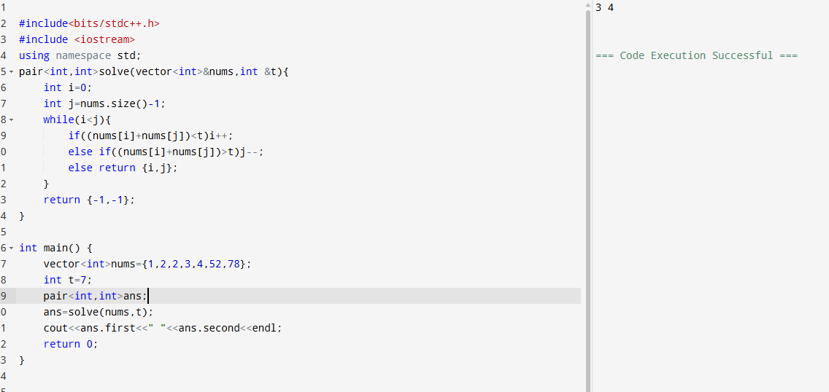

1. Subarray Sum Equals K Given an array of integers and a target sum k, return the total number of continuous subarrays whose sum equals to k

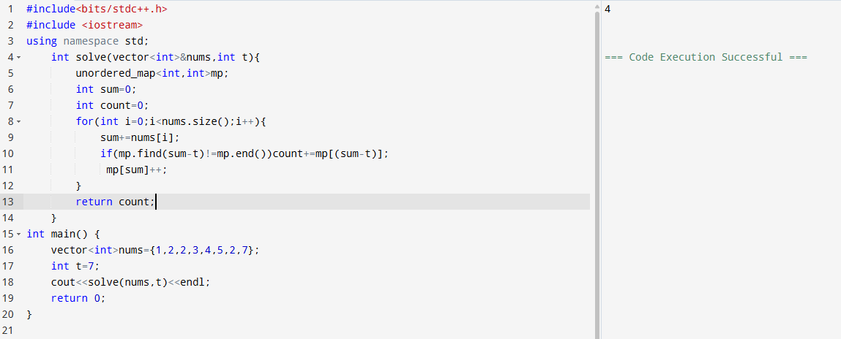

1. Linked Lists Add Two Numbers You are given two non-empty linked lists representing two non-negative integers. Add the two numbers and return the sum as a linked list.

