**CMP4272- DATA STRUCTURES AND ALGORITHMS**

**Student ID: anishkarki_24152356**

1. **Lab Submission Exercises:**

* **Submitting the solution of the following exercises is mandatory.**
* **Solutions that comprise of python code, must be well documented. (Include necessary comments)**

**For Exercise-6 and 7, use the** [**memory visualization tool**](https://werp.site/cs-toys/memory.html)**.**

**Exercise-6: Create a char array (size 5, values A, E, I, O and U).**

***[Copy the snapshot (showing memory, variables and objects) and attach here***

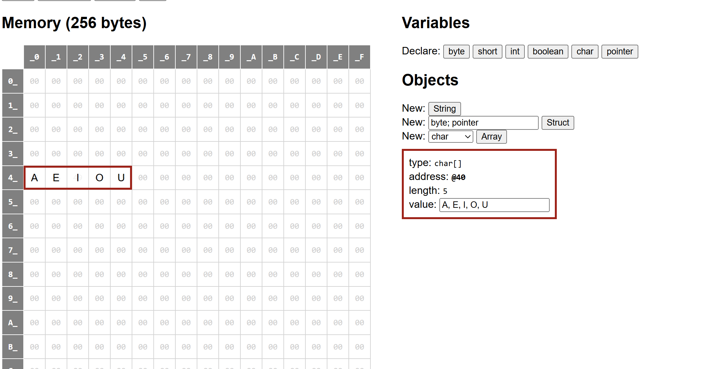

* **Discuss how array elements are arranged in memory.**

***Ans: array elements are together; they are automatically arranged one after another in contiguous memory.***

* **What is the amount of memory allocated to the array?**

***Ans: The total amount of memory allocated to the array is 5 bytes since, it is char,1 char takes 1 byte of memory.***

**Exercise-7: We want to store vowels in a linked list, address of which is stored in a pointer vow.**

* **Create appropriate variables and objects.**

***[Copy the snapshot (showing memory, variables and objects) and attach here]***

* **Create the proper linkages to form a linked list.**

***

* **Discuss what each of the pointer(reference) fields hold.**

**Ans: *In the picture, As you can see a linked list where char value A,address is @F2 and pointer value is @E2 that points to the second char value Similarly it repeat to U. It shows how linked list is connected to each other though its place will be random.***

**Exercise-8: The following classes (Foo and Bar) are defined:**

* **Draw a box-and-pointer diagram showing the program state after the following Python code has been executed:**

***

* **Write the necessary python code that when executed results in the state as reflected in the following BPD:**

***[Write your answer here Draw/Include necessary python code]***

***Solution:***

**Exercise-9: Refer to the Linked List implementation (Exercise 5), write the functions to add and delete a node at the end of the linked list. Test your code.**

***[Write your answer here Draw/Include necessary python code and output]***

1. **Moodle Submission:**

**You are required to submit your solution in the word document.**

**Naming Format: StudetName_studentID.docx [ or other word formats]**

**Example: AliceSmith_514099.docx**

**NOTE**

* **It is important to complete the weekly labs in particular labs 2, 3, 4, 5 and 6 because it contains questions that are part of the coursework. (Weightage: 25%).**
* **Only one of these labs will be chosen randomly for marking, so it is important that you complete and submit each of these labs.**
* **You must submit each lab within one week of that lab session.**
* **If you are unable to finish all the tasks, submit whatever you’ve managed to produce by the due date.**
* **Solutions that comprise of python code, must be well documented. (Include necessary comments)**