SMART IRRIGATION SYSTEM

*Anish karki*

Bachelor of science with Honors computer and data science, Sunway college Kathmandu

Birmingham city University (BCU)

[Anish.Karki@mail.bcu.ac.uk](mailto:A%6e%69%73%68%2eKa%72k%69@%6d%61i%6c%2e%62c%75.a%63%2e%75%6b)

*Abstract*-This research article addresses the significant global issue of water overconsumption in agriculture and proposes a solution through the implementation of a smart irrigation system. It highlights the advantages of utilizing IoT technology to reduce labor costs and enhance crop production. Additionally, the article includes a Tinker cad model for a smart irrigation system that monitors soil moisture and temperature conditions, watering the plants until the soil reaches optimal moisture levels.

*Keywords*- *internet of things, health, traffic, logistic, retail, smart cities, smart irrigation system, benefit of smart irrigation system*

# Introduction

Agriculture forms the foundation of human civilization, having been practiced from around 12,000 years according to the National Geographic Society. Despite its long history, the scientific optimization of agricultural methods remains incomplete. Currently, agriculture consumes 70% of the world’s freshwater resources, which is greater than human and business industry consumption, while 2.2 billion people lack access to clean drinking water, as reported by the world bank. With the skyrocketing of human population, industry is rising too, which means more consumption of water. Given the anticipated rapid population growth worldwide through 2050, farmers will need to increase food production by 70% to ensure adequate food supply for everyone So, Farmer need to meet future goal of production, while using less water than today and producing more food then now. Implementing smart irrigation techniques could potentially reduce water usage by about 50%, according to farmers who have adopted these methods. Without such innovations, the increasing strain on freshwater resources could have severe implications for human civilization. Smart irrigation can play a crucial role in addressing these challenges, helping farmers produce more food with less water and ensuring a sustainable future for agriculture and water resources (Ragab, 2022).

# Literature Review

The Internet of Things (IoT) is a network that connects devices and technology with humans and each other through sensors, software, and other mediums, enhancing comfort and convenience. First introduced by Kevin Ashton in 1999 at Procter & Gamble with the development of radio-frequency identification (RFID) chips for supply chain tracking, IoT has since evolved to include applications like smart irrigation systems (Radouan Ait Mouha, 2021). These systems make agriculture more scientific by automating the watering process based on soil moisture and temperature improving crop performance. A significant amount of time and human effort is wasted on watering plants inefficiently, often leading to overwatering or underwatering due to a lack of precise knowledge. However, with a smart irrigation system, farmers can avoid these issues. The system automatically waters the plants when needed, eliminating the need for human intervention, and can even be controlled remotely via a smartphone.

## Inovation:

Environment in today’s world is hyper competitive so to sustain innovation is necessary IoT began with the use of radio frequency technology to track supply chains, and it has since evolved to be in every industry to make people life easier (Aslam et al., 2020).From transparent supply chain through IOT device, smart homes, smart cities, E-health and many other field there is development in each sector ( et al., 2013). In the past, farmers had to visit their fields or employ workers to assess soil conditions and decide on watering. However, innovations in IoT have revolutionized agriculture. By connecting soil moisture and temperature sensors with water supply systems and Wi-Fi modules, IoT allows farmers to monitor conditions digitally and enables automated decision-making for watering plants based on real-time data (Obaideen et al., 2022).

## Security

With advancements in innovation, there has also been an increase in cyberattacks. If the data is stored using Wi-Fi electronics, there is a high chance of security risks. Specific measures should be taken to detect those behaviors. Additionally, privacy is a major concern that ensures consumers feel safe and confident while using IoT solutions (Srivastava & Pandey, 2022). Therefore,it is essential to secure our data to prevent misuse.

## Current trends

The Internet of Things (IoT) has become a prominent topic in today's tech-driven world as a next technological revolution. It has application in smart health monitoring, smart parking, smart homes, autonomous vehicles and many more fields (Islam et al., 2020). Besides the use of sensor and water motor to water plant directly the study is done which provide comprehensive insights into the physiological and environmental factors influencing plant responses to drought conditions in greenhouse settings, contributing valuable knowledge to the field of plant physiology and water management strategies in agriculture (Montesano et al., 2018).

## Future trends

It is estimated that there will be more than 21 billion IOT devices according to Norton which means there will be expansion in the amount of industry. Every current IOT sector will update as needed. With implementation of block chain data will be secure (Nartey et al., 2021). 5G transceiver will be capable of transmitting and receiving the data simultaneously on the same frequency (Shafique et al., 2020). More sensors can be added in smart irrigation such as PH, sunlight, groundwater in the field and take decision of water requirements based on results which will be more scientific (Salaria & Rakhra, 2024). Co2 concentration sensor can work with big data in the future (Pathak et al., 2019).

# Methodology

## Technnical Development

1. Flowchart

FIG-1 presents the flowchart required for smart irrigation. It starts by measuring soil moisture and temperature using sensors. If the soil moisture is less than 50% or the temperature is less than or equal to 30°C, the motor will start watering the soil. This will continue until the soil moisture level reaches or exceeds 50%. The data from these measurements will then be stored in a Wi-Fi module, allowing the user to have access to it. The process will stop thereafter.

*Fig 1: Flowchart of smart irrigation system*

## Logic gate

Fig 2 illustrates the logic gate expression for the smart irrigation system. A represents the power supply for all components. B and C represent the soil moisture and temperature, respectively, which pass through an OR gate. This indicates that if either soil moisture or temperature condition is met, the output will be true. The result from the OR gate is then combined with A using an AND gate, ensuring that both the power supply and either soil moisture or temperature condition must be true for water motor to start which results to A.(B+C). When both conditions are satisfied, the water motor will run. D represents the Wi-Fi module, which stores the data for user access. The output A(B+C) passes through another AND gate with D, activating the Wi-Fi module and storing the data, enabling user access and control over the system art.

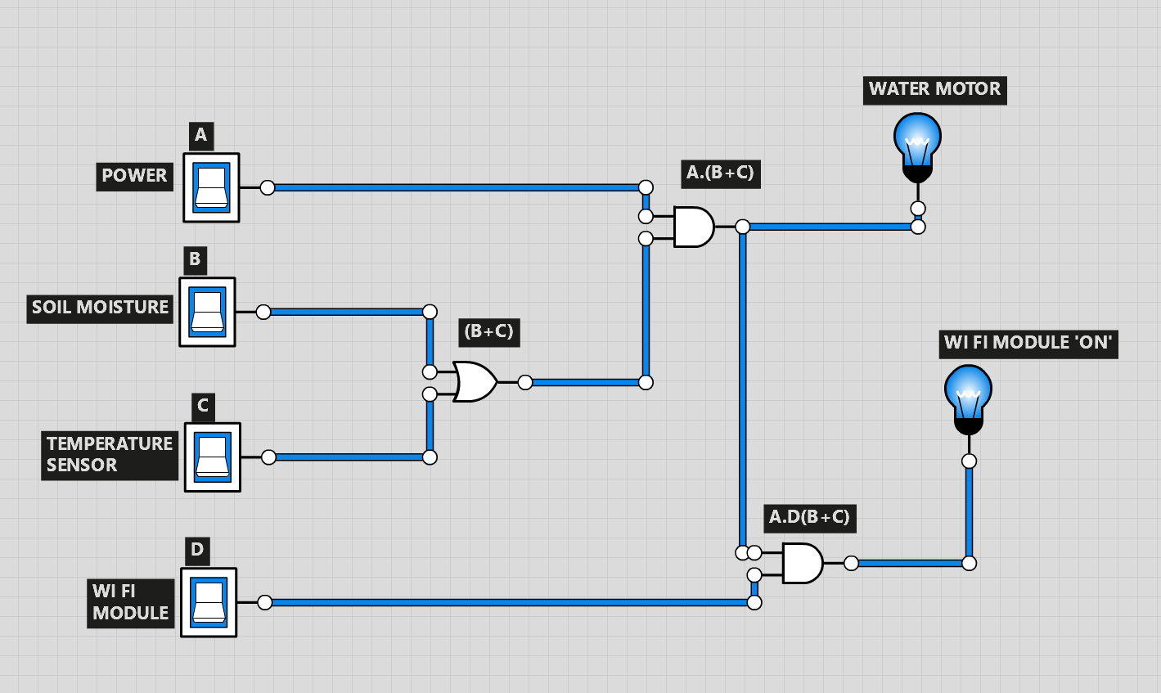

*FIG 1: LOGIC GATE OF SMART IRRIGATION SYSTEM*

## Truth table

The final equation of the system is:

Equation: A.(B+C)………….(1)

for water flow and A.D(B+C) for Wi Fi module

*TABLE 1: TRUTH TABLE OF SMART IRRIGATION SYSTEM*

|  |  |  |  |  |  |  |  |
| --- | --- | --- | --- | --- | --- | --- | --- |
| *CASES* | *Power* | *Soil Moisture* | *Temperature* | *Wi fi module* | *(B+C)* | *Water Flow* | *Wi fi module ‘ON’* |
| *A* | *B* | *C* | *D* | *OUTPUT* | *OUTPUT* |
| 1 | 0 | 0 | 0 | 0 | 0 | 0 | 0 |
| 2 | 0 | 0 | 0 | 1 | 0 | 0 | 0 |
| 3 | 0 | 0 | 1 | 0 | 1 | 0 | 0 |
| 4 | 0 | 0 | 1 | 1 | 1 | 0 | 0 |
| 5 | 0 | 1 | 0 | 0 | 0 | 0 | 0 |
| 6 | 0 | 1 | 0 | 1 | 0 | 0 | 0 |
| 7 | 0 | 1 | 1 | 0 | 1 | 0 | 0 |
| 8 | 0 | 1 | 1 | 1 | 1 | 0 | 0 |
| 9 | 1 | 0 | 0 | 0 | 0 | 0 | 0 |
| 10 | 1 | 0 | 0 | 1 | 0 | 0 | 0 |
| 11 | 1 | 0 | 1 | 0 | 1 | 1 | 0 |
| 12 | 1 | 0 | 1 | 1 | 1 | 1 | 1 |
| 13 | 1 | 1 | 0 | 0 | 0 | 0 | 0 |
| 14 | 1 | 1 | 0 | 1 | 0 | 0 | 0 |
| 15 | 1 | 1 | 1 | 0 | 1 | 1 | 0 |
| 16 | 1 | 1 | 1 | 1 | 1 | 1 | 1 |

Table 1 presents the truth table for the smart irrigation system based on logic gates. The table includes inputs such as power supply, soil moisture sensor, temperature sensor, and Wi-Fi module, and outputs such as water motor and Wi-Fi module status. Inputs are defined as 0 and 1, where 1 represents presence and 0 represents absence. Similarly, the outputs are binary, indicating the system's response based on the inputs. This truth table provides a comprehensive overview of the system's behavior, helping to analyze the relationship between inputs and outputs. Researchers can use this table to understand the system's logic and functioning

# hardware requirements

The components used in making digital version of device used in smart irrigation systems are listed in the table. It is designed in Tinker card. Each component has its own purpose, which is connected to a quantity utilized in the set up.

1. P2: 5,5 Power Supply: The power supply delivers power to the Arduino, which in turn supplies the necessary power to the output components, allowing them to carry out their tasks (Davis & Clowers, 2023).
2. U4: Arduino Uno R3: The Arduino Uno R3 is a microcontroller board where all input and output devices are connected. Tasks are executed using the C and C++ programming language (D’Ausilio, 2011).
3. SEN2: Soil Moisture Sensor: Tool to measure moisture of the soil and send information about the condition of the soil (Yu et al., 2021).
4. U5: Temperature Sensor [TMP36]: A sensor which measures the current temperature of specific surroundings and generates an output voltage linear with the Celsius temperature using an Arduino.
5. U6: PCF8574-based, 32 (0x20) LCD 16 x 2 (I2C): It serves as a user interface, allowing user to control the simulation (Davis & Clowers, 2023).
6. M2: DC Motor: The water flow is determined by the input channel. If the specified condition is met, water will flow. When the transistor receives a signal indicating that the condition to stop the water flow has been met, it stops the flow accordingly (Abdelmoamen Ahmed et al., 2020).
7. K2: Relay SPDT: IT is an electrical main voltage switch which can be turned on or off letting the current flow or not.
8. D1: Red LED: The LED works by sending digital signals. When the signal is high, the LED lights up and when the signal is low the LED is off.
9. R1: 220 Ω Resistor:

*TABLE II. Hardware Component used in Tinker Cad Design*

|  |  |  |  |
| --- | --- | --- | --- |
| S. N | Hardware | Quantity | Name |
| 1. | 5, 5 Power Supply | 1 | P1 |
| 2. | Arduino Uno R3 | 1 | U 7 |
| 3. | Soil Moisture Sensor | 1 | SEN 2 |
| 4. | Temperature Sensor [TMP36] | 1 | U 3 |
| 5. | PCF8574-based, 32 (0x20) LCD 16 x 2 (I2C) | 1 | U 2 |
| 6. | DC Motor | 1 | M 9 |
| 7. | Relay SPDT | 1 | K 4 |
| 8. | Red LED | 1 | D 5 |
| 9. | 220 Ω Resistor | 1 | R 6 |

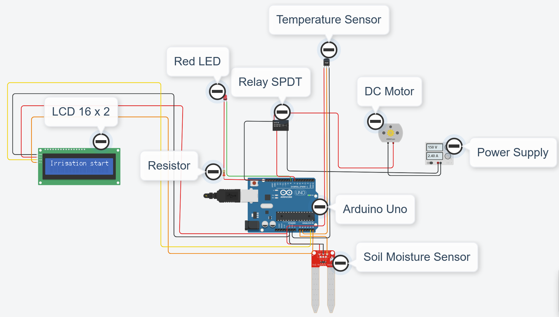

*FIG 2: Smart Irrigation System Tinker Cad Design*

*FIG 3: Systematic Diagram of Smart Irrigation System Tinker Cad Design*

# hardware implementation

There is a power supply in Arduino. The soil moisture and temperature sensor are connected to Arduino, if the condition is meet then motor will run until condition says to stop then these data will cloud through Wi-Fi module then it will send notification to user.

# discussion

The smart irrigation system utilizes an Arduino microcontroller interfaced with a soil moisture sensor, a temperature sensor, an LCD display, a DC motor, a Relay SPDT, a Red LED, and resistors to measure soil moisture and temperature. When the temperature is above a set threshold and the soil moisture is below a certain value, the system automatically activates water flow until soil moisture is above a certain value.

First, power is supplied through a power supply to the motor and the SPDT relay, which are connected to the Arduino. Other components like the LCD, soil moisture sensor, temperature sensor, and resistors are also connected through the Arduino.

The Arduino reads the soil moisture sensor (connected to analog pin A0) and the temperature sensor (connected to analog pin A1). It simultaneously checks the soil moisture and temperature values. If the soil moisture is below a certain threshold (600 in this case) or the temperature is less than or equal to 20 degrees Celsius, this status is displayed on the LCD. The SPDT relay, which controls the power to the DC motor, is then switched on, allowing water to flow through the DC motor until the soil moisture exceeds the threshold of 600. If these conditions are not met, the system remains off.

# CONCLUSION AND RECOMENDATION

To save water resources and human energy, low-income farmers often struggle to afford automatic devices that help water plants based on soil needs, as these devices are expensive. This research proposes an IoT-based smart irrigation system, built with various components and a machine learning algorithm, designed to be affordable for farmers and anyone with a garden or small crop field. Although the initial setup may involve some costs, it is more beneficial in the long run compared to manual watering, which can lead to over or under-watering. This system maximizes irrigation efficiency while maintaining plant health and quality. The system collects data through a Wi-Fi module and provides information to the user, allowing remote access and control from anywhere in the world. This not only simplifies human effort but also supports UN Sustainable Development Goal 6 (clean water and sanitation) by ensuring sustainable water management, and Goal 8 (decent work and economic growth) by enhancing crop efficiency and reducing the need for external energy for irrigation.

# SECURITY CONSIDERATION

Multiple sensors used for smart irrigation are connected and store their data in the cloud. This makes the data vulnerable to cyber-attacks, so encryption is essential to ensure it remains secure. Employing methods such as Advanced Encryption Standard (AES) and Data Encryption Standard (DES), among others, can protect the data. Additionally, regularly updating passwords can further safeguard the system from attacks.

##### References

Eason G, Noble N, and Sneddon N.I, (1995) “On certain integrals of Lipschitz-Hankel type involving products of Bessel functions,” Phil. Trans. Roy. Soc. London

Ragab, M. (2022) ‘IOT based Smart Irrigation System’, *International Journal of Industry and Sustainable Development*, 0(0), pp. 0–0. doi:10.21608/ijisd.2022.148007.1021.

Radouan Ait Mouha, R.A. (2021) ‘Internet of things (IOT)’, *Journal of Data Analysis and Information Processing*, 09(02), pp. 77–101. doi:10.4236/jdaip.2021.92006.

Aslam, F. *et al.* (2020) ‘Innovation in the era of IOT and industry 5.0: Absolute Innovation Management (AIM) framework’, *Information*, 11(2), p. 124. doi:10.3390/info11020124.

Obaideen, K. *et al.* (2022) ‘An overview of smart irrigation systems using IOT’, *Energy Nexus*, 7, p. 100124. doi:10.1016/j.nexus.2022.100124.

Thorsten Kramp *et al.* (2013) *Enabling things to talk*. Springer-Verlag GmbH.

Srivastava, N. and Pandey, P. (2022) ‘Internet of things (IOT): Applications, trends, issues and challenges’, *Materials Today: Proceedings*, 69, pp. 587–591. doi:10.1016/j.matpr.2022.09.490.

Islam, Md.M., Rahaman, A. and Islam, Md.R. (2020) ‘Development of Smart Healthcare Monitoring System in IOT environment’, *SN Computer Science*, 1(3). doi:10.1007/s42979-020-00195-y.

Pathak, A. *et al.* (2019) ‘IOT based smart system to support agricultural parameters: A case study’, *Procedia Computer Science*, 155, pp. 648–653. doi:10.1016/j.procs.2019.08.092.

Pathak, A. *et al.* (2019a) ‘IOT based smart system to support agricultural parameters: A case study’, *Procedia Computer Science*, 155, pp. 648–653. doi:10.1016/j.procs.2019.08.092.

Montesano, F.F. *et al.* (2018) ‘Sensor-based irrigation management of soilless Basil using a new smart irrigation system: Effects of set-point on plant physiological responses and crop performance’, *Agricultural Water Management*, 203, pp. 20–29. doi:10.1016/j.agwat.2018.02.019.

Nartey, C. *et al.* (2021) ‘On Blockchain and IOT integration platforms: Current implementation challenges and future perspectives’, *Wireless Communications and Mobile Computing*, 2021, pp. 1–25. doi:10.1155/2021/6672482.

Shafique, K. *et al.* (2020) ‘Internet of things (IOT) for next-generation smart systems: A review of current challenges, future trends and prospects for emerging 5G-IOT scenarios’, *IEEE Access*, 8, pp. 23022–23040. doi:10.1109/access.2020.2970118.

Salaria, A. and Rakhra, M. (2024) ‘Analysis on future of farming: Smart Energy Systems in agriculture’, *2024 11th International Conference on Reliability, Infocom Technologies and Optimization (Trends and Future Directions) (ICRITO)* [Preprint]. doi:10.1109/icrito61523.2024.10522415.

D’Ausilio, A. (2011) ‘Arduino: A low-cost multipurpose lab equipment’, *Behavior Research Methods*, 44(2), pp. 305–313. doi:10.3758/s13428-011-0163-z.

Yu, L. *et al.* (2021) ‘Review of research progress on Soil Moisture Sensor Technology’, *International Journal of Agricultural and Biological Engineering*, 14(3), pp. 32–42. doi:10.25165/j.ijabe.20211404.6404.

Davis, E.J. and Clowers, B.H. (2023) ‘Low-cost Arduino controlled dual-polarity high voltage power supply’, *HardwareX*, 13. doi:10.1016/j.ohx.2022.e00382.

Davis, E.J. and Clowers, B.H. (2023) ‘Low-cost Arduino controlled dual-polarity high voltage power supply’, *HardwareX*, 13. doi:10.1016/j.ohx.2022.e00382.

Abdelmoamen Ahmed, A. *et al.* (2020) ‘A distributed system for supporting smart irrigation using internet of things technology’, *Engineering Reports*, 3(7). doi:10.1002/eng2.12352.