Lab 3: DSA

Exercise- 1

Create variables of different types and assign appropriate values.

* + 1. Types: byte

When variables are created, first it will take random memory address. Here the memory address is @1C i.e. Column number 1 and row number C. Each one box represents the size 1 byte and 1 byte = 8 bits.

* + 1. Types: int

Int data type is a type of data which represents whole numbers e.g.1,2,21 etc. It has the size of 4 bytes i.e. 32 bits.

* + 1. Type: short

Short datatype is a part of int data type which size is 2 bytes i.e. 16 bits. It is used to save memory in large arrays where memory saving matters though in python, we don’t use shorts.

* + 1. Type: Boolean

Boolean is a datatype which represents two values: ‘True’ and ‘False’. It is typically used in logical operation. The size is typically 1 byte(8bits).

* + 1. Type: char

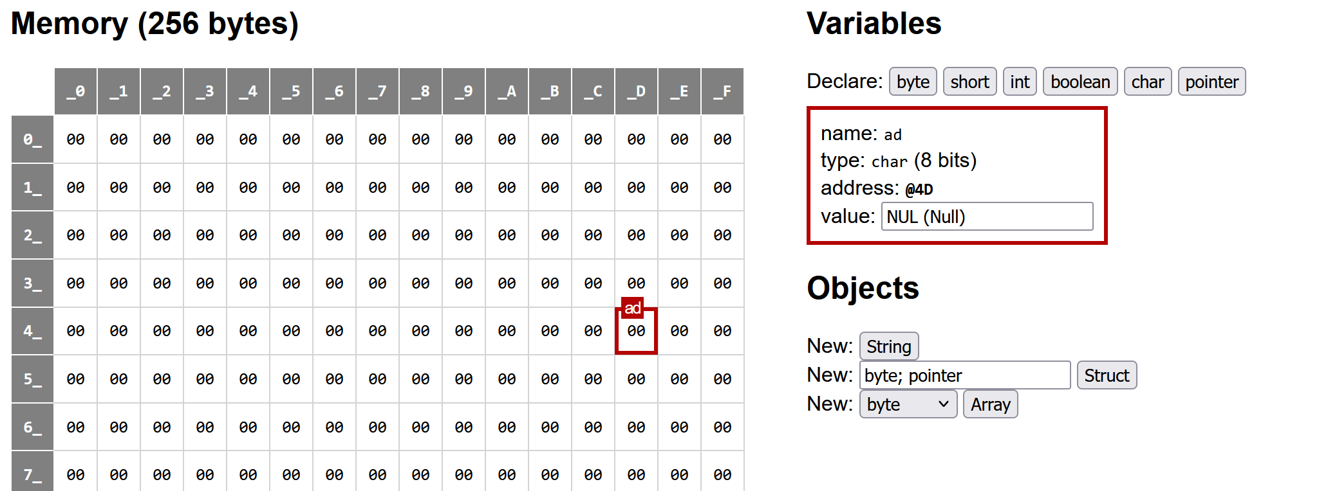

Char is a datatype which represents single value such as ‘A’, ‘E’. Its size is 2 bytes

(8bits).

Exercise: 2

Create a variable of pointer type.

Exercise: 3

Create an integer array (size 5, values 10,20,30,40 and 50).

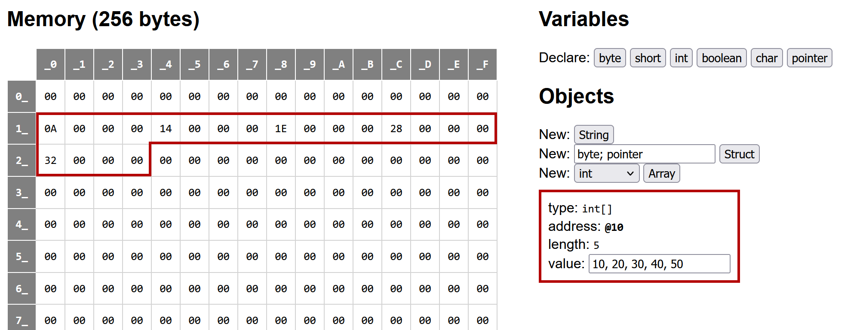

* When we create integer arrays, as a nature of RAM it takes a random memory space to put a value. We create int of size 5 and each contain 4 bytes so value 10 takes 4 bytes where @10 has value ‘0A’ and three space has value of ‘0’. Similarly, it goes to 20,30,40 and 50.
* Since each size of 1 int is 4 byte and we create size of 5, i.e. 20 byte which also means 160bits.

Exercise: 4

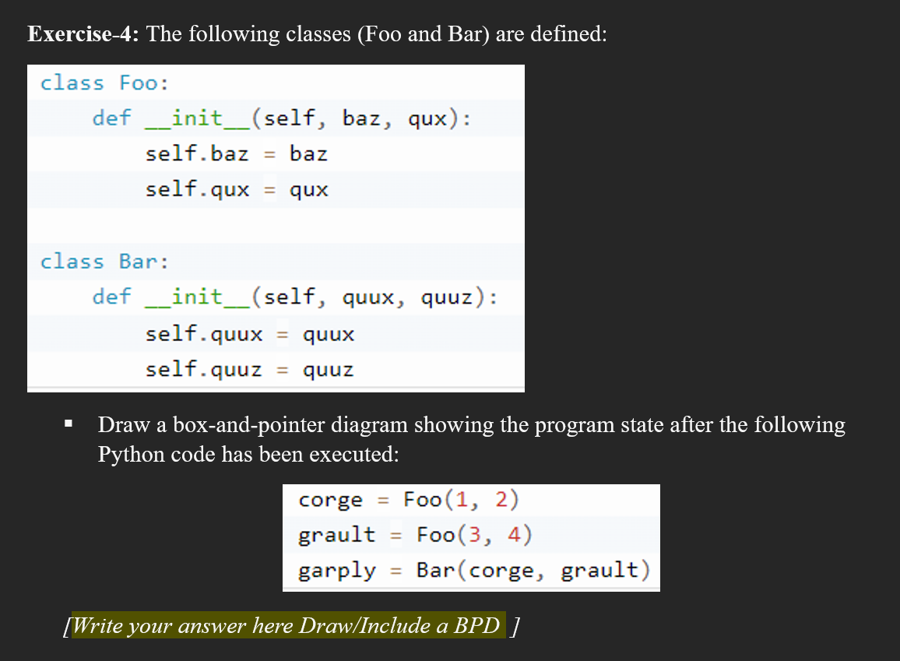

Solution:

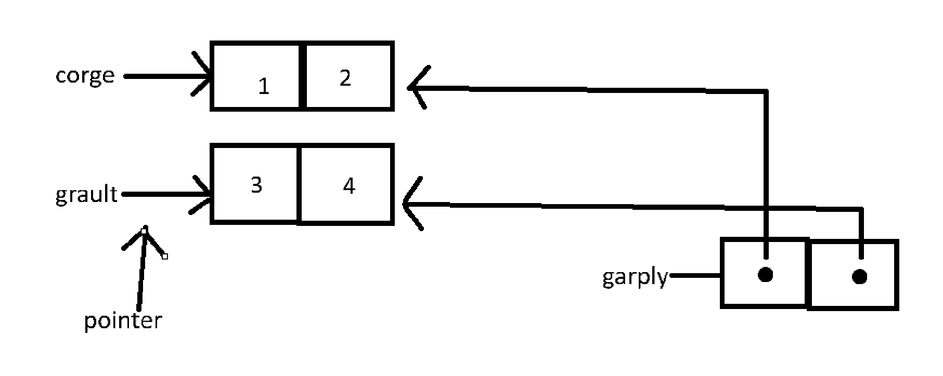

ii)

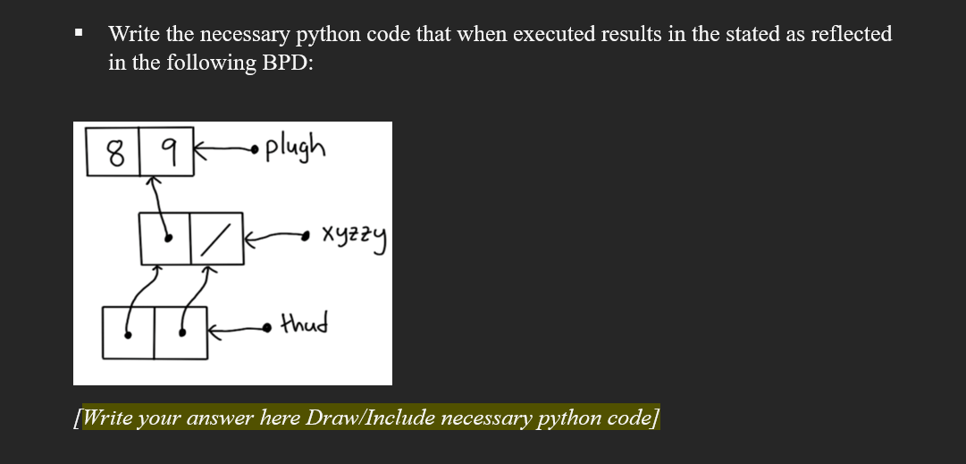

Solution:

Exercise: 5

Linked list Operation (Implementation)

1. We define the class for Node.
2. We define the class for LinkedList.
3. Add, Delete Operations
4. We will write a display method where we traverse the list and display the data of each node.

