Energy Efficient Wireless Sensor Networks
  - COA APSO LEACH research and project documentation
Implementation, experiments, demonstration guide and research plan
14 October 2026
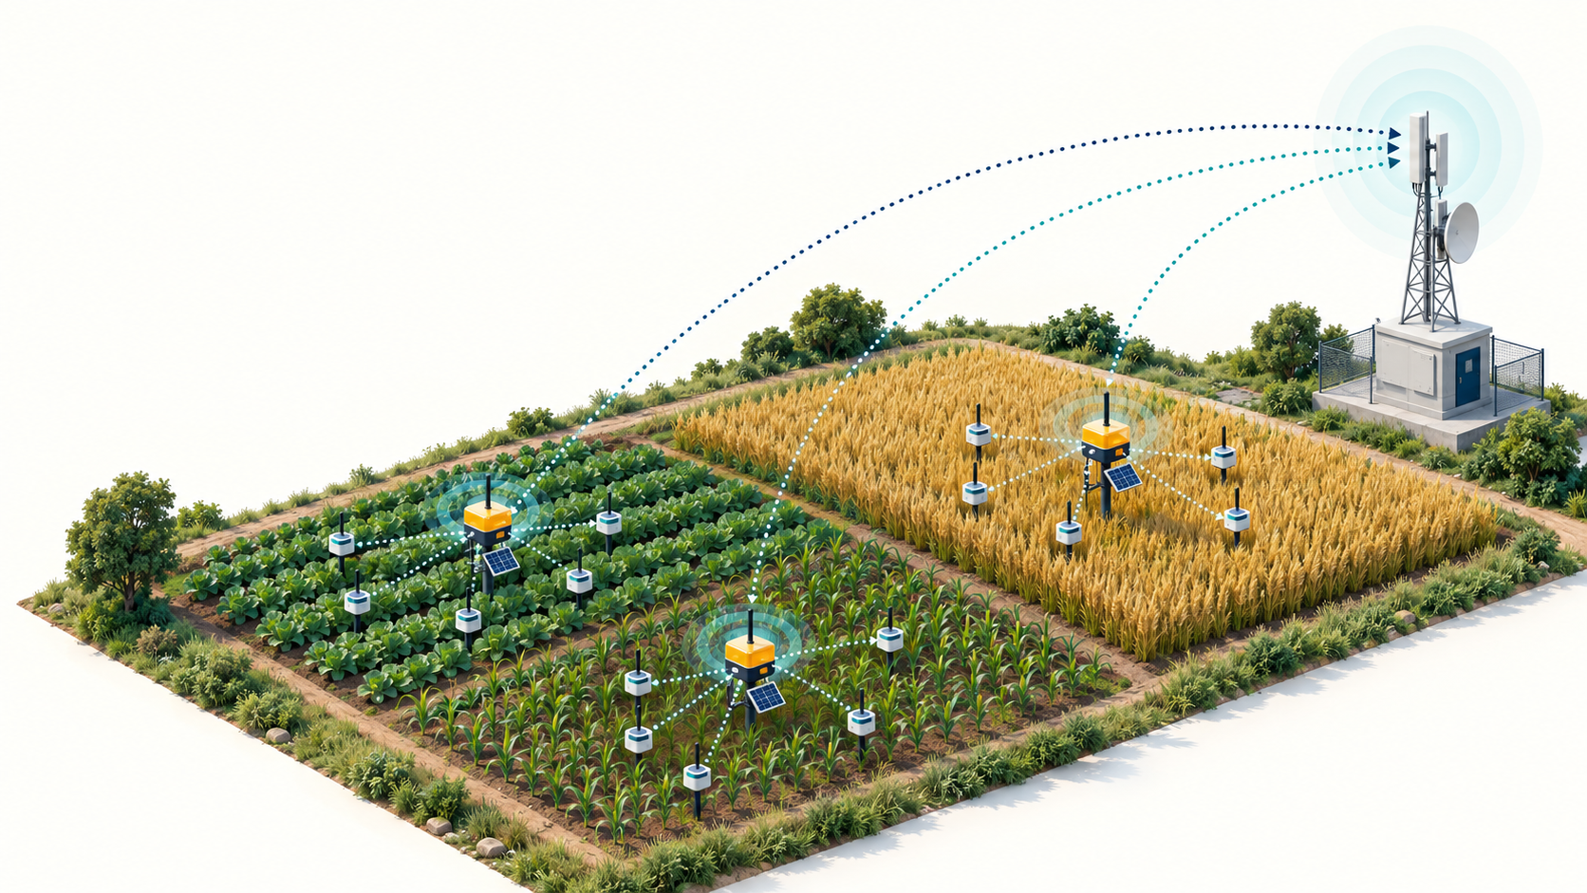
Conceptual illustration. See the evidence index for visual provenance.

Purpose and status
A detailed guide for understanding and presenting the working Python and Contiki-NG prototype. The saved numerical experiment and Cooja networking smoke test succeeded. Comparative lifetime, calibrated device energy and research novelty require further evaluation.

Contents
01 Project overview
02 Network concepts and research problem
03 Related work and contribution boundaries
04 Architecture and division of responsibilities
05 Python radio and control energy model
06 Particle swarm search and fitness
07 Control overhead aware decision rule
08 Experimental configuration and baseline fairness
09 Python results and interpretation
10 Reading the Python visualizations
11 Contiki firmware and message exchange
12 Cooja window and verified execution
13 Energest accounting and measurement limits
14 Run and demonstrate the project
15 Code map and reproducibility record
16 Limitations and engineering follow up
17 Research evaluation plan
18 Viva questions and troubleshooting
19 References and evidence index
The accompanying PowerPoint contains 28 slides with speaker notes. Headings in this report support navigation through Word’s Navigation Pane.

1 Project overview
This report explains the COA-APSO-LEACH research prototype, its implementation, the completed experiments and the steps needed to demonstrate it. The intended audience is a student presenting the work to a project supervisor or examination panel. The central question is whether the predicted benefit of a new cluster arrangement justifies the energy spent establishing it.
COA means control-overhead-aware. APSO means adaptive particle swarm optimization. LEACH expands to Low-Energy Adaptive Clustering Hierarchy. The project combines a custom clustering optimizer with a switching decision and an optional modeled relay strategy. The name describes the implementation concept; it does not establish that the combination is a new research contribution.
The Python experiment completed a comparison of five protocols for 60 sensors over 450 rounds with seed 42. The proposed method retained all 60 sensors, recorded seven cluster reconfigurations and consumed 0.046516 J of modeled control energy. Periodic APSO recorded 24 reconfigurations and 0.069045 J of control energy. These are single-run model outputs.
The Contiki-NG application compiled and passed a separate Cooja test lasting 600 simulated seconds with one root and eight sensors. All sensors received configurations and produced activity reports. The root received 114 aggregate packets containing 299 samples. This establishes working application communication under the tested scenario. It does not establish comparative lifetime improvement or physical-device energy consumption.
The report proceeds through the problem and research hypothesis, implementation details, the Python results, Cooja operation, reproducibility, limitations and the proposed research programme. The accompanying presentation provides concise slides with fuller explanations in the speaker notes.
Conceptual illustration of clustered field sensing, generated for explanation. The tested software does not implement energy harvesting or this physical deployment.

2 Network concepts and research problem
A wireless sensor network consists of sensor nodes that collect readings and communicate with a collection point called the base station or sink. Each sensor has a finite energy budget in the Python model. A cluster groups several sensors around a selected cluster head. Members send to the head, which receives and aggregates observations before forwarding data toward the sink.
Cluster heads typically perform more work than ordinary members because they receive multiple messages and transmit an aggregate. Leaving one poorly positioned or depleted node as a head can concentrate the burden. Periodic re-selection can distribute load, but every reconfiguration introduces setup messages. The optimal frequency therefore depends on both the future data cost and the cost of changing the configuration.
The proposed research question is: under matched operating conditions, can an explicit cost-benefit decision suppress unnecessary APSO cluster changes while preserving network service and lifetime? The candidate decision uses the estimated reduction in one-round data energy, multiplies it by a lookahead horizon, and compares that benefit with a margin-adjusted setup estimate.
H1 predicts fewer reconfigurations and lower control energy than periodic APSO. H2 predicts that any reduction remains useful when total energy, surviving sensors and communication quality are considered. H3 predicts consistent effects over repeated seeds and alternative network conditions. Current evidence demonstrates one example of H1, while H2 and H3 remain research questions.
A credible contribution would show where this decision helps, where it does not, and how its sensitivity compares with prior overhead-aware reclustering methods. A newly combined project name, a single graph or a successful simulator run cannot independently establish novelty.
Term | Meaning in this project
Sensor | A modeled node in Python or a Contiki mote in Cooja
Cluster head | A selected sensor that collects member readings
Control overhead | Communication used to establish or monitor configuration
Lifetime | Rounds until a specified node-death event
Reconfiguration | A change in the selected set of cluster heads

3 Related work and contribution boundaries
Haris and Nam (2025) study PSO-based cluster-head selection with adaptive inertia and residual-energy considerations. Their institutional abstract describes a double-exponential inertia update and cluster construction informed by energy and location. This motivates adaptive optimization, but the project uses its own cosine inertia rule and fixed fitness weights. Its PSO baseline is therefore a simplified local implementation, not a reproduction of that paper.
Zhang, Yang and Tan (2025) study adaptive routing for heterogeneous wireless sensor networks, including improved PSO and hybrid single-hop/multi-hop communication. This motivates testing different energy levels and relay choices. The present code uses a simple energy comparison for a possible head-to-head relay. It does not reproduce all mechanisms, analysis or experiments in that publication.
The proposed focus is the adoption gate after candidate optimization: retain the current clustering unless predicted savings exceed reconfiguration cost, with an energy safety override. This claim should be positioned as a research hypothesis until a focused search and comparison with prior event-driven, threshold-based and overhead-aware reclustering algorithms is complete.
Published performance percentages from other papers are not used as expected performance for this project. Their configurations, algorithms and traffic models differ. The README also lists Abose et al. (2024), DOI 10.1109/ACCESS.2024.3429645, as a reading lead. That paper should be reviewed from its primary text before using it to support a specific algorithm or novelty claim.
For a literature comparison, record each method’s head-selection criterion, state-collection cost, reclustering trigger, radio model, topology, packet size, sink placement and lifetime definition. This prevents the comparison from rewarding an algorithm simply because its evaluation omits costs that another algorithm pays.
Source | Use here | Boundary
Haris and Nam 2025 | Motivates adaptive PSO | No exact reproduction
Zhang et al 2025 | Motivates heterogeneity and relay tests | Simplified relay model
Contiki-NG documentation | Defines simulator and activity accounting | No calibrated energy profile
Local source and saved outputs | Supports implementation and result claims | Single-seed model run and smoke test

4 Architecture and division of responsibilities
Python contains the complete optimization logic in simulator/engine.py. run_demo.py creates the saved comparison, figures and dashboard. export_cooja_policy.py executes a separate small-network optimization and writes a fixed assignment table to cooja/policy.h. The table becomes part of the compiled root firmware.
Contiki-NG is the embedded operating system and networking environment used by the C programs. root.c starts the routing root, records sensor IPv6 addresses and distributes assignments. node.c registers with the root, processes configuration, sends readings or aggregates, and logs Energest activity. IPv6 and RPL provide addressing and routing, while UDP carries application messages.
Cooja executes virtual motes and models their communication. The project uses native Cooja motes rather than cycle-accurate emulation of a selected physical sensor board. Its Network view displays mote positions, Mote output displays firmware logs, Radio messages exposes packets and Timeline displays activity. See the official tutorial in the references.
The connection between Python and Cooja is an offline file exchange: Python produces policy.h before compilation. There is no live feedback controller that reads Cooja energy or packet measurements and reruns PSO during execution. A future online controller would need a measurement interface, state estimator, decision schedule and reliable configuration protocol.
The Python and Cooja experiments intentionally answer different questions. The former compares modeled algorithm costs. The latter demonstrates application messages traversing a real network stack in simulation. Their different node counts, geometry, payloads and energy abstractions mean that their numeric results must remain separate.
Stage | Input | Output
Python comparison | Configuration and seed | Graphs, CSV and dashboard
Policy export | Eight sensor positions and modeled energy | Six-epoch policy.h
Firmware build | C sources and policy.h | Root and sensor mote binaries
Cooja execution | demo.csc and binaries | Packet and activity logs
Log analysis | Saved text output | JSON report and per-node tick CSV

5 Python radio and control energy model
For a packet containing b bits and a link distance d, the model uses Etx(b,d) = b[Eelec + εfs d²] when d < d0, and Etx(b,d) = b[Eelec + εmp d⁴] otherwise. Reception costs Erx(b) = bEelec. The switching distance is d0 = sqrt(εfs/εmp), approximately 87.71 m with the implemented constants.
Each non-head sensor sends one modeled data packet to its nearest selected head. The head pays receive and aggregation costs for those readings, aggregation for its own reading, and transmission toward the sink. Optional hybrid routing compares direct head-to-sink transmission with a one-relay path through another head, including the relay receive and forwarding cost. Relays below 12% of initial energy are excluded from consideration.
setup_energy estimates two head broadcasts, representing advertisement and schedule, plus a join request from each member. It charges modeled transmission and intended-receiver reception costs. It does not include all nodes overhearing broadcasts. status_energy charges an alive sensor’s transmission of a control packet toward the powered base station when the PSO controller collects state.
The simulator subtracts energy and clips residual values at zero. Its first-order model assumes successful data communication and omits collisions, MAC retransmissions, channel interference and idle listening. The packet counter records generated modeled traffic, so it is not evidence of packet delivery ratio. Controller CPU energy is excluded under the assumption of a powered base station.
Near depletion, charged energy may exceed an individual node’s remaining energy before clipping. Cumulative charged control cost is therefore an accounting estimate, not always identical to physically spendable battery loss. A more rigorous lifetime model should reconcile energy-limited transmissions and failed operations.
Parameter | Value
Eelec | 50 nJ/bit
EDA | 5 nJ/bit
εfs | 10 pJ/bit/m²
εmp | 0.0013 pJ/bit/m⁴
Data packet | 4000 bits
Control packet | 128 bits

6 Particle swarm search and fitness
A particle is a continuous vector containing k pairs of candidate coordinates. decode_cluster_heads maps each coordinate pair to a distinct, existing alive node, selecting nearby eligible sensors without duplicates. assign_nodes then associates each alive sensor with its nearest selected head. This mapping keeps the optimizer’s output deployable as sensor identities.
For each iteration, the optimizer evaluates each particle, updates its personal best and the swarm’s global best, and updates velocity and position. The implementation uses v = wv + 1.6r1(pbest − x) + 1.6r2(gbest − x), then x = x + v. Random coefficients r1 and r2 vary by coordinate. Velocities are clipped to one quarter of the area length and positions remain within the sensing area.
Standard PSO fixes inertia at 0.70. Adaptive PSO uses w(t) = 0.45 + 0.225[1 + cos(πt/(T − 1))], giving a smooth decrease from 0.90 to 0.45 for T > 1. This encourages wider movement initially and smaller steps later. When feasible, the current clustering initializes one particle so the search can retain a useful incumbent.
The fitness is F = 0.65E_norm + 0.16L_imbalance + 0.14S_energy + 0.05D_energy. E_norm divides the estimated total data-round energy by an alive-node reference cost. Load imbalance is the standard deviation of cluster sizes divided by the mean-size reference. Scarcity is the mean of one minus relative head energy. Dispersion is the standard deviation of relative head energy.
These weights are design choices. They have not been established as optimal by a tuning study. Fitness mixes immediate data cost and distributional penalties, whereas the final adoption gate compares only predicted data-energy saving against setup cost. A lower fitness therefore does not necessarily imply that the gate should accept a candidate.
Saved demo setting | Value
Particles | 9
Iterations | 10
Target cluster heads | 5
Learning coefficients | 1.6 and 1.6
Adaptive inertia endpoints | 0.90 and 0.45

7 Control overhead aware decision rule
At a scheduled check or emergency, the proposed controller pays the modeled status-reporting cost and asks APSO for a candidate head set. Let C_old be the estimated one-round data energy under the existing set and C_new the corresponding estimate for the candidate. With horizon H, predicted saving is B = H(C_old − C_new). Let S_new be candidate setup cost and m the safety margin. The ordinary rule accepts a different head set when B > mS_new.
The saved Python experiment uses H = 15, m = 1.15 and a check period of 15 rounds. A head with residual energy below 22% of its initial energy triggers the safety condition. Missing or dead heads also require reconsideration. The same-set check avoids counting an ineffective replacement as a change. A rejected candidate still incurs reporting and optimization effort.
For a teaching example, suppose a new clustering saves 0.20 mJ per round and needs 2.00 mJ of setup. The predicted benefit over 15 rounds is 3.00 mJ. The margin-adjusted cost is 2.30 mJ, so the change passes. At 0.10 mJ per round, benefit would be only 1.50 mJ and the current heads would remain. These numbers illustrate the rule and are not project measurements.
The estimate assumes the current round-cost difference persists over the horizon. It does not forecast changes in residual energy, channel quality, traffic or membership. A large horizon can overstate benefits under changing conditions; a small horizon can reject beneficial long-term moves. Sensitivity analysis must therefore vary both horizon and margin.
A useful ablation keeps topology, telemetry schedule, PSO fitness, random seed and relay setting fixed while changing only the adoption gate. Additional ablations can then isolate adaptive inertia and hybrid routing. This makes it possible to attribute an observed improvement to the proposed mechanism.
Step | Action
1 | Collect state and debit reporting cost
2 | Generate APSO candidate
3 | Estimate old and new data costs
4 | Compare horizon benefit with setup cost
5 | Accept if worthwhile or safety override applies
6 | Debit setup only for an actual change and run data round

8 Experimental configuration and baseline fairness
The saved single-run experiment uses 60 sensors placed within a 100 m by 100 m square, seed 42 and 450 rounds. The base station is at (50,125), outside the sensing area. Initial node energies are sampled from 0.5, 1.0 and 2.0 J with probabilities 70%, 23% and 7%. These are probabilities, not guaranteed counts in a finite sample.
All protocols start from the same sampled positions and energies. The target number of heads is five. LEACH uses a randomized threshold approximation with eligibility history and a fallback election; its actual head count can vary. E-LEACH ranks alive nodes by residual energy. Standard PSO and APSO evaluate periodically or on a safety event. The proposed method evaluates on the matching check schedule but can reject candidates.
Setup cost and reconfiguration count increase only when the selected set changes. Thus a 15-round evaluation interval does not imply exactly 30 changes over 450 rounds. The counter includes initial formation. The PSO and proposed variants use the same optional relay model, which avoids attributing all relay benefits exclusively to the proposed method.
There is an important accounting asymmetry: E-LEACH reads residual energies without the status-report cost charged to the PSO methods. Its very low control-energy result is therefore not a fair deployment-level estimate under a common centralized reporting protocol. A revised benchmark should explicitly harmonize information acquisition and disclose which nodes receive each control message.
run_demo.py uses a reduced search budget of nine particles and ten iterations for the saved run. run_research.py uses the Config defaults of ten particles and twelve iterations, and seeds starting at one. The repeated-seed script therefore does not exactly repeat the saved demo configuration without adjustment. Record the complete configuration for each experiment.
Parameter | Saved value
Nodes, rounds, seed | 60, 450, 42
Area and sink | 100 × 100 m; (50,125)
Target heads | 5
Period and check period | 15 rounds each
Lookahead and setup margin | 15 rounds and 1.15
Hybrid routing | Enabled

9 Python results and interpretation
The proposed method ends with all 60 sensors alive, 31.065565 J residual energy, 0.046516 J control energy and seven reconfigurations. Periodic APSO also retains all 60 sensors, with 31.021166 J residual energy, 0.069045 J control energy and 24 reconfigurations. The control-energy reduction is 32.63%, and the reconfiguration reduction is 70.83%, relative to APSO in this run.
The final residual-energy difference against APSO is 0.044400 J, approximately 0.143% of APSO’s residual energy. That is a much smaller effect than the percentage reduction in control energy. The control result must not be relabeled as a total-energy reduction. Standard PSO ends at 31.063750 J, very close to the proposed result, so the model does not show a large separation in residual energy.
E-LEACH has the lowest modeled control cost at 0.024852 J. It also ends with less residual energy than the proposed method. This illustrates why control energy, total energy and service must be considered together, while remembering the telemetry-accounting asymmetry described in the previous section.
LEACH experiences its first node death at round 322 and ends with 52 live nodes. No first-node-death event occurs for the other four methods within 450 rounds. Their first-death times are right-censored by the horizon. Half-node and last-node death are likewise unobserved. These results do not provide a complete lifetime ranking.
The plotted curves and summary table are reproducible outputs of this source revision and seed. They should be described as modeled results, with no claim of statistical significance, universal superiority, hardware validation or measured delivery quality.
Protocol | Alive | Residual J | Control J | Changes
LEACH | 52 | 28.1493 | 0.7478 | 450
E-LEACH | 60 | 30.9295 | 0.0249 | 16
PSO-LEACH | 60 | 31.0638 | 0.0736 | 27
APSO-LEACH | 60 | 31.0212 | 0.0690 | 24
COA-APSO-LEACH | 60 | 31.0656 | 0.0465 | 7

10 Reading the Python visualizations
The alive-node plot shows survival over rounds. The residual-energy plot adds remaining modeled battery energy across nodes. The control-overhead plot accumulates the setup and reporting costs charged by each implementation. The reconfiguration chart counts actual head-set changes, including initial formation. These views answer different questions and should be read together.
The dashboard is results/dashboard.html and can be opened in a normal browser. Its figures are static outputs from the completed run. Changing the Python source or a configuration does not update the page until run_demo.py is executed again. The topology image shows an initial cluster snapshot, not the final battery state.
During a presentation, first identify the axes, units, protocol names, seed and horizon. Then state a result using its exact metric: for example, lower modeled control energy relative to APSO. Explain that all four optimized baselines survive to the end of this short horizon, so their lifetime differences remain unknown.
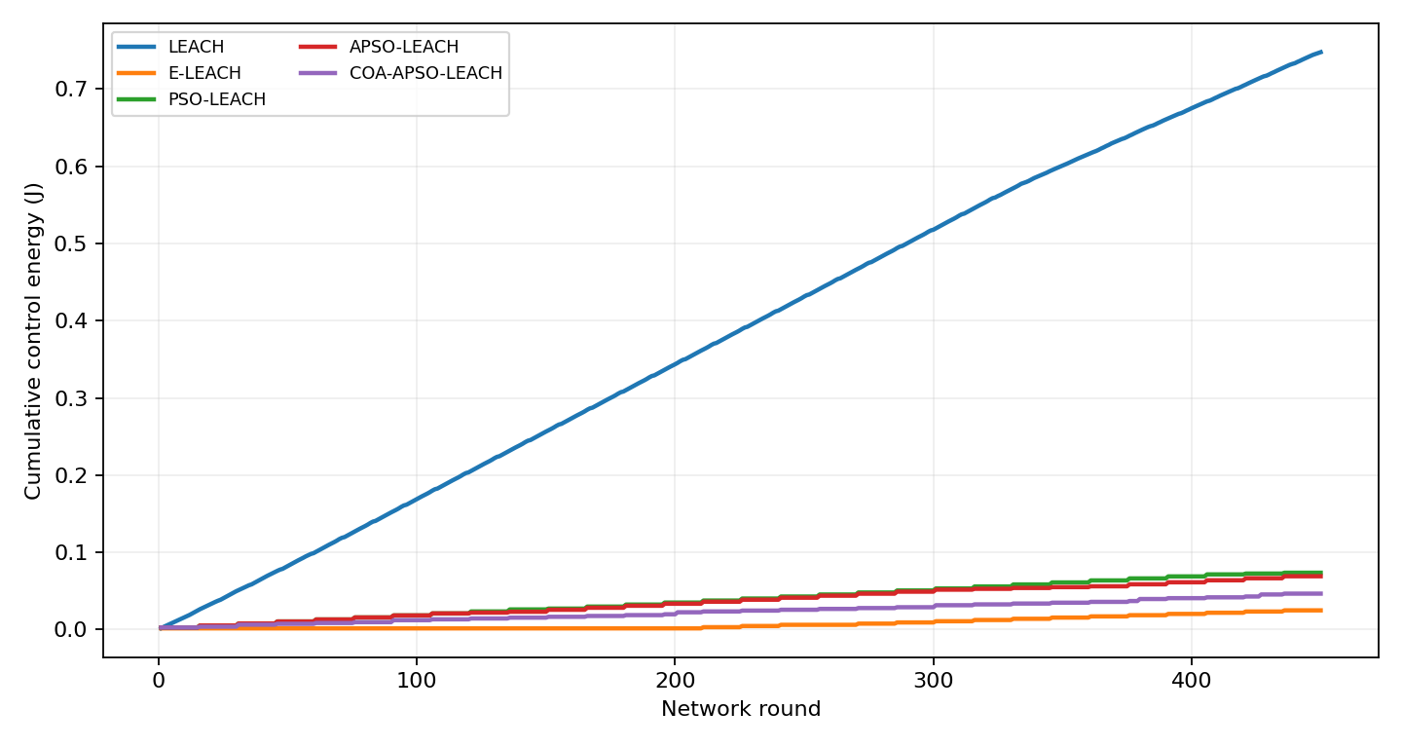
Cumulative modeled control energy for the saved run. The E-LEACH baseline uses different telemetry accounting.
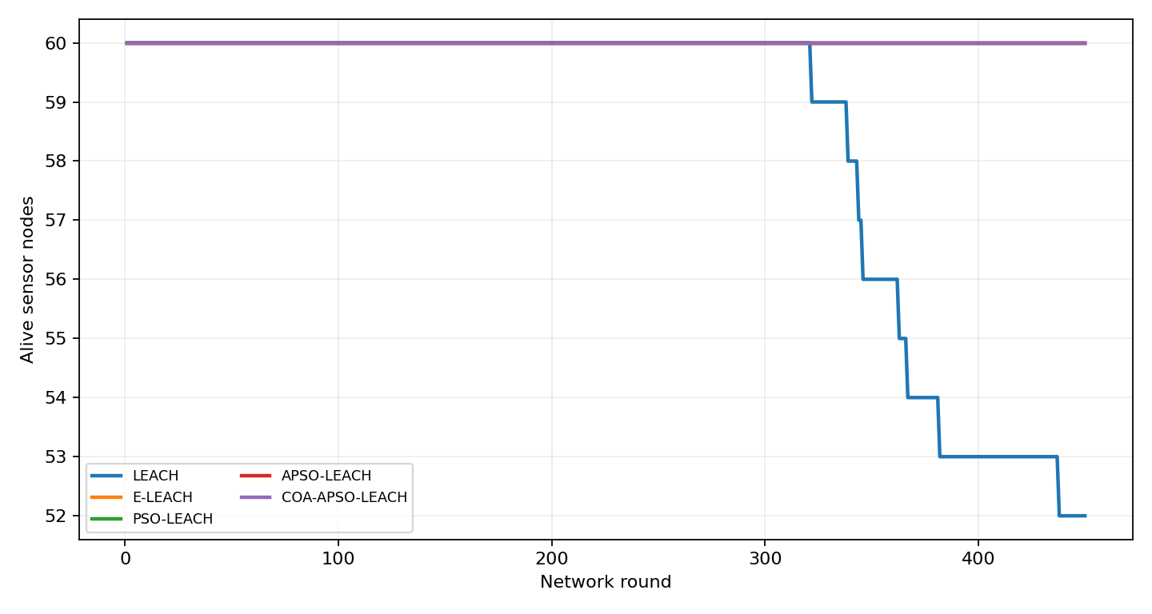
Alive sensors over rounds. Unobserved death events remain censored.

11 Contiki firmware and message exchange
The base station has mote ID 1 and starts the RPL root. Sensor IDs 2 through 9 register their IPv6 addresses. The root selects assignments from policy.h and replies with the chosen head ID and its address when known. It caches the last head and address-readiness state to suppress repeated identical replies. The root cycles through six epochs of 90 simulated seconds.
Sensors report approximately every 15 seconds after an ID-dependent startup offset. A member sends a reading to its configured head when that address is available. Otherwise it sends a direct fallback to the root. A head accumulates member sample counts, includes its own observation and sends an aggregate count to the root. This is application-level aggregation of counts; the program does not implement physical sensing or compression of measured values.
Each application message uses a fixed 24-byte layout: type, sender, head, epoch, two sequence bytes, two count bytes and a 16-byte IPv6 address. The root receives on UDP port 5678, while sensors use 8765. Network headers and lower-layer traffic add bytes beyond this application payload.
The generated policy keeps heads 3, 7 and 8 for every epoch. Members 2 and 4 use head 3, member 6 uses head 7, and members 5 and 9 use head 8. Consequently, the current demo illustrates retained clusters and packet exchange rather than visibly rotating heads. Python’s small-network export uses different settings from the 60-node comparison, including a centered sink and a longer modeled lookahead.
RPL controls the actual IPv6 routes. A packet whose application destination is a cluster head can physically travel through the root, especially under source routing. The demonstration therefore must not be described as a custom LEACH MAC, TDMA scheduling implementation or proof of direct physical member-to-head links.
Log text | Meaning
ROOT ready | The base-station process started
ASSIGN / CONFIG | The root sent / sensor received a policy
MEMBER DATA / CLUSTER RX | Application reading sent / received
AGG head | Root received an aggregate count
ENERGEST | Sensor reports cumulative activity ticks

12 Cooja window and verified execution
The screenshot below shows the running project in Cooja. Network displays the nine motes; Radio messages exposes link-layer packet records; Mote output shows the application’s text messages; Timeline displays mote activity. At unlimited speed, hours of simulated time can elapse quickly. Pause or choose a 100% speed limit when explaining the trace.
The screenshot is a capture of the continuing GUI session and is separate from the recorded 600-second validation run. Its cumulative counters are therefore different. Do not use the screenshot’s later values as if they were the ten-minute test totals.
The repeatable validation scenario checks configuration and Energest reporting from every sensor, plus evidence of member transmission, cluster reception and root aggregation. It finished with TEST OK. The parsed ten-minute log reports ten assignment sends, 114 aggregate packets and 299 samples contained in aggregates. Ten assignment sends for eight sensors can include updates when a head address becomes available.
This test verifies that the application’s basic networking path works in the tested topology. It does not establish zero packet loss, complete sample delivery, calibrated energy, lifetime or robustness across seeds. The root’s total sample count can include direct fallback readings that the aggregate-only parser excludes.
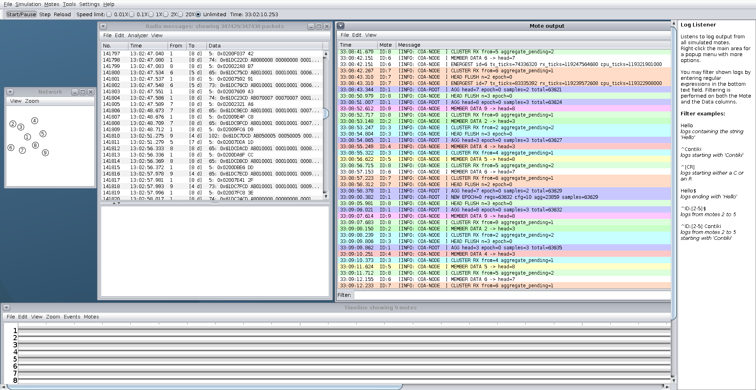
Actual Cooja GUI captured on this PC during the continuing demonstration. Quantitative validation values come from results/cooja-run.txt, not from this screenshot.

13 Energest accounting and measurement limits
Energest records time spent in platform activity states. The firmware calls energest_flush before reading cumulative transmit, listen and CPU counters. A log field called rx_ticks corresponds to radio listening time, not only the time needed to receive successful application packets. The official API defines ENERGEST_SECOND as the platform’s number of ticks per second.
A calibrated estimate over an interval would use E = V × Σ[I_state × Δticks_state / ENERGEST_SECOND], with a consistent hardware current model. Use differences between start and end counters rather than simply comparing cumulative totals from runs of different lengths. CPU and radio may be active at the same time, so state-current profiles must be defined consistently to avoid double counting whole-device currents.
The present project does not include a validated device current profile or voltage calibration. Its Cooja outputs therefore remain activity ticks. Native Cooja motes are also not a cycle-accurate emulation of a particular board. Numerical agreement with Python Joules should not be expected without a deliberately matched energy model.
parse_cooja_log.py retains the last observed activity record for each node and counts assignment and aggregate lines. Reports arrive at staggered times, approximately every fourth reachable transmission cycle. The summed counters consequently do not form a synchronized end-of-test snapshot. Future measurement should align the start and stop boundaries and include low-power modes where the selected platform supports them.
For communication quality, add unique sample identifiers and generation timestamps, distinguish duplicates and retransmissions, and count root-delivered samples over a fixed observation interval. That instrumentation is needed for packet delivery ratio and latency. The current aggregate count alone cannot provide those metrics.
Ten-minute parser output | Value
Sensors with latest activity records | 8
Assignment sends | 10
Aggregate packets | 114
Samples in aggregate packets | 299
Summed latest transmit ticks | 3,404,824
Summed latest listen ticks | 4,505,187,176

14 Run and demonstrate the project
On this Windows PC, the project directory is D:\WORKSPACE\PYTHON\COA_APSO_LEACH_Demo. Open PowerShell in that directory. The Python runtime already has the required numerical and plotting packages. Use the commands below to rerun the checks and comparison, then open the dashboard.
python -m pytest tests -q
python run_demo.py --nodes 60 --rounds 450 --out results
Start-Process .\results\dashboard.html
To reopen the installed Cooja scenario, run .\Launch-Cooja.ps1. If the window is already open, use that instance. Maximize it, choose a readable speed limit and click Start/Pause as needed. Allow about 30–60 simulated seconds for registration and route formation before discussing traffic.
Use a five-minute explanation: introduce the battery-lifetime problem, explain the setup-versus-saving decision, show the Python control and survival plots, identify node 1 and heads 3/7/8 in Cooja, then follow a member message into a cluster and an aggregate to the root. End by stating that assignments are precomputed and Energest reports ticks.
For headless validation, open Ubuntu, enter the project directory through /mnt/d, install current firmware into the Contiki checkout and generate validation.csc. The final command runs the simulator with a ten-minute timeout. Success requires a TEST OK entry.
cd /mnt/d/WORKSPACE/PYTHON/COA_APSO_LEACH_Demo
sh install_cooja.sh ~/coa-demo/contiki-ng
python3 validate_cooja.py ~/coa-demo/contiki-ng
cd ~/coa-demo/contiki-ng/tools/cooja
java -jar build/libs/cooja.jar --no-gui --logdir=/home/anish/coa-demo --contiki=/home/anish/coa-demo/contiki-ng ../../examples/coa-apso-leach/validation.csc
To process a copied text log, use python parse_cooja_log.py results/cooja-run.txt --out results. The generated JSON and CSV contain counts and activity counters. Keep raw logs alongside these summaries so that the reported evidence can be checked.

15 Code map and reproducibility record
The following files separate the optimization model, experiment scripts and embedded demonstration. Preserve results/config.json together with summary.csv and the round traces whenever a new result is reported. Store policy.h and repository revisions with each Cooja run.
The verified local environment uses Windows with Ubuntu 24.04 under WSL2 and WSLg, OpenJDK 25 and GCC 13. The installed Contiki-NG repository is /home/anish/coa-demo/contiki-ng. Its commit is 7a4df8a941d552b10c730db70e934a9be10937af. The Cooja submodule commit is fabff3ee41eeeb6f3de7bd11f7c9cdf0a7d7dfc4.
Six Python tests cover radio-cost behavior, reproducible topology, nonnegative and monotone residual energy, positive setup cost, valid distinct head identities and parsing of Cooja log records. Their passing result is evidence for those specific checks, rather than proof that the algorithm is correct under every configuration.
The validation added a sensor logging include and module settings, made shared message helpers inline to satisfy compiler warnings, and corrected inherited Cooja plugin references and log filtering. validate_cooja.py creates a separate automated scenario. Launch-Cooja.ps1 and launch_cooja.sh reopen the visual demonstration.
For repeated model runs, run_research.py writes raw records and descriptive means and standard deviations. Its observed-only first-death mean excludes censored runs and can bias interpretation. It should not be reported as an unbiased lifetime mean. A common restricted horizon or survival analysis is preferable.
File | Responsibility
simulator/engine.py | Energy, topology, PSO and adoption gate
run_demo.py | Single-run graphs and dashboard
run_research.py | Repeated-seed descriptive analysis
export_cooja_policy.py | Offline policy schedule
cooja/root.c and node.c | Root and sensor processes
cooja/message.h and policy.h | Wire format and assignments
make_cooja_scenario.py | Nine-mote scenario generation
validate_cooja.py | Automated networking smoke test
parse_cooja_log.py | Activity and message-count summaries

16 Limitations and engineering follow up
Model limitations include ideal delivery, omitted idle listening and retransmissions, no channel dynamics and no controller CPU-energy measurement. The Python setup traffic is an abstraction rather than a packet-for-packet reproduction of the Cooja firmware. E-LEACH state acquisition must be aligned with the other baselines before a strong control-energy comparison.
The current Cooja application has no battery-depletion state, no online optimizer and no measurement-driven change in the policy. It will continue communicating while the simulator runs. Its fixed policy does not exercise difficult transitions between different heads. The successful smoke test therefore covers the steady-state communication path but not the full proposed control algorithm in a network-stack environment.
Configuration reliability needs explicit design. The root records an assignment as sent and suppresses identical future replies, but there is no application-level acknowledgement. If a configuration packet is lost, a repeated sensor registration may not trigger a resend while the cached state remains unchanged. A versioned acknowledgement and retry mechanism would make policy application observable and reliable.
Head changes also need rules for pending samples, stale epochs and duplicates. A node can still have unforwarded counts when its role changes. Validate what happens to those counts, reject stale configurations and define how a member behaves when its head disappears. The present count-only aggregate and bounded count field are insufficient for a general loss audit.
Long-duration runs should inspect counter widths and wraparound. The firmware casts activity counters to unsigned long before logging; portability depends on target width. Logging 64-bit counters explicitly and computing interval deltas would make measurements safer across platforms. These follow-ups should be tested with loss, delayed registration, restarts, head failure and changing policies.
A publication claim needs stronger evidence than this prototype provides. In particular, successful packet exchange does not prove superiority over a baseline, and the Python savings do not demonstrate real-device battery gains. These boundaries should appear in the presentation rather than being left only for questions.

17 Research evaluation plan
Start with a matched model comparison in which all centralized algorithms pay equivalent state-collection costs. Keep topology, battery assignment, packet size, traffic rate and sink location paired by seed. Isolate the adoption gate before changing other mechanisms. Store the code revision and full configuration for every run.
A practical initial design can use 20 or more paired seeds, then justify the replication count using observed variance or a power calculation. Vary sensor count, sink placement, traffic interval, heterogeneity, lookahead and safety margin. Extend the horizon if the target lifetime event is usually censored, or choose a common restricted-horizon metric.
Report paired differences in control energy and residual energy with confidence intervals. Include effect size, seed count and distributions. For FND, HND and LND, explicitly represent unobserved events. Avoid calculating a lifetime advantage only from the subset in which a node died. run_research.py offers descriptive summaries but does not perform these inferential analyses.
For Cooja, create matched policies or controllers for the relevant baselines, use the same deployment and duration, and instrument generated and delivered samples with unique IDs. Measure application delivery ratio, latency, duplicate rate, control packets/bytes and calibrated per-node energy. Start with stable topology, then test packet loss and head transitions.
Finally, compare the adoption rule with recent overhead-aware and event-driven reclustering methods from primary papers. A useful result might identify a range of setup costs and traffic rates where the gate helps, while exposing cases where retained heads create imbalance. Such conditional evidence is more credible than a universal-better claim.
Experiment | Purpose
Gate disabled versus enabled | Isolate the proposed decision
Fixed versus adaptive inertia | Separate search behavior
Relay disabled versus enabled | Separate routing benefit
Horizon and margin sweep | Measure trigger sensitivity
Equal telemetry across baselines | Remove accounting advantage
Loss and role-transition tests | Validate network robustness

18 Viva questions and troubleshooting
What is the main idea? Choose a new clustering only when its predicted future savings can repay setup cost, unless a low-energy or failed head requires a safety change. APSO proposes candidates; the cost gate decides whether to adopt them.
What is the difference between Contiki and Cooja? Contiki-NG supplies the embedded operating system and network stack. Cooja runs the virtual devices and exposes communication. Python provides the numerical algorithm experiment and precomputes the policy table.
Is PSO running on the sensor motes? No. The controller is assumed to be powered at the base station in the numerical design. The current Cooja firmware replays assignments exported beforehand. Running a live controller would be a separate integration task.
Why are cluster heads not changing in the GUI? All six rows of the current generated policy select heads 3, 7 and 8. Retaining a configuration is intentional in this demonstration. generate_baseline_policy.py can generate an illustrative rotating schedule, but it must not be called canonical randomized LEACH and should be restored after the demonstration.
Are Energest numbers energy in Joules? They are time counters. Conversion requires a chosen platform, ticks per second, voltage and current parameters. The stored parser report is based on staggered latest records, so it is not a synchronized measurement interval.
Why does Cooja show NO ROUTE? The network may still be forming, a root may be missing or connectivity may be insufficient. Check node 1, allow startup time and inspect the network configuration. If logs appear empty, clear the Mote output filter. Reinstall and recompile the example after editing firmware or policy.h.
Why does the browser show old graphs? dashboard.html is a static generated file. Rerun run_demo.py and refresh the browser. If Cooja fails to open, verify Ubuntu WSL starts and the installed repository and Java executable still exist. If firmware fails, retain the compiler log and check that this is Contiki-NG rather than the legacy Instant Contiki VM.
Can this be submitted as a research paper now? It is a working prototype with initial numerical evidence. A submission still needs a defensible novelty review, matched baselines, repeated experiments, reliable policy transitions and validated communication and energy metrics.

19 References and evidence index
[1] Haris, M., and Nam, H. (2025). Enhancing Energy Efficiency in IoT-WSNs Through Optimized PSO Cluster Head Selection. IEEE Access, 13, 126496–126512. DOI: 10.1109/ACCESS.2025.3583922. Institutional source: https://erica.scholarworks.kr/item/f4334541-1e7a-49ad-b3bf-b43838f819d2
[2] Zhang, Y., Yang, L., and Tan, Y. (2025). Energy-efficient adaptive routing in heterogeneous wireless sensor networks via hybrid PSO and dynamic clustering. Journal of Cloud Computing, 14, 46. https://doi.org/10.1186/s13677-025-00768-3
[3] Contiki-NG documentation. Running Contiki-NG in Cooja. https://docs.contiki-ng.org/en/master/doc/tutorials/Running-Contiki-NG-in-Cooja.html. Accessed 14 October 2026.
[4] Contiki-NG documentation. Energest. https://docs.contiki-ng.org/en/master/doc/programming/Energest.html. Accessed 14 October 2026.
[5] Local project implementation: simulator/engine.py, run_demo.py, run_research.py, export_cooja_policy.py and cooja/*.c/*.h. These files establish the implemented formulas and behavior described in this report.
[6] Python experiment evidence: results/config.json, results/summary.csv, results/*_rounds.csv and generated figures. Seed 42, 60 sensors, 450 rounds. Percentage comparisons in this report are calculated from the full-precision CSV values.
[7] Cooja evidence: results/cooja-run.txt, results/cooja-validation.log, results/cooja_report.json and results/cooja_energest.csv. These files establish the 600-second test result and its message/activity counts.
[8] Visual provenance: the network concept illustration is AI-generated and purely explanatory. The Python graphs come from this project’s saved run. The Cooja image is a capture of the actual continuing application window on this PC. No third-party paper figures are reproduced.
Further reading lead, not relied upon for a specific claim: Abose et al. (2024), Optimized Cluster Routing Protocol With Energy-Sustainable Mechanisms for Wireless Sensor Networks, DOI: 10.1109/ACCESS.2024.3429645. Obtain and examine the primary paper before adding it to a formal comparative literature review.

