India Goes Cashless
UPI Analytics — Project Report
A comprehensive data analysis of India's Unified Payments Interface (UPI) for the calendar year 2024. Covers data cleaning, KPI metrics, trend analysis, geography, demographics, bank analysis, device usage, fraud detection, and interactive Streamlit dashboard outputs.

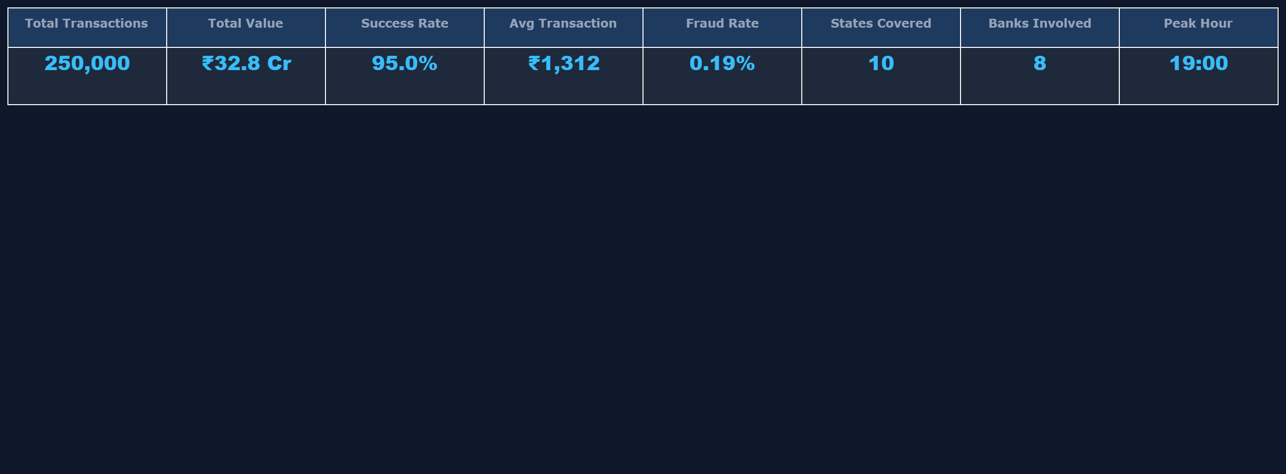
▲ Dashboard KPI Banner — 8 key metrics computed live from the dataset
Dataset: upi_transactions_2024.csv | Records: 250,000 | Period: Jan 2024 – Dec 2024 | Success Rate: 95.0% | Fraud Rate: 0.19%

1 Executive Summary
This project analyses 250,000 UPI transactions recorded across India throughout 2024 using a single-file Streamlit dashboard (app.py). The data is loaded, cleaned, and explored across 8 interactive tabs: Trends, Categories, Geography, Banks, Device & Network, Demographics, Fraud, and Raw Data.
Key findings: success rate 95.0%, fraud rate 0.19%, average transaction ₹1,312, peak usage at 19:00 hrs. Android + 4G dominates. The 26–35 age group is the most active demographic. A small number of states drive the majority of transaction volume.
2 Dataset Description
File: upi_transactions_2024.csv | Rows: 250,000 | Columns: 17
Column | Data Type | Description
transaction_id | String | Unique transaction identifier
timestamp | DateTime | Date and time of transaction
transaction_type | Categorical | P2P (Person-to-Person) or P2M (Person-to-Merchant)
merchant_category | Categorical | Grocery, Fuel, Entertainment, etc.
amount (INR) | Numeric | Transaction amount in Indian Rupees
transaction_status | Categorical | SUCCESS / FAILED / PENDING
sender_age_group | Categorical | 18-25, 26-35, 36-45, 46-55, 56+
receiver_age_group | Categorical | Age bracket of receiver
sender_state | Categorical | Sending state (Delhi, Karnataka …)
sender_bank | Categorical | SBI, ICICI, Axis, HDFC, Yes Bank …
receiver_bank | Categorical | Receiving bank
device_type | Categorical | Android or iOS
network_type | Categorical | 4G, 5G, or WiFi
fraud_flag | Binary 0/1 | 1 = fraud, 0 = normal
hour_of_day | Integer 0-23 | Hour of transaction
day_of_week | Categorical | Monday – Sunday
is_weekend | Binary 0/1 | 1 = weekend, 0 = weekday

3 Data Cleaning & Preprocessing
- Column Normalisation — names stripped, lowercased, special chars → underscores.
- Duplicate Removal — full duplicate rows dropped via pandas drop_duplicates().
- Type Coercion — timestamp → datetime64; amount / fraud_flag / hour_of_day / is_weekend → numeric.
- Feature Engineering — month_name, month_year, quarter, week derived from timestamp column.
- Null Handling — missing amount values imputed with median; others retained for data quality display.

4 Transaction Trends Over Time
Monthly, hourly, and day-of-week breakdowns reveal clear temporal patterns. Evening hours (18–21) show peak activity; Q4 drives highest value due to festive-season spending.
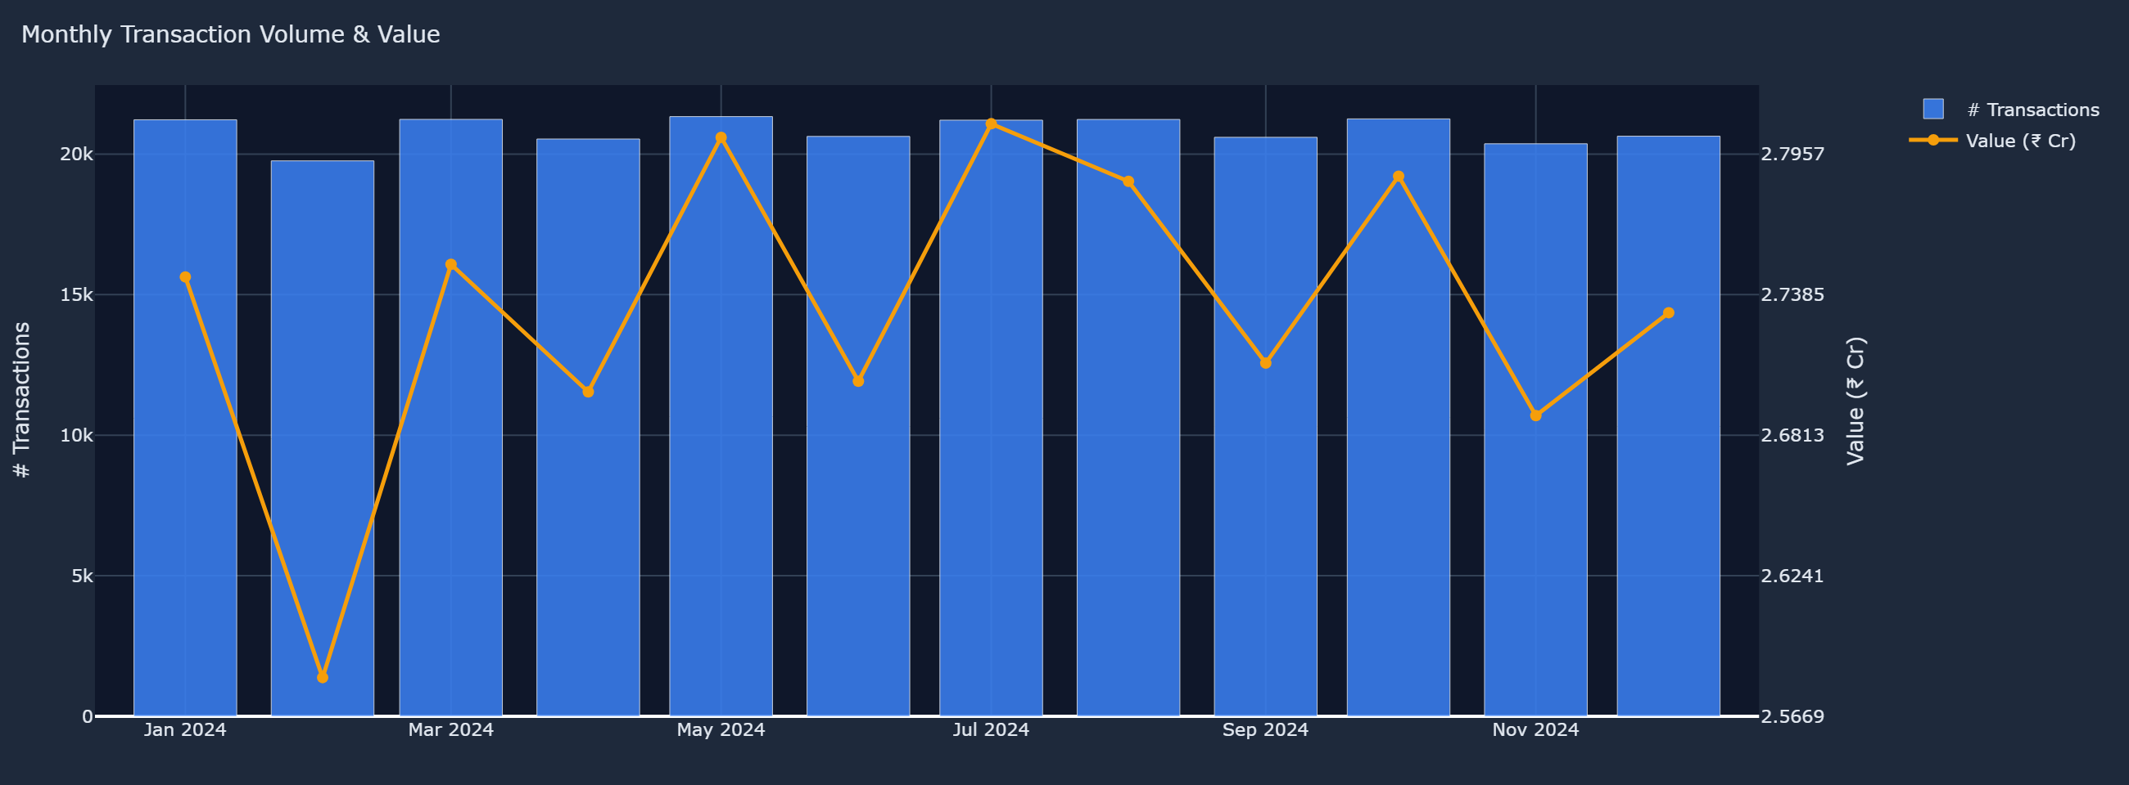
▲ Tab: Trends — Monthly Transaction Volume (bars) and Value in ₹ Cr (line), Jan–Dec 2024
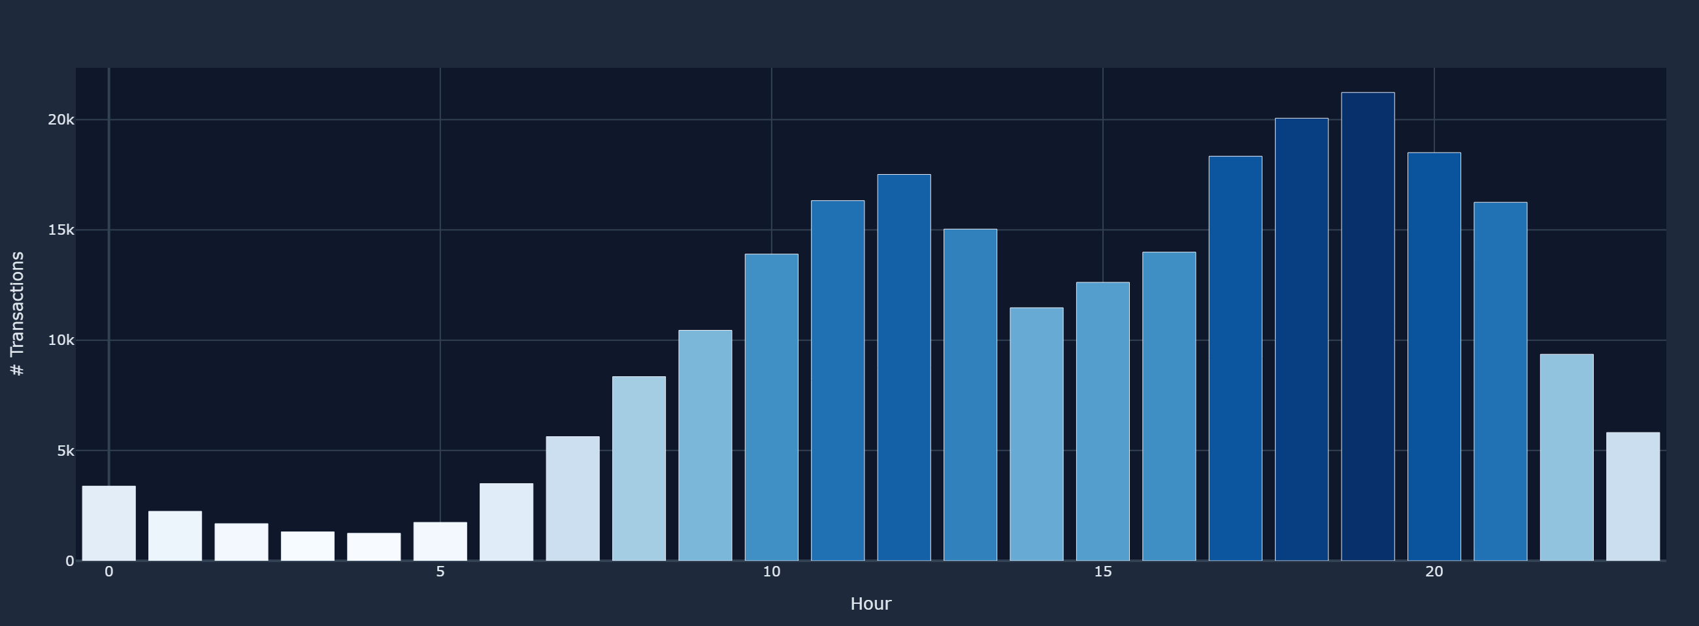
▲ Tab: Trends — Transactions by Hour of Day (0–23); peak at 19:00 hrs
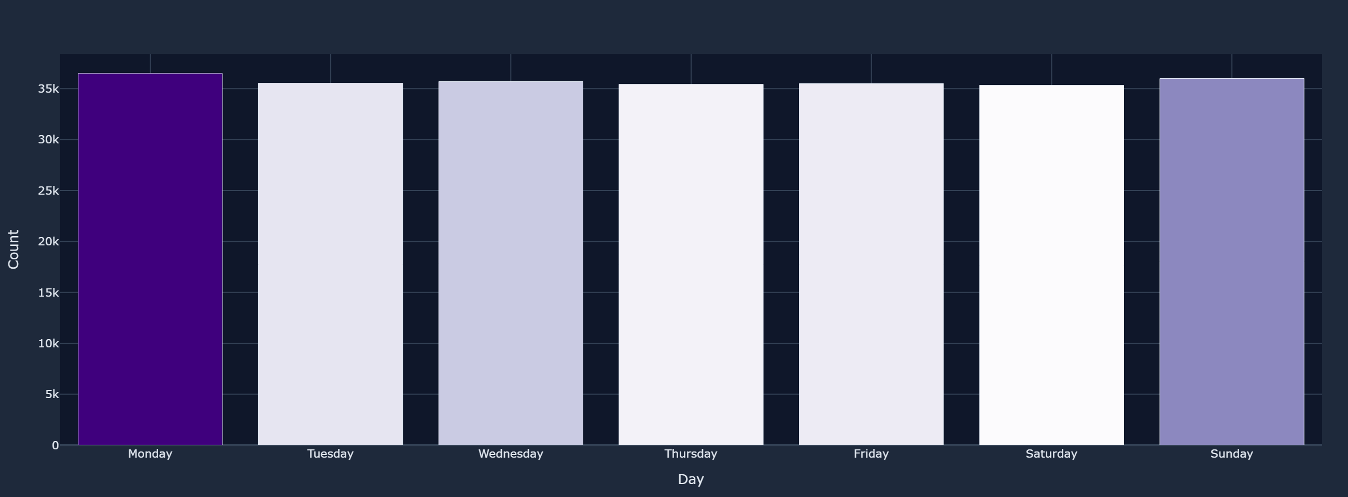
▲ Tab: Trends — Transactions by Day of Week; consistent weekday dominance
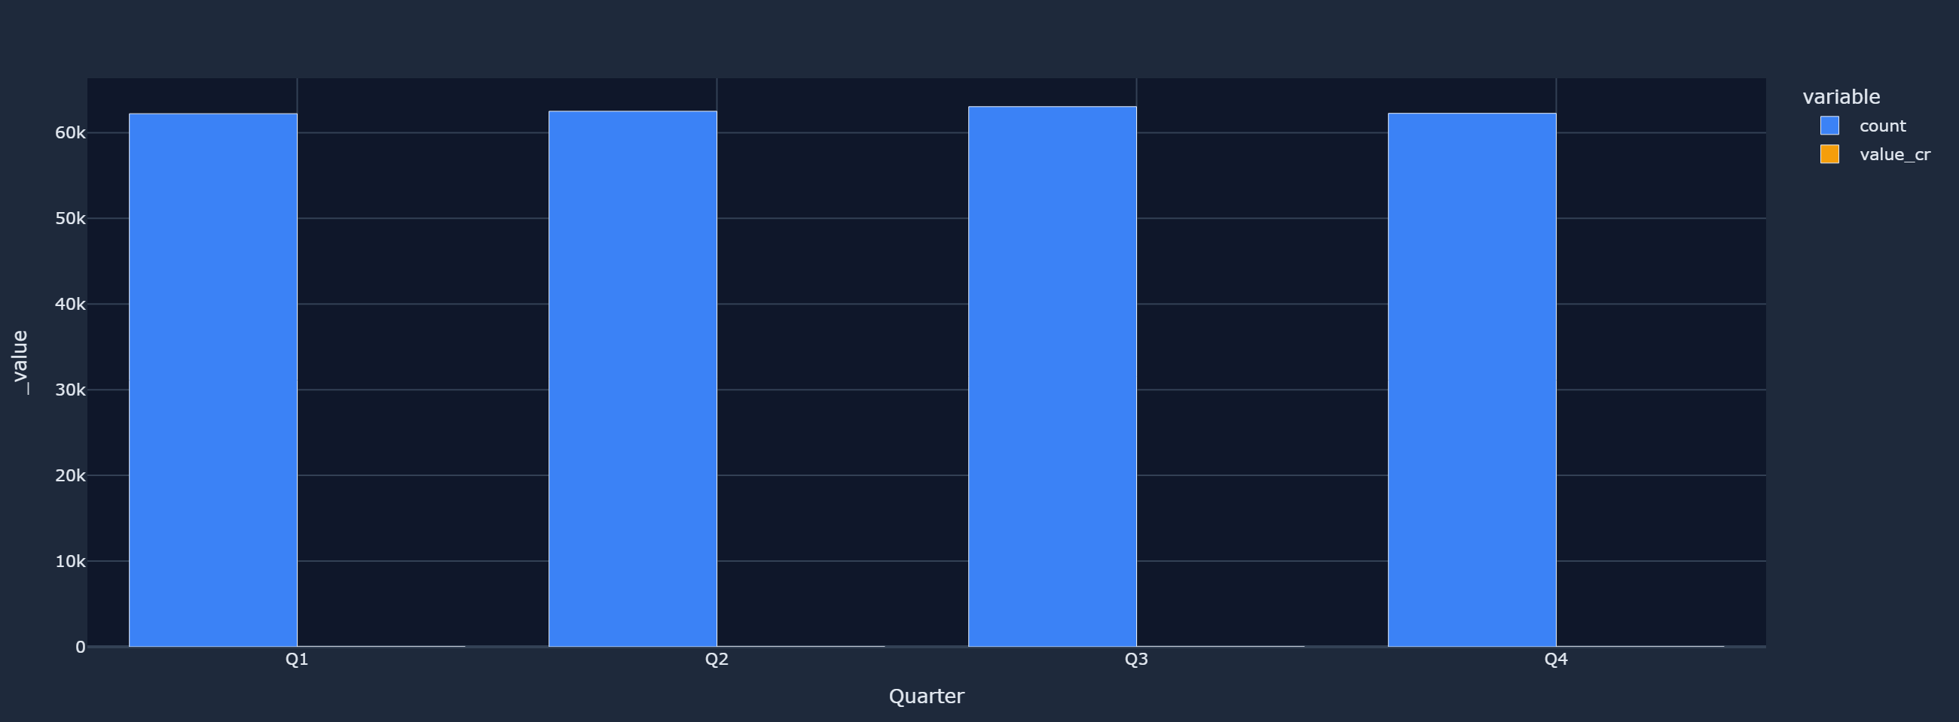
▲ Tab: Trends — Quarterly Overview (count + value); Q4 festive spike visible

5 Merchant Categories & Transaction Types
Grocery, Fuel, and Entertainment are the top merchant categories. The success rate donut confirms UPI's reliability; amount histogram shows most transactions are below ₹2,000.
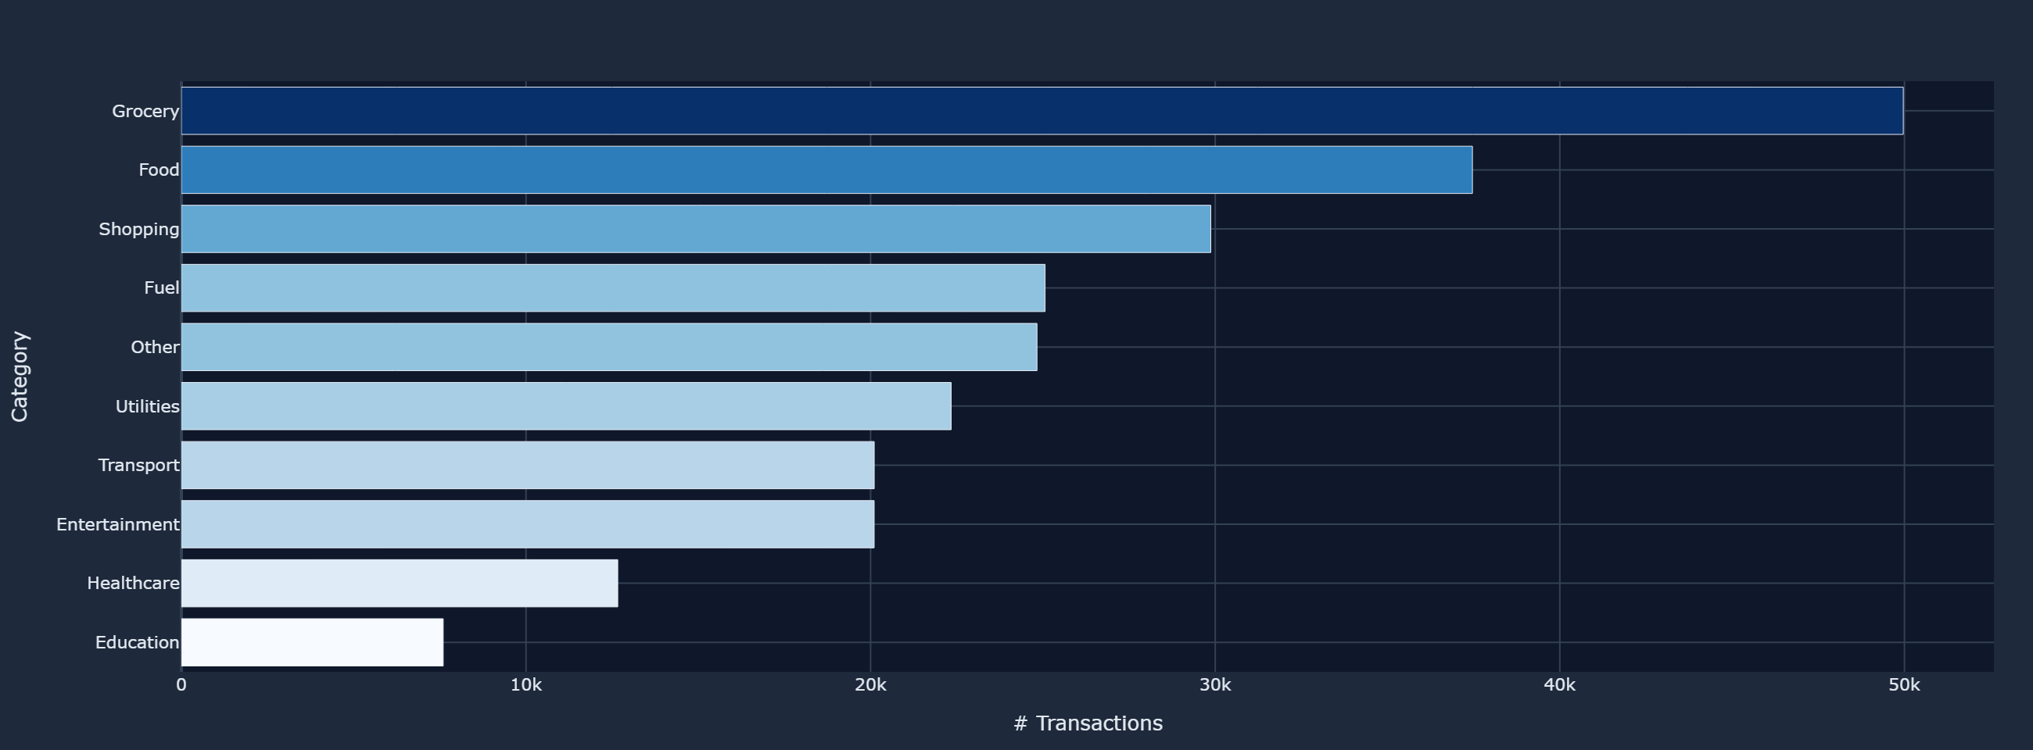
▲ Tab: Categories — Transactions by Merchant Category (horizontal bar)
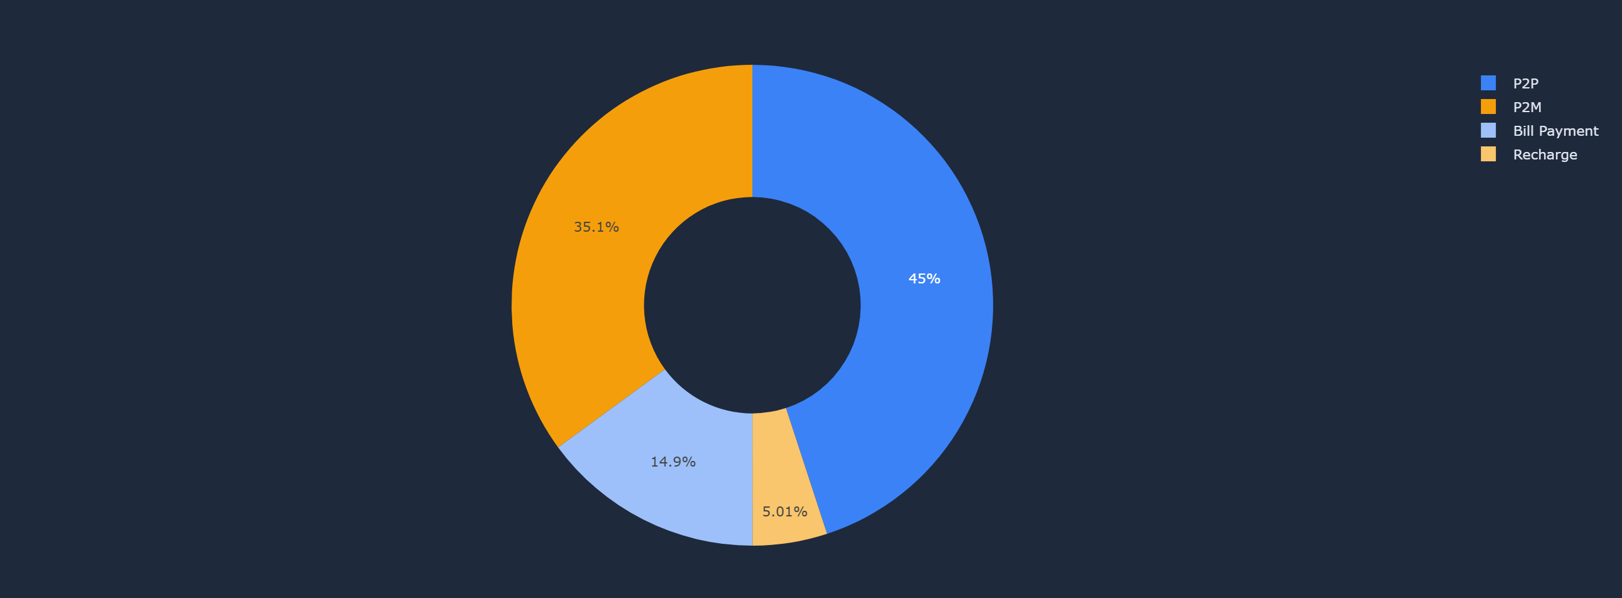
▲ Tab: Categories — P2P vs P2M Count Split (donut)
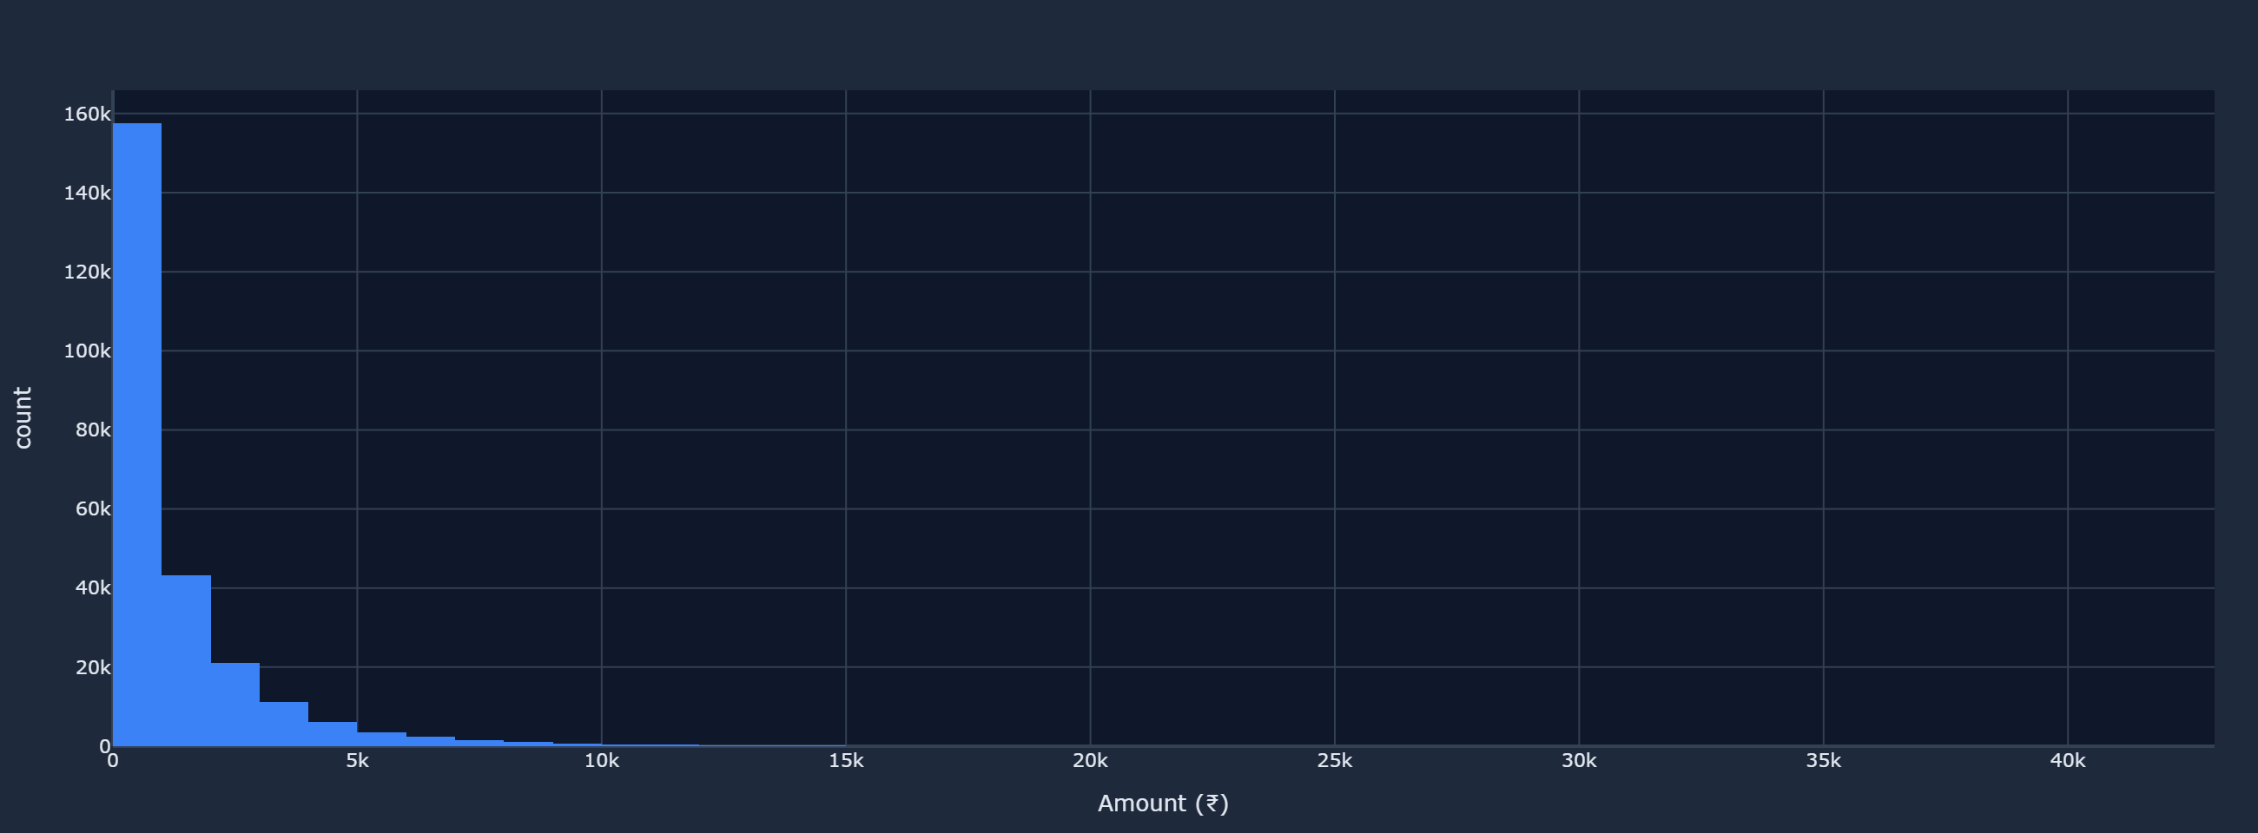
▲ Tab: Categories — Distribution of Transaction Amounts (histogram)

▲ Tab: Categories — Transaction Status: SUCCESS / FAILED / PENDING (donut)

▲ Tab: Trends — Weekend vs Weekday Transaction Split

6 Geographic Analysis
A handful of states (Delhi, Karnataka, Maharashtra, UP) drive the majority of UPI transactions. Rural and Tier-2 states represent the next growth frontier for UPI adoption.
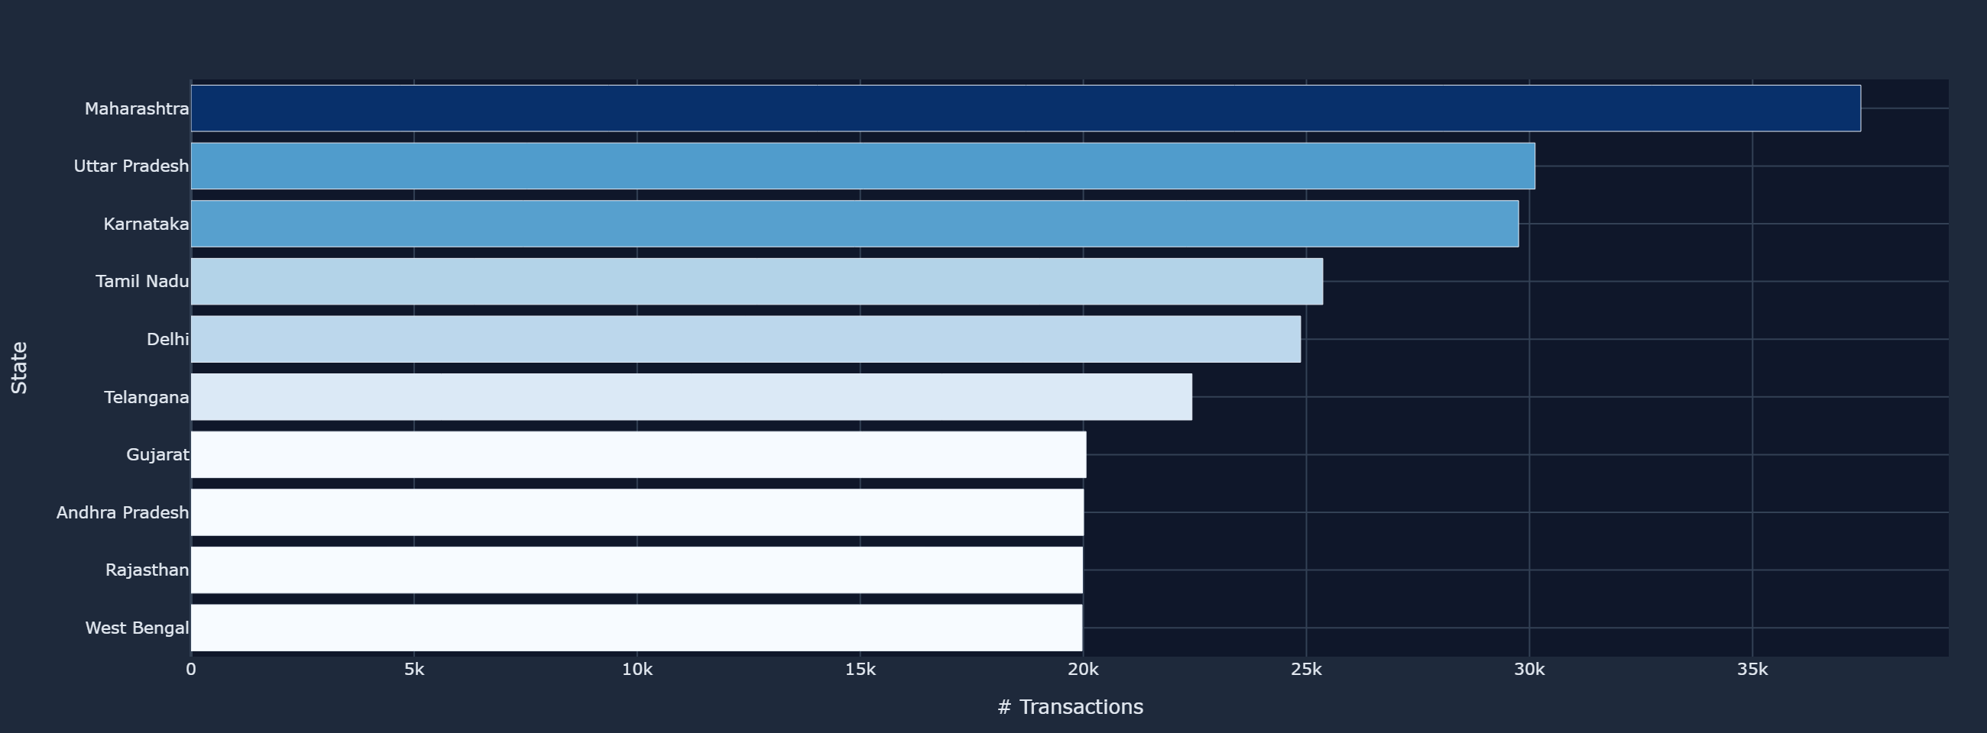
▲ Tab: Geography — Transaction Count by Sender State
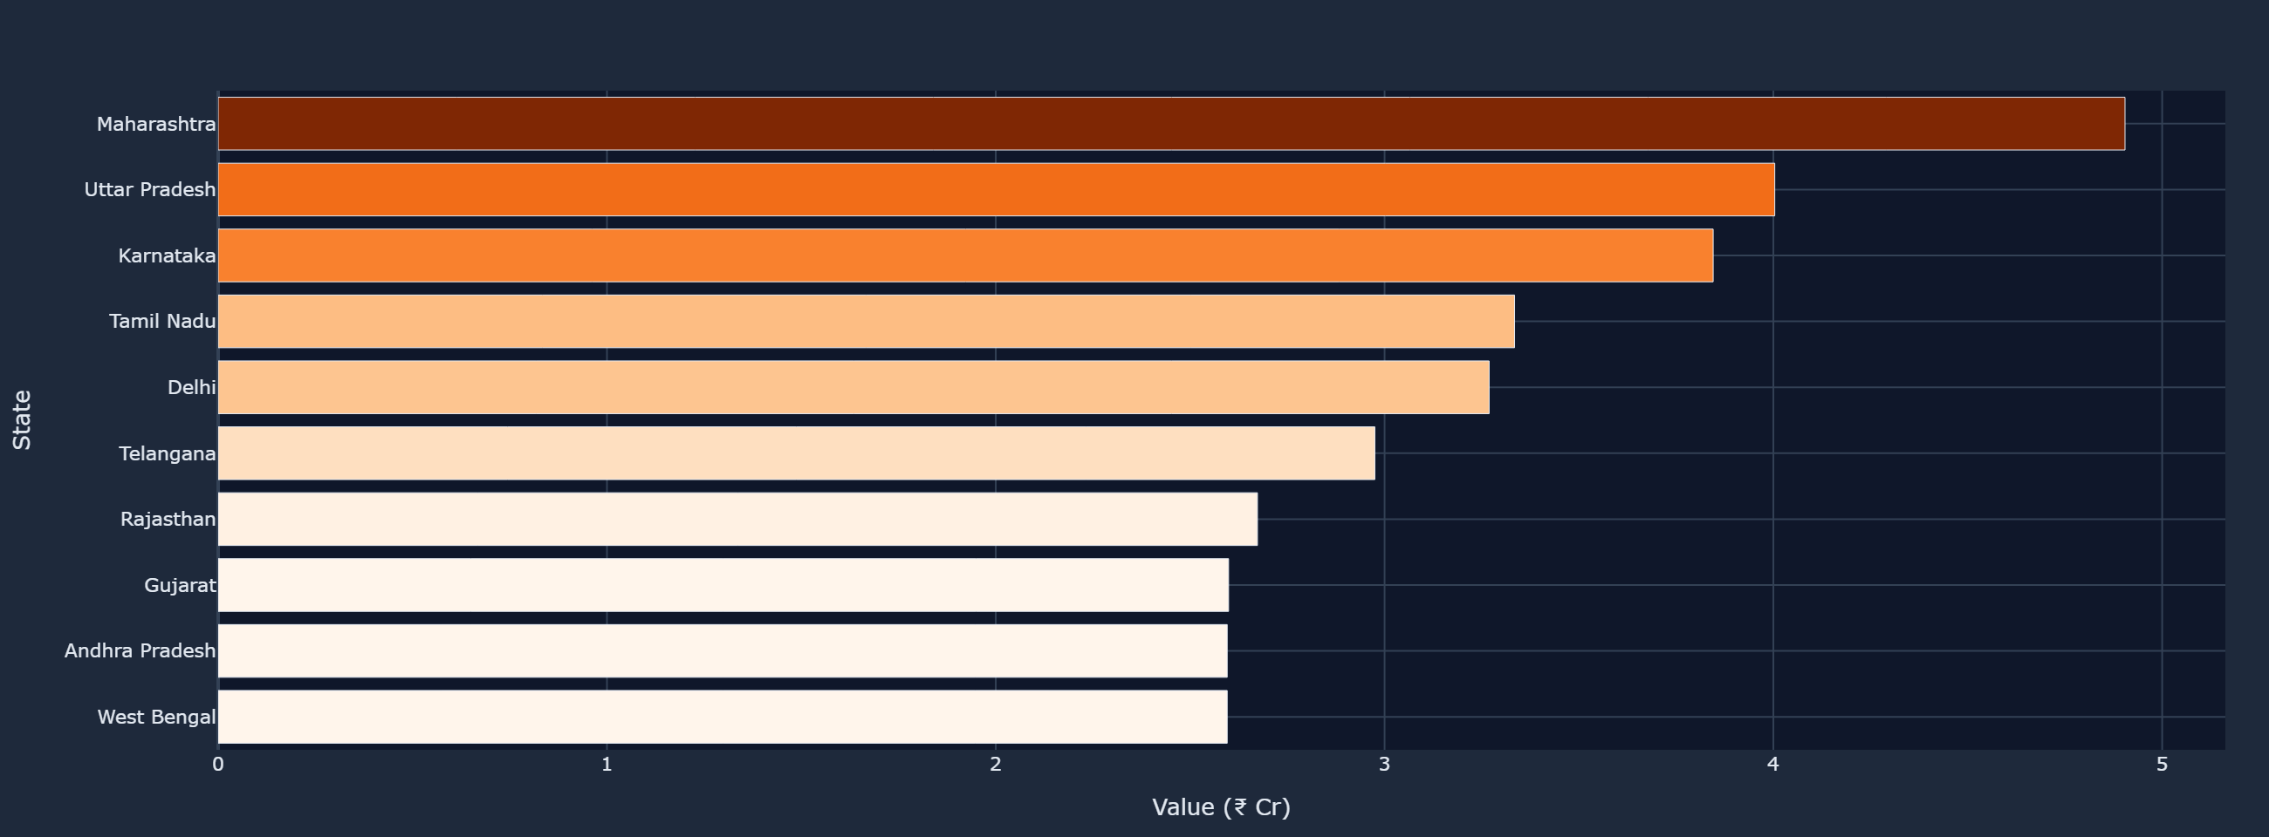
▲ Tab: Geography — Transaction Value (₹ Cr) by Sender State
State-level Summary:
State | Transactions | Total Value (₹ Cr) | Avg Amount (₹)
Maharashtra | 37,427 | 4.90 | ₹1,310
Uttar Pradesh | 30,125 | 4.00 | ₹1,329
Karnataka | 29,756 | 3.85 | ₹1,292
Tamil Nadu | 25,367 | 3.33 | ₹1,314
Delhi | 24,870 | 3.27 | ₹1,314
Telangana | 22,435 | 2.98 | ₹1,326
Gujarat | 20,061 | 2.60 | ₹1,295
Andhra Pradesh | 20,006 | 2.60 | ₹1,297
Rajasthan | 19,981 | 2.67 | ₹1,338
West Bengal | 19,972 | 2.60 | ₹1,299

7 Bank-wise Analysis
Sender bank analysis reveals market share on UPI. The cross-bank heatmap shows which bank-to-bank combinations carry the highest average transaction amounts.
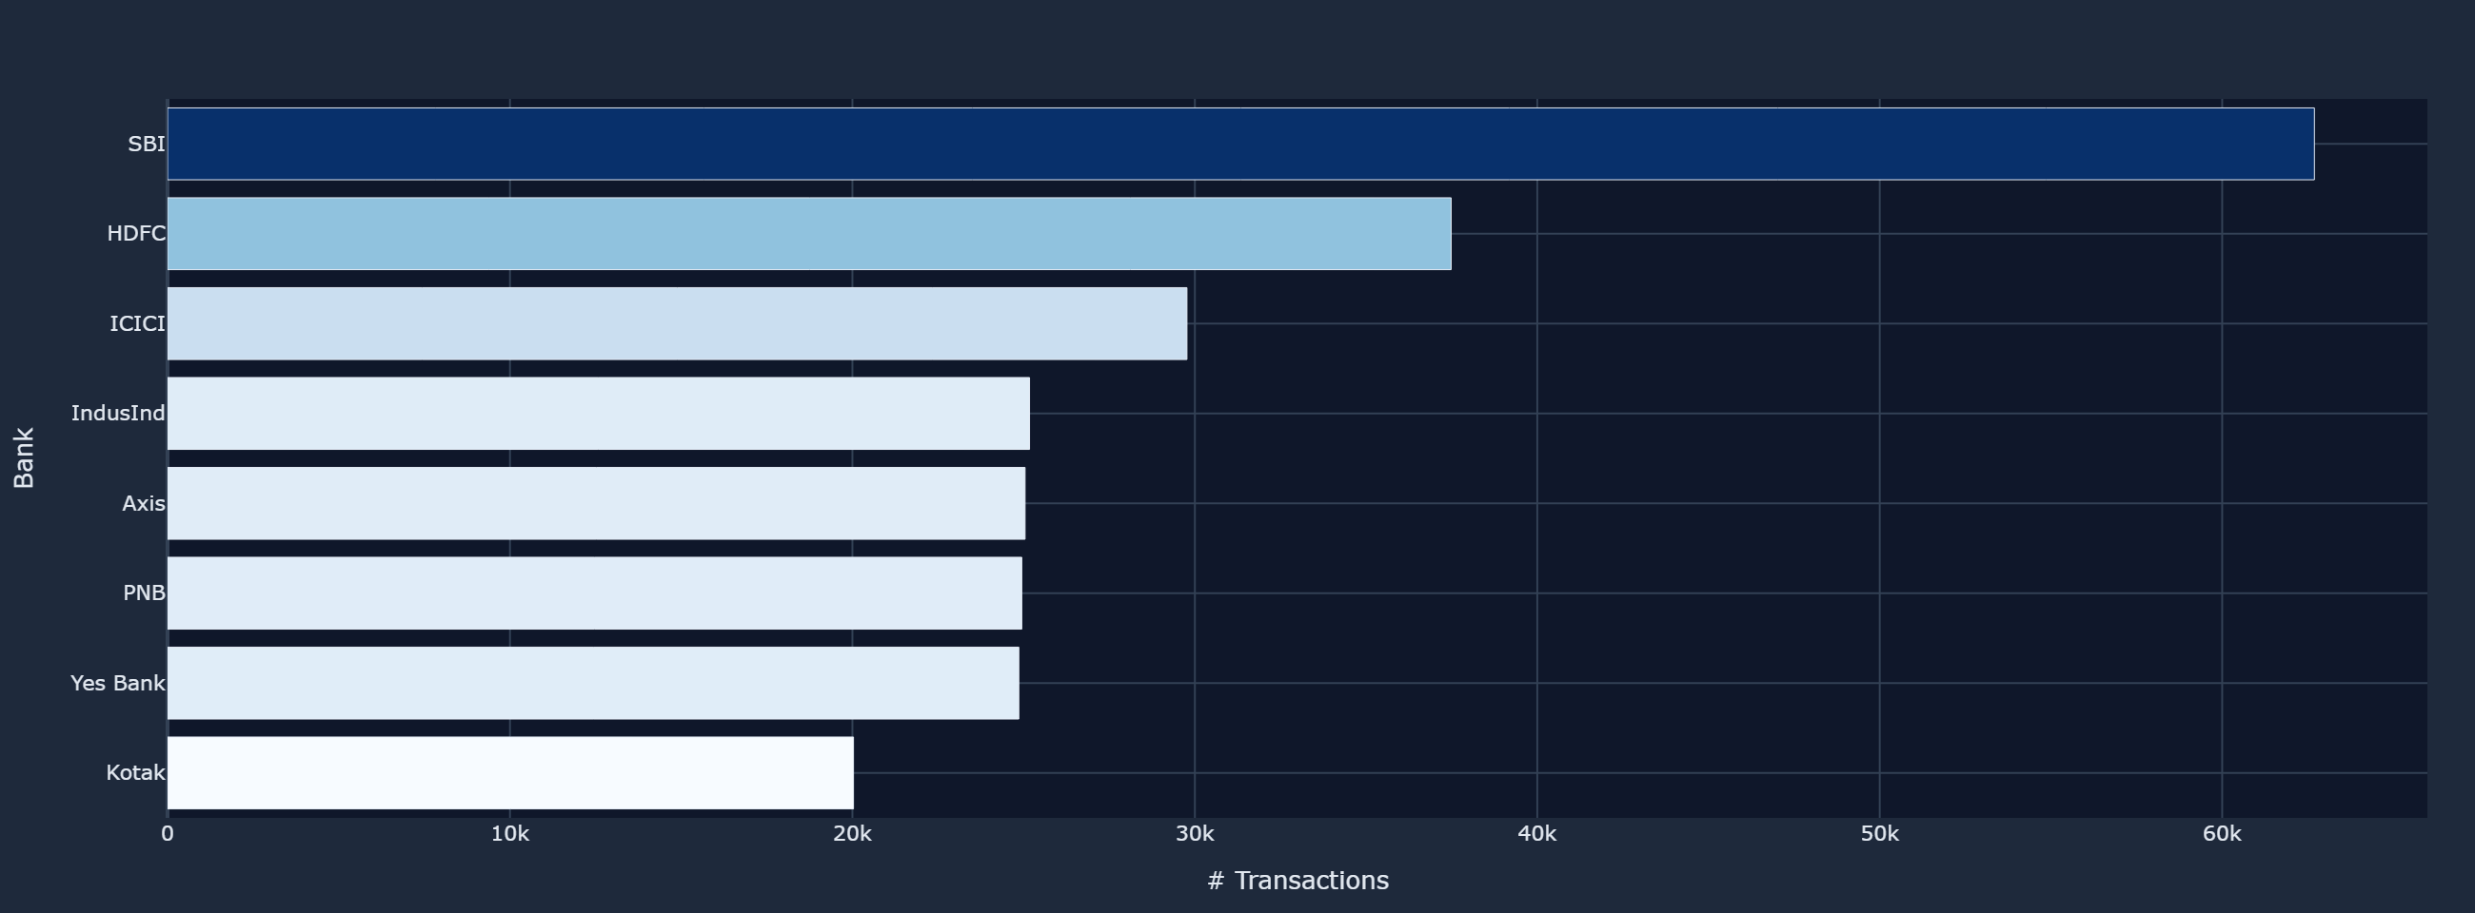
▲ Tab: Banks — Sender Bank Transaction Count Ranking
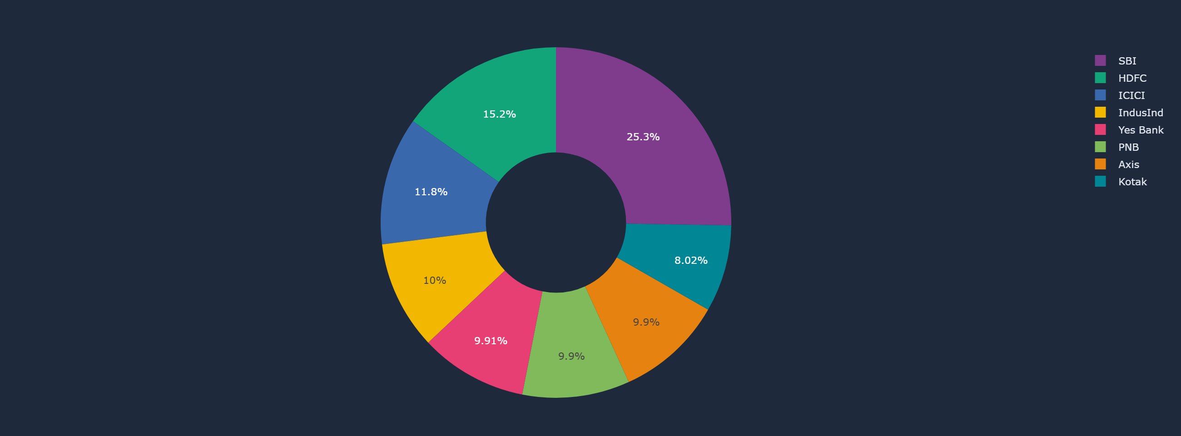
▲ Tab: Banks — Transaction Value Share by Sender Bank (donut)
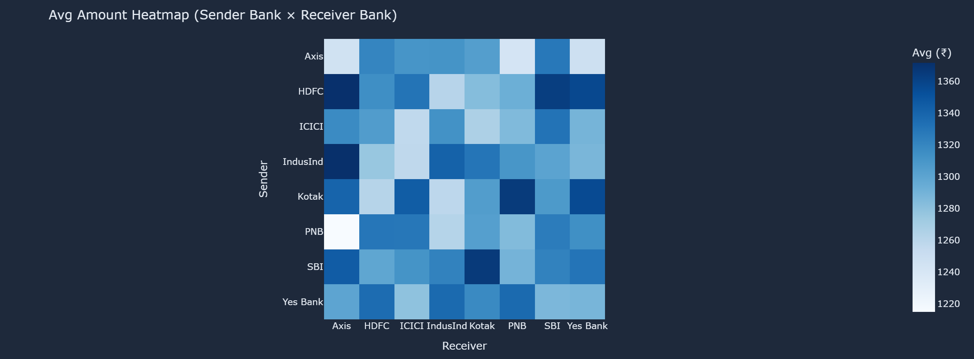
▲ Tab: Banks — Avg Amount Heatmap: Sender Bank × Receiver Bank

8 Device & Network Analysis
Android dominates UPI transactions; 4G is the primary connectivity layer. The grouped bar reveals how device–network combinations distribute across transaction volume.
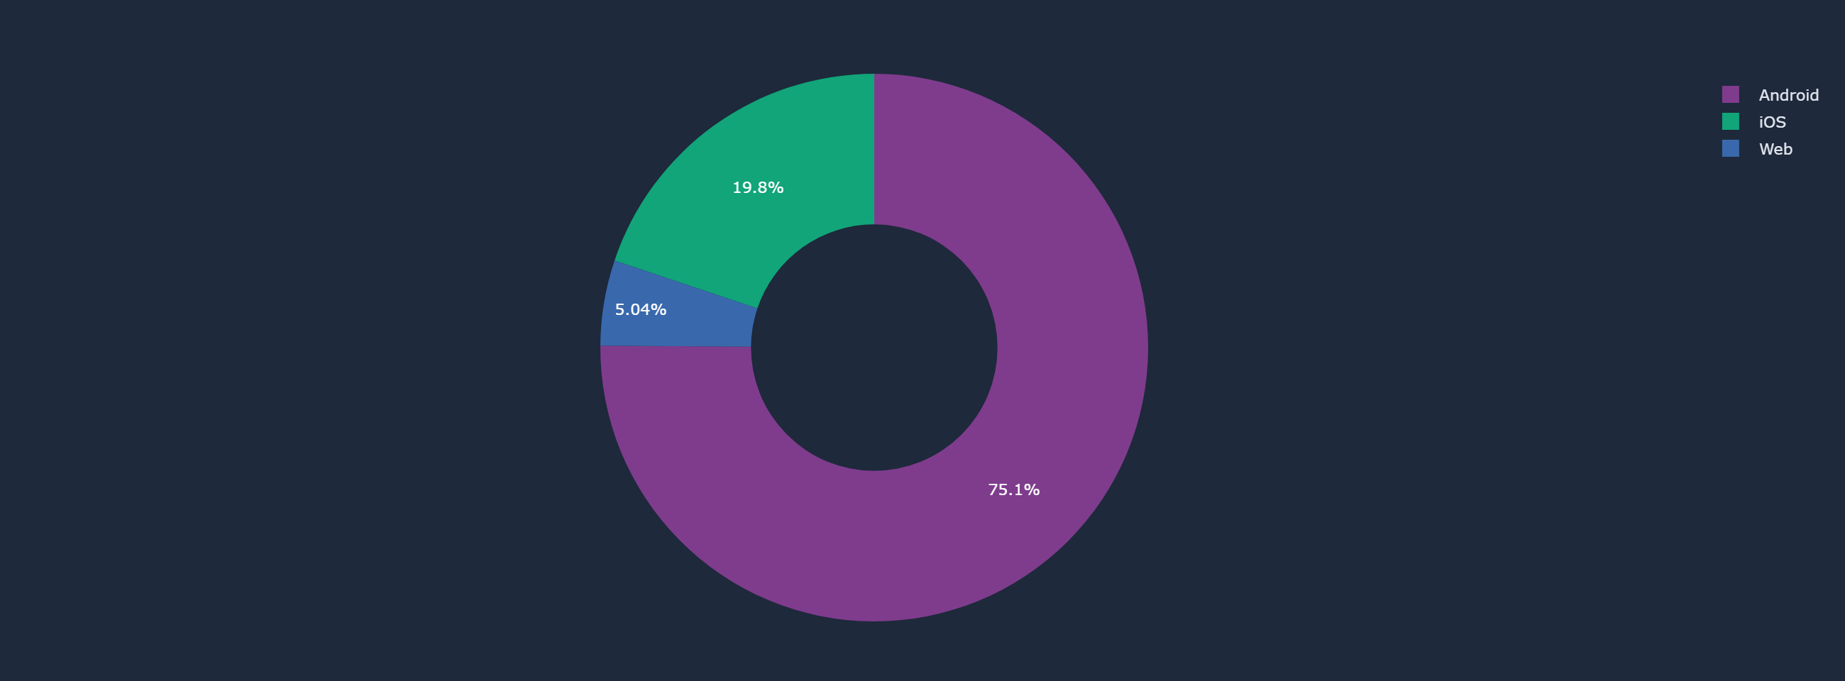
▲ Tab: Device & Network — Transactions by Device Type
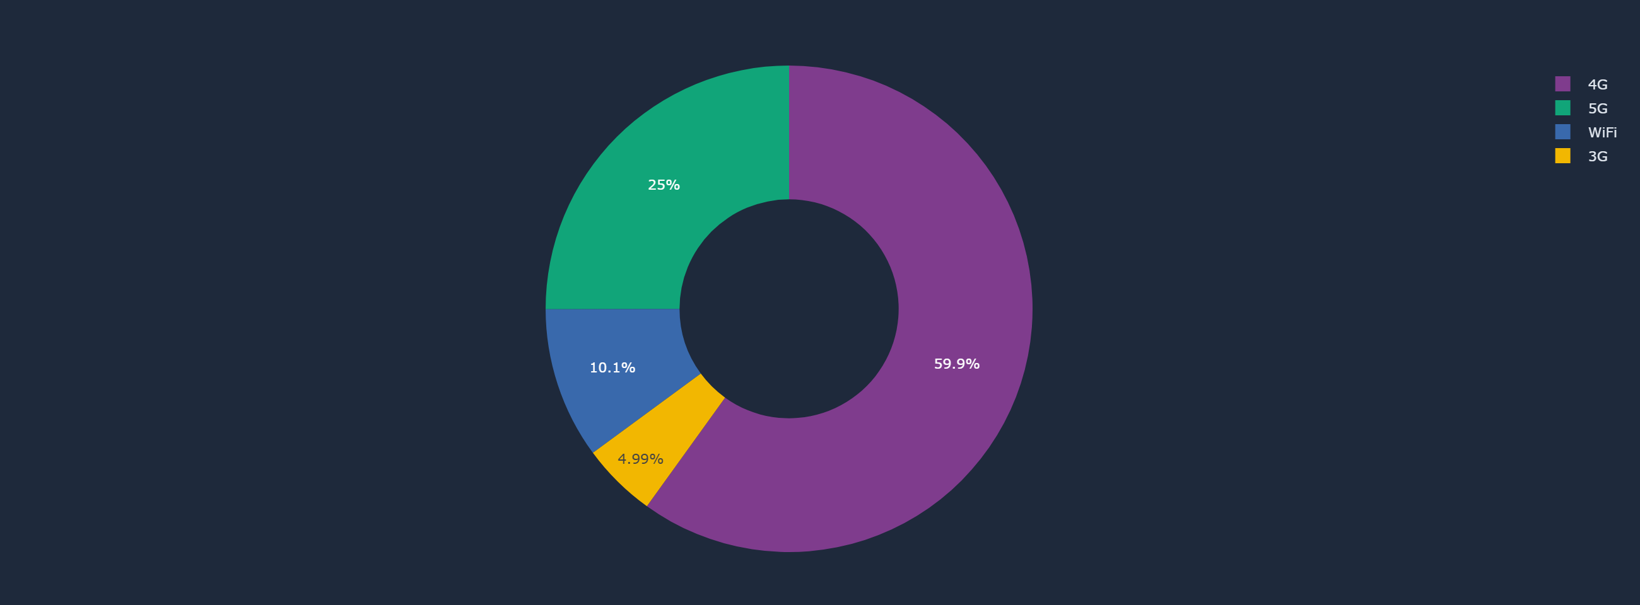
▲ Tab: Device & Network — Transactions by Network Type
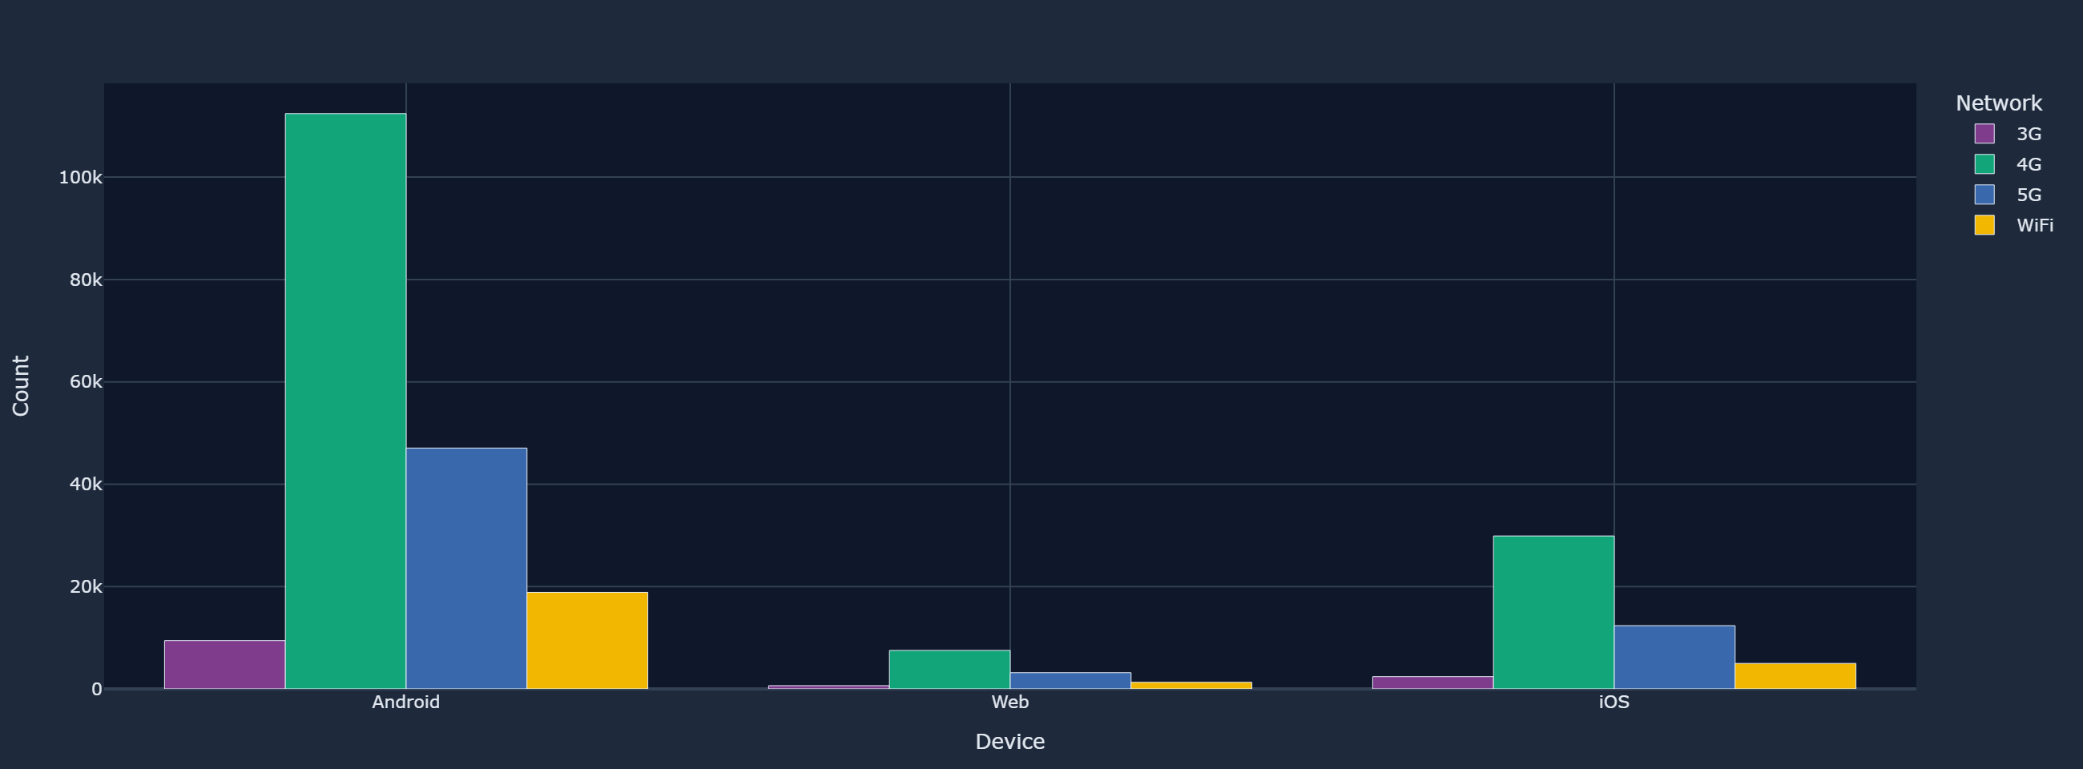
▲ Tab: Device & Network — Device × Network Grouped Breakdown

9 Demographic Analysis
The 26–35 age group is the dominant sender segment. Older senders (46+) tend to transact larger amounts. The age-group heatmap reveals intra-cohort transaction flows.
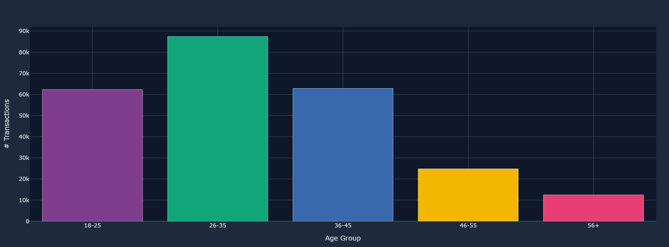
▲ Tab: Demographics — Transactions by Sender Age Group
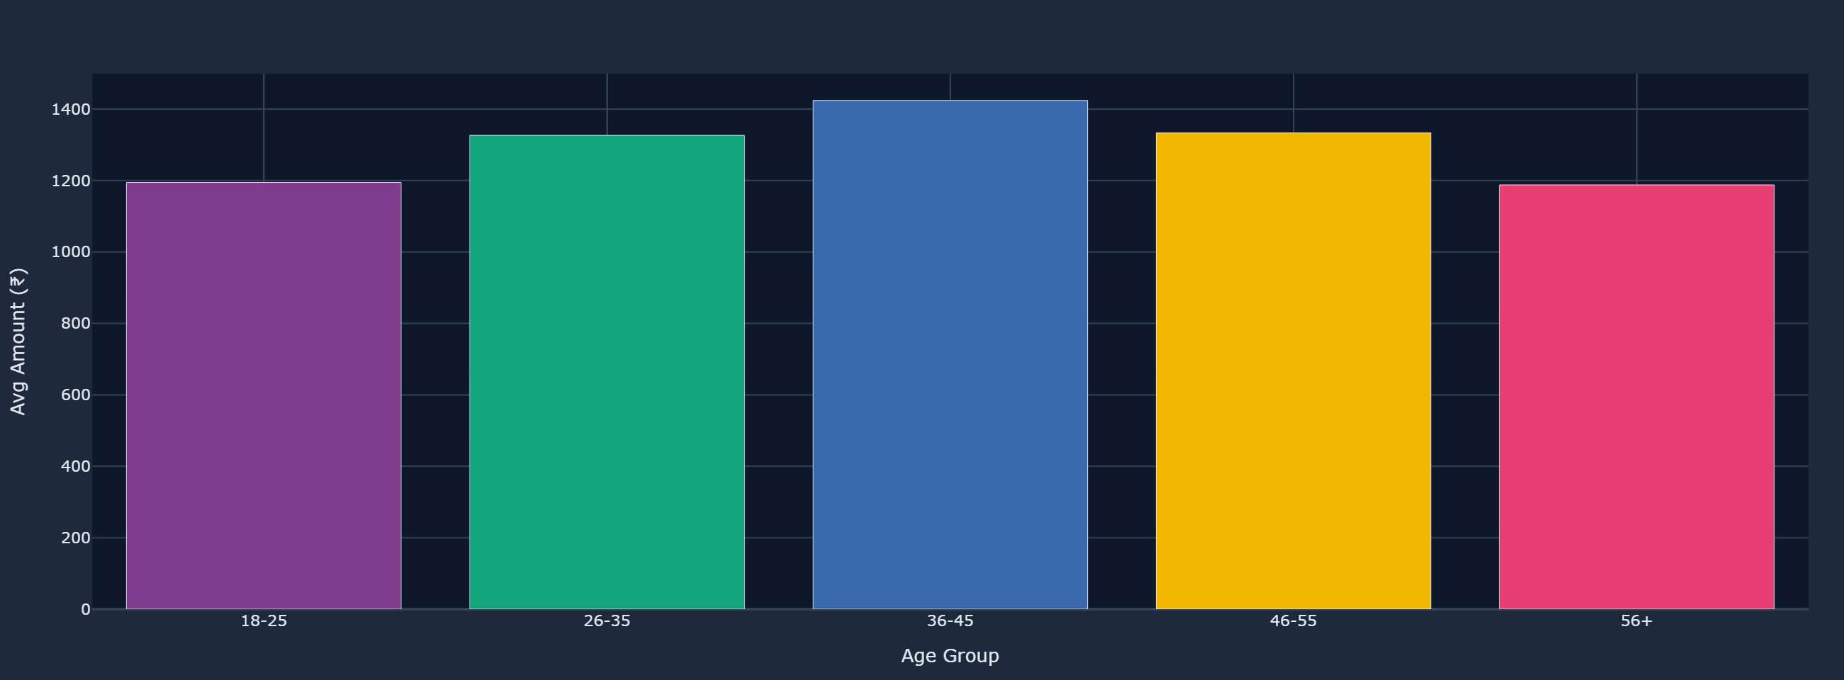
▲ Tab: Demographics — Avg Transaction Amount by Age Group
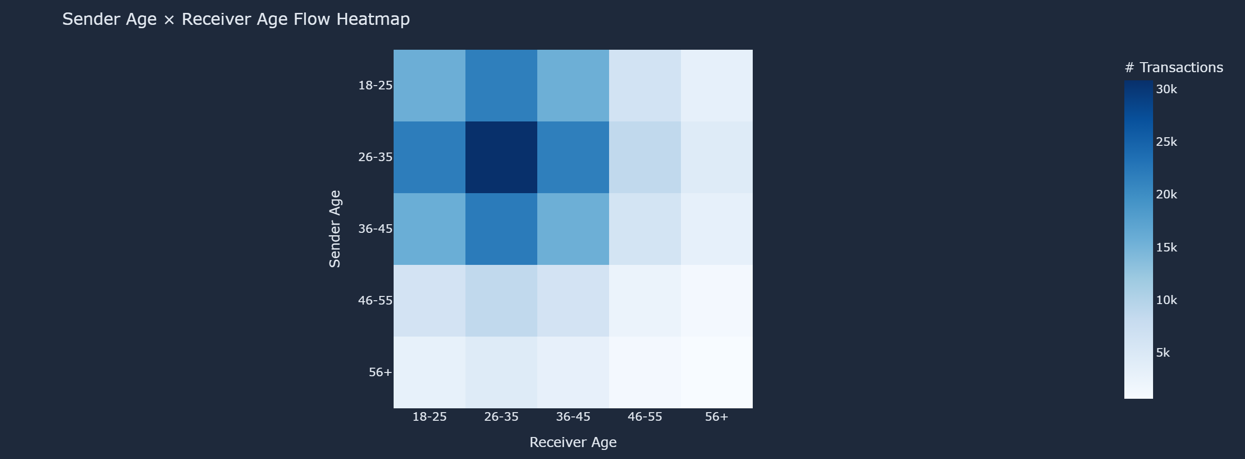
▲ Tab: Demographics — Sender Age × Receiver Age Flow Heatmap

10 Fraud Analysis
Total Fraud Transactions | 480
Fraud Rate | 0.192%
Avg Fraud Amount | ₹1,499
Total Fraud Value | ₹0.072 Cr

Only 480 of 250,000 transactions (0.19%) are flagged as fraudulent — demonstrating UPI's robust two-factor authentication and NPCI's real-time fraud detection.
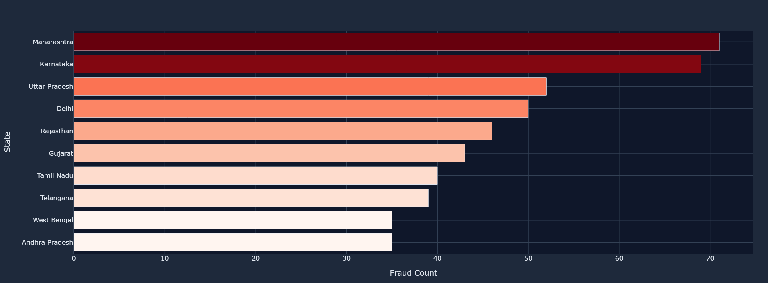
▲ Tab: Fraud — Fraud Transactions by Sender State
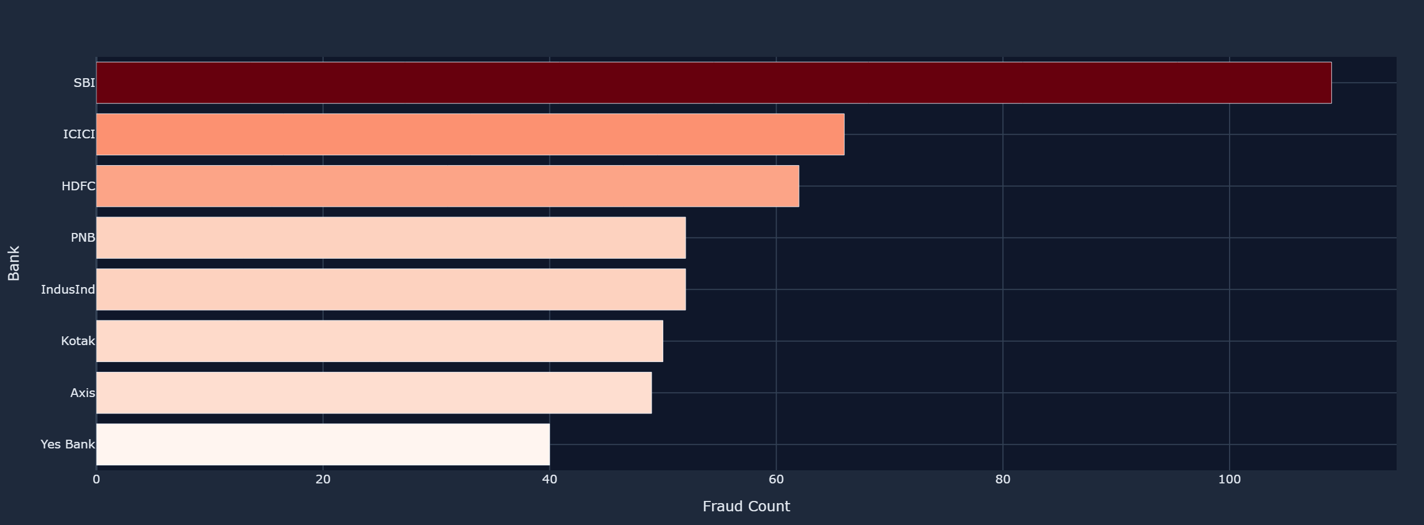
▲ Tab: Fraud — Fraud Transactions by Sender Bank
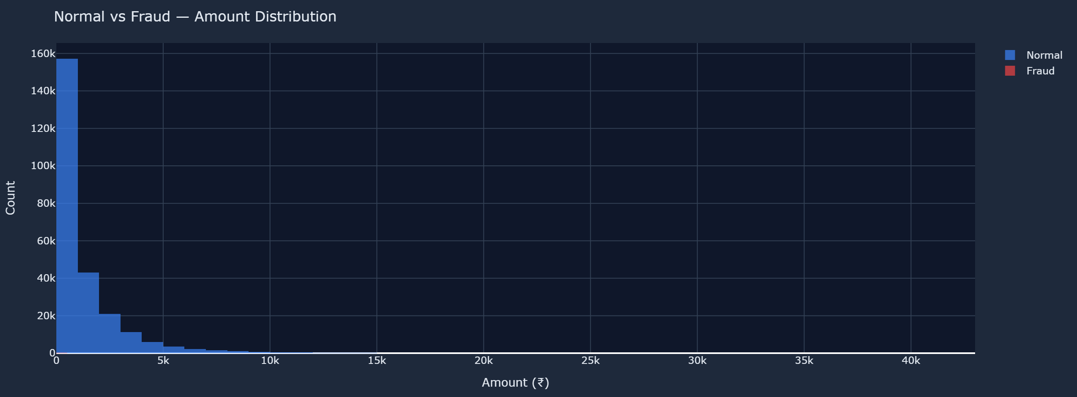
▲ Tab: Fraud — Normal vs Fraud Amount Distribution (overlay histogram)
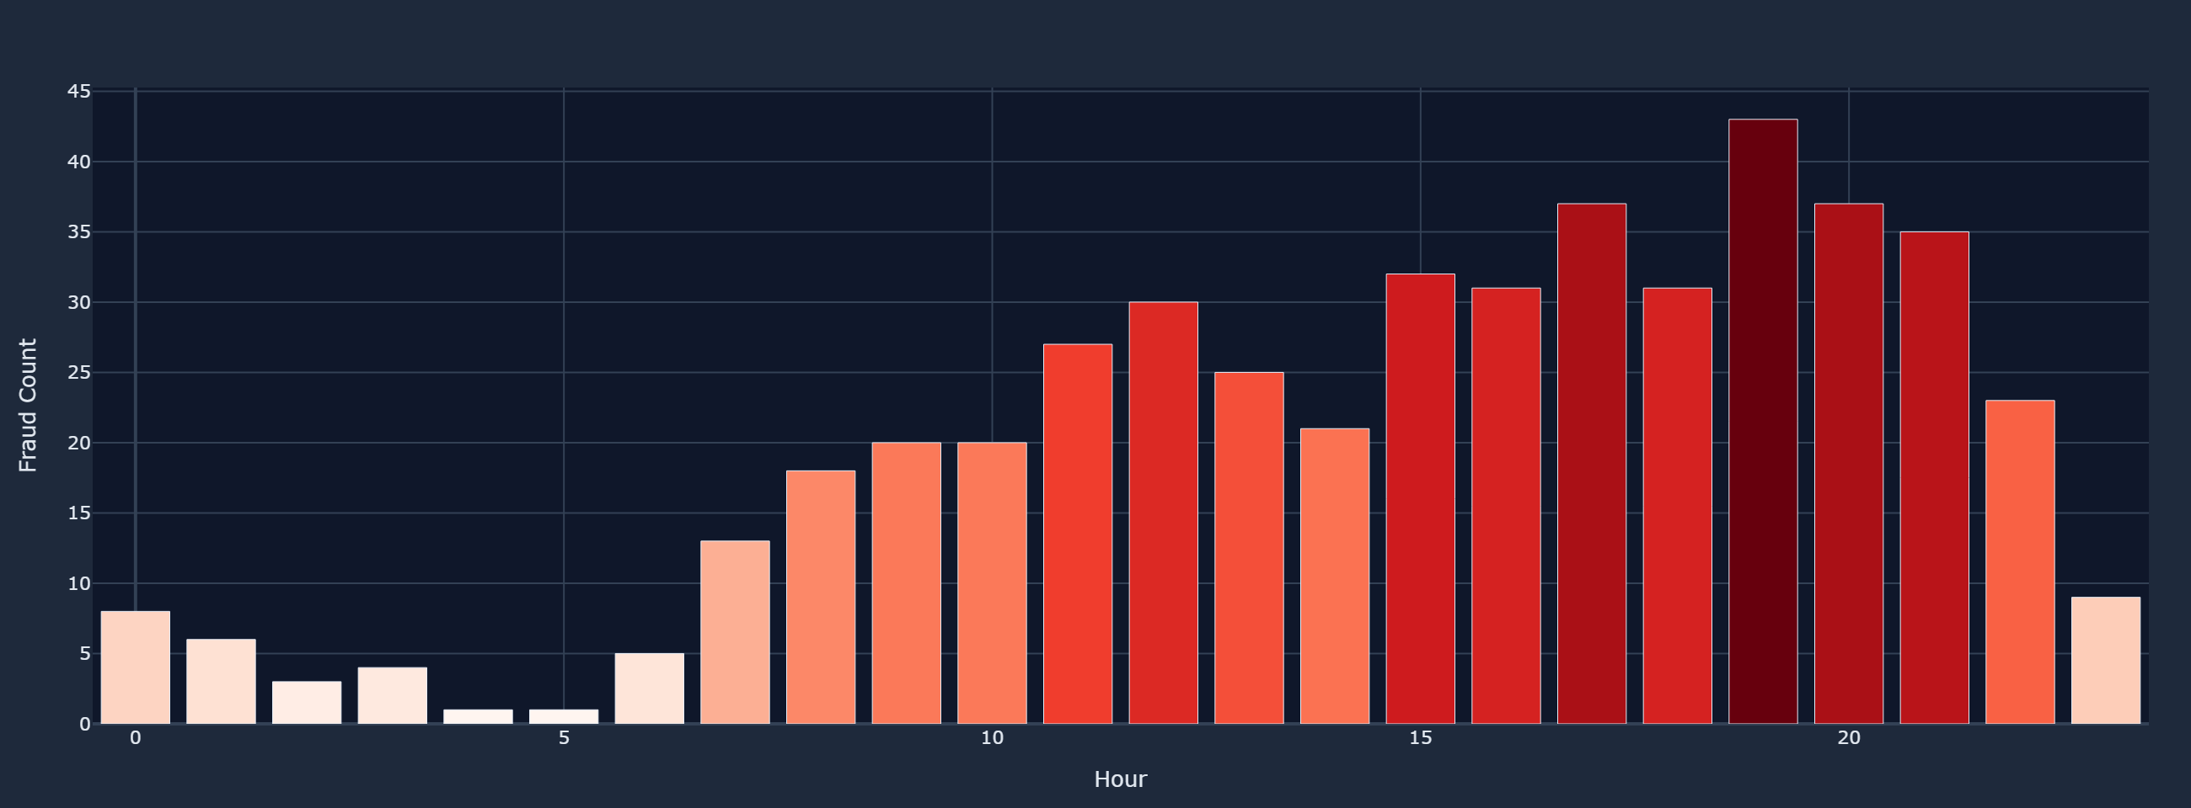
▲ Tab: Fraud — Fraud Transactions by Hour of Day

11 Key Insights
Dominant State: Maharashtra leads with 15.0% of all transactions.
Peak Hour: Highest activity at 19:00 hrs — post-work payment behaviour.
P2P vs P2M: P2P dominates at 45.0% of total transactions.
Fraud Rate: 0.19% — extremely low, confirming UPI's strong security controls.
Success Rate: 95.0% — UPI is a highly reliable payment infrastructure.
Top Category: Grocery is the most transacted merchant category.
Device Preference: Android accounts for 75.1% — Android-first ecosystem.
Core Demographic: 26-35 age group is the most active UPI user segment.

12 Conclusions
UPI is India's financial backbone: 250,000 transactions, ₹32.8 Cr total — essential infrastructure.
Security is excellent: Fraud rate 0.19% — NPCI and banks have built highly effective fraud prevention.
Demographic diversity growing: 36–45 and 46–55 groups showing meaningful participation beyond early adopters.
Geographic concentration remains: Tier-2/3 cities and rural states are the next UPI growth frontier.
4G is the enabler: Affordable mobile internet is the critical infrastructure for India's cashless transition.

13 Technology Stack
Library | Version | Purpose
Streamlit | >=1.32.0 | Web app framework — UI, widgets, layout
Pandas | >=2.1.0 | Data loading, cleaning, aggregation, feature engineering
NumPy | >=1.26.0 | Numerical operations
Plotly Express + GO | >=5.20.0 | All charts: bar, pie, histogram, heatmap, scatter, dual-axis
python-docx | 1.2.0 | This report generation
kaleido | 1.4.0 | Plotly static image export (PNG)

14 How to Run
Install dependencies: pip install -r requirements.txt
Ensure dataset present: upi_transactions_2024.csv in same folder as app.py
Launch dashboard: python -m streamlit run app.py
Open browser: http://localhost:8501

India Goes Cashless: UPI Analytics | Built with Streamlit & Plotly | Dataset: upi_transactions_2024.csv

