Smart Study Planner
A Web-Based Study Management System

Final Project Report
Submitted in partial fulfillment of the requirements for the degree of

[Dongshin University]
Supervisor: [Professor Musa]
Members

- Anish Raj Pandey
- Sudurshan Timilsina
- Prayash Thapa
- Shubhash Oli
- Pemba Thing Dorge
- Rishab Chand

Abstract
The Smart Study Planner (SSP) is a web-based application designed to help students organize their academic activities efficiently. The system provides a comprehensive platform for managing study tasks, taking subject-based quizzes, and tracking academic progress over time. Built using React 18 with Vite as the frontend framework and a Node.js/Express backend with PostgreSQL database, the application implements modern web development practices including JWT-based authentication and RESTful API design. The system supports two distinct user roles: students who can manage their study schedules and administrators who can monitor platform-wide activity. This report documents the complete software development lifecycle of the Smart Study Planner, including requirements analysis, system design, implementation details, and testing outcomes. The application was developed following the Software Requirements Specification (SRS) methodology and successfully implements all 18 functional requirements defined during the planning phase.
Keywords: Study Planner, Web Application, React, Node.js, PostgreSQL, JWT Authentication, SRS

Abstract 2
Chapter 1: Introduction 5
1.1 Background and Motivation 5
1.2 Problem Statement 5
1.3 Objectives 5
1.4 Scope of the Project 5
1.5 Technology Stack 6
1.6 Report Organization 6
Chapter 2: Software Requirements Specification (SRS) 7
2.1 Introduction to SRS 7
2.2 Overall Description 7
2.2.1 Product Perspective 7
2.2.2 Product Functions 7
2.2.3 User Classes and Characteristics 7
2.2.4 Operating Environment 7
2.2.5 Design and Implementation Constraints 8
2.3 Functional Requirements 8
2.4 Non-Functional Requirements 9
2.4.1 Performance Requirements 10
2.4.2 Security Requirements 10
2.4.3 Usability Requirements 10
2.4.4 Reliability Requirements 10
2.4.5 Maintainability 10
2.5 External Interface Requirements 10
2.5.1 User Interface 10
2.5.2 Hardware Interfaces 11
2.5.3 Software Interfaces 11
2.5.4 Communication Interfaces 11
Chapter 3: System Design 12
3.1 System Architecture 12
3.2 Use Case Diagram 12
3.3 Use Case Descriptions 13
3.4 Frontend Design and Mockup Descriptions 15
3.4.1 Welcome / Landing Page 15
3.4.2 Login Page 15
3.4.3 Dashboard Page 15
3.4.4 Tasks Page 15
3.4.5 Quiz Page 15
3.4.6 Progress Page 16
3.4.7 Admin Panel 16
3.5 Database Schema 16
3.6 API Endpoints 18
Chapter 4: Implementation and App Screenshots 20
4.1 Development Environment Setup 20
4.2 Frontend Implementation 20
4.3 Backend Implementation 20
4.4 App Screenshots 20
4.4.1 Welcome / Landing Page 20
4.4.2 Login Page 21
4.4.3 Signup Page 21
4.4.4 Dashboard 22
4.4.5 Study Tasks Page 22
4.4.6 Quiz Selection Page 23
4.4.7 Progress Page 23
4.4.8 Admin Panel 24
4.5 Deployment 24
Chapter 5: AI Tools and Business Analysis 26
5.1 AI Tools Used in Development 26
5.2 Business Analysis 26
5.2.1 Target Market 26
5.2.2 Value Proposition 26
5.2.3 Business Model (Potential) 27
5.2.4 Competitive Analysis 27
Chapter 6: Conclusion and References 28
6.1 Conclusion 28
6.2 Group Photo 28
6.3 References 28

Chapter 1: Introduction

1.1 Background and Motivation
Students in modern academic environments face increasing challenges in managing their study time, tracking assignments, and preparing for assessments. Traditional paper-based planners and generic calendar apps lack the subject-specific features needed by students. The Smart Study Planner addresses this gap by providing a purpose-built digital platform tailored to academic needs.

1.2 Problem Statement
Many students struggle with the following challenges:
- Disorganized study schedules leading to poor time management
- Lack of a centralized platform to track tasks and academic progress
- No integrated self-assessment tools to identify weak subject areas
- Inefficient review cycles that reduce overall academic performance

1.3 Objectives
The primary objectives of the Smart Study Planner are:
- To provide a secure, role-based web application for student study management
- To enable students to create, manage, and track study tasks
- To offer subject-based quizzes for self-assessment
- To display visual progress reports to motivate continued learning
- To provide administrators with oversight of platform usage

1.4 Scope of the Project
The Smart Study Planner covers the following functional areas:
- User registration and secure login with JWT authentication
- Task management (create, view, complete, delete)
- Subject-based quiz module with scoring
- Progress dashboard with visual statistics
- Admin panel for user and content management
- Deployment via Docker and Railway cloud platform
Out of scope: mobile native apps, video content, payment integration, third-party LMS integrations.

1.5 Technology Stack
- Frontend: React 18, Vite, React Router, CSS custom design system
- Backend: Node.js, Express.js
- Database: PostgreSQL (via pg / node-postgres library)
- Authentication: JSON Web Tokens (JWT), bcrypt for password hashing
- Deployment: Docker, Railway
- Version Control: Git/GitHub
- Fonts: Fraunces (display), Outfit (body)

1.6 Report Organization
This report is organized into the following chapters:
- Chapter 2 presents the Software Requirements Specification (SRS)
- Chapter 3 covers the system design including use cases and mockups
- Chapter 4 presents the implementation with screenshots
- Chapter 5 documents the AI tools and business analysis
- Chapter 6 provides the conclusion and references

Chapter 2: Software Requirements Specification (SRS)

2.1 Introduction to SRS
This chapter defines the complete software requirements for the Smart Study Planner system. It follows the IEEE 830 SRS standard and covers functional requirements, non-functional requirements, system interfaces, and constraints.

2.2 Overall Description

2.2.1 Product Perspective
The Smart Study Planner is a standalone web application that operates independently without integration to any external academic systems. It uses a client-server architecture where the React frontend communicates with a Node.js/Express REST API.

2.2.2 Product Functions
Main functions include:
- User Authentication (Register, Login, Logout)
- Task Management (CRUD operations)
- Quiz Engine (Multiple choice questions, scoring, history)
- Progress Tracking (Visual charts and statistics)
- Admin Dashboard (User management, system overview)

2.2.3 User Classes and Characteristics
Two user classes exist within the system:
- Student Users: Primary users who register, manage tasks, take quizzes, and view progress
- Admin Users: Platform administrators who view all users, manage content, and monitor activity

2.2.4 Operating Environment
- Web browsers: Chrome 90+, Firefox 88+, Safari 14+, Edge 90+
- Server: Node.js 18+ on Linux/macOS/Windows
- Database: PostgreSQL relational database
- Network: Internet or local network access

2.2.5 Design and Implementation Constraints
- Must run on Node.js 18 or higher
- PostgreSQL used for reliability and scalability
- Supports concurrent connections via connection pooling
- JWT tokens expire in 7 days
- Frontend served separately from backend API

2.3 Functional Requirements
The following table lists all 18 functional requirements for the Smart Study Planner:
Req ID | Requirement Description | Priority | Implementation Location
REQ-1 | User shall enter email and password to log in | High | pages/Login.jsx
REQ-2 | System shall validate credentials against database | High | server/db.js
REQ-3 | System shall show error message on invalid login | High | pages/Login.jsx (error banner)
REQ-4 | System shall redirect to dashboard on successful login | High | pages/Login.jsx
REQ-5 | Dashboard shall display personalized greeting | Medium | pages/Dashboard.jsx
REQ-6 | Dashboard shall contain a "Let's Begin" button | Medium | pages/Dashboard.jsx
REQ-7 | "Let's Begin" button shall navigate to tasks section | Medium | Dashboard /tasks route
REQ-8 | User shall be able to add new study tasks | High | pages/Tasks.jsx
REQ-9 | User shall be able to delete tasks | High | pages/Tasks.jsx
REQ-10 | Tasks shall be stored persistently in PostgreSQL database | High | server/db.js
REQ-11 | Tasks shall be displayed in a list view | Medium | pages/Tasks.jsx
REQ-12 | User shall be able to start a quiz | High | pages/Quiz.jsx
REQ-13 | Quiz questions shall be displayed one at a time | Medium | pages/Quiz.jsx
REQ-14 | System shall evaluate selected answers | High | pages/Quiz.jsx
REQ-15 | System shall show final score after quiz completion | High | pages/Quiz.jsx (result screen)
REQ-16 | Completed tasks shall be recorded in progress | High | server/db.js
REQ-17 | Quiz scores shall be stored in the database | High | server/db.js
REQ-18 | Progress page shall display visual statistics | High | pages/Progress.jsx

2.4 Non-Functional Requirements

2.4.1 Performance Requirements
- Page load time: under 3 seconds on standard broadband
- API response time: under 500ms for database queries
- Support: minimum 50 concurrent users

2.4.2 Security Requirements
- Passwords hashed using bcrypt with salt rounds
- JWT tokens used for session management
- Protected routes reject unauthenticated requests
- Admin-only routes verified server-side

2.4.3 Usability Requirements
- Intuitive navigation requiring no training
- Responsive design for desktop and tablet viewports
- Consistent visual design system using custom CSS

2.4.4 Reliability Requirements
- System uptime: 99% during academic terms
- Data persistence guaranteed by PostgreSQL ACID transactions

2.4.5 Maintainability
- Modular React component architecture
- Clear separation of frontend and backend concerns
- Documented API endpoints

2.5 External Interface Requirements

2.5.1 User Interface
- Welcome/landing page accessible without login
- Login and Signup forms with validation
- Dashboard with task summary and navigation
- Quiz interface with question cards
- Progress page with charts/statistics
- Admin panel with user tables

2.5.2 Hardware Interfaces
No special hardware required. Standard web browser and internet connection suffice.

2.5.3 Software Interfaces
- Node.js runtime environment
- PostgreSQL database engine
- Modern web browser with JavaScript enabled

2.5.4 Communication Interfaces
- HTTP/HTTPS protocol
- RESTful JSON API between frontend and backend
- JWT Bearer token in Authorization header

Chapter 3: System Design

3.1 System Architecture
The Smart Study Planner follows a three-tier architecture:
- Presentation Tier: React 18 SPA (Single Page Application) built with Vite
- Application Tier: Node.js + Express REST API server
- Data Tier: PostgreSQL relational database

3.2 Use Case Diagram
The system involves the following actors and use cases:
Actors: Student, Admin, System
Student Use Cases:
- Register Account
- Login to System
- View Dashboard
- Add Study Task
- Delete Study Task
- Mark Task as Complete
- Start Quiz
- Answer Quiz Questions
- View Quiz Score
- View Progress Report
- Logout
Admin Use Cases:
- Login to Admin Panel
- View All Users
- Monitor Platform Activity
- Manage Quiz Content
[Insert Use Case Diagram here]

3.3 Use Case Descriptions
The following table describes the top five use cases in detail:
Use Case: User Login
Actor | Student
Precondition | User has a registered account
Main Flow | User enters email and password. System validates credentials. JWT token is issued. User is redirected to Dashboard.
Alternate Flow | Invalid credentials: error message displayed
Postcondition | User is authenticated and on Dashboard

Use Case: Add Study Task
Actor | Student (authenticated)
Precondition | User is logged in
Main Flow | User clicks Add Task. Enters task details. Submits form. Task saved to DB. List updates.
Alternate Flow | Empty input: validation error shown
Postcondition | New task appears in task list

Use Case: Take Quiz
Actor | Student (authenticated)
Precondition | User is logged in, quiz questions exist
Main Flow | User selects quiz. Questions displayed. User answers. Score calculated. Score saved. Result shown.
Postcondition | Score stored in database, visible on Progress page

Use Case: View Progress
Actor | Student (authenticated)
Precondition | User has completed tasks and/or quizzes
Main Flow | User navigates to Progress. System fetches stats from DB. Charts rendered.
Postcondition | User sees visual progress overview

Use Case: Admin Dashboard
Actor | Admin
Precondition | Admin credentials valid
Main Flow | Admin logs in. Redirected to /admin. Views user list and stats.
Postcondition | Admin has full visibility of platform

3.4 Frontend Design and Mockup Descriptions

3.4.1 Welcome / Landing Page
The landing page features the app name 'Smart Study Planner' with the tagline 'Plan smarter, not harder', a descriptive paragraph, a 'Let's begin' CTA button, and a study desk hero image on the right side.

3.4.2 Login Page
Centered card layout featuring the application name at the top, email and password input fields, a Login primary button, a link to the Signup page, and an error banner shown on failed authentication.

3.4.3 Dashboard Page
After login, the dashboard greets the user by name (e.g. 'Good morning, Macuser'), shows today's date/time, four summary cards (Tasks planned, Completed, Quizzes taken, Completion rate), a Today's Tasks panel with add-task button, and a Progress panel with a circular chart.

3.4.4 Tasks Page
The tasks page shows a form to add new tasks with fields for Task title, Subject, Due date, and Priority. Below the form, existing tasks are listed with subject, due date, priority badge, and a delete button.

3.4.5 Quiz Page
The quiz page shows a grid of quiz cards, each showing the quiz title (e.g. Web Fundamentals, Cloud & Databases, Study Strategies) and question count, with a 'Start quiz' button.

3.4.6 Progress Page
The progress page displays a Tasks completed progress bar, three stat cards (Completion rate, Quizzes taken, Total tasks), and a Quiz history section.

3.4.7 Admin Panel
The admin panel has two tabs: Quizzes and Users. The Quizzes tab lists all quizzes with question counts and allows adding new quizzes or questions.

3.5 Database Schema
The Smart Study Planner uses PostgreSQL with the following five tables:
users Table
Column | Type / Description
id | TEXT PRIMARY KEY
name | TEXT NOT NULL
email | TEXT UNIQUE NOT NULL
password | TEXT NOT NULL (bcrypt hashed)
is_admin | BOOLEAN DEFAULT FALSE

tasks Table
Column | Type / Description
id | TEXT PRIMARY KEY
user_id | TEXT NOT NULL REFERENCES users(id)
title | TEXT NOT NULL
subject | TEXT DEFAULT 'General'
due_date | TEXT
priority | TEXT DEFAULT 'MEDIUM'
completed | BOOLEAN DEFAULT FALSE
created_at | TEXT NOT NULL

scores Table
Column | Type / Description
id | TEXT PRIMARY KEY
user_id | TEXT NOT NULL REFERENCES users(id)
quiz_id | TEXT NOT NULL
quiz_title | TEXT NOT NULL
score | INTEGER NOT NULL
total | INTEGER NOT NULL
taken_at | TEXT NOT NULL

quizzes Table
Column | Type / Description
id | TEXT PRIMARY KEY
title | TEXT NOT NULL
description | TEXT DEFAULT ''
created_at | TEXT NOT NULL

questions Table
Column | Type / Description
id | TEXT PRIMARY KEY
quiz_id | TEXT NOT NULL REFERENCES quizzes(id) ON DELETE CASCADE
text | TEXT NOT NULL
options | JSONB NOT NULL
answer_index | INTEGER NOT NULL
order_index | INTEGER NOT NULL DEFAULT 0

3.6 API Endpoints
Method | Endpoint | Description | Auth Required
POST | /api/auth/register | Register new user | No
POST | /api/auth/login | Login and receive JWT | No
GET | /api/tasks | Get all tasks for user | Yes
POST | /api/tasks | Create a new task | Yes
PATCH | /api/tasks/:id | Toggle task completion | Yes
DELETE | /api/tasks/:id | Delete a task | Yes
GET | /api/progress | Get progress statistics | Yes
POST | /api/quiz/score | Save quiz score | Yes
GET | /api/admin/users | Get all users (admin only) | Yes (Admin)
GET | /api/quizzes | Get all quizzes | No
GET | /api/quizzes/:id/questions | Get questions for a quiz | No

Chapter 4: Implementation and App Screenshots

4.1 Development Environment Setup
The project was developed using the following tools:
- Visual Studio Code as the IDE
- Node.js 18+ runtime
- Git for version control with GitHub
- Docker for containerization

4.2 Frontend Implementation
The frontend was built using React 18 with functional components and hooks. React Router v6 handles client-side routing. The AuthContext provides global authentication state. Protected routes redirect unauthenticated users to the login page.

4.3 Backend Implementation
The backend uses Express.js to define RESTful API routes. The pg (node-postgres) library provides asynchronous PostgreSQL access via a connection pool. Passwords are hashed with bcryptjs. JWT tokens are signed and verified using the jsonwebtoken library.

4.4 App Screenshots
The following sections show screenshots of the application.

4.4.1 Welcome / Landing Page

Figure 1: Welcome / Landing Page

4.4.2 Login Page
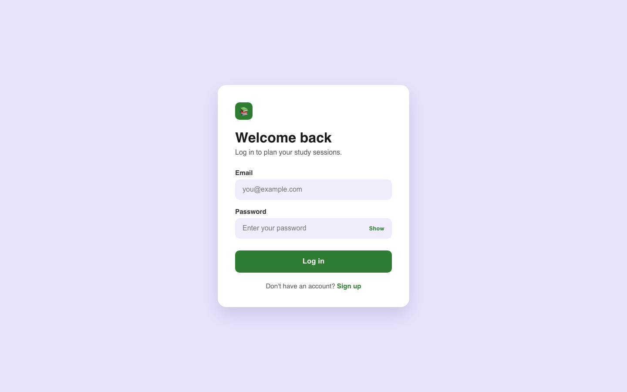
Figure 2: Login Page

4.4.3 Signup Page
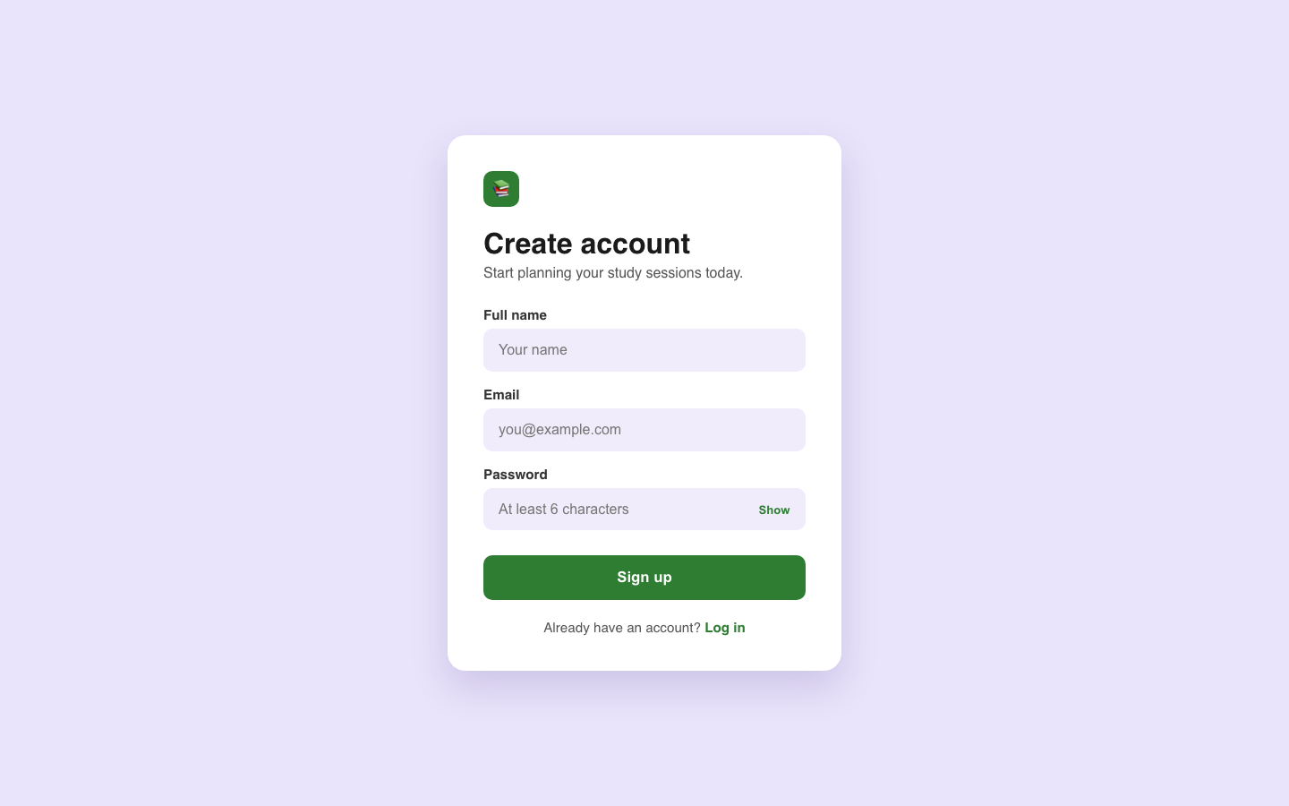
Figure 3: Signup Page

4.4.4 Dashboard
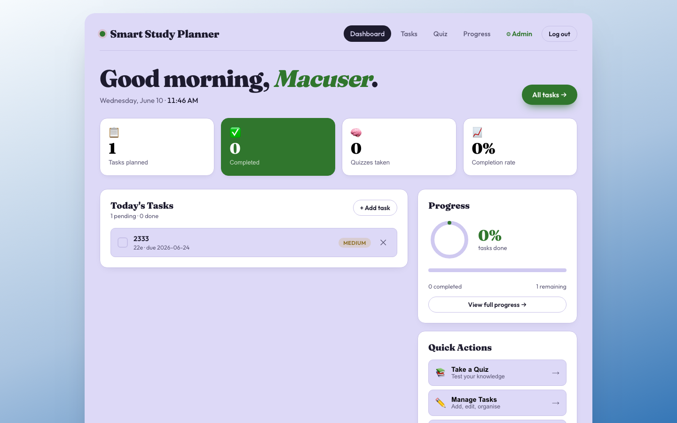
Figure 4: Dashboard

4.4.5 Study Tasks Page
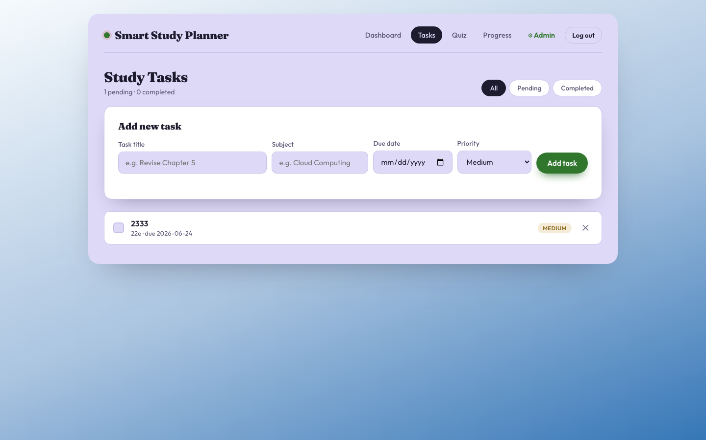
Figure 5: Study Tasks Page

4.4.6 Quiz Selection Page
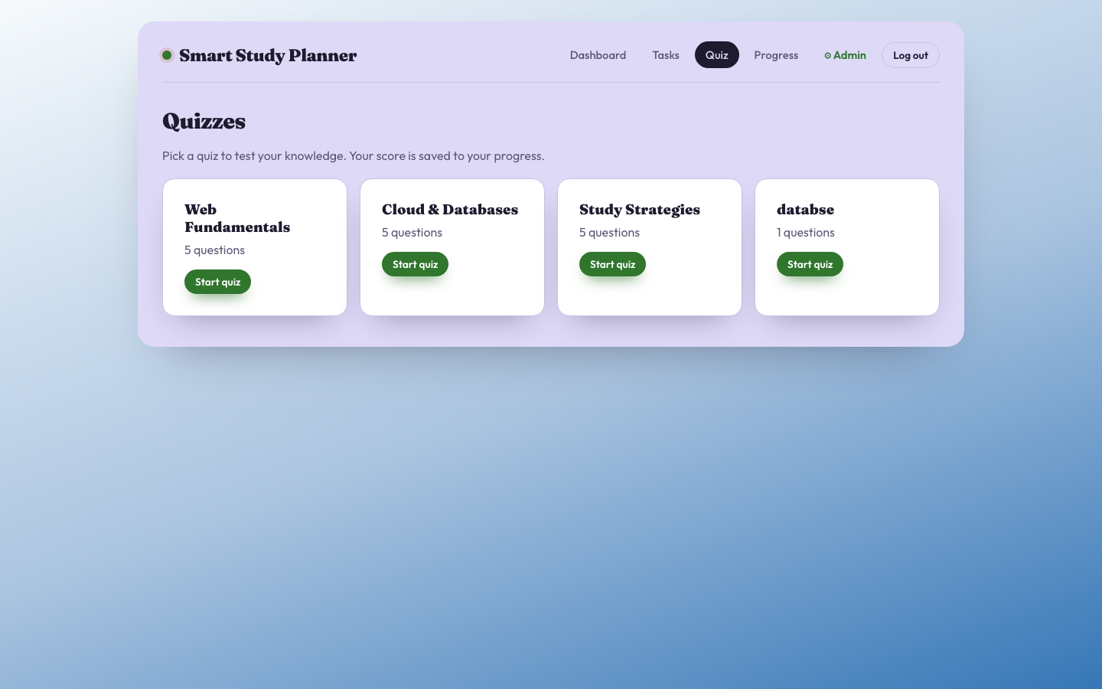
Figure 6: Quiz Selection Page

4.4.7 Progress Page
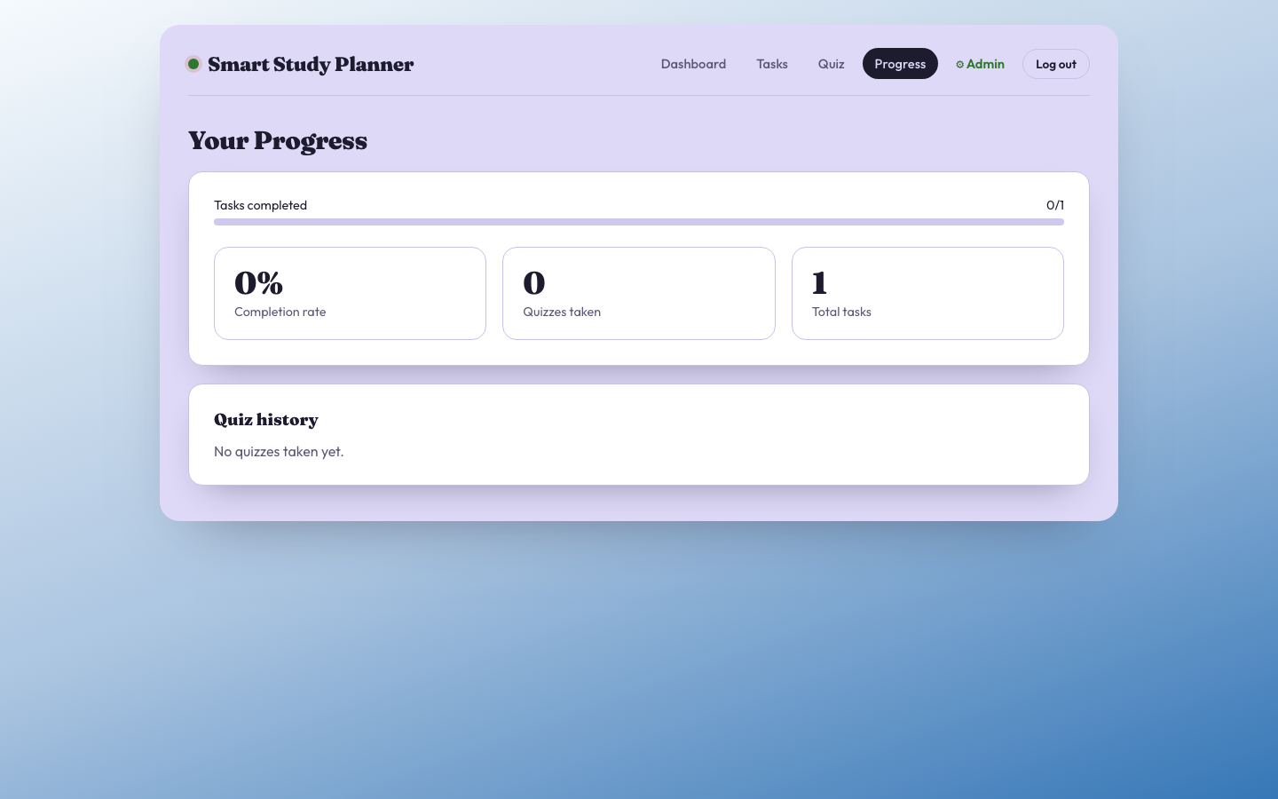
Figure 7: Progress Page

4.4.8 Admin Panel
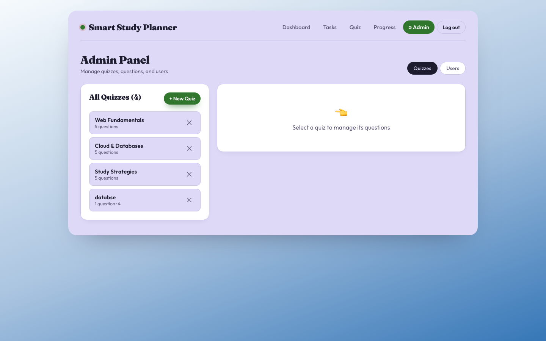
Figure 8: Admin Panel

4.5 Deployment
The application is containerized using Docker. A Dockerfile defines the production build steps. docker-compose.yml orchestrates the frontend and backend services. The app is deployed on Railway cloud platform for live access.

Chapter 5: AI Tools and Business Analysis

5.1 AI Tools Used in Development
The following AI tools were utilized during the development of the Smart Study Planner:
Tool | Purpose | How It Was Used
Claude (Anthropic) | Code generation and debugging | Used to generate React components, Express API routes, and debug authentication logic
GitHub Copilot | Inline code suggestions | Assisted with boilerplate code and completing repetitive patterns
ChatGPT | Research and documentation | Used for researching best practices, SRS writing guidance, and generating quiz content

5.2 Business Analysis

5.2.1 Target Market
The Smart Study Planner targets:
- University and college students aged 18-25
- Academic institutions looking for student productivity tools
- Self-learners and professionals pursuing certifications

5.2.2 Value Proposition
The application provides:
- Free, accessible study management without subscription fees
- Integrated quiz and progress tracking in one platform
- Simple, intuitive interface with no learning curve

5.2.3 Business Model (Potential)
A future commercial version could adopt:
- Freemium model: basic features free, premium features paid
- Institutional licensing: universities pay per-seat licenses
- API access: expose quiz engine for third-party LMS integration

5.2.4 Competitive Analysis
Competitors include Google Tasks, Notion, and Quizlet. The Smart Study Planner differentiates by combining task management, quizzing, and progress tracking in one purpose-built academic tool.

Chapter 6: Conclusion and References

6.1 Conclusion
The Smart Study Planner successfully achieves all stated objectives. The system implements all 18 functional requirements defined in the SRS. The application demonstrates a clean separation of concerns between the React frontend and Node.js backend. JWT-based authentication ensures secure access control. The admin and student role separation provides appropriate access levels. Future work could include mobile app development, integration with university LMS systems, and AI-powered study recommendations.

6.2 Group Photo
[Insert Group Photo here]

6.3 References
References (APA format):
- React Documentation. (2024). React - A JavaScript library for building user interfaces. Meta Open Source. https://react.dev
- Node.js Foundation. (2024). Node.js Documentation. OpenJS Foundation. https://nodejs.org/en/docs
- Express.js. (2024). Express - Fast, unopinionated, minimalist web framework for Node.js. https://expressjs.com
- PostgreSQL Global Development Group. (2024). PostgreSQL Documentation. https://www.postgresql.org/docs
- node-postgres. (2024). pg - PostgreSQL client for Node.js. https://node-postgres.com
- Auth0. (2024). Introduction to JSON Web Tokens. https://jwt.io/introduction
- IEEE. (1998). IEEE Std 830-1998: IEEE Recommended Practice for Software Requirements Specifications. IEEE.
- Pressman, R. S., & Maxim, B. R. (2020). Software Engineering: A Practitioner's Approach (9th ed.). McGraw-Hill Education.
- Vite. (2024). Vite Next Generation Frontend Tooling. https://vitejs.dev
- React Router. (2024). React Router Documentation. https://reactrouter.com
- Docker Inc. (2024). Docker Documentation. https://docs.docker.com

