**Design Thinking Project Workbook**

**Don't find customers for your product but find products for your customers**

**1. BookWise (Library Management System)**

**Team Name:**

**TEAM 9**

**Team Logo (if any):**

**Team Members:**

1. [BITLA SRI HARI-2320030300]
2. [T.SAI HARSHA-2320030308]
3. [T. VARSHITH SWMAY-2320030196]
4. [TAVISI ANISH-2320030351]

**2. Problem/Opportunity Domain**

**Domain of Interest:** The Domain of Interest for this project is Library Management Systems with a focus on User-Centered Digital Solutions for libraries. It emphasizes enhancing the library experience for both librarians and users by leveraging Java-based backend development with Java Servlets and JDBC for efficient database management. This domain involves digital catalog management, user notifications, real-time inventory management, and automated fine tracking to address the core challenges in library operations and provide a seamless, accessible system for library stakeholders.

**Description of the Domain:** The Library Management System (LMS) domain focuses on digital solutions to streamline library operations. It covers catalog management, borrow tracking, and user notifications for a seamless experience. Through Java Servlets for web functions and JDBC for database management, LMSs allow real-time book availability, reservation, and automated overdue tracking, improving resource management and user satisfaction in libraries.

**Why did you choose this domain?** This domain was chosen because Library Management Systems play a crucial role in modernizing libraries, making resources more accessible and manageable. By leveraging technology, LMS addresses key challenges like cataloging, real-time tracking, and user notifications, enhancing both librarian efficiency and user experience. This field offers the opportunity to blend user-centered design with technical skills in Java and database management to create impactful, functional solutions for everyday use.

**3. Problem/Opportunity Statement**

**Problem Statement:** The current library management process faces challenges in efficiently managing book inventories, tracking borrows and return activities and notifying users about due dates and fines. Librarians and users struggle with limited access to real-time book availability, difficulties in locating desired resources, and a lack of timely notifications for overdue items. This results in operational inefficiencies and a less user-friendly experience. A digital Library Management System is needed to provide seamless catalog search, real-time inventory tracking, and automated notifications, enhancing resource management and improving the overall library experience.

**Problem Description:** Libraries face significant operational challenges in managing book inventory, tracking checkouts and returns, and ensuring timely communication with users about due dates and fines. Traditional systems often lack real-time visibility into book availability, making it difficult for users to locate resources and for librarians to keep track of inventory accurately. Additionally, the absence of automated notifications can lead to overdue books and fines, inconveniencing both users and library staff. These limitations result in inefficient resource utilization, reduced accessibility, and a subpar user experience. A digital Library Management System is required to streamline these processes, offering features like searchable catalogs, real-time updates, and automated notifications to meet the needs of modern libraries effectively.

**Context (When does the problem occur):** The problem occurs during the daily operations of libraries, specifically when users need to search for, reserve, or borrow books, and when librarians manage inventory and user transactions. Issues arise when users cannot locate books due to outdated availability information or lack of a searchable catalog, causing frustration and inefficient time usage. Additionally, overdue fines accumulate when users are not promptly notified of due dates, which can damage user relationships and complicate return tracking for librarians. These challenges frequently occur in high-traffic libraries, during peak usage times, and when manual processes cannot keep up with demand.

**Alternatives (What does the customer do to fix the problem):** Customers rely on physical catalogs, spreadsheets, and basic library software to manage inventory and checkouts. Manual notifications for due dates are common, but these methods are time-consuming, lack real-time updates, and reduce efficiency.

**Customers (Who has the problem most often):** The primary customers affected are students and libraryusers seeking efficient book search and checkout options, as well as librarians responsible for inventory management and user notifications.

**Emotional Impact (How does the customer feel):** Customers often feel frustrated by delays in finding books and receiving overdue notifications. Librarians may feel overwhelmed managing tasks manually, while users experience disappointment when desired books are unavailable or difficult to locate.

**Quantifiable Impact (What is the measurable impact):** The measurable impacts include increased time spent by users and librarians on book searches and manual management, as well as higher overdue fines from delayed notifications, leading to reduced user satisfaction and a decrease in overall library engagement. Additionally, operational inefficiencies impact library staff, taking time away from other critical tasks.

**Alternative Shortcomings (What are the disadvantages of the alternatives):** Manual systems and basic software are time-consuming and lack real-time updates, leading to inaccurate inventory tracking and book availability issues. They often require significant manual effort for notifications and checkouts, resulting in delayed user updates, increased chances of errors, and low user satisfaction due to inefficient service.

**4. Addressing SDGs**

**Relevant Sustainable Development Goals (SDGs):**

* SDG 4 - Quality Education: By improving library accessibility and resource management, this project supports inclusive and equitable access to information and educational materials for all users.
* SDG 9 - Industry, Innovation, and Infrastructure: Implementing a digital Library Management System promotes technological innovation, building resilient infrastructure within educational institutions.
* SDG 12 - Responsible Consumption and Production: Efficiently managing library resources and minimizing waste (like paper for manual tracking) supports sustainable consumption within the library environment.

**How does your problem/opportunity address these SDGs?**

* SDG 4 - Quality Education: A Library Management System enhances accessibility to learning materials, enabling students and users to find resources quickly and easily, supporting inclusive education.
* SDG 9 - Industry, Innovation, and Infrastructure: By digitizing catalog and inventory management, the system introduces innovative technology in library infrastructure, fostering efficient resource management.
* SDG 12 - Responsible Consumption and Production: The system reduces reliance on paper-based records and manual tracking, promoting sustainable resource management and responsible consumption within the library.

**5. Stakeholders**

Answer these below questions to understand the stakeholder related to your project

1. **Who are the key stakeholders involved in or affected by this project?**

The key stakeholders in the Library Management System project include librarians, who manage book inventories and user accounts, and students, who use the system to search, borrow, and return books. Library administrators oversee operations and reporting, while the IT department ensures system functionality. Additionally, university management monitors costs and scalability, and book vendors may be involved in tracking inventory needs. Each group has specific needs that will influence the system's design, ensuring efficiency and user satisfaction.

1. **What roles do the stakeholders play in the success of the innovation?**

Each stakeholder plays a crucial role in the success of the Library Management System. Librarians ensure accurate inventory management and user assistance, while students and library users drive system adoption through daily use. Library administrators contribute by overseeing system operations and reporting, ensuring efficiency. The IT department maintains system performance and security, while university management provides support through funding and strategic decisions. Book vendors help maintain inventory levels. Collaboration among all stakeholders ensures the system meets user needs and operates smoothly, leading to successful implementation.

1. **What are the main interests and concerns of each stakeholder?**

Stakeholders in the Library Management System have varied interests and concerns. Librarians want efficient inventory management but worry about system complexity. Students seek quick access to book information and clear due dates, while fearing downtime. Library administrators focus on accurate reporting but are concerned about inefficiencies. The IT department prioritizes reliability and security, worried about bugs. University management aims for cost-effectiveness and user experience, wary of high expenses. Lastly, book vendors want timely inventory updates but are concerned about demand inconsistencies.

1. **How much influence does each stakeholder have on the outcome of the project?**

Each stakeholder's influence on the Library Management System project varies. Librarians hold significant sway due to their interaction with users and feedback on usability. Students, as primary users, are crucial for the system's success. Library administrators impact resource allocation and policy decisions, while the IT department's expertise is vital for functionality and troubleshooting. University management shapes the project through budgetary decisions, and book vendors affect inventory management but have less direct influence on the system's design. Overall, librarians and students are the most influential, as their experiences will drive adoption and effectiveness.

1. **What is the level of engagement or support expected from each stakeholder?**

Librarians are expected to engage actively by providing feedback and training users. Students should participate by using the system and sharing their experiences. Library administrators will support the project through policy implementation and resource allocation. The IT department is expected to maintain and troubleshoot the system, ensuring reliability. University management will provide strategic support and budget approval, while book vendors are expected to collaborate on inventory needs but have minimal engagement in system design. Overall, active participation from librarians and students is crucial for success.

1. **Are there any conflicts of interest between stakeholders? If so, how can they be addressed?**

Conflicts of interest may arise between stakeholders, such as librarians prioritizing user-friendly features while university management focuses on cost-effectiveness. Students might want more resources, which could clash with budget constraints. To address these issues, open communication and collaboration are essential. Regular meetings can facilitate discussions of priorities, enabling compromises that align user needs with operational and budgetary constraints. Involving all parties in decision-making helps ensure that diverse interests are effectively balanced.

1. **How will you communicate and collaborate with stakeholders throughout the project?**

**To communicate and collaborate with stakeholders, we will hold regular meetings and feedback sessions, using project management tools to track progress and share updates. Surveys will gather input from users, particularly students and librarians, to refine system features. Establishing a dedicated communication channel, like a group chat, will facilitate ongoing dialogue, ensuring all stakeholders feel engaged and valued throughout the project.**

1. **What potential risks do stakeholders bring to the project, and how can these be mitigated?**

Stakeholders can introduce risks such as resistance to change from librarians and users, budget constraints from university management, and technical challenges from the IT department. To mitigate these risks, involving stakeholders early in the design process can help gain their buy-in and address concerns. Providing training and support will ease transitions, while regular budget reviews will proactively address financial limitations. Continuous communication with the IT department will help identify and resolve technical issues early, minimizing disruptions to the project.

**6. Power Interest Matrix of Stakeholders**

**Power Interest Matrix:**

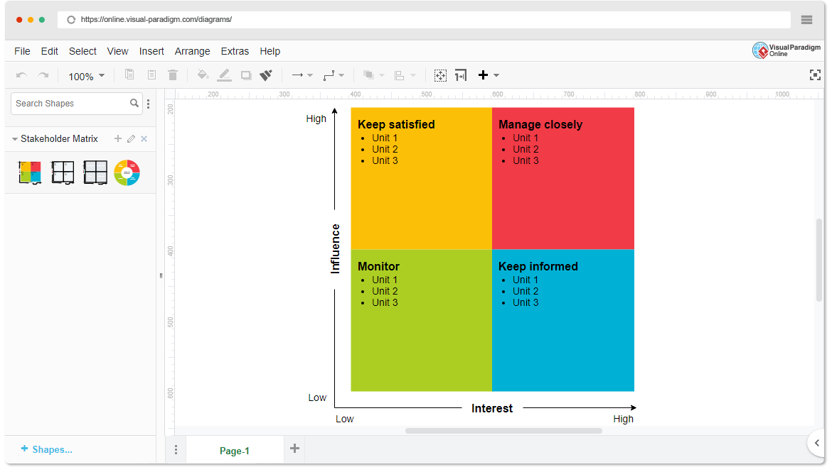

* High Power, High Interest: Librarians, Library Administrators
* High Power, Low Interest: University Management
* Low Power, High Interest: Students and Library Users
* Low Power, Low Interest: Book Vendors

1. **Empathetic Interviews**

**Conduct Skilled interview with at least 30 citizens/Users by asking open ended questions (What, why/How etc) and list the insights as per the format below**

|  |  |  |
| --- | --- | --- |
| **I need to know**  **(thoughts, feelings, actions)** | **Questions I will ask**  **(open questions)** | **Insights I hope to gain** |
| Thoughts | How do you usually find books in the library? | Understand users' current process for locating books and any difficulties faced. |
|  | What challenges do you face in tracking borrowed books? | Identify common problems in managing book checkouts and returns. |
|  | How do you think a digital system would impact library usage? | Gauge users' opinions on the potential benefits of a digital library system. |
| Feelings | How do you feel when you can’t find a book you need? | Capture the frustration or inconvenience users experience without effective search tools. |
|  | Why is it important for you to receive reminders on due dates? | Understand how overdue notifications impact user satisfaction and responsibility. |
| Actions | What do you currently do to locate books in the library? | Learn about the methods users employ and any challenges they face in finding books. |
|  | How often do you miss due dates for returns? | Understand how often users face issues with overdue books and how it affects them. |
|  | What could make your daily work more efficient? (For librarians) | Discover specific needs from librarians to streamline their daily tasks and improve efficiency. |

**SKILLED INTERVIEW REPORT**

|  |  |  |
| --- | --- | --- |
| **User/Interviewee** | **Questions Asked** | **Insights gained (NOT THEIR ANSWERS)** |
| Abhishek R., Student | How do you usually find books in the library? | Students often struggle to locate books without a digital catalog. |
| Srinivasan R., Librarian | |  | | --- | |  |  |  | | --- | | What challenges do you face in tracking borrowed books? | | Manual tracking leads to errors and difficulty in managing returns. |
| Jethander K., Student | Why is it important for you to receive reminders on due dates? | Overdue notifications help students avoid fines and manage returns |
| Sunitha W., Library Admin | How do you think a digital system would impact library usage? | Believes it would increase library engagement and streamline tasks. |
| Samantha P., Librarian | What could make your daily work more efficient? | Real-time book availability updates would greatly improve efficiency. |

**Key Insights Gained:**

* Students need a digital catalog for easy book search and retrieval.
* Librarians want automated tracking to reduce errors in checkouts and returns.
* Users appreciate notifications, as they help avoid overdue fines and improve user satisfaction.

**Empathy Map**

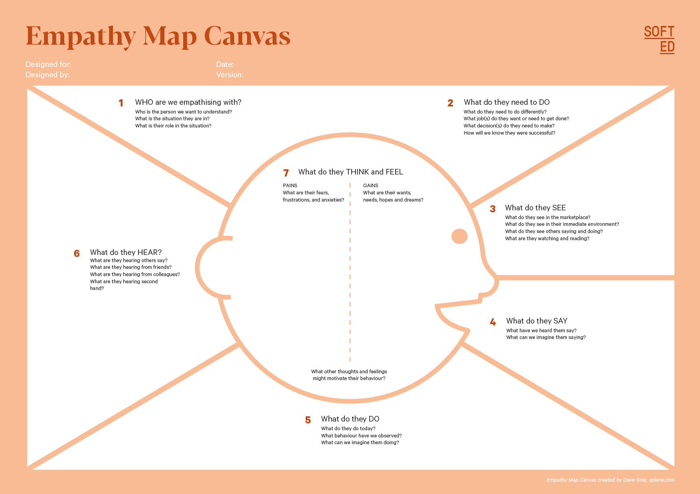

Your Answer: Efficiently manage checkouts and avoid overdue issues. Find books easily, get availability alerts, and receive reminders for returns. Gain insights into library usage, optimize resources, and enhance user satisfaction.

Your Answer: Librarians, Students, Library Users, Administrators

Who is your Customer Segment: Libraries

Idea/Innovation Title: BookWise (Library Management System-LMS)

Designed By: Team 9

Date of Submission: 29/10/2024

Your Answer: Tracking inventory, handling overdue items, manual processes. Long searches, unclear availability, overdue fines. Lack of data insights, difficulty with user management.

Your Answer: Streamlined management, reduced workload, improved user service. Quick access, real-time updates, reminders to avoid fines. Analytics for decision-making, efficient operations, better resource allocation.

Your Answer: Having a user-friendly system will make my library experience enjoyable

Your Answer: Catalog and Organize Books, Search for Books Easily, Check Availability and Reserve Books, Manage Borrowing, Oversee Library Operations, Analyze Data

Your Answer: Dashboard, Inventory Management, User Management, Search Bar, Personal Dashboard, User and Permissions Management

Your Answer: We need a streamlined way to manage books, track checkouts, and support users, I want to find, reserve, and manage my books easily.

Your Answer: Process checkouts, returns, and reservations. Catalog books, update inventory, and manage user accounts. Search and reserve books. Check availability and manage personal borrowing records. Track due dates and receive alerts for returns. Ensure system security and address technical issues.

1. **Empathy Map**
2. **Who is your Customer?**

**Description:** Our primary customers are students and librarians.

**Key points:**

* **Customer Profile:** Students (18-25 years, primarily college/university students) and Librarians (30-50 years, professionals managing library operations).
* **Goals and Needs:** Students need quick access to books and efficient return reminders, while librarians need streamlined book tracking and inventory management.
* **Context:** Students use the library for research and study resources, while librarians work daily to manage checkouts, returns, and overdue reminders.

1. **Who are we empathizing with?**

**Description:** We are empathizing with students and librarians who face challenges in book search, checkouts, and overdue management.

**Key points:**

* **User Characteristics:** Students are tech-savvy, time-conscious, and focused on academic success. Librarians are detail-oriented, organized, and responsible for maintaining library order.
* **Goals and Challenges:** Students want quick access to resources, while librarians aim to manage inventory efficiently. Both face challenges due to outdated or manual systems.
* **Broader Situation:** Students are focused on their academic goals, while librarians juggle multiple tasks, including assisting students and maintaining library order.

1. **What do they need to DO?**

**Description:** Users need to perform tasks related to book searching, checkouts, returns, and due date management.

**Key points:**

* **Tasks/Actions:** Students need to find, check out, and return books on time. Librarians need to track book availability, checkouts, and manage returns.
* **Decisions:** Students decide which books to borrow based on availability. Librarians make inventory and notification decisions.
* **Success Definition:** Students define success as easily finding and borrowing needed books. Librarians see success as accurate records and efficient management.

1. **What do they SEE?**

**Description:** Users interact with the library’s physical setup and the catalog system.

**Key points:**

* **Environment:** Students see the physical library shelves and card catalog; librarians see the inventory records.
* **Trends and Competitors:** Users may notice digital library systems in other institutions.
* **Influence:** A streamlined digital system could improve their satisfaction and efficiency in library tasks.

1. **What do they SAY?**

**Description:** Users openly express their experiences with library challenges.

**Key points:**

* **User Expressions:** Students may say, “It’s hard to find books,” or “I wish I got reminders for due dates.” Librarians might express frustration with manual inventory tasks.
* **Goals and Frustrations:** Students want faster searches; librarians want efficient systems.
* **Feedback:** Users request notifications, better tracking, and easier access to books.

1. **What do they DO?**

**Description:** Observing the actual behaviours of students and librarians in the library.

**Key points:**

* **Observable Actions:** Students spend time searching for books, librarians manually track inventory.
* **Habits/Routines:** Students visit the library for assignments; librarians organize books daily.
* **Problem-Solving:** Students ask librarians for help, and librarians rely on manual records to track books.

1. **What do they HEAR?**

**Description:** Users receive feedback and information from various sources about library management.

**Key points:**

* **External Feedback:** Students hear from peers about hard-to-find books; librarians hear complaints from users.
* **Information Channels:** Librarians receive industry news or updates on library technology.
* **Influencers:** Other libraries’ use of digital systems may influence their expectations.

1. **What do they THINK and FEEL?**

**Description:** Capturing the deeper thoughts and emotions of students and librarians regarding library use.

**Key points:**

* **Fears/Worries:** Students worry about missing due dates and incurring fines; librarians worry about losing track of inventory.
* **Motivations/Desires:** Students want convenient access; librarians want efficient workflows.
* **Alignment:** Students’ desire for easy access and librarians’ need for control align with a digital system’s benefits.

1. **Pains and Gains**

**Description:** The challenges users face and the benefits they seek from a Library Management System.

**Key points:**

* **Pain Points:** Difficulty finding books, lack of due-date reminders, and manual tracking for librarians.
* **Gains:** Quick book search, automated reminders, and accurate inventory management.
* **Benefits Sought:** A digital system that makes library management efficient, timely, and user-friendly for both students and librarians.

**9. Persona of Stakeholders**

**Stakeholder Name: Stakeholder Name: Samantha P., Librarian**

**Demographics:**

* **Age:** 45
* **Gender:** Female
* **Income:** Middle-income, around ₹50,000 monthly
* **Location:** Urban university campus library

**Goals:**

* Improve library efficiency by implementing a system that automates book tracking and notifications.
* Make it easier for students to locate and access resources.
* Reduce the time spent on manual tasks like checking overdue books and managing inventory.

**Challenges:**

* Manually tracking the large inventory of books, which is time-consuming and prone to errors.
* Difficulty in notifying students about due dates and overdue fines, leading to poor library resource management.
* Managing a high volume of daily checkouts and returns with limited staff.

**Aspiration:**

* To create a seamless and efficient library environment where students can find and borrow books easily, and librarians can manage inventory without stress.
* To establish the university library as a modern and tech-forward space that serves as a model for other institutions.

**Needs:**

* A digital library management system that simplifies book searching, tracking, and notifications.
* Tools that allow for real-time updates on book availability and user activity, reducing the need for manual records.
* Automated reminders for students to minimize overdue books and fines.

**Pain Points:**

* Frequent complaints from students who can’t find books or don’t know if a book is available.
* Lost time due to checking and updating book records manually.
* Frustration over overdue books and fines, leading to negative interactions with students.

**Storytelling:**

Samantha has been a librarian at the university for over 10 years and has seen the library grow in popularity, especially during exam seasons. However, as student demand increased, so did the challenges. Students often ask for help locating books, and many complain about overdue fines they didn’t anticipate. Samantha feels overwhelmed managing the high volume of books and wishes there were a more efficient way to track inventory and notify students of due dates.

With the new Library Management System, Samantha can finally streamline the checkout process. Students can search for books online, view real-time availability, and receive automated reminders before due dates. For Samantha, this system has transformed her workday—she now spends less time on manual tracking and can focus on helping students with their research needs. The library has become a well-organized, user-friendly space, making Samantha’s goal of a modern, efficient library a reality.

**10. Look for Common Themes, Behaviours, Needs, and Pain Points among the Users**

**Common Themes:**

* **Frequent Need for Information Access:** Many users prioritize easy and quick access to resources.
* **Desire for User-Friendly Systems:** Users want systems that are intuitive and don’t require extensive training.
* **Preference for Digital Notifications**: Users often expect reminders and updates through digital channels to stay informed.

**Common Behaviours:**

* **Checking Availability Online:** Users habitually check for book availability before visiting the library.
* **Avoiding Overdue Fines:** Users tend to be cautious and appreciate reminders to avoid late fees.
* **Reserving Books in Advance:** Many users prefer to reserve high-demand items to ensure they get what they need.

**Common Needs:**

* **Efficient Search Functionality:** Users need a quick way to find specific titles or topics.
* **Real-Time Availability Updates:** Users require accurate, up-to-date information on resource availability.
* **Clear Borrowing Guidelines:** Users need clear instructions on borrowing limits, renewals, and return dates.

**Common Pain Points:**

* **Difficulty Finding Resources:** Users often struggle with locating specific materials in the library or system.
* **Lack of Return Reminders:** Overdue fines are a frustration due to missed return dates.
* **Inconsistent Book Availability Information:** Users are frustrated by discrepancies between online and in-library availability.

**11. Define Needs and Insights of Your Users**

**User Needs:**

**Librarians:**

* Librarians require efficient cataloging and inventory management tools to streamline their workflow, which not only enhances their sense of accomplishment in effectively managing resources but also alleviates stress from administrative tasks. They are driven by a commitment to providing excellent service to the community, and engaging with users helps create a welcoming environment.

**Students/Library Users:**

* Students need an intuitive system for quickly searching for books, with clear information on availability and due dates. This ease of navigation boosts their confidence and satisfaction, as timely reminders help prevent overdue fines. Access to educational resources fosters their learning and growth, and an inclusive library environment meets diverse needs, enhancing their overall experience.

**Administrators:**

* Administrators seek tools to analyze library usage and user engagement effectively. They require efficient management of user permissions and system settings to ensure smooth operations. Empowered by data-driven insights, they gain confidence in their decision-making, all while maintaining a commitment to improving library services and ensuring a well-organized, accessible environment for the community.

**User Insights:**

**Librarians:**

* Often feel overwhelmed by administrative tasks, detracting from their passion for helping users.
* Motivated to create a welcoming environment but hindered by outdated systems.

**Students/Library Users:**

* Frustrated by complicated search processes and lack of timely information, leading to a negative experience.
* Appreciate tools that simplify tasks, responding positively to personalized notifications and recommendations.

**Administrators:**

* Recognize the importance of data for informed decision-making but lack tools for effective analysis.
* Driven by a need to improve library services and ensure user satisfaction but face challenges with system inefficiencies.

**12. POV Statements**

**POV Statements:**

|  |  |  |  |
| --- | --- | --- | --- |
| PoV Statements | Role-based or Situation-Based | Benefit, Way to Benefit, Job TBD, Need | PoV Questions |
| When searching for a book, students need a way to quickly check availability so they can save time. | Situation | Time-saving benefit | What can we design to help students quickly check the availability of a book? |
| Librarians need a way to organize inventory efficiently to reduce manual work. | Role-based | Less manual workload | How can we design a system that helps librarians manage inventory more efficiently? |
| When borrowing a book, users need a way to set return reminders to avoid late fees. | Situation | Less stress over fines | What can we design to help users remember return deadlines? |
| Students need a way to reserve popular books, so they don't miss out. | Role-based | More access to resources | How can we allow users to easily reserve books? |
| When searching online, users need a way to filter books by category to find relevant material faster. | Situation | Timesaving in search | What can we design to allow effective filtering by category? |
| Librarians need a way to track overdue books to ensure timely returns. | Role-based | Better inventory control | How can we help librarians track overdue items effectively? |
| Users need a way to view their borrowing history to track their reading progress. | Role-based | More user engagement | What can we design to provide users access to their borrowing history? |
| Students need a way to access digital resources when physical copies are unavailable. | Role-based | Increased accessibility | How can we integrate digital resources for easy access when physical copies are unavailable? |
| Librarians need a way to update book statuses in real-time to keep the catalog accurate. | Role-based | Accurate catalog | What can we design to help librarians update book statuses in real time? |
| Users need a way to provide feedback on the library system for continuous improvement. | Role-based | Better user experience | How can we allow users to easily provide feedback? |

**13. Develop POV/How Might We (HMW) Questions to Transform Insights/Needs into Opportunities for Design**

Turn your user needs and insights into actionable opportunities by framing them as "How Might We" (HMW) questions. These questions will spark creative problem-solving and guide your innovation process.

|  |  |
| --- | --- |
| User Need/Insight | "How Might We" Question |
| "Library users need a way to quickly find and reserve books in high demand." | "How might we make it easier for users to locate and reserve popular books efficiently?" |
| "Users find it challenging to keep track of return dates and avoid late fees." | "How might we create a reminder system that helps users remember return dates and avoid overdue fees?" |
| "Librarians need an efficient way to manage and update inventory in real time." | "How might we streamline the process for librarians to update book statuses and manage inventory effectively?" |
| "Users feel limited when physical books are unavailable or checked out." | "How might we integrate digital resources to offer users alternative access when physical books are not available?" |
| "Users want to provide feedback to improve their library experience but find the process inconvenient." | "How might we design an easy and accessible feedback system for users to share their library experiences?" |

**14. Crafting a Balanced and Actionable Design Challenge**

**Design Challenge:** "How might we create an accessible, user-friendly digital platform that allows library users to easily find information about events, borrow materials remotely, and receive personalized recommendations, aiming to increase user engagement by 30% over the next year?"

**Breakdown of the Design Challenge**

* **Actionable Statement**: "Create an accessible, user-friendly digital platform" — This gives a clear direction on what needs to be designed.
* **Quantifiable Goal**: "Increase user engagement by 30% over the next year" — This sets a measurable objective.
* **Balanced Scope**:
  + Not too narrow, as it addresses multiple aspects (event information, borrowing materials, recommendations).
  + Not too broad, as it’s focused on user engagement through a digital platform.

This design challenge provides a clear and actionable path while keeping the focus on enhancing the library experience.

**15. Validating the Problem Statement with Stakeholders for Alignment**

**Validation Plan:** To ensure the problem statement is aligned with the needs and concerns of stakeholders, we will gather feedback from at least 10 stakeholders or experts. This feedback process will involve structured interviews and surveys to capture insights on the relevance and accuracy of the problem statement.

**Stakeholder/User Feedback**

|  |  |  |  |
| --- | --- | --- | --- |
| Stakeholder/User | Role | Feedback on Problem Statement | Suggestions for Improvement |
| Library Patrons | Frequent library users | The problem statement resonates as users face long wait times for book reservations and difficulty finding available resources. | Suggests adding an online catalog with real-time availability updates. |
| Librarians | Library staff | Strongly resonates as staff struggle with tracking inventory and managing overdue books manually, which is time-consuming. | Recommends implementing an automated tracking system to simplify inventory checks. |
| Students | University library users | The problem aligns with their needs as they frequently face issues with locating and accessing books during peak exam times. | Suggests a reservation feature to hold books in advance, especially during exams. |
| Teachers | |  | | --- | |  |  |  | | --- | | Educators using the library | | Teachers find the issue relevant, as they need reliable access to multiple copies of books for class assignments, which is currently inconsistent. | Recommends setting up a “priority reservation” for teachers needing class materials. |
| University Administrators | Library budget decision-makers | Resonates with their concern over increasing operational costs related to overdue books and resource management inefficiencies. | Suggests a budget report feature to identify high-cost areas and reduce expenses. |
| Senior Citizens | Community users of the library | The problem resonates as they find the current system challenging to navigate, especially with limited tech experience. | Recommends creating a user-friendly, simplified interface for senior patrons. |
| IT Department | System maintenance and support | Recognizes the issue with frequent system downtimes and the outdated software that hampers user access. | Suggests a modern cloud-based system to improve stability and accessibility. |
| Parents | Guardians of young library users | Relevant to them as they want a way to monitor their child’s reading habits and manage checkouts to avoid fines. | Proposes adding parental control features and notifications for due dates. |
| Researchers | Advanced users needing resources | Resonates as they frequently experience challenges in finding rare or specialized resources promptly. | Recommends a feature for advanced search and access to external research databases. |

**16. Ideation**

**Ideation Process:**

|  |  |  |  |
| --- | --- | --- | --- |
| Idea Number | Proposed Solution | Key Features/Benefits | Challenges/Concerns |
| Idea 1 | **Online Book Reservation System** | Allows users to reserve books online, reducing wait times and ensuring availability during peak periods. | Potential issues with cancellations, ensuring fair access during high demand. |
| Idea 2 | **Automated Overdue Notification** | Sends automated reminders via email or SMS for due dates and overdue books, reducing fines and improving book return rates. | User contact information needs to be updated; some users may ignore notifications. |
| Idea 3 | **Digital Library Cards** | Provides virtual library cards via an app or web portal, allowing for easy access and checkout without physical cards. | Concerns about data privacy and the need for robust security measures. |
| Idea 4 | |  | | --- | |  |  |  | | --- | | **Interactive Library Catalog with Search Filters** | | Advanced search filters help users find books by genre, author, availability, and user reviews, improving user experience. | Requires frequent catalog updates; may require additional staff training. |
| Idea 5 | **Library Usage Analytics Dashboard** | Provides data on popular books, peak hours, and most used resources, helping the library to optimize inventory and services. | Requires investment in data analytics tools and skilled staff to interpret data. |

**17. Idea Evaluation**

Evaluate the Idea based on 10/100/1000 grams

|  |  |  |  |  |
| --- | --- | --- | --- | --- |
| Idea | Impact (10/100/1000 grams) | Feasibility (10/100/1000 grams) | Alignment (10/100/1000 grams) | Total Weight |
| Idea 1 | **1000** | **100** | **1000** | **2100** |
| Idea 2 | **100** | **1000** | **100** | **1200** |
| Idea 3 | **100** | **100** | **100** | **300** |
| Idea 4 | **1000** | **100** | **1000** | **2100** |
| Idea 5 | **100** | **100** | **1000** | **1200** |

**Solution Concept Form**

**1. Problem Statement:**

* **Library users experience difficulty in accessing popular books, especially during peak times, due to high demand and limited availability.**

**2. Target Audience:**

* **Library patrons, including students, researchers, and avid readers, who want a reliable way to secure popular books in advance.**

**3. Solution Overview:**

* **An Online Book Reservation System that allows users to reserve books remotely, ensuring that they can access desired materials without waiting or being disappointed by unavailability.**

**4. Key Features:**

| **Feature** | **Description** |
| --- | --- |
| **Reservation System** | **Users can reserve books online, reducing physical wait times and improving access during peak hours.** |
| **Notification Alerts** | |  | | --- | |  |  |  | | --- | | **Sends alerts when reserved books are available, improving user experience and reducing missed pickups.** | |
| **Flexible Hold Periods** | **Offers options to extend reservation periods based on demand, balancing access and availability.** |

**5. Benefits:**

| **Benefit** | **Description** |
| --- | --- |
| **Enhanced Accessibility** | **Provides a fair and reliable way for users to access popular books, particularly during high-demand times.** |
| **Increased User Satisfaction** | **Reduces frustration associated with unavailable books, leading to better user experiences.** |
| **Efficient Library Management** | **Helps the library optimize book circulation and anticipate high-demand resources.** |

**6. Unique Value Proposition (UVP):**

* **The Online Book Reservation System allows library patrons to easily secure books in advance, reducing wait times and improving access to high-demand materials. This system will set the library apart as a user-centered, efficient service provider.**

**7. Key Metrics:**

| **Metric** | **Measurement** |
| --- | --- |
| **Reservation Rate** | **Percentage of users utilizing the reservation system.** |
| **Pickup Compliance Rate** | **Ratio of reserved books that are picked up within the hold period.** |
| **User Satisfaction Rate** | **Feedback from users regarding ease of access and satisfaction.** |

**8. Feasibility Assessment:**

* **[This solution is achievable with moderate technological requirements, using existing library databases and digital platforms. It may require initial setup costs but is feasible within existing library resources.**

**9. Next Steps:**

* **Conduct a pilot test of the reservation system in a specific section (e.g., fiction or research journals) to gather user feedback.**
* **Adjust the system based on pilot feedback and refine user notifications and hold period options.**
* **Roll out the full system library-wide, incorporating necessary changes based on the pilot phase.**