PRACTICAL NO. 06
K-Means and Hierarchical Clustering

Field | Details
Student Name | Anish Tawade
Roll Number | D15B 21
Class / Division | D15B
Subject | Machine Learning Lab
Experiment No. | 06
Date | 2 April 2026

1. Aim
Apply K-Means and Hierarchical Clustering on a generated sample dataset, visualize the results of both algorithms, and then compare their outcomes.

2. Theory

2.1 What is Clustering?
Clustering is an unsupervised machine-learning technique used to group data points that are similar to each other into clusters. Unlike classification, clustering does not require labelled training data — the algorithm discovers hidden structure in the dataset on its own. Clustering is widely used in customer segmentation, anomaly detection, image segmentation, and many other domains.

2.2 K-Means Clustering
K-Means is one of the most popular and computationally efficient clustering algorithms. The algorithm partitions a dataset of n points into k non-overlapping clusters by minimising the within-cluster sum of squared distances from each point to its assigned cluster centroid.

Algorithm Steps
- Choose the number of clusters k.
- Initialise k centroids (K-Means++ for smarter initialisation).
- Assign each data point to the nearest centroid using Euclidean distance.
- Recompute centroids as the mean of all assigned points.
- Repeat steps 3–4 until convergence (centroids do not change).

Key Parameters Used
- n_clusters = 4 — number of clusters to form.
- init = 'k-means++' — smarter centroid initialisation reduces chance of poor local minima.
- n_init = 10 — algorithm is run 10 times with different centroid seeds; best result is kept.
- random_state = 42 — ensures reproducibility.

Advantages
- Simple, easy to understand and implement.
- Scales well to large datasets.
- Converges quickly in practice.

Limitations
- Requires specifying k in advance.
- Sensitive to outliers and poor initialisation.
- Assumes spherical, equally sized clusters.

2.3 Hierarchical Clustering (Agglomerative)
Hierarchical Agglomerative Clustering (HAC) builds a hierarchy of clusters bottom-up: each data point starts as its own cluster, and clusters are successively merged according to a linkage criterion until all points belong to a single cluster (or a specified number of clusters is reached). The result can be visualised as a dendrogram.

Algorithm Steps (Agglomerative)
- Treat each data point as an individual cluster.
- Compute a proximity matrix of distances between all cluster pairs.
- Merge the two closest clusters into one.
- Update the proximity matrix.
- Repeat steps 3–4 until the desired number of clusters is reached.

Linkage Method Used — Ward
Ward linkage minimises the total within-cluster variance. At each step, the pair of clusters that leads to the minimum increase in total within-cluster variance after merging is chosen. This tends to produce compact, well-separated clusters.

Advantages
- Does not require k to be specified upfront (dendrogram guides selection).
- Deterministic — produces the same result every time.
- Produces a hierarchy of clusters at multiple granularities.

Limitations
- Quadratic time complexity — not suitable for very large datasets.
- Sensitive to outliers (for some linkage methods).
- Merges are irreversible — a wrong merge cannot be undone.

2.4 Comparison: K-Means vs. Hierarchical Clustering
Criterion | K-Means | Hierarchical (Agglomerative)
Type | Partitional | Hierarchical
Requires k? | Yes (before running) | Optional (read from dendrogram)
Approach | Centroid-based | Distance matrix merging
Complexity | O(n·k·t) | O(n² log n) — Ward
Output | Flat cluster labels | Dendrogram + flat labels
Deterministic? | No (depends on init) | Yes (Ward)
Handles non-spherical? | Poorly | Better (single/complete linkage)
Scalability | High | Low to medium

3. Dataset Description
A synthetic dataset was generated using the make_blobs function from scikit-learn with the following parameters:

Parameter | Value
n_samples | 300
n_features | 2
centers | 4
cluster_std | 0.60
random_state | 42

The dataset consists of 300 two-dimensional data points organised into 4 well-separated Gaussian blobs. Using a synthetic dataset with known ground-truth labels allows us to qualitatively verify that both clustering algorithms discover the correct structure. The dataset shape after generation: X.shape = (300, 2) and y_true.shape = (300,).

4. Source Code

4.1 Importing Libraries and Generating the Dataset
from sklearn.datasets import make_blobs

X, y_true = make_blobs(n_samples=300, centers=4,
cluster_std=0.6, random_state=42,
n_features=2)

print(f"Shape of generated features (X): {X.shape}")
print(f"Shape of true labels (y_true): {y_true.shape}")

4.2 Applying K-Means Clustering
from sklearn.cluster import KMeans

kmeans = KMeans(n_clusters=4, random_state=42,
init='k-means++', n_init=10)
kmeans.fit(X)
kmeans_labels = kmeans.labels_

print("K-Means model fitted and labels stored.")
print(f"First 10 K-Means labels: {kmeans_labels[:10]}")

4.3 Applying Hierarchical Clustering
from sklearn.cluster import AgglomerativeClustering

hac = AgglomerativeClustering(n_clusters=4, linkage='ward')
hac_labels = hac.fit_predict(X)

print("Agglomerative Clustering model fitted and labels stored.")
print(f"First 10 Hierarchical Clustering labels: {hac_labels[:10]}")

4.4 Visualising the Results
import matplotlib.pyplot as plt
import seaborn as sns
from sklearn.cluster import KMeans

kmeans = KMeans(n_clusters=4, random_state=42, init='k-means++', n_init=10)
kmeans.fit(X)
kmeans_labels = kmeans.labels_

fig, axes = plt.subplots(1, 2, figsize=(14, 6))

# K-Means plot
sns.scatterplot(x=X[:, 0], y=X[:, 1], hue=kmeans_labels,
palette='viridis', legend='full', ax=axes[0])
axes[0].set_title('K-Means Clustering')
axes[0].set_xlabel('Feature 1')
axes[0].set_ylabel('Feature 2')

# Hierarchical Clustering plot
sns.scatterplot(x=X[:, 0], y=X[:, 1], hue=hac_labels,
palette='viridis', legend='full', ax=axes[1])
axes[1].set_title('Hierarchical Clustering')
axes[1].set_xlabel('Feature 1')
axes[1].set_ylabel('Feature 2')

plt.tight_layout()
plt.show()

5. Output

5.1 Console Output
Agglomerative Clustering model fitted and labels stored.
First 10 Hierarchical Clustering labels: [0 0 3 1 0 1 2 1 3 2]

5.2 Visualisation Plot
The scatter plots below show the cluster assignments produced by both algorithms. Each colour represents a distinct cluster.

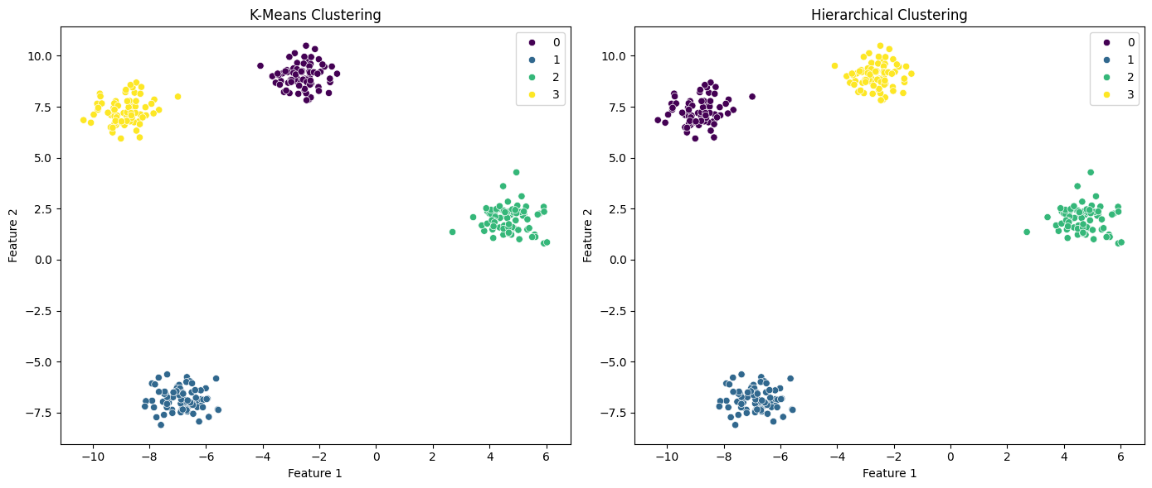
Figure 1 — K-Means Clustering (left) vs. Hierarchical Clustering — Ward Linkage (right)

6. Observations
- Both algorithms successfully identified the 4 distinct clusters present in the dataset.
- The cluster boundaries produced by K-Means and Agglomerative Clustering (Ward linkage) were nearly identical, as expected for a well-separated Gaussian blob dataset.
- The cluster label numbering differs between the two algorithms (e.g., what K-Means labels '0' may be labelled '3' by HAC), but the actual groupings of points are consistent.
- The viridis colour map correctly distinguishes 4 separate clusters in both scatter plots.
- The make_blobs dataset, by design, has minimal overlap between clusters, making it an ideal testbed to validate both algorithms.

7. Result
K-Means Clustering: Successfully applied with n_clusters = 4, init = 'k-means++', n_init = 10, and random_state = 42. The algorithm converged and produced accurate cluster labels for all 300 data points.

Hierarchical Clustering: Successfully applied using AgglomerativeClustering with n_clusters = 4 and Ward linkage. The algorithm produced cluster labels consistent with those of K-Means.

Comparison: For clearly separated, spherical, Gaussian clusters, both algorithms yield equivalent results. K-Means is faster and more scalable, while Hierarchical Clustering is deterministic and provides a richer cluster hierarchy without requiring k to be fixed in advance.

8. Conclusion
In this practical, two widely-used unsupervised clustering algorithms — K-Means and Agglomerative Hierarchical Clustering — were applied to a synthetic dataset generated with make_blobs. Both algorithms correctly partitioned the 300 data points into 4 well-defined clusters. Visualisation confirmed that the cluster assignments are visually consistent and meaningful.

For datasets with clearly defined, spherical, and well-separated clusters, both K-Means and Hierarchical Clustering (Ward linkage) produce highly similar results. The choice between the two in practice depends on the dataset size (K-Means scales better), the need for a deterministic solution (Hierarchical is deterministic), and whether an exploration of multiple granularities is needed (Hierarchical provides a dendrogram).

Future steps could include computing quantitative metrics such as the Silhouette Score and the Adjusted Rand Index to rigorously compare the two algorithms, as well as testing on more complex, non-spherical datasets where the differences between the algorithms become more pronounced.

Anish Tawade | D15B 21

