MACHINE LEARNING BASED APPROACH FOR REAL-TIME MALICIOUS URL AND PHISHING DETECTION
INTERNSHIP WORK SUBMITTED IN PARTIAL FULFILLMENT OF THE
REQUIREMENT FOR THE AWARD OF THE DEGREE
OF
BACHELOR OF COMPUTER SCIENCE WITH CYBER SECURITY
SUBMITTED
BY
<YOUR NAME> (<REGISTER NO>)
GUIDED
BY
<GUIDE NAME>, <QUALIFICATIONS>,
Department of Computer Science with Cyber Security,
PSGR Krishnammal College for Women,
Coimbatore-641004.

JULY 2026

TABLE OF CONTENTS
S.NO | TITLE | PAGE NO
 | ABSTRACT | 1
1 | INTRODUCTION | 2
 | 1.1 PROBLEM IDENTIFICATION | 3
2 | LITERATURE SURVEY | 4
3 | SYSTEM ANALYSIS | 5
 | 3.1 EXISTING SYSTEM | 5
 | 3.2 PROPOSED SYSTEM | 6
4 | TOOLS AND TECHNOLOGIES USED | 8
5 | METHODOLOGY | 10
 | 5.1 SYSTEM WORKFLOW | 10
 | 5.2 FEATURE EXTRACTION | 11
 | 5.3 RANDOM FOREST CLASSIFICATION | 12
6 | RESULTS AND DISCUSSION | 13
 | 6.1 EVALUATION METRICS | 13
 | 6.2 RESULTS | 13
 | 6.3 DISCUSSION | 15
7 | CONCLUSION | 17
8 | FUTURE ENHANCEMENT | 17
 | BIBLIOGRAPHY | 18

ABSTRACT
The rapid growth of online services has been matched by a rise in phishing and malicious websites that steal credentials, deliver malware and defraud users. A malicious link is typically distributed by electronic mail or messaging and needs only a single click to compromise an account or a host, so the interval between a domain being registered and a victim visiting it can be a matter of hours. Conventional defences depend on blacklists such as Google Safe Browsing and PhishTank, which record a site only after it has been reported and verified. This leaves a window during which a newly created phishing domain operates without hindrance, and the position is aggravated by the ease with which attackers register fresh domains or make small alterations to a URL in order to evade signature matching. A detection method is therefore required that can judge an address it has never encountered.
This project develops a Malicious URL Detection System that classifies an address as benign or malicious from the URL string alone, before the page is opened. The data used is a publicly available corpus of 651,191 labelled URLs comprising 428,103 benign, 96,457 defacement, 94,111 phishing and 32,520 malware samples, which are mapped to a binary target. Thirty lexical and host-based features are extracted from each address, including its length, the counts of particular characters, the Shannon entropy of the URL and of the hostname, the number of subdomains, the length of the top-level domain, the presence of a raw address in place of a hostname, the use of a shortening service and the occurrence of suspicious keywords. A Random Forest of 200 decision trees is trained on a stratified sample of 200,000 records and evaluated on a held-out partition of 45,315 records.
On that held-out partition the system attains an accuracy of 89.43 percent, a precision of 86.56 percent, a recall of 81.16 percent and an F1 score of 83.78 percent. Two artefacts of the way the corpus was assembled were identified during development and removed, because each allowed the classifier to reach a higher score while behaving incorrectly on genuine addresses. Their removal reduced the measured accuracy from 95.80 percent to 89.43 percent, and the lower figure is the trustworthy one. The trained model is served through a web interface that accepts a single address or a batch of addresses and returns a verdict with a confidence value; the address is treated purely as text and is never opened, requested or resolved over the network.

I. INTRODUCTION
The World Wide Web has become the principal medium through which individuals conduct banking, government and commercial business, and it is correspondingly the principal medium through which they are attacked. Phishing, in which a counterfeit page imitates a trusted service in order to capture credentials, remains among the most common initial vectors in reported security incidents. Malicious links are distributed at negligible cost through electronic mail, messaging applications and social media, and a single successful click may yield an account takeover, a fraudulent payment or the installation of malware on a corporate host.
The defences deployed against this threat are predominantly reactive. Blacklists record addresses that have already been reported, examined and confirmed as malicious, and a domain is blocked only once that process has completed. Because a phishing site is often operational for no more than a few hours, the campaign may have concluded before any entry appears in the list. Signature and rule based filters are similarly limited, since an attacker who alters a small portion of an address, or who registers a new domain altogether, produces a string that no existing rule matches.
A URL, considered simply as a string of characters, nevertheless carries measurable structure. Legitimate addresses tend to be short, to use a recognisable registered domain and a small number of subdomains, and to consist of pronounceable words. Addresses constructed for deception tend to be longer, to place a trusted brand name in a subdomain rather than in the registered domain, to contain unusual proportions of digits and punctuation, and to exhibit higher character entropy. These regularities are statistical rather than absolute, which makes them well suited to machine learning: a classifier trained on a large labelled corpus can learn combinations of such properties and apply them to addresses that have never been observed. The aim of this project is to construct such a classifier and to deliver it through a usable interface.
1.1 PROBLEM IDENTIFICATION
The first problem is the structural delay inherent in blacklisting. A list can only describe what has already been discovered and reported, so every newly registered malicious domain enjoys a period of guaranteed effectiveness. Since domains are cheap and may be generated in bulk, the number of entries required to provide complete coverage grows without limit while the protection obtained from each entry diminishes.
The second problem concerns the features on which a detector should rely. Retrieving the content of a page in order to examine it is attractive in principle, but it requires the detector to visit an address that is suspected of being hostile. That introduces both a security risk and a delay, and it is unsuitable for a system intended to give a verdict before the page is opened. Features must therefore be derived from the address itself.
The third problem, and the one that proved most consequential in this work, is that a public corpus may contain regularities which arise from the way it was assembled rather than from any property of the threat. A classifier will exploit such a regularity because doing so raises its measured score, and the result is a model that appears accurate under evaluation while failing on ordinary addresses. Identifying and eliminating these artefacts is a necessary part of building a detector that is of any practical use.

II. LITERATURE SURVEY
S.NO | TITLE | AUTHORS | METHODOLOGY | TOOLS USED | KEY FINDINGS
1. | Phishing URL Detection via CNN and Attention-Based Hierarchical RNN (2019) | Huang et al. | Character-level CNN with attention RNN | Deep learning toolkit | Learns from raw URL text without hand-crafted features
2. | Detecting Phishing Websites Using Machine Learning (2019) | Alswailem et al. | Random Forest over URL and page features | Python, scikit-learn | Feature selection matters more than classifier choice
3. | Phishing Web Site Detection Using Diverse ML Algorithms (2020) | Zamir et al. | Compares classifiers and stacking | Python, WEKA | Stacked ensembles outperform single classifiers
4. | A Hybrid DNN-LSTM Model for Detecting Phishing URLs (2021) | Ozcan et al. | Hybrid deep network on character and word features | Keras, TensorFlow | Combining representations improves detection
5. | Highly Accurate Phishing URL Detection Based on ML (2023) | Jalil, Usman and Fong | Engineered lexical features with ensembles | Python, scikit-learn | Lexical features alone give strong performance
6. | A Deep Learning-Based Phishing Detection System (2023) | Alshingiti et al. | Benchmarks CNN, LSTM and a hybrid | TensorFlow | Hybrid architecture outperforms either alone
7. | PMANet: Malicious URL Detection via Language Model (2023) | Liu et al. | Post-trained language model on URL text | PyTorch, transformers | Pre-trained models transfer well to URL data
8. | Detection of Malicious URLs Using Machine Learning (2024) | Reyes-Dorta et al. | Classical classifiers on large public corpora | Python, scikit-learn | Classical models remain competitive at scale
9. | Intelligent Malicious URL Detection Using Kernel Methods (2024) | Ariawan et al. | Kernel based learning on lexical features | Python, SVM libraries | Kernel methods suit small feature sets
10. | From Past to Present: A Survey of Malicious URL Detection (2025) | Tian, Yu, Sun and Wang | Systematic survey of the field | Literature review | Dataset quality is a recurring and under-examined problem

III. SYSTEM ANALYSIS
3.1 EXISTING SYSTEM
The defences in general use today rest principally on reputation lists. Services such as Google Safe Browsing, PhishTank and OpenPhish gather reports of malicious addresses, verify them and distribute the results to browsers and security products. The approach is effective against established campaigns and produces very few false alarms, because an entry is added only after confirmation. Its weakness is one of timing: an address cannot be blocked until it has been seen, reported and checked, and a phishing site that is operational for a few hours may complete its purpose within that interval.
A second class of defence applies fixed rules or regular expressions to the address, flagging those that contain a raw network address in place of a hostname, an unusual number of subdomains or a recognised brand name in an unexpected position. Such rules are transparent and inexpensive, but they are brittle. An attacker who inspects the rule set can construct an address that satisfies none of the conditions, and rules written to catch one campaign frequently produce false alarms on legitimate sites with unusual addressing.
A third approach relies on domain reputation, weighing the age of a registration, its traffic history and the reputation of the hosting network. This is informative for established domains but offers little for the newly registered domains that phishing campaigns overwhelmingly employ, precisely because such domains have no history to assess. Sandboxing, in which the page is retrieved and executed in isolation, provides deeper evidence at the cost of considerable time and computation, and requires the suspicious address to be visited.
DISADVANTAGES
- Blacklists are reactive and cannot classify an address that has not previously been reported and verified.
- Short-lived phishing domains complete their campaigns before any list entry is created.
- Fixed rules and regular expressions are readily evaded by minor alterations to the address.
- Reputation services depend on registration age and traffic history, which newly created domains do not possess.
- Sandboxing requires the suspected page to be fetched and executed, which is slow and carries risk.
- Manual analyst review cannot scale to the volume of domains registered each day.
3.2 PROPOSED SYSTEM
The proposed system classifies an address using supervised machine learning applied to features derived from the URL string. The corpus employed contains 651,191 labelled addresses, of which 428,103 are benign and the remainder are divided among defacement, phishing and malware categories; these three are combined into a single malicious class, giving a binary problem. From each address thirty features are computed. They include the lengths of the whole address and of its hostname, path and query; counts of the characters that commonly distinguish crafted addresses; the Shannon entropy of the address and of the hostname; the number of subdomains and the length of the top-level domain; indicators for a raw network address used as a host, for the presence of a port, and for the use of a known shortening service; and the occurrence of keywords such as login, secure, verify and account.
Two properties of the corpus were found to act as shortcuts and were neutralised. The first is the presence of the scheme: only 8.3 percent of benign entries carry an http or https prefix, whereas every defacement entry and 96.3 percent of malware entries do, so a model permitted to observe the scheme learns to treat its presence as evidence of malice. The second is the absence of a path: benign addresses were gathered at the level of individual pages and only 0.1 percent are bare domains, while phishing feeds list bare domains and 23.1 percent of phishing entries take that form, with the consequence that 98.8 percent of all bare-domain entries in the corpus are malicious. The scheme is now removed during normalisation, and the training data is augmented with host-only copies of existing addresses carrying the same label, so that neither property remains predictive.
A Random Forest of 200 decision trees is trained on a stratified sample of 200,000 records, augmented as described, and is evaluated once on a held-out partition of 45,315 records that takes no part in training. The fitted model is serialised to disk so that the application starts without repeating the training cycle, and is exposed through a web interface offering both single-address and batch analysis. At no point does the system retrieve, request or resolve the address it is examining.
ADVANTAGES
- An address that has never been seen before can be classified, since the decision depends on structure rather than on prior reports.
- A verdict is produced in milliseconds from the string alone, without contacting the site.
- Examining a suspected malicious address is safe, because it is never opened or resolved.
- Two corpus artefacts were identified and removed, so the reported figures reflect genuine structure rather than collection procedure.
- The model returns a confidence value and the contributing features, so a verdict can be examined rather than merely accepted.
- Batch analysis allows a list of addresses to be screened in a single operation.

IV. TOOLS AND TECHNOLOGIES USED
The system is implemented as a small Python application in which each component has a clearly separated responsibility. The technology stack was kept deliberately narrow so that the entire project can be read and understood in a single sitting.
4.1 PYTHON
Python is the implementation language for the whole project. It was chosen for the maturity of its scientific and machine learning libraries and for the clarity of the resulting code. Feature extraction, model training, evaluation and the web application are all written in Python 3, and the project depends on no compiled component of its own.
4.2 SCIKIT-LEARN
Scikit-learn supplies the RandomForestClassifier used for classification, the stratified train and test splitting routine, and the functions that compute accuracy, precision, recall, F1 score and the confusion matrix. Using an established library for these steps ensures that the reported figures are produced by well tested implementations rather than by code written for this project.
4.3 PANDAS
Pandas is used to read the corpus from its comma separated file, to construct the binary target from the four original class labels, and to take the stratified sample and build the augmented training set. Its vectorised string operations make it practical to examine and transform hundreds of thousands of addresses without writing explicit loops.
4.4 NUMPY
NumPy provides the numerical array that carries the extracted features into the classifier. Feature extraction assembles a list of rows and converts it to a single array in one operation, which keeps the extraction of 200,000 addresses within a few seconds.
4.5 JOBLIB
Joblib serialises the fitted model, together with the ordered list of feature names and the measured metrics, into a single file. Storing the feature names alongside the estimator allows the application to reject a request whose features do not match those the model was trained on, instead of silently producing a meaningless prediction.
4.6 FLASK
Flask provides the web layer. It serves a single page through the Jinja2 template engine and exposes two endpoints in JSON, one for a single address and one for a batch. Flask was chosen over a larger framework because the application requires only routing, template rendering and request parsing.
4.7 HTML, CSS AND JAVASCRIPT
The interface is a single page written in plain HTML with a small amount of inline styling and vanilla JavaScript. No front-end framework is used. The page provides a field for one address, an area for a batch of addresses, and a table showing the verdict, the confidence and the features that contributed most strongly.
4.8 PYTEST
Pytest runs the automated test suite. Thirty-six tests exercise the real feature extractor and the real trained model, covering malformed and hostile input, the ordering of batch results and the rejection of invalid requests. Nothing is simulated, so a passing run demonstrates that the pipeline itself works.

V. METHODOLOGY
5.1 SYSTEM WORKFLOW
The system is organised as a single sequence that begins with the raw corpus and ends with a running web service. Each stage is executed once when the model is first built, after which the fitted artefacts are cached and reused.
- Corpus loading. The file of 651,191 labelled addresses is read, and the four original labels are mapped to a binary target in which benign becomes zero and defacement, phishing and malware all become one.
- Sampling. A stratified sample of 200,000 records is drawn, preserving the proportion of each class, in order to keep the training time within a few minutes.
- Augmentation. Host-only copies of a proportion of the sampled addresses are added, each carrying the label of the address from which it was derived. This places bare domains in both classes and prevents the absence of a path from acting as a shortcut.
- Feature extraction. Thirty lexical and host-based features are computed for every address. The scheme is stripped during normalisation, so that addresses differing only in their prefix produce identical features.
- Splitting. The augmented set is divided by stratified sampling into 181,256 training and 45,315 test records, the latter taking no part in fitting the model.
- Training. A Random Forest of 200 decision trees is fitted to the training partition.
- Evaluation. The fitted model is applied once to the held-out partition, and accuracy, precision, recall, F1 score and the confusion matrix are computed.
- Persistence and service. The model, the ordered feature names and the metrics are written to a single file with joblib, and the Flask application loads that file at start-up and serves predictions.
5.2 FEATURE EXTRACTION
All thirty features are derived from the address considered as a string. The address is first normalised: the scheme is removed, and a prefix is supplied internally so that the standard parser can separate the hostname, path and query even for a bare domain. The extractor never raises an exception, returning a valid set of features for any input whatsoever, including an empty string, a fragment that is not a URL at all, or a string several thousand characters long.
The features fall into three groups. Length and count features record the size of the address and of its components, together with the number of occurrences of the characters that most often distinguish crafted addresses, such as the full stop, hyphen, slash, question mark, equals sign, at sign and percent sign. Structural features describe the hostname: the number of subdomains, the length of the top-level domain, whether a raw network address has been used in place of a name, whether a port is specified and whether the host belongs to a known shortening service. Statistical features capture the character distribution, comprising the Shannon entropy of the whole address and of the hostname, the ratio of digits to letters, the length of the longest token and the number of suspicious keywords present.
5.3 RANDOM FOREST CLASSIFICATION
A Random Forest constructs a large collection of decision trees, each fitted to a bootstrap sample of the training data with a random subset of features considered at every split, and classifies by majority vote across the trees. The randomisation decorrelates the individual trees, so that the variance of the ensemble is substantially lower than that of a single deep tree. The method is well suited to the present task because the features are of mixed scale and are not independent of one another, and because tree-based methods require no normalisation of the input.
A forest of 200 trees was used, grown to full depth. The proportion of trees voting for the predicted class supplies the confidence value shown in the interface. The forest also yields a measure of the importance of each feature, which is recorded with the model and reported among the results, and which provides a means of examining what the classifier has actually learned.

VI. RESULTS AND DISCUSSION
6.1 EVALUATION METRICS
Four measures are used, computed on the held-out partition. Accuracy is the proportion of all addresses classified correctly. Precision is the proportion of addresses flagged as malicious that genuinely are malicious, and therefore expresses how far an alert may be trusted. Recall is the proportion of genuinely malicious addresses that the system succeeded in flagging, and therefore expresses how much hostile traffic escapes detection. The F1 score is the harmonic mean of precision and recall; because the harmonic mean is dominated by the smaller of its arguments, a high F1 score requires both quantities to be high and cannot be obtained by sacrificing one for the other. In this application the two kinds of error are not equivalent: a false positive costs a user a moment of inconvenience, whereas a false negative permits a phishing page to be opened. The F1 score is accordingly treated as the primary indicator, with accuracy reported in support.
6.2 RESULTS
The Random Forest was fitted to 181,256 training records and evaluated once on the 45,315 records of the held-out partition. It attained an accuracy of 89.43 percent, a precision of 86.56 percent, a recall of 81.16 percent and an F1 score of 83.78 percent. The confusion matrix was [[28165, 1919], [2869, 12362]], indicating 28,165 benign addresses correctly identified, 12,362 malicious addresses correctly identified, 1,919 false positives and 2,869 false negatives.
The features contributing most to the decision were the entropy of the hostname, the number of full stops, the length of the top-level domain, the entropy of the whole address and the length of the path. This ordering is consistent with the manner in which deceptive addresses are constructed: a hostname assembled from a brand name, additional words and punctuation exhibits both higher entropy and a greater number of full stops than an ordinary registered domain.
The behaviour of the system was also examined on addresses supplied by hand rather than drawn from the corpus. Of eleven well known legitimate sites, ten were classified as benign, the exception being an address whose two-part country top-level domain is uncommon in the benign portion of the training data. All eight of the phishing and malware examples tested were classified as malicious. The thirty-six automated tests pass.
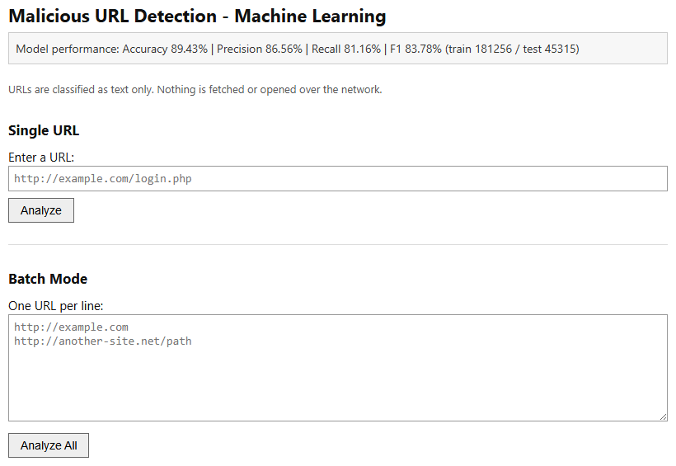
Fig 6.1 Web interface showing the measured model performance
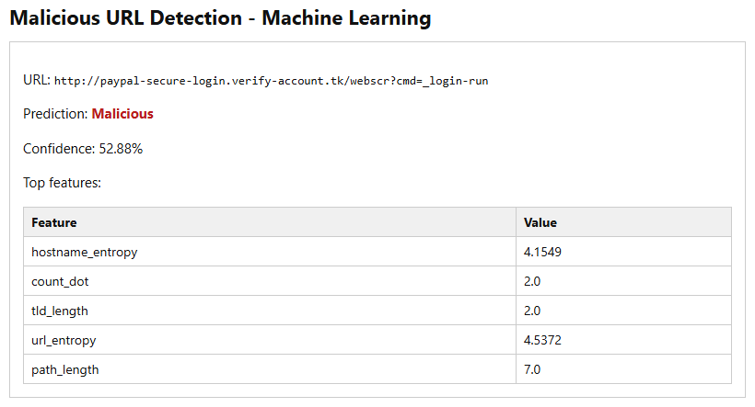
Fig 6.2 A phishing-style address classified as malicious
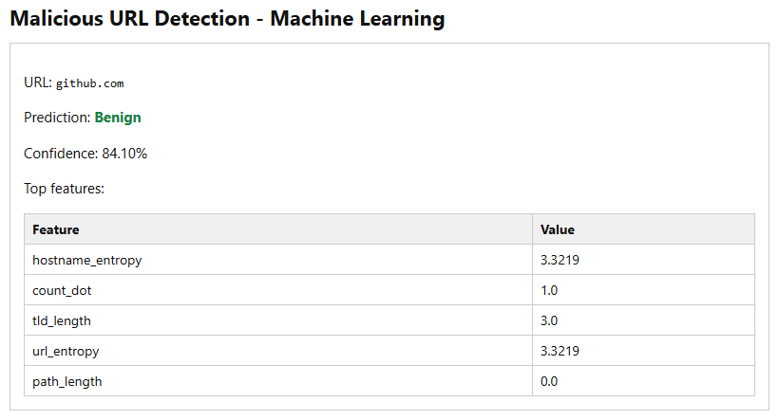
Fig 6.3 A legitimate domain classified as benign
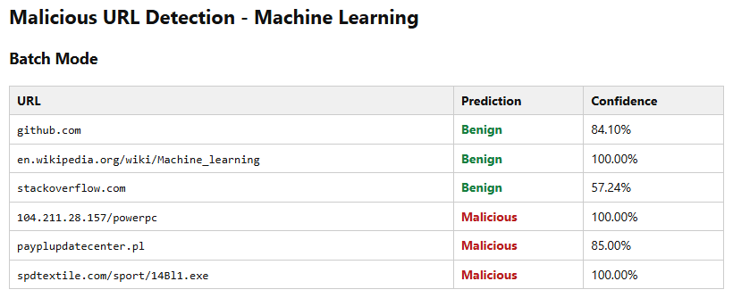
Fig 6.4 Batch analysis of six addresses
6.3 DISCUSSION
The most instructive result of this project is not the final figure but the sequence by which it was reached. The first model attained an accuracy of 95.80 percent, yet it classified the addresses of Google, GitHub and Wikipedia as malicious with confidences between 87 and 98 percent. The cause was that only 8.3 percent of benign entries in the corpus carry an http or https prefix while every defacement entry does, so the model had learned that the presence of a scheme indicates malice. Since an address typed by a user almost always carries a scheme, the detector was of no practical use whatever its measured accuracy. Removing the scheme during normalisation reduced accuracy to 92.57 percent.
A second artefact was then found. Benign addresses had been collected at the level of individual pages, so only 0.1 percent of them are bare domains, whereas phishing feeds list bare domains and 23.1 percent of phishing entries take that form; in consequence 98.8 percent of all bare-domain entries in the corpus are malicious. The model had learned that an address without a path is malicious, and returned that verdict with complete confidence for github.com and google.com while classifying the same domains as benign when a path was appended. Augmenting the training data with host-only copies carrying the correct label removed the shortcut and reduced accuracy further, to 89.43 percent.
The measured accuracy therefore fell at each stage while the system improved at each stage, and 89.43 percent is the figure that may be relied upon. The episode illustrates a general point: a classifier optimises whatever quantity is placed before it, and if a corpus contains a regularity produced by the manner of its collection, the classifier will exploit that regularity in preference to the phenomenon under study. Evaluation on a held-out partition of the same corpus cannot detect this, because the artefact is present in both partitions. Only testing on addresses drawn from outside the corpus revealed the fault.
Two weaknesses remain. The address of the college, whose two-part country top-level domain is uncommon among the benign training data, is misclassified as malicious. Shortened addresses are classified as benign, since a shortening service produces a string that is lexically indistinguishable from an ordinary short address; detecting these would require the shortened address to be expanded, which entails contacting the service and lies outside the design of this system.
VII. CONCLUSION
This project set out to construct a system capable of judging whether a web address is malicious without opening it, and that objective has been met. A Random Forest of 200 decision trees, trained on thirty lexical and host-based features derived from a corpus of 651,191 labelled addresses, classifies a held-out partition of 45,315 addresses with an accuracy of 89.43 percent and an F1 score of 83.78 percent. The trained model is served through a web interface that accepts either a single address or a batch and returns a verdict with a confidence value and the contributing features, and the correctness of the implementation is supported by thirty-six automated tests.
The principal contribution of the work, however, lies in the identification and removal of two artefacts in the public corpus. Each permitted the classifier to obtain a higher measured score while behaving incorrectly on ordinary addresses, and each was invisible to evaluation on a held-out partition of the same data. Their removal lowered the reported accuracy from 95.80 percent to 89.43 percent and, in doing so, converted a detector that labelled the world's most visited websites as malicious into one that does not. The resulting figure is lower and considerably more honest.
VIII. FUTURE ENHANCEMENT
- Evaluation against an independently collected corpus, in order to establish that the reported figures are not themselves dependent on the assembly of this particular data set.
- Extension of the output from a binary verdict to a named category, distinguishing phishing from defacement and from malware distribution, so that an analyst is given actionable information.
- Addition of features derived from the domain registration record, such as the age of the registration and the identity of the registrar, which would materially assist with newly created domains.
- Expansion of shortened addresses before classification, so that the destination rather than the shortening service is assessed.
- Calibration of the decision threshold, permitting the balance between false positives and false negatives to be adjusted to suit the deployment.
- Integration with the browser as an extension, so that an address is evaluated at the moment a link is followed rather than through a separate interface.

BIBLIOGRAPHY
[1] Kaggle, Malicious URLs Dataset, 651,191 labelled URLs, 2021. https://www.kaggle.com/datasets/sid321axn/malicious-urls-dataset
[2] L. Breiman, "Random Forests," Machine Learning, vol. 45, no. 1, pp. 5-32, 2001.
[3] F. Pedregosa et al., "Scikit-learn: Machine Learning in Python," Journal of Machine Learning Research, vol. 12, pp. 2825-2830, 2011.
[4] S. Tian, Y. Yu, H. Sun and X. Wang, "From Past to Present: A Survey of Malicious URL Detection Techniques," 2025.
[5] OWASP Foundation, OWASP Top 10 - Web Application Security Risks, 2023. https://owasp.org/www-project-top-ten/
[6] Anti-Phishing Working Group, Phishing Activity Trends Report, 2024. https://apwg.org/trendsreports/
[7] Pallets Projects, Flask Documentation, 2024. https://flask.palletsprojects.com/
[8] C. R. Harris et al., "Array Programming with NumPy," Nature, vol. 585, pp. 357-362, 2020.
[9] The Pandas Development Team, pandas Documentation, 2024. https://pandas.pydata.org/docs/
[10] Scikit-learn Developers, Ensemble Methods - RandomForestClassifier Documentation, 2024. https://scikit-learn.org/stable/modules/ensemble.html

