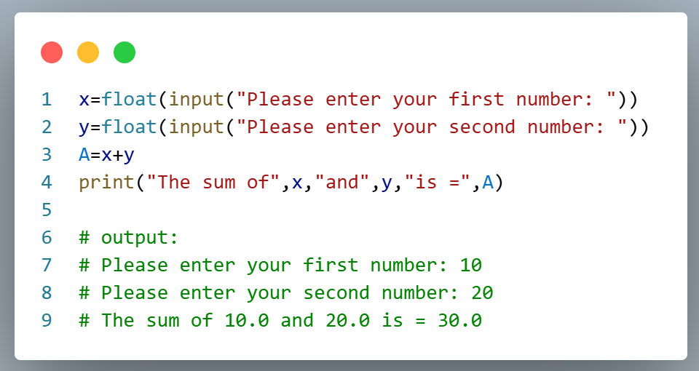
- Expriment Name : Adding two numbers by using python.

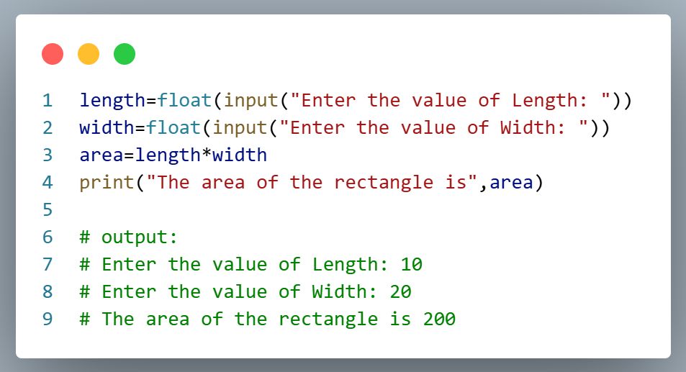
- Expriment Name : Find the area of Rectangular.

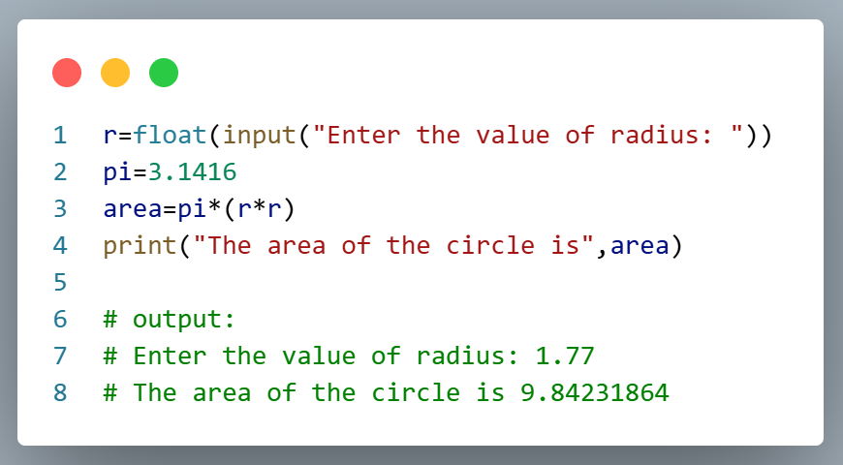
- Expriment Name : Find the area of the Circle.

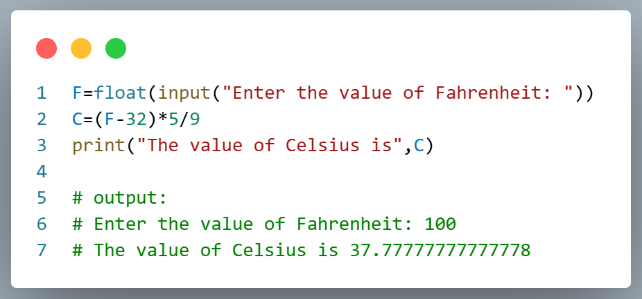
- Expriment Name : Convert the Fahrenheit temperature to Celsius value.

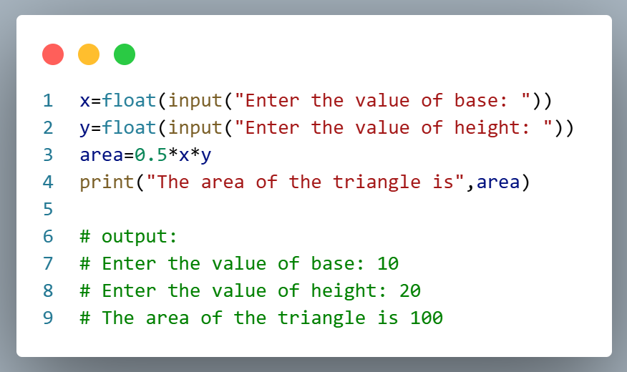
- Expriment Name : Find the area of Triangle.

