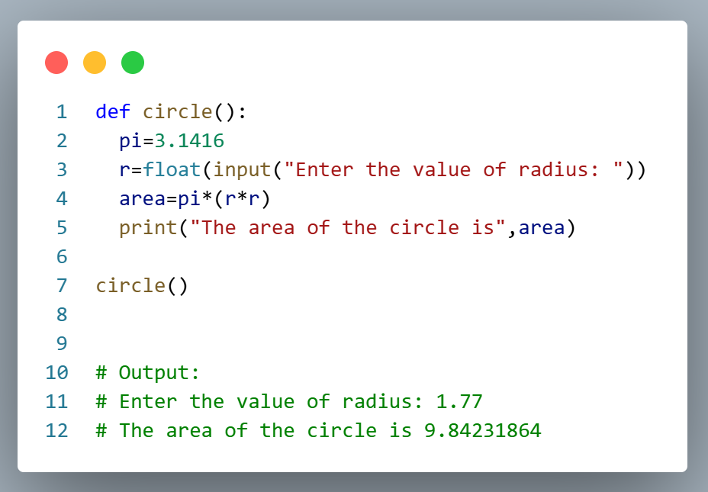
- Expriment Name : write a program by using function to calculate the area of circle.

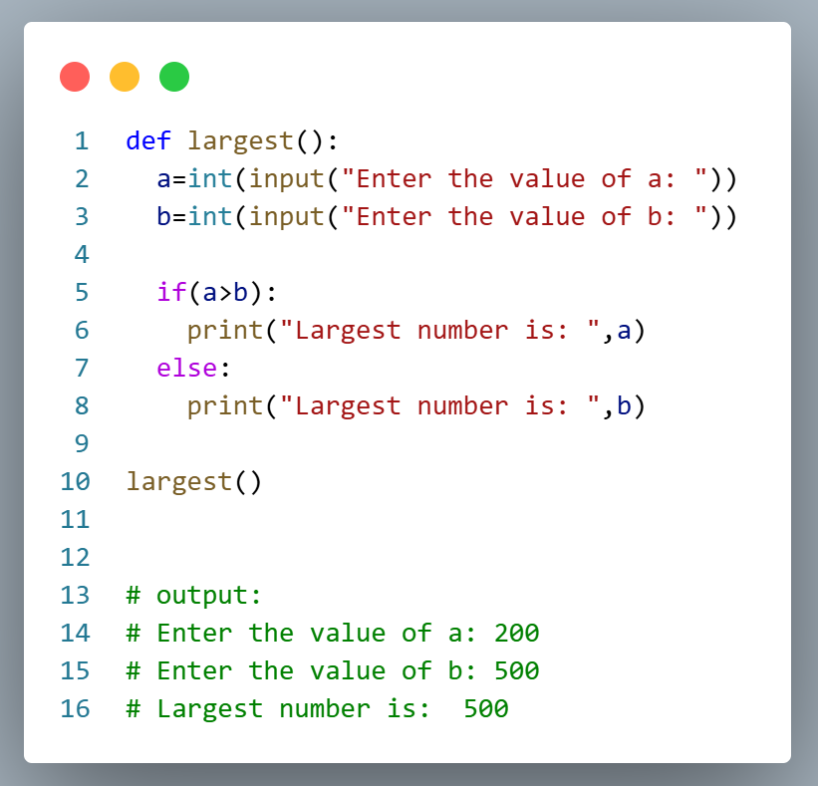
- Expriment Name : write a program by using function to find the largest number.

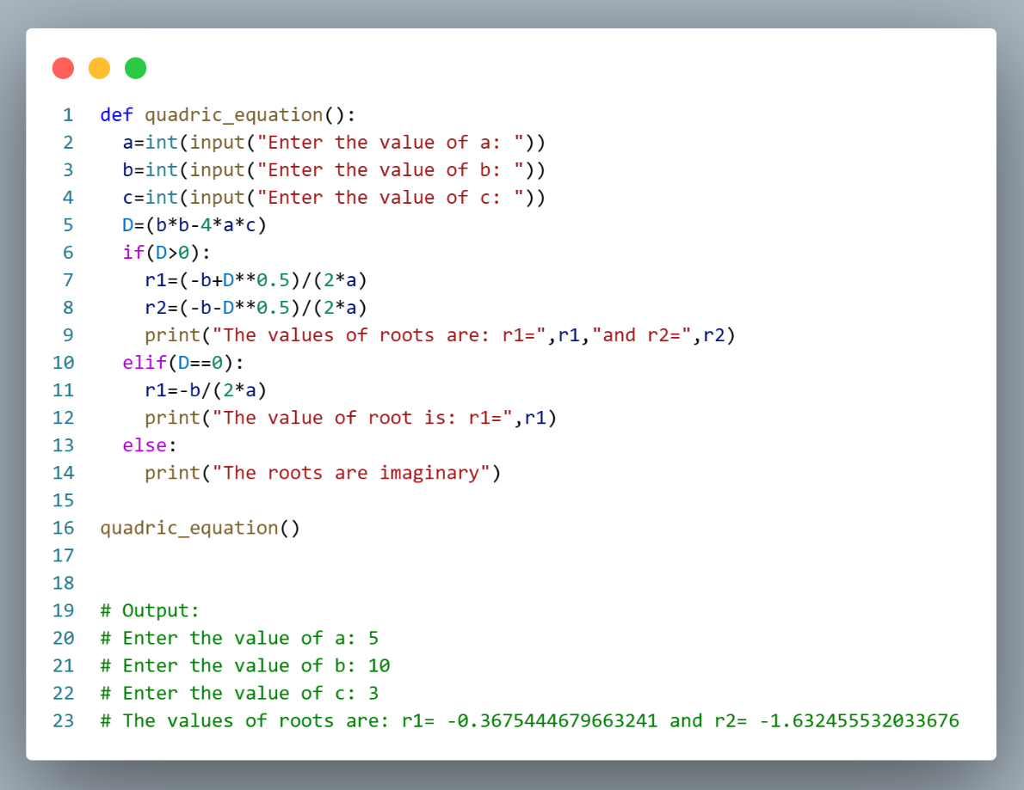
- Expriment Name : Write a program by using function to find the root of quadric equation.

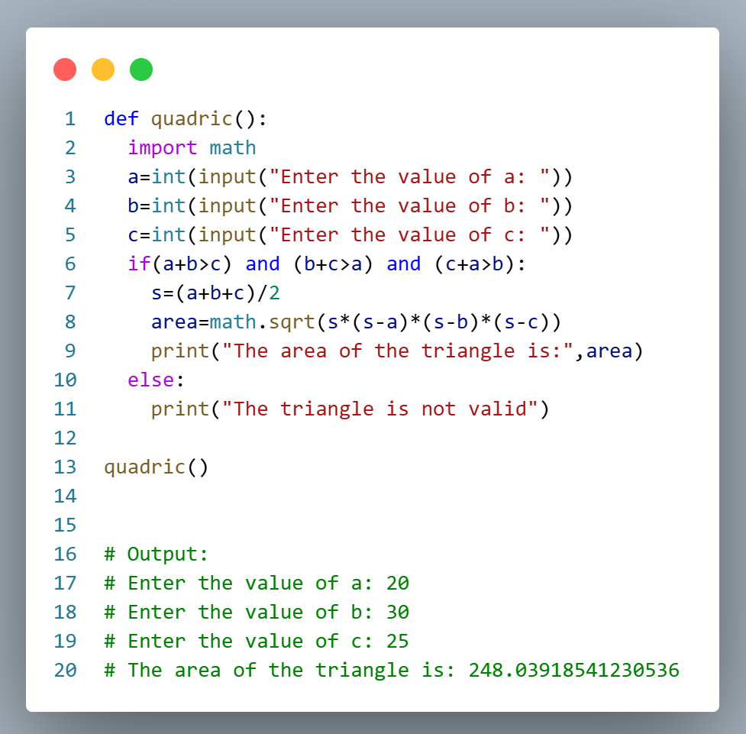
- Expriment Name : Write a program by using function to find the area of Triangle.
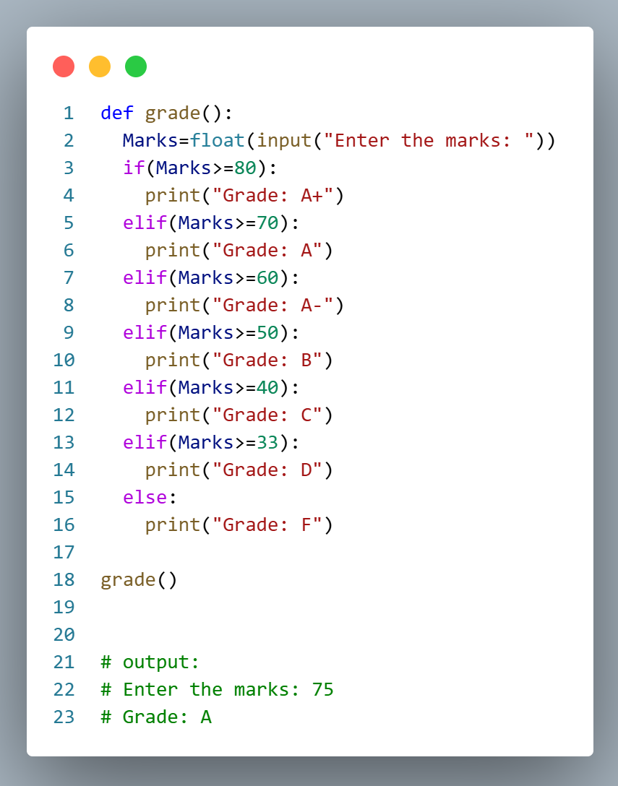
- Write a program by using function to calculate the grade of the student.

