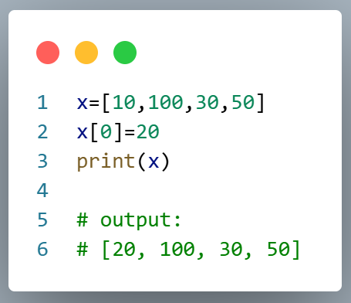
- Expriment Name : Access item of list.

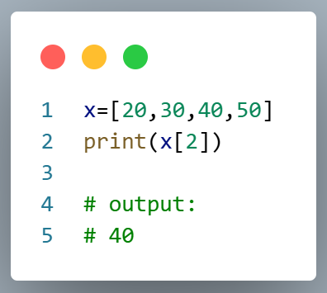
- Expriment Name : Modify item of list.

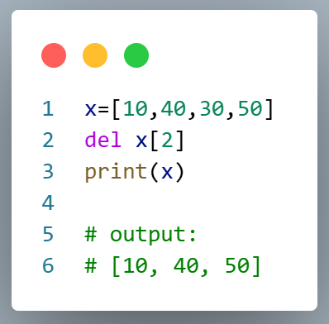
- Expriment Name : Delete item of list.

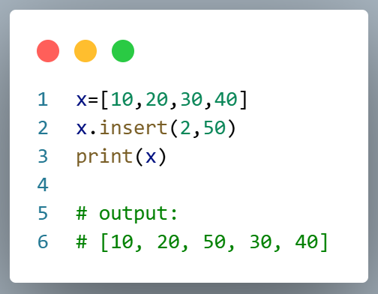
- Expriment Name : Insert item of list.

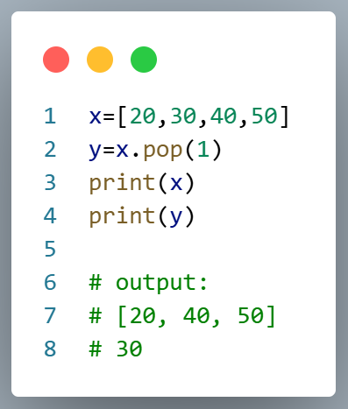
- Expriment Name : Pop item of list

