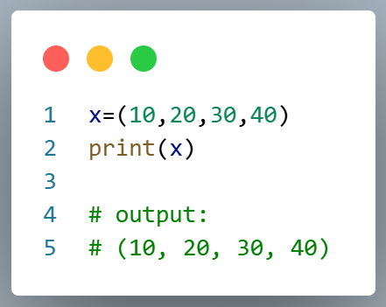
- Expriment Name : Access the item in tuple

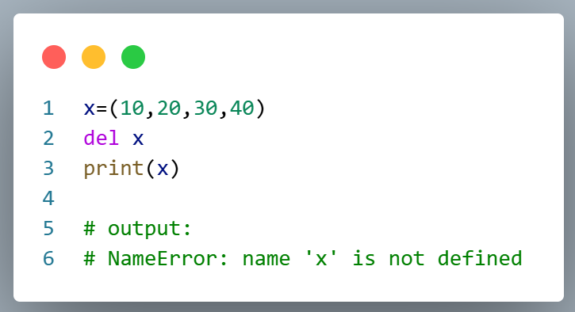
- Expriment Name : Delete tuple

